The Stephen James
CSRA Coin Club of Aiken
P.O. Box 11
New Ellenton, SC 29809
Web site: www.sjcsracc.org
The SJ CSRA CC of Aiken, SC meets on the 1st Thursday of the month at the Aiken Public Library

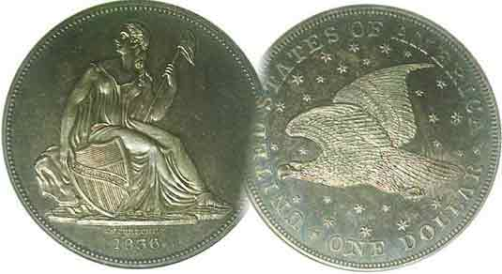
Pres. J.J. Engel
V .P. Pat James
Sec. Jim Mullaney
Treas. Chuck Goergen
Sgt. in Arms: Jim Sproull

Programs: Pat James
ANA Rep.: Glenn Sanders
Show Chair: Board members
Photos: Steve Kuhl
Publicity: Pat James
Newsletter: Arno Safran
E-Mail: arnosafran@comcast.net
Auctioneer: Jim Sproull
Web site: Susie Nulty (see above.)

Our upcoming Zoom and “live” Meeting will be held Thursday, May, 6 at 6:45 PM at Jim Mullaney’s barn

2021 Club “Zoom” Meeting Schedule
Volume 20, No. 5 the Stephen James CSRA Coin Club, Founded in 2001 May, 2021
Monthly Newsletter
Collecting an attractive 1921 Year Set, a big challenge
Jan. 7 Apr. 1 July 1 Oct. 7
Feb. 4 May 6 Aug. 5 Nov. 4
Mar. 4 June 3 Sept. 2 Dec. 2

A Interesting Mexican Dollar from 198 years ago

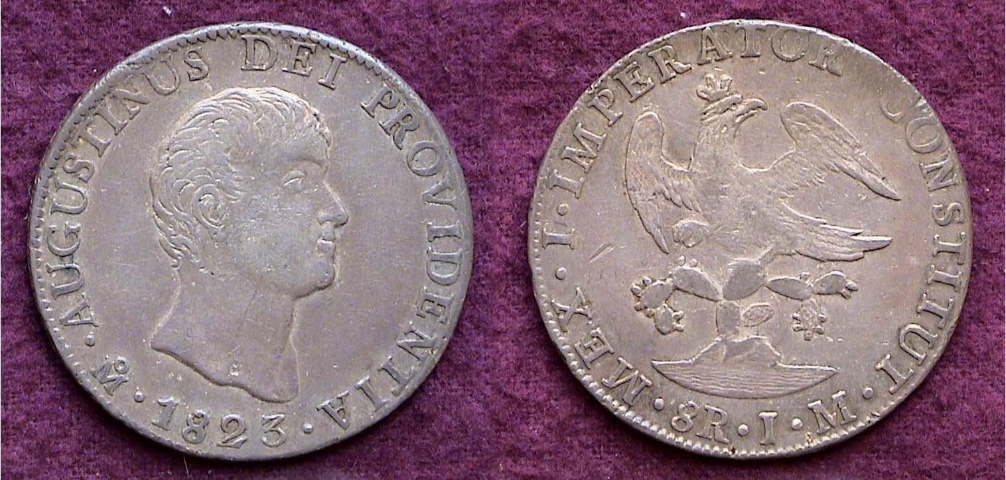

An 1823 8 Reales showing Augustin Iturbide on the obverse
and a crowned eagle on cacti on the reverse
[Enlarge page to fill monitor screen to view details more clearly.]

The War of Independence by Mexico against Spain lasted 12 years, (1810-1822) when General Augustin Iturbide--who entered the battle rather late--declared himself, Imperator. During his short rule, 1822 and ’23, his portrait appeared on the obverse of the silver and gold coinage, and throughout those two years of service, he proved to be dictatorial for which the Mexicans--after 12 years of war with the former mother country, Spain, had little appetite. So, the Mexican army forced him to resign and exiled him with the proviso that if he ever returned he would be summarily arrested and executed.

During his two year reign, his portrait appeared on the obverse of all the silver and gold denominations with a crowned eagle perched on a cactus plant on the reverse. The 1822 dated 8 Reales is far scarcer than the far more common 1823 shown above. The Legend on the obverse reads, Augustinus Dei Providentia, (Latin for Augustus, the provider) with the date centered below. To the left of the date curving slightly upward is the mintmark featuring a large capital M under a tiny o which stands for the Mexican Mint. On the reverse is the Legend continues from the obverse, MEX I IMPERATOR / CONSTITUT. Similar legends appeared on the lower silver denominations. These included the ½ real, Real, 2 Reales which equaled a US quarter or “2 bits” but no 4 Reales which would have equaled our half-dollar. Iturbide was a vain man and after a few years, clandestinely returned to Mexico, was spotted, captured and executed.

Collecting the US Coins of 1921, 100 years ago (excluding gold) By Arno Safran

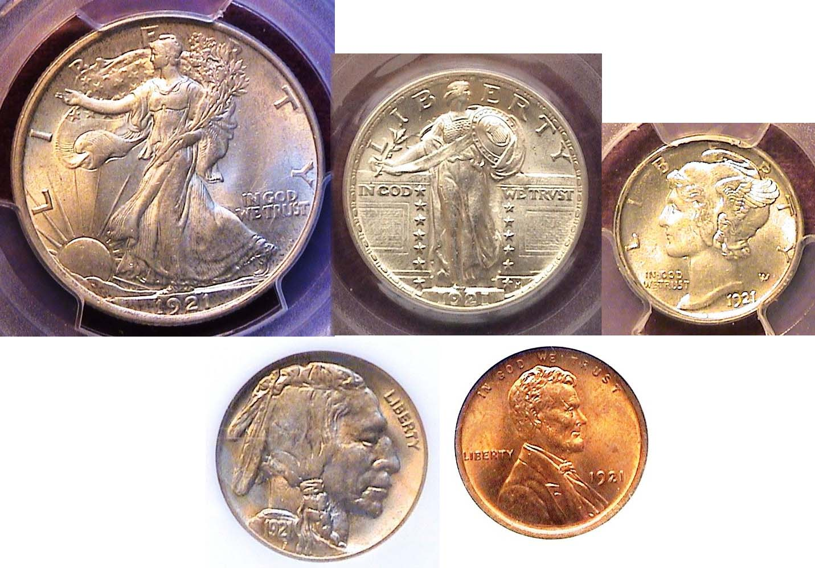
BU obverses of our 1921 coinage (excluding the $1.00)
[Enlarge page to fill monitor screen to view details.]

Years ago, the writer aspired to assemble uncirculated US coin sets from the current year which at the time was 1976, gradually going back in time. The Bicentennial anniversary of the Declaration of Independence stimulated a return to coin collecting that had begun during his teen years but abruptly ended when he could not explain to his father why he was spending $4.50 for an 1825 Bust dime graded AU-53 on his $2.00 a week allowance. In the late 1970s, there were lots of coin shops including some in the malls. If you were a regular, the dealer would allow you to search through uncirculated rolls of coins to form BU year sets. A number of eye appealing fairly attractive Franklin halves were acquired that way. Over the years as his interest grew, he started to seek coins from the 1940s and 1930s but obtaining coins struck prior to 1934--the year dealers began putting away rolls of uncirculated coins--stopped his “habit” in its tracks. Years later, when he had became better numismatically educated he found some attractive “raw” coins from the 1920’s such as a 1923-S WL half dollar but back then, he never had the money to acquire a BU 1921 Mercury dime, SL quarter or WL half-dollar even approaching XF-45, let alone, one in uncirculated condition.
_____________________________________________________________________________________________________________
(Continued on page 2, column 1)
Collecting the US Coins of 1921 (excluding gold)
100 years ago (Continued from page 1, column 2)

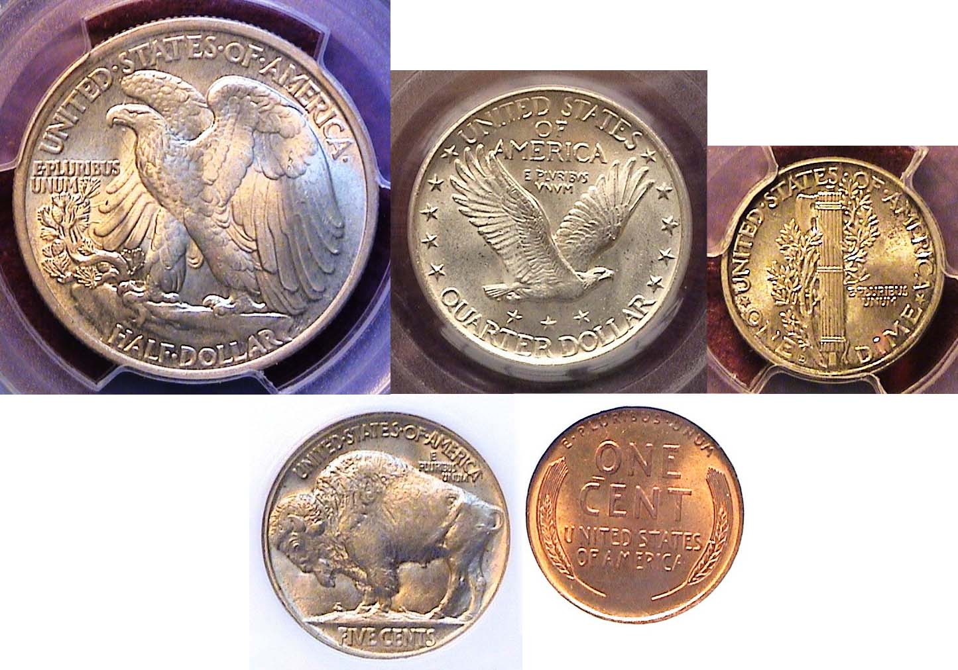
BU reverses of our 1921 denominations excluding the $1.00
50c, 25c and Denver mint 10c over 5c & 1c
[Enlarge page to fill monitor screen to view details.]

Excluding gold, a 1921 year set consists of six denominations, the bronze cent, five-cent nickel along with the silver dime, quarter, half-dollar and dollar. Actually two silver dollar coin types were struck that year; the resumption of the Morgan dollar after a hiatus of seventeen years for a final “last hurrah”--as it were--and the introduction of the new Peace dollar, emblematic of a world at peace first struck three years after the armistice that concluded World War I.
With the exception of the Morgan dollar which had huge mintages at all three Mints, all the other 1921 dated denominations--including the Peace dollar were low mintage issues, some with severe drops in numbers from the previous four years. The plunge was due to a post WWI economic recession as the nation attempted to adjust its economic needs from a wartime to a peacetime economy.

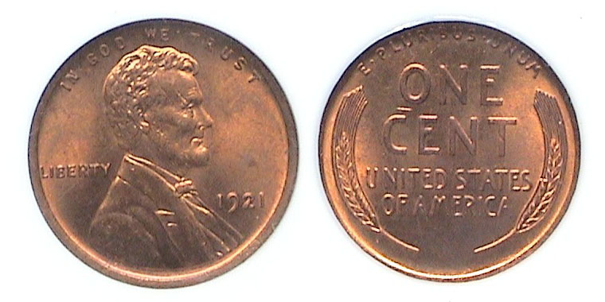
A 1921-P Lincoln cent graded MS-64 RD by NGC
[Enlarge page to fill monitor screen to view details.]

In 1921, 39.1 million cents were coined in Philadelphia with 15.2 million being produced at the San Francisco facility. No cents were struck at the Denver Mint that year. Except for the 1915-P, the 1921-P is the second highest priced Philadelphia Mint Lincoln cent in uncirculated condition of the entire wheat-back series, (1909-1958). That said, the date is still moderately priced up through MS-64. The coin shown was acquired at the Augusta Coin Club Show held back in May, 2010.

Of all the Philadelphia Mint issues of the Buffalo nickel, the two most difficult dates to find in mint state are the 1918 despite a mintage of 32 million and the 1921 with only 10.6 million struck compared with 63 million in the previous year. Neither date however is considered comparable in rarity to a number of branch-mint dates from the teen years and 1920s.
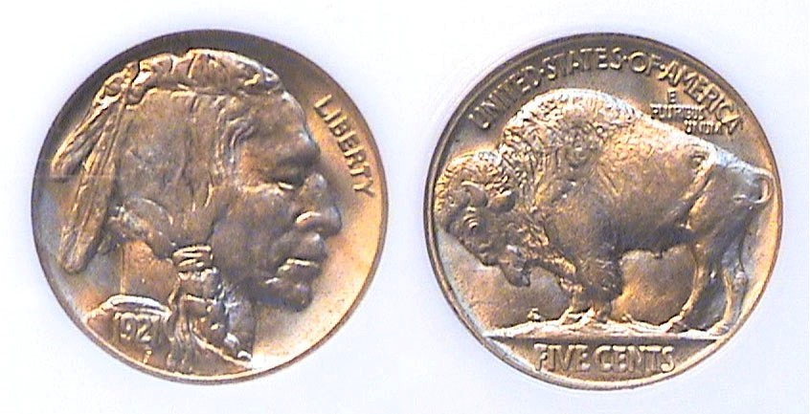
A 1921-P Indian Head/ Buffalo nickel graded MS-63 by NGC
[Enlarge page to fill monitor screen to view details.]

The specimen shown was acquired at the Georgia Numismatic Association Convention in April, 2010. It was housed in an obsolete PCI holder graded MS-64 and by its appearance was well struck coin with ample luster and eye appeal having no distracting marks. The dealer however, priced it as a MS-63, possibly because the now defunct company’s reputation for grading was not as stringent as PCGS or NGC. Before purchasing the piece, I showed the coin to a couple of respected dealers and both thought the coin to be a legitimate MS-64. In 2012, curiosity got the best of me. I decided to crack out the 1921 nickel and submitted it “raw to NGC. It came back as a 63. Since I was into the piece for ’63 money, any slight disappointment I may have felt, soon ebbed, because many seasoned collectors have observed grade inflation across the board by grading companies--which they refer go as “market grading”--that include rare to scarce date coins to extremely common date Morgan and Peace dollars, so who knows, maybe the 1921 nickel would come back a MS-64 holder today. In 1921, the 5c nickel coin was the workhorse of the economy.

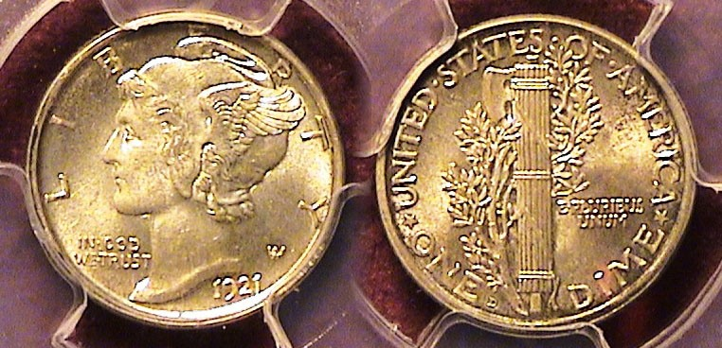.
A 1921-D Mercury dime graded MS-64 Full Bands by PCGS
[Enlarge page to fill monitor screen to view details.]

Unlike many of the other year sets from the 1920s and early 1930’s, the 1921 set has three very tough denominations to acquire in grades from AU-58 to MS-64, let alone MS-65 or higher. They include the Mercury dime, Standing Liberty Quarter and the Walking Liberty half-dollar, the last named, a “stopper” in every sense of the word. In 1921, only 1.2 million Mercury dimes were struck at the Philadelphia Mint with just a tad over 1 million coined at the Denver facility. No dimes were produced the San Francisco Mint that year. Both the 1921-P and D issues are among the key dates of the series behind the popular the 1916-D rarity and the 1942/1-P and D issues.
One of the best sources to locate the availability of specific date US type coin is on the PCGS Collectors’ Corner web-site. One clicks the type under the choice of denomination and an entire date list of the design types for the denomination appears. Finally, one clicks the desired date and up comes a number of currently available specimens ranging in grades from circulated to mint-state including the various Mints in operation at the time of issue. The examples are usually pictured on the site and can be enlarged to check for impurities or surface distractions. This is how the writer was able to locate the 1921-D Mercury dime shown above. Mercury Dimes with full bands on the reverses carry a premium. At the time, no 1921-P dimes in the desired grade range were available, so the 1921-D was acquired.
(Continued on page 3, column 1)

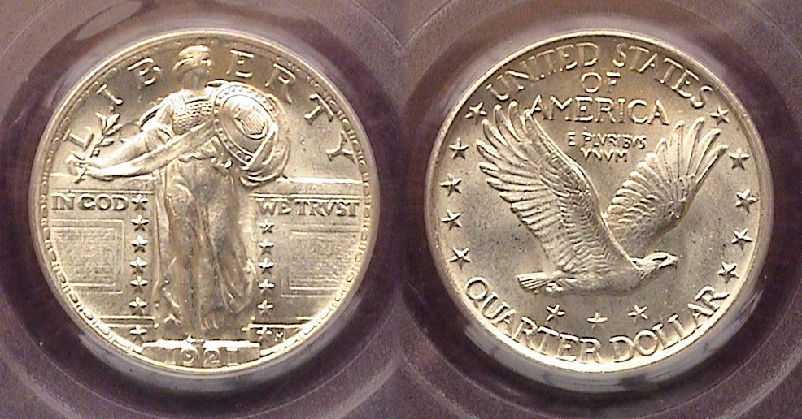

A 1921 Standing Liberty Quarter graded MS-63 by PCGS
[Enlarge page to fill monitor screen to view details.]

After the 1916, Standing Liberty quarter the 1921 is the scarcest Philadelphia Mint issue. The 25c coin was struck only at the Philadelphia Mint that year with a reported mintage of 1,916,000, a drop of 25.9 million from the 27,860,000 struck at the Philadelphia Mint in 1920. According to J. H. Cline, a Standing Liberty quarter dealer and author of the book on the series, the 1921 issue is generally well struck but a lot scarcer than one would believe. “We routinely have more 1916 quarters in stock than the 1921 or 1923-S.” The certified MS-63 specimen shown was acquired at the FUN Show held in Orlando, FL in January, 2010 but has the eye appeal of a 64.

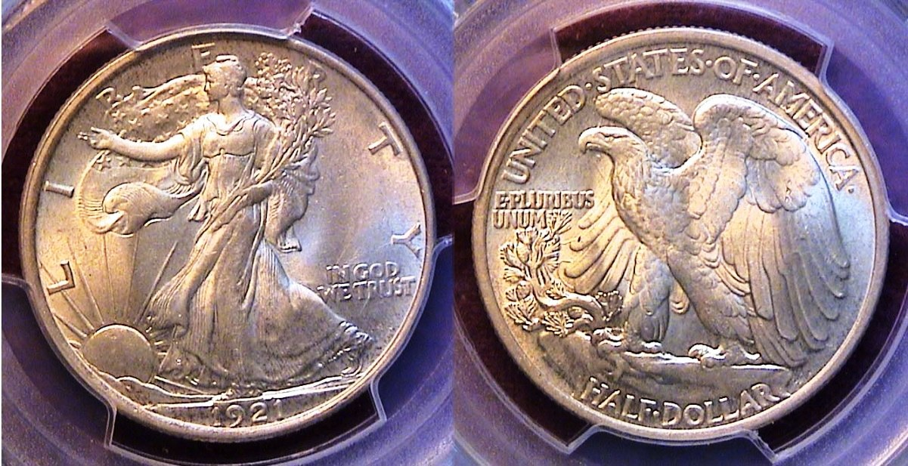

A 1921-P Walking Liberty half-dollar graded MS-63 by PCGS
[Enlarge page to fill monitor screen to view details.]

The crowning glory of the entire 1921 seven piece denomination set is the beautiful Walking Liberty half-dollar designed by engraver Adolph Weinman and first issued 105 years ago in 1916. The coin was struck at all three mints but in extremely low numbers due to the post WWI recession. 246,000 were struck at Philadelphia, 208,000 in Denver and 548,000 in San Francisco. Despite the drop in mintages, there are more survivors today of the 1921-P and while it is the least pricey of the three Mints across the entire grading spectrum, a 1921-P half-dollar certified MS-63 will still cost plenty. One has to be either wealthy or have sufficient reserves from the sale of other coins in his or her collection in order to purchase the date. The specimen shown was located on a reputable national dealer’s web site. Not every MS-63 example looks the same and while the pic appeared well struck and very attractive it was important to have the coin in hand so I requested the coin be sent “on approval” before acquiring it.

Most people living in the United States today hardly use the half-dollar when they encounter one. It doesn’t fit in a vending machine and cannot buy even a candy bar the way a nickel could during the 1940s but until 1934--the year before dealers starting putting away rolls of mint-state coinage as soon as they left the mint--the half-dollar circulated heavily with the result that survivors from the teens and 1920s grading XF-45 or higher have become increasingly harder to find. In 1921 according to the on-line research group, Measuring Worth, a 50¢ piece had the purchasing power of $7.14 today. People could use such a coin to pay for lots of basic goods.

The Resurrection of the Morgan dollar

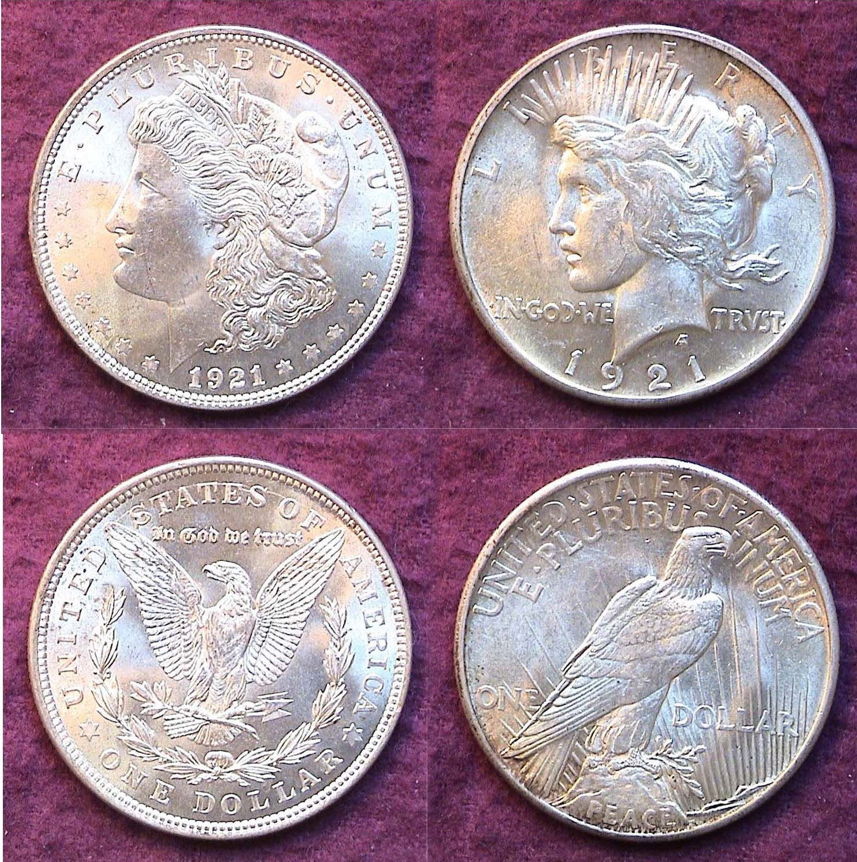

1921-P Morgan and Peace dollars
The Morgan $1.00 was graded MS-65 and the Peace $1.00 MS-62
[Enlarge page to fill monitor screen to view details.]

A 1921 certified year set (excluding gold) would not be complete without the inclusion of both the Morgan dollar and the Peace dollar. After a hiatus of seventeen years, the long forgotten Morgan dollar was resurrected as part of a provision of the 1918 Pittman Act, but at a price higher than its silver value. To make matters worse, the coin was to be produced in huge numbers. Engravers George Morgan with J.R. Sinnock (who would later engrave the Roosevelt dime in 1946) were appointed to produce new hubs that were rushed and were vastly inferior to the destroyed ones used for the original series (1878-1904). Close to 45.7 million Morgan dollars were struck at the Philadelphia Mint, 20.3 million at the Denver Mint and almost 21.7 million at the San Francisco Mint in 1921. Virtually none of these coins entered circulation.

The 1921-P Morgan dollar pictured above was acquired as an MS-64 “raw” a generation ago for $59 and recently submitted for certification where it was graded MS-65. The 1921 Peace dollar was released toward the end of that year and only struck at the Philadelphia Mint with a reported mintage of 1,006,473. It often comes lackluster looking nowhere near as brilliant as the extremely common date 1922-P.. The specimen shown above was acquired “raw” with Anacs papers as an MS-60 in 1982 before the advent of third party professional grading. It was submitted for certification in 2012 where it was returned in a hermitically sealed holder graded MS-62. The goal of most collectors is completion whether it be a series run, a set of type coins of a single denomination or a year set. Completing the set of BU US coins of 1921 (excluding gold) was one of the major highlights of the author’s career in numismatics.
_____________________________________________________
The Commemorative Coinage
Celebrating the Wright Brothers First Flight
Part One: US Commemoratives
By Robert Sanborn

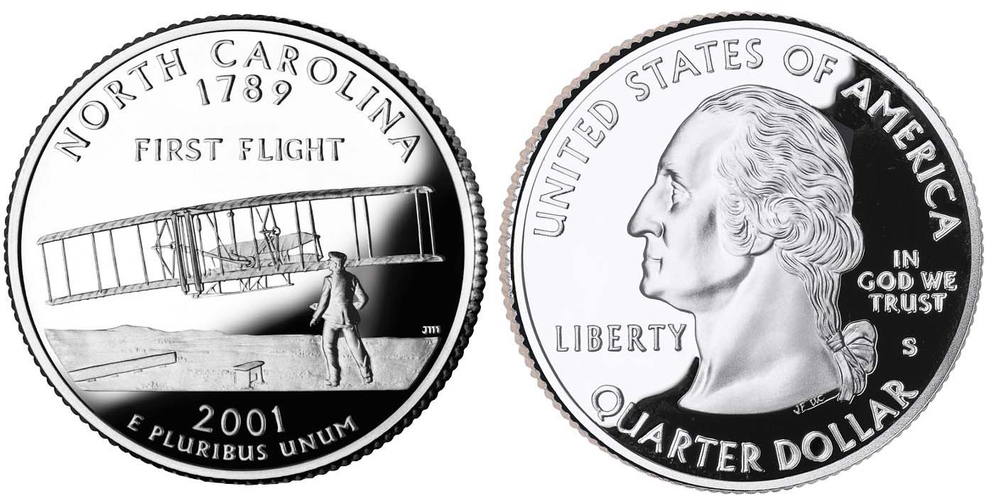

An uncirculated 2001 North Carolina Statehood Clad quarter
displaying the Wright Bros. First Flight on the obverse
[For better viewing of all coin types magnify the page to fill monitor screen.]

One of the topics that I have always enjoyed reading about are the coins that have been made commemorating a date or event. After having just read a fabulous book by David McCullough regarding the Wright Brothers, I started to wonder what coins were made commemorating that incredible event. To my surprise, I discovered that there really were not very many coins created by government mints to celebrate such an achievement considering the fact that in today’s world, one can travel to any place in the in less than 24 hours. While there are quite a few tokens, medals, and all sorts of knickknacks to celebrate the event, I could find no paper money. So, let’s start with the USA.
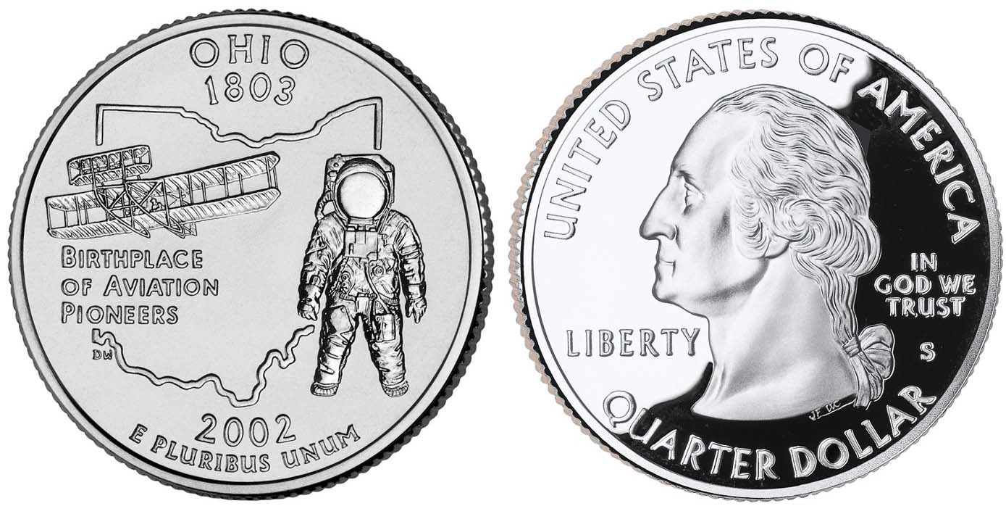

A proof 2002 Ohio Statehood Clad quarter
displaying the Wright Bros. First Flight on the obverse

It really took the US government quite a while to latch on to the idea of the flying machines and in fact, it was the French who really gave the Wright Brothers the kick start that they needed. Wilbur Wright was born in 1867 near Millville Indiana and Orville four years later in 1871 in Dayton Ohio. Their beginnings in flight began as young boys in 1878 when their father brought home a toy helicopter, about a foot long, made of paper, bamboo, and cork and powered by a rubber band to spin the rotor. They played with it till it broke and the proceeded to build their own. From there, you need to read the book. Another option is the excellent material in Wikipedia

The first coins to celebrate the Wright Brothers came from the very popular US State Quarters program with North Carolina, in 2001, and then Ohio, in 2002, featuring the two brothers’ flights. For North Carolina, the mint created over a billion coins from the Philadelphia and Denver mints. For Ohio, the mintage was around 660 million. In 2003, the US Mint issued a commemorative Half Dollar, Dollar, and Ten Dollar coin to celebrate that first powered flight that took place in 1903.

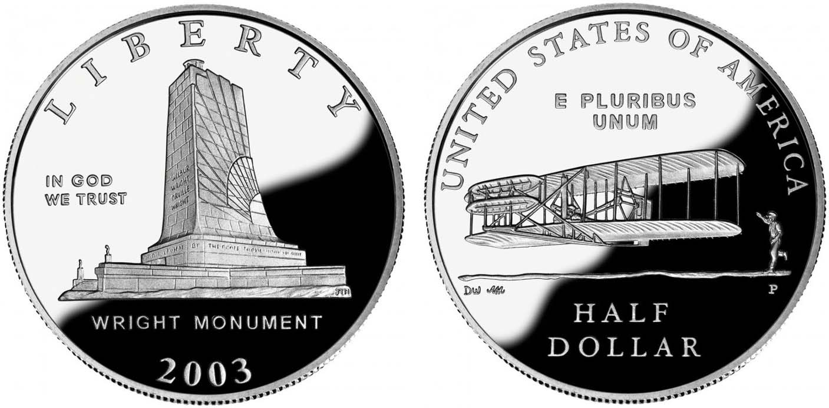

A 2003 Commemorative Proof half-dollar featuring the Wright Monument on the obverse and the first flight on the revere

The Red Book shows that the clad half dollar weighs 11.34 grams, is 1.205 inches in diameter, and who knows what it is made of. It had a mintage of 57 thousand clad pieces and 109 thousand copies in proof.

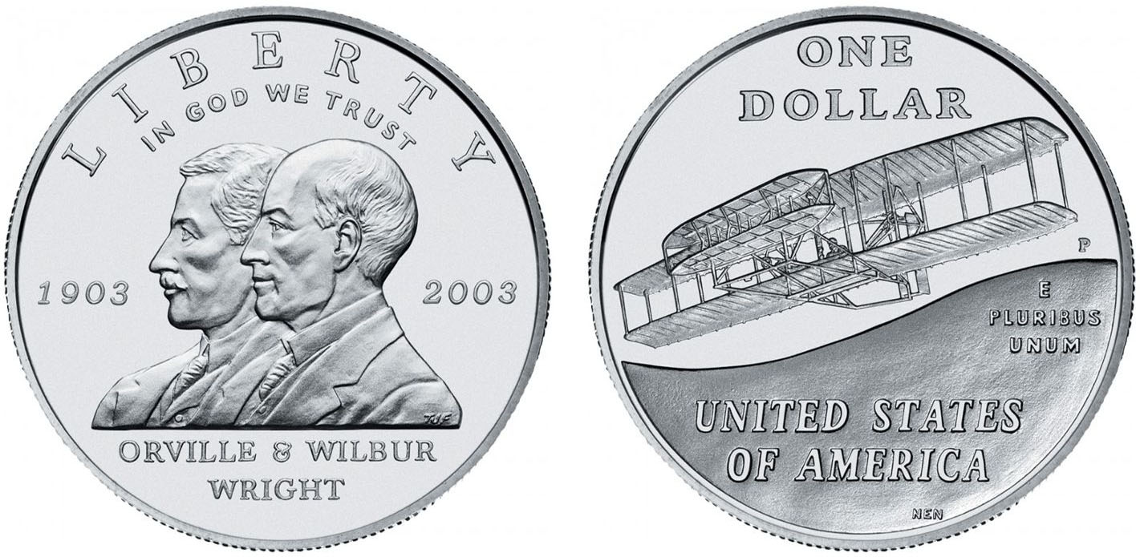
A 2003 Commemorative silver dollar featuring Orville and Wilbur Wright on the obverse and the First Flight on the reverse

The Silver Dollar coin weighs 26.73 grams, is 1.5 inches in diameter and contains 90 percent silver, had 53 thousand copies while 190 thousand were proof.

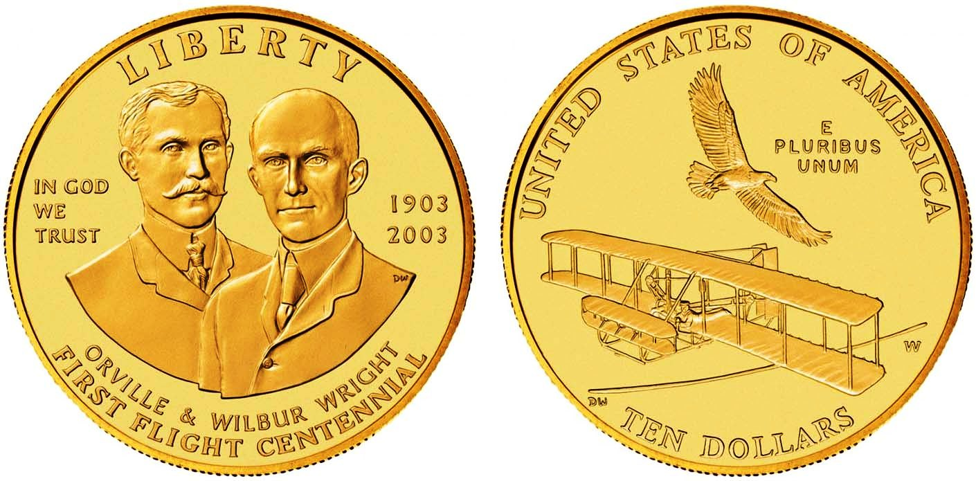
A 2003-W $10.00 gold commemorative featuring the
two Wright Brothers on the obverse
with the first plane flying below and eagle on the reverse

As for the $10 Gold piece, it contusions 90% gold, weighs 16,718 grams, and is 1.06 inches in diameter, The West Point Mint struck 10 thousand pieces with an additional 21 thousand proof. Here are the US Mint links to the Dollar Half , and Gold coins. The details of the coins come from the US Public Law 105-124 and you can read it here. As far as the US mint goes, that is it. Hopefully, there will be more.

What is amazing is that they were probably more celebrated early on overseas than here in the USA. It took an early interest from foreign governments before the US government finally realized the potential to be had in their own back yard. Oddly enough, the foreign coins that celebrate and commemorate the Wright Brothers comes from some interesting places.
__________________________________________________________________________________________________________________
(Continued on page 5, column 1)

The Commemorative Coinage
Celebrating the Wright Brothers First Flight
By Robert Sanborn
(Continued from the previous page)

Part 2: Foreign commemoratives

Much of the following comes from Numista, a terrific source of information.
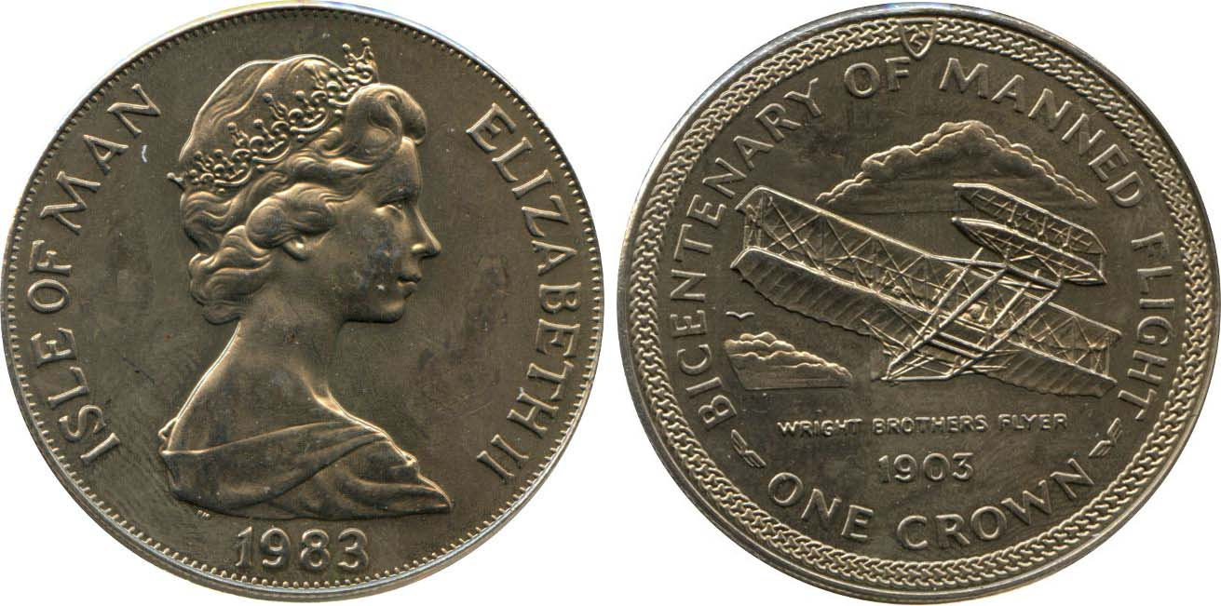

​An 1983 British Crown from the Isle of Man
[For better viewing, magnify the page to fill monitor screen.]
[For better viewing of all coin types magnify the page to fill monitor screen.]

In 1983, the Isle of Man created a One Crown Copper-nickel non-circulating 200th anniversary of Manned Flight (from 1783, must have been a balloon ?) It weighs 28.47 grams and I s38.61mm in diameter. 50,000 were minted.

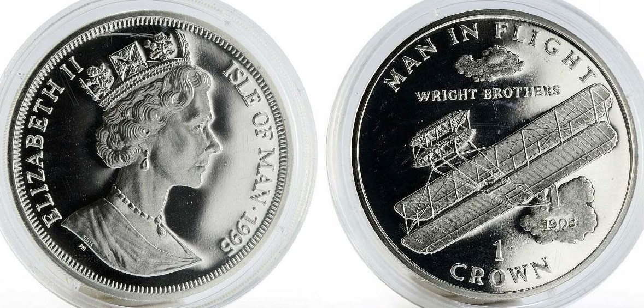

Another Isle of Man Crown, this one a proof, dated 1995
featuring Queen Elisabeth II on the obv. & the first flight on the rev.

Also from the Isle of Man in 1995 was a One Crown .925 Silver non-circulating Isle of Man in Flight coin. It weighs 28.28 grams, and is 38.5mm in size 30,000 coins were minted. All proof. A Copper-nickel version of the same coin was also ma de that same year.

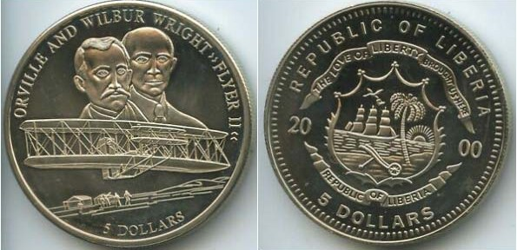

A 2000 $5.00 coin from the Republic of Liberia

In 2000, the Republic of Liberia issued a Five and Twenty dollar coin. The Five Dollar coin is 40mm (about 1.57 inches) and weighs 32 grams and is Copper-nickel. Five dollars in Liberia is worth about 3 US Cents. 20,000 were minted according to Numista.

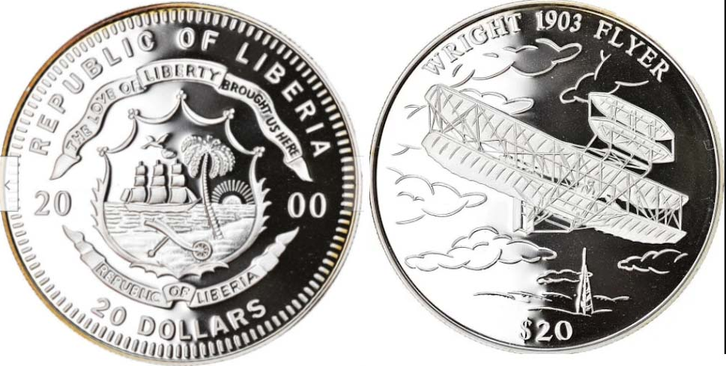

A 2000Republic of Liberia $20.00 ,999fine silver coin
Commemorating the 1903 First Flight

The Republic of Liberia also issued this Twenty Dollar coin that is .999 Silver and weighs 20.04 grams and is also 40mm in diameter. 2,000 were minted. In 2003, Liberia issued a 10 Dollar Milestones of Aviation Series coin. It is .925 Silver, weighs 25 grams and is a bit smaller at 38.61mm in diameter. 5,000 were minted.

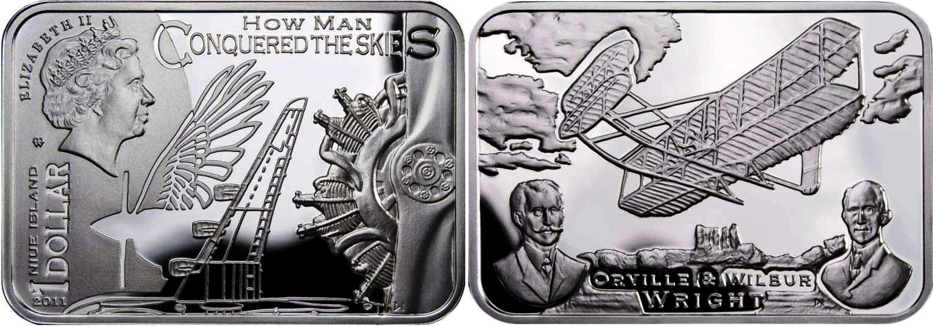

In 2011, New Zealand issued a 1 Dollar .925 Silver non-circulating coin from the How Man Conquered the Skies series featuring the Wright Brothers. It was a rectangular 40 x 28 mm coin that weighs 29.28 grams. Only 6,000 were minted but not in New Zealand. Instead, they were struck at the Warsaw Mint in Poland.
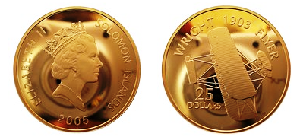
A 2005 Gold plated silver coin

Between 2003 and 2021, the Solomon Islands issued five non circulating commemorative coins. These are probably the most unique yet; having starting with the 2003 Aeroplanes series. The 2005 dated $25.00 coin is valued at $3.13 US, is composed of ..999 silver, although gold-plated weighing 31.1 grams and is 38.61mm in size, (similar to a US silver dollar). It features Elizabeth II on the front and the Wright Brothers’ 1903 Flyer on the back.
__________________________________________________________
(Continued on page 6, column 1)
The Commemorative Coinage
Celebrating the Wright Brothers First Flight
(Continued from the previous page)
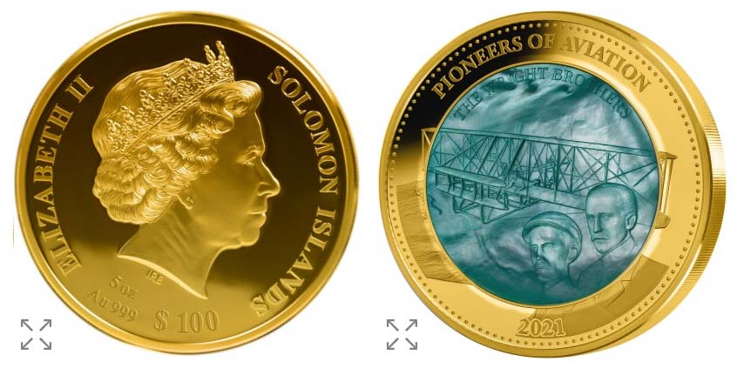
A 2021 $100 gold coin from the Solomon Islands

This year 2021, the Solomon Islands issued a 25 and 100 Dollar Pioneers of Aviation coin is that is part Mother of Pearl, one in gold and one in Silver. Both feature Elizabeth II on the front and Orville and Wilbur with their Wright Glider on the reverse. The silver coin weighs 155.5 grams and is 65mm in size and the silver is .999. Only 750 were minted. The 100 Dollar gold coin is quite a coin to look at. Same weight and size as the silver coin, it is .999 Gold. One site I saw listed it for $15,999 US. According to Numista.com, there were only 25 made.
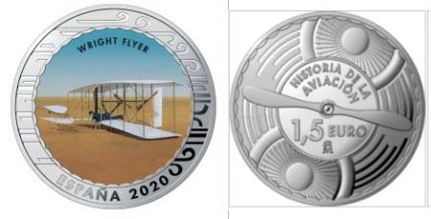
A 2020 Wright Brothers First Flight
commemorative Euro coin of Spain

In 2020 Spain issued a 1½ Euro Wright Flyer colored coin that is Copper-Nickel; weighs 15 grams and is 33mm in size. This was part of “History of Aviation” series. 7,500 were minted.
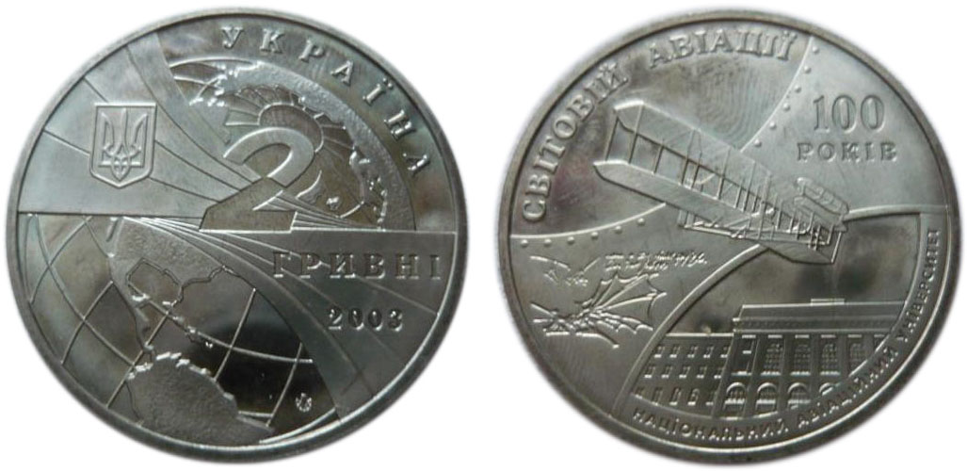

A 2003 Ukrainian 2 Hyrvni coin

The Ukraine also issued a non-circulating Wright Brothers coin in 2003 at the 100th Anniversary of World Aviation and the 70th Anniversary of their National Aviation University. It is a smaller 31mm coin weighing 12.8 grams and is Nickel and Silver in composition. The value is 2 Hryvni. 30,000 were minted.

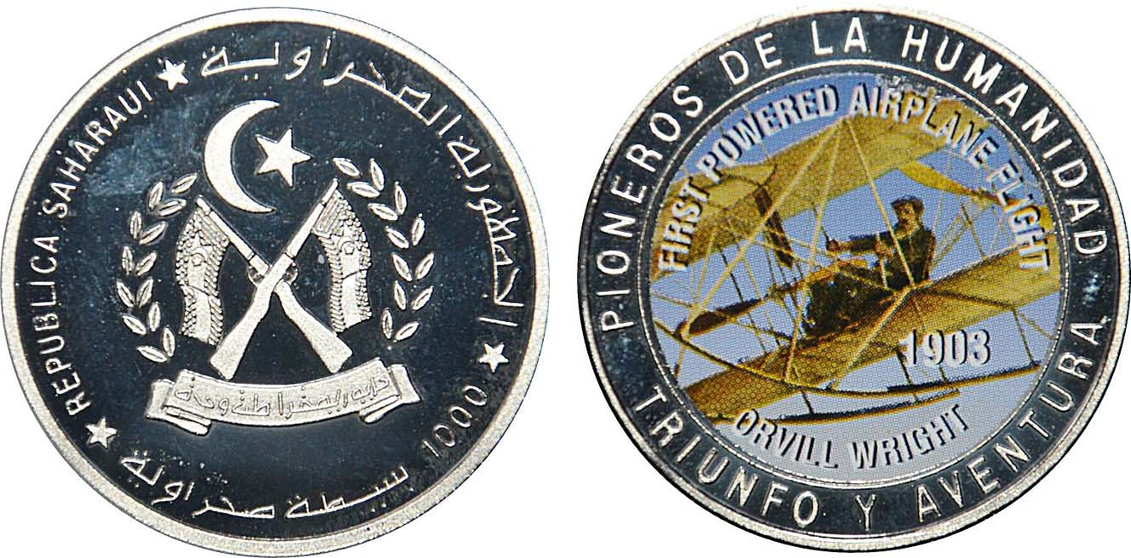

A 1997 Western Sahara 1,000 Pesetas

And finally, in 1997 the Western Sahara issued a 1,000 Pesetas Orville Wright coin. Note the misspelling of his name. It is a Copper-nickel colored coin weighing 29 grams and is 38.1mm diameter. Western Sahara is now part of Morocco depending on who you talk to.

This journey to find these coins was a lot of fun and while it was quite easy to find the US coins, seeing the tiny availability of some of the foreign, I may just have to look longingly at them.

Robert Sanborn
Indianapolis, IN

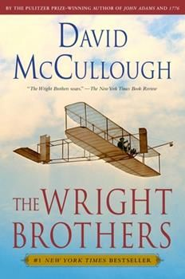

[The author, Robert Sanborn resides in Indianapolis, IN. He is a cousin of VP Pat James and also a club member who has attended a number of our meetings over the years and at our September shows in the past. He is also the Web master of the Augusta Coin Club. , ED.]
_______________________________________________________________________________________________________________

STEPHEN JAMES CSRA COIN CLUB
Regular Meeting Thursday, April 1, 2021 VIA Zoom

The Club held the April 1, 2021, meeting via a Zoom session. President J.J. Engel called the regular meeting of the club to order at 6:58 p.m. There were 12 members and one guest who joined the Zoom session.

A motion was made by Steve Kuhl, seconded by Bob Sanborn, and passed, to dispense with the reading of the March 2021 meeting minutes. A copy of the minutes will be on file with the other club records, and a copy will appear in the club newsletter.

Treasurer Chuck Goergen reported the Club’s bank balance is $1,074.39. Chuck also said that it was time for the annual audit. Member Garry Naples had previously agreed to do last year’s audit, and Pat James offered to contact Garry to see if he’d do the audit due this Spring.

Jim Sproull reported that the Georgia Numismatic Association’s annual Coin Show is scheduled for April 16 -18, 2021, in Dalton, Georgia, and the Augusta Coin Club’s annual Spring coin show is scheduled for May 14 -15, 2021, at the Columbia County Exhibition Center in Grovetown, Georgia.

President Engel reported that the coin club’s May meeting will be our first hybrid meeting combining online and in-person attendance. Jim Mullaney will be sending out information for directions. The meeting will be in the breezeway of a barn. Jim will sweep it out beforehand, but it will still be a barn so dress accordingly.

President J. J. Engel installed the officers for the coin club’s 2021 year. In last month’s club elections, our previous officers were all reelected for another year. J. J. thanked to all the officers for their service last year, and for agreeing to serve an additional year. Pat James said that she still had the gifts that were to be presented to the club’s officers at the April 2020 meeting thanking them for their service for the previous year; however, there was no April 2020 meeting due to the Coronavirus pandemic. Pat said she will bring the gifts, 2020 Silver Eagles, to the May meeting at Jim Mullaney’s place. President Engel noted that he officers give a tremendous amount of time in service to the Club and don’t get thanked enough.

President Engel stated that previously the Board had determined to survey Dealer interest in a September Coin Show in Aiken. Pat James, Show Coordinator, reported that she was about to send out the letters but she was delayed in rounding up the Dealer email addresses due to the change in her email program from 2019. Steve Kuhl offered to help her with the addresses if needed, and Pat said the letters will go out this week.

President Engel reminded members that the current annual dues of $15 for adult members were due and checks could be mailed to: Post Office Box 11, New Ellenton, SC 29809. Secretary Jim Mullaney said an email concerning dues will be sent to our membership along with a note about starting hybrid meetings (online/in-person) in May. Pat James, VP and Program Chair, said that the educational program in May will be by Will Gregg from Imo SC,
the SCNA Numismatist of the Year, on Courtesy Autograph Notes. She thanked Steve Kuhl for his wonderful recent efforts in finding three excellent new presenters, including Mr. Gregg and the May meeting’s speaker.

The presenter of our April, 2021 program, entitled, Counterfeit Coins in the Numismatic Market and Collector Impact was. Richard has been the US National Outreach Programs Coordinator for the American Numismatic Association since 2015. In his interesting and informative presentation, Richard related that many counterfeits were now appearing in the U.S. numismatic market with the numbers ever-increasing of all denominations of U.S. money, including paper money as well as coins. Most of the counterfeits come from China.
Richard related that dealing with counterfeiting falls under the aegis of the Secret Service, and that agency does a cost/benefit analysis when ordering its investigation and prosecution priorities and is required to base it on the face value of the object, coin or currency. He explained that was why scant attention is paid to counterfeiting of collectable coins with a low face value but high numismatic value. He recommended that crimes involving high numismatic value should be first reported to the local enforcement authorities, then to the state and federal law enforcement agencies.

Richard described how the quality of counterfeit coins has risen to the point where the professional grading companies are being challenged to detect them.
____________________________________________________________________________________________________
(The Minutes continue on page 8, column )
Minutes of the STEPHEN JAMES CSRA COIN CLUB
(Continued from page 7, column 2)

Review of Richard Jozefiak program (continued)
Since the best counterfeits are pressed from dies and minted like true coins, in some cases the grading companies detected the fakes because a ding or scratch on the coin used to produce the dies is replicated on all the copies of the coin – and exactly the same coin (denomination, mint mark, grade, and blemishes) showing up multiple times concurrently at various graders desks raises red flags – since it is not possible for real coins to have the exact same blemishes. Richard also described how counterfeit bullion bars
and rounds are being produced such that the counterfeiters can achieve both the correct dimensions and weight by using a composite of different density materials under a thick enough surface layer of gold/silver such that the most common methods of detecting the fakes are not effective.

Richard related that in China it was legal to reproduce the money of other countries, and it was a thriving business for manufacturers who exported the goods and local shops around China that displayed almost foolproof counterfeits.

A further problem for U.S. collectors was the rise of counterfeit slabs. Richard gave an example of a real PCGS slab being listed on e-Bay for $14,500, and the fake PCGS slab with the same registration number being listed for $6,500.
He explained there was the federal Hobby Protection Act, but there was a lack of sufficient penalties for selling and trading of counterfeit coins, which has given rise to organizations fighting the proliferation of counterfeiting, including the Anti-Counterfeiting Educational Foundation (ACEF), and the Anti-Counterfeiting Task Force (ACTF), an independent organization in association with the Professional Numismatic Guild (PNG). Richard also recommended watching the video by Beth Deisher on Modern Chinese Counterfeiting of U. S. Coins,
(https://nnp.wustl.edu [scroll to the last video on the page]). Deisher, the now-retired Editor of Coin World, has been fighting counterfeiting in the trenches for a number of years through providing information and as a member of ACEF.

Richard said the impact to collectors included primarily a scaling back of collecting, a drop in prices for genuine coins, young and inexperienced collectors being discouraged from taking up the hobby, and negative publicity; all of which made it harder for dealers to sell and thrive. He recommended that buyers patronize dealers they knew and/or were ANA members, get invoices with the dealers’ name and don’t buy if the dealer refuses to provide one, beware of great deals, and buy coins of greater numismatic value in slabbed form only. Also, use the grading service smart-phone apps to verify the authenticity of slabbed coins based on the registration number.
President Engel reminded the members that the next meeting would be on May 6, 2021, and adjourned the meeting at 8:25 p.m.
Respectfully submitted,
Secretary James Mullaney
__________________________________________________________________________________________________________________

Two Show and Tells by Member John Kolmar

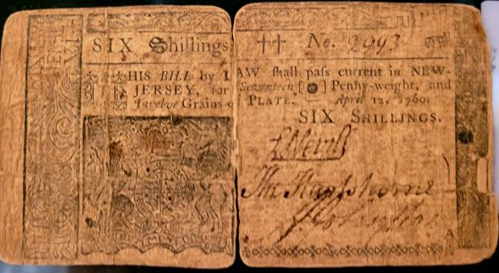

A rare April 12, 1760 colonial 6 Shillings note
from New Jersey
The note was graded Very Good but is still considered rare.

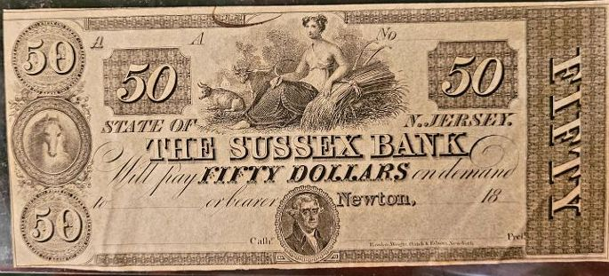

A $50.00 Bank note from the Sussex, NJ Bank. The reverse side was probably blanks as a number of such notes showed only th4 face.
This $50.00 bank note from Newton, NJ, a town located in Sussex County was never used because surrounding the portrait of Thomas Jefferson, the signatures at the bottom of the note are unsigned. The note was made prior to 1861 when the state Banks had to be chartered and considered solvent by backing their notes with “specie”, hard money. The editor thanks member, John Kolmar for his recent contributions of Show & Tells and encourages members to do likewise
________________________________________________________________________________________________________________________
The Augusta Coin Club will be holding its annual spring coin show on Friday and Saturday, May 14 and 15 at the Columbia Exposition Center in Grovetown, GA off I-20 exit 190. Over 75 tables are expected to be sold for the two day event. An ANACS grading representative will be on hand to grade your coins. See details below flyer

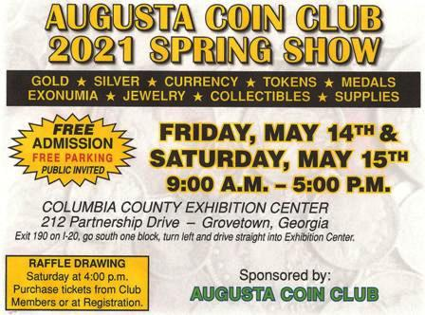

Rusty Cumberledge
ANACS S.E. Regional Representative
706-951-1316
rustedrocky@gmail.com
Fellow & Lady members,
I am a retired Registered Nurse after 40 years in Critical Care. I started coin collecting around 1999 and have been doing Coin Shows in GA, SC, TN, AL and FLA with Bill Orne since 2005 As a member of many local Coin Clubs as well as state Clubs, I also volunteer for the FUN Show in Registration doing photo “IDs.” I look forward working with everyone in their coin submissions with ANACS.

Rusty Cumberledge
A member of the Augusta Coin Club

Kindly Patronize our advertisers

