The Stephen James
CSRA Coin Club of Aiken
P.O. Box 11
New Ellenton, SC 29809
Web site: www.sjcsracc.org
The SJ CSRA CC now meets at the South Aiken Presbyterian Church at 1711 Whiskey Road

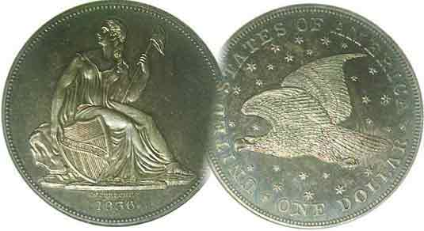
Pres. J.J. Engel
V .P. Pat James
Sec. Jim Mullaney
Treas. Chuck Goergen
Sgt. in Arms: Jim Sproull

Programs: Pat James
ANA Rep.: Glenn Sanders
Show Chair: Board members
Photos: Steve Kuhl
Publicity: Pat James
Newsletter: Arno Safran
E-Mail: arnosafran@comcast.net
Auctioneer: Jim Sproull
Web site: Susie Nulty (see above.)

Our next will be on Thursday, May, 5 at 6:45 PM in the South Aiken Presbyterian Church Gymnasium
Due to the latest Omicron variant of Covid-19, please wear a face mask inside the building

2022 Club Meeting Schedule
Volume 21, No. 5 the Stephen James CSRA Coin Club, Founded in 2001 May, 2022
Monthly Newsletter
The Early US Quarters from 1796 thru 1828
Jan. 6 Apr. 7 July 7 Oct. 6
Feb. 3 May 5 Aug. 4 Nov. 3
Mar. 3 June 2 Sept. 1 Dec. 1

The Interesting Ulysses Simpson Grant
Commemorative Half-dollar

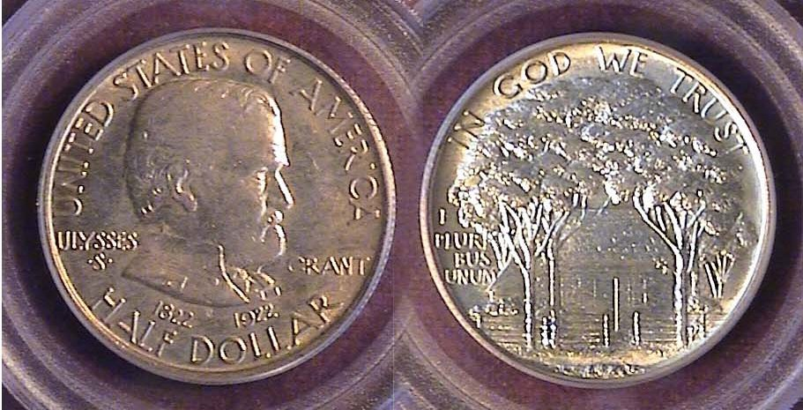

A 1922 Grant Commemorative 50c graded MS-64 by PCGS
[Increase page size to fill monitor screen to view details.]

Ulysses Simpson Grant is the subject of this month’s early US commemoratives. The famed Civil War General was born on August 27, 1822 in Point Pleasant, Ohio in 1822 and at age 2, his family moved to Georgetown, OH, a hamlet in western part of the state south of Cincinnati. At 19, he attended West Point in New York State and later became Lincoln’s supreme General during the Civil War. He was elected as the 18th President of the United States in 1868 and served two terms despite a period of corruption--perhaps not of his own doing--that occurred during his two term tenure. In 1884, Grant completed his memoirs on his eight years as president and just four days later, on July 23 of that year, he died just a month short of his 63rd birthday.

In 1922, a commemorative fifty-cent piece as well as a $1.00 gold coin was designed by renowned engraver Laura Gardin Fraser. In the case of the half-dollar, 67,405 were released into circulation, and at some point, an additional 4,256 were made showing a tiny star inserted above the n in Grant’s name which appears on the right side of the obverse. The price of a regular Grant commemorative without the star, certified MS-64 like the coin shown above sells for $200 today, while at several recent Heritage auctions the winning bids for the Grant commemorative certified MS-64 with star has been selling for as much as $4.500 despite the current retail price of just $2,600. It is the author’s opinion that such a price is mere tomfoolery; a waste of money that could be better used to acquire true rarities involving early date US coins to one’s collection like the feature article that follows.
Collecting early US Quarters from 1796 thru 1828
By Arno Safran

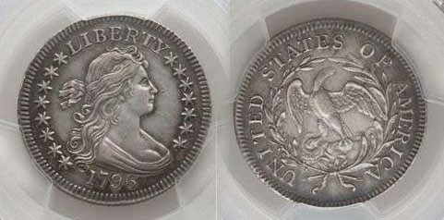

A 1796 Draped Bust quarter, B-2, R3 graded XF-45 by PCGS
(Courtesy of PCGS COINFACT and Heritage Auction Archives)

One of the most fascinating and challenging US coin denominations to collect are the early quarters of the United States, and assembling a collection of the large size quarters that were struck from 1796 thru 1828 are both difficult and sometimes frustrating for most collectors on a middle class discretionary income. The quarter was the last of the ten authorized denominations in the Coinage Act of 1792 to be produced as it wasn’t until 1796 that the first quarters were released. Like the other silver denominations that preceded it, the coin’s obverse displayed our first Chief Engraver, Robert Scot’s Draped Bust design and a small eagle reverse. The coin was 27.5 mm in diameter and weighed 6.74 grams with a composition of .8924 silver bonded by .1076 copper. The reported mintage was just 6,146 and despite many being saved the date is still considered rare and expensive in virtually all grades. The XF-45 example shown above recently sold for $46,500 but even one grading just VG-10 is pricey ranging between $15,000 and $26,000 in recent auctions, so it is unlikely that most of us reading this chronological account are likely to acquire one for our collection.

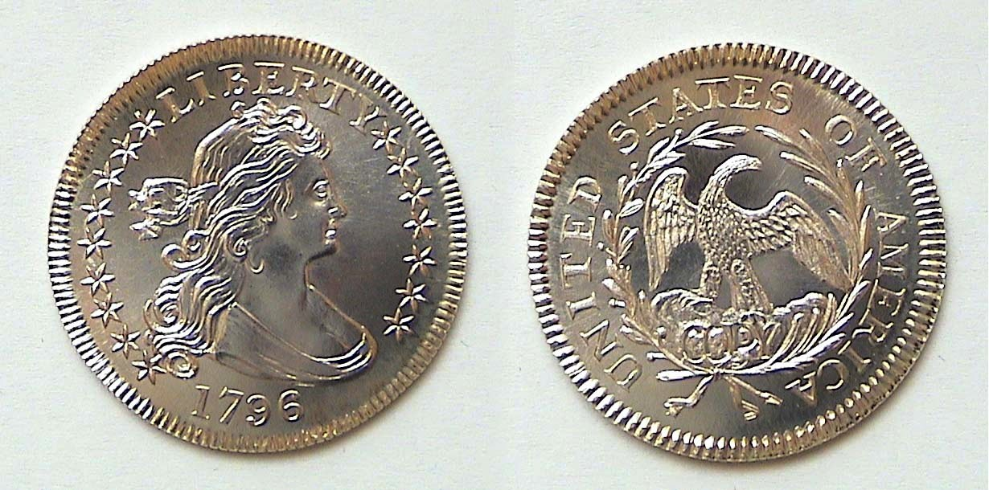

A BU 1796 Draped Bust Quarter replica struck at the Gallery Mint
That said, there may be is a silver lining, because in 1996, the quarter’s bicentennial year, Ron Landis, a talented engraver of the Gallery Mint Museum in Eureka Springs, Arkansas, engraved
(Continued on page 2, column 1)
Collecting early US Quarters from 1796 thru 1828
(Continued from the previous page)

a lovely replica of the original 1796 quarter with the word COPY placed just below the eagle’s talons on the reverse in the same size and thickness with the exact amount of silver and weight; the price? just $15.00! Since then, the relic has increased in value in its own way due to the increase in the price of silver as well as its artistic popularity as the Gallery Mint specimen still costs a tiny fraction of what the “original” did in the XF-45 grade on the top on page one, column 2.

It would not be until 1804; eight years later, when the quarter denomination would resurface with a slightly different reverse.

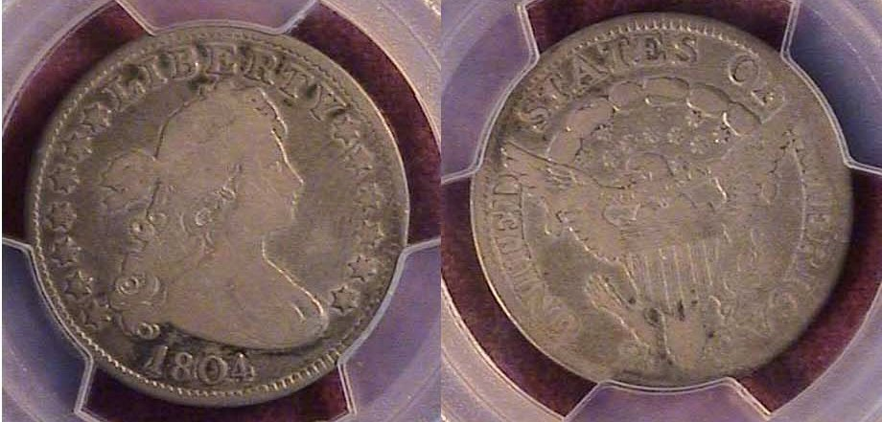

An 1804 Draped Bust quarter, B-1, R3 also graded VG-10 by PCGS
[Increase page size to fill monitor screen to view details.]

Shown directly above is a certified example of the 1804 quarter; another renowned rarity. The grade is no higher than Very Good-10 because the reported mintage was also small; 6,738; just 592 pieces more than its predecessor, yet the coin circulated more heavily than the 1796 but is not as sought after and less expensive.

The 1804 is also different from the 1796 in two respects. The reverse now displays a heraldic eagle and at the bottom, the denomination, 2 & 5 appears; although in this low a grade, it is not all that clear. The coin shown is the first of two die varieties since the 4 in the date is lower in Var. 1 while in Var. 2, the numeral 4 almost touches the figure. Another significant aspect of this particular example of the 1804 is that it was acquired with a CAC sticker (shown below) which stands for “Certified Acceptance Corporation” and is currently worth a higher premium than coins certified without it.

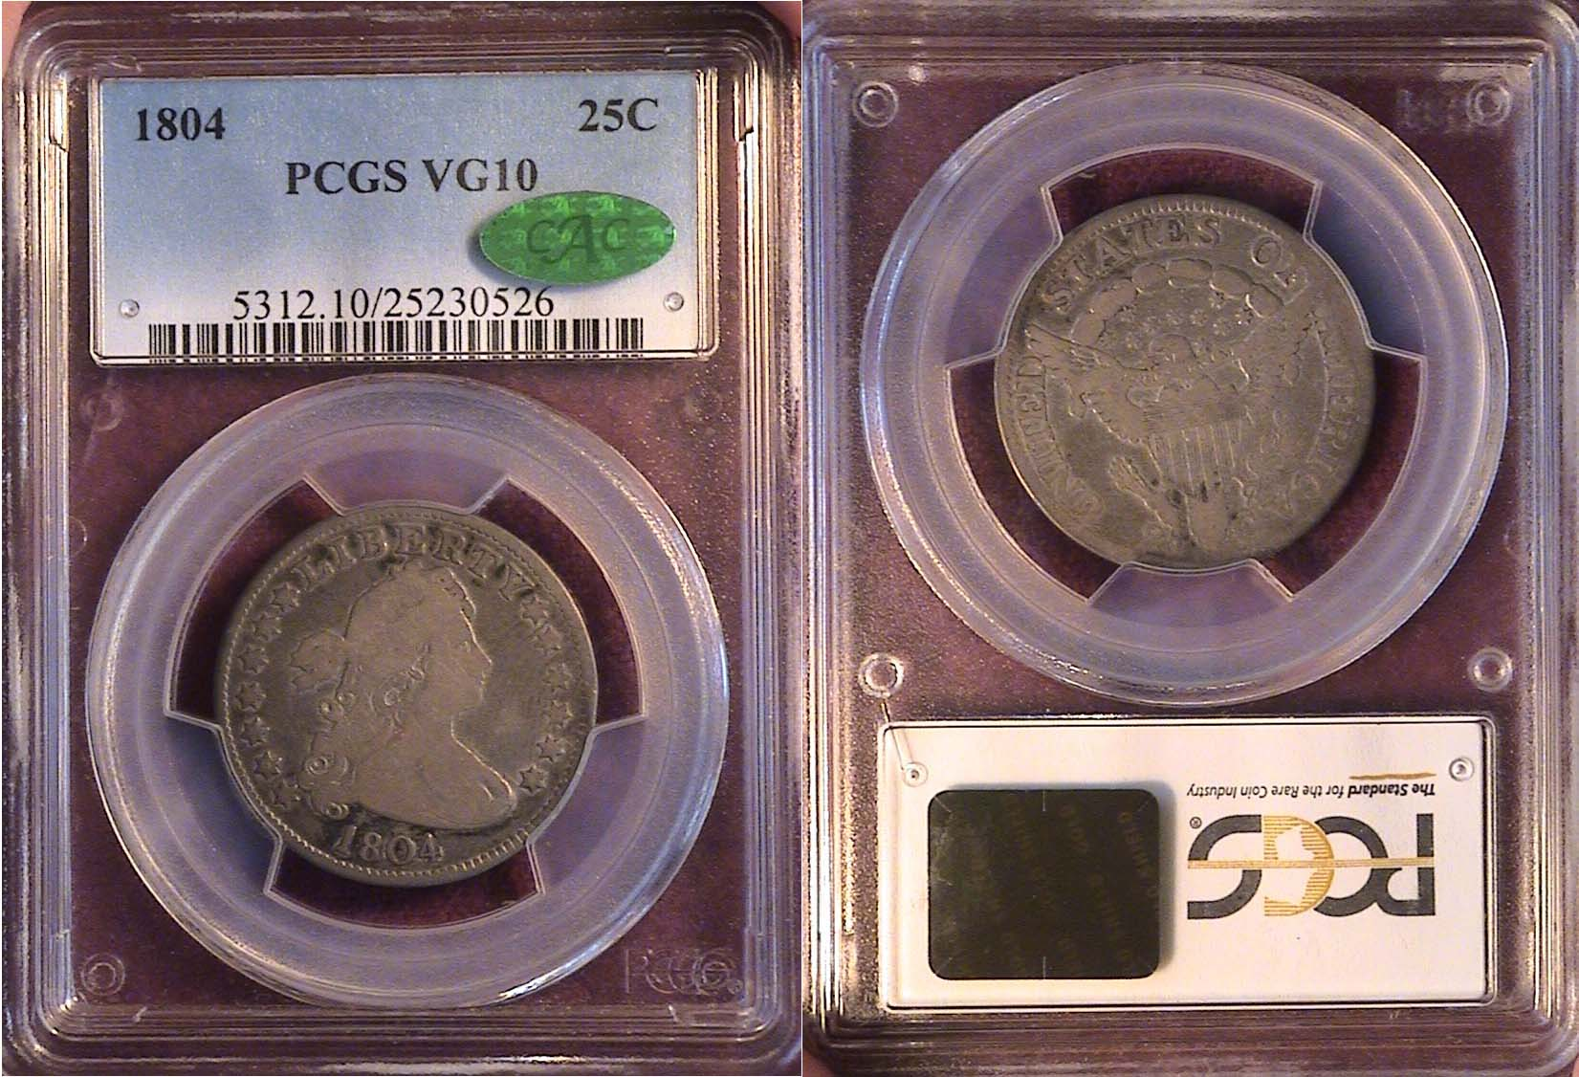
The same 1804 Draped Bust quarter in the holder with CAC sticker
[Increase page size to fill monitor screen to view details.]

The value of the certified 1804 shown above is backed by its originality; i.e. it hasn’t been messed with during the more than two centuries it has survived either when it was in circulation or after it became a collectible.

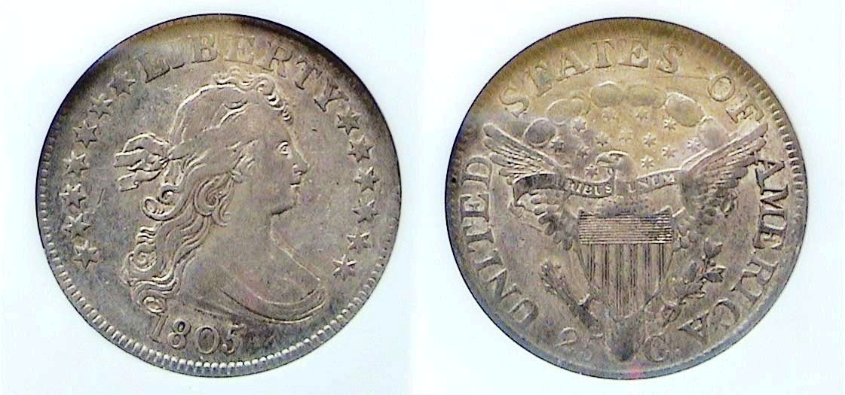
An 1805 Draped Bust Heraldic Eagle quarter, B3, R1
graded XF-45 by NGC [Increase page size to view coin’s details

In 1805, the reported mintage for the Draped Bust/ Heraldic eagle quarter was 121,394 compared with just 6,738 the previous year, so one would think that the date would be considerably less expensive than the 1804--which it was--BUT, the grade shown on the 1805 dated coin directly above is not a fairly warn VG-Good-10; but one certified XF-45 by NGC and that raises the ante quite a bit despite it being considered a common date. The coin was acquired by the writer away back in 2001 from a dealer who used to set up at the major shows held at the Baltimore Convention Center when the author lived in New Jersey, and it sold for $1,600 back then, but now in 2022, it retails for $3,750 so, the coin has more than doubled in value during that twenty-one year span.
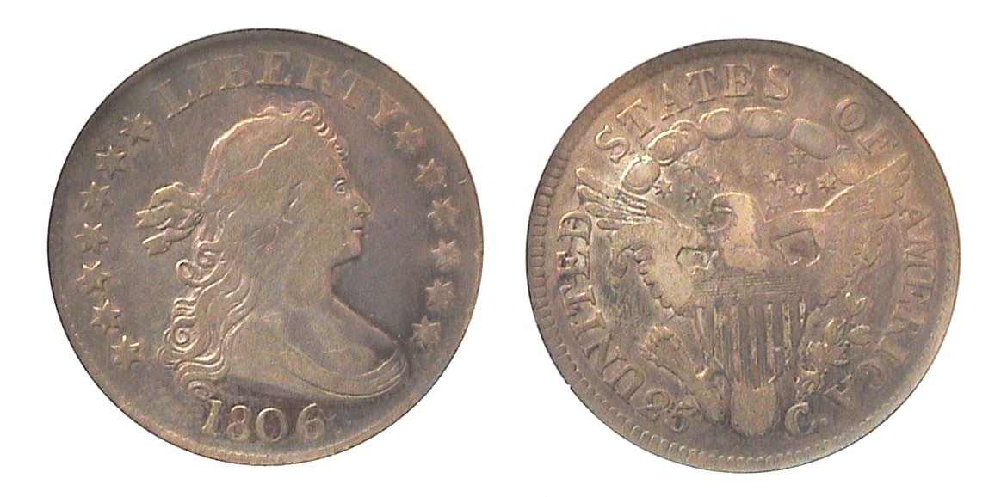
An 1806 Draped Bust quarter, B3, R1 graded Fine-12 by ANACS
[Increase page size to fill monitor screen to view details.]

The 1806 Draped Bust quarter had a reported mintage of 206,124 and is considered the most common date of the four year series. This coin was acquired away back in December of 1991 at a small monthly show held in Mount Holly, NJ across the Delaware River from Philadelphia. It cost only $240 at the time. Today, a Fine-12 specimen retails for $950 or slightly higher. For the grade, this particular specimen has nice eye appeal since the surfaces--despite its wear--are free of unsightly nicks or marks and the coin appears completely original.

The elusive if popular 1806/5 Draped Bust quarter

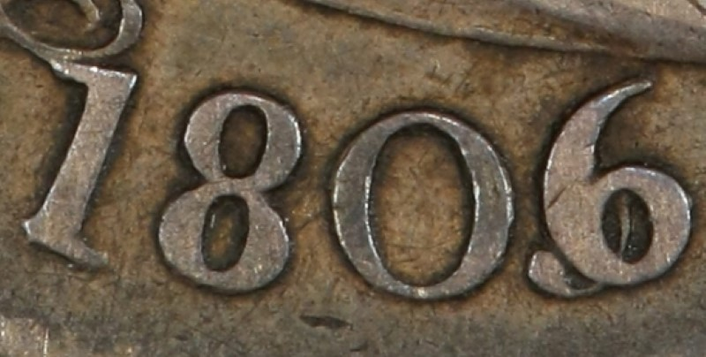

A detail enlargement of the overdate example

Another scarce but still collectible quarter of the Draped Bust quarter series is the popular 1807/6 over-date. Above, is an enlargement of its appearance. Most of the affordable examples of the 1806/5 quarter the writer has seen recently--either on line, or in auctions--have not graded any higher than VG-10. Adding a Fine-12 specimen of the overdate similar to the normal date is still one of his collecting goals.
_______________________________________________________________________________________________
(Continued on page 3, column 1)
Collecting early US Quarters from 1796 thru 1828
(Continued from the previous page)

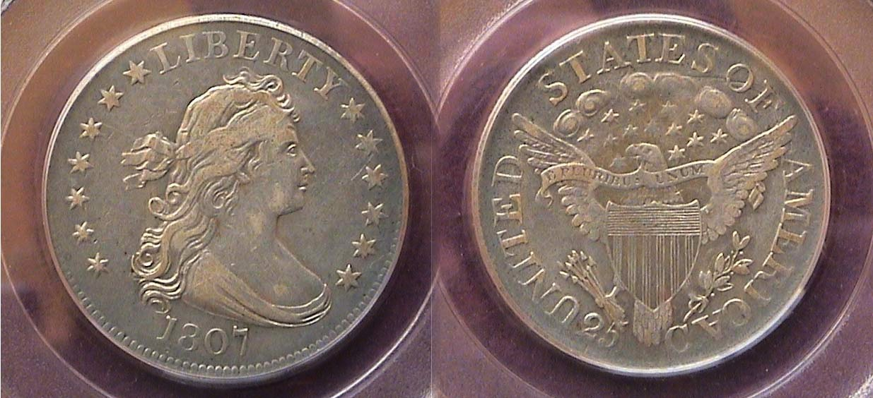

An 1807 Draped Bust quarter, B-1a, R2 graded VF-35 by PCGS
[Increase page size to fill monitor screen to view details.]

The reported mintage of the 1807 Draped Bust Heraldic eagle quarter was 220,643 which was distributed by the Philadelphia Mint in five different warrants between January 24 and April 14, 1807 according to the research of Steve Tomkins in his brilliant tome, “Early United States Quarters, 1796 thru 1838.” The coin shown was acquired on line from the firm of Bowers and Merena away back in March of 1999. While not as high a grade as the 1805 specimen, the 1807 piece displays a perfect balance in wear rendering the coin’s appearance as the most attractive of the Draped Bust type examples shown. Just before the turn of the century, the coin was priced at $1,200. Today, it retails for as high as $3,000 in the same grade. That said, the author has seen a few that have sold for far less although they lack eye appeal or have problems such as a weak strike, off coloring, spotting, digs, rim-dings or other unpleasant markings that lowers a specimen’s eye appeal.

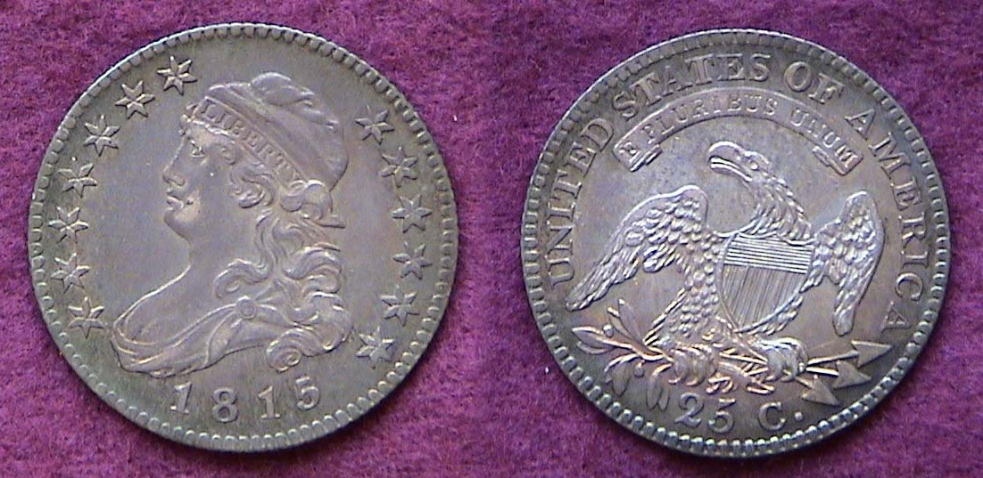

An 1815 Capped Bust quarter graded AU-50 by ICG
[Increase page size to fill monitor screen to view details.]

After 1807, no quarters were coined until 1815; an eight year hiatus. By then, John Reich was in his ninth year serving as Asst. Chief Engraver to Robert Scot. Reich was an indigent German émigré who was appointed by President, Thomas Jefferson on the recommendation of the then current Mint Director, Robert L. Patterson to recreate all our coinage types starting in 1807 with the Capped Bust half-dollar.
The size of the new Capped Bust quarter facing left was reduced from 27.5 mm to 27 mm and thickened accordingly, weighing the same as before at 6.74 grams with a ratio of 6.74 silver to .1076 copper. It is the author’s opinion that new style is just as attractive as Scot’s design.
In 1978, the writer had been collecting obsolete US coins only two years when he discovered this lovely 1815/2 quarter in Stack’s Coin Shop; then located on West 56th Street in Manhattan, NY, roughly 65 miles north of his home in New Jersey; the price, just $350, then! The reported mintage was just 89,235; far less than the 1805 thru 1807 Draped Bust quarters but presumably saved due to its new design. Today, the date it is listed at $2,850 in the same grade with very few examples extant graded AU-50 currently based on PCGS’ COINFACTS. While not scarce, the 1815 dated coin is found to be more accessible in the VF to XF grades and lower than AU or above.
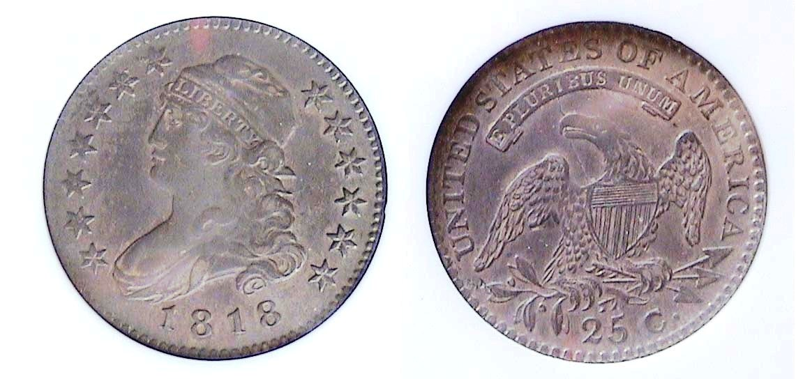

An 1818/5 Capped Bust Quarter, B-1, R2 graded XF-45 by NGC
[Increase page size to fill monitor screen to view details.]

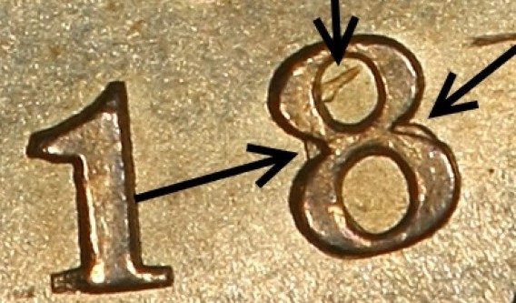
After 1815, the Capped Bust type quarter was not struck again until 1818; then supposedly produced in consecutive years through 1825, although the 1823/2 dated quarter as a collectable date is questionable. The important aspect regarding the 1818 quarter was its recorded mintage; a record-breaking 361,174 coins including ten different die varieties; easily, the most common date of the large size Capped Bust quarter series. The coin shown above is a well struck XF-45 example. The overdate however is difficult to discern since the top of the number 5 usually appears very faintly inside the upper portion of the numeral 8 and not very easy to locate. The overdate was made from leftover dies from the 1815 quarter. The writer acquired it at the GSNA (Garden State Numismatic Association) Convention in 1999. It cost $750 back then. A recent example of the same overdate graded similarly sold for $1,920 at a Heritage auction.

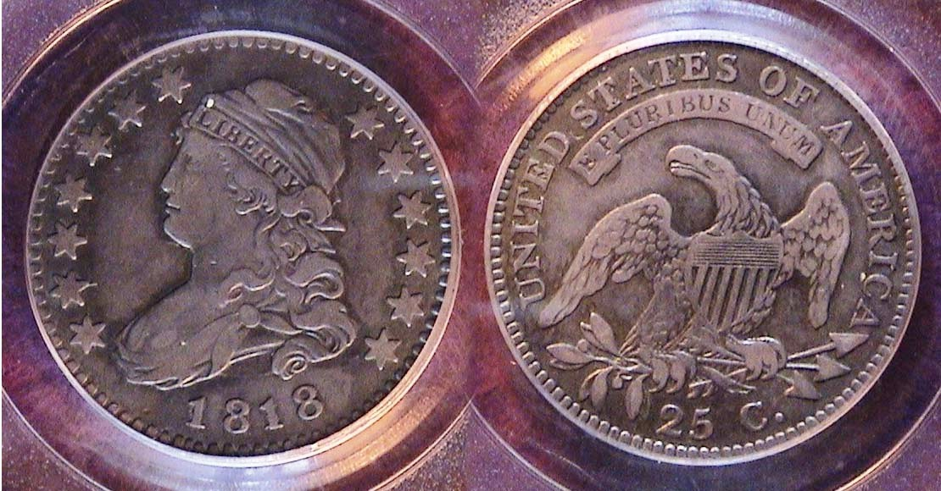

An 1818 Capped Bust quarter, B-8, R3 graded VF-35 by PCGS
[Increase page size to fill monitor screen to view details.]

This version of the 1818 Chapped Bust quarter is designated, B6, Rarity 3 which is slightly scarcer than the so-called overdate variety shown directly above. It is very well struck and quite attractive. The coin was acquired back in June, 2013 at a the Whitman Show held in Baltimore, MD, another major show in the eastern part of the United States. It is usually at shows like the ANA, FUN in Florida and the Whitman in Baltimore that collectors living on the eastern part of the United States are likely to find older and scarcer date US coins but occasionally they will come across some at the state organization annual shows as well; such as the South Carolina Numismatic Assoc. show in Greenville usually held in late October or either the two Georgia annual shows such as the Georgia Numismatic Assoc. (GNA) or Blue Ridge Numismatic Assoc. shows held at the Dalton, GA Convention Center shows in April and August respectively.

Over the decades, the author has managed to put a date set together of all of the collectible dates of this short series of large Capped Bust quarters. These include the 1815, 1818, 1819, 1820, 1821, 1822, 1824, 1825, and finally, the 1828. Each of these dates have a number of die varieties, some that are subtle like the 1818 overdate that is hardly noticeable or the more popular ones such as the 25c over 50c that some appear on the reverses of the 1822 and 1828 pieces. Both the 1823/2, despite a reported mintage of 17,800 but with only 39 examples currently known to exist and the 1827 dated Capped Bust quarter are extremely rare and beyond the reach of virtually 99% of collectors.
________________________________________________________________________________________________________________________
(Continued on page 4, column 1)
Collecting early US Quarters from 1796 thru 1828
(Continued from the previous page)

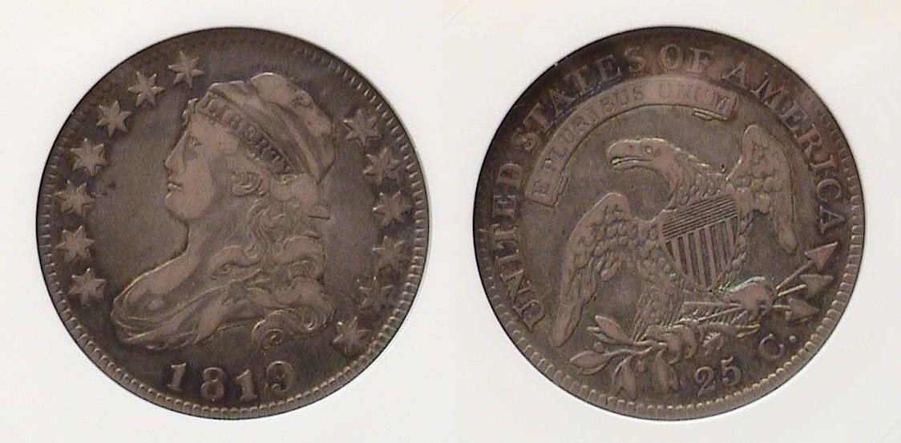

An 1819 Capped Bust quarter, B1-R5 graded VF-20 by Anacs
[Increase page size to fill monitor screen to view details.]

The reported mintage for the 1819 large size Capped Bust quarter was 144.000, which during that timeframe of the nation’s history was considered considerable, although nothing near as comparable to the far larger numbers of large cents or half-dollars that were being coned during the same period.
In 1819, there were four die varieties of the Capped Bust large size quarter; the first two with large dates and the second pair with smaller dates. The first variety, shown above was the scarcest. It was acquired at the FUN show back in January, 2002 an cost $300 whereas today, the variety is worth three times that figure. It is distinguished by a large 9 in the date and a fancy top 5 on the reverse. In his masterful book on Early United States Quarters, author Steve Tomkins shows how one can find the subtle differences for each variety by both word description and photos showing the subtle changes in the positions of letters or numerals in relation to one another or whether the number 2 is flat at he bottom or curled base etc.

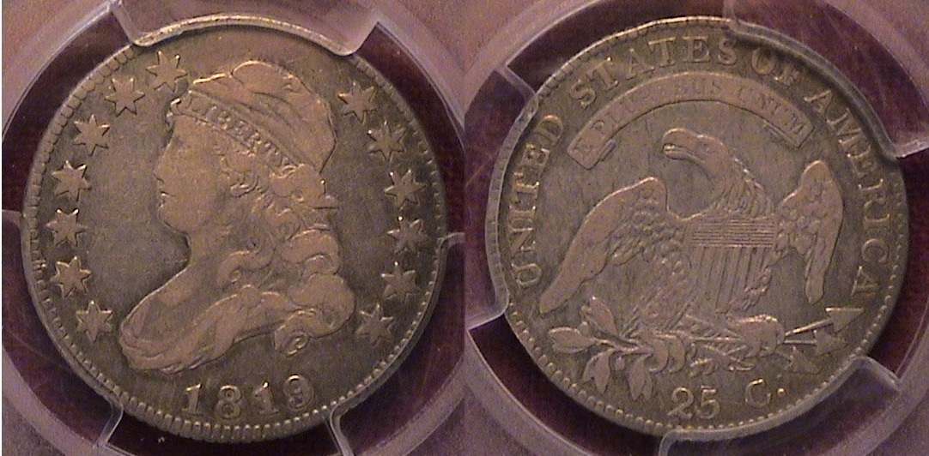

An 1819 Capped Bust quarter, B3, R1 also graded VF-20 by PCGS
[Increase page size to fill monitor screen to view details.]

On first glance, both coins look similar because not only are in the same grade, VF-20, but share the same color in relation to its similar amount of wear. On closer inspection if enlarged sufficiently, lets, say to 500%, on the bottom of the reverse, the 2 is curled and the 5 appears re-struck over the top on the lower coin whereas the coin immediately above it, the 2 appears flat based and the top of the five is normal.
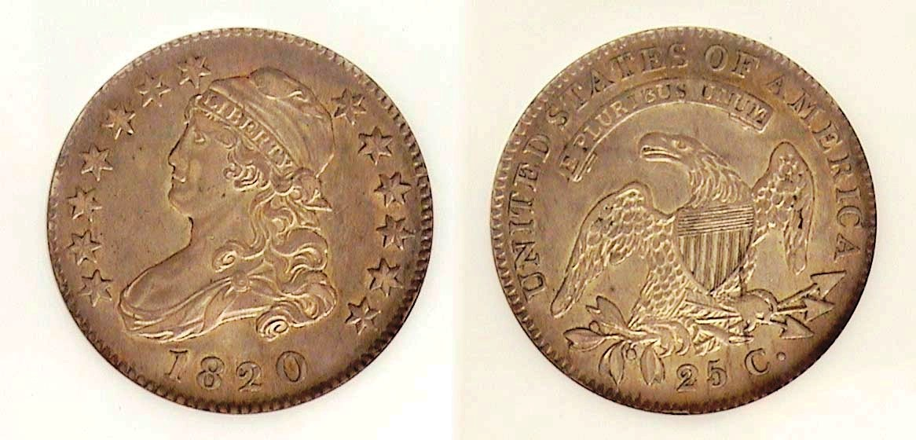
An 1820 Capped Bust quarter B-2, R2 graded AU-55 by NGC
[Increase page size to fill monitor screen to view details.]

In 1820, the reported mintage for the quarter was 127,444 and is considered a relatively common date for the period in which the population of the United States had reached 9,638,453 of which 1,538,002 were slaves. There were five die varieties struck with the first being listed as a R4, scarce, and the 5th, an R-5, very scarce. The other three are more common and available but still pricey; although back in 2001, when the author acquired the specimen shown certified AU-55 near the bottom of the previous column, it was a lot less expensive than it is today and that goes for all the other early quarters that were acquired twenty or more years ago.

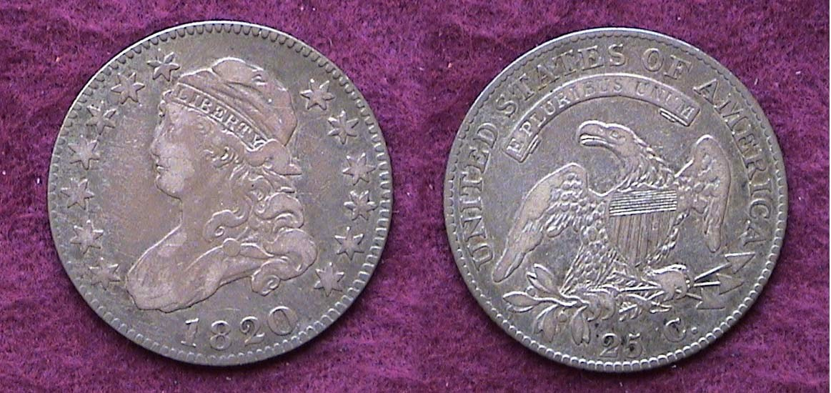

An 1820 Capped Bust quarter, B3, R3 graded VF-25
[Increase page size to fill monitor screen to view details.]

Two years later, at the FUN show held in January, 2003, the author picked up another variety of the 1820, this one, an R-3 showing a medium size zero in the date which was slightly scarcer but due to its lower grade, VF-25, was quite inexpensive at the time, selling for a mere fraction of what the higher grade R2 example cost. Despite the lower grade, the coin appears wholly original and equally attractive in the author’s opinion.
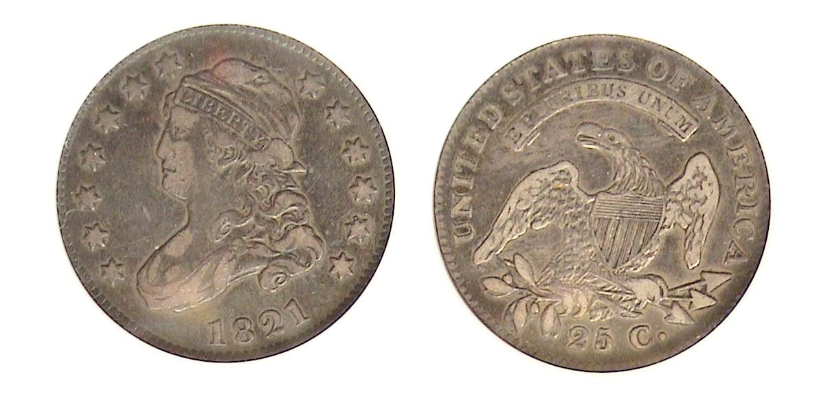
An 1821 Capped Bust quarter, B4, R3 graded VF-25 by NGC
[Increase page size to fill monitor screen to view details.]

In 1821, the reported mintage for the Capped Bust quarter increased to 216,151. There are six known die varieties; the last discovered as recently as 1988 and confirmed in 1991 that is listed as an R7, extremely rare. According to Numismatic scholar, Steve Tompkins, many of the coins struck with the 1821 date were from previous dies not released as planned in 1820 with a couple of varieties listed as R4s leaving the B4, R3 shown directly above as the third most common variety of the six and therefore more affordable, especially in the grade shown. The coin was acquired for just $350 back at the ANA spring show held in Jacksonville, FL in March, 2022 and certified VF-25 by NGC. Today, the price has increased to $650.

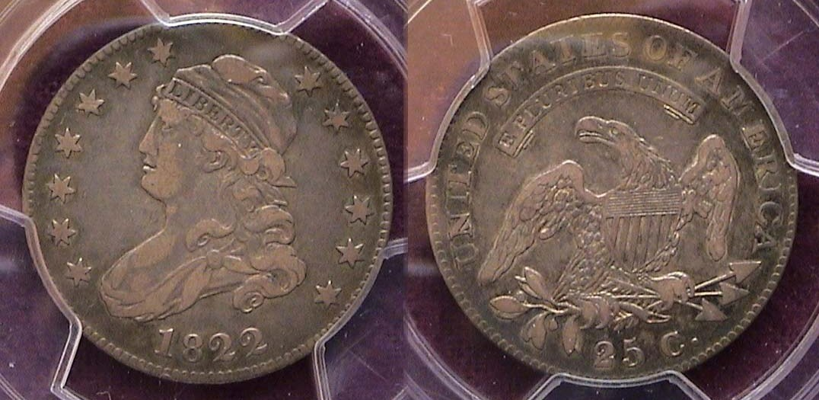

An 1822 Capped Bust quarter, B-1, R2 graded VF-35 by PCGS-
[Increase page size to fill monitor screen to view details.]

In 1822, the reported mintage dropped considerably from six figures to only five with only 64,080 quarters struck There were just two varieties, the first with the vast majority of those produced and the second, the famous error coin where the reverse shows the 25c punched over 50c at the bottom; an error that also latter appears on the reverse of the 1828 quarter. In both instances the quarters baring that feature are quite rare and expensive while the normal date with correct denominators on the reverse are both much more common, available and affordable.
________________________________________________________________________________________________________________
(Continued on page 5, column 1)
Collecting early US Quarters from 1796 thru 1828
(Continued from the previous page)

The enigmatic 1823/2 Capped Bust quarter

According to the various US mint records over the course of almost two centuries, the rarity of the 1823/2 Capped Bust quarter has gone somewhat unnoticed compared with other major rarities. The Philadelphia Mint had reported that 17,800 Capped Bust quarters were produced in the year 1823 in two warrants, but according to Steve Tompkins, author of Early Quarters of the United States (1796 to 1838), the second warrant total of 16,000 quarters, he believes were dated 1824/2 instead of the combined mintage of 160,000 struck in both 1824 and 1825 shown in the annual Red Book which is wrong. Tompkins suggests that only 1,800 pieces were made with the 1823/2 date with the final warrant of 1,600 quarters struck with the 1824/2 date After searching through a variety of auctions that took place over the past 125 years, Tompkins can only account for about 29 to 35 1823/2 quarters in existence. So, it is unlikely that the writer will obtain a specimen in his lifetime along with millions of others.

1823 was also year that our first Chief Engraver, Robert Scot--who was still working at the Mint--passed away on Nov. 3. Christian Gobrecht was temporarily installed to replace him. William Kneass would later serve as the official second Chief Engraver of the US Mint beginning on Jan. 9, 1824, a position he actively held until 1835.
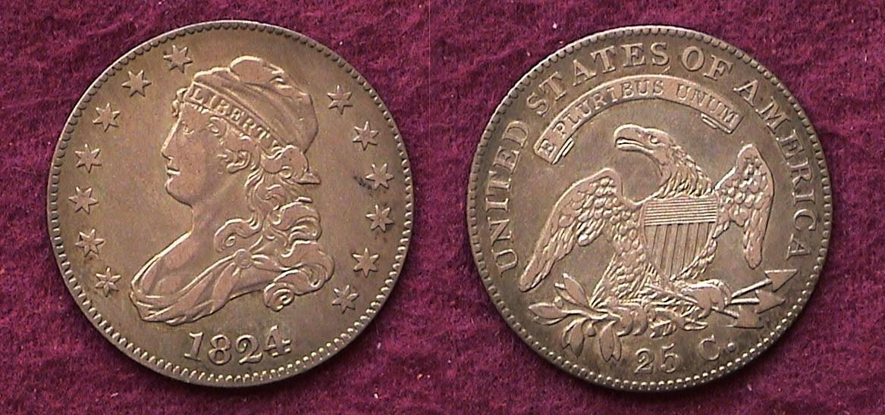

An 1824/2 Capped Bust quarteB-1, R3 graded VF-35 by PCGS
[Increase page size to fill monitor screen to view details.]

The author’s favorite date of the series is the 1824/2 quarter shown directly above, which he acquired for $550 away back in 1991. The Red Book still combines the mintages of the 1824 and 1825 listing a mintage of 168,000 next to the 1824 for both dates, but once again, recent research by Steve Tompkins indicates that only 16,000 were minted with the 1824 date and although not rare, it is third scarcest date in the series! The author obtained the piece via mail order from a national coin dealer from Colorado who used to set up at many of the major shows. He was an excellent grader, supremely honest and fair in his pricing based on his knowledge of the value of scarcer coins.

At the 1997 summer ANA Convention held in New York City, the author was considering acquiring another even more popular quarter rarity, a 1916 Standing Liberty quarter with a mintage of just 52,000; a lot better known than the 1824/2 quarter at that time. So he took his 1824 quarter with him in case he needed to sell it in order to purchase it since a 1916 Standing Liberty quarter certified MS-63 was selling for around $3,000 at the time. Before he did anything rash, he walked the huge bourse to see how many 1824/2 Capped Bust quarters were on hand, and after more than an hour, found nary a one; none in the same grade, none better and none worse; none at all! That’s when he put it back in his pocket, and stopped looking for the 1916 SL quarter as well. He realized he had a prize in his hands and was not about to sell it. At the time of purchase the author believed the date was “sleeper”. Apparently, he was proven right since the coin is currently worth $3,850, retail in the same grade. Timing is an important factor in numismatics.
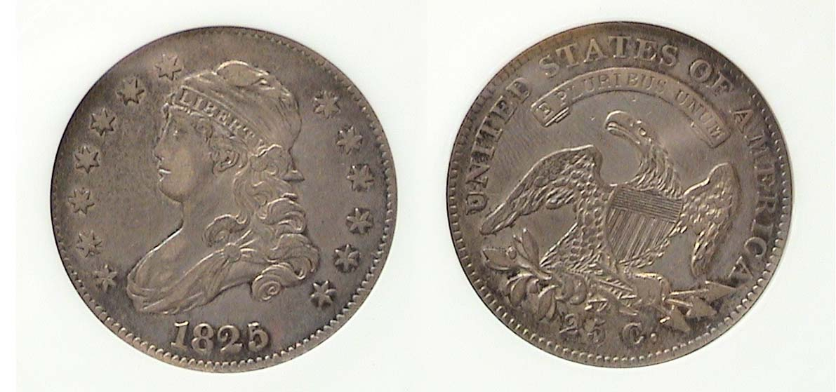

An 1825/ 4/2 Capped Bust quarter, B-2 R2 graded XF-40 by Anacs
[Increase page size to fill monitor screen to view details.]

The 1825/4/2 Capped Bust quarter pictured above is the most common of the three major die varieties for that year but was once designated simply B-3, but since Steve Tomkins’s book was released in 2008, further study and analysis points to a triple overdate used during that period. The coin shown was obtained by the author back in April of 1999 at a Tri-State monthly show held in a suburb of Philadelphia called Fort Washington. It sold for just $425. Today it retails for $1,500. The date is considered one of the more common of the series.
The reader may wish to know what the B that is placed in front of the numeral under each coin stands for. It recognizes Ard W. Browning who back in 1925 published the first 20th century major reference work on early quarters that were produced from 1796 thru 1838. The R stands for rarity and the number after it represents the coin’s die variety and rarity, the number 1 being the most common to 8 being, extremely rare with a handful to just one or two known to exist.

When it comes to the original 1827 Capped Bust large size quarters, Numismatic scholar, Steve Tomkins believes that only 12 original specimens were produced, two with an experimental close collar device attached to the older printing press which was only limitedly successful, but saved and eight more struck on a new open collar screw press which were later given to V.I.P.’s. as Christmas presents. Restrikes of the 1827 date during the 1850s and beyond helped enlarge the extremely low mintages a bit but aside from those factors, the 1827 Capped Head quarter whether struck as a business strike or a proof; as a date is extremely rare.

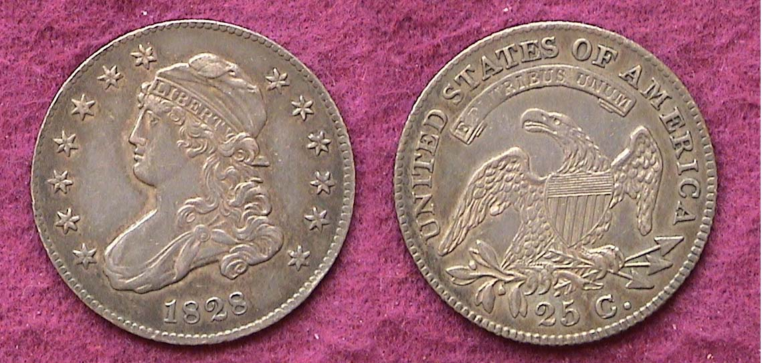

An 1828 Capped Bust Quarter, B-1, R1 graded AU-50
[Increase page size to fill monitor screen to view details.]

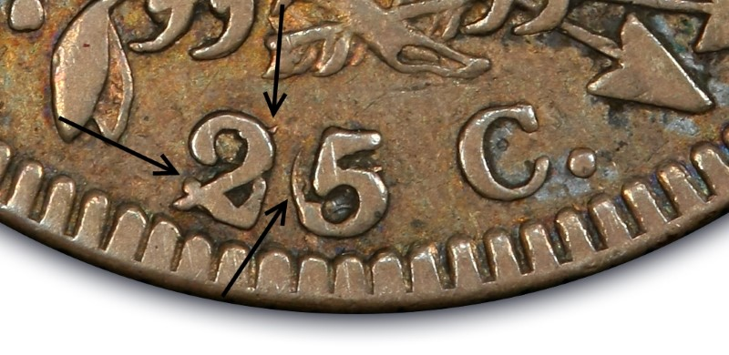
Last but not least is the final coin in the author’s collection of the large size Capped Bust quarters, the 1828 normal date issue. The reported mintage for that year was 106,000 and is considered a common date. There were three die varieties, the second, much scarcer while the third, shows the same 25c over 5 over 50 at the bottom of the reverse which also appeared on the reverses of 1822.

The 1828 coin shown above was acquired at that same American Numismatic Association convention held in New York City back in 1997 when the author decided not to sell his 1824/2 VF-35 version of the large size Capped Bust quarter shown on the preceding column. Like the 1815 first year of issue example, the 1828 specimen is similar in strike and clarity that comes with the AU-50 grade. The US quarters struck from 1796 thru 1828 represent a fascinating group of lovely coins that were far less common than the other silver denominations of this period yet superior artistically not only to them but also the 90 year old Washington quarter that is still with us.
________________________________________________________________________________________________________________________
STEPHEN JAMES CSRA COIN CLUB
Regular Meeting Thursday, April 7, 2022

President J.J. Engel, called the regular meeting of the club to order at 6:45 p.m. The Club members once again enjoyed meeting at the South Aiken Presbyterian Church for their new monthly meetings since the Aiken Public Library no longer provided that option. April was the month that our annual dues of $15.00 were due and virtually, all the attendees did so. Pat James gave a summary of the status of our upcoming September show which appears like it is going smoothly with a number of dealers from the 2019 event expected to return.

Steve Kuhl gave another interesting PP program featuring “The history of the Bank Notes of South Carolina”.
Charted on December 1812 by Act 2021 of the General Assembly and capitalized with the assets of the state treasury, the Bank of the State of South Carolina provided a stable currency for the state through most of the bank’s fifty-six year history. Ruined by the general economic collapse at the end of the Civil War, the bank was formally closed by Act 17 of the General Assembly passed on passed on the 15th of September, 1868. Among the worthless assets upon closure were approximately $65,000 in Confederate Treasury notes. Little did the contemporizes of that period know that in later years, thanks to their being saved and later catalogued that these same “worthless notes” would be worth plenty a century later.

The reason for this is due to the fact that the notes were stored in the basement of the South Carolina State House until they were transferred from the state Treasurer, to the State Archives in the early 1960s. In 2007, the Archives began a project to assess the large quantity of banknotes and it was during this project that these Confederate notes were discovered.

The sale of these notes is authorized by the General Assembly under Section 60-11-102 of the South Carolina Code of Laws. All funds of the sale are to be used solely for the improvement of access to as well as the preservation of the archival collection held by the SC Dept. of archives and History. Past auction proceeds have been used to purchase more efficient shelving for the collection, upgrade online access software and to purchase conservation materials for better safeguarding the archival collection. President JJ. Engel thanked Steve for sharing this information with us and VP Pat James and Program’s Chairperson presented Steve with a Certificate of Appreciation.
The Program for the May 5 meeting will be Collecting Ancient Coins by Chuck Goergen. (That’s another one you won’t want to miss because Chuck always presents interesting numismatic data; ED.) After President Engel gave members time to look over at the lots, the auction began. After the auction was over, he adjourned the meeting. Submitted by Pat James and Arno Safran
__________________________________________________________________________________________________________-

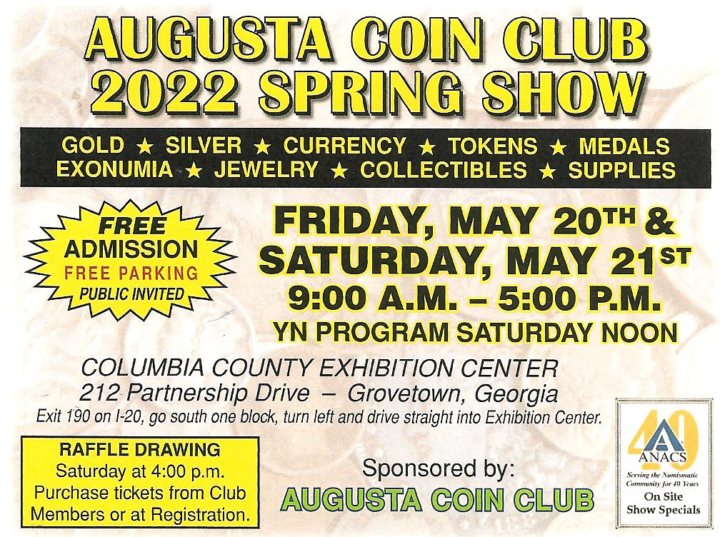

Kindly patronize our Dealers
