Pres. Willie Simon
V .P. James Barry
Sec. Helen Barry
Treas. Pat James
Sgt. in Arms: J.J. Engel
Committees:
Auction: J.J. Engel
Programs: James Barry
Newsletter: Arno Safran
The Stephen James
CSRA Coin Club of Aiken
P.O. Box 1739
Aiken, SC 29802
Web site: www.sjcsracc.org
The SJ CSRA CC Now Meets on the 2nd Thursday of the Month at the Cedar Creek Club House in New Ellenton

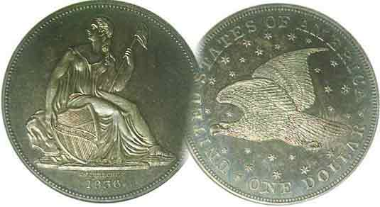

Volume 5, Number 6 the Stephen James CSRA Coin Club Monthly Newsletter June, 2006
New Club Meeting Site; a Nice Ambiance
Our Next Meeting is on the 2nd Thursday, June 8, 2006 at 7:00 PM

2006 Meeting Schedule - 2nd Thursdays at 7 PM

June 8, July 13, Aug. 10, Sep 14,
Show: Sep 16 Oct 12, Nov 9, Dec 14_

First Meeting at Cedar Creek Very Pleasant

On Thursday, May 11, President Willie Simon gaveled the meeting to order at 7:00 PM sharp and a new era began for the Stephen James CSRA Coin Club. Meeting for the first time at the Cedar Creek Community Club House, the members present seemed comfortable with their new surroundings. The room is commodious and quiet. There is a video consol with a large high LCD monitor screen in the front and Vice President Jim Barry--with the help of JJ Engel--used it for a program on Waffle Coins after the Business session was concluded. Jim also showed two interesting Greek coins representing the vast territories covered by the armies led by Alexander the Great. The first was a Tetradrachm grading EF of Baktria struck between 171 and 145 B.C. The obverse showed Eukratides I facing right. The reverse portrayed Dioskouri on a rearing horse; also facing right. The second was another Tetradrachm; this one of Scythian origin from Azes II who ruled from 35 B.C. to 12 B.C. The obverse showed Azes on horseback with a whip and the reverse portrayed Palla with shield. Jim prefaced his Show & tell of his coins with a short background sketch of Alexander, the Great who is said to have had the finest education of his time. Thanks Jim for an illuminating display and history; part of what coin collecting is all about.

The video program described what the US Mint does with failed planchets or coins. They destroy them via a process called waffling. Waffled coins are machine squeezed into quasi accordion folded planchets with some aspects of the design still visible. These are then transferred for recycling, but some escape this fate leaving the Mint in a manner that the personnel responsible for Security are unable to fathom. A small amount of these waffle coins have recently found their way into “slabs” where hucksters promote and then sell them for a good piece of change to those who believe they are acquiring great rarities.
________________________________________________________________________________________________________________________
(More Club News continues on page 5, column 2)

The Latin American Alternative
Part One of a Series by Arno Safran –An Introduction-

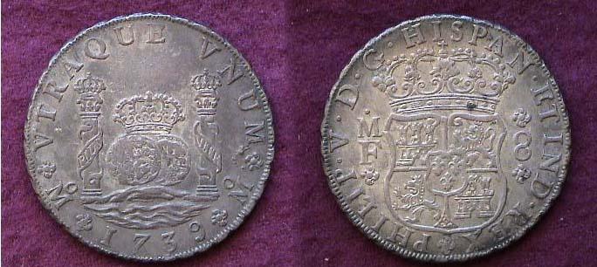

A 1739 Pillar Dollar of Philip V of Spain struck at the Mexico City Mint.
The inscription, UTRA QUE UNUM, “Both Worlds are one” is on the date side. Surrounding the shield, the Legend PHLIP V D.G. HISPAN ET IND. REX translates, PHILIP V by the Grace of God, King of Spain and the Indies.
The Latin words, PLUS UTRA on the Pillars means, “More beyond.”

Back in the early 1980’s I stopped in at the American Numismatic Society Headquarters and Museum in New York City to view the coins on display. It was there that I saw my first Hispanic-American ‘Piece of Eight’ with its famed Pillars of Hercules surrounding a crown over two orbs floating on the sea. I recognized it as the first coin pictured in “A Guide Book of United States Coins” (AKA, the Official Red Book). On the other side appeared the crowned coat of arms of the Bourbon dynasty. This represented the most majestic coin I had ever seen and I determined to find out more about it and Colonial Latin American coinage in general. Valued at 8 Reales, the Pillar dollar was the first to be machine struck or “milled”. I subsequently learned that the Latin inscription on the Pillars side, UTRA QUE UNUM meant “Both Worlds Are One” and the two tiny words on the pillars, PLUS UTRA meant “More beyond”; a poetic as well as romantic concept. Some years later while attending a show in Eastern Pennsylvania I espied another interesting Hispanic silver-dollar sized coin in a dealer’s case. It was dated 1799 and featured a portrait of Charles IV of Spain struck at the Mexico City Mint. I graded it CH VF and so did the dealer who was asking only $40 for it compared with $650 being charged then for a 1799 US Bust dollar in the same grade.
_____________________________________________________________________________________________________________________
(Continued on page 2, column 1)
The Latin American Alternative (Continued from page 1, column 2)

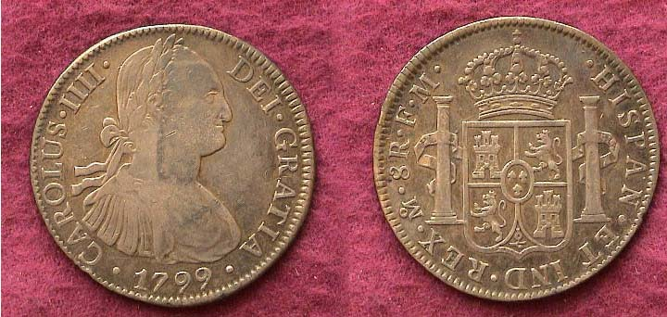

A 1799 Portrait dollar of Charles IV struck at the Mexico City Mint
Showing the King and Crowned Coat of Arms surrounded by the two pillars.
The inscription on the obverse translates, Charles IIII by the Grace of God
The legend on the reverse starting at 7:00 and reading upside down and
counter clockwise translates, King of Spain and the Indies

Today the VF coin you see above would retail for around $60 but the 1799 U.S. Bust dollar in a similar grade shown below will cost closer to $2,500.

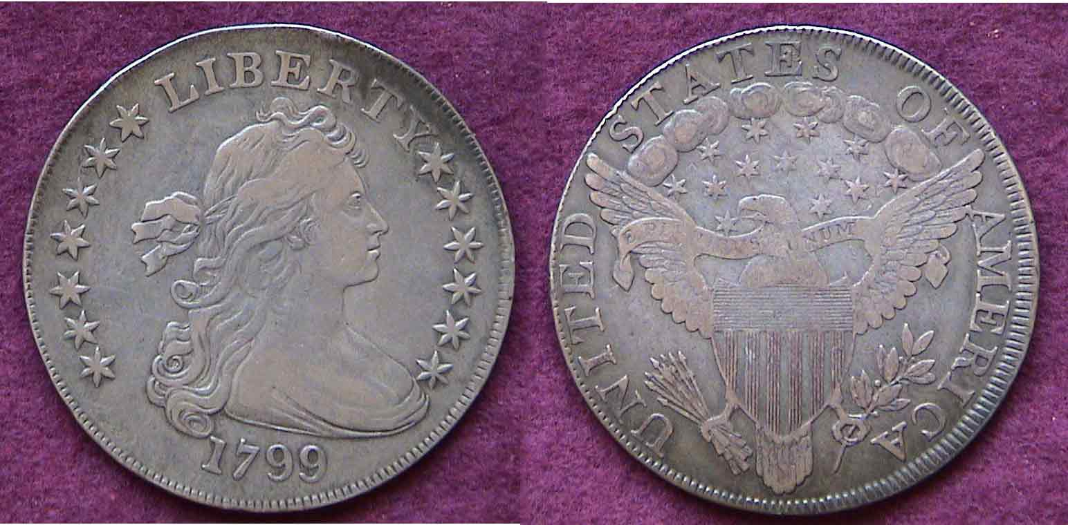

A 1799 U.S. Draped Bust Dollar

Despite a rather large reported mintage of 423,515 in 1799 for all varieties of US dollars struck that year, Colonial Portrait dollars produced by the Latin American Mints were coined in the tens of millions and circulated all over the world. Furthermore, the ‘Spanish’ dollars contained more silver (.917 fine) compared with the US dollars of that era (.8924 fine) and weighed more than their American counterparts, and since the early US Mint in Philadelphia didn’t have enough silver to strike sufficient numbers of Bust dollars or any other silver coinage to meet the demands of commerce, Latin American Portrait dollars as well as the earlier Pillar 8 Reales were welcomed by the banks and merchants at equal value to the US dollar. Consequently these large crown-size silver coins were granted legal tender status and renewed by law periodically.

If our citizens in the early years of our republic used these Spanish dollars freely along with the lower denominations, (the 4 Reales, 2 Reales, Real and ½ Real) it doesn’t take much of a leap of faith for today’s collectors of US coins to consider these numismatic items to be American in spirit--even if they were struck in foreign mints--and therein lies the attraction for the US collector. Most of the Hispanic silver coins circulated here well into the mid-19th century in far larger numbers than did their US counterparts yet today are priced at a fraction of the cost for US Mint issues issued during the same period (1793-1857).
Another factor often overlooked by US collectors is that the Latin American 8 Reales continued to be coined during the years when US dollars were suspended (1805-1835) and within the four year transitional period that followed (1836-39) when the small number of proof Gobrecht dollars were issued for circulation. With 1836 dated Gobrecht dollars grading EF-40 selling for $10,000 and more today, the collector can opt to acquire a Republic of Mexico Cap & Rays or Peruvian Libertad 8 Reales from the 1830’s in the same grade for as little as $85.

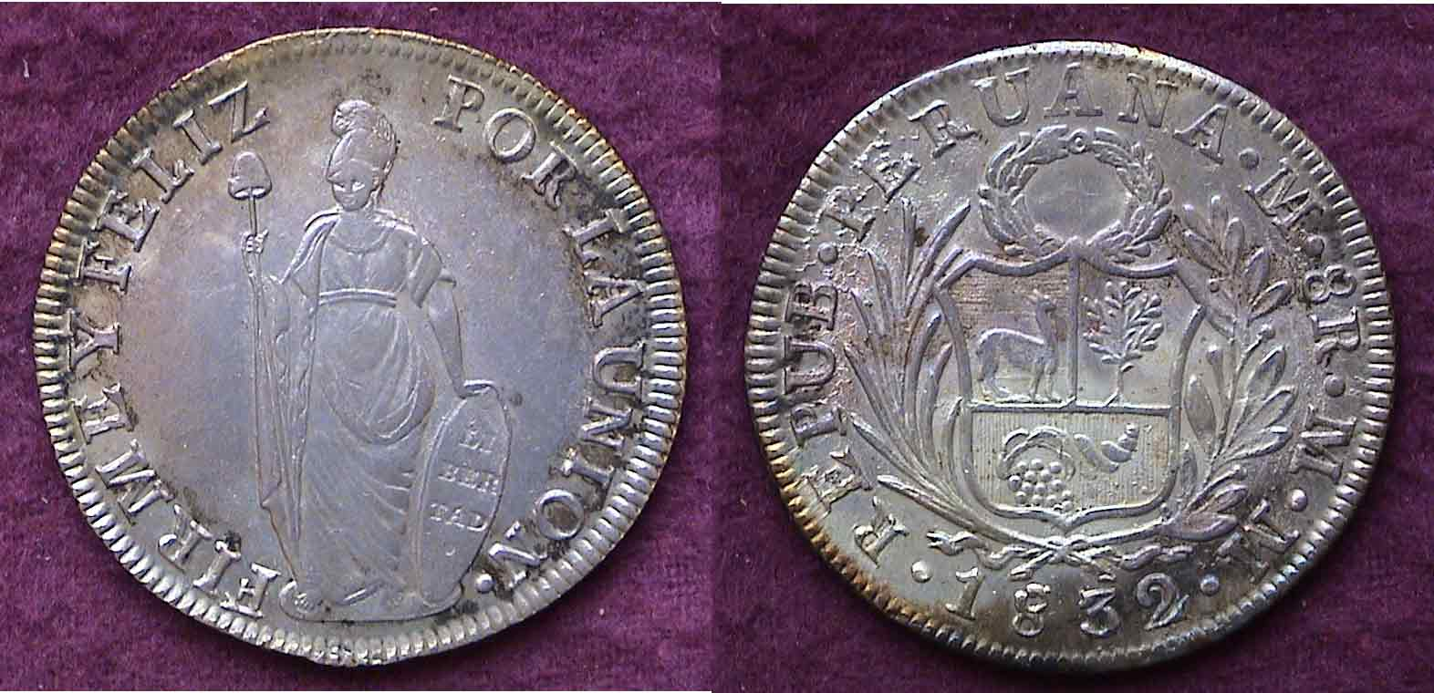

A 1832 Republic of Peru Libertad 8 Reales; valued at c. $85 today.

Another attraction for the US collector is the numerous design types offered by both the Colonial and early Republican portion (1822-1857) of the Latin American series. During the Colonial period, Spain established Mints in Mexico City, Guatemala City, Popayan in Colombia, Lima, Peru, San Luis Potosi in Bolivia and Santiago, Chile. All of the colonial silver coins were struck in at least .903 fine and this standard continued into the years that followed the wars of independence between Spain and its most of the new republics being formed.

The Colonial era may be divided into two categories; Pillar and Portrait Coinage. Each represented three Spanish monarchs. For the Pillar dollar type, legends are engraved for Philp V [spelled with one L] (1732-1747), Ferdinand VI (1747-1760) and Charles III (1760-1772). For the portraits, the obverses show the Busts of Charles III (1772-1790), Charles IV (1790-1808) and Ferdinand VII (1808-1825). As news traveled slowly during the colonial era, engravers were hard pressed to come up with a likeness of the new king. As a result, there are numerous overlapping portraits of Charles III appearing with inscriptions reading Charles IV or IIII; (e.g., 1789-90) and beyond and again between Charles IIII and Ferdinand VII. With Ferdinand VII, fantasy portraits exist during the early years of his reign (1808-1811). While some varieties are scarcer than others, all are collectible and affordable up to EF-45.

The early Republican coinage from South America also includes Argentina (from 1813) and Brazil, (a Portuguese colony dating back to colonial times) and offers an even greater number of design-types and varieties for the collector to consider; all at reasonable prices. Until 1857--when a new US coinage act demonetized all foreign coinage--most of these issues were granted legal tender status in the United States and circulated here despite the differences in the monetary systems between the countries involved. In the following installments, many of the various types will be discussed in more detail and illustrated.
__________________________________________________________________________________________________________________________
-to be continued-
Philippines JIM Notes
By Bill Myers

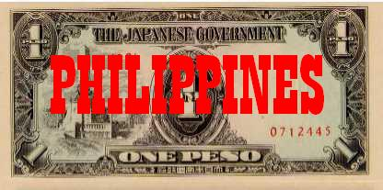

A J.I.M. Philippines One Peso Note
The Philippines fell to the Japanese in 1942. The Japanese released three issues of JIM for use there. The Philippine JIM series is complex, like Malaya. There are many varieties and an interesting series of counterfeits, as well. There are specimens of many notes and these will not be listed. The first series notes were lithographed and only of fair quality. They were produced in fractional and peso notes. All the notes have red block letters (PA) or fractional block letters (P/AA). The issues in denominations of 50 centavos and higher have a quatrefoil (flower with four petals) watermark. Fractional notes are available in 1, 5, 10 and 50 centavos denominations.
The face of the notes has "THE JAPANESE GOVERNMENT" and the denomination spelled out and in repeating numerals. The 50 centavos also has a plantation vignette on the right of the face. The backs have
repeating numerals on an ornate design. There is no watermark.
The varieties are:
1 centavo -block letters
- fractional block letters
5 centavos-block letters
-fractional block letters
10 centavos-block letters
-block letters, on the face-upper left outline of "T" in "CENTAVOS" is missing
- fractional block letters
50 centavos-block letters
-counterfeit
The peso notes come in denominations of 1, 5 and 10 pesos. The face has "THE JAPANESE GOVERNMENT", as well as the denomination spelled out and in numeral form repeated around the bill. The 1 peso has a plantation scene on the left of the face, "ONE PESO" in the center and "1" on the right. The 5 pesos has the Roman numeral "V" on the left, the plantation scene in the center and "FIVE" on the right. The 10 pesos note has the Roman numeral "X" on the left, TEN PESOS in the middle and the plantation scene on the right. The back of all the notes has an ornate design, with the denomination both spelled out and in numeral form.
The varieties are:
1 peso - block letters, 26-28mm from top of frame on right
- block letters, 17-20mm from top of frame on right,
5 pesos-block letters, orange back
-block letters, yellow-gold back
-counterfeit
10 pesos-block letters
-counterfeit
Counterfeit notes were made by the Allies. They were to be supplied to the Philippine guerrillas fighting the Japanese. Only the first issue of JIM was counterfeited. Ten million pesos were ordered, and 8.3 million pesos were made available for distri-bution. The diagnostic points for counterfeit detection are: (See diagrams.)
50 centavos - small break in curved line below upper right "50" on face (continuous line on genuine notes) 1 peso - two veins of leaf emerging from upper left border on the face are joined (separated on genuine notes) 5 pesos - two lowest lines in curved ornament below upper right "5" touch outer line of ornament on the face (separated on genuine note) 10 pesos - on the back of the note, a small nipple extends up at intersection of "1" and "0" in "10" in upper left corner (absent in original notes). Channel between "P" and "E" of PESOS on center back is short and blunt, long and sharp on genuine notes.
The second series from the Philippines are the Rizal Monument notes. The notes come in denominations of 1, 5, 10 and 100 pesos. These notes were well-printed and have an engraved face and lithographed back. They all have a vignette of the Rizal Monument, "THE JAPANESE GOVERNMENT", a banana tree watermark and the denomination printed and in numeral form on the face. On the back of all the notes you will find the denomination spelled out and in numeral form, as well as in Roman numeral form for the 10 peso. The notes have red block numbers and serial numbers. (After block 81, the 1 peso notes have two block numbers only.)

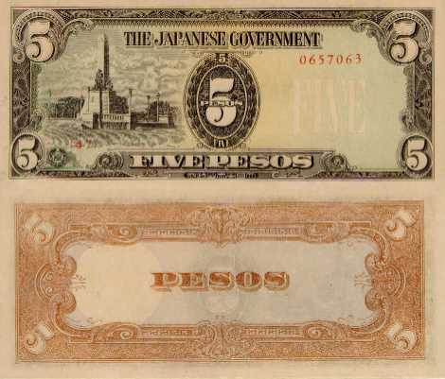

A Five Peso ‘Rizal’ JIM Note of the Philippines

Replacement notes have a "1" in the first position of the serial numbers, instead of a "0". On the face of the 1 and 5 pesos notes is the Rizal Monument on the left, the numeral and printed denomination in the center and the watermark, with a
___________________________________________________________________________________________________________________
(Continued on page 4, column 1)
JIM Notes from the Philippines During World War II
(continued from the previous page)

faint overprint of the denomination, on the right. The face of the 10 pesos has "10" on the left with the watermark, "TEN PESOS" in the center, and the Rizal Monument on the right.

The face of the 100 pesos has the watermark on the left, with a faint "ONE HUNDRED" overprint, "100" in the center and the Rizal Monument on the right.

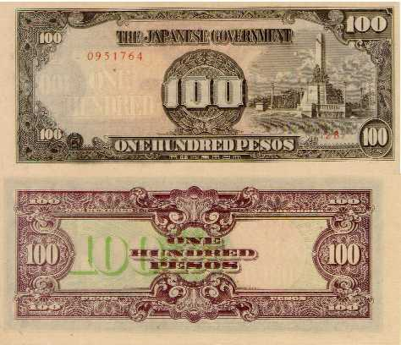
A 100 PESO RIZAL Monument JIM Note of the Philippines
The varieties are:
1 peso - block number, serial number
- replacement: block number, serial number
- block number only
- block number only, inverted watermark
5 pesos-block number, serial number
-replacement: block number, serial number
-block number, serial number, watermark on left
10 pesos-block number, serial number

The last series are the Inflation Issues. These notes, which were poorly executed, are in values of 100, 500 and 1,000 pesos. The 100 pesos note is very rare. Both sides of these notes are lithographed and they have block letters but no serial numbers. The face of all the notes has “THE JAPANESE GOVERNMENT” and the denomination spelled out and in numeral form. On the 100 peso note, "100 PESOS" is found in the center, with "100" repeated on an ornamental design around the edges on the face and back of that note. The face of the 500 pesos has the watermark on the left with a faint "FIVE HUNDRED" overprint, "FIVE HUNDRED PESOS" below "500 PESOS" in the center, and the Rizal Monument on the right. The back has the denomination spelled out in the center and "500" in the four corners on an ornate design. The 1,000 pesos note has "1000 PESOS" in the center with "1000" repeated in the corners on an ornamental design, on the face and back. The back also has the leaves of a plant on the right and left of the denomination.
The varieties are:
100 pesos - block letters, no watermark
500 pesos - block letters, banana tree watermark on left
- block letters, quatrefoil watermark
- block letters, "utsu"(copy) stamped on back
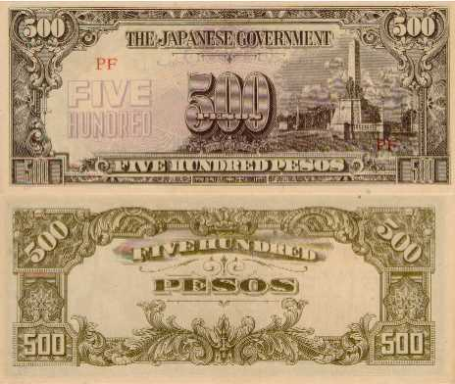

A 500 Peso JIM Note from the Philippines

1,000 pesos-block letters, no watermark, no ink soak through
-block letters, no watermark, soaking through of ink from face to back.
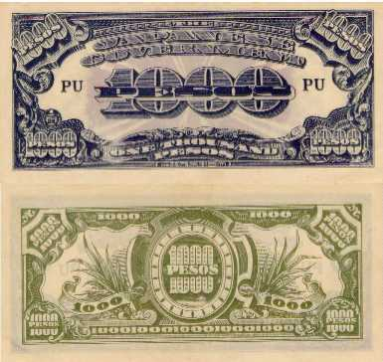
A 1,000 Peso Inflation JIM Note from the Philippines

The varieties are:
100 pesos - block letters, no watermark
500 pesos - block letters, banana tree watermark on left
- block letters, quatrefoil watermark
- block letters, "utsu"(copy) stamped on back
1,000 pesos-block letters, no watermark, no ink soak through
-block letters, no watermark, soaking through of ink from face to back.
____________________________________________________________________________________________________________________________
A Lion’s Tale By Dave Bailey

Spin – the ability to change a negative situation into a positive one by manipulating the truth.

Word War I saw its share of propaganda. Germans were referred to as “Huns”. Sauerkraut was changed to “liberty cabbage” and many other changes were made to influence the minds of civilians on both sides of the Atlantic. However, one of the greatest propaganda coups of the war was numismatic in origin and therein lies the tale.

World War I saw the development of the submarine as an important weapon of the German navy. England used its navy to cause a strangle hold on imports to Germany. Germany retaliated by sending submarines against the British fleet. Germany later expanded this undersea warfare to include all ships of the Allied nations including passenger ships.

The New York Times of May 1, 1915 ran a Cunard Line advertisement that the Lusitania, the largest and fastest liner of the time would sail that very day at 10 AM. The German Embassy placed an ad next to this informing the public that a “state of war exists” and the war zone includes the waters adjacent to the British Isles. On May 7, 1915 the Lusitania was torpedoed and sank with the loss of almost twelve hundred souls. The American public was infuriated by the idea of defenseless civilians killed by an unseen vessel.

A few weeks later, the noted medalist, Karl Goetz issued a medal to mark the sinking of the liner. The obverse featured a smiling skeleton representing Death selling tickets to people while a man reads a newspaper with “U-Boot Gefahr” (U Boat Danger). Also shown is Count Bernstorff, the German ambassador waving a warning finger. The reverse shows the Lusitania sinking. The deck is filled with contraband war goods and the legend in German translates as “The Liner Lusitania sunk by a German submarine May 5, 1915.” The Goetz medal was struck from iron and had a mintage of about 800 pieces.

The British took this medal and prepared a copy and scored tremendous propaganda influence in not only England but America as well. The English copy had a mintage of 250,000. Why? Goetz made a mistake by dating the sinking May 5 instead of May 7. The difference in dates--according to the English--was a matter of cold blooded murder planned in advance. Not only did the British score an important point with the Americans, it raised money for the Red Cross and St. Dunstan’s Hospital.
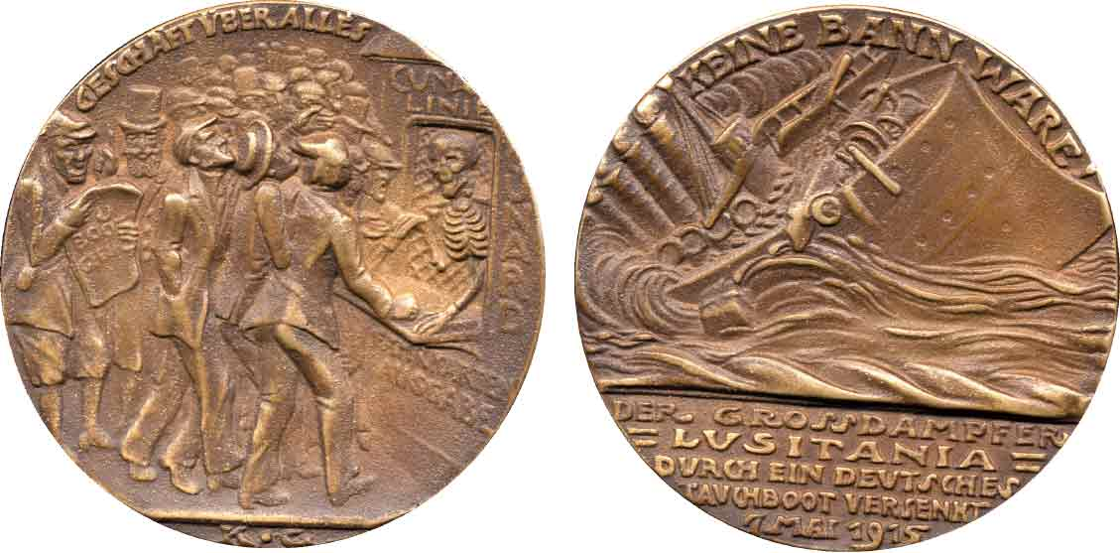

The corrected version of Goetz’s Lusitania Medal dated 7 Mai 1915
The Lusitania Medal, be it the original German or the British copy, serves as a tangible reminder of a great ship as well as the carnage of war.
___________________________________________________________________________________________________________

More Club News

Our esteemed Treasurer Pat James reported the club’s current balance at $711.24. 2006 Dues is still due for some. President Willie Simon welcomed guest Gene Sarrow to our meeting and reported on the Club Road Show held at the Aiken Public Library in April as being even more successful than the previous year. He also asked if there was any interest by members in acquiring a 2007 Red Books at a discount. After constructing a raffle tickets tumbler for the Augusta Coin Club show, the club approved a sum for member Howard Black to make one for our club’s Sept. 16 show. Winners of the door prize and 50/50 were Doug Moody and Helen Barry respectively. Congratulations to both members! Our next meeting is coming up fast; Thursday, June 8 at the Cedar Creek Club House starting at 7 PM. Hope to see you all then.
