Pres. Willie Simon
V .P. James Barry
Sec. Helen Barry
Treas. Pat James
Sgt. in Arms: J.J. Engel
Committees:
Programs: James Barry
Show Chairman: JJ Engel
Newsletter: Arno Safran
E-Mail: arnosafran@comcast.net
The Stephen James
CSRA Coin Club of Aiken
P.O. Box 1739
Aiken, SC 29802
Web site: www.sjcsracc.org
The SJ CSRA CC Now Meets on the 2nd Thursday of the Month at the Cedar Creek Community Center in Aiken, SC

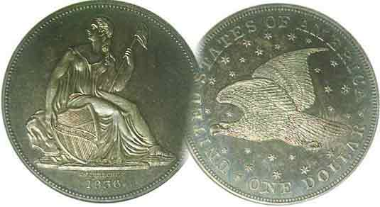

Volume 6, Number 6 the Stephen James CSRA Coin Club, Founded in 2001 June, 2007
Monthly Newsletter
Club Holds another Grade a Slab program
Our next meeting is on the 2nd Thursday of the month, June 14, 2007 at 7:00 PM
2007 Club Meeting Schedule - 2nd Thursdays at 7 PM Jan. 11 Apr. 12 July 12 Oct. 11
Feb. 8 May 10 Aug. 9 Nov. 8
Mar. 8 June 14 Sep. 13 Dec. 6
Annual Club Show: Sat. Sept. 15, 2007
_____________________________________________________________________________________________________________________________

Grading Skills Honed at May 10 Meeting

After a two year hiatus, our club decided to hold another grade a’ slab’ contest. Members were invited to bring in examples of certified coins from their collection that were authenticated as genuine and given a grade by one of the established professional grading companies. These were then presented to VP and Programs Chairman Jim Barry who taped over the grade with a removable adhesive. The hermetically sealed holders were then circulated among the 20 members present along with a sheet of paper indicating the date, mint mark (if any) and denomination of each item in which the members were to grade each coin. Sixteen coins were evaluated. The results included the following with the certified grades alongside each coin and the members’ consensus at right:

Certified Grade Members’ Consensus
1908 $20 Saint Gaudens no motto, (MS-61); same
1904-S $20.00 Liberty, (AU-58), same
1886 Morgan $1.00, (PCI-65) AU-58 to MS-61
1893cc Morgan $1.00, (NGC-AG-4) Fine-12
1899-O Morgan $1.00, (NGC-64) same
1921 Morgan $1.00, (“raw” AU) XF-40
1935 Peace $1.00, (PCGS-62) same
1981-S Proof SBA $1.00, (ICG-PF-68-Cameo) PF-65
1900 Lafayette Commem $1.00, (ANACS-50) same
1806 Draped Bust 50¢, (NGC-VF-35) VF-20
1812/11 Bust 50¢, (ANACS-XF-45) VF-35 to XF-40
1844-O Liberty Seated 50¢, (NGC-XF-45) XF-40 cleaned
1835 Bust 25¢, (ANACS-45), same
1938-D Buffalo 5¢ (NGC-65) same
1924 Lincoln 1¢, (NGC-64 Red) same
1931-S Lincoln 1¢ (NGC-63 Red). same

The members agreed with 9 out of the 16 certified grades.
______________________________________________________________________________________________________________________
(More Club News continues on page 3, middle of column 2)

Collecting Large Capped Bust Quarters
A Challenging Short Series
By Arno Safran

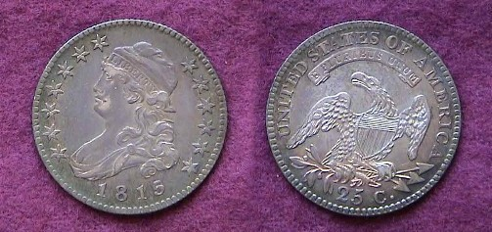

The 1815 Bust Quarter had a reported mintage of 89,235.
It was struck in .8294 silver and .1076 copper with a diameter of 27 mm.
The Bust quarter was a virtual reduction in size of the lettered edge Bust half dollar but with a reeded edge. [Photo is actual size. Magnify to 200%.]

The coin shown above was acquired back in 1979 when early US type coins were a lot less expensive than they are today. It was purchased at Stack’s on W. 57th Street in the heart of midtown Manhattan, New York and was described as a Choice Extra Fine with russet toning. On the obverse, wear is noticeable on Miss Liberty’s brow, along the right side of her mouth and chin and slightly along the top portion of her gown. The stars are sharp as are the rest of the major details while the dentils along the edge appear weaker along the lower portions. The reverse shows virtually no wear; not even on the wing tips where one would expect it to appear. This specimen was purchased seven years before third party professional grading companies were launched. Based on the small amount of wear, it could conceivably certify as high as AU-55 today.

The large size capped Bust quarters (1815-1828) are only beginning to become popular with collectors. For years they languished in the shadow of the lettered edge Bust half (1807-1836) a denomination struck in the millions like the later Morgan dollar but with a large number of die varieties for each date. By contrast, the overall mintages of the large size Bust quarters never exceeded 362,000 in a single year and they were sometimes not struck at all during its short 14 year span.
________________________________________________________________________________________________________________________
(Continued on page 2, column 1)
Collecting Large Capped Bust Quarters (1815-1828)
(Continued from page 1, column 1)

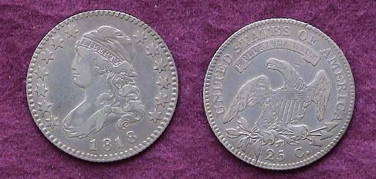

An 1818 Large Capped Bust Quarter B-8 R3
A “raw” VF-30 specimen acquired in 1999
Magnify up to 200% to increase clarity.

During the early years of our Republic silver for coining was in short supply and though all five silver denominations (the half disme, disme, quarter dollar, half dollar and dollar) were struck sporadically from 1794 thru 1807, the mintages were moderate at best to very small. During this time sufficient Hispanic American silver trade pieces of equivalent value were accepted as legal tender here. These included the 8 Reales = $1.00, the 4 Reales (50¢) the 2 Reales = 25¢, the 1 Real, = 12½¢ (closest to our disme) and the ½ Real = to 6¼¢ (approximating our half disme.) These foreign silver pieces lessened the Mint’s need to produce minor silver coins. Only the Spanish 4 Reales were not struck in large enough numbers to circulate here. As a consequence, the half dollar’s mintage was increased while the Draped Bust types for the dollar coin were suspended in 1804, the half disme in 1805 and the quarter in 1807.

In 1807 John Reich was brought in as Assistant Engraver to Robert Scot to redesign all our coinage and produced the Capped Bust Half Dollar. The combined reported mintages for Scot’s Draped Bust and Reich’s Capped Bust half dollar types for 1807 exceeded 1 million for the first time; the most for any silver denomination up to then. With the exception of 1815 and 1820, the reported mintage for Reich’s lettered edge Capped Bust half dollars would exceed a million or more through the end of its run in 1836. [No half dollars were coined in 1816 due to a fire at the US Mint.] These large coins were used ostensibly as specie by banks to cover large commercial transactions.

After a hiatus of eight years, US quarter dollar coinage was resumed in 1815. None were made the following two years, but in 1818, some 361,174 were reported struck; the high water mark for that period. If the collector wished to own one specimen for type, the 1818 would be the most available across the grading spectrum and the least expensive.
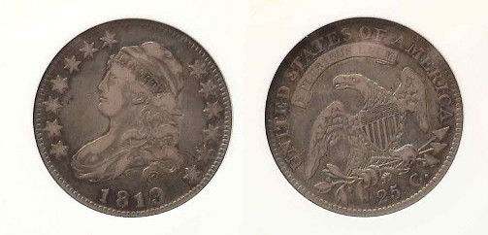
An 1819 Bust Quarter B1 R5 graded VF-20 by ANACS; a rare variety.
The reported mintage for the date was 144,000 for all varieties.
Magnify up to 200% for clearer details.

Large Bust quarters continued to be struck in consecutive years from 1818 through 1825 though the 1823, with a reported mintage of 17,800--but with fewer than two dozen known--is considered a great rarity. No quarters were reported issued in 1826. Of the 4,000 reported of the 1827, only ten are known. As a result, both the 1823 and the 1827 are considered “uncollectible” and not required to complete the short set. In 1828, some 102,000 were reported minted and while the date is not considered rare, it surfaces less often than the 1818, 1819, 1820 and 1825.
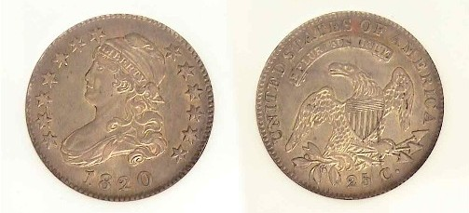
An 1820 Bust Quarter, B-2 R2 graded AU-55 by NGC acquired in 2001
The reported mintage for the date is 121,444 for all varieties
The coin is wholly original with natural color.
Magnify to 200% to see details.
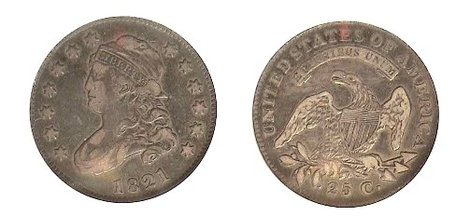
An 1821 Bust Quarter B4 R2 graded VF-25 by NGC acquired in 2002
The reported mintage for the date was 216,851
Magnify to 200% to see details.

Of the collectible dates of this series, the 1822 with a reported mintage of just 64.080 is more difficult to locate than the preceding dates; with the exception of the ultra scarce 1823.

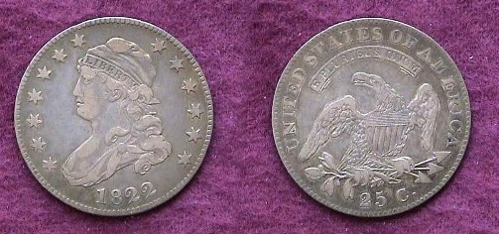

This 1822 Bust Quarter, B1 R3+ grading VF-30, (Mintage, 64,080) was acquired twice; first in the late 1980’s, sold in 1996 and repurchased in 1998.
Magnify to 200% to view the amount of detail still remaining.

Rarely does a collector get the opportunity to get a second chance at a desirable coin but this actually occurred with the acquisition of the 1822 quarter. In 1996 it was necessary for me to sell off a large portion of my collection. One of the casualties was letting the 1822 go! Big mistake! By 1998 I was ready to replace a number of better date pieces and found the 1822 quarter particularly elusive. Then, at a small local coin show, I found the very dealer to whom I had sold a number of these Bust quarters. To my surprise, he still had the 1822 and sold it to me for less than he paid me, exclaiming nobody seemed interested in the series and was glad to be rid of it.
_________________________________________________________________________________________________________________________
(Continued on page 3, column 1)
Collecting Large Capped Bust Quarters (1815-1828)
(Continued from page 1, column

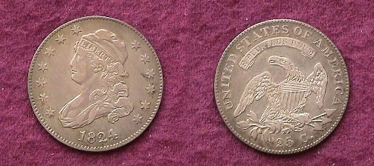

This 1824 Bust Quarter, B1 R3 grading XF-40 was acquired in 1991.
It has an estimated mintage of 24,000 with only one known die variety.
The coin is actually dated 1824/2 but difficult to detect.
[Magnify up to 200% to view details.]

The 1824 Bust Quarter’s reported mintage of 168,000 is combined with the considerably more common 1825. The late numismatic scholar Walter Breen estimated that only 24,000 were struck of this date based on Mint records showing a delivery made of 1824 quarters by the Mint in December, 1825. Only one die variety is known and it features the 1824/2; an overdate that is difficult to detect in which the top of the 2 appears under the 4 at left. The estimated low mintage figure makes sense based on the author’s personal experience. At the 1997 America Numismatic Convention held in New York City, he could not find a single specimen of the 1824 quarter in any grade. Since then, around ten different examples have appeared, most in lower grades than the coin shown. The 1824 Bust quarter is the toughest to locate of all the “collectible” dates.
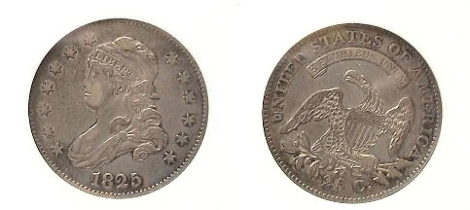
An 1825/3 QuarterB-2 R1 graded by ANACS as an EF-40
This is probably the second most common date though the reported mintage of 168,000 is less than the 1818 and 1821. The coin was acquired in 1999.
[Magnify up to 200% to view details.]

When one attends some of the larger coin shows or surfs the internet, the 1825 quarter is one date the collector is most likely to encounter. Breen estimates a mintage of 144,000 based on the 24,000 he believes were dated 1824. Of these, there are three known die varieties; all overdates; the 1825/2, an R5, (quite scarce), the 1825/3, an R1, the most common and the 1825/4, an R4- (scarce.)

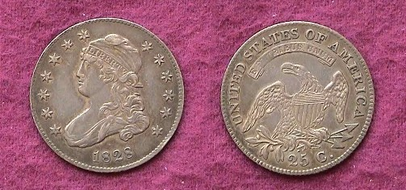

The 1828 Large Capped Bust Quarter, B1, R2
was acquired at the NYC ANA in 2002 as an EF-45
The last year of the large Capped Bust quarter series was 1828. The reported mintage was 102,000 with four known varieties of which the first is the more common.

On July 4, 1829, the cornerstone for the second United States Mint in Philadelphia was laid. During the next two years improvements in the coining process were undertaken that produced raised rims around a beaded border with a close collar. The last named provided for an equal diameter for all coins struck within their respective denominations. The half dimes, suspended since 1805 were resumed in 1829 under the new system and the dimes were slightly reduced in size. During this transitional period no quarters were struck. When the 25¢ denomination resurfaced in 1831, it featured these changes with the diameter having been reduced from 27 mm to 24.3 mm. The large Capped Bust quarter series had come to and end.
________________________________________________________________________________________________________________

More Club news (Continued from page 1, column 1)

Thirty-eight members have rejoined the SJ CSARA CC for the 2007-08 fiscal year. These include John and Linda Attaway, Jerry Axner, Helen and Jim Barry, Howard Black, Charles Braun, Merle Davis, Jr., J.J. and Marion Engel, Charles and Elizabeth Goergen, Claudia and Pat James, Thomas Kmetz, Steve and Austin Kuhl, Richard Lasure, Marlene Leich, James Marshall, Doug Moody, William Myers, James Nix, Billy Ray Randall, Gene Riggins, Arno and Vilma Safran, Glenn Sanders, Robert C. Sanborn, John Schulz, Jack Seech, Paul Silva, Willie Simon, Marjorie and Paul Simons, Richard Smoot, Catherine. S. Thomas and Rebekah J. Travis. If you have already paid your dues and find your name not on this list, please notify the editor at arnosafran@comcast.net or Pat James c/o the club PO Box on the Masthead of the newsletter prior to June 30. That’s the date when all unpaid members will be removed from the club mailing list.

At the May 12 meeting Willie Simon won the Door Prize, (a 2007 silver eagle) and Dick Smoot took the 50/50. Congratulations gentlemen! Merle Davis will be presenting a program entitled "A History of Wooden Nickels" at the June 14 meeting .

Club Annual Road Show Held May 12

There were some very interesting coins brought in by members of the Aiken community to our club’s third annual Road Show held at the Aiken Public Library May 12. One person seemed to have a complete set of United States $2.50 Gold Indian coins (1908-1929). Member Jim Barry, who saw the collection, advised the individual to have the set certified. On the key date, 1911-D $2.50 the “D” is notoriously weak and such was the case on this particular specimen. If that coin and the rest of the set can be authenticated as genuine, the woman who brought it in will realize a considerable return. (At the recently held Augusta Coin Club Show on May 4 & 5, one of the dealers had a 1911-D $2.50 in a NGC-MS-61 holder priced at $11,000. The “D” on the reverse was very weak on that coin as well.) Another individual brought in a large number of foreign coins he acquired as a GI in World War II. The members who served as appraisers were President Willie Simon, VP Jim Barry, also Sgt. in Arms, J.J. Engel, Glenn Sanders and Arno Safran. A review of the event was published in the May 13 edition of the Aiken Standard on page 4A.
__________________________________________________________________________________________________________________________
A Lion’s Tale By Dave Bailey

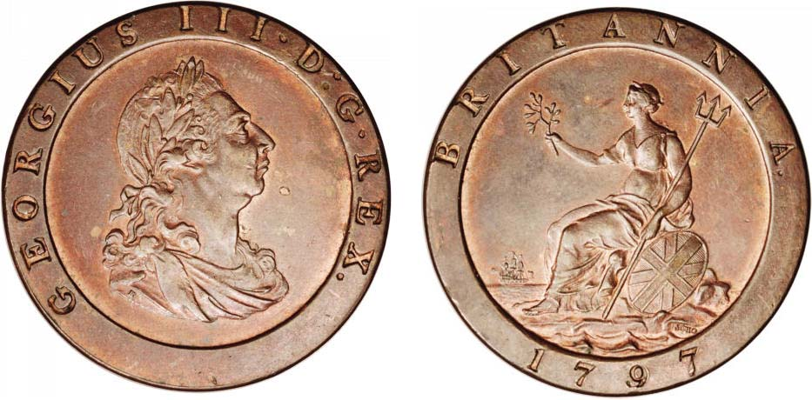

A 1797 George III “Cartwheel” Copper ‘Tuppence’
(Courtesy of Heritage Auctions Archives)

I have read recently that the price of copper and zinc may force us to say goodbye to our old friend, the cent, which has had a history of over two hundred years. The Mint claims that is losing money with every cent issued. There was a time when the opposite was true which resulted in one of the strangest coin issues in all of British history, and therein lies the tale.

Matthew Boulton was a man with a mission, as well as a vision. The Royal Mint had ceased production of copper coinage for over twenty years. This was at a time when industrialists needed small denominations to pay their workers. The only copper coins available were regal coins that were worn slick or lightweight counterfeits. It was time for Boulton to step up and solve the problem. Steam was the answer. Boulton had joined with James Watt at Soho, outside Birmingham, England. After spending several years perfecting the modern steam coin press, he attempted to obtain the Royal contract for copper coinage.

Finally, he was given the contract and started the famous 1797 cartwheel issue. Only one world could describe the coins! Massive! The penny weighed in at one ounce of pure copper and the two pence weighed in at two ounces. The coins were handsome as well as heavy with a bust of George III on the obverse and Britannia seated on the reverse. They were more than just good looking. They were technological marvels of the day. Boulton incorporated an outer rim to protect the design features and sunk the legends into the coin rather than raised; (i.e., incused). In addition, there was no doubt where it was made. SOHO was boldly stamped under Britannia’s shield.

The issue was a tremendous success as it helped drive out not only the shoddy counterfeits but also gave the public the expectation of large copper for their low denomination coins.

In 1805 the price of copper soared and many of the recently minted SOHO issues were melted. Shopkeepers kept a few to serve as balance weights for scales since they weighed exactly two ounces. The cartwheels were also used at political rallies where they could be thrown at rival candidates, thus the term, “a cheap shot”

One can hold a piece of the “Industrial Revolution” just by picking up one of these massive coins. Thank you, Mr. Boulton.

_______________________________________________________________________________________________________________________________

Another “gem” from the pen of Dave Bailey, author of “The Lion’s Tale”, (Ed.)

Coin of the Month

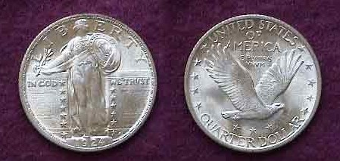

A Mint State 1924 Standing Liberty Quarter

The 1924 Standing Liberty Quarter was the last year of the pedestal date subtype. Because the date was raised, it wore out quickly. In 1925, the date was recessed which is why the later sub types are found with full dates even in the lower grades.
__________________________________________________________________________________________________________________________________

Kindly Support Our Advertisers

