Pres. Willie Simon
V .P. James Barry
Sec. Helen Barry
Treas. Pat James
Sgt. in Arms: Glenn Sanders
Committees:
Programs: James Barry
Show Chairs: The Barry’s
Newsletter: Arno Safran
E-Mail: arnosafran@comcast.net
The Stephen James
CSRA Coin Club of Aiken
P.O. Box 1739
Aiken, SC 29802
Web site: www.sjcsracc.org
The SJ CSRA CC Now Meets on the 2nd Thursday of the Month at the Cedar Creek Community Center in Aiken, SC

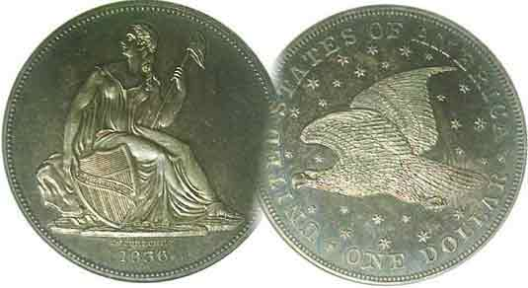

2008 Club Meeting Schedule
Volume 7, Number 6 the Stephen James CSRA Coin Club, Founded in 2001 June, 2008
Monthly Newsletter
Coins of the 12 Caesars Shown at the May meeting
Our next meeting is on Thursday, June 12 from 6:15 to 9:00 PM
Jan. 3 Apr. 10 July 10 Oct. 9
Feb. 14 May 8 Aug. 14 Nov. 13
Mar. 13 June 12 Sep. 11 Dec. 4 dinner
____________________________________________________________________________________________________________________

Our Next Club Show- Sat. Sept. 13, 9:30 AM to 4:30 PM
H. Odell Weeks Activity Center - Whiskey Rd (Rte. 19) Aiken
___________________________________________________________________________________________________________

Wayne Damron Presents Program on the
Coinage of the 12 Caesars

At our May 8 meeting Wayne Damron, proprietor of Clein’s Rare Coins in Augusta presented a program on the coinage of the Twelve Caesars. Wayne explained the parameters of this amazing period in the Roman Empire as lasting around 145 years from Julius Caesar who ruled Rome from 49 to 44 BC as Caesar to Domitian, AD 81 to 96. He presented a brief biographical sketch of each of the 12 Caesars, mentioning in greater detail each significant emperor’s strengths and weaknesses. He cited Augustus 27 BC to 14 AD as the greatest who led the Roman Empire longer than any of the twelve Caesars, leaving a treasury equivalent to 1.4 billion dollars to the citizens of Rome upon his death. Caligula (AD 37 to 44), a favorite of the mean spirited Tiberius (AD 14 to 37), was considered the most depraved. Claudius (AD 41 to 54) was the most pleasantly surprising, since in his early years, while in the shadow of Tiberius and later Caligula, he gave no indication of his ability for administration or wisdom in matters of law. Beginning with Nero (AD 54-68), the empire became unsettled as the emperor’s extravagances increased his unpopularity among the people eventually resulting in Nero’s suicide. Following Nero, mistrust and greed for power created a period of chaos in the empire when the reigns of Galba (AD 68-69), Otho (AD-69) , and the gluttonous Vitellius (also AD 69) were cut short to one year or less by assassination or suicide. After these civil wars, Vespasian (AD-69-79) restored a semblance of stability to the empire.

Wayne described the three main denominations of Roman coins struck during this period as being the copper Sestertius, (about the size of the British half penny and US large cent), the silver Denarius, (similar in size to our dime) and the gold Aureus; (roughly the diameter of our $2.50 quarter eagle.) Wayne’s concluded his presentation by displaying his impressive collection of denariii; each representing one of the twelve Caesars save Vitellius who served for less than a year.
________________________________________________________________________________________________________________________
(Club News continued on page 5, column 1)

Collecting Short Sets – Part Two - Quarter Dollar options
By Arno Safran
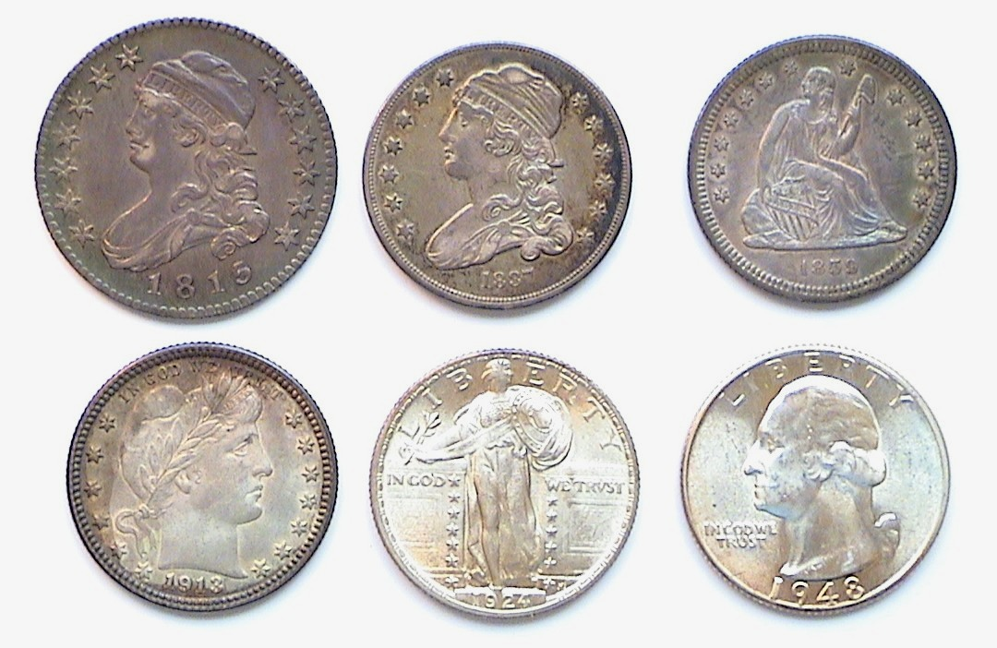
The obverses of a composite 25¢ type Set featuring
both the large & small Bust Quarter (The coins are actual size)
1815 Lg. size Capped Bust, 1837 sm. size Capped Bust and 1859, Lib. Std. bottom: 1913 Barber, 1924 Standing Liberty & 1948-D Washington
[Magnify page up to 200% to view details.]

The coins pictured above represent a composite--if incomplete--US type set of quarter dollars. Some years ago the Capital Plastics Company made a number of Lucite holders designed to motivate the collector towards completing a short set that would include the more affordable design types within one denomination. These included one each for the cent, nickel, and dime (discussed last month), the quarter, half dollar, dollar and gold issues. Capital actually issued two different holders for the quarter denomination. One featured five slots which included the large Capped Bust type (1815-1828) along with the later Liberty Seated (1838-91), Barber (1892-1916), Standing Liberty (1916-30) and Washington (1932 to date). After 1976 a second holder containing six slots was made that began with the less expensive small capped Bust type (1831-1838) followed by the Liberty Seated, Barber, Standing Liberty and the two Washington types that incorporated the dual dated 1776-1976 Bicentennial Drummer Boy reverse. Capital Plastics viewed the earlier Draped Bust small and large Eagle types as being too costly and omitted them in favor of the later issues.
_____________________________________________________________________________________________________________________
(Continued on page 2, column 1)
Collecting Short Sets – Part Two - Quarter Dollar options
(Continued from page 1, column 2)
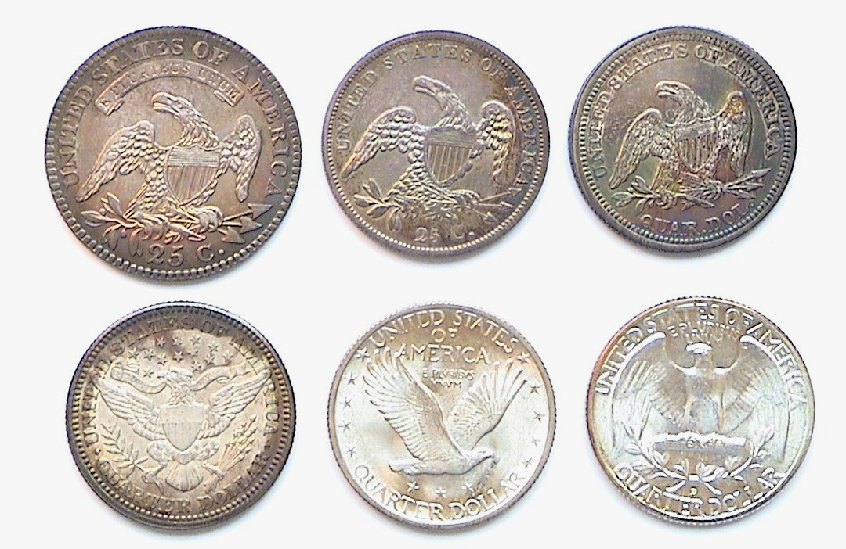
The reverses of the composite 25¢ type Set featuring
both the large & small Bust Quarter (The coins are actual size)

Three of the reverses depict the Spread eagle; (top row above). This became one of our longest running reverse design types as it lasted some 85 years (thru 1891). It was designed by John Reich in 1807 for the new lettered edge Capped Bust half dollar and placed on the quarter in 1815. Unlike the half dollar--then our largest circulating silver coin--which was struck every year except 1816, quarter production, was spotty until the reduced size Capped Bust quarter was reworked by William Kneass for 1831. Kneass removed the motto E PLURIBUS UNUM while refining the eagle and lettering. In 1835 Christian Gobrecht replaced Kneass who had suffered a stroke. Gobrecht is best known for the 1836 Liberty Seated no stars, soaring eagle dollar which bears his name. This was followed in 1837 by the no stars obverse Liberty Seated dime and half dime. By 1838, it was the quarter’s turn to receive a face lifting but Mint Director William Maskell Patterson for reasons unknown decided to retain Reich’s Spread Eagle for the quarter, (on the third reverse top right shown above.) Gobrecht’s most significant alterations were the changeover from 25c to QUAR DOL. The upper lettering appears larger while the Spread Eagle is smaller.
The following three design types in the bottom row reflect the changing artistic tastes of each period, each portraying different approaches by engravers Charles Barber, Hermon MacNeil and John Flanagan.

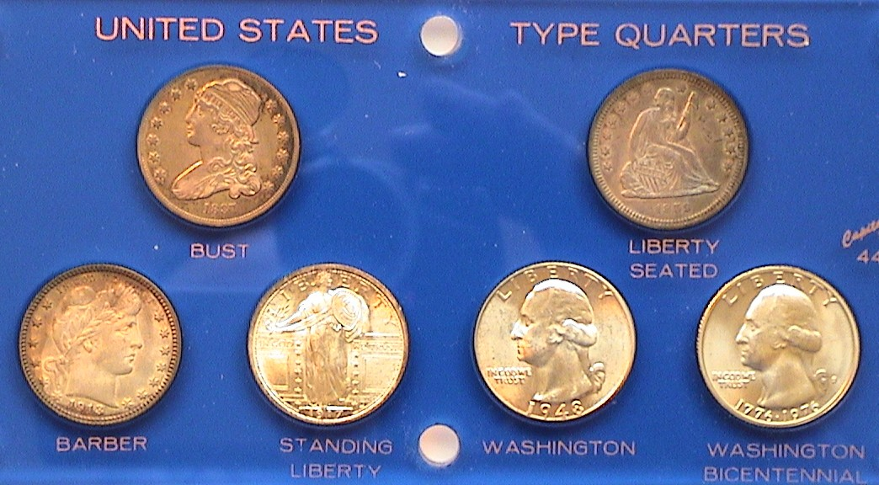

Capital’s six coin US Type Quarters Short Set in Lucite Holder
Shown at top are the obverses of the 1837 small Bust and 1859 Lib. Std.
Bottom: 1913 Barber, 1917 Type I Std. Lib., 1948-D and 1976 Washington’s
As recently as 2002 there were still a number of early US type coins grading full Fine-15 through XF-45 that middle class collectors could afford, but with the tremendous increase of entrants attracted to the Hobby by the introduction of the Statehood quarter series in 1999, the supply has dropped while prices have soared for the small number that do surface. As a result, most serious collectors now opt to by only those coins that have been slabbed by the major certification companies. One of the by-products of third party certification has been the virtual elimination of quality “raw” coins from the market and regrettably, this has adversely affected the collector’s options to display portions of one’s collection in these attractive holders as shown at the bottom of column 1 and below.

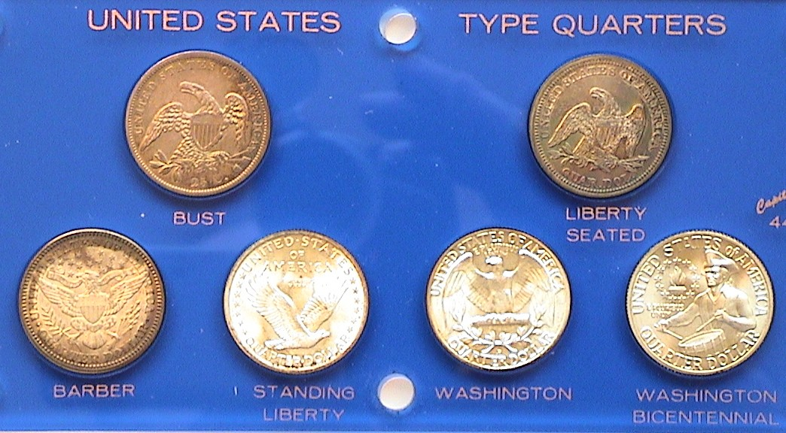

Capital’s six coin US Type Quarters Short Set in Lucite Holder
Shown at top are the reverses of the 1837 small Bust and 1859 Lib Std.
Bottom: 1913 Barber, 1917 Type I Std. Lib., 1948-D and 1976 Washington’s
[Magnify to 200% to see details.]

Still, one has to move with the times and if these holders are becoming a thing of the past, one can display “slabbed coins” via the computer thanks to such software as “Picture It” and “Photo Shop” as well as for PowerPoint presentations.
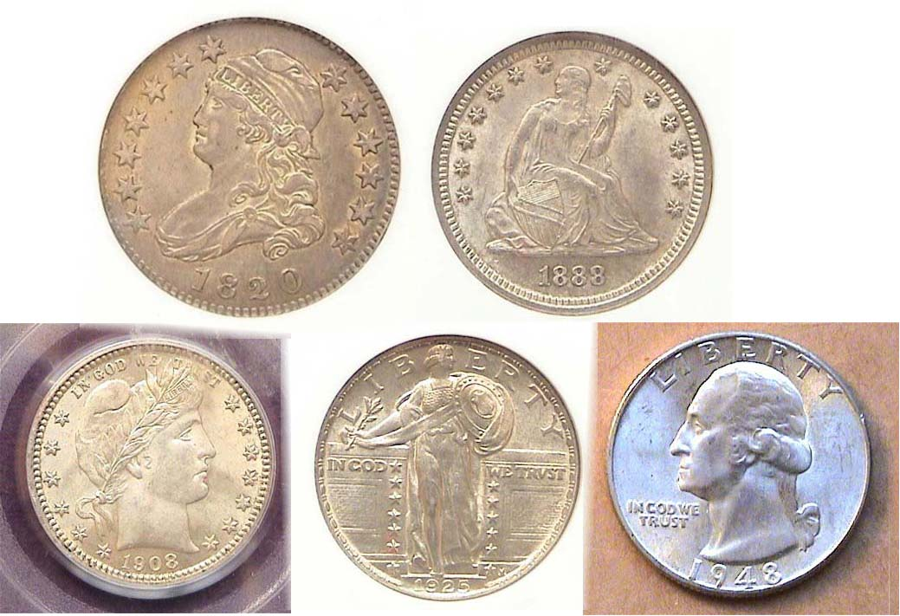

The obverses of a certified five piece 25¢ slabbed Short Set
Top: l to r: 1920 large Bust quarter alongside 1988-S Liberty Seated
Bottom: 1908 Barber, 1921 Standing Liberty and “raw” 1948-P Washington

None of these coins shown directly above were removed from their hermetically sealed plastic holders (AKA “slabs”) but they can still be displayed visually as if they were represented in a Short Set of US type quarters. A complete type set of quarters would encompass at least seven major obverse types but there are a large number of sub-type varieties from the Liberty Seated and Standing liberty types that would double the total.
___________________________________________________________________________________________________________________

Henning Nickels
By Eric Knapp

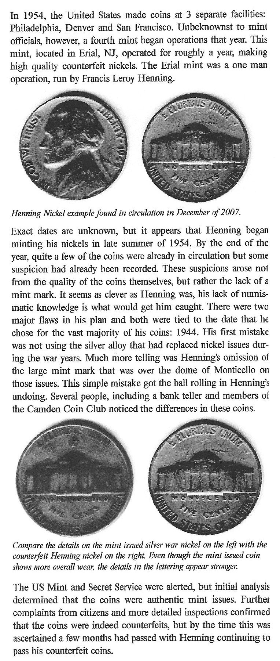
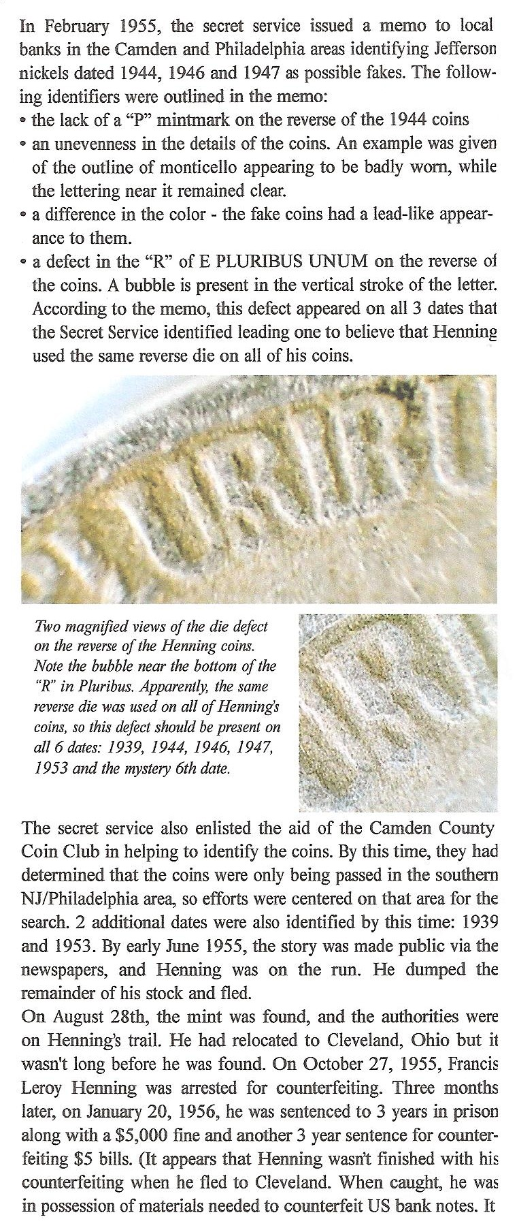
______________________________________________________
(Continued on page 4, column 1)

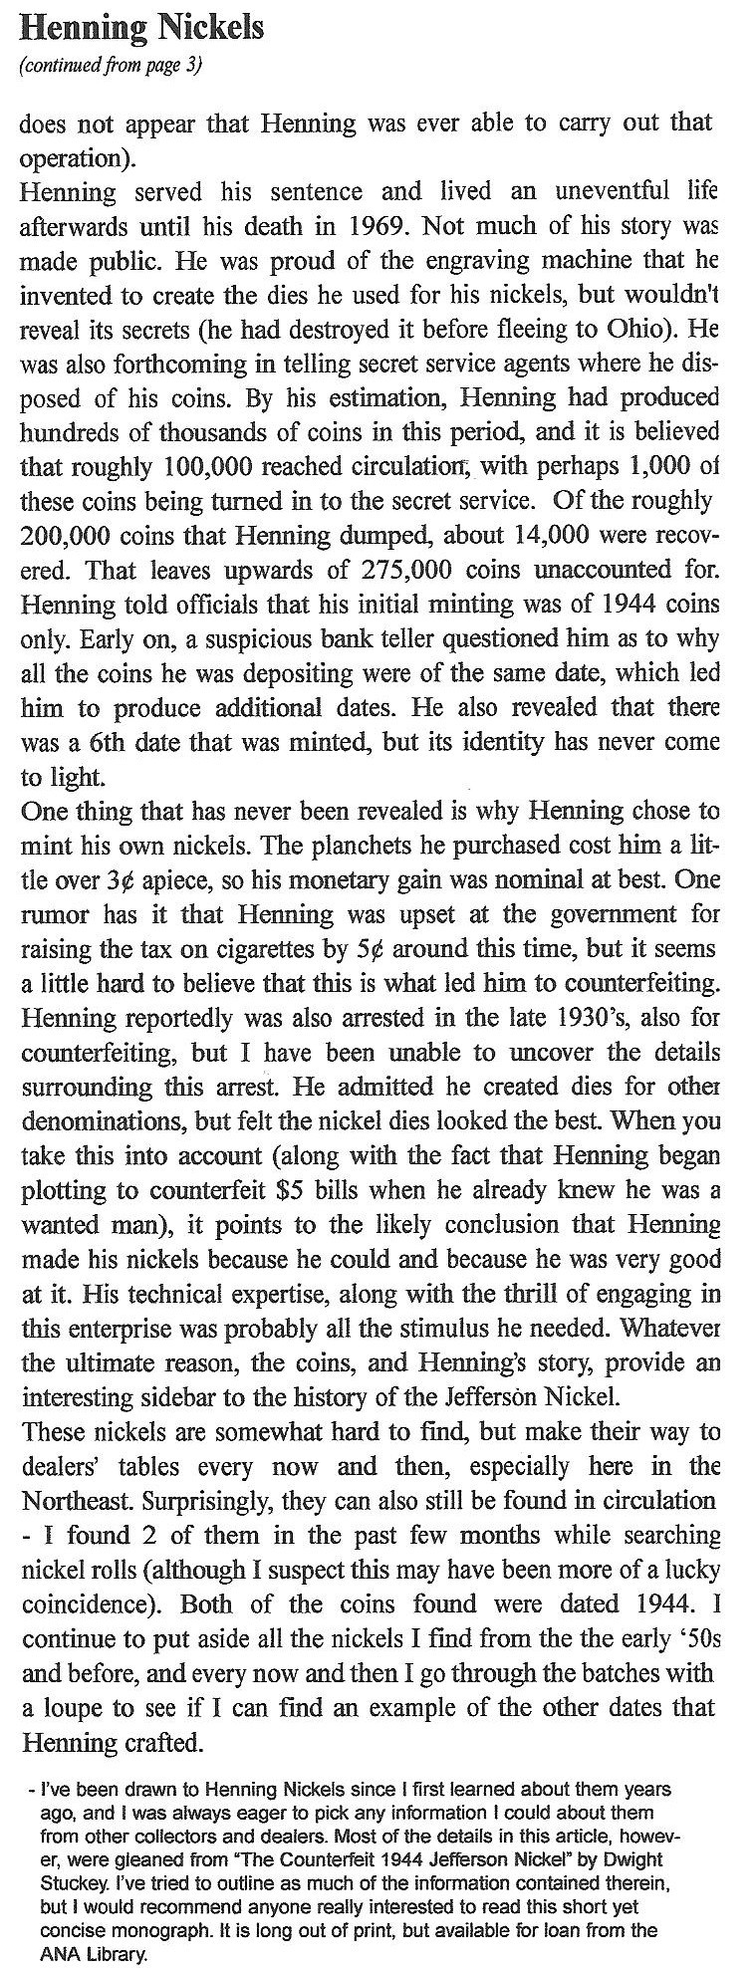
_________________________________________________________
Eric Knapp is the editor of the Hills Numismatist, monthly newsletter of the Watchung Hills Coin Club in NJ. He was the recipient of the 2008 “Numismatist of the Year” award at the Garden State Numismatic Association Convention held in May; Ed.
ANT NOSE MONEY
By Bill Myers
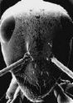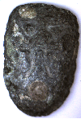
I recently acquired a piece of odd and curious money known as “ant nose money”. Its origins date back before the use of coins in China and can actually be considered a predecessor to coins. The history of ant nose money dates back to the first use of “money” in China. Cowry shells, known in China as bei, which means shell, were a very early barter unit. The evidence is very strong that cowry shells were used as money. Their small weight and size made them suitable for use in trade. Cypraea moneta and Cypraea annulus are the species used. They are thought to have started to be used as money at the end of the Xai Dynasty (2200 BC). They were most likely imported from the Indian Ocean or Ryukyu Islands, as they are not found in the waters around China. Due to limited availability of cowry shells, imitations of them were made out of stone, clay, bone, bronze, iron as well as semiprecious stones. Bronze imitations of cowry shells with inscriptions were produced by the time of the Zhou Dynasty (1125-255 BC) and may have preceded spade and knife money. The bronze imitations were called “ant nose money” or “ghost face money”.

I have found several different explanations for the names of this money. One is that the Chinese calligraphy on the bronze pieces resembles a face and thus was called ghost face money. Another style resembles an ant walking across it and thus was referred to as ant nose. One style looks like an ant and another like a human nose so it became “ant and nose” money, while yet another resembles a skull and is called ghost face money. A totally different explanation is that these pieces were placed in the noses of the dead to keep out ants. I feel this may have been a use for the ant nose money but not the primary reason for their manufacture.

It was not until the Qin Dynasty (336 BC) that the Chinese developed their “cash” money - the round coin with a square hole in the middle which most people are familiar with. But as you can see that was not the start of money in China. Due to the age of this piece I acquired, and limited records from the time, the true meaning and use of ant nose/ghost face money may never be known. But it is an interesting part of numismatic history, and I was able to obtain this 2400 year old predecessor to coins for less then $10.
_________________________________________________________________________________________________________________________
References:
Jen, David. Chinese Cash. Identification and Price Guide. Krause Publications. 2000. Pgs 1-4, 13,14, 201.
http://chinesecoins.lyq.dk/History/cowry_money.htm
Cowry and Cowry Imitation Coins. http://www.calgarycoin.com/reference/
china/china1.htm
http://www.vcoins.com/ancient/dltcoins/store/viewItem.asp?idProduct=1811
http://www.lotn.org/~calkinsc/coins/000036.html
Club News – Wayne Damron’s program
(Continued from page 1, column 1)

In summation Wayne stated that during the reigns of the twelve Caesar going back to Julius Caesar, the Roman Empire covered a larger area than the Unites States of America.

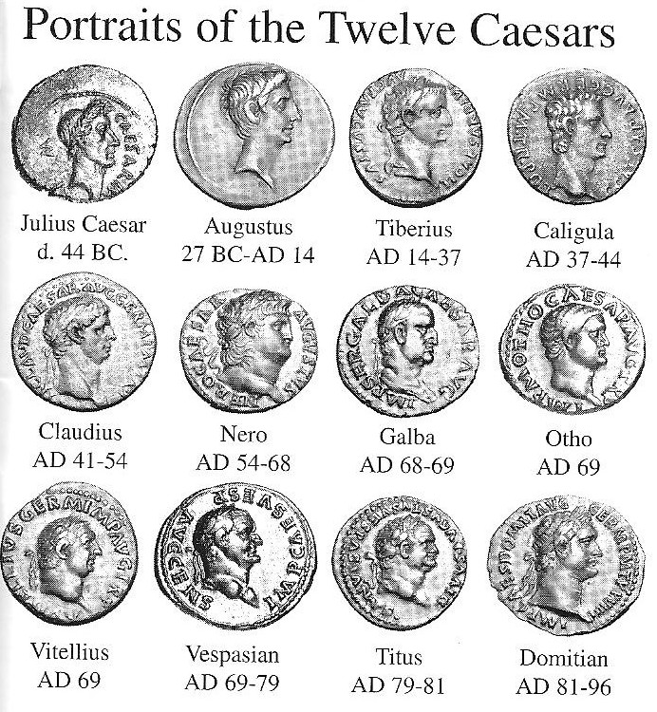
(Courtesy of Pegasi Numismatics; wwwPegasiOnline.com)

VP Jim Barry presented Wayne Damron with a Certificate of Appreciation at the conclusion of his talk.

At our upcoming June 12 meeting Xavier Pique--who last spoke before our club on “Counter stamped coins through History”--will return to present a PowerPoint program on “Heraldry: Coats of Arms on Coinage.”
____________________________________________________________________________________________________________

More Club News

In Treasurer Pat James’ absence, Secretary Helen Barry reported a club balance $845.79. Pat was taken ill and after spending g a few days at the Aiken Regional Hospital is resting comfortably at home now with her daughter Claudia at her side. The club wishes Miss Pat a speedy recovery and looks forward to seeing her smiling face at our meetings again soon. Member Bill Myers has reported that he has another article appearing in the ANA’s “Numismatist” magazine coming out this month. It is called “The P Mint” and is also the subject of a program Bill gave at the Augusta Coin Club in May.

For Show & Tell Arno Safran brought in three denominational “Short Sets” on cents, nickels and dimes housed in Capital Lucite holders. The prize winners at the May 8 meeting were Jim Clapp who won a 2008 Silver Eagle as the attendance prize and Helen Barry who won the 50/50. Congratulations to our winners. Glenn Sanders ran the auction. Our next meeting is June 12. Bring in numismatic items for Show & Tell, the auction or coins to trade or sell.
_______________________________________________________________________________________________________________
Club Annual Road Show Held May 17

The SJ CSRA CC held its annual Road Show on Saturday, May 17 at the Aiken Public Library. Six members were on hand at 12 noon to examine and appraise coins, tokens, medals and obsolete bank notes that area folks might bring in. The appraisers were Willie Simon, Jim Barry, Glenn Sanders, J.J. Engel, Dick Smoot and Arno Safran. After a slow start, folks began coming in between 1:30 and 3 PM. This is another fine service our club provides to the Aiken community.
____________________________________________________________________________________________________________________________

Kindly Patronize Our Advertisers

