Pres. Steve Kuhl
V .P. James Barry
Sec. Helen Barry
Treas. Sharon Smoot
Sgt. in Arms: Glenn Sanders
The Stephen James
CSRA Coin Club of Aiken
P.O. Box 11
New Ellenton, SC 29809
Web site: www.sjcsracc.org
The SJ CSRA CC meets on the 2nd Thursday of the Month at the Cedar Creek Community Center in Aiken, SC

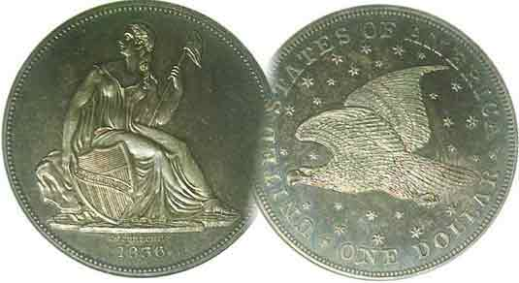
Committees:
Programs: James Barry
Show Chairs: The Barry’s
Newsletter: Arno Safran
E-Mail: arnosafran@comcast.net
Auctioneer: Glenn Sanders

2009 Club Meeting Schedule
Volume 8, Number 6 the Stephen James CSRA Coin Club, Founded in 2001 June, 2009
Monthly Newsletter
Bill Fivaz Presents Diagnostics on Key Date Coins
Our next meeting is Thursday, June 11, 2009 from 6:15 to 9:00 PM
Jan. 5 Apr. 9 July 9 Oct. 8
Feb. 12 May 14 Aug. 13 Nov. 12
Mar. 12 Jun. 11 Sep. 10 Dec. 3
_ ___________________________________________________________________________________________

Renowned Numismatist Presents Program
On Popular US Key Date Coin Diagnostics

At the May 14 meeting of the SJ CSRA CC, numismatic scholar Bill Fivaz returned as our featured guest speaker; this time presenting a slide program on the most popular US key date coins and how to recognize a legitimate example from a fake. All the slides were originally produced for pictures to be used in a small spiral bound monograph simply titled, “Bill Fivaz’s COUNTERFEIT Detection Guide”, copyrighted in 2001. Bill’s approach was straightforward. Show only genuine examples of each key date coin; not those that had been altered. In most cases, if one knows what to look for on the actual key date, a departure from any of the main diagnostics should trigger a caution signal to the potential buyer.

Bill arranged the sequence of his program from the cent to the dollar starting off with what to look for on a genuine an 1877 Indian Head cent. He pointed to three areas on the coin; first, the date. Both sevens must appear identical in style with the top and base of the second 7 appearing slightly broader. On the reverse look for weakness on the lower right side of the “N” in ONE and check for casting marks, “pimples” on both sides.

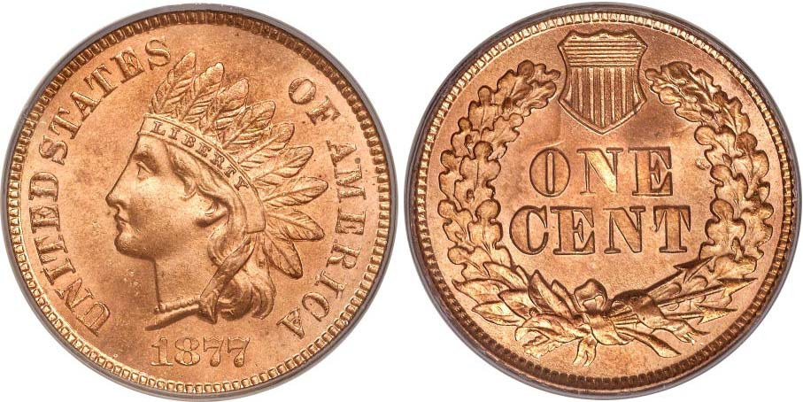

A Brilliant Uncirculated PCGS-66 example of a genuine 1877 cent
Magnify up to 500% to see diagnostics. (from Heritage Auctions archives)

Bill applied the same type of scrutiny to the 1909-S VDB and 1914-D Lincoln cents all the way up through the 1889 cc and 1893-S Morgan dollars. The club thanks VP Jim Barry and Secretary Helen Barry for arranging for Bill’s talk and providing lodging for him and his lovely wife Marilyn for the night.
_______________________________________________________________________________________________________________________
(More Club News continued on page 4, column 1)

Half Cents and Large Cents Were Still Around in 1849
Collecting the Coins of 160 years ago By Arno Safran

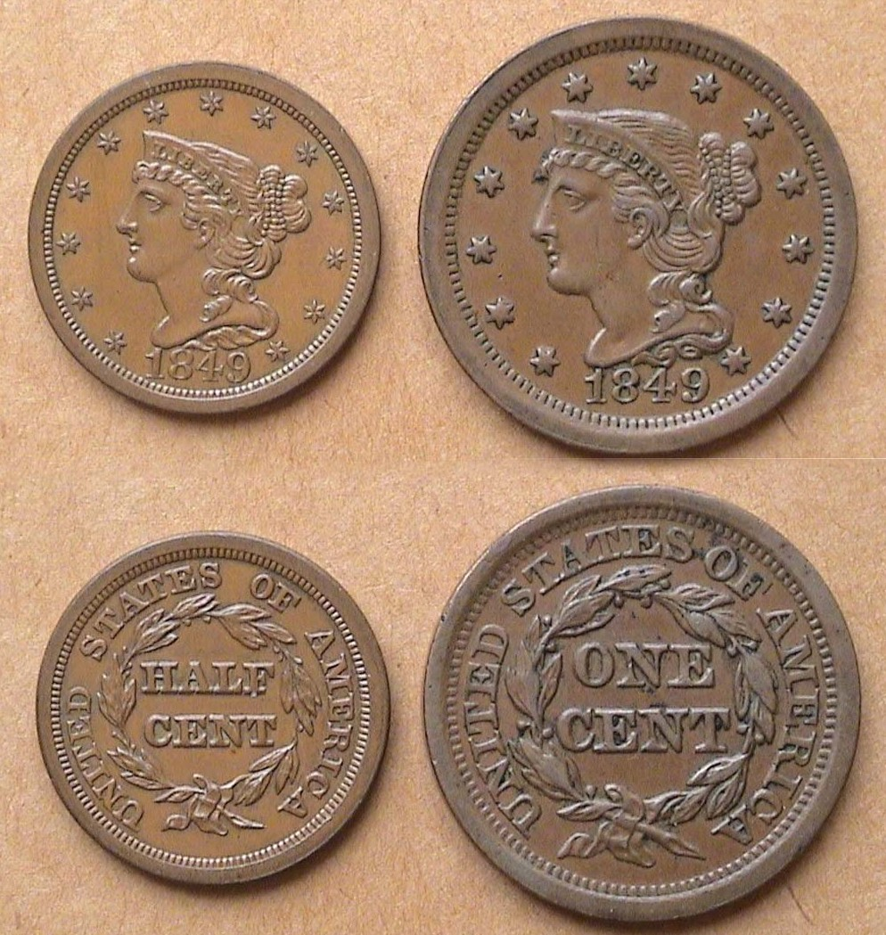

1849 Braided Hair “Mature Head” Coronet half cent and large cent

Due to a surplus of over 450,000 half cents at the end of 1836, the Mint suspended production of half cents until 1849. During that period an indeterminate number of 1836 dated proof half cents with the Classic Head design were followed in 1840 through 1849 by an even smaller number of proofs using the Gobrecht modified Coronet (aka Mature head) type. All of these and the restrikes that followed were presumably made as part of sets for world leaders or for collectors and since no known Mint records of these issues survive, a sense of mystery remains regarding these extremely rare and expensive pieces.

In 1849 the Mint resumed the striking of half cents for circulation. A total of 34,864 business strikes were issued that year. Despite their modest number the coin hardly circulated and is available at moderate prices up through AU grade. In the 2010 Red Book just released, an AU specimen is listed at $240.

By comparison, the 1849 large cent had a mintage of 4,178,500 and in AU is priced at $135, almost one-half the value of the 1849 half cent in that grade. XF’s are listed at $80 for the cent and $150 for the ½¢; both excellent values.
_____________________________________________________________________________________________________________________
(Continued on page 2, column 1)
The US Coins of 1849: 160 Years Ago
(Continued from page 1, column 2)

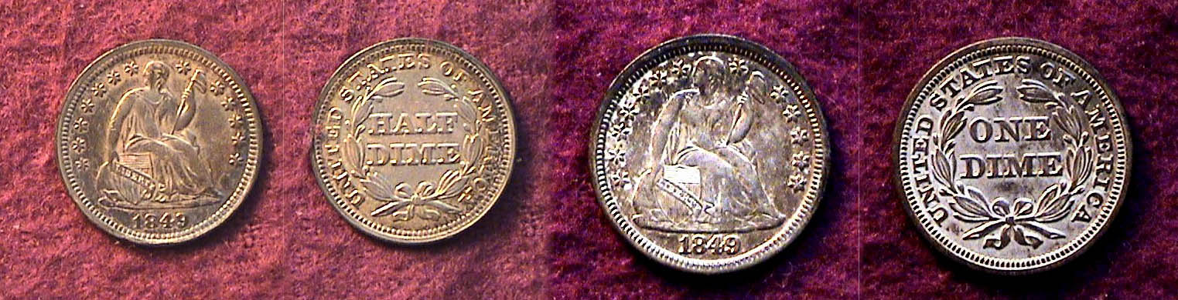

The 1849 Liberty Seated Half dime and dime
[Magnify to 200% to see details.]

Until 1851, the two smallest silver denominations were the 5¢ half dime and 10¢ dime. With 1.3 million half dimes struck at the Philadelphia Mint in 1849 compared with just 140,000 coined at the New Orleans facility, the 1849-O half dime is priced eight times higher in AU than its Philadelphia counterpart according to the 2010 Red Book. In terms of relative availability the dimes share a similar relationship. The 1849-P Liberty Seated dime has a mintage of 839,000 compared with 300,000 for the 1849-O, but in AU the 1849-O is priced at six times that of the 1849-P dime, so if you are attempting to put together a year set, you are better off in the short term selecting the nicest P Mint specimen that you can afford for each.

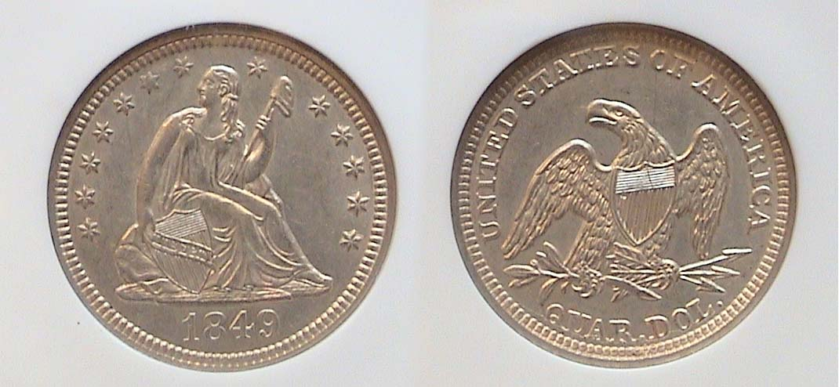

An 1840 Liberty Seated Quarter graded AU-58 by NGC

According to Mint records all Liberty Seated quarters struck at the New Orleans facility in 1849 were included with the 1850-O totals and in Good 4; the 1849-O is listed at $450 in the 2010 Red Book rising to $6,000 in AU-50. The 1849-P quarter on the other hand enjoyed a whopping 340,000 struck; a fairly good size mintage by mid 19th century standards though it hardly compares with the 25¢ coin’s one billion plus output per year in our time. While an 1849-P in Good-4 is listed at a paltry $25, it soars dramatically to $800 in MS-60 and to $1,600 in MS-63. An AU-58 will sell for around $400 to $450.

The reason fore the enormous price increase for a supposedly common date coin is tied to the discovery of gold in California in 1848 and the subsequent gold rush the following year. These events produced a rise in the price of silver in relation to gold. Silver coin began to be melted and sold for its increased bullion value almost as soon as it left the Mint. As a result virtually all silver coins produced for circulation from 1849 through the early 1850’s are far less common today than its reported mintage would suggest. Larry Briggs, author of “A Comprehensive Encyclopedia of United States Liberty Seated Quarters”, (DLRC Press -1991) assesses the rarity factor for the 1849-P quarter as a R4 suggesting that from 76 to 250 survive for all grades out of the original 340,000 mintage.

Of the five silver denominations displaying the Liberty Seated design, only the half dollar comes closest to Gobrecht’s original concept that appeared on the extremely low mintage dollars of 1839. In 1840 Robert Ball Hughes was brought in by Mint Director Robert Maskell Patterson “to improve” Gobrecht’s original renderings. In mid year drapery had been added to Miss Liberty’s gown under her left arm on the half dime, dime and quarters. The shield which had been tilted like on all five denominations was realigned to an upright position on the half dimes and dimes as well. Miss Liberty’s head and arms were fattened. It appears that only the half dollar survived these “improvements” and remains arguably the more beautiful design type of the five seated denominations used from 1840 on.

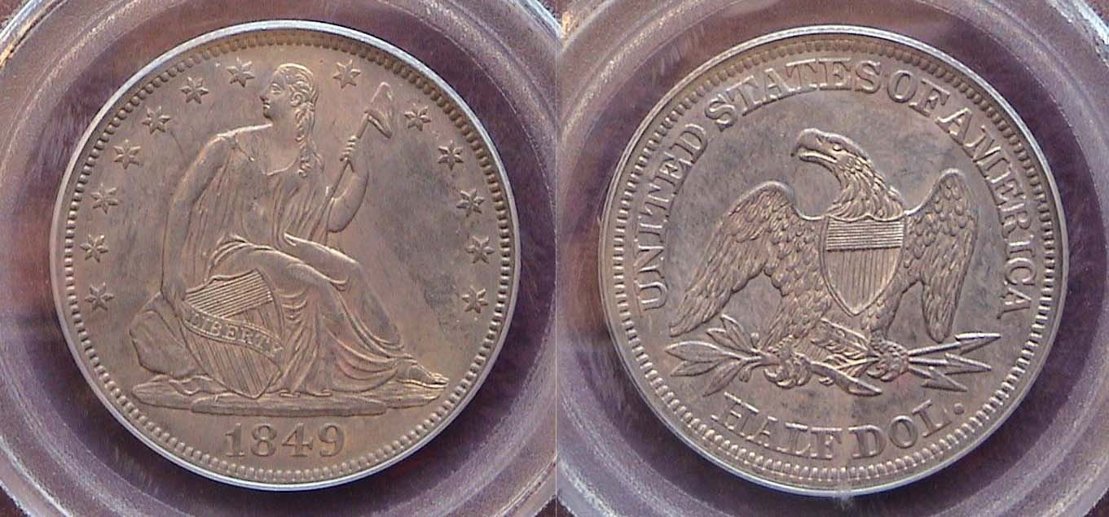

An 1849-P Liberty Seated Half dollar graded AU-58 by PCGS
[Magnify to 200% to see details.]

The 1849 Liberty Seated half dollar was produced in large mintages; 1,252,000 at the Philadelphia Mint and 2, 310,000 at the New Orleans facility and surfaces more frequently in the higher grades. Upon magnification (either with a small 3X magnifying glass for those who receive the printed version) or up to 200% for members reading the digitized copy,) one will observe a slight flatness along Miss Liberty’s upper portion of her leg. This would account for the certified grade of AU-58. The streaking across the reverse is an effect of the natural toning.

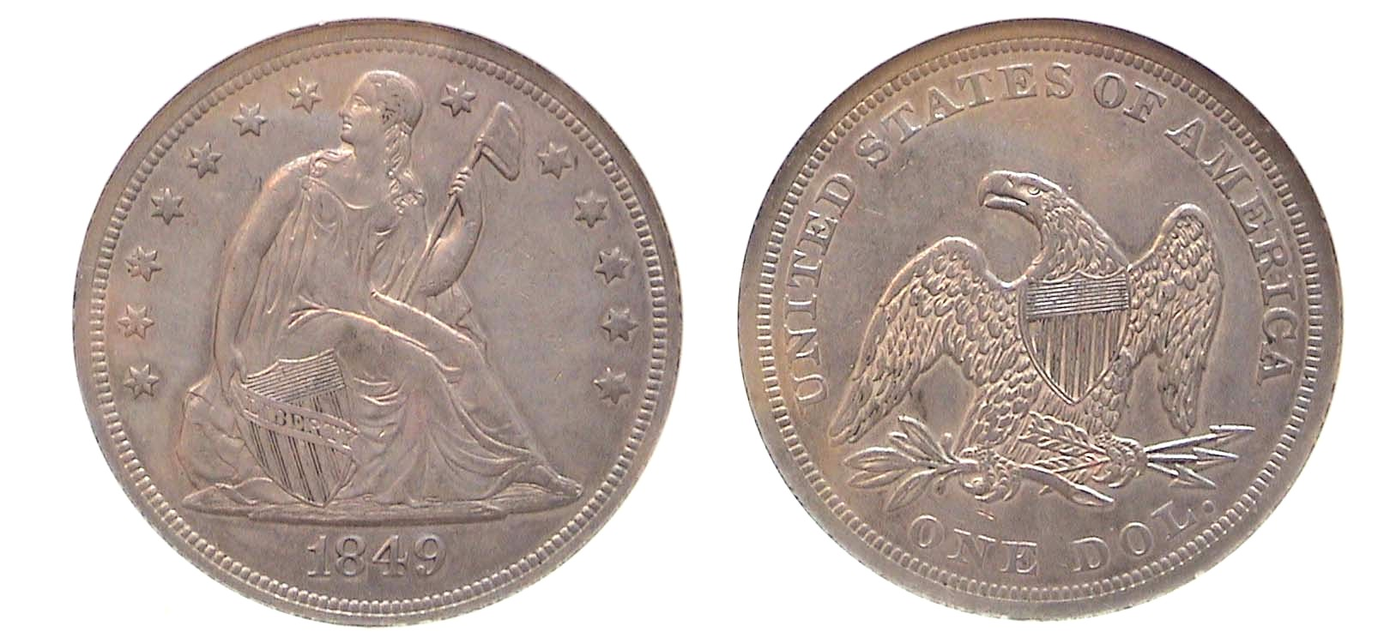
An 1849 Liberty Seated dollar graded AU-58 by NGC
[Magnify to 200% to view details,]

In 1849 only 62,600 Liberty Seated dollars were minted in Philadelphia with none being coined at New Orleans. Comparatively speaking, this low mintage 1849 dollar should be scarce and unduly expensive. However, this has turned out to be wrong on both counts! Due to its cumbersome size, (38.1 mm) and weight (26.73 grams) the US silver dollar saw little circulation, especially in the east and enough survivors of the 1849 issue exist to keep the price moderate up through AU-58.

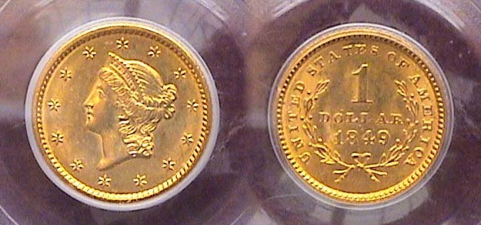

An 1849-P Gold dollar graded MS-61 by PCGS
[Magnify to 200% to view details,]
____________________________________________________________________________________________________________
(Continued on page 3, column 1)
The US Coins of 1849: 160 Years Ago
(Continued from page 2, column 2)

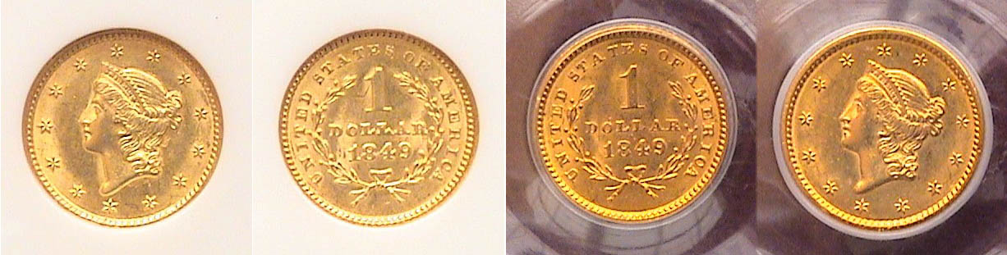

1849-P $1.00 gold pieces showing closed and open wreath reverses
The Closed wreath is at the left center and the open wreath at the right center.
[Magnify to 200% to see details more clearly.]

The Act of March 3, 1849, authorized the issuing of two new gold coin denominations; the $1.00 gold piece and the $20.00 double eagle. While only one of the latter was made as a trial that year and resides in the Smithsonian today, some 688,567 of the new $1.00 gold coins were coined at the Philadelphia Mint. 215,000 were struck at the New Orleans Mint while only 21,588 at the Dahlonega Mint and a scant 11,634 at the Charlotte Mint. There were two reverse subtypes issued in about equal measure at the Philadelphia Mint; the closed wreath and the open wreath with the open wreath slightly less common.

The 1849 Gold dollar was the first US coin to enter circulation with the date on the reverse. During the four year period (1849-1853) when silver coins were being melted for profit on the bullion market, the new $1.00 gold coin proved to be popular and did circulate far more than kits silver dollar counterpart.

For most moderate income collectors, the 1849 dated $2.50, $5.00, and $10.00 gold pieces are simply too costly to include in a such a year set but assembling even the eight denominations shown can be both challenging and rewarding.

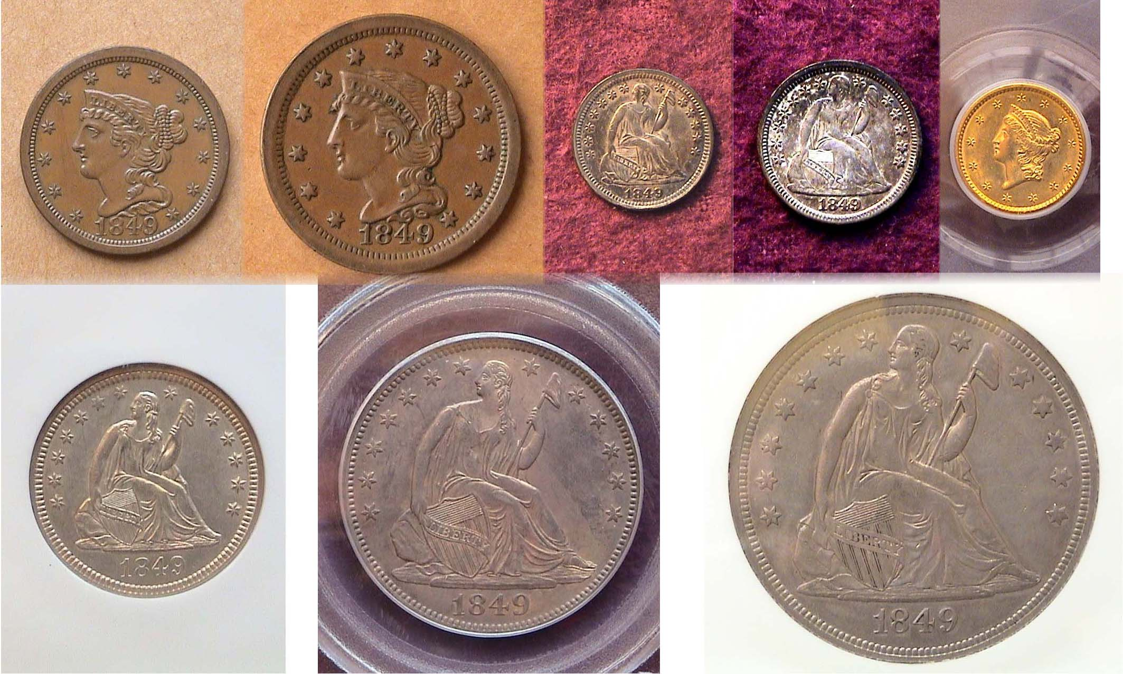
The obverses of an 1849 Year set shown pretty close to actual size
Top from Left: ½¢, 1¢, half dime, dime and $1. 00 gold
Bottom from left: 25¢, 50¢ and $1.00 silver
[Magnify to 200%]
________________________________________________________________
(All of the above coins have increased in value over the years. If one buys the best coins you can afford, accurately graded with eye appeal and holds them for five years or more, their value is likely to grow, Ed.)

CHERRY PICK YOURSELF
By Bill Myers

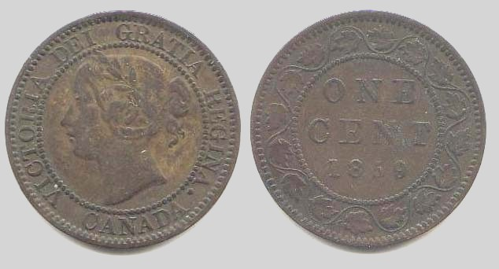

A Canadian 1859 Large cent
[Magnify to 200%]

I am sure all of us say “yes” when ask if we are coin collectors. But I think many of us are coin accumulators. I am guilty of the latter. I have coins stuffed into boxes that “I will get to in the future”. The current economic crunch has affected a lot of us. We do not have as much money to spend on coins at shows and shops as we used to, and may forgo traveling to some coin shows because of the cost. That does not mean you also have to cut back on numismatics. Turn you attention to your own accumulations. I have begun to do that and have already made an interesting discovery. I have a handful of Canadian large cents that have been stored in a plastic bag for years. One of these cents is dated 1859. I turned to the Standard Catalog of World Coins - 19th century. The coin is listed as KM# 1. It also lists four varieties: 9/8 wide 9, narrow 9 and double-punched narrow 9 types I & II. In VG 8 the values range anywhere from $2.25 to 175.00 (in the 4th edition). With such a big spread in the values, identifying which type you have becomes more important, but in SCWC there are only vague descriptions. This is another reason to have a good numismatic library. I turned to Charlton Standard Catalogue Canadian Coins and they have clear pictures of each type. The coin I have is the double-punched narrow 9 type I. I grade my coin Fine to Very Fine and find out it is valued at $250-350.

I have no idea where or when I got the coin and how much it cost me. I probably got it with a bunch of foreign coins and just tossed it in the bag with the rest of my Canadian large cents. It is getting much better treatment now. A majority of the time that I check my coins for varieties I discover that I have the common variety. But every once in awhile I find a more valuable variety which keeps me searching. You never know – “What’s in your accumulation?”

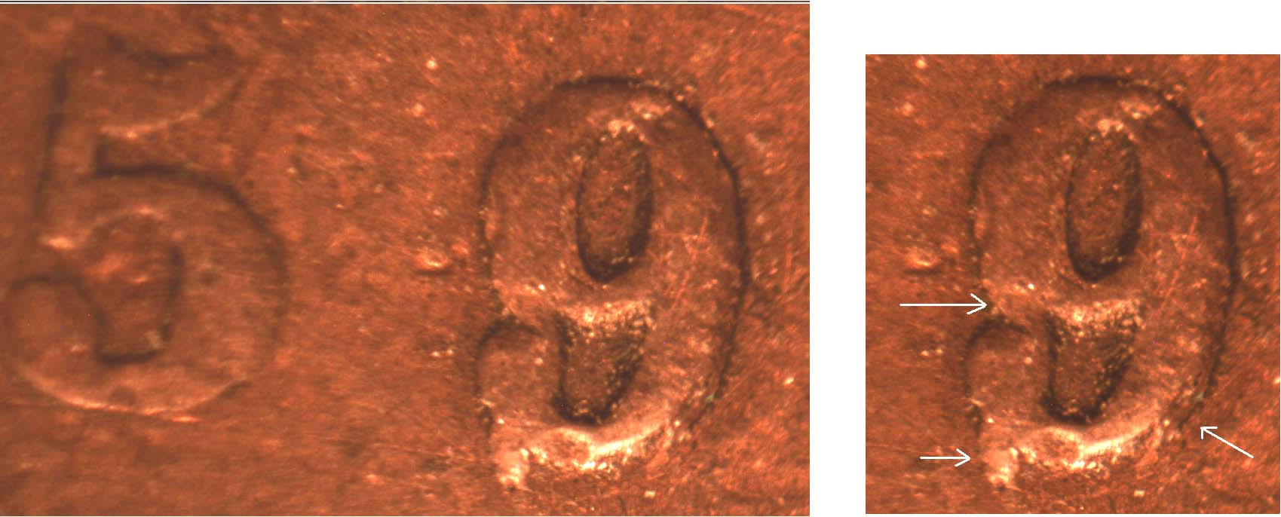

An 1859 Canadian double-punched narrow 9\, type I;
Diagnostic arrows at right
-------------------------------------------------------------------------------------------------------------------------------------------------
(Thanks Bill for another illuminating article, Ed.
More Club News (Continued from page 1, column 1)

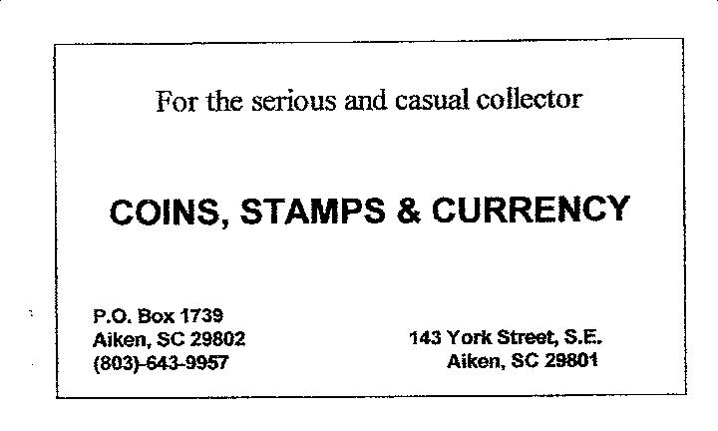
At the May 14 meeting our new President Steve Kuhl welcomed the members and acknowledged our special guests, Bill and Marilyn Fivaz. He also mentioned that the club has been able to purchase a number of 2010 Red Books at a price of $8.00 per member. Treasurer Sharon Smoot’s report was read. With all expenses paid, the net balance is currently $965.63. Thanks Sharon. Sgt. in Arms and club auctioneer Glenn Sanders announced that the Anderson Area Coin Club will be holding a show on June 12 & 13 at the Anderson Recreation Center located at 1107 N. Murray Avenue in Anderson, SC. The hours are from 10 AM to 6 PM both days. Thanks Glenn.

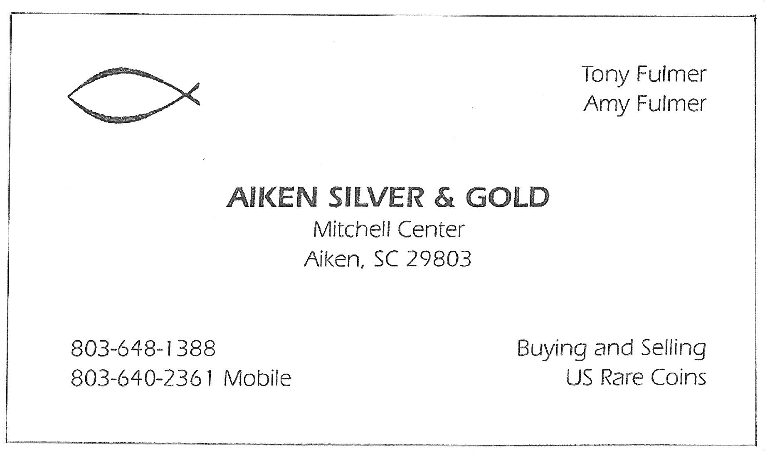
There were three Show & Tells: Young Numismatist Austin Kuhl displayed an Australian 2000 dated one ounce silver coin with a portrait of Queen Elizabeth II on the obverse and a dragon on the reverse. Arno Safran brought in an 1899 Liberty nickel he had acquired at the Augusta Coin Club show. The coin had a die chip in the upper part pf the upper loop and evidence of re-cutting in the lower loop. Our guest speaker, Bill Fivaz was on hand to verify the repunched date which appears in “The Cherry Picker’s Guide…” he co-authored with J.T. Stanton. Bill had copies of the latest edition on sale for $25.00.

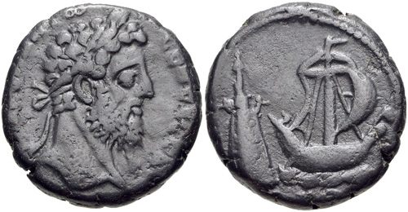

Egypt: Tetradrachm of Pharos Lighthouse of Alexandria
AD 177-192 (22 mm, 12.61 grams)
Obverse shows a Laureate Bust of Commodius facing right
Reverse Corbita under sail right; Pharos of Alexandria to left

(Courtesy CNG Website: Electronic Auction #211 under
“Roman Provincials”, Lot 339)

VP Jim Barry exhibited a most fascinating and historic coin from Egypt. Known as the Pharos Lighthouse it was considered one of the last built of the 7 Wonders of Ancient World. Jim has provided the following notes on this silvered-copper 5¢ nickel size coin.

Alexander the Great established the city of Alexandria after driving out Persians from Egypt in 332 BC. The lighthouse was started by Ptolemy I, one of Alexander’s generals at the beginning of the 3rd Century and completed between 283 - 246 by his son, Ptolemy II. Built of stone it was encased in white marble 384 feet high with a statue of Poseidon on top. It used fires reflected by mirrors to aid ships that could see from a distance of 30 miles. It was the tallest structure of type until the building of Eiffel Tower in France in 1889. It lasted 1000 years. Two earthquakes did serious damage during the early 14th Century and it was disassembled by the Mameluk sultan who used the stones to build a fort in that area.

Several coins of Ancient Rome depict the lighthouse. The bust of Commodus, son of Marcus Aurelius appears on the obverse. On the reverse the lighthouse is seen on left with a galley sailing by. The inscription is in Greek - not Latin.

The prize winners at the May 14 meeting were Helen Barry who won the silver eagle door prize and Doug Moody who took the 50/50 raffle drawing. Congratulations winners!

The upcoming June 11 meeting program will feature a DVD on the Art of Augustus Saint-Gaudens.
____________________________________________________________________________________________________________
Kindly patronize our Advertisers

