Pres. Steve Kuhl
V .P. Arno Safran
Sec. Jim Mullaney
Treas. Sharon Smoot
Sgt. in Arms: Glenn Sanders
The Stephen James
CSRA Coin Club of Aiken
P.O. Box 11
New Ellenton, SC 29809
Web site: www.sjcsracc.org
The SJ CSRA CC of Aiken, SC meets on the 1st Thursday of the month at the Aiken Public Library

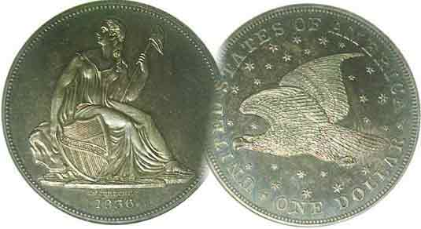
Committees:
Programs: Arno Safran
2010 Show: Jim & Helen Barry
Publicity: Jim Clapp
Newsletter: Arno Safran
E-Mail: arnosafran@comcast.net
Auctioneer: Glenn Sanders

2010 Club Meeting Schedule
Volume 9, Number 6 the Stephen James CSRA Coin Club, Founded in 2001 June, 2010
Monthly Newsletter
Coins and Postcards are Portals to the Past
Our next meeting is on Thursday, June 3, 2010 from 6:00 to 8:45 PM

Jan. 7 Apr. 1 July 1 Oct. 7
Feb. 4 May 6 Aug. 5 Nov. 4
Mar. 4 Jun. 3 Sep. 2 Dec. 2

____________________________________________________________________________________________________________

Coins and Postcards provide portals to History

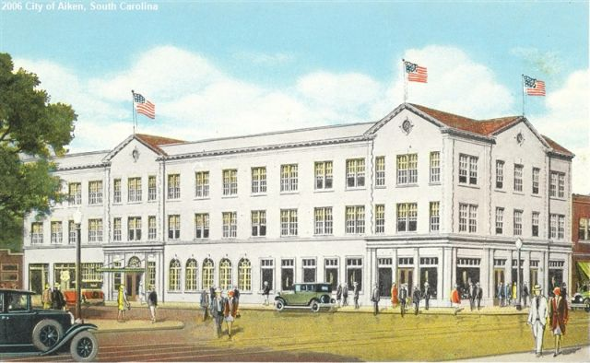

The Aiken Hotel, 235 Richland Ave. W. and Laurens Ave. c. 1930
Illustration for an old postcard circa 1930’s
[Use 3X glass or magnify to 200% to see details]

The land of the vineyard, valley and streams
The four square County of Aiken
Where scenic beauty reigns supreme
An empire in the making.
Secure from tides and ocean mists
And free from sleet and snow,
Old Aiken County heads the list
With plenty of room to grow.
Thomas H. Williamson

Shown above is an artist’ sketch, presumably for an old postcard depicting the Aiken Hotel as the building looked around 1930. The hotel has a fascinating history as does the city of Aiken. The town was founded by William Aiken. He was a cotton merchant who was responsible for the building of the railroad from Charleston through Aiken to Hamburg (a portion of North Augusta today) from 1828 to 1833. In 1834 the town site was laid out and in 1835 the city of Aiken was incorporated.
______________________________________________________________________________________________________________________________
(Continued on page 3, column 1)

The Collectible Coins of 1930: Eighty Years Ago
By Arno Safran

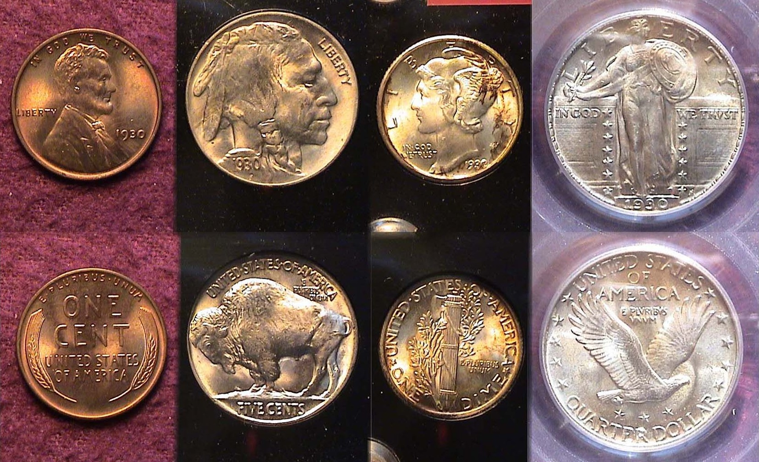
A BU 1930-P Year set: From l. to r. 25¢, 10¢, 5¢ and 1¢
[Use 3X glass or magnify to 200% to see details]

As the year 1930 began, our nation was deepening into the Great Depression that would last the entire decade. During economic hard times, the government produces less coins and 1930 saw not only a reduction in the mintages but also in the number of denominations produced. Of the ten authorized coin denominations intended for circulation only six were released in 1930 but in actually just four circulated; the cent, nickel, dime and quarter. The $10.00 and $20.00 gold pieces were issued in low numbers and only at the San Francisco Mint. They hardly circulated because during the early days of the New Deal US gold issues were recalled with the result that the 1930-S $10 and $20 gold pieces have become great rarities, are extremely expensive and considered virtually uncollectible today.

After 1928, the Peace dollar was suspended until 1934 and from 1930 thru 1932; no Walking Liberty half dollars were coined. The two lower gold denominations, the $2.50 quarter eagle and $5.00 half eagle were discontinued after 1929. Fortunately the remaining four 1930 denominations (the 1¢ thru 25¢) are collectible in all grades up through MS-65 either as a four piece Philadelphia Mint set like the one shown above or as a complete nine piece year set that include the branch mints.
_____________________________________________________________________________________________________________
(Continued on page 2, column 1)
The Collectible Coins of 1930: Eighty Years Ago
(Continued from page 1, column 2)

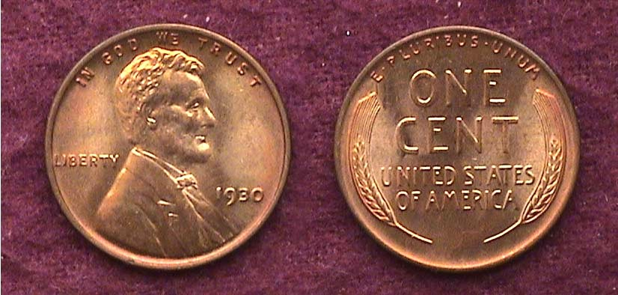

A 1930-P Lincoln Cent grading at least MS-64 Red
[Use 3X glass or magnify to 200%.]

Over 157 million Lincoln cents were struck at the Philadelphia Mint in 1930, down from 185 million produced the previous year before the Stock Market crash in October 1929 changed everything. Still, that is a large number compared with only 19.3 million coined a year later in 1931 as the Depression deepened further. The Bi-monthly Coin Prices Magazine published by Krause Publications lists the date at $31.50 in MS-65 while Coin World’s monthly supplement, Coin Values prices a MS-64 Red specimen at $45.00. Meanwhile the just released 2011 Red Book shows the date at just $10.00 in MS-63, the highest grade offered there. If the collector can obtain a decent MS-63 specimen with enough Red color in it for $15, such a coin would be a nice addition to one’s year set at a modest cost.

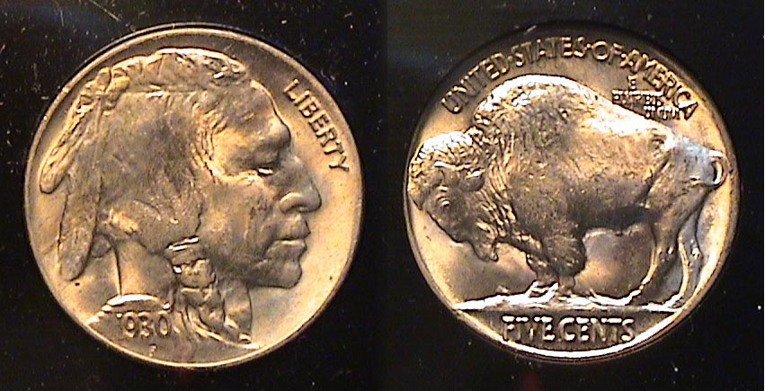

A 1930-P Indian Head/ Buffalo nickel grading MS-65
[Use 3X glass or magnify to 200%.]

The reported mintage for the 1930-P nickel was 22,849,000. That is 13½ million less than the 1929-P but still a large number, so the date is considered common for the Buffalo nickel series (1913-1938-D). The 2011 Red Book list the date only as high as MS-63 where it is priced at just $75.00. In MS-65, it is listed at $235, this according to Coin Prices Magazine. Upon greater magnification, notice how well defined the 1930-P specimen appears. It has not only a superb strike but also blazing reflective luster.

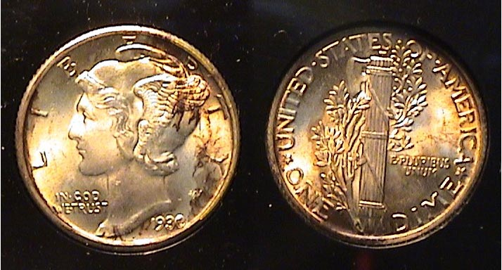

A 1930-P Mercury dime grading MS-64
The russet toning may keep it from receiving a higher grade.
[Use 3X glass or magnify to 200%.]

With the exception of 1921, one of the key dates of the Mercury dime series (1916-1945), the Philadelphia mintages for Mercury dimes during the Roaring Twenties were fairly large, ranging from 19 million to over 50 million. In 1930, the Philadelphia Mintage plunged to 6,770,000 compared with 25.9 million coined in 1929. Without fully split bands across the center of the fasces on the reverse a 1930-P dime graded MS-64 is listed at only $55.00 in Coin Values, (formerly known as Coin World Trends). By comparison, an MS-64 with fully split bands on the reverse is listed at $175. The coin above is fairly well struck but over the years has toned a russet reddish brown color. Some collectors like toned coins while others prefer them to be blast white. Obviously, the toning was caused by some moisture seeping onto the surfaces of this specimen during the twenty years the coin was housed in the Lucite holder.

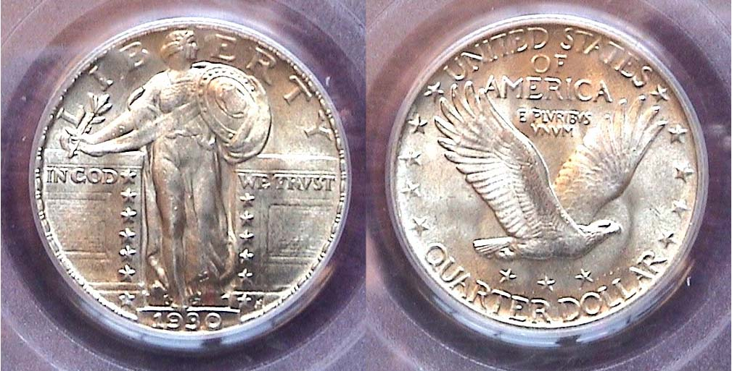

A 1930-P Standing Liberty quarter graded MS-64 FH by PCGS
[Use 3X glass or magnify to 200%.]

The Standing Liberty quarter is arguably one of our most beautiful coinage designs and it is a pity the series begun in 1916 was truncated after the 1930 mintage to make way for a new commemorative quarter to celebrate the 200th anniversary of George Washington’s birth in 1932. Despite a mintage of just 5,632,000, the 1930-P issue is one of the most common and least expensive of the series. According to Coin World’s Coin Values monthly magazine, a 1930-P quarter in MS-64 is listed at $350.00. One showing a Full Head (FH) what is described is currently priced at $600.00. Although the coin shown above was certified as MS-64FH, the price paid was much closer to the non-full head issue. A best buy for this date is finding a nice MS-63, which sells for around $200 today.

The Branch Mint issues

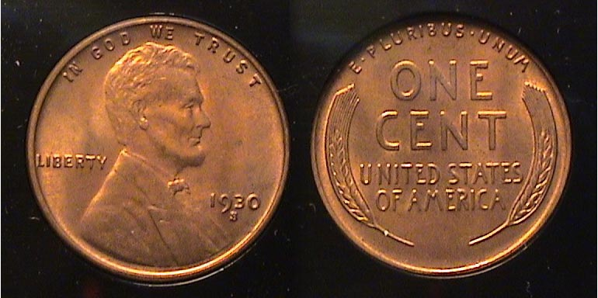

A 1930-S Lincoln Cent grading MS-64 Red
[Use 3X glass or magnify to 200%.]

24 million Lincoln Cents were struck at the San Francisco Mint in 1930 compared with 40 million produced at the Denver Mint, the only D Mint denomination coined that year. More 1930-S cent specimens survive in the higher grades, (from XF-40 through MS-65) which is why the 1930-S cent is less expensive in Mint State than the 1930-D.

Despite a mintage of only 5.4 million, the 1930-S Buffalo nickel is available in all grades up through MS-65, although more expensive than the 1930-P. Finding a lustrous well struck example is another matter as most 1930-S 5¢ pieces have soft strikes or were unevenly struck.

As a rule 1930 coins struck at the SF Mint were not as sharply struck as those produced at the Philadelphia Mint and the 1930-S Mercury dime is no exception. The mintage for this issue was just 1.8 million, the seventh lowest in the series but according to David Lange, author of The Complete Guide to Mercury Dimes, it is common in all grades except AU and Gem BU.
____________________________________________________________________________________________________________________
(Continued on page 3, column 1)
The Collectible Coins of 1930: Eighty Years Ago
(Continued from page 2, column 2)

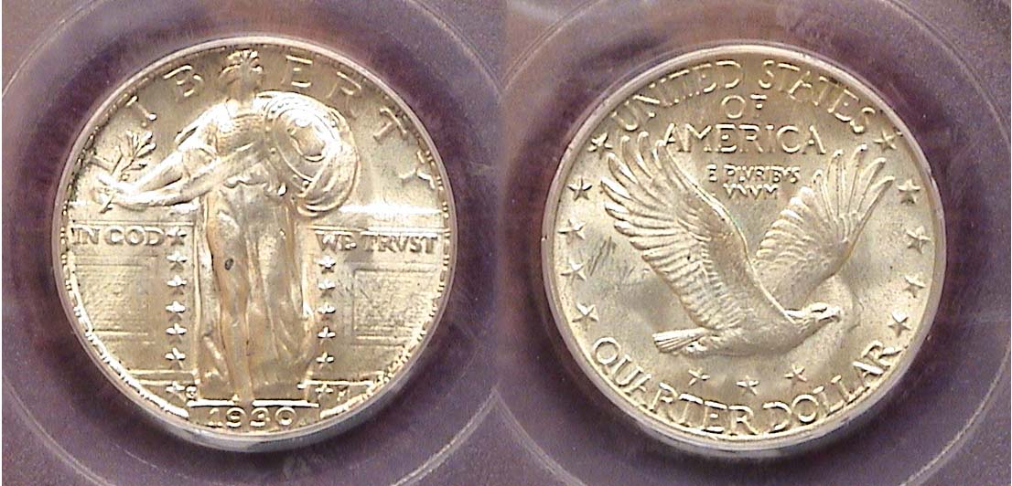

A 1930-S Standing Liberty 25¢ graded MS-64 by PCGS
The tiny mintmark appears to the right of the lower left star on the obverse.
[Use 3X glass or magnify to 500%

The 1930-S Standing Liberty quarter had a mintage of only 1.5 million but word had already gone out that a new Washington quarter was in the offering resulting in a large number of mint state specimens being put aside. As a result, the 1930-S 25¢ piece is priced the same as the P-Mint issue up through MS-63 according to the 2011 Red Book. from $35.00 in XF-40 to $235 in MS-63. Unlike the other 1930-S mint issues, the quarter comes reasonably well struck. Some however, believe this date may be underrated.

1930 in the United States

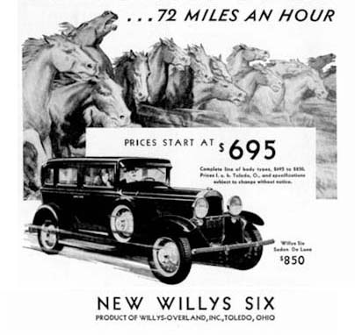
In 1930, the population of the United States reached 122,775,000. The life expectancy for a male was 58.1 years of age while a woman’s was 61.6 years. The average annual salary was $1,368 or $27.00 for a 5½-day week. Most people lived in the cities where rent for a three-room apartment averaged $18.00 a month. A five-room house cost around $3,500. The average price of a new car was $646.00. A gallon of gas cost 10¢.

Food prices were a lot cheaper than today’s. A quart of milk cost 14 cents, a loaf of bread 9 cents and a pound of beef cost 42 cents. To put things in greater perspective, a cent had the purchasing power of 13¢, a nickel, 65¢, a dime, $1.30 and a 1930 Standing Liberty quarter had the purchasing power of $3.25. The paper dollar, which had been reduced in size in 1928, could buy 13 times more goods than a $1.00 bill can today. However, when one considers the cost of a postage stamp; 3¢ as opposed to 44¢ (almost 15x greater) a 5¢ trolley, bus , El or subway ride in the larger cities, which today would cost $2.00 or 40 times more, folks may have seemed better off then.

In 1930, the cost of a movie was 15¢. Now it is around $7.00. Greta Garbo and John Barrymore Sr. were two of the major stars of the early “talkies”. Our four 1930 coins functioned a lot more efficiently than the same denominations do today.

Greta Garbo
Aiken, SC in 1930
(Continued from page 1, column 1)

The Hotel Aiken on 235 Richland Ave. W. and Laurens Streets was built in 1898 by architect Henry Hahn and completely refurbished by the Holley family in 1929 with private baths and fireproofed rooms. It has since changed ownership a number of times.

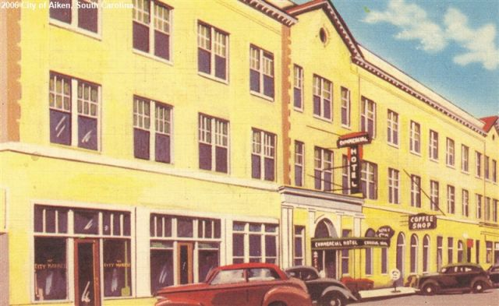

Another pic of the Aiken Hotel probably taken in the later 1930’s

In 1930, the Aiken Standard, which began publishing in 1915, changed its name to the Aiken Standard and Carolina Gazette. In 1935, it changed its name again, this time to the Aiken Standard and Review and existed as such until 1969 when it returned to using its original name, The Aiken Standard.

Club News from the May 6 Meeting

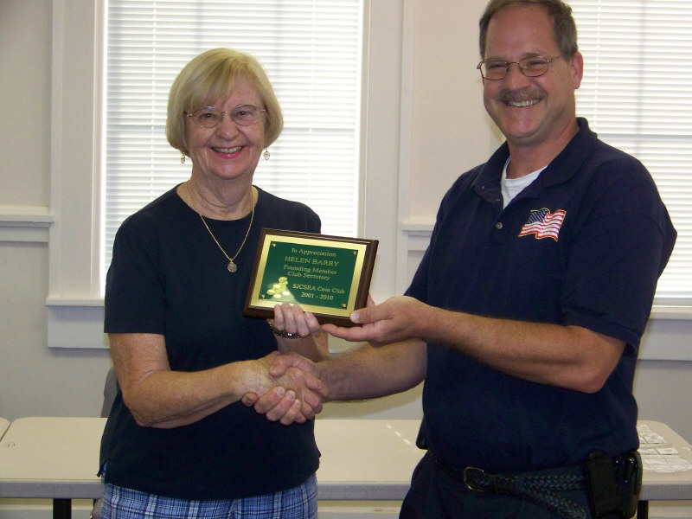

Helen Barry receiving a plaque for her 9 years service as
Club Secretary from President Steve Kuhl

At the May 6 meeting, President Kuhl presented Helen Barry with a special Appreciation plaque for her nine years of service as Secretary of our coin club. During her tenure, Helen kept everyone informed about meeting dates, the updating of the roster and general club business. With her husband Jim, she also co-chaired the arrangements for both the pre Christmas club dinners and for most of those years, the club annual Coin Show.
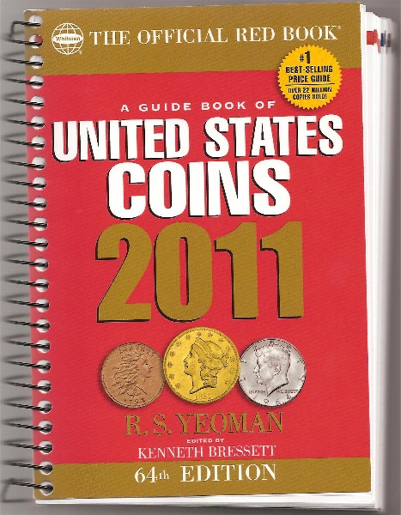
Treasurer Sharon Smoot announced that the club has purchased a case of the 2011 Red Books. The list price is $14.95 but club members can obtain a copy at the club discount price of $8.00. This is a must for every coin collector interested in US coinage.
_____________________________________________________________________________________
(More Club News continues on page 4, column 1)
More club News (Continued from previous page)

Sharon also reported the treasury balance at $862.63 and thanked member Marjorie Simons for performing the annual audit. Thank you Sharon and Marjorie.

Show & Tells Session Most Interesting

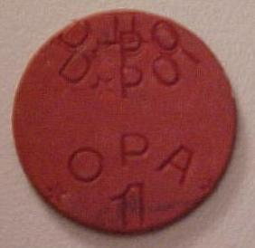

A red OPA Error token
Magnify to 200%

Red Error OPA
Magnify to 200%

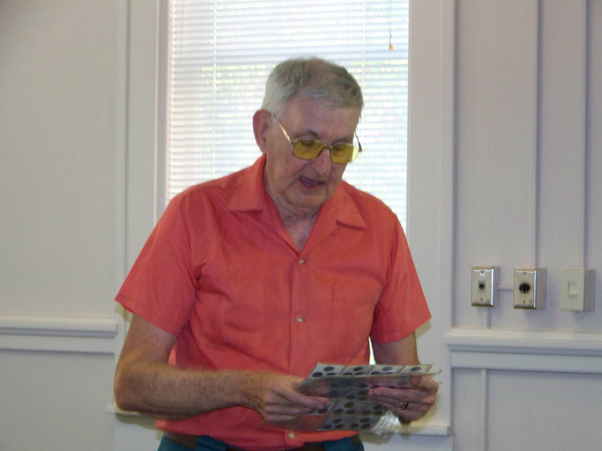
There were three Show & Tell exhibits at the May 6 meeting., each quite different from the other but all extremely interesting and well presented. Member Howard Hillman brought in sheets of Red and Blue OPA tokens used in the US during WW II . These were given in change for the rationing stamps used during that time. He explained that the red tokens were used for meat and were more common than the blue ones used as change for canned veggies and fruit.. The tokens bore letters for city, area, state and country. Tokens are collected under the umbrella of WWII memorabilia. Howard explained that as with any collectible, there are OPAs that are common, rare and some desirable error pieces Howard Hillman describing WWII OPA tokens
[Photos taken by Helen Barry]

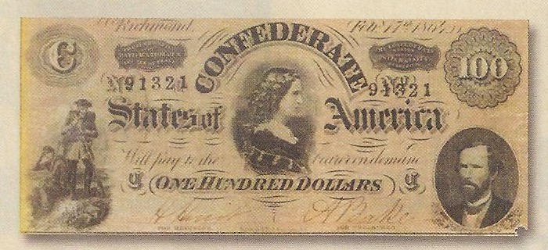

Lucy Pickens on the Confederate $100 note
Courtesy of the May 2010 issue of “The Numismatist”
[Use 3X glass or magnify to 200%]

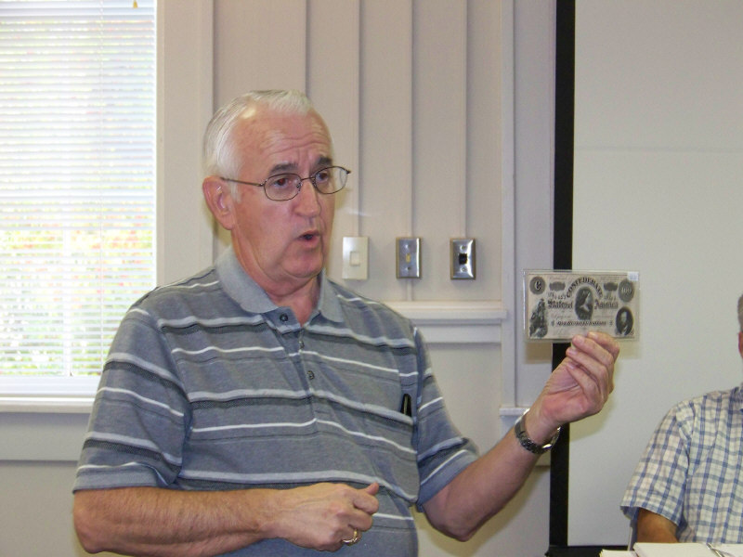
Member Glen Sanders was reading the May issue of the Numismatist (monthly journal of the ANA) and discovered an article of local interest titled, “Queen of the Confederacy”. It pictured a $100 confederate banknote similar to the one he had in his collection. Glenn’s note was actually a higher-grade specimen. The centerpiece portrays Lucy Pickens, nee Holcombe a true southern belle who after a long courtship became the wife of Francis W. Pickens in 1857, a diplomat, later General during the Civil War and Governor of South Carolina. As Governor, he often relied on her on state matters.
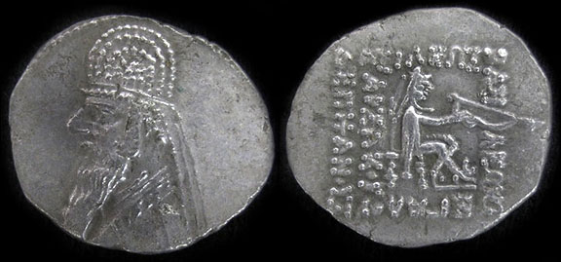

A Parthian drachm of Mithradates II (238-21)


Jim Barry brought in a Hellenistic stylized Parthian drachm portraying the Bust of Mithradates II (238-21 BC) on the obverse and Arsaces I founder of the Parthian kingdom (238-21 BC) seated with bow on the reverse.
The three Show & Tells provide yet another series of displays showing just how vast an area is generated by Numismatics.
Jim Barry describing coin

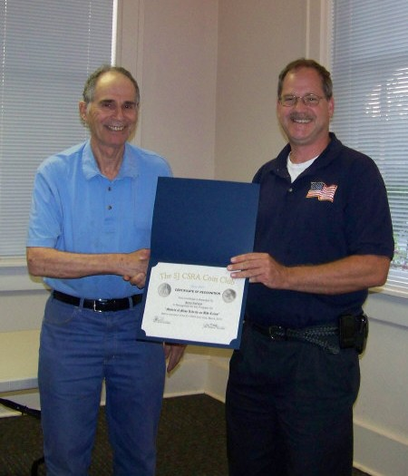
The Program: Arno Safran gave a PowerPoint presentation on the women who posed for Miss Liberty during the first 155 years the allegorical figure was represented on our nation’s circulating coinage. He related some anecdotal information on some of the actual women who have been identified but for the several other coin types in which no information is available, he suggested contemporary influences or conjecture. The woman at the left was Hettie Anderson, a South Carolina born model who moved to NYC in 1894 and posed for Augustus Saint-Gaudens in 1897 for a couple of important monuments. He later used her visage on the $10.00 and $20.00 gold coins of 1907.

At our June 3 meeting member, Walter Kublius will present a program on Banknotes of the Mexican Revolution (1910-1920). You won’t want to
miss this one! President Steve Kuhl presenting
Arno Safran with award certificate

The Prizewinners at May 6 meeting were Jim Mullaney who won the silver eagle attendance drawing. Glenn Sanders won the 50/50 - $21.00. Congratulations gentlemen!
______________________________________________________________________________________________________________

Grade-A-Coin PP Program Proposed for July 1 meeting

At the moment, the program schedule for the main summer months is open, so for the July 1 meeting, let us hold another “grading bee” with a slight twist. This time we will present a special PowerPoint program, called “Grade-a coin”. It will feature a large number of certified US type coins with the grades hidden. Before the presentation, members will receive a listing each coin’s date and denomination. As the slides appear they will grade each coin. After the program we will find out how close the graders came to the actual certified grade.
SJ CSRA CC members attend Augusta Coin Club Show

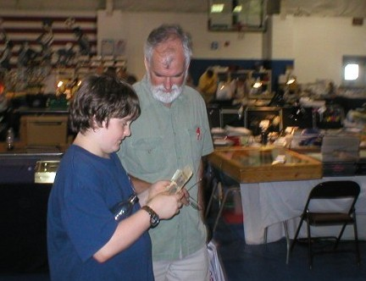

YN Austin Kuhl shows Jim Mullaney his latest acquisition at ACC Show

On May 7 & 8, the Augusta Coin Club held its spring Coin Show at a new site, Patriot’s Park located in Columbia County, GA. Despite the distance, several of our stalwart members were in attendance including our President Steve Kuhl along with his son Austin and the entire SJ CSRA CC Board. Also attending were Jim & Helen Barry, Howard & Sonia Hillman, Doug Moody, Walter Kublius, Dick Smoot and new members Rick Owen and Todd Starbuck. Over forty tables were sold yet overall attendance was spotty. Friday was disappointing and while traffic improved on Saturday morning, with many members of both area clubs browsing the bourse, most dealers surveyed said their sales were down from previous years.

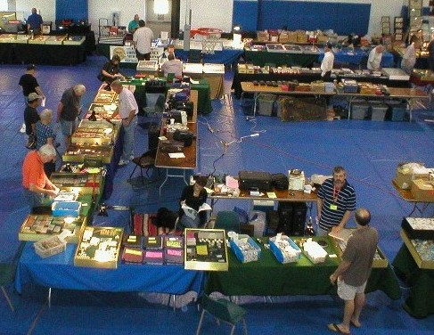

The Augusta coin Club Show
[Use 3X glass or magnify to 200%]

One could attribute the new location or its distance from the population centers of the Central Savannah River Area as the major cause for the low public turnout but during the past two months a number of coin shows across the nation have also experienced a fall off in attendance compared to previous years and the reason given appears to be the uncertain economy.

For those fellow members who were able to attend, if you acquired something at the show why not share your new acquisition with your fellow members at our Show & Tell session during the upcoming June 3 meeting.
_____________________________________________________________________________________________________________________

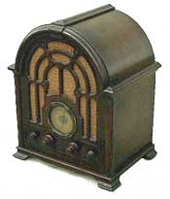
Parting Shot: A 1930 Radio

Kindly Patronize our Advertisers

