Pres. Steve Kuhl
V .P. Pat James
Sec. Jim Mullaney
Treas. Sharon Smoot
Sgt. in Arms: Glenn Sanders
The Stephen James
CSRA Coin Club of Aiken
P.O. Box 11
New Ellenton, SC 29809
Web site: www.sjcsracc.org
The SJ CSRA CC of Aiken, SC meets on the 1st Thursday of the month at the Aiken Public Library

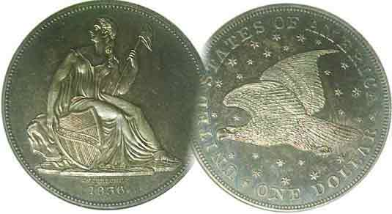
Programs: Pat James
Show: by Committee
ANA Representative: Jim Barry
Publicity: Jim Clapp
Newsletter: Arno Safran
E-Mail: arnosafran@comcast.net
Auctioneer: Glenn Sanders
Web site: Susie Nulty (see above.)

2011 Club Meeting Schedule
Volume 10, Number 6 the Stephen James CSRA Coin Club, Founded in 2001 June, 2011
Monthly Newsletter
Tony Chibbaro to present talk on Aiken tokens
Our next meeting is on Thursday, June 2, 2011 from 6:45 to 8:45 PM

Jan. 6 Apr. 7 July 7 Oct. 6
Feb. 3 May 5 Aug. 4 Nov. 3
Mar. 3 Jun. 2 Sep. 1 Dec. 1

____________________________________________________________________________________________________________

Aiken, SC History through tokens,
Subject of June 2 program

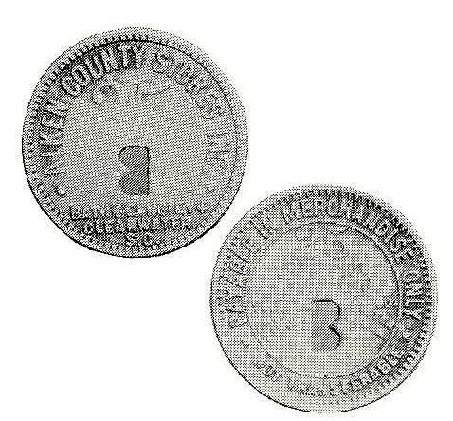
A Bath, Langley, Clearwater token issued for Aiken County Stores
Good for 25 cents of merchandise
[Courtesy “South Carolina Tokens” by Tony Chibbaro
published by Tams (Token and Medal Society) 1990]

At our upcoming meeting noted SC numismatist and author Tony Chibbaro will give a presentation on “The tokens of Aiken and Vicinity”. Back in November, 2001 our featured speaker for that night was Tony who presented a slide program on “The tokens of South Carolina”. To a recent arrival in the CSRA, Chibbaro’s program opened a portal into South Carolina’s mercantile history, recalling the shops, mills, villages and towns of both urban and rural SC. At the end of the program the speaker had with him copies of his recently published book on the subject and I decided to buy one. I was not disappointed by my acquisition for this was one of the best volumes on a state’s tokens that I had ever read. My experience collecting tokens had been pretty much confined to the US Hard Times tokens series (1832-1844). These mostly large-cent size copper pieces, roughly 27 to 29 mm in diameter were struck by private parties who either wanted to make a political statement or as advertisements (AKA “Store Cards”) The tokens of Aiken and vicinity should be of interest to all SJ CSRA CC members.
___________________________________________________________________________________________________________________________

The Coins of the Central American Republic
By Arno Safran

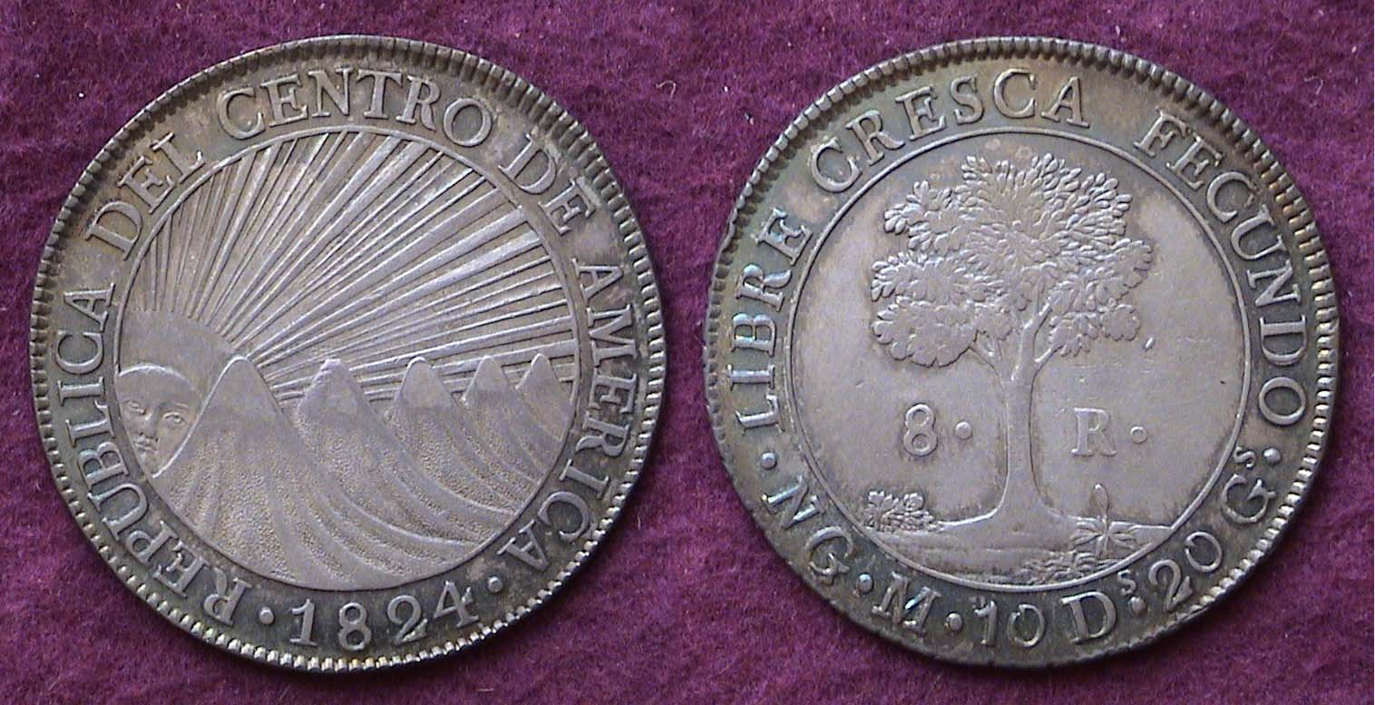

An 1824 8 Reales silver coin of the Republic of Central America
Struck at the New Guatemala Mint (Guatemala City today)
[Use 3X glass or magnify 200% to see details.]

In 1821, towards the end of the War of Independence between Mexico and Spain, The Commission known as the Captaincy General that governed the five provinces of Central America declared the region free of Spanish rule. The countries involved were Guatemala, Honduras, El Salvador, Nicaragua and Costa Rica. (Panama had also declared its independence from Spain in 1821 but chose to be confederated with Colombia and remained part of the South American continent until 1903.) During Iturbide’s short two-year reign as Emperor Augustin I of Mexico, he sent an army to invade El Salvador, because unlike the other four countries, El Salvador decided to join the USA instead of Mexico. No sooner was El Salvador overrun when Iturbide was ousted leaving the five Central American countries to decide for themselves how they wanted to form a government. On July 1, 1823, The Assembly established the Central American Republic and began issuing coinage the following year. Ten denominations were authorized, five to be struck in .903 fine silver, the ¼ Real, ½ Real, 2 Reales and 8 Reales. The obverse featured the sun with extended rays rising behind five volcanoes, each mountain emblematic of one of the five countries. The reverse featured a Ceiba tree in full bloom representing freedom. Five denominations were also struck in .875 fine gold; the ½ Escudo, 1E, 2E, 4E and 8 Escudos. The obverse was modified showing the sun and its rays shining directly overhead.
----___________________________________________________________________________________________________________________
(Continued on page 2, column 1)
The Coins of the Central American Republic
(Continued from page 1, column 2)

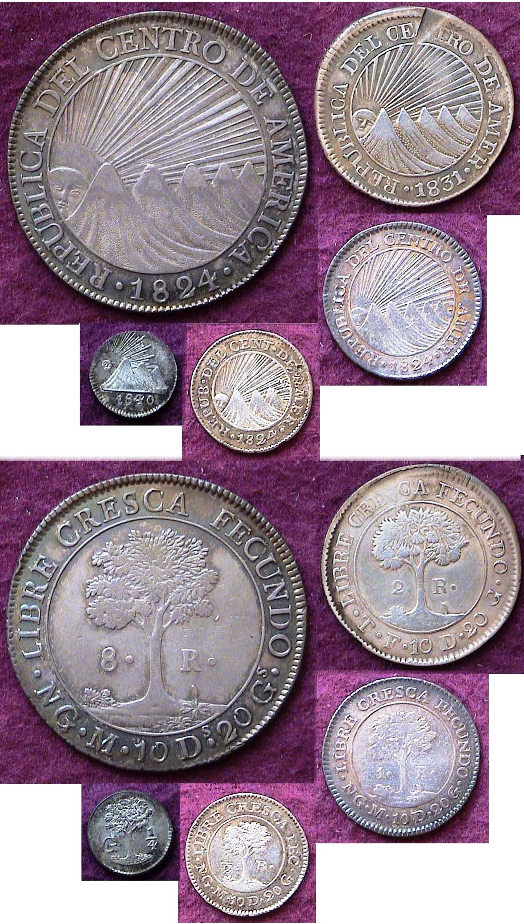

Actual sizes of C.A.R. coinage with obverses above reverses
seen clockwise from the 8 Reales down to the ¼ Real
1824 8R, 1831 2R, 1824 1R, 1824 1/2 R and the tiny 1840 1/4R [Use 3X glass or magnify page to 200% to view details.]

Pictured above are the five silver coins that were struck by the Central American Republic. The dollar-sized 8 Reales was essentially used as specie to back larger business transaction (much as our early Bust half dollars) and was coined on a regular basis in fairly large numbers. Due to its size (ca. 38 to 39 mm in diameter) the C.A. R. 8 Reales is likely to be the first C.A.R. coin in the series to attract a collector’s attention. Ironically, its $1.00 value was well beyond what most native Central Americans could afford to possess at the time these cartwheel silver pieces were issued. Containing .903 fine silver, the coin was accepted as legal tender in the US until 1857. The minor silver coinage--when it was struck at all--circulated heavily among the general population and specimens are far less common today, especially in grades above Fine-12.

Of the five silver pieces only the ¼ Real, with a diameter of roughly 12 mm, had a different obverse design altered to fit its tiny area. One mountain peak appears on the obverse. It’s value was 3 & 1/8 cents on the dollar at the time is was placed into circulation. The ½ Real was close to the size of our silver half dime. It was 15 mm in diameter and had a value of 6 & ¼ cents. Despite being minted a number of years it seldom surfaces. Certified Unc specimens are worth at over $250 today. The 1 Real, valued at 12 & ½ cents when issued, was slightly larger than our dime at around 19 mm in diameter. It was struck in six different years, (1824, 25, ’30, ’31, ’48 & 1849, but only the 1824 date surfaces with any regularity. The quarter-size 2 Reales (valued at 25 cents at the time of issue) was struck mostly at the Tegucigalpa Mint in Honduras in 1825, 1831 and 1832. An 1849 2 Reales was minted in Costa Rica long after the Central American Republic dissolved and is seldom seen. The only date that one is likely to encounter is the 1831T. Most survivors of even this date grade AG to Fine-12. The VF example shown is the highest-grade specimen the author has seen and it contains a serious planchet flaw at 12:00.

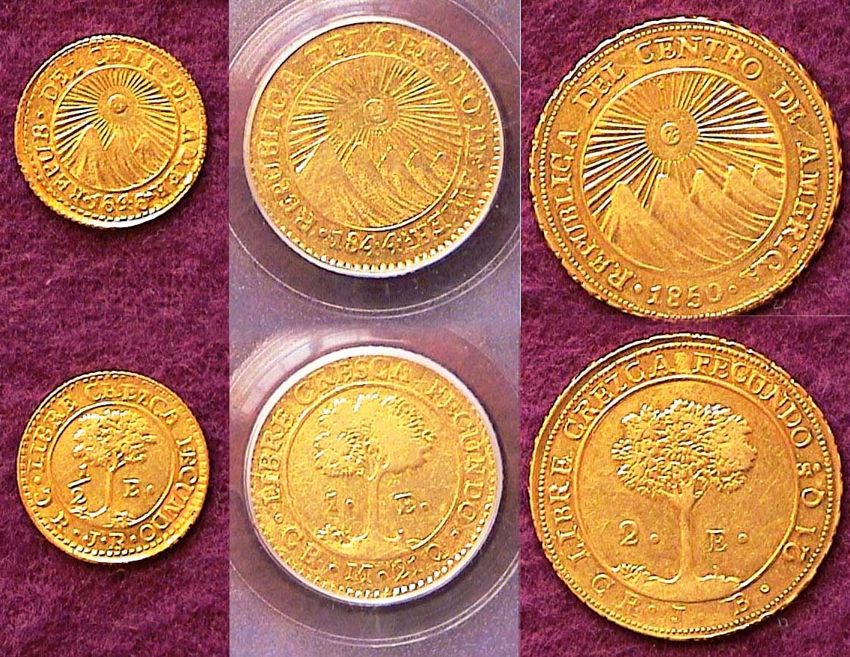

Approximate sizes of C.A.R. 1848 ½ E, 1844 1 E & 1850 2 Escudos
[Use 3X glass or magnify page to 200% to view details.]

While assembling this partial set of C.A.R. pieces between 1997 and 1999 I found the lower denomination gold coins to be not only accessible but surprisingly inexpensive. During the late 1990’s the price of gold per ounce had dropped from around $369 to $255.00. One merely had to pay a numismatic value price for the minor gold coins based on demand in addition to the gold value at the time of purchase which by today’s levels wasn’t very much. Common date foreign gold coins didn’t become relatively expensive until one was seeking the higher gold denominations such as the 4 and 8 Escudos among the Latin American gold types. These were always in demand; the 8 Escudos because it was a large, although not especially scarce gold coin about the size of our Saint-Gaudens $20.00 Double eagle, and the 4 Escudos because it was generally a low mintage issue and the scarcest of all the gold denominations. Even back in the late 1990’s I knew the 4 and 8 Escudos denominations were beyond my discretionary income but being able to assemble eight out of the ten issues from this important region of the western hemisphere was in itself a source of satisfaction.

What became of the Central American Republic? After centuries of Spanish Rule each country had different ideas on how to develop their concept of democracy. The union between these five nations never went beyond the stage of our own Articles of Confederation.. By 1838, the Central American Republic was dissolved, each country going its separate ways. Honduras would continue to use the Ceiba tree on its coins in and Nicaragua would eventually restore the Sun rising behind the mountains to its coinage beginning in 1912. Today many a collector will seek one example of the C.A.R. 8 Reales.
__________________________________________________________________________________________________________________________

It Pays to Know Your Coins
By Bill Myers

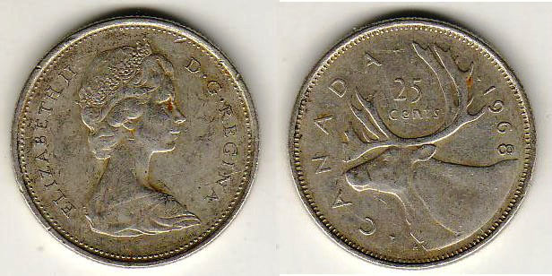

A 1960 silver Canadian Quarter
[Use 3X glass or magnify page to 200% to view details.]

I recently was sent by the Army to Fort Knox, KY for a mission. Of course “Fort Knox” brings up images of gold bars. My mission had nothing to do with that but I did pass by the Fort Knox Depository a few times as it is just inside the Chaffee Gate. It is a two story building up on a hill surrounded by a series of fences. I have no doubt I could not see the true depth of the security.

The reason for this article is to describe a small numismatic find. I had some free time and decided to search out some local coin shops. I found 3 shops in Louisville, KY and only one had any world coins, which is what I was looking for. Those I found consisted of a small box of coins in 2x2s and a small plastic container of world coins marked 25 cents each. I managed to find 8 coins in the junk box that I thought were worth 2 dollars to me. One of the coins was a 1968 quarter from Canada. If I got a 1968 US quarter in change today it would be spent as I know all US quarters are composed of copper-nickel as of 1965. That is not true of Canada. According to the Standard Catalog of World Coins 1901-2000 from 1920 to 1967 quarters in Canada were composed of 0.800 fine silver. In 1968 the composition was changed to 0.5000 silver but Canada also started minting quarters composed of nickel that year . Now I had to determine which I had. The quarter looked and felt like it had silver in it. The true test is to weigh the coin. The silver coin weighs 5.8319 gm and the nickel coin weighs 5.0600 gm. The coin I bought was indeed composed of silver. It is also a one year type as it is the only Canadian quarter composed of 0.500 fine silver.

The silver content of the coin is 0.0937 oz ASW. The price of silver has been very volatile but at $35 an ounce the coin has $3.28 of silver in it. I certainly cannot buy much with the profit but it was a nice find. It was not all luck that I found the coin. I knew that Canada had minted silver coins in 1968 and I recognized the look of a silver coin. This is not the first silver coin I have plucked from a junk box and hopefully not the last. It does pay to know your coins.
___________________________________________________________________________________________________________________________

Thanks Bill for another interesting article reflecting “Knowledge is power”, ED.
_________________________________________________________________________________________________________________________

The Editor welcomes articles by fellow members and other readers of this newsletter. Please E-mail to arnosafran@comcast.net.

_______________________________________________________________________________________________________________________

Club News: Minutes of the May 5 Meeting

President, Steve Kuhl, called the regular meeting of the club to order at 6:45 p.m.
Glenn Sanders reported that there were 20 members present (20 adults, 0 junior). There were two visitors; Sonia Hillman and Wayne Damron. As 15 regular members are needed to conduct the business of the club a quorum for the meeting was met.
Glenn announced that upcoming coin shows in the area included the Midlands Coin Show this Saturday in Columbia, a 2-day show at Augusta next weekend, Camden Coin Show on the 21st, and Anderson SC June 3-4.
Pat James won the door prize.
A motion was made by Pat James, seconded by Paul Simons, and passed to dispense with the reading of the April 2011 minutes of the April 7 meeting.
The treasurer’s report was read. The balance as of 4/30/11 was $1733.26.
The program in June will be “Tokens of Aiken County and Vicinity”, by Tony Chibbaro.
Glenn Sanders will be doing the annual audit of the club accounts.
A poll of club members presented showed that at least two members were interested in getting the 2012 Red Book through the club.
Jim Barry informed the club about the upcoming election for ANA officers. The two candidates were discussed, including their previous contributions to the ANA. The consensus of the members present concurred with Jim’s recommendation to support Walter Ostromecki.
Arno Safran presented a Show & Tell on a set of replicas of early American type coins from 1796 struck by the Gallery Mint between 1996 and 1998. Jim Barry discussed the recent withdrawal of an Athenian decadrachm from the Chicago International Coin Fair auction April 14 because of questions on authenticity. The coin had been on the cover of the catalog and was valued at about $850,000. Jim shared a replica of a similar coin with the club. Chuck Braun had a Show & Tell on a 4-dirham coin from Afghanistan that was about 1000 years old.
The program was “Collecting Key Date Coins” by Wayne Damron.
Jack Schulz won the 50/50.

Respectfully submitted,

Jim Mullaney, Secretary
__________________________________________________________________________________________________________________________

Wayne Damron’s Program

Wayne Damron, proprietor of Clein’s Rare Coins in Augusta
and a numismatist of long standing as a collector of Ancient coins was our guest speaker at the May 5 meeting. His topic for the evening was on “The Case for Collecting Key Dates”. Wayne gave everyone a sheet of paper listing the most popular key date United States coins such as the 1909-S VDB Lincoln cent, the 1916-D Mercury dime, the 1901-S, Barber Quarter and the 1921 Walking Liberty Half dollar et al. Instead of using the higher grades such as XF-45 to MS-65, Wayne selected the grades of VG to Fine, grades that most US type collectors can afford to show the marked increases in value US key date coins have enjoyed from 1963 to 2008, the last peak in the coin market. In almost every case with few exceptions, if one purchased one of these keys back in 1963, they would have realized a profit well in excess over the common date coins acquired in the same grade kept over the half century had they sold any of these keys in 2008.

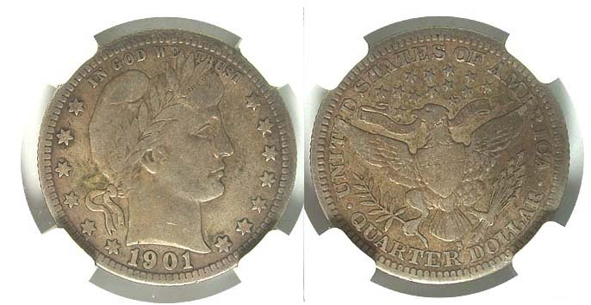
A 1901-S Barber Quarter graded Fine-15 by PCGS
[Use 3X glass or magnify page to 200% to view details.]
This coin appeared on a dealer’s recent price list for $20,875.
In the 1963 Red Book it was listed in the sane grade for $475.
Case closed!, ED.

The club thanks Wayne for taking the time out of his busy schedule to share his expertise with members of the SJ CSRA CC.
_____________________________________________________________________________________________________________________

Inexpensive Coin of the Month

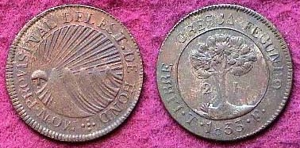

An 1833 2 Reales from Honduras, KM-19
Considered a contemporary silver washed counterfeit

Above is an example of a quarter-size 2 Reales coin from Honduras. It displays the same design as the Central American Republic coinage that it appears on the scarcest of the five silver denominations except for its coppery tone. According the Krause Publications’ Standard Catalogue of World 19th Century Coins, this piece described as silver washed copper may have been a contemporary counterfeit. In some instances such coins are valued as much as the real ones and this is one such example. For one thing, it is not as crude as many counterfeits appear and for another, it circulated freely during the 1830’s in the country of origin. A 2 Reales piece had the equivalent value of 25 cents which had a great deal of purchasing power in Honduras during the first third of the 19th century. As a collectible, this coin is not expensive, retailing for around $25.00. It surfaces more frequently than the genuine .903 fine silver issues, usually in higher grades and has a pleasing appearance. If you are seeking an example of the beautiful Central American Republic design type, this specimen would be a relatively inexpensive choice if you can find one. Happy hunting!
___________________________________________________________________________________________________________________________

Our Next Meeting is Thursday, June 2. For Show & Tell, please bring in a numismatic item or set, or a token from your local area to show our guest speaker Tony Chibbaro whose topic will be “The Tokens of Aiken County and Vicinity”
______________________________________________________________________________________________________________________________

Please Patronize Our Dealer Advertisers
