Pres. Steve Kuhl
V .P. Pat James
Sec. Jim Mullaney
Treas. None!
Sgt. in Arms: Glenn Sanders
The Stephen James
CSRA Coin Club of Aiken
P.O. Box 11
New Ellenton, SC 29809
Web site: www.sjcsracc.org
The SJ CSRA CC of Aiken, SC meets on the 1st Thursday of the month at the Aiken Public Library

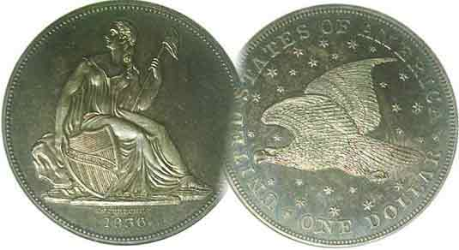
Programs: Pat James
Show: by Committee
ANA Representative: Jim Barry
Publicity: None!
Newsletter: Arno Safran
E-Mail: arnosafran@comcast.net
Auctioneer: Glenn Sanders
Web site: Susie Nulty (see above.)

2012 Club Meeting Schedule
Volume 11, Number 6 the Stephen James CSRA Coin Club, Founded in 2001 June, 2012
Monthly Newsletter
Our Club Needs More Active Participants
Our next meeting is on Thursday, June 7, 2012 at the Aiken Public Library

Jan. 5 Apr. 5 July 5 Oct. 4
Feb. 2 May 3 Aug. 2 Nov. 1
Mar. 1 Jun. 7 Sep. 6 Dec. 6

______________________________________________________________________________________________________

After a decade, has apathy taken over Our Club?
-An Editorial-

The Newsletter, now is well into its eleventh year of publication, features a masthead that is incomplete for the first time since the Club was founded. Under the Officers’ column at upper left, there is no Treasurer listed and under the Committees at right, no name appears alongside Publicity. A couple of years ago the Executive Board had the devil of a time trying to get a member to volunteer to do an annual audit. A club can be run without a President because there is a VP to take over in case the President becomes indisposed but it cannot be maintained without a Treasurer. With no one to handle the publicity, our meetings and future shows will go unnoticed. Fortunately, VP Pat James has taken care of it for June.

Last month, the editor published a feature in the upcoming Augusta Coin Club Show right on the front page. With a roster of around 40, it was disheartening to see less than 10 SJ CSRA CC members turn out to attend the event. Our Club needs more members to be more actively engaged otherwise it will cease to exist. The various members who founded the club back in 2001 were dedicated to its operation but they could not be expected to continue managing the club’s affairs in perpetuity.

An organization is only as productive as its overall membership. During its eleven years the club roster has ranged between 40 and 50 members a year yet only 14 different persons have served in key roles. Popular meeting activities have included the Educational Programs, also the Show & Tell (with a number of members participating in both categories) and the monthly auction which Glenn Sanders runs with such skill and good humor. It was due to the dedication of its members that the SCNA once awarded the SJ CSRA CC “South Carolina Club of the Year”. Now it’s time for others to begin contributing.
_________________________________________________________________________________________________________
Collecting the US Coinage of 1932: 80 Years Ago
By Arno Safran
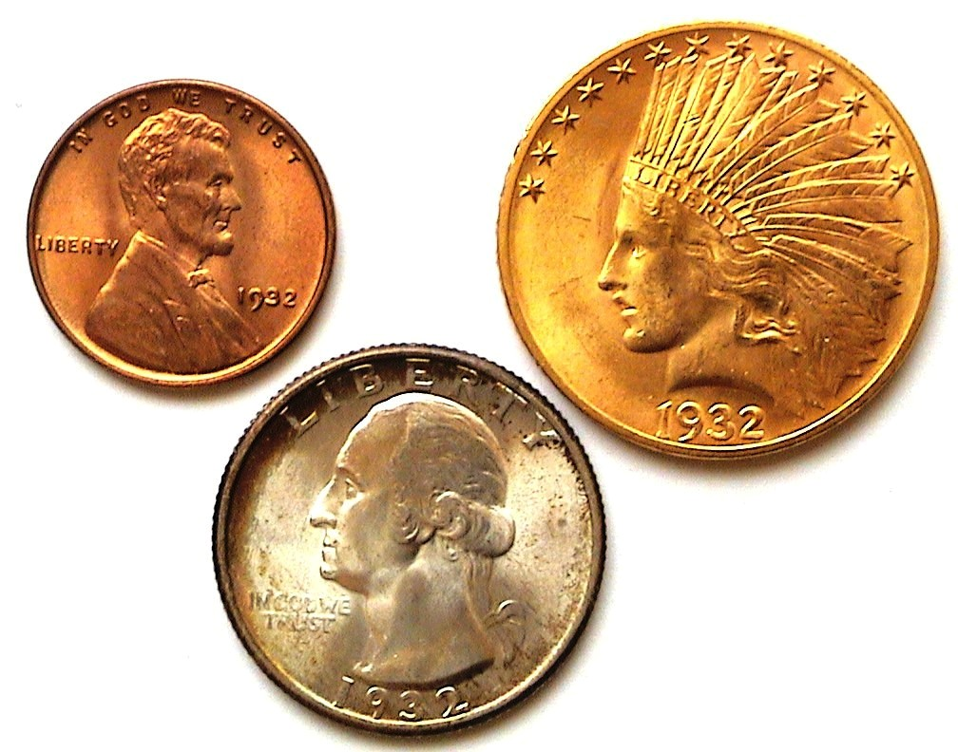

The Obverses of a collectible 1932 Year Set
The Lincoln Wheat cent, Washington quarter
and $10.00 Indian Head Eagle gold coin
[Use 3x magnifying glass or magnify to 200% to view details.]

In 1932, America along with the rest of the world was in the midst of the Great Depression. Since the stock market crash in October of 1929, the Depression had steadily deepened with the result that by 1932 25% of our labor force was unemployed. As a matter of principle President Hoover had resisted providing major federal assistance programs either to the unemployed or to get businesses moving again. The Depression deepened further. In the November, 1932 election, Franklin Delano Roosevelt defeated President Herbert Hoover by more than 7 million votes, then considered a landslide victory based on the voting population at the time.

The deepening Depression seriously affected our coinage program. Mintages dropped across the board with some denominations not being struck at all. The Peace dollar, last coined in 1928 would not be resumed until 1934. No Walking Liberty half-dollars were struck in 1930, 1931 or 1932. As 1930 began, not many persons realized that the Standing Liberty quarter would be terminated after that year. No quarters were struck in 1931; just the Lincoln cent, Indian Head Buffalo nickel and Mercury dime band in small numbers. The last $2.50 and $5.00 gold coins were struck in 1929, the $10.00 Indian in 1930.
___________________________________________________________________________________________________________________________
(Continued on page 2, column 1)
Collecting the US Coins of 1932: 80 Years Ago
(Continued from page 1, column 2)

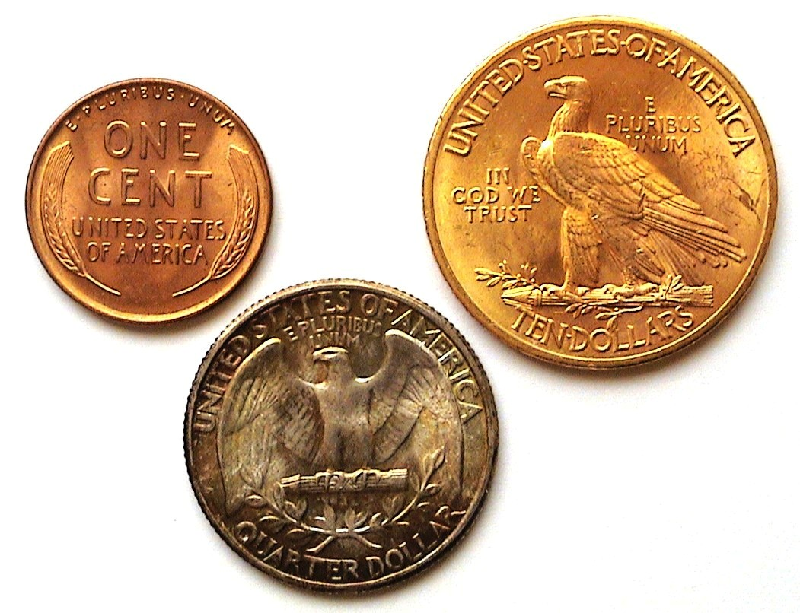
The reverses of our collectible 1932 dated coinage
[Use 3x magnifying glass or magnify to 200% to view details.]

Despite a reported mintage of over 1.1 million for the 1932 $20.00 Saint-Gaudens double eagle, most were melted and the small number of specimens that have survived bring huge prices at auction and are today deemed uncollectible for most.

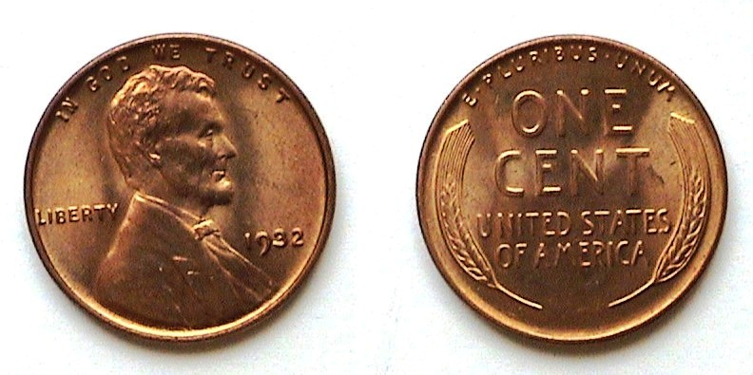
A 1932 Lincoln Wheat back cent graded MS-64 by ICG
[Use 3x magnifying glass or magnify to 200% to view details.]

In 1932, just over 9 million Lincoln cents were struck at the Philadelphia Mint while 10.5 million were produced at the Denver Mint. None was coined at the San Francisco facility. Compared with well over with 200 million cents struck at all three Mints in 1930 this was a huge drop in production. In MS-63, the 1932-P & D cents are listed at $28.00 retail in the 2013 Red Book. By contrast, a MS-65 specimen will bring anywhere from $150 t $175 if full red according to Numismatic News’s monthly Coin Market supplement. Full red Lincolns from the Depression era years are becoming more difficult to find. In 1932, a cent had the purchasing power of 16¢.

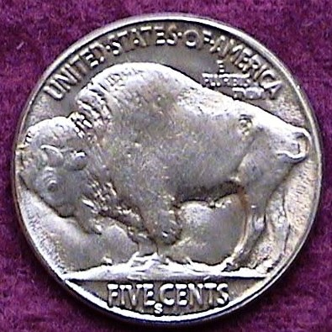
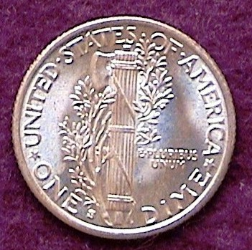
Here is a trivia question for all you collectors out there. Without looking it up, which were the only years 5¢ nickels were not coined since its initial year, 1866? The nickel was the workhorse of our economy going back to the 1870s. In 1932, a nickel had the purchasing power of 80¢. A dime had the purchasing power of $1.60. Now, let us get back to our Trivia Question: No nickels were coined in 1922, 1932 and 1933. Likewise, the dime, as none were issued in those same years as well. There were more than enough nickels and dimes to go around and the government needed to cut mint production costs. For nickels and dimes not to be issued in consecutive years had to mean the economy was in pretty bad shape and indeed it was. When FDR took the oath of Office on March 4, 1933, almost 3½ years after the Crash of 1929, the Depression was at its deepest.

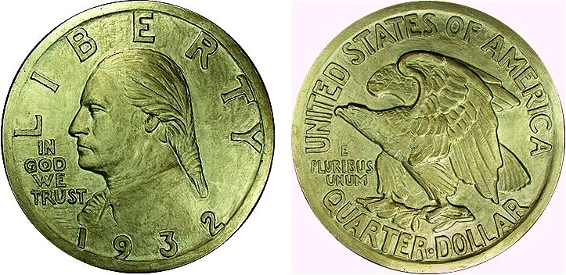

Laura Gardin Fraser’s design for the 1932-P Washington Quarter
[Use 3x magnifying glass or magnify to 200% to view details.]

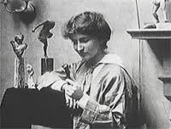
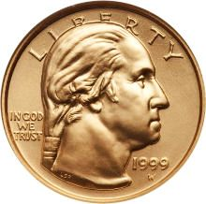
With the 200th birthday of George Washington’s coming up in 1932, the Government decided to honor our first President’s bicentennial year by issuing a new quarter. A contest was held in 1931 and Laura Gardin Fraser who had created the magnificent 1926-39 Oregon Trail commemorative half dollar-- also the wife of James Earle Fraser, the designer of the Indian Head Buffalo nickel-- won the honor going away. Unfortunately, the US Treasurer at the time was Andrew Mellon, now serving under his third President going back to Warren G. Harding’s administration. Mellon who was unscathed by the famous Teapot dome scandal, preferred John Flannigan’s concept for the Washington quarter and twice overruled the Commission on Fine Arts choice of Laura Fraser’s design. The Treasurer’s decision was final in such matters, so… what could have become one of our more outstanding 20th century coin design types languishes in mediocrity Many numismatists are of the opinion that Mellon’s alleged male chauvinist tendencies biased his decision. In 1999, Laura Fraser’s original quarter design, facing right, would appear on the obverse of the $5.00 gold coin commemorating the bicentennial of George Washington’s death.
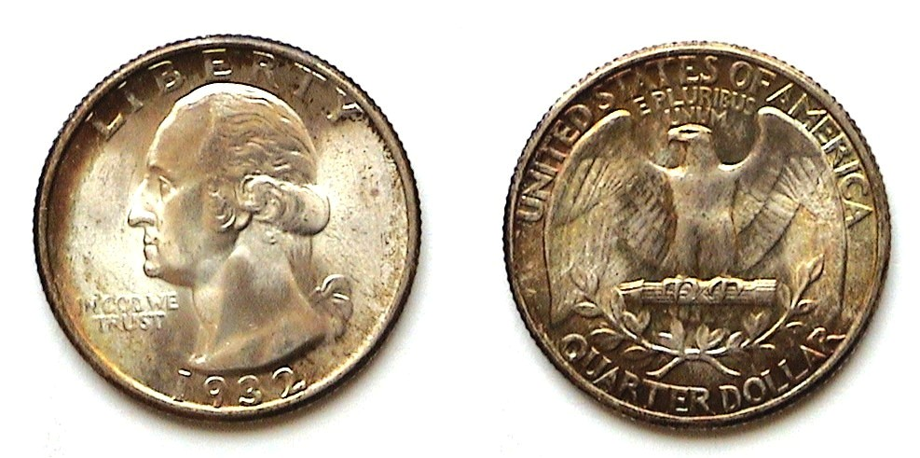
A 1932-P Washington Quarter grading MS-64
[Use 3x magnifying glass or magnify to 200% to view details.]

The 1932 Washington Quarter was issued at all three US Mints then in operation, Philadelphia (no mintmark), Denver, (D) and San Francisco (S). The mintmarks were placed below the eagle under the ribbon on the reverse. While over 5 million were coined at the Philadelphia Mint, only 436,800 were struck at the Denver Mint and even less at the San Francisco facility, just 408,000. Due to the Depression, fewer mint state 32-D quarters were put aside than the 32-S issue accounting for the greater price differential between them. According to the 2013 Red Book in MS-63, the 32-P is listed at $50 with the 32-S at $1,200. The much scarcer 1932-D is priced at a whopping $2,100.
______________________________________________________________________________________________________________________________
(Continued on page 3, column 1)
Collecting the US Coins of 1932: 80 Years Ago
(Continued from the previous page)

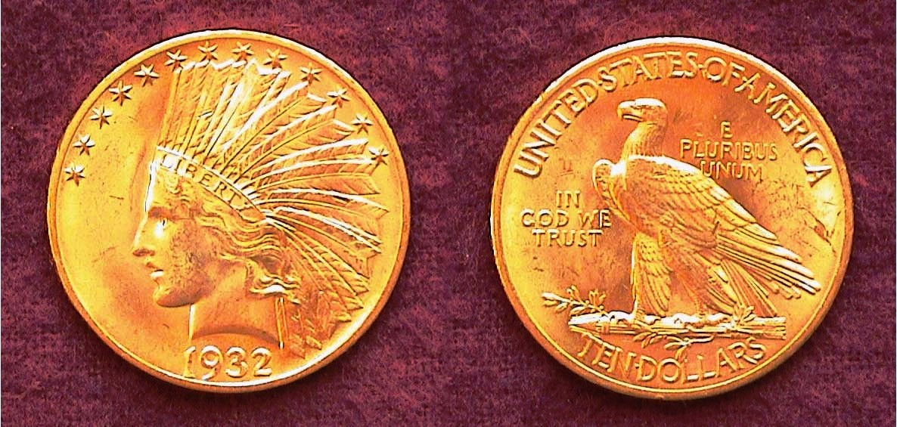

A 1932-P Indian $10.00 Gold Eagle graded MS-64 by ICG
The coin was struck in .900 fine gold, 100 copper was 27 mm in diameter and weighed .48375 ounces
[Use 3x magnifying glass or magnify to 200% to view details.]

The 1932 $10.00 Gold Eagle is special for a number of reasons. It was one of the two magnificent design types created by Augustus Saint-Gaudens in 1907. With a mintage of 4,463,000 the 1932 issue is by far the most common date of the series; this despite being struck during the depths of the Great Depression. The other two most often seen dates of the series are the 1926 with just over 1 million coined and the 1910-D with the second highest mintage of 2,356,640. The 1932 piece is also a well-struck coin that usually appears lustrous. Finally, as obsolete US $10.00 gold type coins go, this date is by far the most common specimen for the entire history of the $10.00 gold eagle denomination.

Because of this data, a hobbyist wishing to acquire one $10,00 gold coin for his/or her collection, should find the 1932 $10 Indian to be reasonably priced. An MS-63 specimen is listed in the 2013 Red book at $1,500 but with gold having dropped somewhat from its high of almost $1,800 an ounce over the past several months one should be able to acquire a certified MS-63 of the 1932 $10.00 gold piece for around $1.050 according to the latest Heritage Auction Archives listings. AU-58s should be priced at under $1,000 in today’s market. For a collector still troubled by the suggested four figures retail price, consider the current value of the gold in a 1932 $10,00 coin, around $700 based on gold priced at $1,550 an ounce as this is being written. Looked at in these terms, a 1932 $10.00 grading MS-63 would cost a buyer around $350 over melt. And speaking of the $300’s, a $10.00 gold coin had the purchasing power of $320 in 1932.
______________________________________________________________________________________________________________________

The Presidential Election Results of 1932

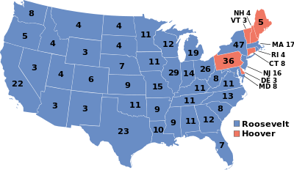
Club News

President Steve Kuhl called the meeting to order at 6:48 PM. Sgt. In Arms Glenn Sanders announced that there were 19 members and 5 guests present. He then presented a list of upcoming coin shows for the month of May. Thank you, Glenn. A reading of the Minutes of the April Meeting prepared by Recording Secretary Jim Mullaney was waived, a copy to be placed on file. President Kuhl reported that our newly elected Treasurer John Meinhardt notified him that he would be unable to serve on that post due to health issues. We wish John well! Sharon Smoot graciously volunteered to continue as Treasurer in the interim and reported the club balance at $1,696.98. Thank you, Sharon. President Kuhl thanked Roger Worpel for performing the annual club audit. After a three-year stint of doing the publicity for our club, Jim Clapp informed President Kuhl that he was stepping down. Clapp received both praise from Steve and applause from the members for his excellent handling of the publicity during that period. President Kuhl then asked if anyone among the members present were willing to take on the two open positions. Since none was immediately forthcoming, VP Pat James and the original Treasurer of the club said she would be happy do serve again in that post if someone would volunteer to serve as VP and Program Chair. This too was met by silence. President Kuhl asked the members to consider serving and moved on to other business.

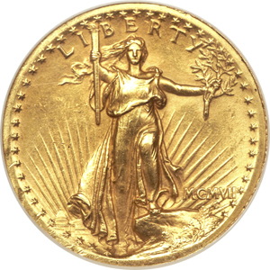
President Kuhl asked for Show & Tells and four members came forward. Rick Owen displayed the rare 1995-W (for West Point , NY Mint) silver eagle graded PF-68 by PCGS. He then related how he came to win the 2012 Grand Prize of a 1907 Roman Numeral $20.00 Saint-Gaudens Double Eagle sponsored by Heritage. He displayed the wonder coin via his Smartphone because during the interim, he sold it for $13,000 at a Show in Atlanta. as he does not collect gold coins. Congratulations just the same, Rick! 1907 $20.00 Saint-Gaudens

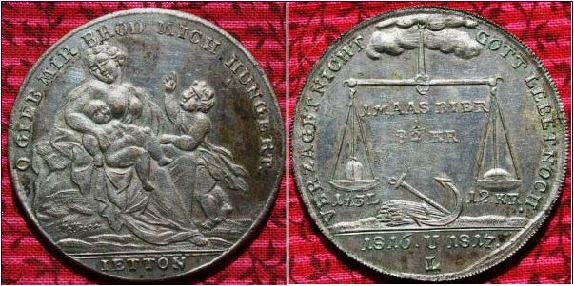

The 1816-1817 dated German Famine Jetton
Struck in Brass, silver-plated, 33 mm weighing 12.8 grams
Shown actual size
[Use a 3x magnifying glass or magnify page to 200% to view details.]

Jim Barry brought in a German Famine Jetton dated 1816-1817 commemorating the widespread famine that occurred throughout Europe in 1816 and 1817, a result of the eruption of Mt. Tambora in 1815. 1816 came to be known as “the year without summer”.
_________________________________________________________________________________________________________________________
(Continued on page 4, column 1)
Club News & Show & Tells
(Continued from previous page)

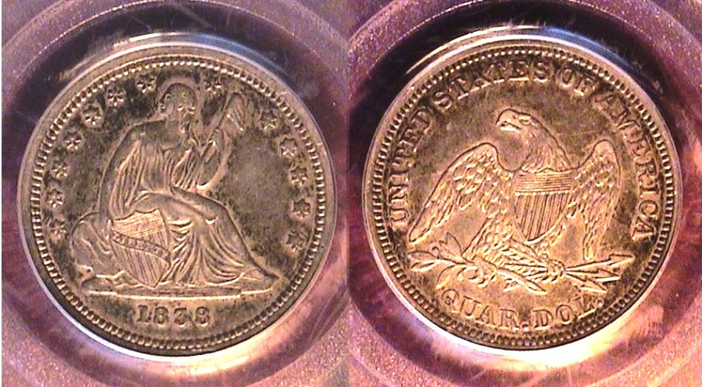

An 1838 Liberty Seated Quarter graded AU-50 by PCGS
The Reverse is the “Closed Claws” variety, quite rare
[Use 3x magnifying glass or magnify to 200% to view details.]

Arno Safran brought in a new acquisition from the recent Georgia Numismatic Show held in Dalton the weekend of April 27-29. He displayed an 1838 Liberty Seated no drapery quarter housed in a PCGS-AU-50 holder. In addition to being the first year of the Liberty Seated quarter series, what made the coin significant was the rare die variety known as the “closed claw”. It was first discovered in 1990 by Larry Briggs, the author of the Complete Comprehensive Encyclopedia of United States Liberty Seated Quarters (1991). At the time of preparing the attribution guide, Briggs knew of only one other example.

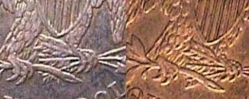

Details showing reverses of open claw (left) and closed claw (right)

David Amey brought in two German Thalers, from Saxe-Weimar and Saxony, one dated 1552, the other 1564 . He described these silver dollar-size coins as extremely attractive for type yet reasonably priced for their age and condition.

The Program

Our guest speaker for the May 3 meeting was Robert Moon whose numismatic specialty area is in US paper money with emphasis on National Bank Notes. Mr. Moon is no stranger to our club having given a program here back in April 2011. He is a first class numismatist who is able to cover a lot of ground in a relatively short space of time. Bob started out giving a brief history of the 1st, 2nd and 3rd Charter National Bank Notes explaining that each of these charters was renewable at twenty year intervals. He displayed a number of rare large bank notes including some issued to South Carolina banks representing each charter/ He Also showed examples of some of the smaller notes that were introduced around 1929. He explained the symbols and numbers appearing on these notes and what they represented and how they differed from regular federal notes. In closing, he displayed important books on the subject including the Robert Friedberg important annual tome, Paper money of the United States known as the ‘Red Book” for paper money collectors. The club wishes to thank VP Pat James for arranging for Mr. Moon to return to speak before the SJ CSRA CC.

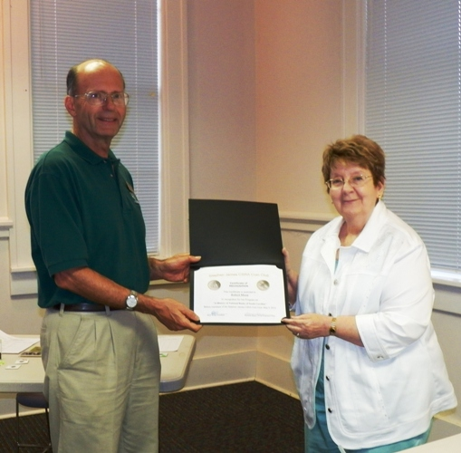
Robert Moon, receiving
the Club Certificate of
Appreciation Award
from VP Pat James
at our May 3 meeting
(photo taken by Helen Barry)

The prize winners at the May 3 meeting were Steve Kuhl who won the door prize, a Proof Franklin 50c and David Amey who took the 50/50 drawing - $22.00. Congratulations, winners! Our next meeting in scheduled for Thursday, June 7. Arno Safran will be presenting a PowerPoint program on the US Coins of 1875, the year his grandfather was born. This will be the final reminder for 2012-13 dues: $12.00 for adults. We don’t want to lose anybody, but after June 1, those who have not remitted will be taken off the club’s roster.
_________________________________________________________________________________________________________________

Kindly Patronize our Advertisers
