The Stephen James
CSRA Coin Club of Aiken
P.O. Box 11
New Ellenton, SC 29809
Web site: www.sjcsracc.org
The SJ CSRA CC of Aiken, SC meets on the 1st Thursday of the month at the Aiken Public Library

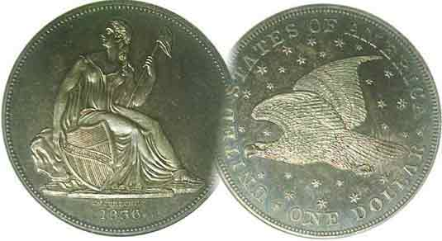
Pres. Willie Simon
V .P. Pat James
Sec. Jim Mullaney
Treas. Chuck Goergen
Sgt. in Arms: Jim Sproull

Programs: Pat James
ANA Representative: Jim Barry
Show Chairman: Steve Kuhl
Photos: Helen Barry
Publicity: Pat James
Newsletter: Arno Safran
E-Mail: arnosafran@comcast.net
Auctioneer: Jim Sproull
Web site: Susie Nulty (see above.)

2014 Club Meeting Schedule
Volume 13, No. 6 the Stephen James CSRA Coin Club, Founded in 2001 June, 2014
Monthly Newsletter
Our next meeting will be held on Thursday, June 5, 2014 at the Aiken Public Library

Wayne Damron to speak on Counterfeit Coins in June
Jan. 2 Apr. 3 July 3 Oct. 2
Feb. 6 May 1 Aug. 7 Nov. 7
Mar. 6 June 5 Sept. 4 Dec. 4

Counterfeit Coins, subject of next Club Program

. When attending a coin show you may have observed a coin in a PCGS holder characterized as GENUINE, perhaps labeled cleaned or artificially toned etc. having VF details. Although the submitter of such a coin may have been disappointed that the specimen had been artificially improved in some way, its so-called genuineness means it is not a counterfeit. This is especially important when dealing with rare coins.
Long before professional coin certification was introduced, dealers and collectors had to call in experts in the field to evaluate the genuineness of rare coins. Over the years, a number of these experts published manuals. Today, the amateur collector can appraise a “raw” coin such as a 1916-D Mercury dime or a 1914-D Lincoln cent to ascertain whether the coin is genuine or has been altered in some way. In some cases where mintmarks are involved the appraiser has to know how to recognize whether the mintmark punch used corresponds to the mintmark associated with the genuine specimen. Possibly the mintmark has been added to the coin or the date has been altered.
After the hullabaloo arose over engraver Victor David Brenner placing his initials prominently at the bottom of the reverse of the 1909 Lincoln cent compelling the Mint to remove them, the coin did not bare the VDB until they were reinstalled with tiny letters under the truncation of Lincoln’s collar on the obverse. Some unscrupulous individual took a 1944 Lincoln cent and scraped off the first four in the date leaving just the left side. However, he forgot to remove the tiny VDB and the alteration was discovered. While this did not make the coin a counterfeit, alterations of coins are just as problematic for the numismatic industry. At our June, meeting dealer and collector Wayne Damron will present a program on his many professional years of experience dealing with counterfeit and altered coins. You will not want to miss this.
_________________________________________________________________________________________________________________

Collecting a Short Set of minor US Coins
From the Civil War Decade by Arno Safran

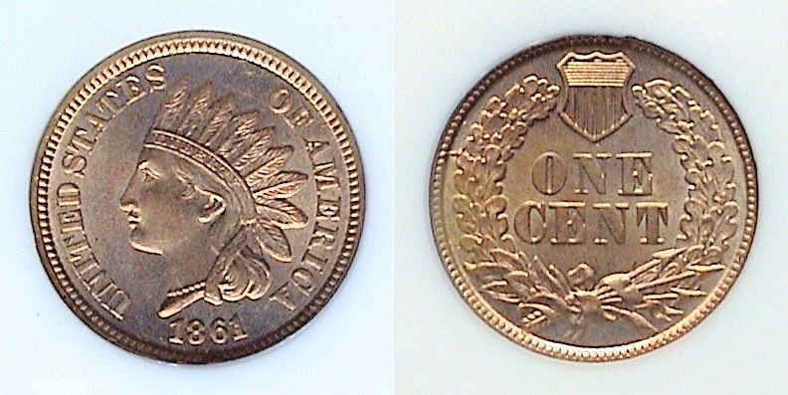

An 1861 Indian Head copper nickel cent graded MS-64 by NGC
[Use 3X glass or magnify page to 200% to view details]

One of the pleasures in Numismatics is obtaining the final piece in a particular set. Attempting to complete a run of Lincoln Wheat-back cents or Mercury dimes may be ambitious but due to the numerous scarcer dates involved, condition and the ultimate cost present difficult barriers to overcome. Since completion is the ultimate goal, one might consider the Short set option to collecting. For one thing, the period for completion is a lot shorter. For another, the cost is much lower. A short set is easier to display and is more likely to appear balanced in grade, having greater eye appeal.

Inexpensive popular short sets of US coins are BU proof or year sets from mid 1950s on, BU War nickels of 1942-1945. More costly are the BU short sets of Buffalo nickels, (1934-38), Mercury dimes (1941-45) or the more ambitious short set of XF to BU Walking Liberty Half dollars (1941-47). A more difficult challenge would be assembling a short set of minor US coins struck around the Civil War, from 1861 thru 1867.

During this 1860s the US Mint produced two copper coins, the Indian Had cent and the Shield 2c piece, three nickel coins, the Indian Head copper-nickel cent, the Coronet 3c piece and the Shield 5c piece; also six silver pieces, the 3c trime, plus the Liberty Seated half-dime, dime, quarter, half-dollar and silver dollar. All gold issues are rare. A set of minor coins should include one coin for each date and alloy minus the silver and gold coins, which are scarce to rare and expensive

The 1861 copper-nickel cent shown above had a mintage of slightly over 10 million pieces and is considered a common date. It can be found in virtually all grades from G-4 to MS-64 but only jumps in price at the MS-65 level.
__________________________________________________________________________________________________________________________
(Continued on page 2, column 1)
A Short Set of US Coins of the Civil War Decade
(Continued from page 1, column 2)

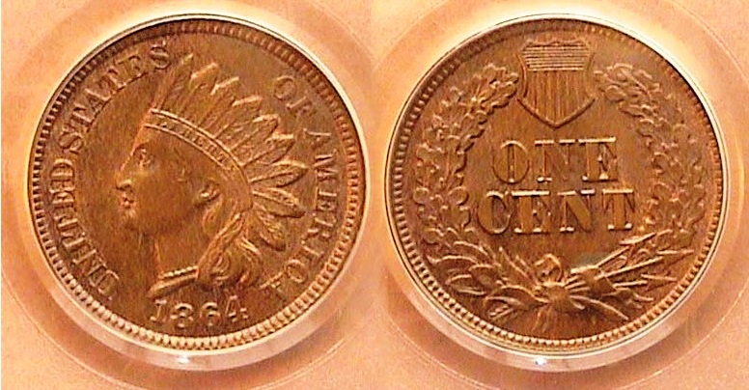

An 1864 (No L) Bronze Indian Head cent graded MS-64 BN by PCGS
[Use 3X glass or magnify page to 200% to view details.]

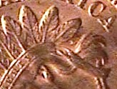
During the Civil War, many Americans began taking silver coins out of circulation. Even the copper-nickel Indian Head cent--which looked silver to some--was not safe from the hoarding panic that set in during the early 1860s. By 1863, crude bronze tokens about the size of the cent were being put into circulation. Some were patriotic featuring “OUR NAVY” or a flag while others bore an Indian Head design closely resembling the copper-nickel cent. Soon these Civil War tokens began flooding the market with the result that by 1864, Congress enacted a law prohibiting them from being used as legal tender and simultaneously authorized all our Indian Head cents to be struck in bronze. As a result, three sub-types of Indian Head cents were coined in 1864, one with the older copper-nickel alloy, and two with the new copper alloy. Why two? Our Chief Mint Engraver James Barton Longacre wished to take some credit for all of the coins he was producing since being appointed in 1844 and decided to add an almost microscopic L sideways onto the ribbon of the Indian. This was done later in 1864 after most of the preceding copper-nickel and bronze 1864 cents had been released without the L. As a result, the 1864-L became something of an instant rarity. From then on all Indian Cents retained that feature until the end of the run.

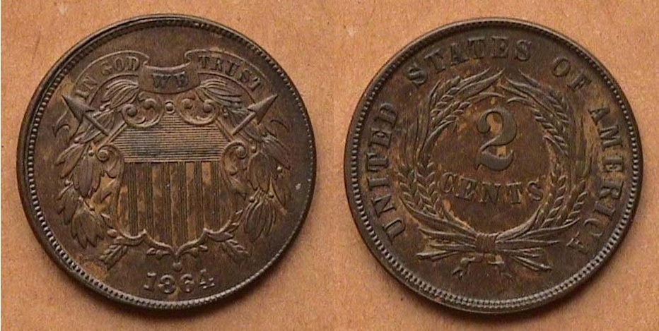

An 1864 Bronze 2c piece with large motto
It was later graded MS-61 Brown by NGC
[Use 3X glass or magnify page to 200% to view details.]

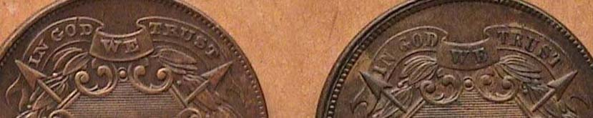
To add more small change to circulation, Congress added a new 2c denomination. Longacre used a new Shield design for the obverse, which for the first time featured the motto IN GOD WE TRUST. The coin was struck in Bronze and was 23 mm in diameter. The first group of 1864 cents displayed a smaller motto that was later changed to a larger one, the latter sub-type being much more common and less costly to acquire.
Detail showing small motto at left & large motto at right
[Use 3X glass or magnify page to 200% to view details.]

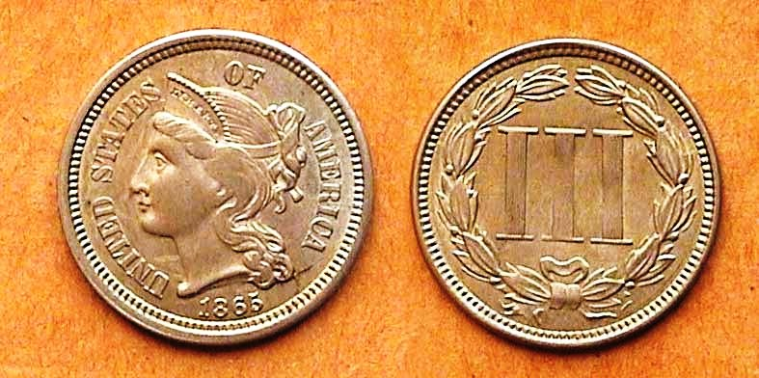

An 1865 Coronet 3c nickel piece graded AU-58
[Use 3X glass or magnify page to 200% to view details.]

During the early Civil War years, Congress approved the issuing of fractional currency (banknotes with a value of less than $1.00). Among these were the lowly 3c fractional notes. These were derogatorily referred to as shinplasters because of their fragility and low value. With the silver 3c piece also not circulating, Congress--under the influence of nickel magnate Joseph Wharton--authorized a new 3c nickel coin to replace the low value currency note and re-establish the 3c denomination originally introduced for postage. The result was the striking of the 1865 Coronet Liberty 3c piece designed by Longacre. It was about the size of a dime but this did not confuse the public since dimes were hardly seen in circulation and the design of the 3c nickel coin appeared markedly different from the Liberty Seated dime. Oddly, the new motto, IN GOD WE TRUST, was omitted on the new 3c nickel coin. More than 11.3 million 3c nickel pieces were struck in 1865 and it was welcomed by the public.

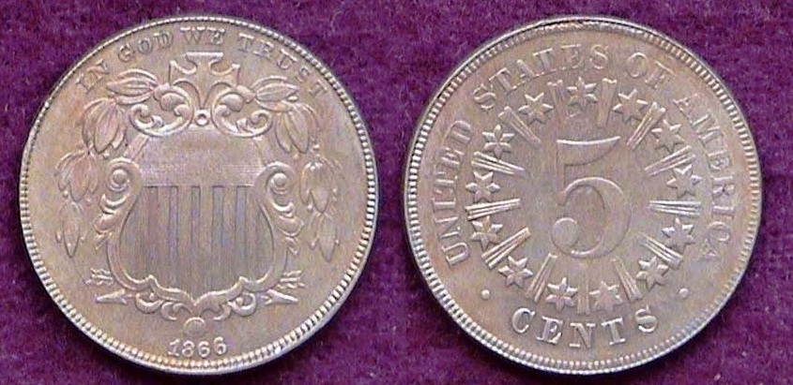

An 1866 Shield nickel (with rays) grading AU-55
[Use 3X glass or magnify page to 200% to view details.]

The fractional currency that brought about the 3c nickel coin also played an important factor in Congress passing legislation in May of, 1866 authorizing a 5c nickel coin. The new 5c denomination designed by Longacre bore an ornate Shield on the obverse similar to the bronze 2c coin. Atop in small letters appeared the motto, IN GOD WE TRUST. The new nickel had a composition of 25% nickel and 75% copper and was 20.6 mm in diameter. 14,742,500 pieces were placed into circulation and the coin was an immediate success. In 1867, the Mint struck 2,019,000 Shield nickels with rays on the reverse before it was decided to remove the rays in an effort to improve the striking quality of the new 5c nickel coin. The 1867 without rays sub-type had a far greater mintage of 28,890,000. While collectors have an opportunity to collect two Shield nickel sub-types for that year, the lower mintage with rays is priced today at more than double the without rays version.

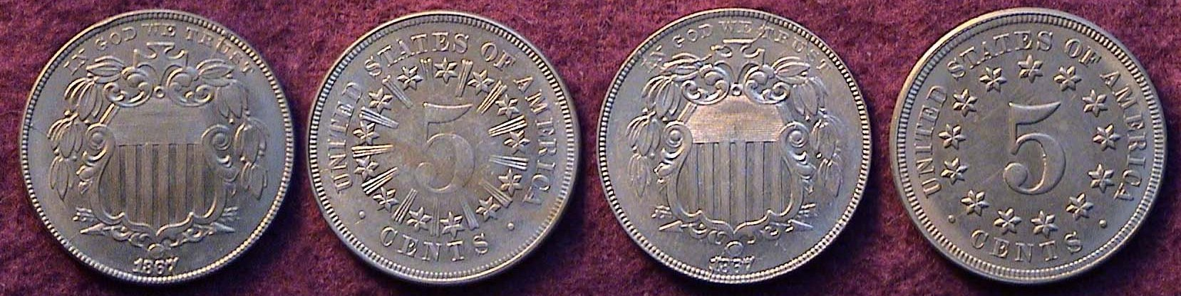

Scarcer 1867 w-r 5c, left & the more common 1867 no rays 5c, right
[Use 3X glass or magnify page to 200% to view details.]

This short set from the 1860s was historically significant.
______________________________________________________________________________________________________________________

STEPHEN JAMES CSRA COIN CLUB
Aiken County Library – Meeting of May 1, 2014

President Willie Simon called the meeting to order at 6:45 p.m.
Glen Sanders, standing in for Sgt at Arms Jim Sproull, reported there were 21 members and 3 guests in attendance. Glen also related information about the upcoming coin shows in the area, including the Augusta Coin Club’s annual Spring Coin Show on May 9 and 10, 2014.
John Sanfratello won the members’ door prize, a Franklin Half Dollar.
There was a motion by J. J. Engel to waive the reading of the minutes of the April meeting. Chuck Goergen seconded the motion, which was voted upon and carried. A copy of the minutes will appear in the Club Newsletter and are on file in the Club’s records.
Treasurer Chuck Goergen reported that the May balance was $1269.18.
In observation of the National Week of Prayer, Steve Kuhl led our group with a prayer in response to a request by Willie Simon.
Bourse Chairman Steve Kuhl provided a brief update on the status of preparations for this fall’s coin show.
There were several Show and Tell presentations, including Glen Sanders with examples of the new baseball commemorative, the US Mint’s first curved coin. Chuck Goergen shared an example of a counterfeit overweight ancient coin of Ptolemy IV he had procured via the internet.
The evening’s program was a power point presentation, Collecting a Type Set of U.S. Silver Dollars Intended for Circulation 1794 – 1935, by Arno Safran.
Zach Richardson won the 50/50.
Glen Sanders conducted the club auction. The meeting was adjourned at 8:30 p.m.
Respectfully submitted,
Jim Mullaney, Secretary]
_______________________________________________________________________________

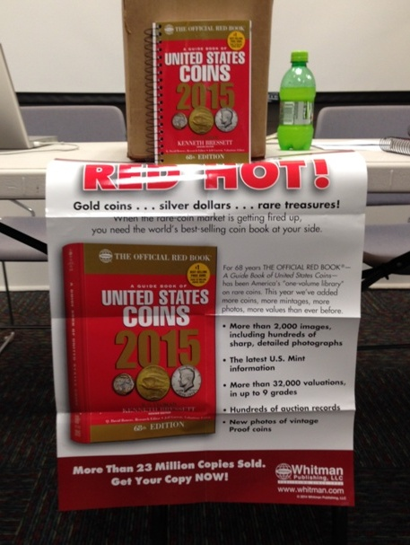

The 2015 Red Books have arrived. They have been discounted to $10.00 to all 2014-15 paid club members at dealer’s cost

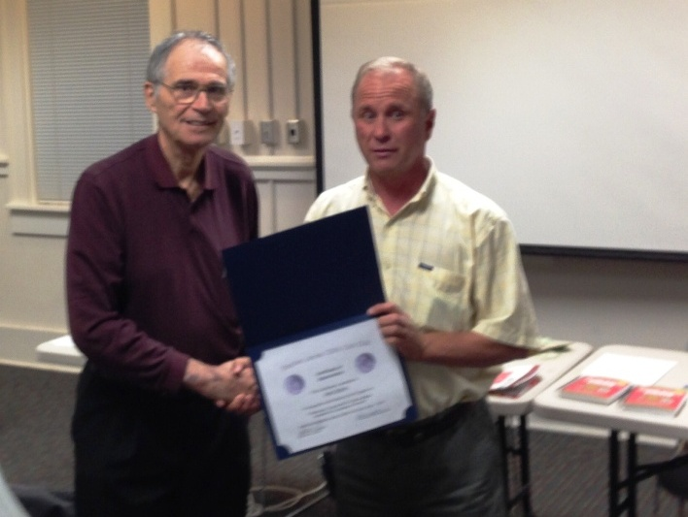

President Willie Simon, at right presenting member Arno Safran with Appreciation Award for his Program on
“US Silver Dollars Intended for Circulation: 1794-1935”
(Pictures taken by Secretary James Mullaney]
________________________________________________

More Club News

Our next club meeting is Thursday, June 5. Sgt. in Arms Jim Sproull will run down the list of upcoming coin shows for our region. For those who may have overlooked their 2014-15 club dues of $12.00, please remit by July 1. Non-renewals are removed from the club roster after that date. We do not want to lose anyone, so, please accept this as a friendly reminder. The meeting room is available to our club on the first Thursday of the month from 6:00 PM thru 8:45 PM. The official start of the meeting is 6:45 PM but early arrivals are welcome from 6:00 on and can help with the set up. For those who wish to share with the members a recent acquisition or even an old one, please bring it in for Show & Tell along with any items you wish to place in the auction. After the business meeting and before the auction, Wayne Damron of Cleins Rare Coins in Augusta will present a program on Counterfeit Coins. There will be the usual attendance and 50/50 drawings.
________________________________________________________________________________________________________________________________

America’s first 5c Nickel coin

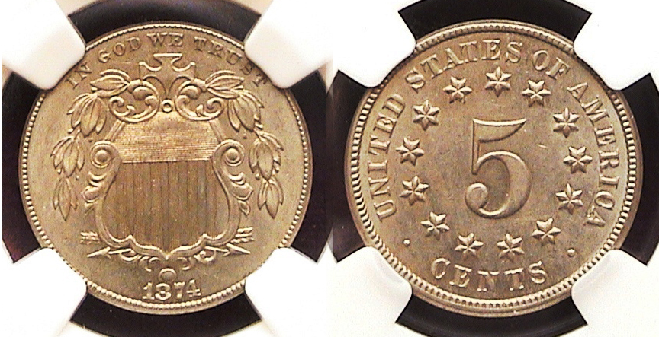

An 1874 Shield nickel graded MS-62 by NGC
[Use 3X glass or magnify page to 200% to view details.]

Because of the coin shortage during the Civil War years and its immediate aftermath, Congress enacted legislation singed into law, first by President Lincoln and later by President Andrew Johnson to introduce bronze cents and two-cent coinage in 1864, a new 3c nickel piece in 1865 and finally a 5c nickel coin in 1866. Small change could purchase many goods during this period in our history and since these new coins contained no silver, the effort proved to be successful during the first several years of issue on all fronts. Oddly, collectors have seemed to have overlooked the 2c bronze pieces (1864-1873), 3c nickel, (1865-1889) and most strangely, the 5c Shield nickel, (1866-1883) with the result that most dates have been affordable up thru MS-63. This was especially so regarding the Shield nickel.

Of the 18 years the Shield nickel was produced, only five dates have been deemed scarce to rare and expensive. These are the two proof-only dates of 1877 and 1878 followed successively by the circulation strikes of 1879, 1880 (quite tough) and the 1881, The not quite so scarce but other better dates have been the 1867 with rays variety, the 1872 and the 1873 closed 3 in date variety, the open 3 being more common of the two. All the others dates are relatively inexpensive thru AU-58.

Since 2000 however, the population of serious collectors have increased three times the number active during the 1970s thru 1990s with the result that more interest has been generated in the Shield nickel series of late. Among the business strikes, such dates as the 1870, 1872 and 1875 have not been surfacing with the same frequency they once did. Even the 1874 shown above, purchased “raw” as an AU-58 back in 1989 does not appear as often. Today. Add to this the grade inflation that has arguably occurred during the past decade and on any given day, a “raw” AU-58 Shield nickel, if attractive and well struck may be certified as a mint state specimen like the coin shown.

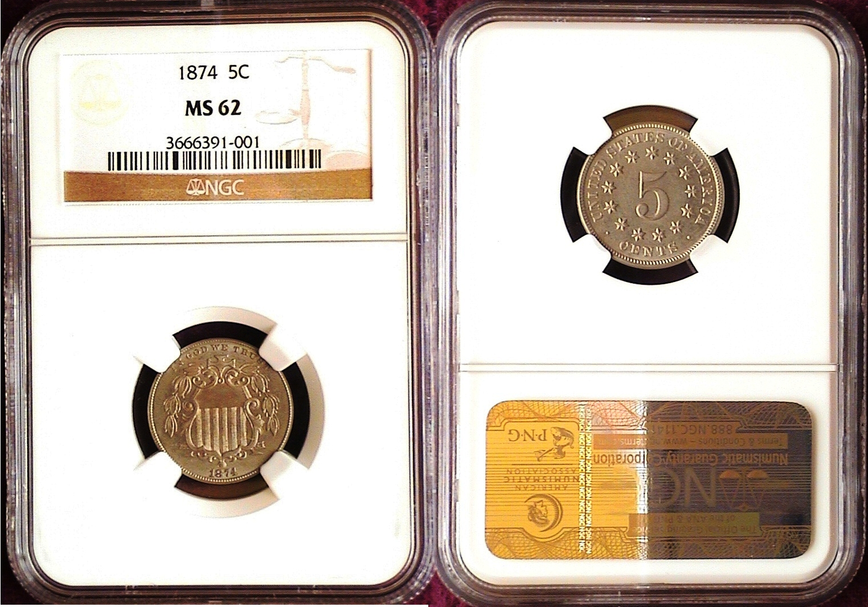
Kindly Patronize Our Advertisers

