The Stephen James
CSRA Coin Club of Aiken
P.O. Box 11
New Ellenton, SC 29809
Web site: www.sjcsracc.org
The SJ CSRA CC of Aiken, SC meets on the 1st Thursday of the month at the Aiken Public Library

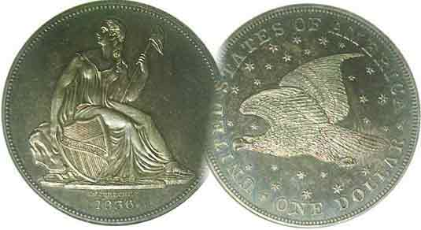
Pres. J.J. Engel
V .P. Pat James
Sec. Jim Mullaney
Treas. Chuck Goergen
Sgt. in Arms: Jim Sproull

Programs: Pat James
ANA Rep.: Glenn Sanders
Show Chair: Board members
Photos: Steve Kuhl
Publicity: Pat James
Newsletter: Arno Safran
E-Mail: arnosafran@comcast.net
Auctioneer: Jim Sproull
Web site: Susie Nulty (see above.)

Our next meeting would have occurred on Thursday, June 4 but is cancelled due to the Coronavirus Pandemic
All Meetings are cancelled in the Aiken public Library until further notice

2019 Club Meeting Schedule
Volume 19, No. 6 the Stephen James CSRA Coin Club, Founded in 2001 June, 2020
Monthly Newsletter
Adding to one’s collection need not cease during a Pandemic
Jan. 2 Apr. 2 July 2 Oct. 1
Feb. 6 May 7 Aug. 6 Nov. 5
Mar. 5 June 4 Sept. 3 Dec. 3

Coin Collecting during the Coronavirus

As we enter the third month since club meetings were suspended and the fourth month with virtually all coin shows cancelled throughout the nation at least thru June, 30, not to mention most of us still attempting to maintain a semblance of social distancing due to the unknown aspects of where the Covid 19 will surface next, many of us may be becoming a bit stir-crazy which is understandable. That said, being involved in a hobby like numismatics allows us the option to conquer boredom by doing research as well as collecting via the internet with Show & Tells or PowerPoint programs being presented via Zoom or through articles with pictures appearing in the newsletter.

For those interested in adding to their collection, as mentioned in the previous issue, there are the two web-sites produced by PCGS; the Collector’s Corner and for those who want to know the facts involving rarity, grading and value of a numismatic item, there is COINFACT. Other options can be gleaned from coin dealer’s actual web-sites which can be placed in your “Favorites” column. You can even bargain down the dealer’s price a little and receive the coin (or banknote) within three day priority mail. Nowadays, virtually all numismatic items are cyber imaged and can be downloaded. When my wife Vilma’s dementia illness increased to a point where we could no longer attend shows, I used the internet in the manner just mentioned with the result that a lot of my recent articles have been based on coins acquired in the approach suggested above.

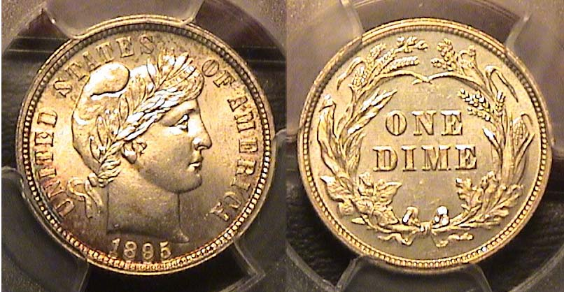

An 1895 Barber dime graded MS-64 by PCGS
[Enlarge page to fill screen to view details.]

This lovely 1895 Barber dime certified MS-64 by PCGS--but looks more like a ’65 in the hand--was acquired off a dealer’s web-site in March of 2018. It is well struck with nice surfaces and brilliant details. During the current Coronavirus pandemic, a collector can acquire quality coins (or banknotes) in a similar fashion. Try it out!
_______________________________________________________________________________________________________________________

Collecting the US Coins of 1890 (ex., gold) 130 Years Ago
By Arno Safran

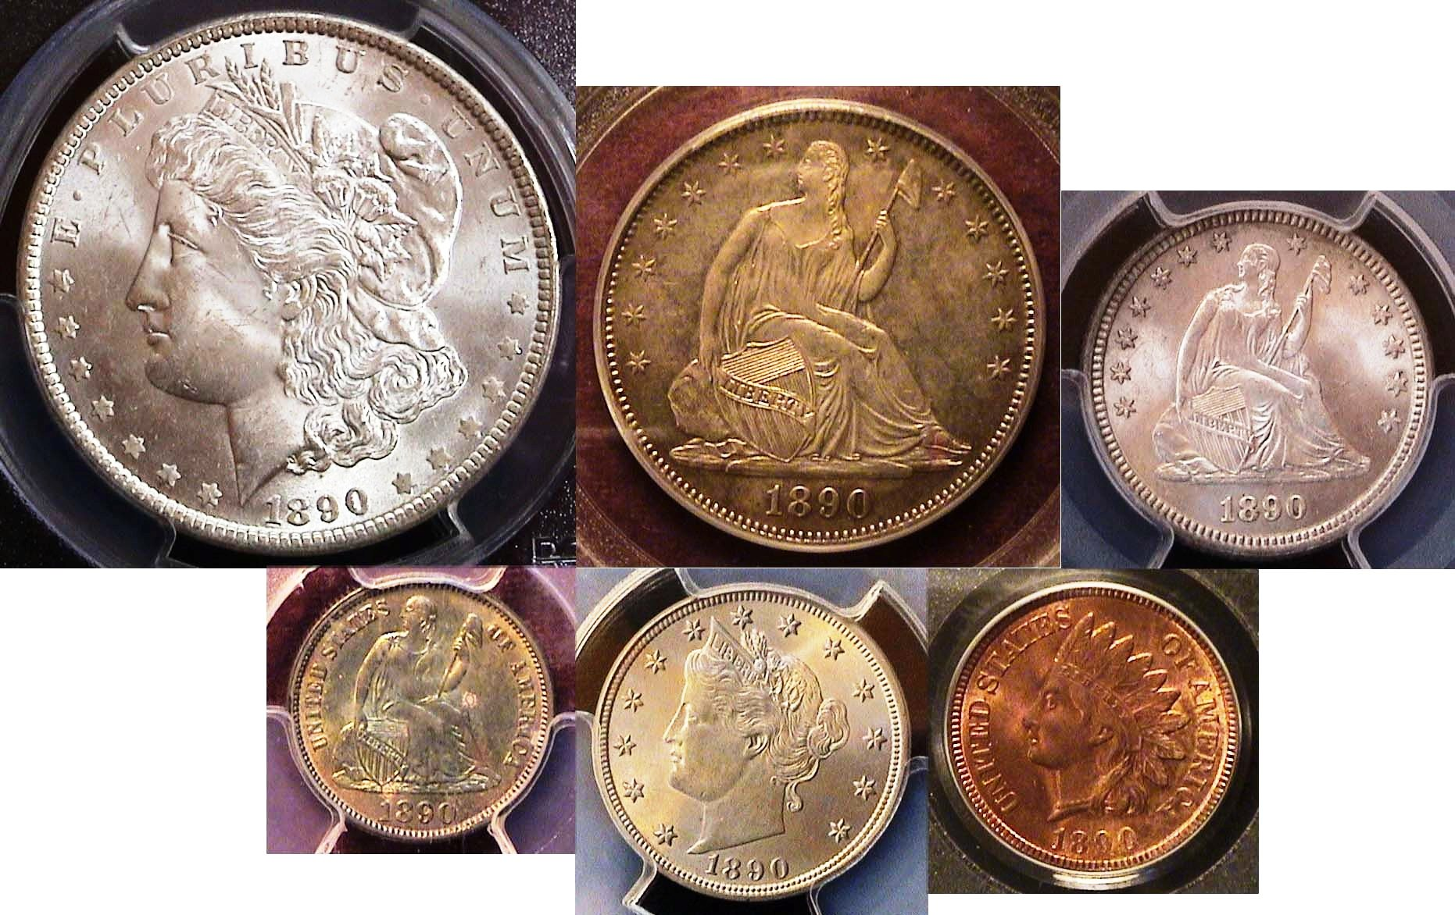

The obverses of an 1890 certified uncirculated year set

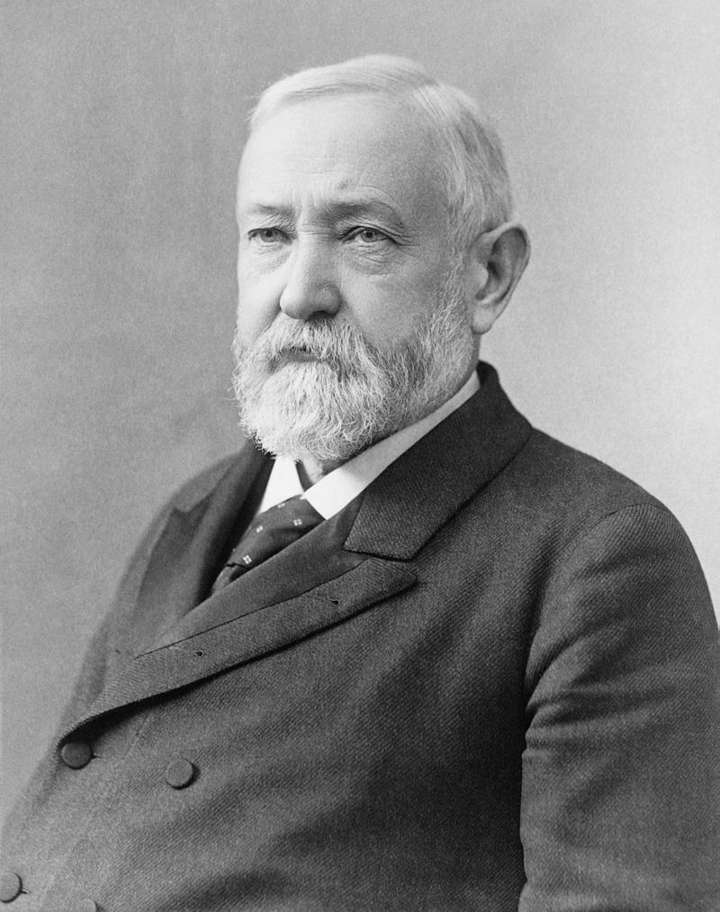
The author’s interest in late 19trh century United States coinage originally began with his love of Charles Barber’s Liberty Head designs which he could acquire out of circulation back during his teen years. Today’s youth cannot obtain even an ultra common 1964 Kennedy silver half-dollar that way unless one of them happens to be buried in a role of clad examples. Another reason for his love of the coins of that era were two fold, the fact that his grandparents were teens during the 1890s while the nation’s technology was entering a second Renaissance with the advance of electricity, telephone service, progress on the motor car and rapid transit along with the phonograph and film industry via the nickelodeon The 1890s was the bridge from the past into the revolutionary 20th century. Collecting the coins of 1890 represents both that era and an a challenge to the collector when it comes to acquiring the quarter and half-dollar.

In 1890, Republican Benjamin Harrison was serving as our 23rd president, having defeated Democrat Grover Cleveland in the presidential election of 1888 in the electoral college although not in the popular vote. He was a moderate on a number of issues evidenced by signing the Sherman Anti Trust Act against monopolies while encouraging civil rights legislation for people of color. Benjamin Harrison
Collecting the US Coins of 1890 (ex., gold) 130 Years Ago
(Continued from page 1, column 2)
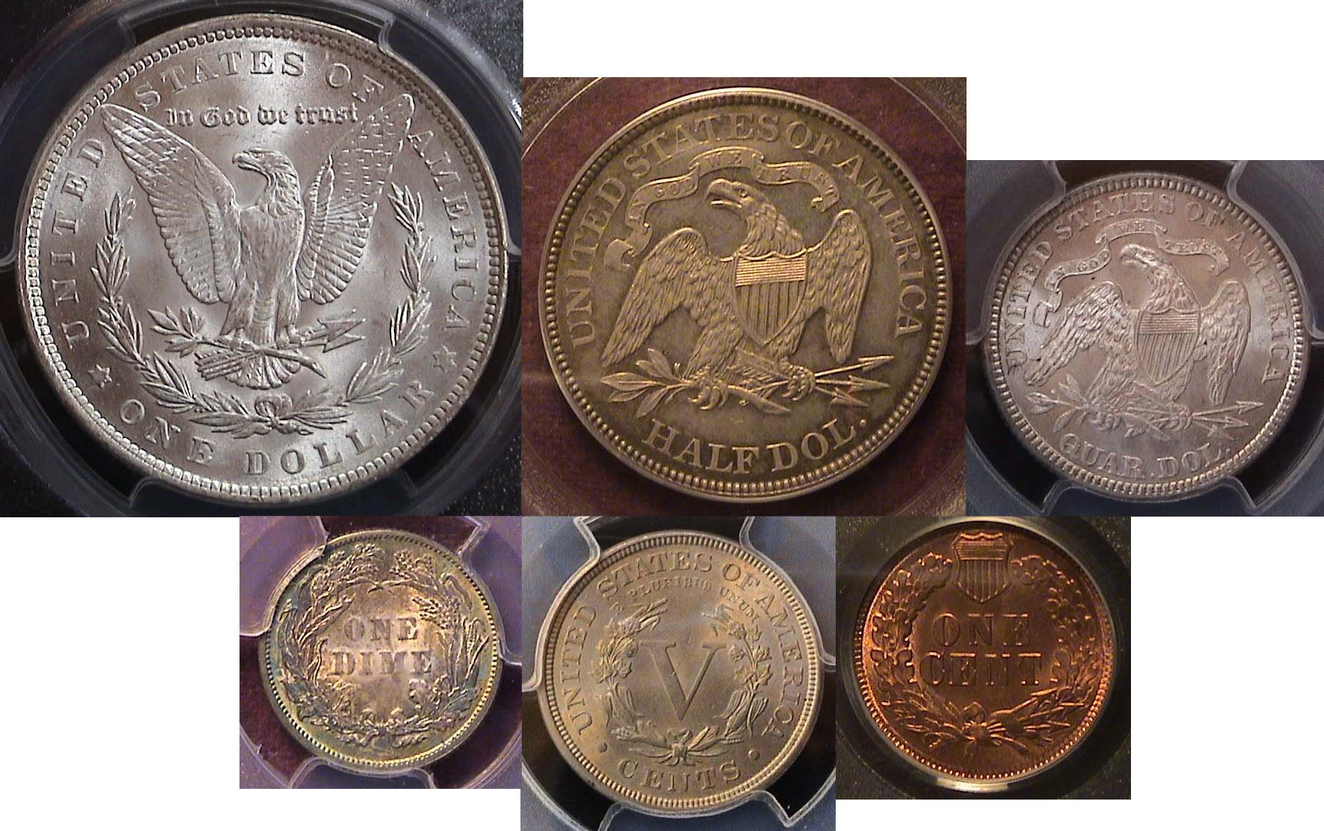
The reverses of an 1890 certified uncirculated year set
Top L-to R: Morgan dollar, Liberty seated half, and quarter
Bottom: Lib. Seated dime, Barber “V” nickel and Indian head cent
[Enlarge page to fill screen to view details.]

Four of the six denominations of the 1890 year set shown above are considered relatively common dates. During this period, the Morgan dollar was being struck in enormous numbers at the expense of the lower silver denominations, especially the quarter and half-dollar. From 1879 thru 1890, the mintages of the quarter--with one exception--and the half-dollar were produced only at the Philadelphia Mint and in small numbers as business strikes mainly for collectors, so a fair number were saved in mint state compared with similarly low mintage pieces struck during the 1860s and early 1870s.

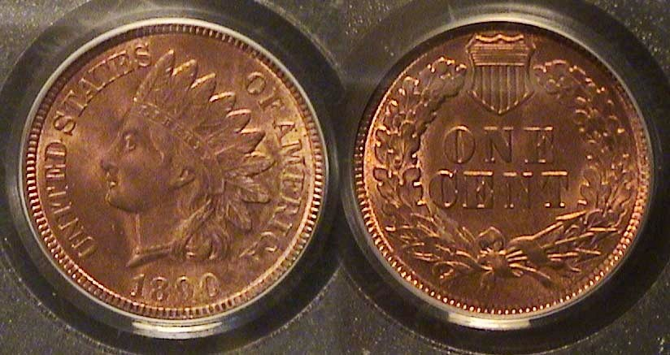

An 1890 Indian Head cent graded MS-64 Red-Brown by PCGS
[Enlarge page to fill screen to view details.]

One of the odd aspects of the Indian Head cent series, (1859-1909) is that despite the continual increase in US population during that half-century span, the middle dates of the series, (1866 thru 1878) tend to be scarcer than some of the earlier dates (1859 thru 1865) while those struck from 1879 to the end of the run, are considered common dates. All Indian Head cent struck prior to 1908 were coined only at the Philadelphia Mint. In the final two years, the San Francisco Mint entered the fray striking cents for the first time but in much lower mintages, especially the 1909-S which is expensive.

The 1890 Indian Head cent had a mintage of 57,180,114, the most of any cent struck up to that time and the sixth highest of the series, so it is considered common date. Unlike silver or gold coinage, copper coinage is evaluated in three conditions based on its overall color, brown, red-brown or full red, with the last being the scarcest and the more expensive. A best-buy is a MS-64 red-brown coin as shown above which was acquired over the internet in an on line Heritage auction.

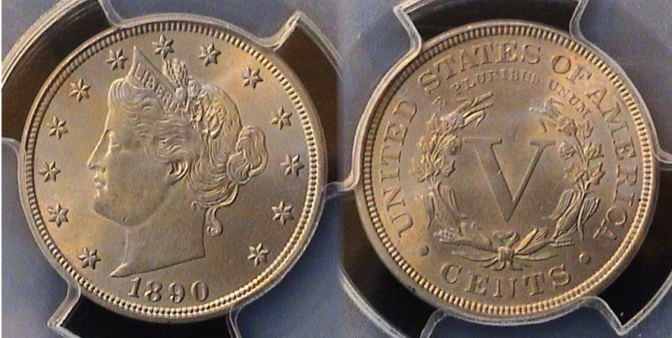

An 1890 Liberty “V” nickel graded MS -63 by PCGS
[Enlarge page to fill screen to view details.’

In 1890, the Philadelphia Mint struck 16,256,532 Liberty nickels that numismatic scholar, Ron Guth of PCGS’s COINFACT believes to be on par with the 1895 and 1896 pieces despite having considerably lower mintages. The three dates apparently surface less frequently in mint state than most of the other common dates of the series. A coin usually certified MS-63 is considered an average uncirculated piece that may show some minor spotting or cuts on the surfaces and is not as sharp or lustrous as one grading MS-64. However, the PCGS-63 specimen shown above turned out to be a pleasant surprise when the author opened the package of his on-line order and found no distracting marks on the coin with lots of eye appeal.
Like the Indian cent denomination, all Liberty Head “V” nickels were struck at the Philadelphia mint from 1883 thru 1912 with both the Denver and San Francisco Mints producing a smaller numbers in 1912, the final year. The 1913 Liberty nickel of which only five proof examples known are not considered part of the series because they were produced clandestinely by a coiner at the Philadelphia mint named Sam Brown. The true keys to the set are the 1885, the 1886 and the 1912-S issues.

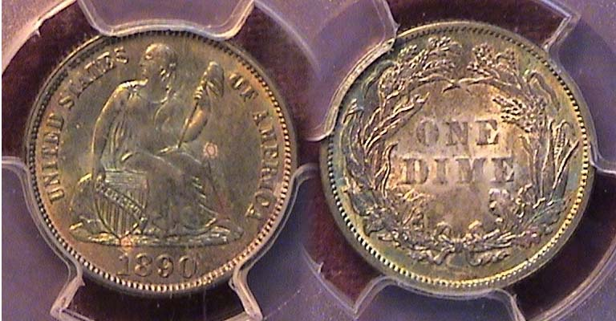

An 1890 Liberty Seated dime graded MS-64 by PCGS
[Enlarge page to fill screen to view details.]

Christian Gobrecht’s Liberty Seated obverse design based upon renowned 19th century painter Thomas Sully’s sketch appeared on the dime in 1837. During the next few years, the coin received minor changes from no stars on the 1837-P to with stars on the obverse in 1838-P; then a bit more drapery was added under Liberty’s arm holding the Phrygian cap above along with the upright shield replacing the slanted one in 1840. From 1853 thru ’55, arrows were placed along side the date to denote a reduction in the silver weight from 2,67 grams to 2.49 and finally, in 1860, the stars on the obverse were replaced by the legend, UNITED STATES OF AMERICA along with the Laurel wreath being supplanted by a fuller wreath comprised of four types of flora on the reverse. In 1873 and ’74, arrows were again placed alongside the date to indicate a slight rise in the silver weight from 2.49 grams to 2.50. From 1860 thru 1891, the Liberty Seated dime looked like the lovely 1890 example shown above which was graded MS-64 by PCGS and acquired in April, 2015 at the Georgia numismatic Association Convention held at the Dalton Convention Center. Since a total of 9.910,951 were struck at the Philadelphia Mint, the seventh highest of the series, the date is considered common and available at a modest price.
_____________________________________________________________________________________________________________
(Continued on page 3, column 1)
Collecting the US Coins of 1890 (ex., gold) 130 Years Ago
(Continued from page 2, column 2)

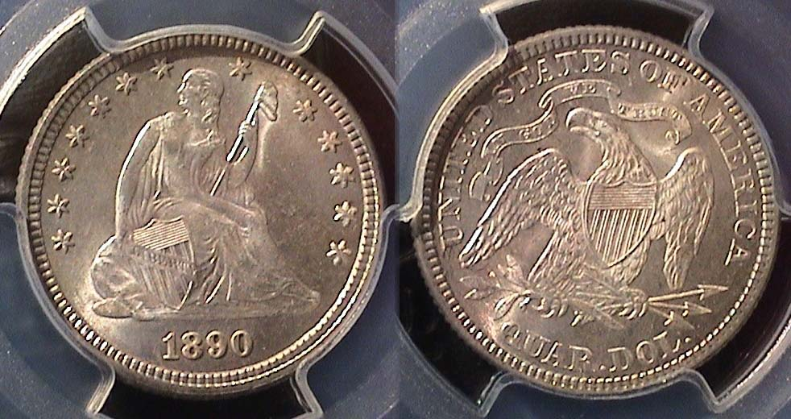

An 1890 Liberty Seated quarter graded MS-66+ by PCGS
[Enlarge page to fill screen to view details.]

One of the features of the Bland Allison Act of 1878 was the provision to strike millions of silver dollars on an annual basis but at the cost of the lower silver denominations which included the dime, quarter and half-dollar. So starting in 1879, an effort to throw a bone to collectors, the Philadelphia Mint struck a small number of business strike issues of these denominations. The dime was less affected because the low mintage dates only lasted three years, 1879 thru 1881, but for the quarter and half-dollar, these low mintages continued thru 1890 with the majority of business strikes ranging from only 5,000 to no more than 13,600 for the quarter--with two exceptions--and for the half-dollar, just 4,000 thru 12,000 with no exceptions.

Regarding the quarter, in addition to the low mintage 1888-P, with just 10,001 coined, the San Francisco Mint struck over 1.2 million and it is considered a fairly common date despite heavy circulation, The other exception regarding the quarter was the 1890 issue when 80,000 were coined at the Philadelphia Mint but a greater percentage of these went into circulation, so the date is somewhat more elusive than one might expect.

So, when the writer was contemplating acquiring a 1890 quarter for his year set during the summer and fall months of 2018, he happened to come across the gorgeous specimen shown above. Numismatically, the writer does not consider grade rarity equal in value to date rarity but since the 1890 quarter was a low mintage business strike, and while more attainable than a very rare date quarter from the 1860s and early 1870s, he decided to do some research regarding the specimen’s provenance. While surfing the internet he discovered the same coin had recently sold at a Sotheby auction by magnifying the piece in order to observe similar characteristics on the coin’s surface and concluded the two cyber images were the same. The dealer was asking a lot more than the coin sold for but the two parties settled on a compromise figure which satisfied both resulting in one of the author’s favorite numismatic acquisitions.

In 1891, the Liberty Seated quarter was struck for the last time and at three of the four active mints with 3,929,000, produced in Philadelphia, the largest mintage since 1877, 2,216,000, in San Francisco, the largest number since 1876, and at the New Orleans Mint but with only 68,000 and the coin circulated heavily and is considered quite rare today. No quarters were coined at the Carson City Mint that year, so obtaining the far scarcer business strike issue of the 1890 piece represented a worthy goal especially with the Barber Liberty Head design replacing the Liberty Seated type in 1892.
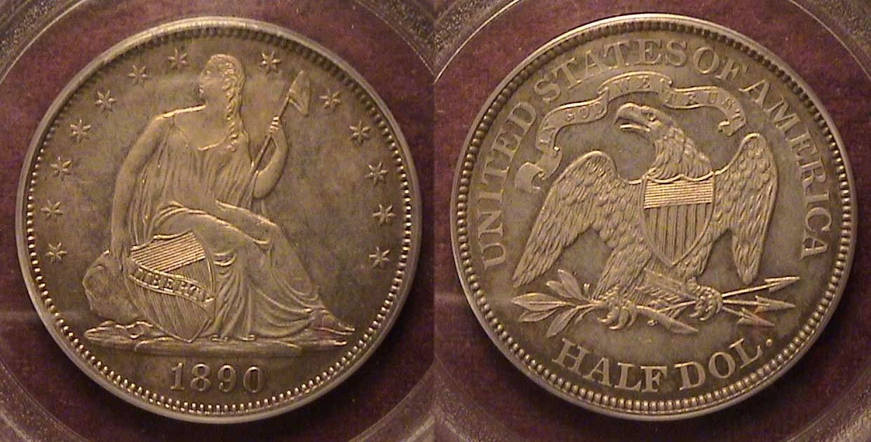

An 1890 Liberty Seated half-dollar graded Ms-62 by PCGS
[Enlarge page to fill screen to view details.]

Unlike the 1890 Liberty Seated quarter, the mintage for the 1890 half–dollar business strike coinage was just 12,000 and while a number were saved by collectors of that period, the business strike version of the coin is still a lot scarcer today than the 590 proof examples and are generally worth a lot more.

Back in December, 2018, the author observed three 1890 half-dollar specimens that were up for auction pictured on the Heritage auctions web-site. Two were proof specimens, one certified 62 and the other, 64, both with noticeable hairlines on the obverses while the one business strike certified AU-55 had a gray dullish appearance. He then, clicked on eBay, punching in the series type and date and up came a few more specimens, one of them being the coin shown above. The piece was housed in an older PCGS green holder reminiscent of a period when many knowledgeable dealers and collectors considered certified grading standards to be more stringent than they are today.

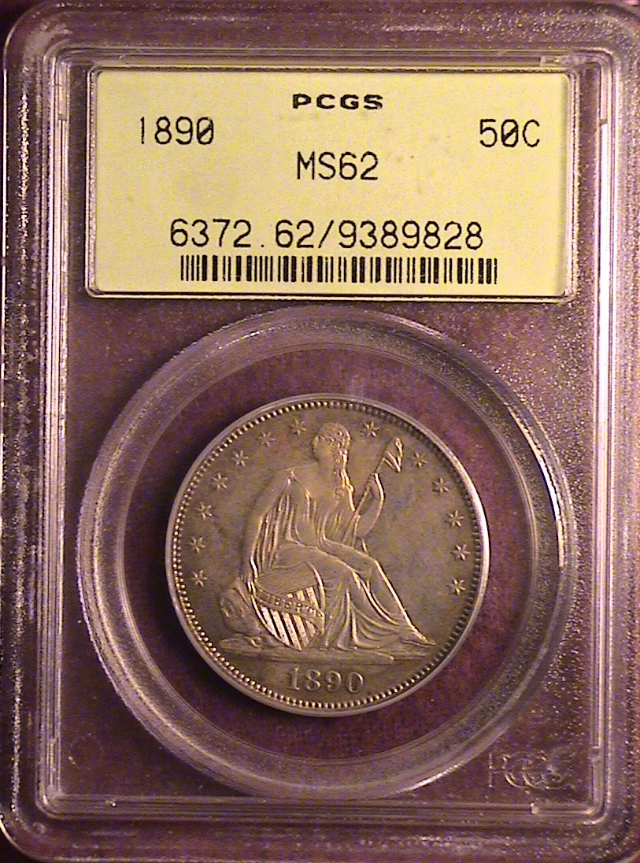
Unlike the PCGS COINFACT web-site, the quality of digital imaging on eBay varies from dealer to dealer and this coin appeared to have some fuzzy markings which concerned the writer. He contacted the dealer who was on vacation but would look at the coin when he returned home. Meanwhile, the writer clicked on the Heritage Auction Archives web-site and discovered the same coin based on the last eight numbers on the PCGS slab, which, upon digital magnification displayed clearer surfaces with no fuzziness along with the price realized.

The author decided to send for the coin “on approval” and found its appeal commensurate with the MS-62 certified grade. It was reasonably well struck with no unsightly marks at a modest increase in price over the auction sale. The upshot of this tale of acquisition is to suggest to the reader that under the current conditions brought about by the Coronavirus pandemic, with shows cancelled, one can still acquire some better date coins at a fair price over the internet.
Collecting the US Coins of 1890 (ex., gold) 130 Years Ago
(Continued from page 3, column 2)

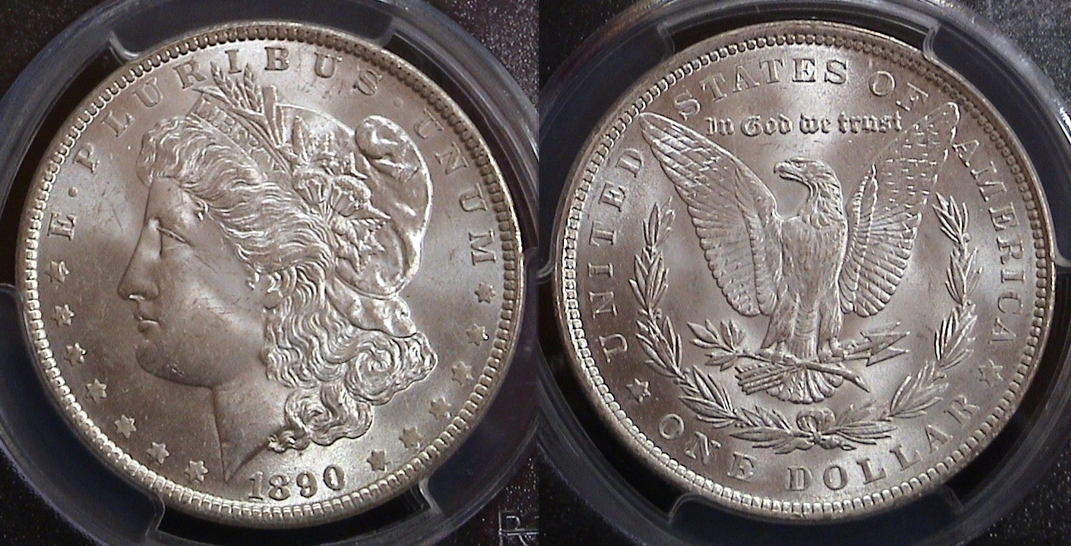

An 1890-P Morgan dollar graded MS-63 by PCGS
[Enlarge page to fill screen to view details.]

In 1890, the Philadelphia Mint struck a whopping 16,802,000 Morgan dollars compared with 10,701.000 at New Orleans, 8,230,273 at San Francisco and 2,309,341 at the Carson City facility for a total of 38,042,671 million of which the vast majority never saw circulation. The 1890-P shown above looks gorgeous for an example certified only MS-63 yet it cost the author just $71.00 at Clein’s Rare Coins on July, 2018. It is ironic that the dollar denomination, which was the least expensive to acquire in today’s numismatic market was worth more than the five lower denomination coins together in 1890, the year they were made. As one can see, the coin is sharply struck with magnificent details which is one of the reasons the Morgan dollar type is so popular with collectors today.

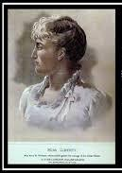
It is hard to understand why this charming young teacher of primary age school children, Miss Anna Williams lost her job when a news reporter revealed in 1879 that she posed for Miss Liberty in 1877 for George Morgan’s first patterns for the new dollar coin which first appeared in 1878. Despite that, she managed to recover from the temporary disaster finding a new teaching position and apparently enjoyed her life although she never married.

