Pres. Willie Simon
V .P. James Barry
Sec. Helen Barry
Treas. Pat James
Sgt. in Arms: J.J. Engel
Committees:
Auction: J.J. Engel
Programs: James Barry
Newsletter: Arno Safran
The Stephen James
CSRA Coin Club of Aiken
P.O. Box 1739
Aiken, SC 29802
Web site: www.sjcsracc.org
The SJ CSRA CC Now Meets on the 2nd Thursday of the Month at the Cedar Creek Club House near New Ellenton

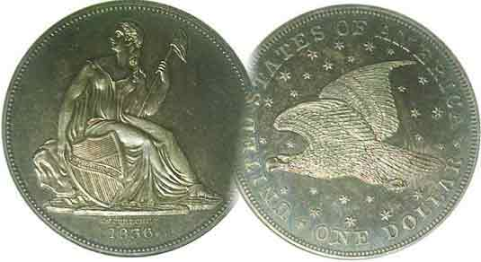

Volume 5, Number 7 the Stephen James CSRA Coin Club Monthly Newsletter July, 2006
Coin Market as Torrid as the Summer Heat
Our Next Meeting is on the 2nd Thursday, July 13, 2006 at 7:00 PM
2006 Meeting Schedule - 2nd Thursdays at 7 PM
June 8, July 13, Aug. 10, Sep 14,
Show: Sept. 16 Oct 12, Nov 9, Dec 14_

Members Hear Program on “Coins of Gibraltar”

At the June 8 meeting, the SJ CSRA CC members were treated to a fascinating program on the coins of Gibraltar by Bill Grant., a noted award winning collector from California. Bill is the uncle of our esteemed Treasurer Pat James and with his wife Freddie stays at Pat’s place when they visit. He was here two years ago and gave a memorable presentation on the medals of Charles Lindbergh. Bill gave a brief history of Gibraltar from the conquest by the Greeks through the Moorish and Spanish influences to the British enclave it is today. He explained that though the Brits have governed Gibraltar since 1779, it did not produce any coinage until 1810. Prior to then and more than occasionally afterwards, the citizens used Spanish coins which included the peseta and its denominations. The first coins from Gibraltar were actually tokens struck in copper in denominations of one quart and two quartos and featured a lion on one side and a castle on the other. In 1841, 1842, 1860 and 1861 regular issues of the ½ quart, quart and 2 quarts portrayed Queen Victoria on the obverse with a fortress on the reverse. From 1967 through 1970 Gibraltar issued Crown coinage featuring Queen Elizabeth II on the obverse. Beginning in 1988 the Royal Mint--which had introduced the decimal coinage in 1970--began striking coins for Gibraltar in denominations from the 1 penny, through the two pound coin though not in every year. Bill brought with him examples of the earliest 1810 copper specimens along with the later cupro-nickel pieces and passed them around to the members. The club thanks Bill for another fine program and also thanks Miss Pat for making this possible.

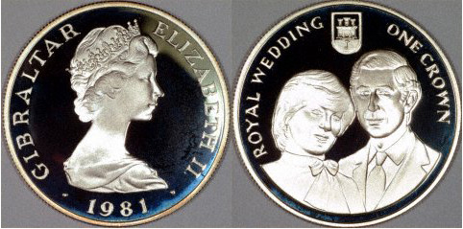

A 1981 commemorative proof crown honoring the Royal Wedding
_____________________________________________________________________________________________________
(Club News continues on page 3, column 2)

The Latin American Alternative
Part Two of a Series: Columarios from the he Colonial Era
By Arno Safran

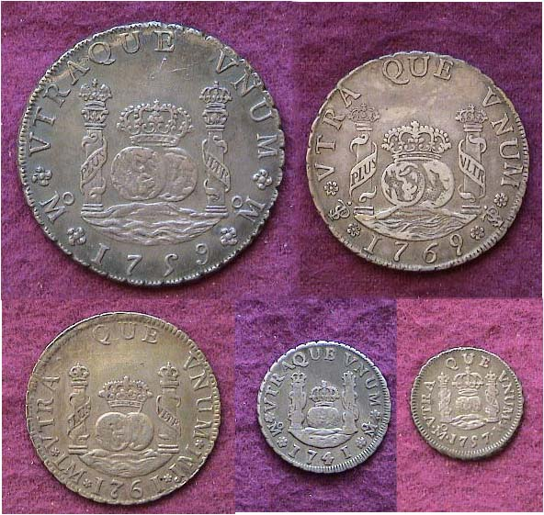

A five piece set of Columarios showing the Pillar type reverses
From top left, 1759 8 Reales, right, 1769 4 Reales
At bottom, left to right: 1761 2 Reales, 1741 Real and 1757 ½ Real

During this Colonial era of Latin American coinage, the Government of Spain authorized the striking of the Pillar design type (aka Columarios) on all silver denominations. These include the 8 Reales, (a $1.00 value) 4 Reales (worth 50¢), the 2 Reales (25¢), the Real (12½¢) and the ½ real (6¼¢) The coins were mostly struck in Mexico and Peru between 1732 and 1772 with some higher denominations from the 2R thru the 8R in Guatemala. The few examples listed for Bolivia and Colombia are extremely rare. The 8R coin represented the world trade dollar during that time. To non-American collectors, it is the Coat of Arms side that is considered the obverse with the Columns surrounding the two hemispheres floating on the ocean the reverse as shown above. It is still possible to collect all five.
________________________________________________________________________________________________________________________________
(Continued on page 2, column 1)

Columarios from the he Colonial Era
(Continued from previous page)

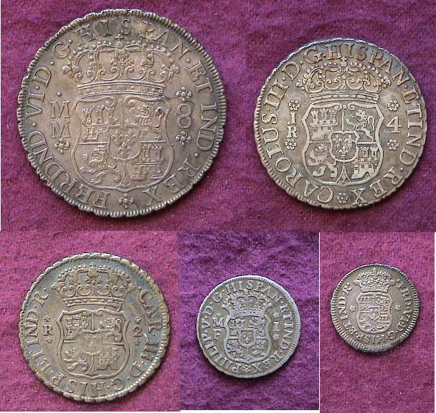

The obverses of a Columarios Denomination Set
Top: from l to r: 8R and 4 R. Below from l to r: 2 R, 1R and ½R
Showing Coat of Arms and crown with the particular King identified
Counter-clockwise up from the bottom of the coin.

The 8 Reales has always been the most common of the five denominations and because of their status as a world trade coin, many have survived in high grade. One used to be able to acquire the minors over time for less money with the exception of the 4 Reales which was not produced in the same quantities as the others. The reason it took time were primarily due the dealers’ reluctance to bring this part of their inventory to shows, claiming they were a burden due to their low numismatic value. Now they’re just hard to find period, especially above Fine in problem-free condition and those quality pieces that occasionally surface sell for double the money of a decade ago. As a result, it is becoming more challenging for one to assemble a matched set today because the minors are no longer cheap. Despite the challenge to the collector all five Pillar denominations are downright cheap when compared with our early half dimes, dimes, quarters, halves and silver dollars.

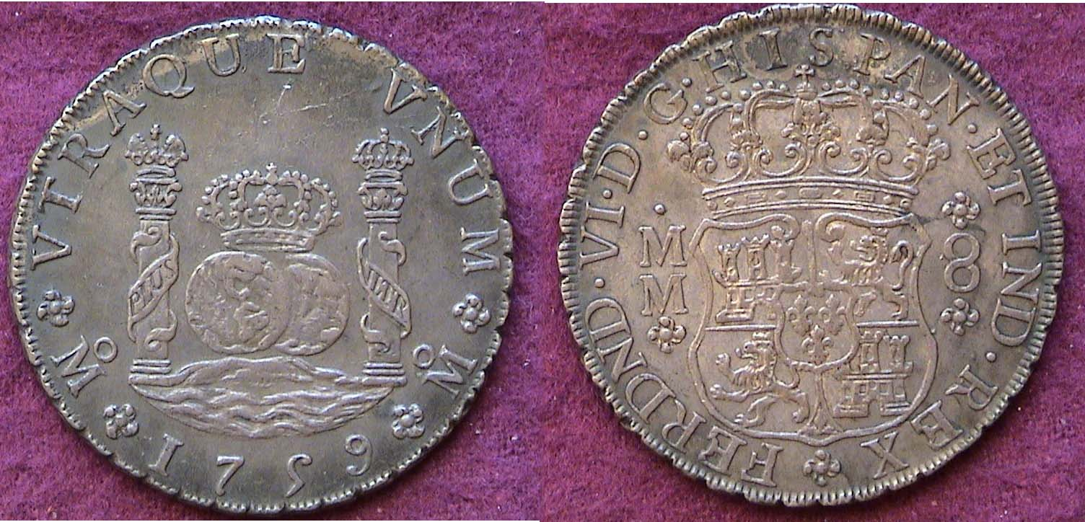

A 1759 8 Reales Pillar Dollar of Ferdinand VI in Choice EF
The obverse is at right inscription and reads,
Ferdinand VI, by the Grace of God, King of Spain and the Indies
This would make up the second piece in a three monarch set.
Ferdinand VI ruled Spain and its colonies from 1747 to 1760.

The 8 Reales piece shown at the bottom of the previous column is a choice example for study. It is a strong XF with original tarnished charcoal gray color still showing lots of detail. On the two lower corresponding sides of the reverse (at left) one can see clearly the o above M for Mexico City Mint; the fleur-de-lis above with the motto explained earlier atop an date centered boldly below the central device; Pillars of Hercules surronding two orbs floating on the sea. On the obverse (at right) the central device shows the jeweled crowned Bourbon coat of arms featuring the castle for Castile and Lion for Leon.
The double M’s at left represent the initials of the two assayers and the 8 at the right the denomination 8 Reales. The inscription circling the inner rim signifies the King and his realm by the grace of God.

Collecting strategies of this series can encompass a number of options from acquiring at least one attractive specimen of the 8R for type to forming a complete denomination set in approximate grades approaching matching color. The author is still working on completing a full denominational set featuring all three kings; Philip V, Ferdinand VI and Charles III for both Mexico and Peru. Adding Guatemala to the mix will be rather difficult. If you really get to like the series try putting together a three piece monarch set of the Crown size 8 Reales as shown below.

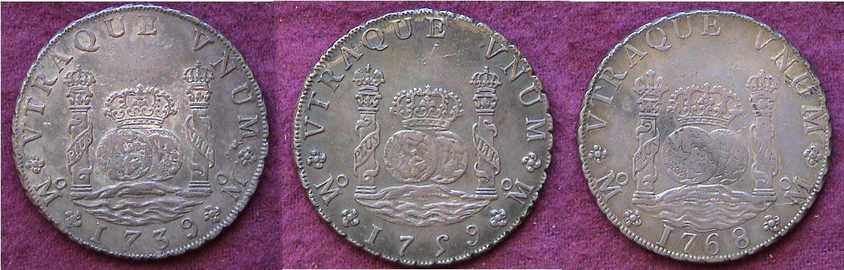

1739, 1759 and 1768 Pillar dollars of Philip V, Ferdinand VI and Charles III

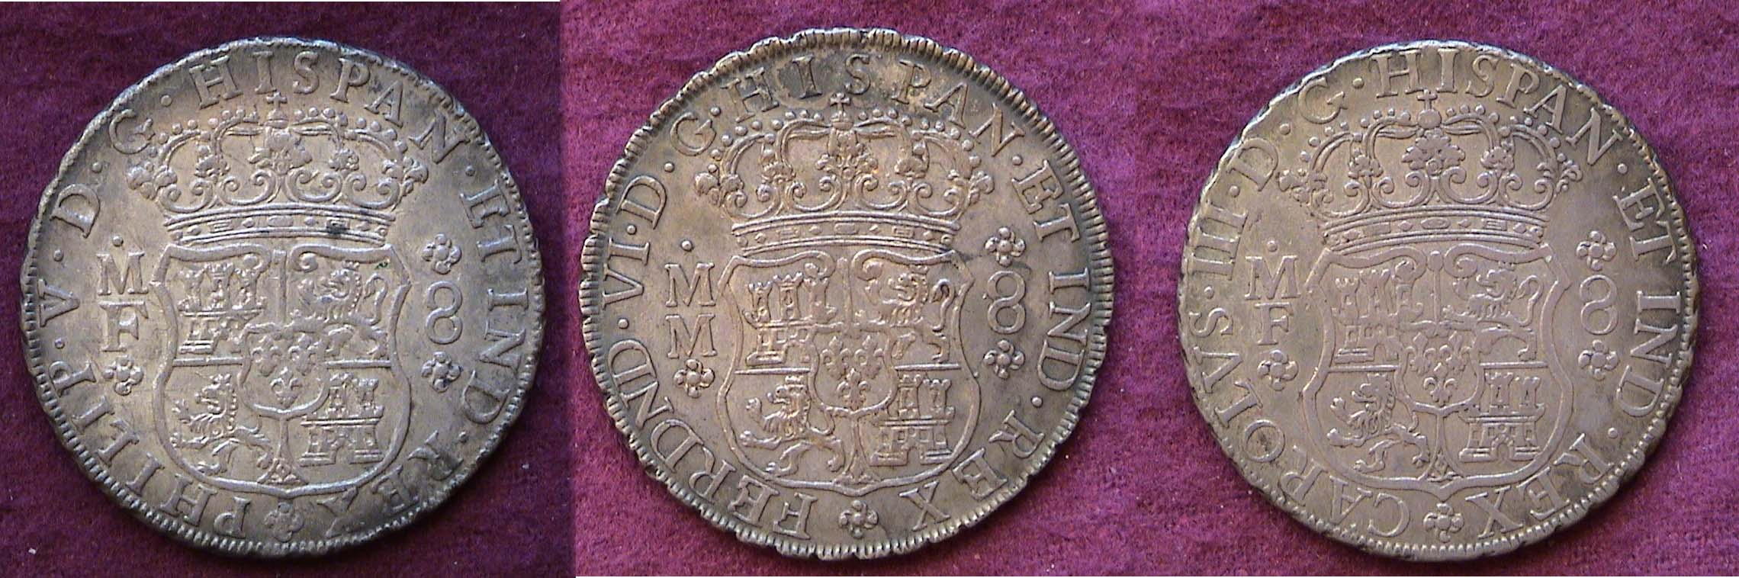

Inscriptions of the three Pillar Dollars showing Philip V at left, Ferdinand VI, center and Charles III at right
[Magnify to 200% for a clearer view of the design and lettering.]

Columarios coinage represents one of the most attractive coin types in the world. A US collector can include it as part of one’s type collection as it enjoyed legal tender status here through 1857. It is the first coin pictured in the Red Book. Columarios supplied US banks and merchants with needed dollars and change to back transactions during the colonial period well into the early years of our Republic. They were struck in large numbers and had a high silver content; .917 fine. As such, Columarios served our young nation when our own silver coinage output was small to virtually insignificant.
_____________________________________________
JapWanCap: Stamped JIM Notes last in a series
By Bill Myers
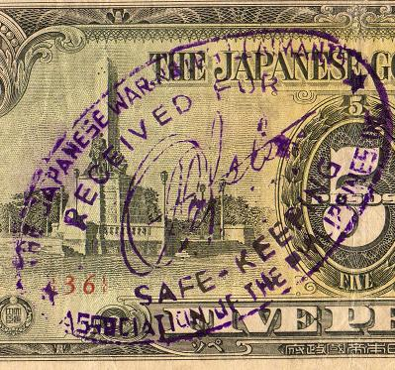

Japwancap Type 1 Oval Stamp in purple

After the liberation of the Philippines, the citizens wanted to redeem their JIM. When they were unable to do this, the "Japanese War Notes Claimants Association of the Philippines, Inc" was formed. Their JIM notes were stamped with the association's name and the owner was given a receipt. Japan would not redeem the JIM notes, so the United States government was sued for payment, claiming the Allies printed counterfeits that undermined the value of their money. The case was dismissed by the Supreme Court, as the statute of limitations had expired. These notes have become available to collectors. There are three styles of stamps used on the notes. They come in purple (most common), black and blue.
The Type 1 is an oval stamp that has four lines reading:
"THE JAPANESE WAR NOTES CLAIMANTS
RECEIVED FOR (signature) SAFEKEEPING
ASSOCIATION OF THE PHILIPPINES, INC."
The two varieties of Type 1 are:
-71x46mm
-51x36mm with "INC" below signature, not on last line
The Type 2 oval stamp has two lines with "by" in the center, surrounded by: "COMPILED" "JAPWANCAP INC"
The three varieties here are:
77x48mm, "by” in script
59x36mm, "by” in script
56x40mm, "by" “in block letters
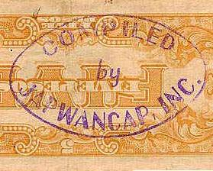

The Type 2

The Type 3 is a 38mm circle stamp with the legend around the Philippines crest, which reads: "JAPANESE WAR NOTES CLAIMANTS ASSOCIATION OF THE PHILIPPINES".
JIM is a varied and interesting area of numismatics that has captured the interest of a relatively small group. Most of the notes are common and can be obtained for a few dollars and many for less then a dollar. (Values for the notes can be found in the Standard Catalog of World Paper Money and WW II Remembered - see references). JIM are often relegated to dealers "junk boxes" so there is an opportunity to find some
of the varieties listed. A collection of JIM will probably never have a great value but it represents an interesting period of history that you can explore without needing to take out a loan
Or mortgage the house. Enjoy the hunt.
___________________________________________________________________________________________________________________
The editor wishes to thank member Bill Myers for his research in providing this extraordinary series of articles on Japanese Invasion Money.
________________________________________________________________________________________________________________

More Club News

President Willie Simon gaveled the June 8 meeting to order at approximately 7:00 PM at the Cedar Creek Club House welcoming members and guests. It was moved, seconded and approved that Secretary Helen Barry’s Minutes of the previous meeting be placed on file. Miss Pat read the Treasurer’s Report. We now have $741.58 in the club’s coffers with all expenses paid. Thanks, Pat! Under Old Business, Willie asked the members to let Arno know if they wanted to be included on the E-mail list in order to receive a digitized newsletter in full living color. He also requested that those who have E-mail capability that preferred not to receive B/W copies my snail mail let Arno know. Thus far, only four have chosen that option.

Willie also reported that member Gary Bailey passed away, that Don Bittner was in University Hospital in Augusta and Merle Davis Jr. had Strep. A Sympathy card is being sent to the Bailey family. There has been no word on Don as yet but Merle attended the Augusta Coin Club meeting the following week and looked all right. We hope both members recover fully and will be able to rejoin us soon. Willie also mentioned that contributions to the young numismatist’s grab bag were made by J.J. Engel and Rich Baker. Thank you gentlemen.

Under New Business it was reported that the ANA had switched their spring, 2007 money show from Sacramento, CA to Charlotte, NC due to a conflict with a show in Baltimore. The dates were moved up to March 16, 17 and 18; a Friday through Sunday. With Atlanta this past April and Charlotte next March, this gives SJ CSRA CC members another splendid opportunity to attend a major coin show.

Our Show is coming up in less than three months, Sept. 16 and perforated raffle tickets without staples are now available. Sell ten and receive one free. Please return the stubs with the money collected to Miss Pat at any of the next three meetings (See schedule atop page 1, column 1) or at the show itself by 2:00 PM. Member Bill Myers--who is currently President of the Augusta Coin Club--announced that its show would be held on Fri. & Sat. Nov. 17-18 at a new location, the Belair Conference Center, 4081 S. Belair Rd. in Augusta, just off I-20 at Exit 194.

Winner of the door prize for June was Howard Black and Billy Ray Randall won the 50/50. Congratulations gentlemen. Tony Chibbaro will present a slide talk on July 13. See y’all then and bring in something for Show & Tell.
_______________________________________________________________________________________________________________
Coin Market Continues At a Torrid Pace
-An Editorial-

Usually the warmer months bring a lull in coin collecting as people concentrate more on outdoor activities or vacation time, but since 2003 the numismatic market has been moving steadily higher in such areas as key dates and early US type with no interruptions during the summer doldrums. One would consider this to be good news for dealers and collectors who have been active for a while but in actuality the current situation poses something of a conundrum. Since the statehood quarter program began in 1999, a large enough number of once casual souvenir hunters has become avid numismatists swelling the collector base to three times what it was during the 1990’s. As a result, dealers cannot replace their inventory fast enough to meet the demand compelling collectors to pay outrageous prices for the small number of the scarce to rarer pieces that occasionally surface. Indeed, some dealer web sites now use a Buy or Bid approach; in short; auction their listings.

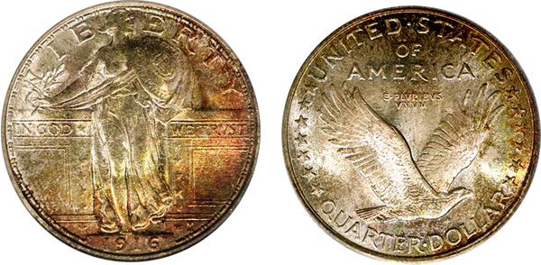

A Gem BU 1916 Standing Liberty Quarter

One has to be concerned by this market direction as it affects the keys and earlier US type. Take the 1916 Standing Liberty Quarter for example. With a mintage of only 52,000 the coin has always been a popular key date but during the past four years the demand has increased to the point where specimens grading Good-4 now sell for more than an MS-63 did ten years ago. While the SL design is exquisite in Choice AU to Mint State, its eye appeal disintegrates rapidly below XF to point where even a specimen grading VF has arguably little attractiveness left. This begs the question, why are there so many collectors willing to pay in the upper four figures for a coin that looks so well worn? The answer may be simply to exclaim, “I have a key date.” But what happens when all these low grade keys start hitting the market during difficult times; especially if gasoline continues its steady rise towards the $5.00 a gallon mark by 2008? The value of these “culls” could collapse compared with the higher end ‘keys’ with eye appeal because there are far more low grade specimens than gems available.

In today’s market the collector has another option that is perhaps just as challenging but at a far lower cost. Try acquiring mid grade obsolete type coins that are both problem-free and attractive. Choice VF-30 through AU-58 grades comes to mind depending on the particular item, availability and rarity. Another option is interesting Foreign coins and finally Ancients. There are a number of late date Roman coppers surviving in XF or better that are beautiful but cost a fraction of what a Sestertius from any of the twelve Caesars will cost in the same grade. A dealer friend of mine once told me, “Eye appeal is Buy appeal”. This is true in good times but especially during bad.
______________________________________________________________________________________________________________________________

‘Sleeper’ of the Month

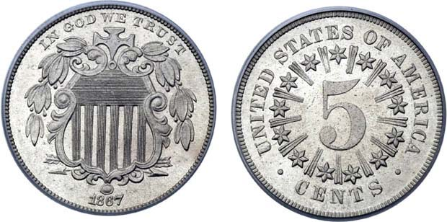

1867 Shield Nickel with Rays

The Shield 5¢ nickel series has been generally overlooked by collectors and one of the more underrated dates is the coin you see pictured above; the 1867 with rays. With a mintage of 2,010,000 compared with the 28,890,500 the 1867 no rays variety, the Coin Dealer Newsletter’s Monthly Supplement lists an AU at $215 for the former compared with $80 for the latter. As expected, right? Wrong! The 1867 with rays is much scarcer than that in AU and higher.

Kindly Patronize Our Advertisers

