Pres. Willie Simon
V .P. James Barry
Sec. Helen Barry
Treas. Pat James
Sgt. in Arms: J.J. Engel
Committees:
Programs: James Barry
Show Chairman: JJ Engel
Newsletter: Arno Safran
E-Mail: arnosafran@comcast.net
The Stephen James
CSRA Coin Club of Aiken
P.O. Box 1739
Aiken, SC 29802
Web site: www.sjcsracc.org
The SJ CSRA CC Now Meets on the 2nd Thursday of the Month at the Cedar Creek Community Center in Aiken, SC

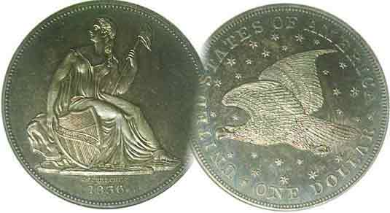

Volume 6, Number 7 the Stephen James CSRA Coin Club, Founded in 2001 July, 2007
Monthly Newsletter
43 Members Renew for 2007-08 Fiscal Year
Our next meeting is on the 2nd Thursday of the month, July 12, 2007 at 7:00 PM
2007 Club Meeting Schedule - 2nd Thursdays at 7 PM Jan. 11 Apr. 12 July 12 Oct. 11
Feb. 8 May 10 Aug. 9 Nov. 8
Mar. 8 June 14 Sep. 13 Dec. 6
Annual Club Show: Sat. Sept. 15, 2007
_____________________________________________________________________________________________________________________________

43 Members Renew Before June 30 Deadline

To date, forty-three members have renewed for 2007-08. Among our regular attendees are collectors, those who have dealt in coins from time to time and one or two full time dealers. To be a successful as a dealer, one has to be familiar with the status of the market, coin values, grading and authenticity. Attendance by collector-dealers at meetings can cut two ways; assisting newer collectors by guiding them through some of the finer points of the hobby such as grading and desirability while displaying their own coins for attendees to view and perhaps purchase before or after the business portion of the meeting.

We have an extremely attractive meeting site--and while it may be slightly out of the way for some--we have been averaging between 20 and 25 members per meeting. More attendees beget more interesting coins in the auction. More dealers setting up stimulate greater collector interest. These two factors produce what is referred to as a symbiotic relationship between collector and seller and help to strengthen the local coin club in the process. We already have interesting Show & Tells and fine programs at every meeting. So, if you not only collect, but occasionally deal in coins, please join us on a regular basis and set up at a table for a nominal $2.00 charge.

At our June 14 meeting Merle Davis, Jr. presented a program on “the History of Wooden Nickels” and Jim Barry displayed two Roman coins portraying martyrs husband and wife Germanicus and Agrippina, both believed to have been executed by the emperor Tiberius. At our upcoming meeting on Thursday, July 12, Tony Chibbaro will be presenting a program on South Carolina tokens and medals.

Prize winners included Paul Simons who won the 2007 silver eagle door prize and Jim Barry took the 50/50. Congratulations gentlemen.
_____________________________________________________________________________________________________________________
Collecting Reduced Size Capped Bust Quarters
A short Series less challenging than Large Size Quarters
By Arno Safran

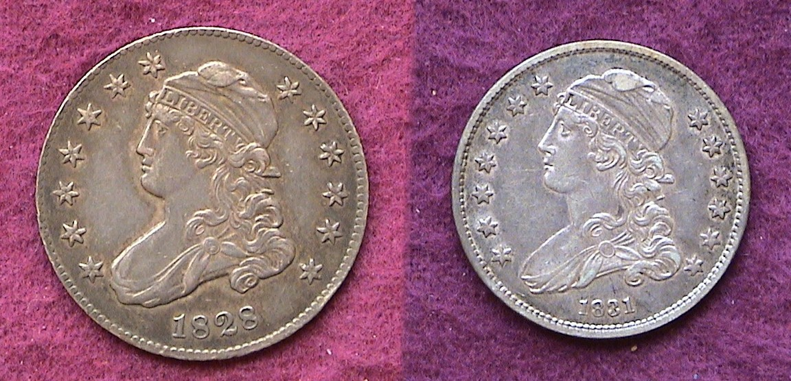

Obverses of an 1828 large Bust 25¢ (l) and 1831 small Bust 25¢ (r)

Collecting early US quarters (1796-1838) has become more challenging. With an increase in the collector base during the past six years fewer problem-free circulated examples are coming on the market. Throughout its first four decades quarter dollar mintages seldom exceeded 300,000 in a single year. In fact, it would not be until 1835 that the 25¢ coin would reach a million in production with almost 2 million struck. Compare those figures with the almost 3 billion struck in 2006.

Back in 1829 improvements were undertaken in the coining process. Among them was the striking of coins in a closed collar that established a standard diameter within their respective denominations. After the last large Bust quarters were struck in 1828 quarters were temporarily suspended. In 1831 they were resumed but substantially reduced in size from 27 mm to 24.3 mm; (roughly one inch in diameter) the same as today. The chief engraver, William Kneass modified John Reich’s obverse design while removing the scroll with motto from the reverse.

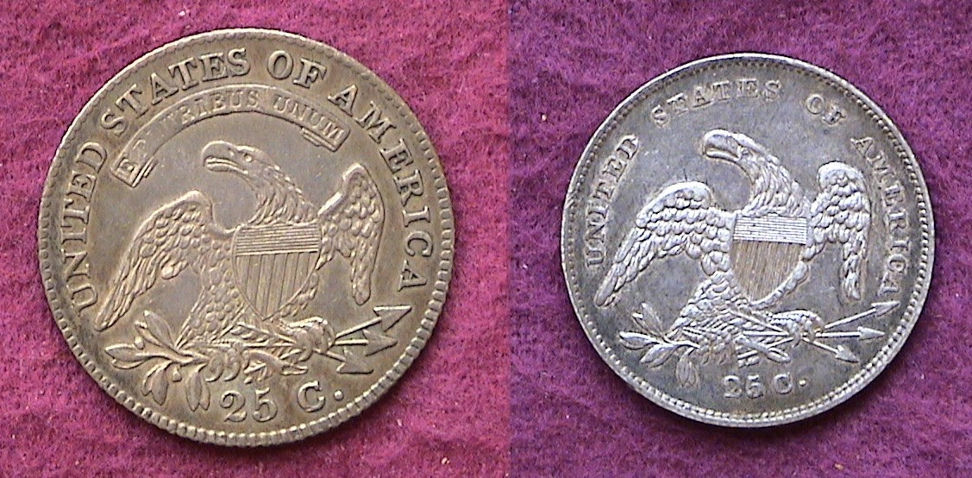

Reverses of the 1828 large Bust and 1831 small bust quarters
___________________________________________________________________________________________________________________
(Continued on page 2, column 1)

Collecting Reduced sized Bust Quarters
(Continued from page 1, column 2)

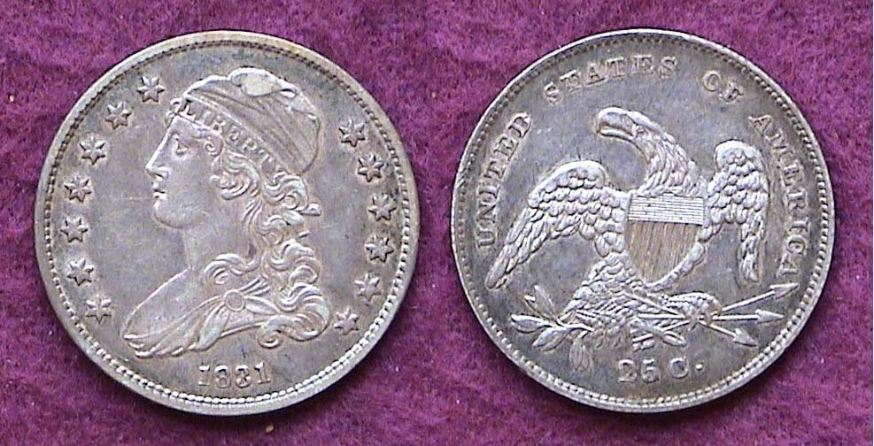

An 1831 Bust Quarter B-3 R5 grading XF-40, mintage, 398,000
Reduced size Bust quarters were struck in consecutive years from 1831-1838

From 1796 through 1818, quarters were seldom struck on a regular yearly basis. After 1807 no 25¢ coins were issued until John Reich’s resplendent Capped Bust type was introduced in 1815; then, none again until 1818. Large Bust quarters were dated from 1818 through 1825 inclusive and again in 1827 & 1828 though in two of those years, 1823 and 1827 only a handful survive and are essentially non-collectible. Recorded mintages are also unreliable since in the early years of the Mint, a coin’s date was no guarantee that it was struck in that year.

Beginning in 1831 this pattern changed. The small Capped Bust quarter was struck in each year of its type run (1831 to 1838 inclusive); then continued to be coined in consecutive years under different types all the way through 1921.

[The first break in the series came in 1922 when no quarter dollars were made. Since then, regular dated quarters have been omitted only in the Depression years of 1931 and 1933. During our Bicentennial celebration, quarters along with the half dollar and dollar coins received dual dates 1776-1976 in both 1975 and 1976. These named have been the only exceptions in the consecutive yearly date procession of 25¢ pieces since 1831.]

Collecting a complete date set of reduced size Bust quarters (1831-1838) should be easier than the earlier large set group (1815-1828). For one thing, the mintages are larger. For another, the type is far less popular than its predecessor with demand still fairly low. For a third; all dates are priced about the same which means there are no rarities among the group. The 1831 quarter had a mintage of 398,000 compared with the 1815 first year for the large size quarter of just 89,235. The 2008 Red Book lists most dates at $95 in F-15, $140 in VF-20, and $325 in XF-40. At only $95, the grade of Fine is a “Best Buy” since Goods and Very Good’s are listed at $70 and $80 respectively.

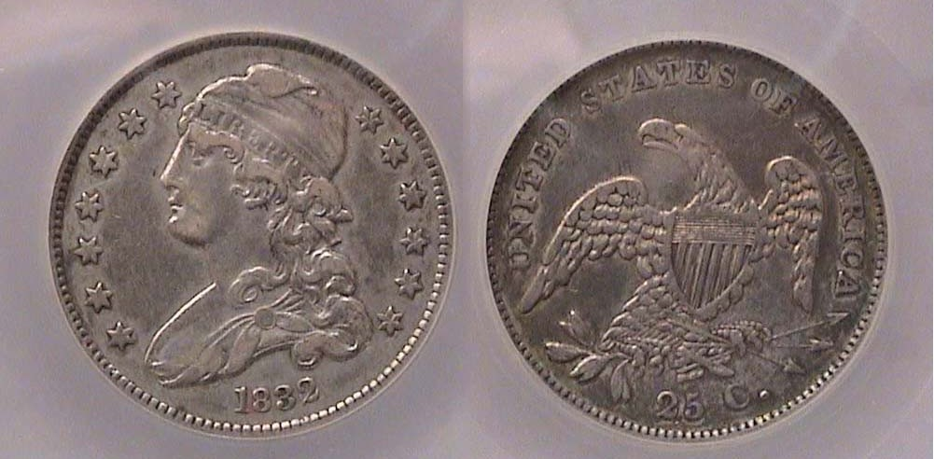

An 1832 Bust Quarter B2 R2 grading XF-40 with 320,000 minted

The reader will observe the letter B followed by a number under each picture. The B stands for A. W. Browning collector and dealer of Bust quarters and author of “The Early Quarter Dollars of the United States: 1796 thru 1838”. The first number represents the die variety and the second its rarity with 1 being the most common and 8 being extremely rare. Prices begin to increase--even for a common date--from R4 on. For 1831 there are now seven known die varieties of which the third and seventh are R5’s, rare. The foregoing said, there are only two known die varieties for 1832 of which both are fairly common.

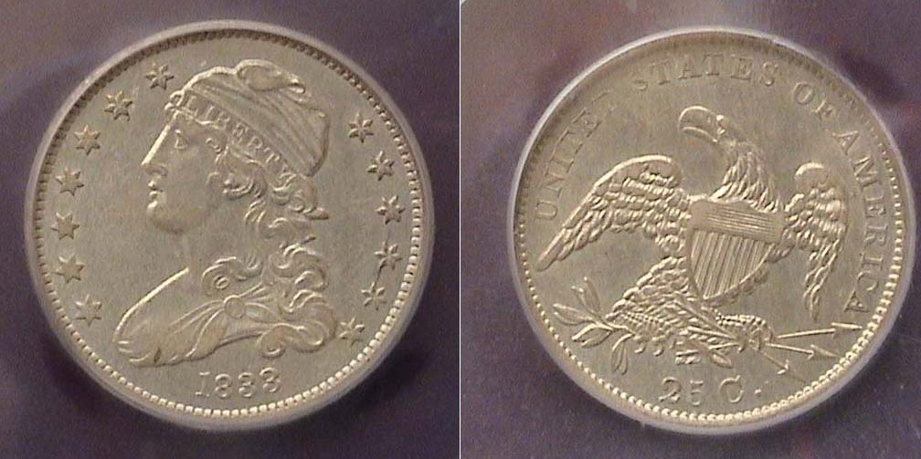

An 1833 Bust Quarter, B1 R2 graded AU-50 by IGC; mintage 156,000

If there is said to be a “key” date to the short series, then the 1833 issue perhaps is it. Only 156,000 were struck that year according to Mint records. Despite this, the 1833 is only slightly more costly to acquire than the others. There are only two varieties for this date, both considered R1s but on the reverse of the second one--not shown--there is no period at the right side of the C in 25C and there are only two vertical gules running down the shield. This same reverse appears on the 1834 B-1 and 1835 B-7.

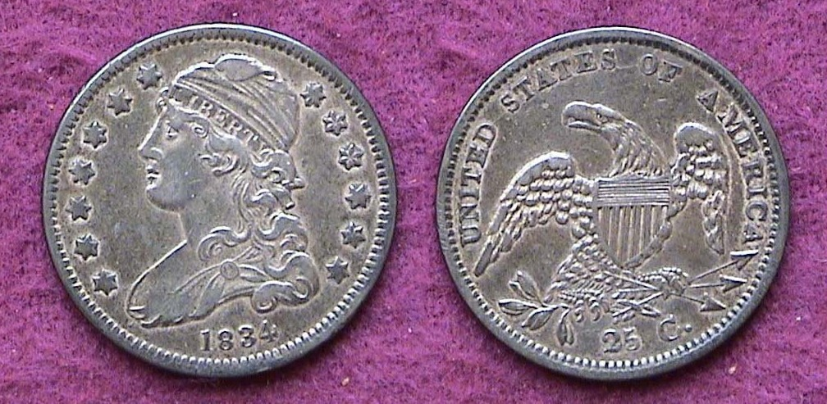

An 1834 Bust Quarter, B4 R1 grading XF-45, mintage 286,000

There are five varieties for the 1834. The one show above is the most common. Varieties are attributed on the obverse by the position of the last digit in the date to the curl, the relationship of the upper left star to Liberty’s headband and the distance between the lower stars to the Bust.. There are other points of attribution as well.

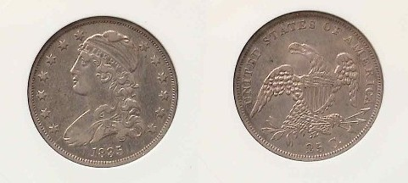

An 1835 Bust Quarter B6, R5 graded XF-40 by Anacs
Reported mintage 1,952,000

If one is interested in only one date for type, the 1835 quarter--with a mintage of almost 2 million--is likely to be the most readily available. In fact 1835 was a banner year for Bust silver coinage as the half dime, dime and quarter were produced in record numbers; each with well over a million. The half dollar received more than 5,350,000 which is the fifth highest in its series. The 1835 has the most varieties; eight in all, of which
________________________________________________________________________________________________________________________
(Continued on page 3, column 1)

Collecting Reduced Size Bust Quarters
(Continued from previous page)

the sixth is rare and the eighth is very rare. Only the first, second and seventh variety are considered common.

In addition to the no period variety after 25 C, other points of attribution on the reverse are determined by approximate distances between specific diagnostic points. These include how close or far away the 25 C is from the eagle’s talons or the lower border, also the distance of the arrows to the right side of the coin; also the size of the letters in the legend; UNITED STATES OF AMERICA and whether the eagle has a tongue or not. The aforementioned Browning attribution guide book is an inexpensive paper back that helps guide the collector.

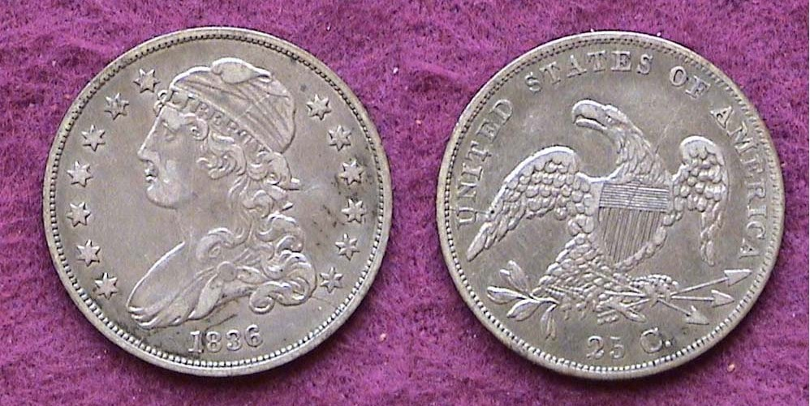

An 1836 Bust quarter B2 R4 grading XF-45, mintage 472,000

The 1836 Bust quarter is the second most common of the eight year series but falls far short of the previous year’s record. Varieties 2 and 3 display interesting die cracks.

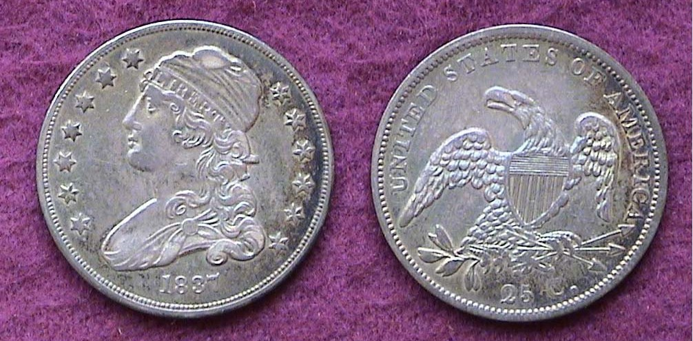

An 1837 Bust Quarter, B2 R2 graded AU-50, mintage 252,400

The 1837 has the second lowest recorded mintage with five known die varieties; four of which are rare to extremely rare. Alas, the coin shown above is the only common variety for that year and not worth a premium. The fascination with collecting early US coinage--especially the quarters for which the collector base is still not very large--is the opportunity for discovery. The three later varieties; B3 through B5 were all recent discoveries by collectors who took the trouble to study the series and their known attributions. When their collections sold at auction years later, their finds realized extensive gains over the original purchase price.

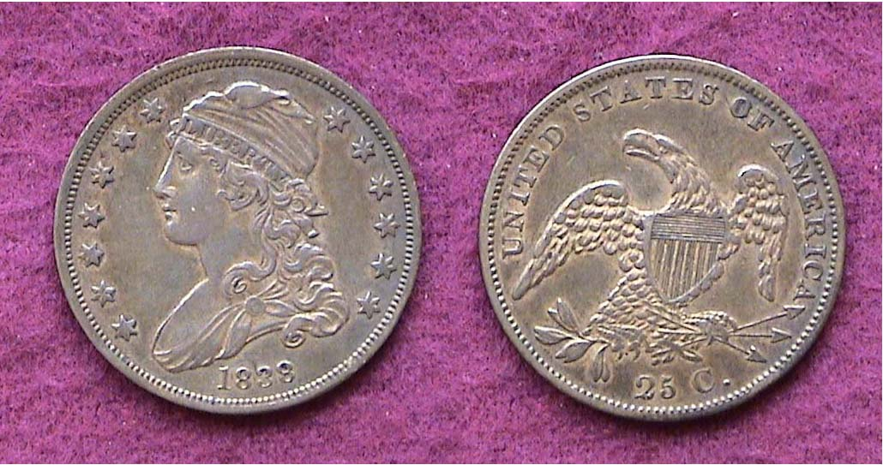

An 1838 Bust Quarter B1 R1 graded XF-45, mintage 366,000

The last date in the series is 1838 for which there is only one known die variety. Later that same year, the new liberty Seated design of Christian Gobrecht replaced the William Kneass’s Capped Bust. The new obverse type would continue through 1891 albeit with a number of modifications.

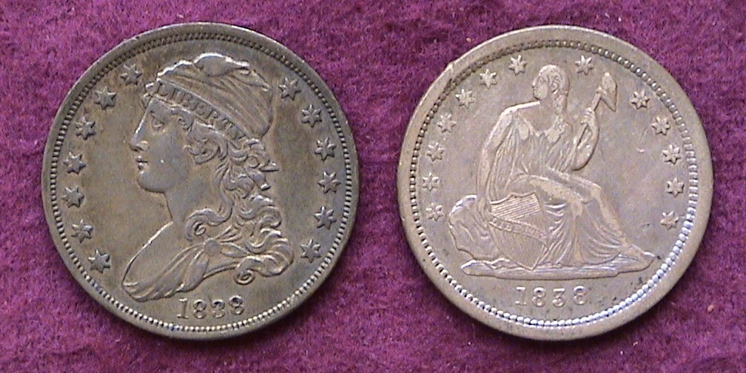

1838 Bust and Liberty Seated quarter obverse types

Originally, the reverse of the new Liberty Seated type was to display Gobrecht’s soaring eagle that appeared on the 1836 dollar coins after Titian Peale’s sketch but for some reason-- never fully explained--the Mint Director Robert Maskell Patterson instead chose to retain Reich’s old Pterodactyl-like eagle with minor modifications. With the striking of some 366,000 in the first portion of 1838 the Capped Bust quarter- type finally came to an end.

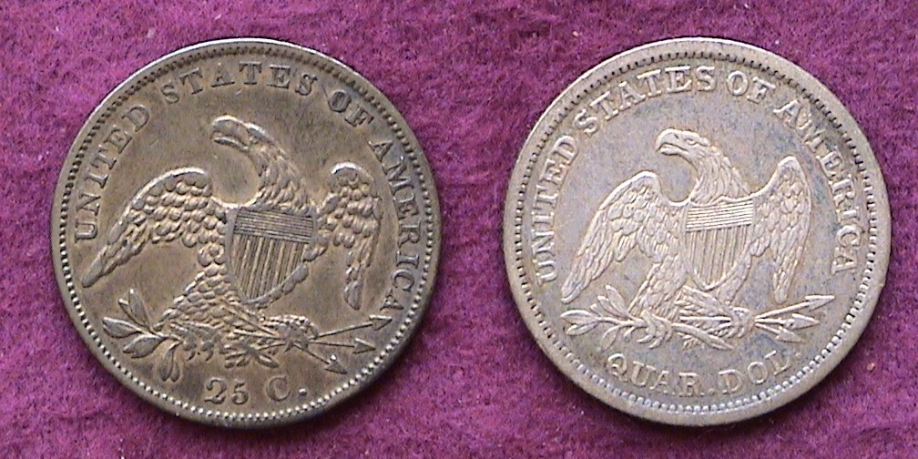

Reveres of the 1838 Capped Bust (l) and Liberty Seated quarters (R)

[For those receiving this by E-mail it is recommended that you magnify
all the coin pictures up to 200% for greater clarity of detail.]

At the time the small Bust size quarters were issued the purchasing power of the quarter dollar averaged $6.00. Andrew Jackson was completing his first of two terms as 7th US President and by the series’ end, Martin Van Buren was serving the second year of his only term as our 8th US president.

The reader can see that all the coins accompanying this article are neither Uncs nor low grade circs. They range between XF-40 and AU-50 and are generally problem-free. Both the large Bust and reduced size quarter sets took 23 years to assemble as they were acquired between 1979 and 2002. While the small size Bust quarter series (1831-38) is arguably less aesthetically attractive than the large size quarters with motto series that preceded it (1815-1828), the author welcomed the challenge of the hunt for these more readily available dates that can still be somewhat elusive in problem-free condition. With the greater collector base yearning for the same material it is becoming increasingly more difficult to acquire mid grade circulated obsolete coins of this era in quality condition. That said it may not be too late to try. Happy hunting!
_________________________________________________________________________________________________________________________

Have a favorite coin or series you like to share with readers? Send via e-mail to the editor at arnosafran@comcast.net.

___________________________________________________________________________________________________________________
Coins of the Month: Remember When?
Happy Independence Day
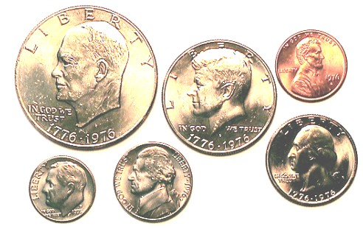

A set of 1976 Bicentennial clad obverses averaging MS-60 to MS 63
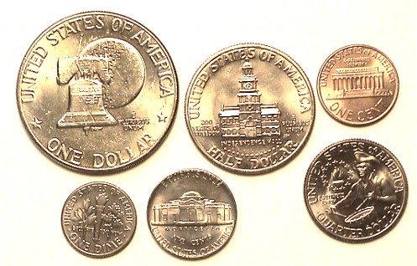

A set of 1976 Bicentennial clad reverses averaging MS-60 to MS 63

1976 was an important year for numismatics in America. The proposed two-year Bicentennial coinage issued in 1975 and 1976 as part of the upcoming Independence Day celebrations scheduled for July 4, 1976 had become a reality. Like the statehood quarter program--initiated almost a quarter of a century later--these special bicentennial reverses seen on the quarter, half dollar and dollar helped to stimulate greater interest in coin collecting. As with many an entry-level collector, some newcomers began trying to assemble Mint sets or Proof sets from the present going back to their youth.

In 1975, the San Francisco Mint stopped issuing Lincoln memorial cents for circulation. If one wanted to continue to keep the S portion of the cent series going you had to acquire the 1975 clad proof set. Prices began to rise and by July, 1976, the 1975 proof set--which originally sold for $7.00--was retailing for $28 and rising. Neophyte collectors--unsure of their grading skills--preferred buying modern US government issues. At least one would be receiving an uncirculated coin that was uncirculated. The unseasoned collector knew nothing about the finer points of grading such as the difference between a MS-60, 63 or 65; but as the two larger coins shown above display bag marks, a week strike with little luster and would probably grade no better than MS-60; these refinements were lost on the entry level collector of that era. As a rule, the coins coming out of the Philadelphia Mint were not as well made as Denver Mint products. Like the 1964 Kennedy 90% silver half dollar which was saved by the millions, Bicentennial coinage of all kinds, whether clad, 40% silver clad uncs or proofs have risen little if at all due to the enormous mintages and hoarding that has occurred. If one takes the trouble to search for true MS-65 or better business strikes of the bicentennial coins and the 1976-P Roosevelt dime with full torch bands on the reverse, you may have acquired some unusual rarities for your grandchildren.
_____________________________________________________________________________________________________________________________
Kindly Support Our Advertisers

