Pres. Steve Kuhl
V .P. Pat James
Sec. Jim Mullaney
Treas. Chuck Goergen
Sgt. in Arms: Glenn Sanders
The Stephen James
CSRA Coin Club of Aiken
P.O. Box 11
New Ellenton, SC 29809
Web site: www.sjcsracc.org
The SJ CSRA CC of Aiken, SC meets on the 1st Thursday of the month at the Aiken Public Library

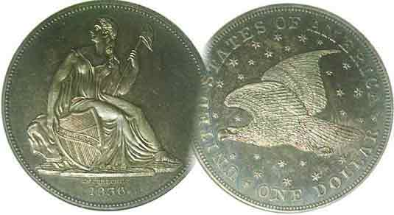
Programs: Pat James
Show: by Committee
ANA Representative: Jim Barry
Publicity: Pat James
Newsletter: Arno Safran
E-Mail: arnosafran@comcast.net
Auctioneer: Glenn Sanders
Web site: Susie Nulty (see above.)

2012 Club Meeting Schedule
Volume 11, Number 7-8 the Stephen James CSRA Coin Club, Founded in 2001 July, Aug. 2012
Monthly Newsletter
Club Treasurer’s slot and Publicity post filled
Our next two meetings are on Thur. July 5 & Aug. 2, 2012 at the Aiken Public Library

Jan. 5 Apr. 5 July 5 Oct. 4
Feb. 2 May 3 Aug. 2 Nov. 1
Mar. 1 Jun. 7 Sep. 6 Dec. 6

______________________________________________________________________________________________________

Summer Issue

On August 7-11, the American Numismatic Association will be holding its annual World Money show at the Pennsylvania Convention Center in Philadelphia. A number of our members plan to attend including the editor. The City of Brotherly Love also offers an opportunity to visit the Philadelphia Mint and the marvelous museums there. This double issue will be the last until the September edition which will be sent out before our Sept. 6 meeting & Sept. 8 Show.

Since our last meeting, the posts of Treasurer and Publicity have been filled. Chuck Goergen has volunteered to take on the duties of club Treasurer and has been appointed by President Steve Kuhl to fill that office. Thank you, Chuck. Since no one volunteered to take on the position of Publicity, VP Pat James decided that she could handle it line with her duties as Programs Chairperson. Thank you, Pat. At least for this current fiscal year we now have a full slate of officers and committee chairpersons.

About a year ago both gold and silver were surging. Gold was heading towards the unchartered $2,000 an ounce mark. Silver at $49.00 an ounce, was perched to break the $50.00 an ounce mark set back in April of 1980. Neither happened! Instead, the bullion market has stalled. Today gold swings from around a high of $1,635 to a low of $1,550 while silver ranges from $26 to $29 an ounce. With the world economy uncertain, the job market wobbly at best, the numismatic market has began to shift once more. A year ago, most coin shops were trading exclusively in bullion items. Today, dealers are beginning to restock their inventory with affordable to better date type coins. Unlike the Hunt Brothers fiasco in 1979-80, the bullion market of 2008 thru 11 never “crashed”. It has just sagged. If you want to buy a Saint-Gaudens double eagle in MS-62, you will still have to pay well over $1,700 to obtain one, a far cry from the 2005 price of $500.
__________________________________________________________________________________________________________________________

Collecting the US Coins of 1812: 200 years ago
By Arno Safran

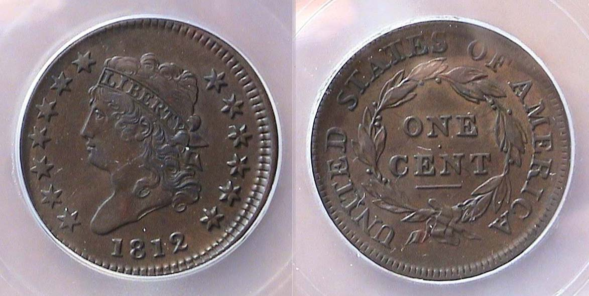

An 1812 Classic Head Large Cent, S-290 graded AU-50 by ICG
[Use 3x magnifying glass or magnify page to 200% to view details.]
The coin image shown is actual size when printed.

The year 1812 is well known in US history as our young nation once again became embroiled in a war with Great Britain. Our democratically elected leader at the time was James Madison, architect of the US Constitution and fourth President of the United States. If one thinks the polarization between our politicos is extreme today, one has only to go back two centuries to discover a president having a bad time of it. Back then it was a young group of politicians known as “the War Hawks” who were giving the president fits. The embargo President Madison tried to enforce against the British navy--which had earlier commandeered a number of our US commercial vessels who the Brits believed, had given safe passage to British deserters--was not working. By 1811, it had become increasingly unpopular with the result that the war hawks in Congress such as Henry Clay of Kentucky and John C. Calhoun of South Carolina were putting pressure on Madison to declare war on the British with the hopes of taking Canada, Florida and Mexico in the bargain. Madison suggested that if they would support him for reelection, he would go to war against Great Britain.

One of the casualties of this unsettling period was our coinage program as only three denominations were issued in 1812, the copper large cent, the silver half dollar and the gold $5.00 half eagle. The Classic Head cent pictured above is one of a reported mintage of 1,075,500. It is an extremely attractive specimen but rare in such a high state of preservation. Why was this so?
_______________________________________________________________________________________________________________________
(Continued on page 2, column 1)

Collecting the US Coins of 1812
(Continued from page 1, column 2)

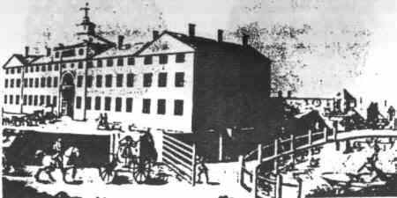

The Soho-Birmingham, England Works
[Courtesy www.eicships.info/ships/s815/boulton.htm]

During the early years of our republic, the US Mint obtained its copper blanks for making cents and half cents from the manufacturing firm of Matthew Boulton, which was located in Soho-Birmingham, England. At first, the quality was excellent. It has been suggested by some numismatic scholars that as tensions began to increase between America and England after 1807, some of the workers at Boulton’s company began inserting the poorer quality planchets underneath the problem-free shinier copper specimens intended for shipment to the US. Another explanation for the poor quality of many of the planchets may have been caused by their storage in porous wooden kegs with the result that during the several weeks voyage from Great Britain to America, the dampness caused the blanks to turn black and corrode. As the copper shortage increased the Philadelphia Mint was compelled to strike cents using these marred planchets with the result that today, many survivors would not pass third party certification due to environmental damage. Classic Head cents grading as low as VG-8 that appear chocolate brown in appearance are worth a considerable premium over dark, corroded or porous coins.

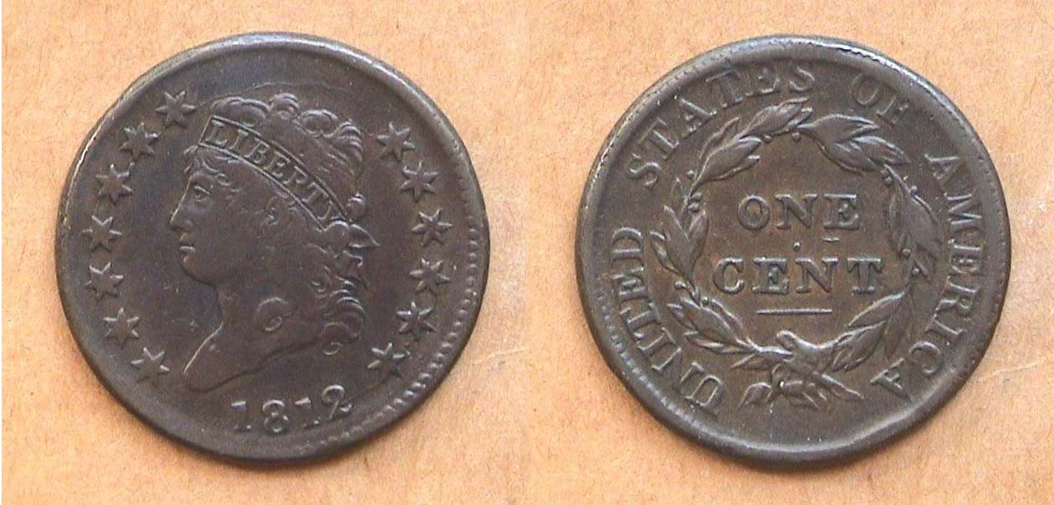

Another attractive chocolate-brown 1812 Classic Head cent, S-291.
This one grades about VF-25 and it is a much scarcer die variety
[Use 3x magnifying glass or magnify page to 200% to view details.]

In the early years of our coinage, the Mint used the screw press, already considered obsolete by British standards. Many of the details were hand punched into the dies. When a die wore out a new one was prepared, each having different characteristics. Coins struck from dies with short life spans are scarce and command higher prices over those with longer spans. The 1812 cent shown directly above comes from a short-lived die variety. It has a small horizontal bar directly below the letter E in ONE on the reverse. This coin was acquired in 2005 at a Whitman show held at the Cobb Galleria in Atlanta.
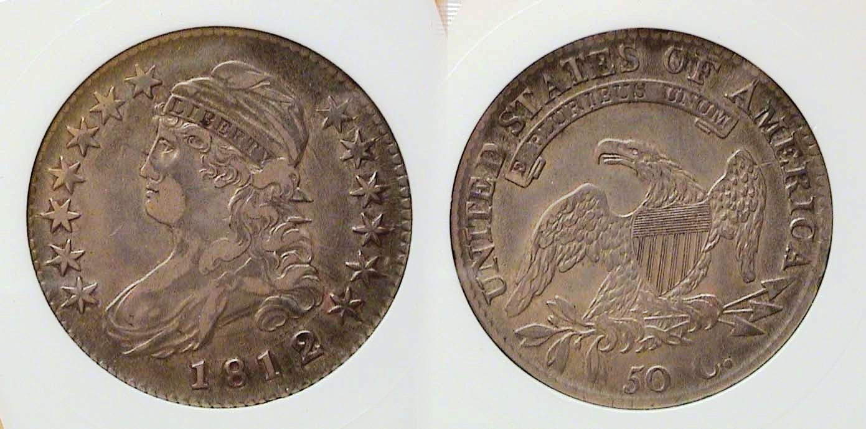
An 1812/11 O- small 8 Capped Bust Half Dollar graded XF-45 by Anacs
[Use 3x magnifying glass or magnify page to 200% to view details.]

After 1804, the dollar was suspended with the result that our largest circulating silver denomination was the half dollar. In 1807, John Reich was brought into the Mint as Asst. Engraver to Robert Scot and was assigned the task of redesigning all our coinage. The first silver coin Reich designed was the lettered edge Capped Bust half-dollar. It would be struck from 1807 thru 1836. The obverse bore the Bust of Miss Liberty facing left, with thirteen stars punched around the figure with the date centered below. The reverse displayed a spread eagle with the motto E PLURIBUS UNUM placed above it and around the sides along the upper portion of the circumference, the legend UNITED STATES OF AMERICA. The denomination 50 C appeared below. Along the edge was etched FIFTY CENTS OR HALF DOLLAR. The coin contained .8924 silver bonded to .1076 copper. The coin weighed 13.48 grams and a had a diameter of approximately 32.5 mm, larger than the 30 mm half-dollars produced from 1836 on. In 1809, the coin was slightly modified. Like the Morgan dollar of the later years, Bust halves were used as specie by banks to back business transactions and did not circulate much. They were struck in large numbers with most dates ranging from over one million to six million a year.

The 1812 issue had a reported mintage of 1,628,059 that included ten different die varieties with two overdate sub-types, the 1812/1 with a small 8 that is common, (shown above) and the 1812/2 with large 8 in date that is quite rare and expensive today. A collector armed with this knowledge can sometimes acquire a rare variety of a particular Bust half (or Classic Head large cent) for a common date price from a dealer whose numismatic knowledge is based more on mintage figures.

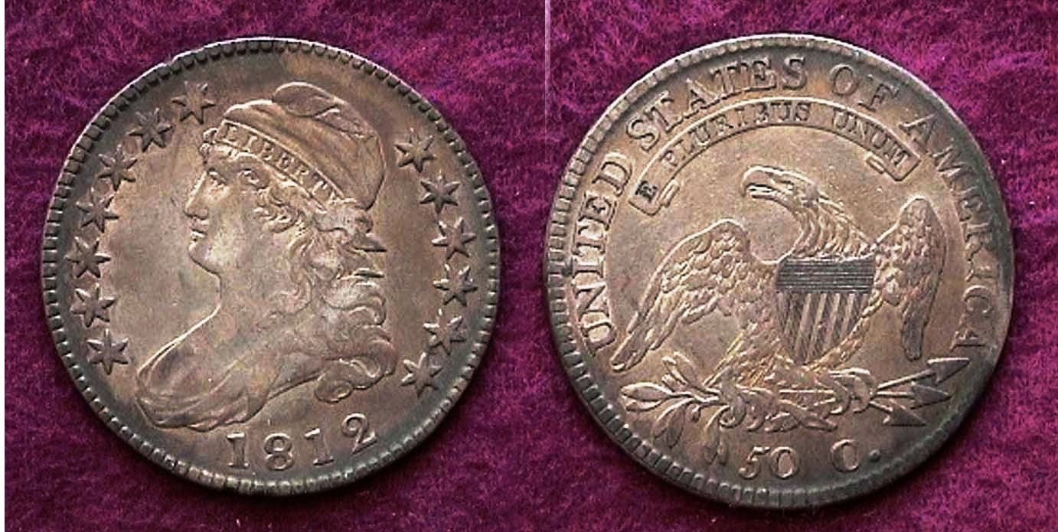

Another 1812 Bust half, O-104 R1 with normal date, a common variety
[Use 3x magnifying glass or magnify page to 200% to view details.]

In 1812, 50¢ had the purchasing power of what $8.75 could buy today. This is one of the more popular coin types sought by collectors. While assembling a complete date set is possible, many prefer to collect by die variety hoping to find a rare one.
________________________________________________________________________________________________________________________
(Continued on page 3, column 1)
Collecting the US Coins of 1812
(Continued from previous page)

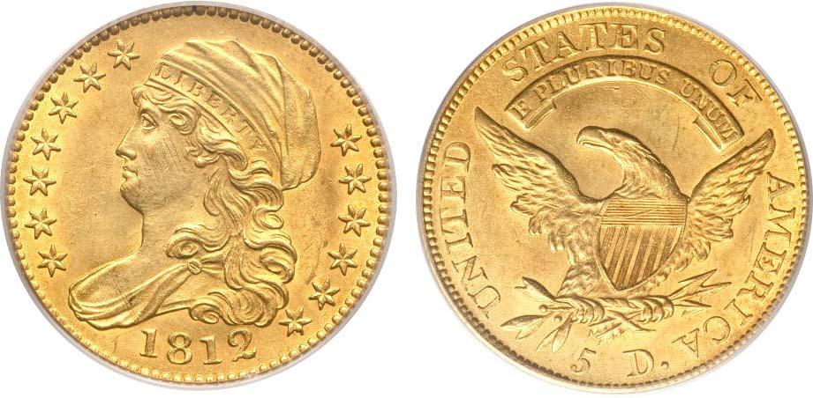
An 1812 $5.00 gold half Eagle graded MS-63 by PCGS
[Use 3x magnifying glass or magnify page to 200% to view details.]
(Courtesy of Heritage Auction Archives)

In 1812 a $5.00 gold piece had the purchasing power of $85.00 but as recently as one year ago a collector desirous of an attractive uncirculated specimen had to shell out $27,025 at the Heritage Auction in order to acquire one. The 2013 Red Book lists its retail value in MS-63 at $28,500, so the buyer paid close enough to the coin’s estimated retail value at the time.

The reasons the 1812 $5.00 half eagle is beyond the reach of most collectors today can be based on three factors. The first is mintage: The reported mintage for the 1812 half eagle was a scant 58,087, a far lower figure than either the cent or the half dollar that were coined in the millions. Another reason for the scarcity of our early gold coins had to do with a large number of them being transported to European markets because of their higher gold value further reducing the number of survivors. Lastly is the tremendous increase in the value of gold since 2006 when an 1812 half eagle grading MS-63 was listed at $15,000 then compared with $27,500 today.

Our early Half Eagles weighed 8.75 grams and were composed of .92.7% gold and .083% silver. They were 25 mm in diameter (or slightly larger than our modern quarters). The 1812 Cap Bust facing left $5.00 gold piece is a beautiful work of art to behold, but for most of us will not likely find a place in any of our collections. Today it is hard enough to find an attractive 1812 Classic Head large cent paired with a Bust half of the same date that will half to suffice for one’s 1812 US year set.

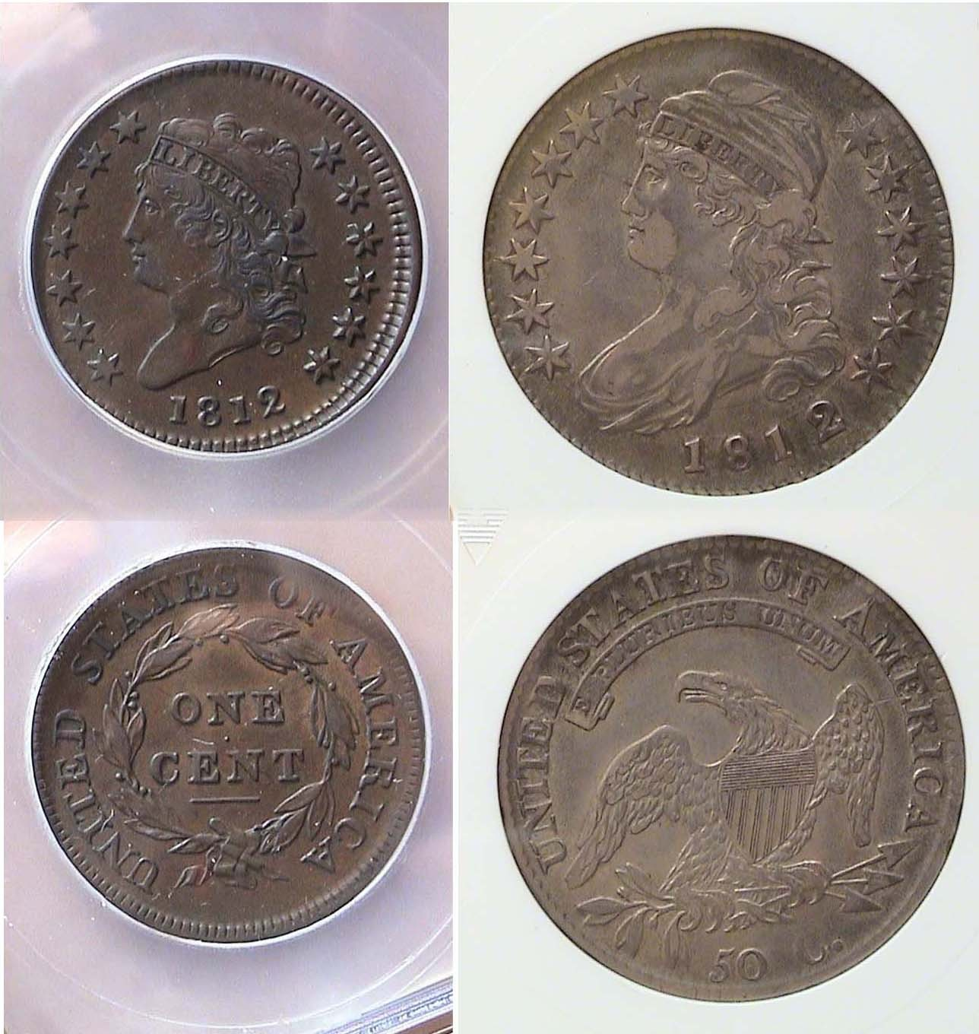

An 1812 Year set (excluding gold), the Cent & Half dollar
[Use 3x magnifying glass or magnify page to 200% to view details.]
_________________________________________________________________________________________________________________

Club News

At the beginning of every meeting President Kuhl asks our Sgt. in Arms and auctioneer Glenn Sanders to read off the number of members and guests in attendance and report on the upcoming regional shows for the month. Glenn does an excellent job not only providing the dates and directions to each event but having attended many of them from Charlotte to Atlanta over the years, gives our members an overall appraisal of each. These include the number of tables, estimated number of dealers, size of the hall, ambience and likely offerings the collectors might find. How many of our current members are taking advantage of this valuable information is uncertain, but Glenn’s contribution is welcomed and is to be applauded.
President Kuhl also announced that the post of Treasurer was filled with member Chuck Goergen volunteering to serve in that position and Publicity with VP and Program Chairperson Pat James offering her services in that area as well. He thanked both Chuck and Pat who received a warm hand of applause from the members.

There were three Show & Tell exhibits: Before mentioning what numismatic item he brought in, member Rick Owen offered his fellow members a special promotion: He would pay their first year dues to the South Carolina Numismatic Association for member who wished to join. He then displayed five certified US type coins he won at a recent Heritage Internet auction. These included an 1857 Mature Head large cent with the large date, the scarce key date 1912-S Liberty nickel and the 1892 Barber Liberty Head dime, quarter and half dollar. The half was graded VF-35 by PCGS but in that grade the 1892 50c piece is scarcer in circulated condition than unc because first year issues tend to be saved in mint state. The particular specimen was attractive and original.
Arno Safran displayed a 1942 P, D & S BU year set each housed in a Capital Lucite holder. He mentioned that despite being 70 years old, as early as 1934, dealers began putting rolls of new coins away in large numbers intended for future sales. This accounts for so many of these earlier dates being affordable in BU today. Chuck Goergen displayed one of the Latin- American silver dollar sized 8 Reales from the portrait series.

The Program: Arno Safran gave a PowerPoint presentation on "Collecting the US Coins` of 1875", the year his maternal grandfather was born. Scenes of New York City during the three quarter century mark were interspersed with coins from Arno’s collection which featured the 1875 Indian Head cent, 3c nickel Shield nickel, 1875-S Liberty Seated dime, the 1875cc 20c piece, 1875 quarter and half dollar and an 1875-S Trade dollar. Arno stated that for the most part 1875 mintages were plentiful depending on the Mint (excluding gold). For the scarce to rare gold issues, he pictured examples from Heritage’s Auctions Archives website along with prices realized at recent auctions. Our next program will be an ANA video, “Old Man Dodge and his Coins”.

The prizewinners at the June 7 meeting were Chuck Braun – a 1957 proof Franklin Half dollar and Jim Mullaney who won the 50/50. $13.00 Congratulations gentlemen! Our next meeting is July 5. Bring in something for Show & Tell and the Auction.
__________________________________________________________________________________________________________________________
How to Grade Early Copper Coins
By Nick D'Amico

It is my opinion, and the opinion of many early copper experts, that the major grading services do not do a very good job of grading the early copper coins they encapsulate for us-that is, Colonial issues, half cents, and large cents. Therefore, laid out before you is the proper way to evaluate the grade and condition of these beautiful copper pieces that we love so much.

The mistake the grading services make is on an overall basis they do not grade early copper taking into consideration the small defects that can bring down the grade and value of a coin. They seem to grade the coin on a “sharpness” basis or the first glance look of the coin-how much of the coin’s design/relief is still left on the planchet. This would be fine if all early coppers came in MS65 condition with absolutely no rim bumps, no gouges, no scratches, etc…But we know that type of a find is virtually impossible and especially when it comes to early copper.

Simply stated, the proper way to grade early copper coins is to first look carefully at the coins and determine what the sharpness grade of the coin in question is; for example VF-20, XF-40, or MS-63. Be certain to explore the coin for subtle and sometimes not so subtle damage, such as on the surfaces and rims. Does the coin have rim bumps or heavy scratches? Has the coin been cleaned harshly-are whizzing marks or surface hairlines present? Has the coin been dipped in a solvent to brighten it or otherwise re-colored or doctored in some way? Is the planchet granular or corroded? These factors all contribute to the overall grade and value of the coin.

Next, after one has determined the sharpness grade of the early copper piece, taken into account the defects of the coin, and ascribed a numerical value to the defects (a net grade of defects), the astute person then subtracts the numerical value of the defects from the sharpness grade of the coin and comes to the coin’s final grade. A simple example is:

Sharpness grade AU50
Net grade of defects (rim bumps) - 10 grade points
Final grade XF40

Now, a relative price can be set for the coin using whatever price guide the purchaser prefers, but early copper experts who purchase and sell these coins on a regular basis use a price guide named “Copper Quotes by Robinson” which takes into account auction prices realized for very rare, and even not so rare, die varieties of half cents and large cents and even private treaty sales when same are recorded in order to find what they call the “real money” or price. For our purposes we should stick to the commercial coin price guides available at our local newsstands, bookstores, etc…

On a related note, the truth of the matter is when ANACS began grading and certifying Morgan Dollars for collectors and dealers back in the 1970’s they used the method of coin grading herein exemplified. They would quite often grade both sides of the coin differently finding the obverse to be MS-63 and the reverse to be MS-65 bringing the NET GRADE
to MS-64. They were on the right track, but this practice (sadly,
in this writer’s opinion) has been abandoned by the major
grading services and we are quite often left with improperly certified, graded, and “holdered” coins.

Generally, the quality of the early copper planchet does not come into play where grade is concerned until a sharpness grade of Fine to VF20 is reached. Planchet quality takes into account surface granularity or porosity, but several of the early coppers we love so much inherently come with these planchet quality issues because many of the 1793 through 1814 large cents were struck on low quality planchets supplied to the Philadelphia mint. Unscrupulous British planchet dealers/makers quite often threw iron nails into the copper mix to “make the weight” of a barrel thus creating a copper/iron alloy, stealing from the purchaser, and the quality of the copper planchet was affected. However, and for example, a 1794 large cent with an evenly granular surface is still a very collectible and valuable coin, depending, of course, on its grade.

Honestly, it takes years of experience and looking at many, many coins to become an expert grader. On the other hand, the collector can put into practice this proper system of grading early copper and minimize possible monetary losses when negotiating the purchase price of a coin. Many dollars have been saved by astute copper collectors/purchasers by using this system.
At the risk of being long-winded, noted below is a condition-range of how early copper collectors consider the condition of a coin:

Choice: Color pleasing to the eye
Surfaces are smooth
Rims have no defects
No significant marks on planchet

Average: Color is reasonable-looks original-not altered
If porosity exists it must be uniformly/even
Porosity must not detract from eye appeal

Scudzy: A rather ugly piece w/several marks,
harsh cleaning, wrong color, severe scratches

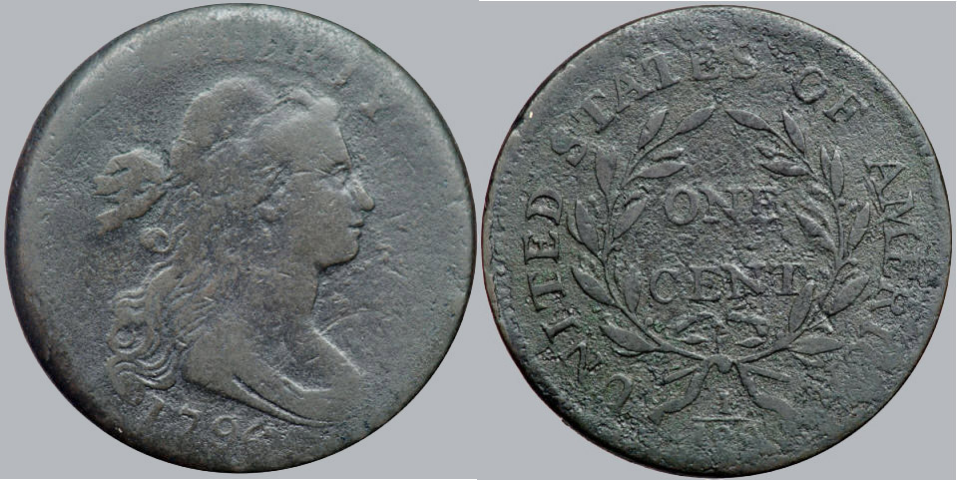

A 1796 Draped Bust 1c, S-92 R3 graded G-4 Scudzy
[Use 3x magnifying glass or magnify page to 200% to view details.]

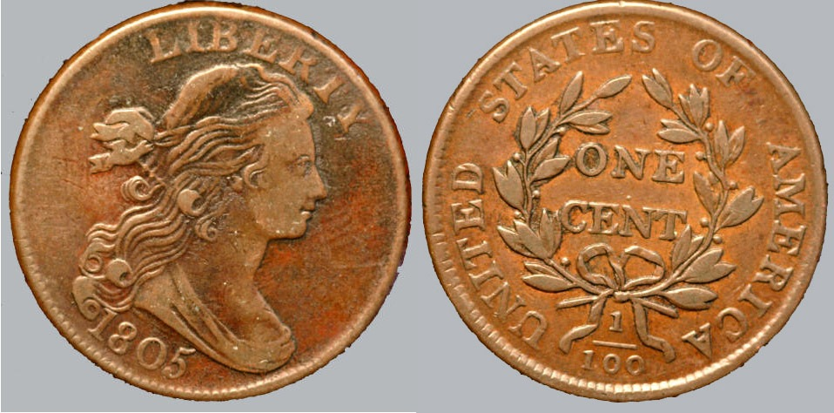

An 1805 Draped Bust 1c S-269 graded VF-30 average
[Courtesy CVM Web site]
__________________________________________________________________________________________________________
(Continued on page 5, column 1)
How to Grade Early Copper Coins
(Continued from previous page)
_____________________________________________________________________________________________________________
Plainly stated, this grading guide portrayed here is simply a rudimentary glimpse at how serious copper collectors/dealers go about grading their coins. It is strenuously suggested that anyone who is interested in pursuing an early copper collection contact an EAC (Early American Coppers) member for half cent and large cent information or contact a C4 (Colonial Coin Collectors Club) for colonial coin information.

In conclusion, remember that we all truly “get what we pay for” when it comes to coin collecting. Negotiate to the best of your a but understand truly rare and high grade early US copper coins are quite scarce and carries a huge premium in most cases.

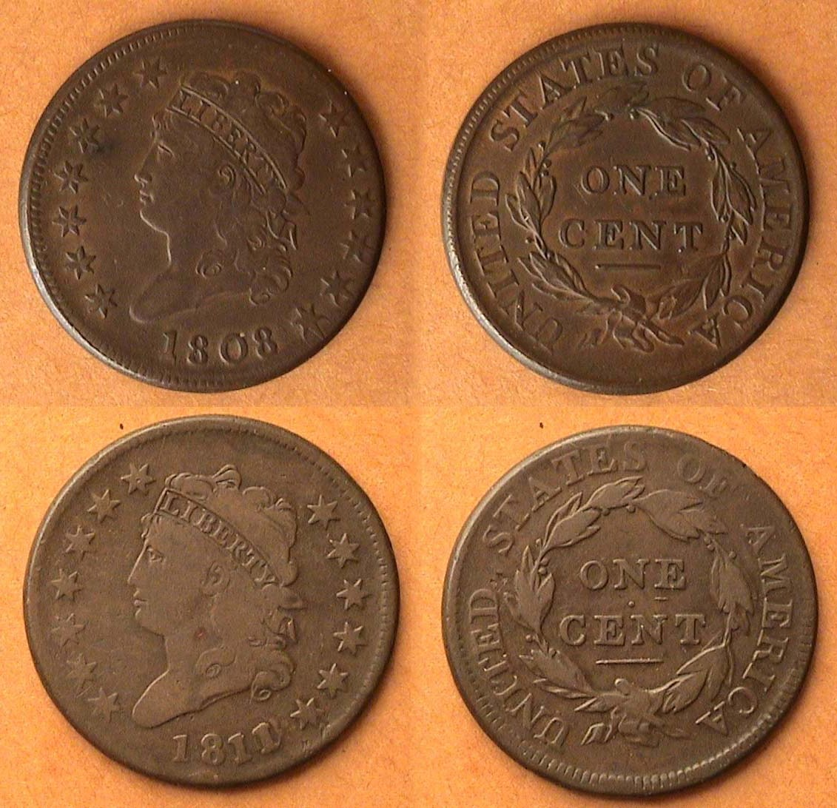

An 1808 Classic Head 1c S-279 VF-30 above an 1811/10 S-286, VG-8
The grades are different but the color and surfaces are choice
[Use 3x magnifying glass or magnify page to 200% to view details.]

On the other hand, that does not mean that an average or even average minus early copper collection cannot be challenging and fun to assemble. Some rarities can still be found on local bourse floors. Happy hunting and keep looking.

__________________________________________________________________________________________________________________

(Nick D’Amico is a collector of large cents and a member of the Trenton Numismatic Club of Trenton, NJ., His article first appeared in the March, 2012 edition of The Coin Chronicles: Newsletter of the Trenton Numismatic Coin Club, Evan Greenberg, editor and was used with the author’s permission and the permission of the author, ED.)

____________________________________________________________________________________________________________________

Editor’s Note

If you look closely at the reverse of the 1811/10 cent shown directly above you will recognize it is from the same die variety as the 1812
S-291 cent appearing in the previous article on page 2, column 1.
_________________________________________________________________________________________________________________________________

Wanted!

Articles for Newsletter

Contact the editor at arnosafran.comcast.net

.

Coin Collecting Fads of the 21st Century

From 2000-2008, the statehood quarters series begun in 1999 were attracting more and more individuals to coin collecting than ever before. During this period some particular state quarter rolls became scarcer than others selling for as much as $40.00 a roll. Today all 50 state quarter rolls are worth $10.00; (in other words, face value). From 2009 and 2011, it was all bullion, but for the past six months, bullion has leveled off and interest has dropped. One of the by-products of the bullion craze has been the silver eagle which displays Adolph Weinman’s beautiful Walking Liberty half-dollar design. This one ounce silver coin boasts a diameter of 40.6 mm, comprising .9993 silver bonded to.0007 copper. It has been issued in consecutive years since 1986 in BU and Proof versions. Most dates are extremely common grading anywhere from MS-68 to 70 with the price based on the value of silver plus a premium at the time of purchase. Some promoters certify these coins which receive the same grades and try to sell them for more. The 1995W (West Point Mint) Proof is the key valued at $3,000.
____________________________________________________________________________________________________________________

Kindly Patronize our Advertisers
