Pres. Willie Simon
V .P. James Barry
Sec. Helen Barry
Treas. Pat James
Sgt. in Arms: Glenn Sanders
Committees:
Programs: James Barry
Show Chairs: The Barry’s
Newsletter: Arno Safran
E-Mail: arnosafran@comcast.net
The Stephen James
CSRA Coin Club of Aiken
P.O. Box 1739
Aiken, SC 29802
Web site: www.sjcsracc.org
The SJ CSRA CC Now Meets on the 2nd Thursday of the Month at the Cedar Creek Community Center in Aiken, SC

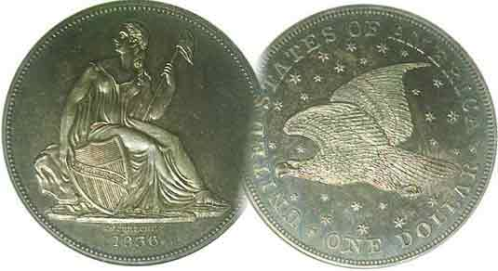

2008 Club Meeting Schedule
Volume 7, Number 7 the Stephen James CSRA Coin Club, Founded in 2001 July, 2008
Monthly Newsletter
Coats of Arms on Coinage Meeting Highlight
Our next meeting is Thursday, July 10 from 6:15 to 9:00 PM
Jan. 3 Apr. 10 July 10 Oct. 9
Feb. 14 May 8 Aug. 14 Nov. 13
Mar. 13 June 12 Sep. 11 Sep. 13 Show
___________________________________________________________________________________________________________________________

Xavier Pique Presents Outstanding Program on Heraldry: Coats of Arms on Coins through the Ages

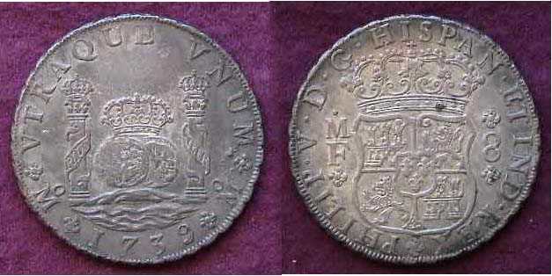

A 1739 Pillar $1.00 of Philip V struck at the Mexico City Mint
The Bourbon Coat of Arms is seen at the right

If you are a SJ CSRA CC member and have been unable to attend our last few meetings, you have not been not taking advantage of the superb numismatic talent we have in the CSRA. At the past three meetings those present have been witness to three excellent numismatic presentations from member Bill Myers, Ancient Roman Coins specialist Wayne Damron and most recently, a superb presentation on the history of Coats of Arms on Coins by Augusta Coin Club Treasurer Xavier Pique. Like his study of Counter stamped coins through the ages given some months ago before the SJ CSRA CC members, Xavier returned last month to speak on his latest research topic. He explained that Heraldry arose throughout Europe within a span of thirty years between 1130 through 1160 in response to invasions from the Magyars from the east, the Muslims from the south and the Vikings from the north. Knights were hired to defend the fiefdoms of the nobles and it became necessary to create emblems identifying the lands under the noble’s control. This led to the structuring of a specific coat of arms on a shield pattern that would articulate through iconic imagery a particular region. These soon became engraved on the coinage produced in the various regions. As the fiefdoms merged into larger territories to eventually become nations, the coat of arms took on more symbols emblematic of their expanded territories.
________________________________________________________________________________________________________________
(Club News continued on page 4, column 1)
Our Bicentennial Coinage for the Fourth of July
The Coins of 1976 By Arno Safran
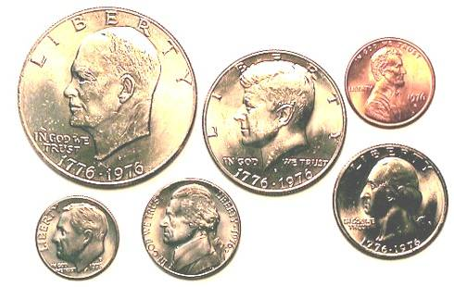
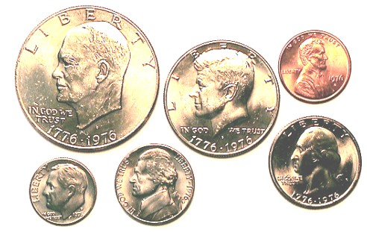
Obverses of the 1976-D Bicentennial Year Set issued for circulation
After eleven boring years of lackluster pocket change (1964 through 1974), Congress threw collectors a bone by authorizing its Bicentennial coinage program. For many collectors, tired of mediocre coinage designs, half a loaf seemed better than none and that is more or less what the proposal offered. The Sesquicentennial of Lincoln’s birth had shown Congress the way when the Lincoln Memorial replaced the Wheat back reverse in 1959. For the Bicentennial, it was decided to offer a two year program (1975 and 1976) in which the reverses of the Eisenhower dollar, Kennedy Half dollar and Washington Quarter dollar would receive special commemorative designs. The only change on the obverse would be the insertion of the dual date of 1776-1976 instead of either 1975 or 1976. The cent, nickel and dime would remain the same, each being dated 1975 and 1976 accordingly.

In 1973 the Treasury announced a Bicentennial coin design contest in which close to 1,000 participated. Winner of the reverse design for the bicentennial dollar was Dennis R. Williams. Seth Huntington’s design was accepted for the bicentennial half dollar and Jack L. Ahr’s Drummer Boy reverse
________________________________________________________________________________________________________________________
(Continued on page 2, column 1)
Our Bicentennial Coinage for the Fourth of July
(Continued from page 1, column 2)

for the quarter. These coins were struck for circulation in the same clad cupro-nickel alloy that first appeared in 1965. They were produced in the hundreds of millions at the Philadelphia and Denver mints.
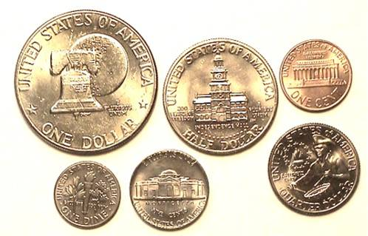

The reverses of a 1976-D Mint Set
The Bicentennial design types featured a Liberty Bell on the moon for the $1.00, the Independence Hall in center city Philadelphia on the half dollar and the Drummer Boy on the quarter; the latter arguably, the most attractive.

Regular clad proof sets were issued for all six denominations (over 4 million) by the San Francisco Assay Office which also struck special collector sets of the three piece Bicentennial coins in 40% silver clad (4.9 million) and 40% silver proofs (almost 4 million). None of these coins are scarce, let alone rare and virtually everyone can afford them. However, most of the bicentennial coins issued for circulation were horrendously struck with the result that those pieces grading MS-64’s or better are incredibly scarce.
There are two varieties for the reverse of the Eisenhower bicentennial dollar. They are known as Type I (block lettering) and Type II (more tapered lettering). The Variety I is scarcer though it appeared on a number of Eisenhower dollars struck in 1975 before the change over. All 1975 proof Ikes have the block lettering as do the 40% silver proofs and clad coins. Most coins struck for circulation are type II’s as are the 1976 clad proofs. Despite being minted in huge numbers, finding MS-64 or better specimens are a challenge for either type.
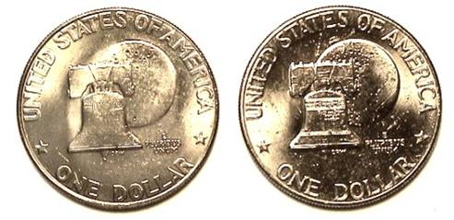
Eisenhower dollar bicentennial reverse varieties shown
At left, the 1975 Type I issue showing the block lettering,
At right, the 1976 Type II showing the more tapered lettering.
The Type II tapered lettering were not as well struck.
[Magnify to 200% to see details more clearly.]

In the earlier years of clad coinage many issues were poorly struck including the government packaged Mint and Proof sets. After generations of producing sharply struck coinage, the Philadelphia Mint’s products became noticeably inferior in strike and luster to those coming out of the Denver facility, especially during the clad era. For collectors who do not want to pay a lot of money for coins, try searching for well struck examples out of the clad mint sets produced from 1968 through 1976. Finding a 1976-P Roosevelt dime with fully struck torch bands is almost as difficult as a full bands 1945 Mercury dime.

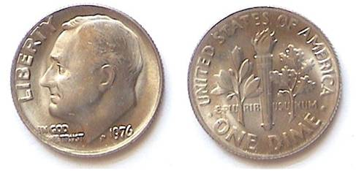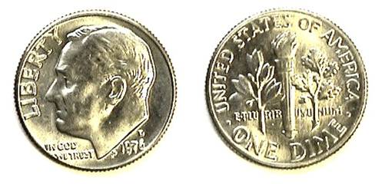

At left, a 1976-P dime; at right, a 1976-D dime
If one magnifies the images to 200%, the coin at right displays more defined details overall.

In this collector’s view the Drummer Boy motif is easily the most aesthetically appealing both in design and proportions of the three bicentennial reverses. It also strikes up the best especially in the 40% silver versions as shown in the picture below.

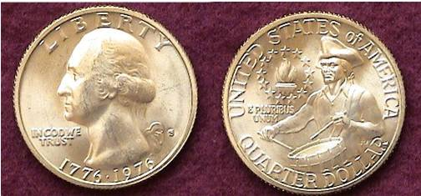

A1976-S 40% silver clad Quarter
The coin was originally issued as part of a three piece set
along with the half dollar and dollar.

At a local coin club some years ago the writer once acquired a slightly toned specimen of the bicentennial half dollar. It cost four times face but how often does one come across a common modern toned coin looking this lovely?

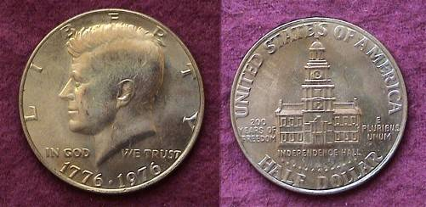

A nicely toned BU 1976 Bicentennial Kennedy Half Dollar

During our bicentennial, the Government issued a number of medals honoring famous Americans including poets, musicians and artists. These have never attracted wide national attention. The Mint also produced some gold medallions. As gold pieces, they appeared slightly paler in color than our former circulating gold coinage and were not issued in large numbers. Not much has been heard about them and some of these could be worth a lot of money should collector interest arise.
_________________________________________________________________________________________________________________

NUMISMATICS IN PANAMA
By Bill Myers

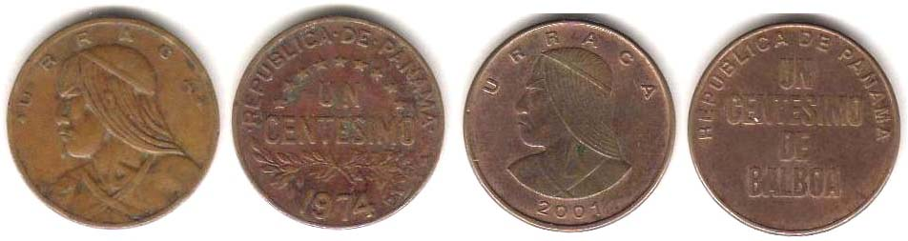
Panama: 1974 and 2001 UN centesimos (1¢ sub-types)
[Magnify to 200% to see details more clearly.]

Courtesy of the U.S. Army I spent the last two weeks of June in Panama on a humanitarian medical mission that delivered medical care to the local population in the David area, (on the Pacific Ocean near Costa Rica).

Panama currently uses U.S. currency, but previously used the Balboa, which is divisible into 100 centesimos. I did not expect to add to my numismatic collection while on this mission, but I did. All of the paper notes in Panama were U.S. dollars and showed more wear then the ones that are obtained in change in the United States. The coins available were a mix of U.S. and Panamanian coins. Coins of the same denomination were the same size and interchangeable.

The one centesimo coin (one cent) has the denomination “un centesimo” or “un centesimo de balboa” on the face and a portrait of Uracca on the reverse. Uracca was an Indian who massed an army of natives and drove out the Spanish from an area near Panama. I obtained three different types and 16 different dates (1966-2001). The earlier issues were made of bronze and the later issues are copper plated zinc. One interesting coin is the 1974 centesimo which was minted at the West Point Mint. Shown above are examples of the 1947 and 2001 1¢ Panamanian coins.

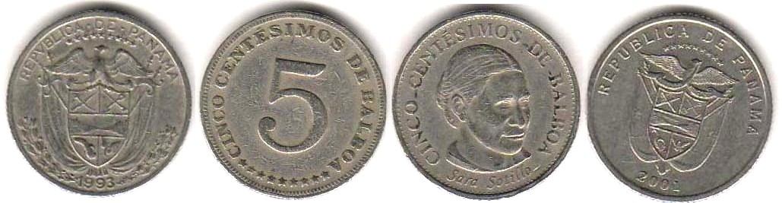

Panama: 1993 and 2001 cinco centesimos (5¢ sub-types)
[Magnify to 200% to see details more clearly.]

The cinco centesimos coin (five cents) has the Panamanian Arms on the obverse and a “5” on the reverse, except for the 2001 coin which has a bust of Sara Sotillo. She was a black Panamanian educator and women’s suffragist. I obtained three types and 12 different dates (1962-2001).

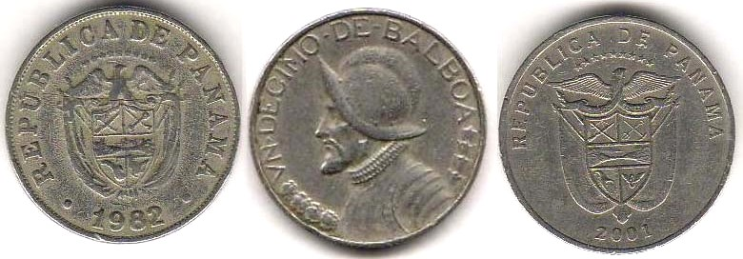
Panama: 1982 and 2001 1/10 Balboa obverse sub-types
[Magnify to 200% to see details more clearly.]

The decimo de balboa equal to 10 centesimos (shown at the bottom of column 1) has the Panamanian Arms on the obverse and a left facing bust of Balboa on the reverse. Balboa crossed the Isthmus of Panama on September 12, 1513 and was the first European to see the eastern shore of the Pacific Ocean. I obtained two different types and five different dates (1966-2001). The coins are composed of copper-nickel clad copper.

The quarto de balboa (25 cents) is also a copper-nickel clad copper coin. The obverse features the Panamanian Arms and the reverse has the left facing bust of Balboa, except for 2003 which features a tower and Spanish ruins and 2005 features a bridge that is labeled “Puenta Del Rey”. I obtained four different types and six different dates (1968-2005).

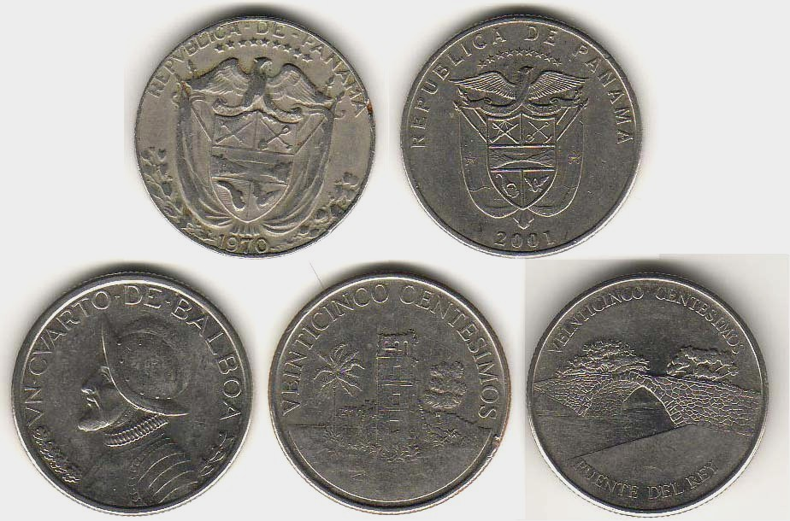

Panama: Quarto de Balboa older and newer obverse types above
Portrait of Balboa ¼ Balboa + 2003 and 2005 25¢ reverses
[Magnify to 200% to see details more clearly.]

The largest coin in circulation is the copper-nickel clad copper medio de balboa (50 cents). Like the U.S. Kennedy half dollar it does not circulate much and I got most of them from the bank. The Panamanian Arms is on the obverse and the bust of Balboa on the reverse. I obtained two different types and 10 different dates from 1973-2001. I did obtain one from 1996 which only has a mintage of 200,000.

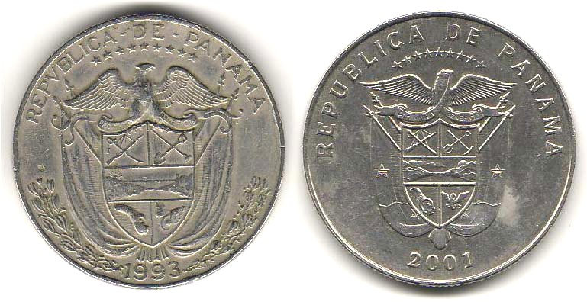

Panamanian 50¢ obverse sub types
[Magnify to 200% to see details more clearly.]

Good thing I was able to find some coins to purchase. The only other thing I brought home was a lousy T-shirt.
___________________________________________________________________________________________________________________
References: In the Wilds of Nicaragua 1521-1524 at: http://www.mainlesson.com/display.php?author=ober&book=desoto&story=wilds
From Defiant Cimarrones to Determined Canal Workers: Racial Identity in Panama by Gregory Cane at: http://www.ncat.edu/iajs/research/Africans_in_Americas_Volume2/Ch10_From_Defiant.pdf
Vasco Nunez de Balboa at http://coloquio.com/famosos/balboa.html
More Club News
(Continued from page 1, column 1)

The latest on club Treasurer Pat James’ condition is that she is recovering nicely; is back in court winning cases for her clients and plans to join us at the July 10 meeting. At last month’s meeting President Willy Simon proposed that members take fliers advertising our Sat., Sept. 13 show and post them on the bulletin boards of major area stores around three weeks before the show date. Around 20 tables have been sold so far.

For Show and Tell member Bill Myers brought in the latest Mint sub-types. These occur only on the 2008-W Proof $1.00 silver eagle. The U in UNITED appears as horseshoe shaped without a serif on the 2007 issues but with a knob on the 2008 pieces but some of the 2007 horseshoe styled “U’s have been found on a small number of 2008-W proof silver eagles as well and Bill was fortunate to receive some with his Mint order. Bill also had another article published in the June, 2008 issue of The Numismatist, monthly journal of the American Numismatic Association. The subject of Bill’s piece was the “First Philadelphia Mintmark” and what makes the read so significant is that the coin in question wasn’t the 1942-P Jefferson nickel. Bill stated that the first P Mintmark appeared on a Dutch Curacao 10¢ coin struck by the Philadelphia in 1941 before the US entered WW II.

Vice President Jim Barry mentioned the upcoming American Numismatic Association (ANA) Convention is being held at the Baltimore Convention Center later this summer (July 30 thru Aug. 3 to be precise) and member Arno Safran added that having attended ANA summer conventions at the attractive Baltimore Inner harbor area in 1993 and again in 2003, he was of the opinion that the venue was the best of all ANA convention sites bar none.
The door prize was won by Vilma Safran; a 2008 silver eagle and Jack Schultz won the 50/50. Congratulations to the winners. Our next meeting is scheduled for Thursday July 10 at the Cedar Creek Community Center when Arno Safran will present a PowerPoint program on the political portion of the Hard Times Tokens series (1832-1844).
_____________________________________________________________________________________________________________________________

Coin of the Month

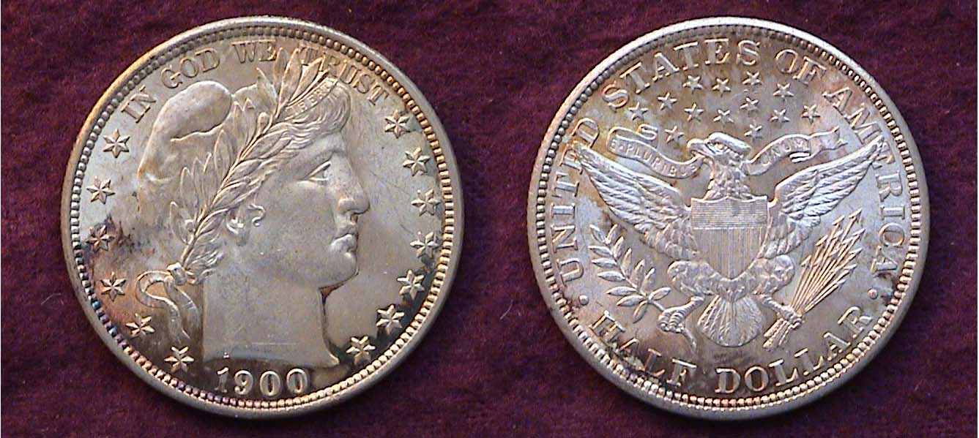

A 1900 Barber Half dollar grading MS-64
[Magnify to 200% to see details more clearly.]

What may keep this coin from grading a high-end BU are a few minor abrasions and a tiny hair-thin scratch just above the truncation of the neck. All Barber halves are scarce above VG-10, even a common date such as the 1900; the fourth most common of the series (1892-1915-S). Back in 1982, shortly after the “crash” from the 1979-1980 bull coin market, I decided to assemble a set of BU coins dated 1900 (excluding gold.). Living in central New Jersey at the time, I would occasionally drive into New York to see if Stack’s Coin Galleries had anything I could afford. Most of the time they didn’t but on occasion I plucked a few “treasures” off the vine at their 57th St. storefront location and it was there that I found this specimen of the 1900 Barber half dollar. Only a year prior, Stack’s had priced a common date Barber half grading MS-65 at a whopping $8,000. That was then. This coin was graded merely BU and priced at $400. I thought the asking price to be extremely reasonable. Later on when the 1900 set was completed I inserted the six coins into a Lucite holder for display, placing it in Safe Deposit Box after a few Show & Tells. After 26 years I recently took the set out and lo and behold, the Barber half had toned a beautiful russet color.
_______________________________________________________________________________________________________________________

Kindly Patronize Our Advertisers

