Pres. Steve Kuhl
V .P. James Barry
Sec. Helen Barry
Treas. Sharon Smoot
Sgt. in Arms: Glenn Sanders
The Stephen James
CSRA Coin Club of Aiken
P.O. Box 11
New Ellenton, SC 29809
Web site: www.sjcsracc.org
The SJ CSRA CC meets on the 2nd Thursday of the Month at the Cedar Creek Community Center in Aiken, SC

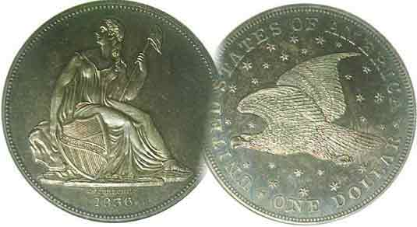
Committees:
Programs: James Barry
Show Chairs: The Barry’s
Newsletter: Arno Safran
E-Mail: arnosafran@comcast.net
Auctioneer: Glenn Sanders

2009 Club Meeting Schedule
Volume 8, Number 7 the Stephen James CSRA Coin Club, Founded in 2001 July, 2009
Monthly Newsletter
Local Area Banknotes the topic for July program
Our next meeting is Thursday, July 9, 2009 from 6:15 to 9:00 PM
Jan. 5 Apr. 9 July 9 Oct. 8
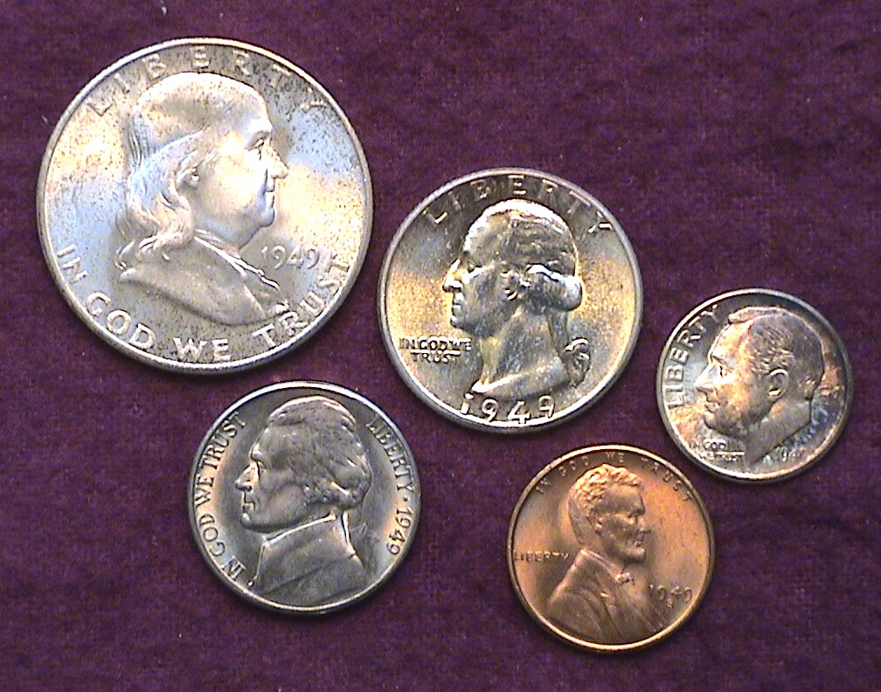
Feb. 12 May 14 Aug. 13 Nov. 12
Mar. 12 Jun. 11 Sep. 10 Dec. 3
_ ___________________________________________________________________________________________

John Attaway to present talk on the banknotes of Hamburg

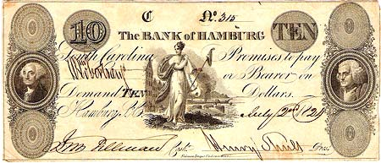

A Bank of Hamburg, SC $10.00 Note issued in 1824
[Courtesy of Truman Shiver] from a 2003 article by Peter J. Hughes]

At the upcoming July 9 meeting member John Attaway will present a program on the paper money of Hamburg, SC. The ‘city’ of Hamburg was settled and developed in the early 19th century fueled by the imagination and energy of an immigrant from Hamburg, Germany named Henry Shultz. He arrived in Augusta in 1806 and over a number of years was responsible for expanding commerce between Augusta and what is known as North Augusta today by constructing the first Augusta Bridge and arranging for the South Carolina Railroad to run from Charleston to Hamburg. John Attaway has done extensive research on the bank notes issued by the banks of Hamburg and will describe and display a number of examples of the paper money issued there.
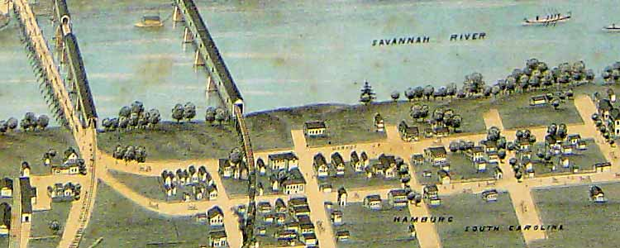
The City of Hamburg as it appeared in 1872
_____________________________________________________________________________________________
(More club News on page 4, middle of column 1)
Collecting the coins of 1949: 60 Years Ago
By Arno Safran

The obverses of a 1949-S Year Set except for the 1949-P quarter

What was it like to be growing up in America sixty years ago? On January 20, 1949 Democrat Harry S. Truman was inaugurated to his second term as 33rd President having defeated Republican Thomas E. Dewey, Governor of New York by 2 million votes in the general election the previous year. This was a surprise as the polls had predicted an easy victory for Dewey especially since former VP Henry Wallace and SC Senator Strom Thurmond, both Democrats, had bolted the party to run as Independents. Despite these challenges from the left and the right Truman won and delivered his inaugural address on television; the first President ever to do so. In 1949, N.A.T.O was ratified in the US Senate. Heavyweight boxer Joe Louis retired. Milton Berle’s comedy hour was the most popular TV show. “South Pacific” was the big hit musical on Broadway. Pizza became the new sensation at America’s eateries. The LP vinyl record had essentially replaced the 78 rpm shellac disc.

As for our coinage, five denominations were produced; the cent through the half dollar but in lower mintages than preceding years with some considered scarce in MS-65 today.
______________________________________________________________________________________________________________
(Continued on page 2, column 1)
The US Coins of 1949: 60 Years Ago
(Continued from previous page)

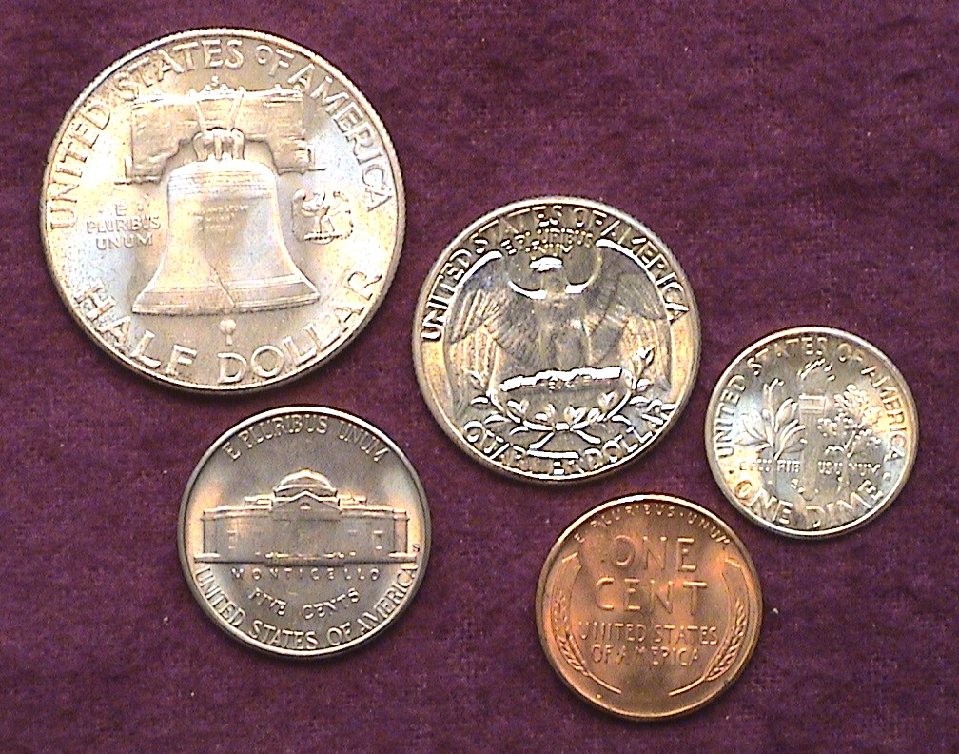

The reverses of the 1949-S Year set except for the 1949-P Quarter

From 1948, the initial year of the Franklin Half dollar through 1964, the first year of the Kennedy 50¢ piece, our dimes, quarters and halves were still struck in .900 fine silver. Unlike the Mercury dime or Walking Liberty half dollar series, there are no major rarities to be found among the yearly coinages during this period other than the 1955 double die cent, also some D over S mint mark issues along with some lower mintage dates grading MS-65 or better. When it comes to 1949, the 1949-D Franklin half dollar in MS-65 is considered quite scarce as it is valued at $650.00 compared with only $70.00 for a MS-63 specimen according to the 2010 Red Book.

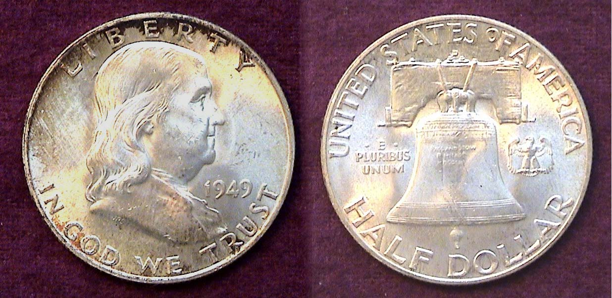

A 1949-D Franklin Half grading MS-64
[Magnify to 200% to see details.]

As a design type, the Franklin half dollar is arguably the least attractive of its predecessors and because of its open fields on both sides of the portrait often displays tiny hits and notches in the fields. MS-63 graded pieces are acceptable but some MS-64’s to 65’s can be stunning. Another factor in calculating desirability and rarity has to do with whether there are full bell lines on the reverse as these tend to have more value.

The 1949-D Franklin half had a mintage of 4.1 million compared with only 3.7 million for the 1949-S but in MS-65 it is a lot rarer. The coin pictured above has some peripheral toning and upon closer magnification one will observe some light streaking but overall, the fields are clean. The uncertified example above would probably grade MS-64. For those seeking an MS-65 1949-D half dollar the collector is strongly advised to choose a certified MS-65 example from any of the four major certification companies, PCGS, NGC, Anacs and IGC.
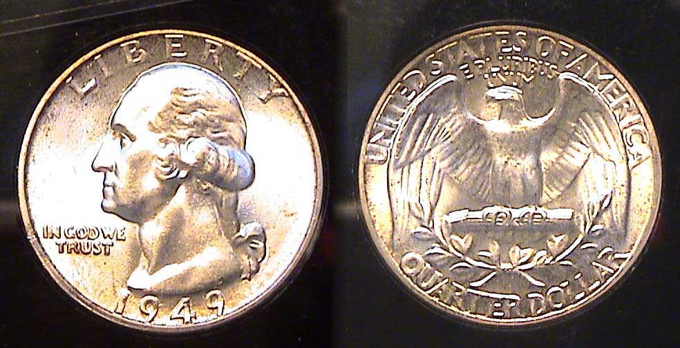

A 1949-P Washington Quarter grading MS-65
[Magnify to 200% to see details.]

No quarters were produced at the San Francisco Mint in 1949 and even the Philadelphia and Denver Mints issued smaller numbers than the surrounding years. Some 9.3 million were struck in Philadelphia and slightly over 10 million at the Denver facility. The latest Red Book lists them at $60 and $50 respectively in MS-65, only slightly less in MS-63.

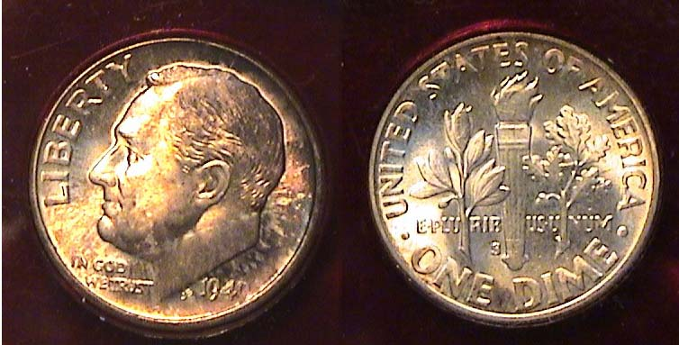

A toned 1949-S Roosevelt dime [Magnify to 200% to see details.]

Of the three Mints issuing Roosevelt dimes in 1949, the San Francisco Mint offering represents the closest to a “key” date in the entire silver portion of the series (1946-64). Going back in time the 1978 Red Book lists a 1949-S in Unc at $15.00, with the ’49-P priced at $12.00. (There was no distinction between MS-63 and MS-65.) Most of the other dates were listed in Unc from 75¢ to $1.00. The recently released 2010 Red Book lists the 1949-S dime at $42.00 in MS-63 and $55 in MS-65 with the 1949-P at $26 and $32 respectively. The commoner dates are $1.75 to $2.50 in MS-63 but in MS-65 they jump to $6.00 to $7.00. After 31 years one could hardly call the Roosevelt dime series a good investment. Even back in the late 1940’s the purchasing power of ten cents had already begun to diminish, so putting away an uncirculated specimen of the low mintage 1949-P or S dime did not create much of a financial burden on the collector. As a result there are simply too many BU 1949 dimes around to warrant an increase above the inflation rate.

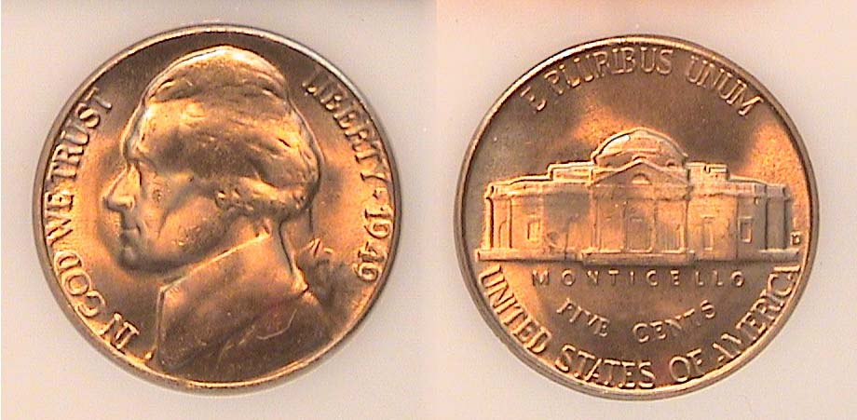

A 1949-D Jefferson nickel grading MS-65
[Magnify to 200% to see details.]

If the 1949-D Jefferson nickel shown above was a D over S variety it would be worth a lot of money; $400 in MS-65. This coin is simply an attractive example from the more than 36.4 million struck at the Denver Mint and is listed from $2.50 in MS-63 to $$5.50 in MS-65 according to the 2010 Red Book. The ’49-S Jefferson nickel has the lowest mintage, only 9.7 million, but is priced the same. The 1949-P has the largest mintage, 60 million yet in MS-65 enjoys the best value at $7.50.
_________________________________________________________________________________________________________________________
(Continued on page 3, column 1)
The US Coins of 1949: 60 Years Ago
(Continued from previous page)

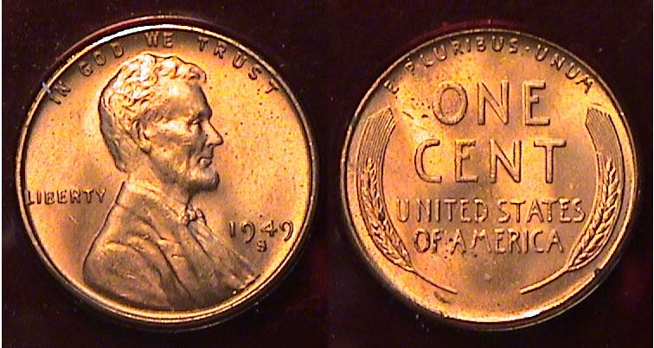

A 1949-S Lincoln cent Full Red MS-65
[Magnify from 200% to 500% to see details.]

In 1949 the production of Lincoln cents at all three mints decreased dramatically with the 1949-S having the lowest mintage, 64,290,000. Compared with over 1 billion from each Mint being delivered today, one would think the ’49-S would be scarce but in MS-65, the 2010 Red Book lists it at only $6.00, $5.00 for the 1949-D and $4.00 for the no mintmark 1949-P.

With gold coinage ending in 1933 and dollar coinage suspended after 1935, the half dollar became our largest circulating coin but even back in 1949 it didn’t circulate very much. The reasons were due to the coin’s size and the absence of an appropriate slot in the vending machines. Still, all three Mints struck half dollars in 1949 along with the dime, nickel and cent. Quarters were coined only at Philadelphia and Denver.

1949 Cost of Living: The minimum wage in 1949 was 75¢ an hour or $30 a week with the median annual wage at $2,950. The average cost of a new home was $7,450. The average price of a new car was $1,420 and a gallon of gas cost 17¢. In 1949 a first class postage stamp still cost 3¢. Carfare on metropolitan transit remained a nickel. Candy bars were only 5¢ as was a fountain soda. A Sundae cost 15¢; a Banana Split, a whopping 25¢. Today one would cost over $3.00. Our five denomination coinage functioned a lot more efficiently back then.
_______________________________________________________________________________________________________________________

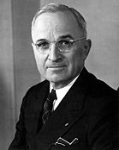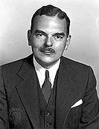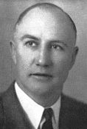

Harry S. Truman, Thomas E. Dewey and Strom Thurmond

1948 Election Results by States
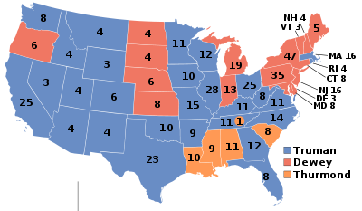
Operation Bernhard by Bill Myers

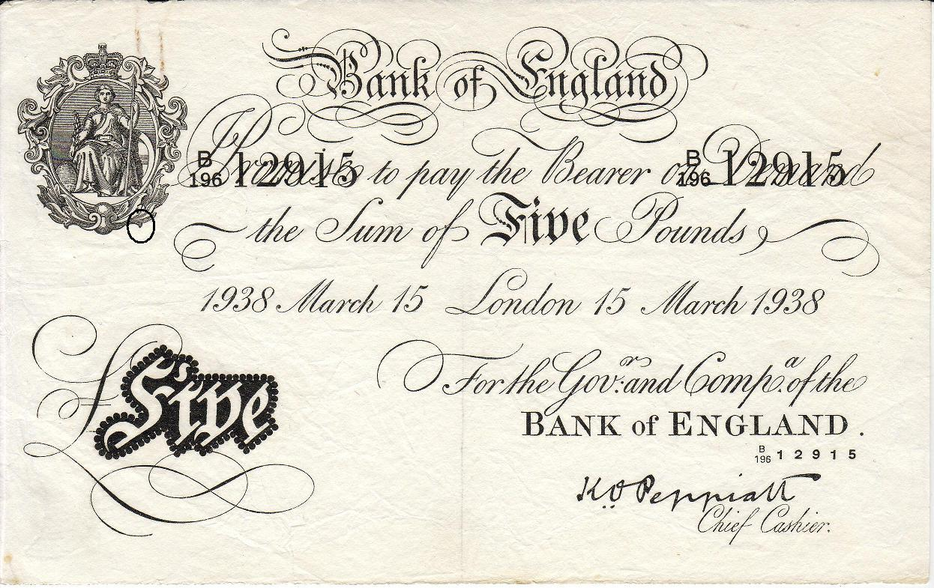A

A counterfeit British 5 pounds note

In a past newsletter I wrote a review on the book entitled “Krueger’s Men”. It was about Operation Bernhard, which occurred during World War II when the Germans forced Jewish prisoners to produce counterfeit British 5, 10, 20 and 50 pound 1938 issue notes (SCWPM Pick #s 335-338). The British notes are white and uniface and are know as “white notes”.

I recently attended the MPC (Military Payment Certificates) Fest in Port Clinton, OH. There was a special guest at the meeting - Hans Walter. Hans was caught during the war forging passports for Jews to leave Germany and after being interrogated by the Gestapo he was sent to Auschwitz Concentration Camp. He was sent to 5 different concentration camps but was saved from the gas chambers and recruited for Operation Bernhard because of his history of being a forger. His task was to inspect the counterfeit notes for quality and place them in one of five categories for distribution. The operation produced over 134 million pounds of counterfeit notes. The next note to be counterfeited was the United States $100 bills. Hans sabotaged the ink with machine oil, which caused the ink to smear when rubbed. No known examples of these notes exist. Even though he is 87 years old, Hans remembered many details. He is one of three know survivors of Operation Bernhard.

I had the opportunity to buy one of the counterfeit five pound notes. There are two key diagnostics to determine it is counterfeit. One is the watermark and the other is in the engraving of Britannia in the upper left of the note

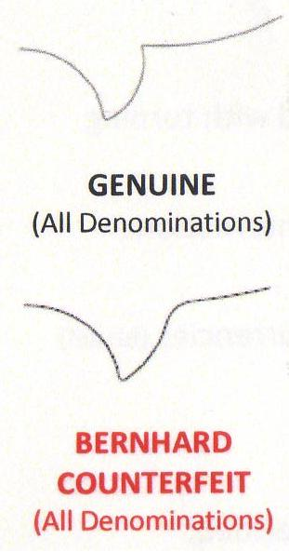
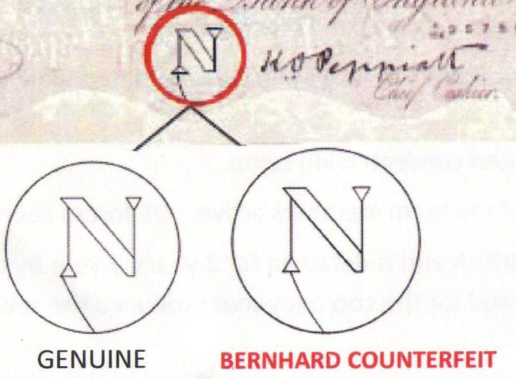

My note also has pinholes in the figure of Britannia. It was common in Britain to pin notes together or pin them to documents.
_________________________________________________________________________________________________________________________________
(Continued on page 4, column 1)
Operation Bernhard (Continued from page 3, column 2)

The counterfeiters tried to signal they were counterfeits by putting pins through the image of Britannia, as they felt no Britain would put pinholes in this image. Details of the counterfeit diagnostics are published in the books and article referenced.

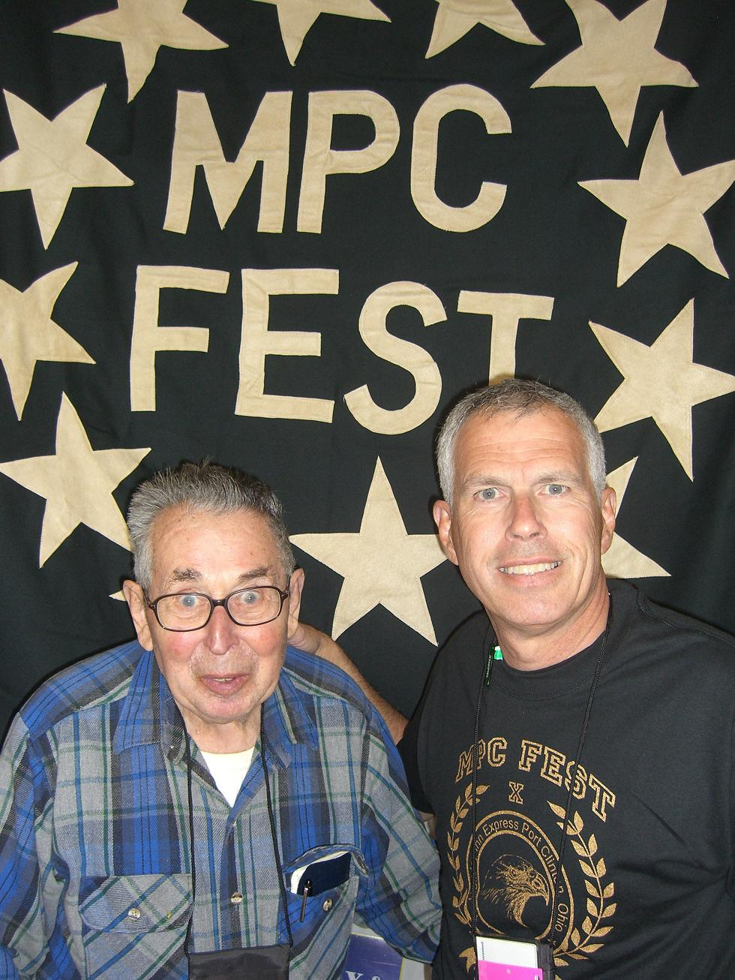
It was a pleasure to meet someone involved in the largest counterfeiting venture ever attempted and to obtain a piece of this history.

Bernhard Counterfeit Production

5 pounds 3,945,867

10 pounds 2,398,981

20 pounds 1.337,335

50 pounds 1,282,902

Hans Walter and Bill Myers
_______________________________________________________________________________________________________________________________
(Thanks, Bill for another fascinating article on numismatic military history, Ed.)
__________________________________________________________________________________________________________________________

More Club News (Continued from page 1, column 1)

Jim Barry wins prestigious Glenn Smedley Award

VP Jim Barry has been named as a recipient’s of this year’s Glenn Smedley Award. The award is presented annually by the ANA to members who have demonstrated extraordinary service in assisting fellow collectors and coin clubs. Congratulations, Jim!

At the meeting of June 11 there were fourteen members present with one visitor. President Kuhl announced that the photos of the 2009-10 club officers are now on our club web site, www.sjcsracc.org. Tickets for the raffle prize drawings for our September show need to be sold. Members present were invited to take some to sell over the summer months. The raffle tickets are $1.00 each or six for $5.00. The stubs must include the donor’s name and telephone number and be returned at our September 10 meeting or at the show before 3:00 PM on Saturday, Sept. 12. Our annual show is being held at the H. Odell Weeks Activity Center located on Whiskey Rd. (Rte. 19) across from the Home Depot. Hours are 9:00 AM to 4:00 PM.
Young numismatist member Austin Kuhl picked out a 1950 Mexican 25 centavos piece from the monthly YN grab bag. Congratulations, Austin! The program was a DVD on “the Art of Saint-Gaudens and the Making of the $20.00 Gold Piece” produced by the American Numismatic Association. The prize winners at the June meeting were Marjorie Simons who won the silver eagle door prize and Glenn Sanders who was the 50/50 winner. Congratulations to our two winners. The editor would like to thank Marion Engel for providing the club meeting information in the absence of Recording Secretary Helen Barry and the editor. Bring in a Show & Tell item. See you all July 9.
____________________________________________________________________________________________________________________
Kindly patronize our Six Advertisers

