Pres. Steve Kuhl
V .P. Arno Safran
Sec. Jim Mullaney
Treas. Sharon Smoot
Sgt. in Arms: Glenn Sanders
The Stephen James
CSRA Coin Club of Aiken
P.O. Box 11
New Ellenton, SC 29809
Web site: www.sjcsracc.org
The SJ CSRA CC of Aiken, SC meets on the 1st Thursday of the month at the Aiken Public Library

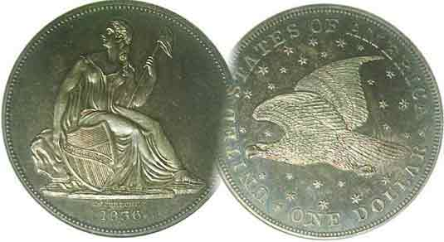
Committees:
Programs: Arno Safran
2010 Show: Jim & Helen Barry
Publicity: Jim Clapp
Newsletter: Arno Safran
E-Mail: arnosafran@comcast.net
Auctioneer: Glenn Sanders

2010 Club Meeting Schedule
Volume 9, Number 7 the Stephen James CSRA Coin Club, Founded in 2001 July, 2010
Monthly Newsletter
All Aboard for the South Carolina Express
Our next meeting is on Thursday, July 1, 2010 from 6:00 to 8:45 PM

Jan. 7 Apr. 1 July 1 Oct. 7
Feb. 4 May 6 Aug. 5 Nov. 4
Mar. 4 Jun. 3 Sep. 2 Dec. 2

____________________________________________________________________________________________________________

Coins and Postcards provide portals to Aiken’s History: Part Two

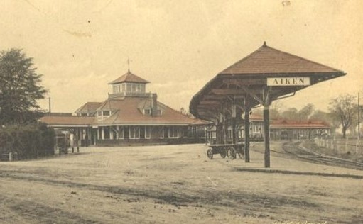

The Aiken Passenger Station built by the Southern Railway
Illustration for an old postcard circa 1915
[Use 3X glass or magnify to 200% to see details]

Shown above is a picture of the Aiken Passenger RR Station as it may have looked in the early dawn hours many decades ago. The line was originally constructed by the South Carolina Canal and Railroad Company in 1833 and ran from Charleston to Hamburg, (North Augusta today) a distance of 136 miles. It passed through a number of important SC towns including Aiken. Over the years, it merged with other RR companies finally being taken over by the Southern Railway system in 1899. That same year, the Aiken passenger station was built at the original site now called Union and Park Avenues. In the first half of the 20th Century, many famous people took the train to winter in Aiken. During the 1950’s passenger traffic began to decline and service was finally terminated in the late 1950’s. Today you can still find the tracks crossing through Aiken, which is currently operated by Norfolk Southern. One can only imagine the excitement of arrivals and departures during the early years of the 20th century.
______________________________________________________________________________________________________

Collecting the US Coins of 1915: 95 Years ago
By Arno Safran

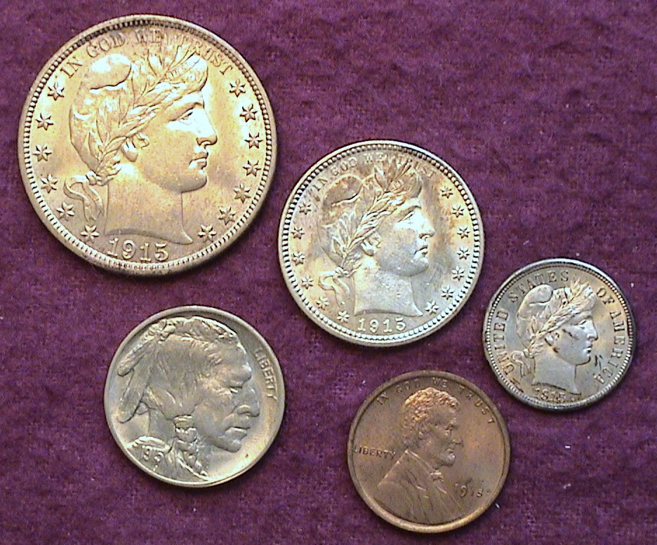

The obverses of a 1915 year set (excluding gold), actual size
[Use 3X glass or magnify to 200% to see details]

During the second decade of the 20th century, the changeover from the late 19th century stylized coins to a more artistic realization was well underway. The architect of this was Theodore Roosevelt who as President encouraged our national artists to participate in developing better designs for our coinage. The release of the magnificent Saint-Gaudens Double Eagle in 1907 paved the way. By 1915, all four gold issues had new design types. In 1909 Victor David Brenner’s realization of Abraham Lincoln appeared on the cent and in 1913 James Earl Fraser’s Indian Head/ Buffalo nickel was placed into circulation. The last named was dubbed, “the most American of our coins”. The Morgan dollar had been suspended at the end of the 1904 mintage and the three remaining silver denominations, the dime, the quarter and the half dollar still displayed Charles Barber’s classical Liberty Head design, which first appeared in 1892. As such, 1915 represents a hybrid year featuring both the old and the new. The short set shown above (excluding gold) is average for grade with the AU-58 1915-D Barber half-dollar being the best of the lot. Since the 1980’s some pieces have been upgraded.
__________________________________________________________________________________________________________________________
(Continued on page 2, column 1)

Collecting the US Coins of 1915
(Continued from page 1, column 2)

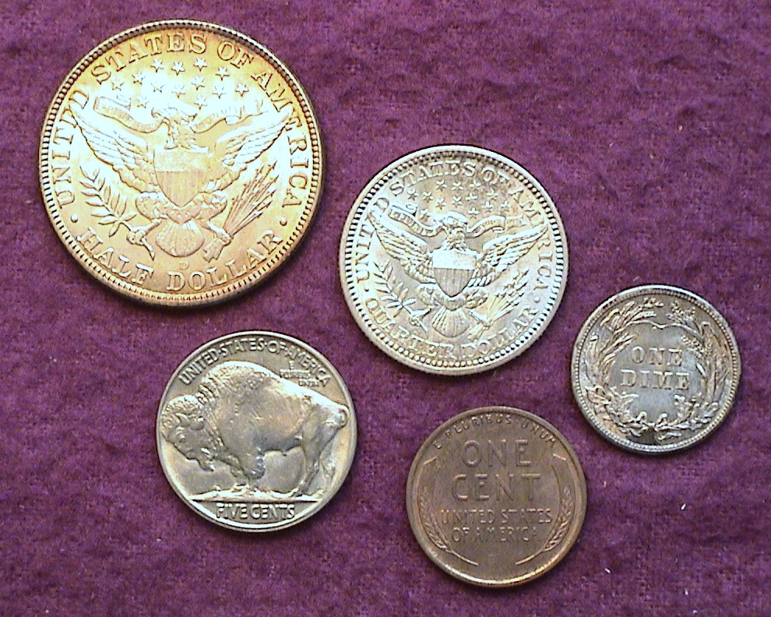

The reverses of a 1915 year set (excluding gold), actual size
[Use 3X glass or magnify to 200% to see details]

In addition to the coin types for the year the article will explore some of the finer points of grading. While the 1915 nickel shown above would probably grade MS-63, the cent, dime and quarter all have problems ranging from misguided attempts at cleaning to some surface damage. By magnifying, the page to 200% or applying a 3X magnifying glass to the photo the reader will see these problems more clearly.

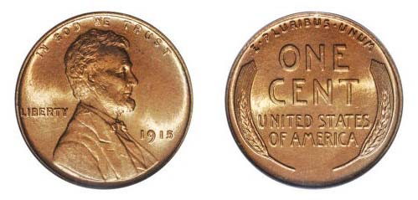

A 1915 Lincoln Wheat 1¢ graded MS-66 Red by PCGS
It realized $2,330 at a Heritage auction
[Courtesy of Heritage Auctions Archives]
[Use 3X glass or magnify to 200% to see details]

The 1915-P Lincoln cent is a true “sleeper” if there ever was one. Slightly over 29 million cents were struck at the Philadelphia Mint that year but the date is quite scarce in mint state. Despite lower mintages for P-Mint Lincolns during the Depression years of the early 1930’s, most of the 1915 issues went into circulation and were not preserved in uncirculated condition. Today, the 1915 is considered the most difficult date to find in MS-63 or better of any Philadelphia Mint issue. As a collector I have only found one “raw” approaching mint state; the one shown in the group picture but there is some evidence of cleaning that lowers its value.

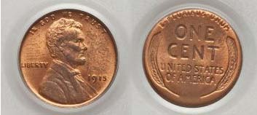

A 1915 Lincoln 1¢ graded MS-64 Red by PCGS
This specimen realized just $219 at a Heritage auction
[Courtesy of Heritage Auctions Archives]
[Use 3X glass or magnify to 200% to see details]
The two 1915-P cent specimens appearing on the previous column represent a good study in date rarity. The first example, graded MS-66 Red by PCGS sold at auction for $2,300. That’s seems like an awful lot of money for a Philadelphia Mint issue but so few truly gem pieces survive for that year that someone was willing to pay that much for it. The example that appears below it was graded MS-64 Red by PCGS and realized a modest $219. Upon magnification, one will see what appear to be the remnants of a fingerprint to the left of Lincoln and a perspiration smudge to the right of the Bust.

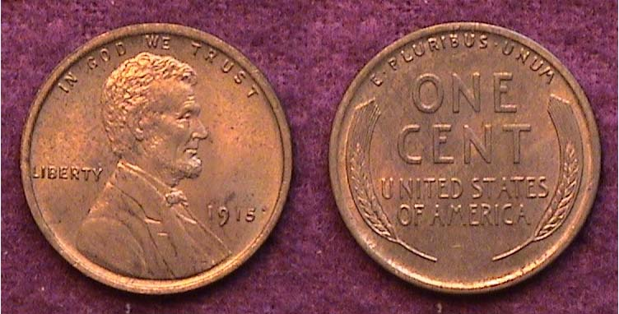

A 1915 Lincoln Wheat 1¢ from the author’s year set.
At best, it grades MS-60 but may have been cleaned at one time.
[Use 3X glass or magnify to 200% to see details]

The example shown above was acquired back in 1984, two years before third party certification began. In those days there was no internet and most coins were acquired either directly from a dealer or via mail order. This was the hardest piece to find among the five non-gold denominations. It cost $70.00.

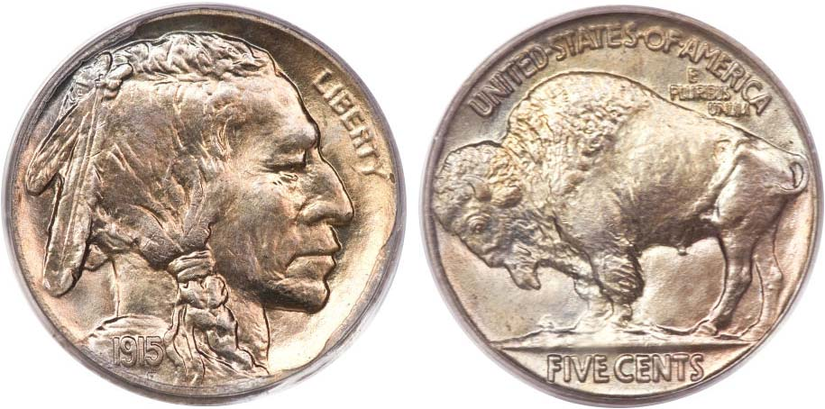

A 1915 Buffalo nickel graded MS-67 by PCGS
It realized $4,025 earlier this month at the Long Beach California sale
[Courtesy of Heritage Auctions Archives]
[Use 3X glass or magnify to 200% to see details]

It is occasionally enjoyable to speculate upon what spectacular coins one might acquire if money were no object. The 1915-P nickel shown above has blazing luster and is better struck than most Gem BU 1938-D’s, the model date for evaluating well struck pieces as there are more “Gem” survivors of that date than any other for the entire series (1913-’38). For a 1915 nickel to have been graded MS-67 as a business strike and not as a matte proof, it has to be very rare indeed.

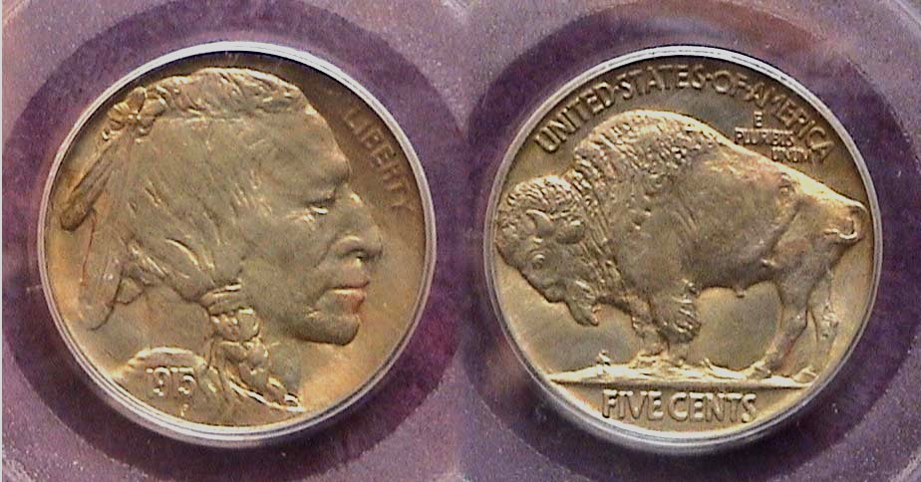

A 1915 Buffalo nickel graded MS-64 by PCGS
[Use 3X glass or magnify to 200% to see details]

The toned specimen shown directly above pales in comparison even though it is certified MS-64 and has a decent strike but it lacks the luster and brilliant detail of the MS-67. It was priced at $150, a far cry from the $4,025 realized at auction for the superior coin.
___________________________________________________________________________________________________________________
(Continued on page 3, column 1)
Collecting the US Coins of 1915
(Continued from previous page)

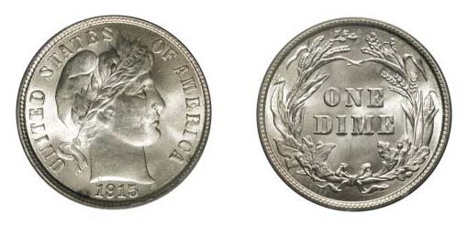

A 1915 Barber dime graded MS-66 by PCGS
It realized $1,955.00 at the Heritage FUN Show Sale in 2005
[Courtesy of Heritage Auctions Archives]
[Use 3X glass or magnify to 200% to see details]

The specimen shown above was graded MS-66 by the Professional Coin Grading Company (PCGS) and hammered down along with the 15% buyer’s fee at $1.955.00 Since 5,620,000 Barber dimes were struck at the Philadelphia Mint one may wonder why a common date can bring such a high bid. In MS-60, the coin is listed in the 2011 Red Book at just $110 and in MS-63 at $170.

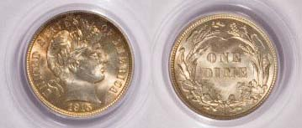

Another 1915 Barber dime graded MS-64 by PCGS
This specimen realized $230 at the Heritage auction in 2009
[Courtesy of Heritage Auctions Archives]
[Use 3X glass or magnify to 200% to see details]

Considering that some individual was willing to part with almost $2,000 for the MS-66 specimen atop the page, the certified MS-64 example shown immediately above would appear to be a much more prudent buy at $230. While the MS-66 is unquestionably a gem, the ’64 is still a very attractive example for the date and type.

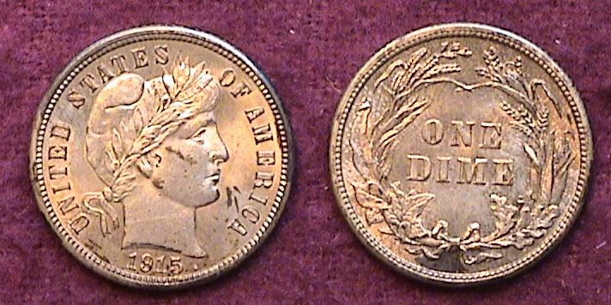

An MS-60 1915-P Barber dime with problems.
[Use 3X glass or magnify to 200% to see details]

By comparison, the lightly cleaned and spotted 1915 dime shown in the year set is no better than a MS-60. Acquired in 1984 for $115, it was housed together with the rest of the set in a Lucite holder but over the more than quarter century the coin developed dark spots and a recent light cleaning with a product called MS-70 only made it worse. Today, the certified MS-64 specimen would be considered a “Best Buy”.

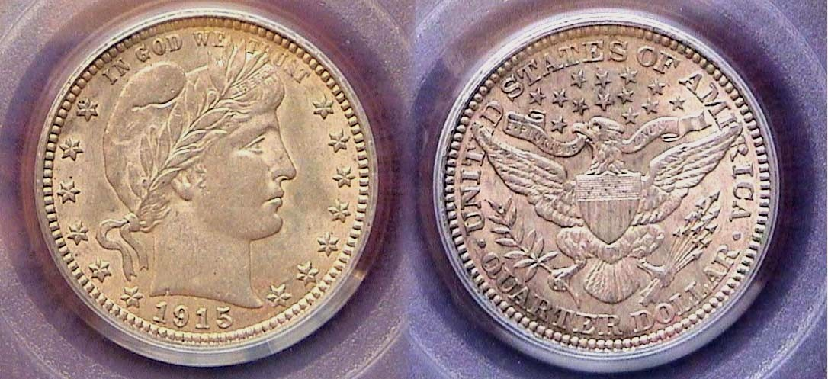

A 1915 Barber Quarter graded AU-58 by PCGS
[Use 3X glass or magnify to 200% to see details]
Unlike the 1915-P Barber 50¢ that had a paltry mintage of only 138,000, more than 3.4 million Barber quarters were struck at the Philadelphia Mint that year. As a result, the date is considered common with prices ranging from $65.00 for an XF-40 example to $325 for one grading MS-63 according to the 2011 Red Book. The coin pictured at the bottom of the previous column was certified AU-58 by PCGS and cost $120.00 in 1994. It was acquired as an improvement over the higher grade but marred MS-60 specimen that appeared in the original year set and shown directly below. The latest Red Book lists an AU-50 at $115 so as an investment one might say the coin has gone nowhere in value although AU-58’s are far more attractive than AU-50’s.

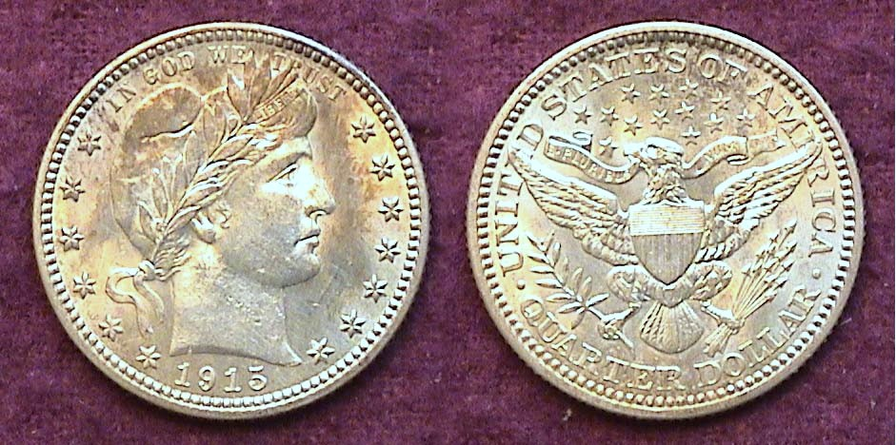

A 1915-P Barber Quarter with the sharpness grading of a MS-63
Surface problems net it down to an AU-50
[Use 3X glass or magnify to 200% to see details]

According to the Heritage Auctions Archives, the source for many of the photos accompanying this article, 1915 Barber quarters certified MS 66 are selling for almost $2,000, MS-65s closer to $1,000 and MS--64’s around $450.

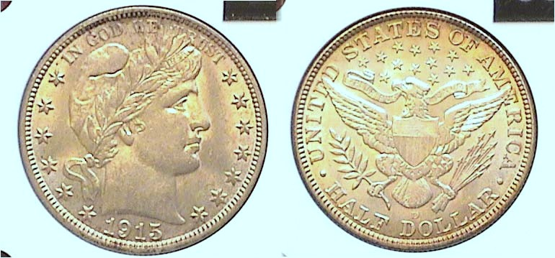

A 1915-D 50 Barber half-dollar grading AU-58 at $350
[Use 3X glass or magnify to 200% to see details]

In 1913, 1914 and 1915, the Philadelphia Mint struck less than 200,000 half dollars each year with the low water mark being 1915 when only 138,000 were produced. By comparison, the mintage for the 1915-D was 1,170,000. According to the 2011 Red Book, a 1915-P grading MS-63 is listed at $2,500 compared with $800 for the 1915-D. The AU-58 specimen shown above cost $325 in 1984. Today it would retail for $500 according to Coin World’s monthly supplement, Coin Values. Magnified to 200% one sees the coin has decent surfaces. The D Mintmark appears on the reverse below the eagle’s talons. Collector demand for Barber halves is strong in all grades, but especially at the higher end of the grading spectrum.

With gold prices over $1,200 an ounce, all gold issues are expensive. Collectors interested in assembling just the five-coin set are advised to look at certified specimens ranging from AU-58 thru MS-64 depending on one’s discretionary income. While the 1915 set totaled 91¢ in face value its 2010 counterparts would have the purchasing power of $20.00 today.
_____________________________________________________________________________________________________________________

Aiken Passenger Station
(Continued from page 1, column 1)

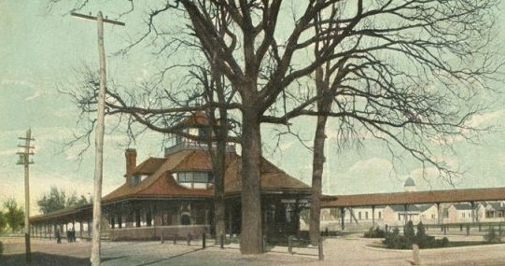

Another view of the Aiken Passenger RR Station
[Use 3X glass or magnify to 200% to see details]

During President Eisenhower’s second term in 1956, the Interstate Highway system was begun. This coupled with increase air travel had an adverse affect on the long distance passenger railway system. By the late 1960’s RR passenger service began to dwindle resulting in the closing of many railroad station landmarks. The train station in Aiken was one such casualty.

In the mid 19th century the American Banknote Company printed Fare tickets for the South Carolina Railroad Company. These were in denominations of $1.00, $2.00 and $5.00 and were based a fare charge of 4¢ a mile.

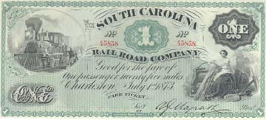

At four cents a mile this $1.00 Fare ticket was good
for 25 miles of travel on the South Carolina Railroad
[Courtesy, collection of Tom Daspit]

A $2.00 Fare ticket could provide a roundtrip ticket from Aiken to Hamburg, SC (North Augusta today) and back. It would be a while before a RR bridge would be built across the Savannah River into Augusta. In the latter part of the 19th century a trunk line from Greenville joined the Charleston to Hamburg line. With Charleston to the southeast, Augusta to the west and Greenville to the north. The Southern Railway allowed Aiken to grow and flourish making it one of the important small resort cities in the nation by 1915, the year the Aiken Standard began publishing its weekly newspaper.
_______________________________________________________________________________________________________________________

Club News

President Steve Kuhl called the June 3 meeting to order at 6:45 PM. The attendance was good for a warm June evening that included three guests. Glenn Sanders reported on upcoming shows being held in Anderson and Charlotte an auction in Kennesaw, GA. The highlights of the evening were three Show and Tell exhibits and a highly informative and interesting PowerPoint program by member Walter Kublius.

Show & Tells: Recently joined member Rick Owen displayed two incredible early 20th Century US groups of proof coins. After 1917, the Mint suspended proof coinage production. When it was resumed in 1936 the mintage for the five-piece set was a miniscule 3,837. The Philadelphia Mint sold the set for $1.90 to collectors.

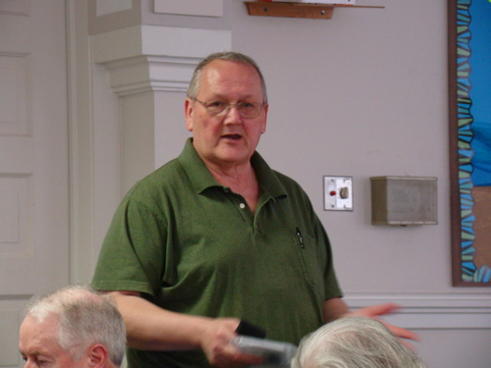

Rick Owen displaying 1936 Proof Set
[Photo (and all those that follow) taken by Secretary Jim Mullaney]

Rick explained how he found one for sale sight unseen in correspondence with a seller and took a chance by ordering it. It arrived in its original sealed square cardboard box. He brought it down to Clein’s Rare Coins in Augusta where both he and the proprietor Wayne Damron carefully opened the box. Back then, the five proof coins were housed in cellophane wrappers bound together by a staple. Fortunately there was no evidence of rust on the metal staple and it was carefully removed. Each coin was then examined and every one looked original, mirror-like and lustrous. Included in the 1936 set was the Walking Liberty half dollar, Washington Quarter, Mercury Dime, Indian Head/ Buffalo nickel and Lincoln Wheat back cent and all were gems.

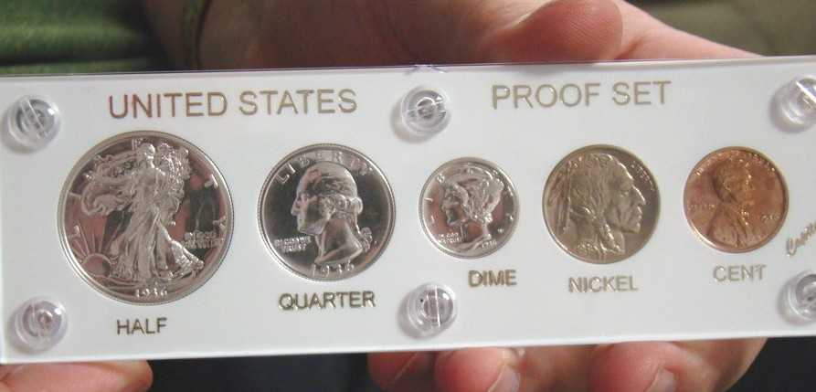

Rick Owen’s recently acquired 1936 Proof Set

Rick also brought in a two piece 1916 proof set. This one included just the 1916 Matte proof Lincoln cent and nickel. Only 600 of each were made, so even as collectible proofs these are uncommon coins. No proof dimes, quarters or halves were made that year. The two were housed in a NGC certified holder.

Next, member Howard Hillman brought in a series of coins that were minted during the Second World War. These included some German 5 & 10 Pfennigs and US pieces.
_____________________________________________________________________________________________________________________
(Continued on page 5, column 1)
Club News and Show & Tells (continued)

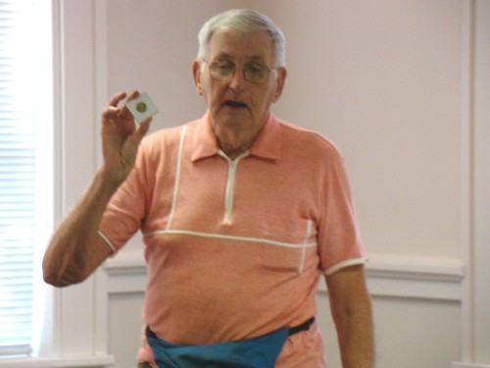

Howard Hillman showing WWII German pfennig

Howard also displayed a US War nickel set (1942-45) in a Capital Lucite holder. In BU condition these are very popular collectibles. He noted that while the mintages of the 1943 Steel Lincoln cents were plentiful, most were not well preserved with many becoming corroded or reprocessed to appear new. Howard opined that many WWII numismatic items might be scarcer than once thought.

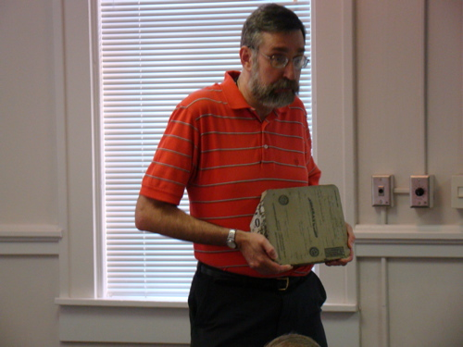

Walter Kublius displaying banknote plate

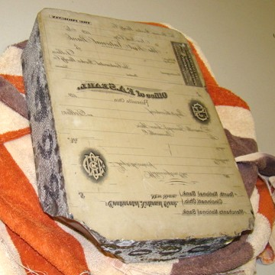
Just before his program, Walter Kublius displayed a special kind of stone used for making “second tier” or “Grade B” banknotes a century ago. Walter explained that most of the Mexican notes were printed in this manner as were the Confederate notes. He said, “A block of limestone from Sohnofen, Germany (where the finest limestone in the world can be found) was engraved with the design. Today we use aluminum plates but 100 years ago, first-rate banknotes from the ABNC used steel plates. Most of the engraving at that time was done on these limestone blocks like the one shown at right. This one weighed 30 pounds and actually had five different printing jobs shown in the picture.

A limestone print block used for making banknotes
[Use 3X glass or magnify to 200% to see details]

The Program: Walter Kublius gave an outstanding presentation on Mexican Banknotes produced during the War of Independence (1910-1920) that also included an extensive history of the decade. The Revolution began in a successful attempt by Francisco Madero and his followers to oust long time President Porfirio Diaz, His success and short- lived presidency lasted from 1910 until 1913 when General Victorian Huerta‘s army overthrew Madero. This led to a brutal military dictatorship under Huerta’s control. Other principles in the long Civil War involved agrarian Emilliano Zapata in the south, a true man of the people, bandito Pancho Villa to the north, a questionable Robin Hood type populist, politico Venustiano Carranza who became President in 1914 after defeating Huerta and finally, General Alvaro Obregon who ended up outlasting the other five, most of them at the expense of their lives.

The banknotes were issued in various Mexican states under different regimes. Some were one sided mono-chromatic while others were two sided and multi colored such as the two printed for the state of Chihuahua from Walter’s collection. Some were never signed by the Tessorora General (Treasury Sec.) and the Interventor (auditor). These are called “Remainder Notes” and are quite common and inexpensive today.

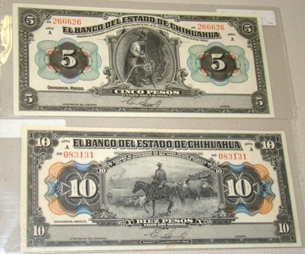

Two Series 1913 Banknotes of the Mexican Revolution engraved for the state of Chihuahua by the American Banknote Company, NY
Top: the Face of a $5 Pesos note (Lacking two signatories)
Below: The face of a $10 Pesos note
[Use 3X glass or magnify to 200% to see details]
[from the collection of Walter Kublius]
[All photos, courtesy of Jim Mullaney]

Walter’s presentation took us back through a portal in time to a period in Mexico’s history that went from Revolution against one despot (Diaz) into what became a Civil War against another (Huerta) eventually resulting in chaos brought about by the inability of the various “war lords” to compromise. For a short period, even the United States played a questionable role in the conflict. The club thanks Walter for sharing his impressive research into this turbulent era and displaying his many banknotes produced during the decade.
___________________________________________________________________________________________________________________
(More Club News continues on page 6, column 1)
More club News
(Continued from the previous page)

The Prizewinners were Todd Starbuck who won the door prize, a silver eagle and Art Ludwig who won the 50/50 - $13.00. Congratulations gentlemen. Our next meeting is Thursday, July 1 at the Aiken Public Library starting at 6:45 PM, early arrivals at 6:00. In addition to offering lots for the monthly auction, please bring in a numismatic item for Show & Tell. The program for the evening will feature another Grade-a Slab event but instead of members bringing in certified coins, all coins will be shown from digital photographs via a PowerPoint projector. You grade the coin and on the following slide, see the actual certified grade. This should be interesting.
__________________________________________________________________________________________________________________

Test Your Grading Skills

Below are three US type coins that appear approximately their exact size when printed out. For those receiving snail-mail printed copes, apply a 3X power magnifying glass to each coin shown before attempting to grade them. For those receiving the newsletter digitally, magnify the page to 200%, then answer the multiple choice questions below.

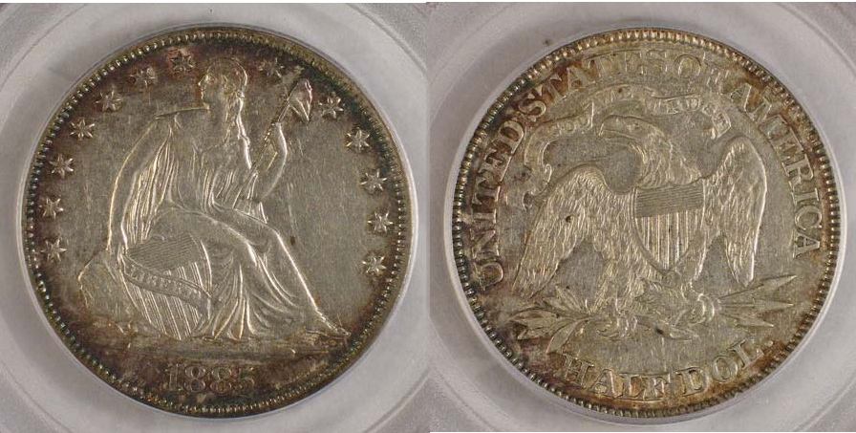

An 1885 Liberty Seated Half Dollar
[Courtesy Alpine Numismatics]

How would you grade this coin? a. VF-30, b. XF-45, c. AU-50

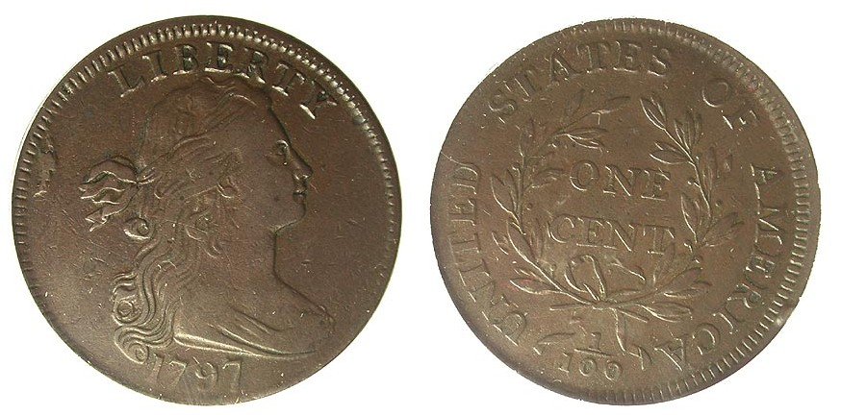

A 1797 Draped Bust Large Cent
[Courtesy J.J. Teaparty]
How would you grade this coin? a. Fine-15, b. VF-20, c. VF-30

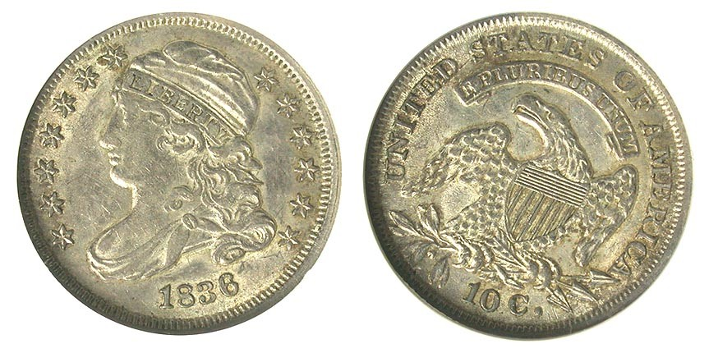
An 1836 Capped Bust dime
[Courtesy J.J. Teaparty]
How would you grade this coin? a. XF-45, b. AU-55, c. MS-62

Answers

1885 50¢ b. PCGS-XF-45
1797 1¢ c. PCGS-VF-30
1836 10¢ b. NGC-AU-55
______________________________________________________________

Kindly Patronize Our Advertisers
