Pres. Steve Kuhl
V .P. Pat James
Sec. Jim Mullaney
Treas. Sharon Smoot
Sgt. in Arms: Glenn Sanders
The Stephen James
CSRA Coin Club of Aiken
P.O. Box 11
New Ellenton, SC 29809
Web site: www.sjcsracc.org
The SJ CSRA CC of Aiken, SC meets on the 1st Thursday of the month at the Aiken Public Library

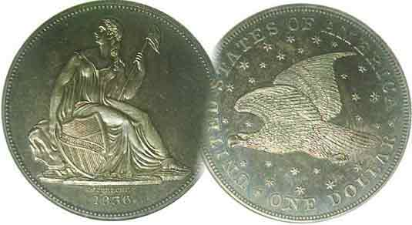

Programs: Pat James
Show: by Committee
ANA Representative: Jim Barry
Publicity: Jim Clapp
Newsletter: Arno Safran
E-Mail: arnosafran@comcast.net
Auctioneer: Glenn Sanders
Web site: Susie Nulty (see above.)

2011 Club Meeting Schedule
Volume 10, Number 7 the Stephen James CSRA Coin Club, Founded in 2001 July, 2011
Monthly Newsletter
Howard Hillman to share Collecting Stories at July Meeting
Our next meeting is on Thursday, July 7, 2011 from 6:45 to 8:45 PM

Jan. 6 Apr. 7 July 7 Oct. 6
Feb. 3 May 5 Aug. 4 Nov. 3
Mar. 3 Jun. 2 Sep. 1 Dec. 1

____________________________________________________________________________________________________________

The Challenge of Coin Collecting

Most of the fun of coin collecting is often gained from the challenge of the hunt; searching for that one elusive item that completes the set. More often that one might think, the missing link towards completion may not be a key date; that low mintage rarity which is so expensive it is sometimes referred to as a “stopper”. Instead, it may be a particular date of a denomination that is considered as relatively common but somehow never seems to turn up at shows or on the internet.

Before 1965, the year silver was removed from our circulating coinage, a collector could find most of the dates of a particular denomination directly out of circulation. Grade wasn’t the criterion back then. Completing sets of Lincoln cents, Buffalo nickels or Mercury dimes from one’s pocket change were enough to satisfy one’s numismatic appetite. If one was lucky, he/she might come across a 1909-S VDB or 1914-D Lincoln, possible a well worn 1916-D Mercury dime. Of course, such circulation finds were as rare as the dates themselves.

Today, one can still acquire current coins out of circulation but since the US Mint as well as the World Mints produce uncirculated sets on an annual basis and at a relatively affordable price, no challenge is involved. One merely produces the credit card and, “Voila! the set is yours in Brilliant Uncirculated condition. On the other hand, if one wishes to acquire obsolete type coins, the challenge of the hunt increases exponentially because of 1) lack of availability, 2) concerns regarding grade and condition, (eye appeal) and 3) price.

At our upcoming July 7 meeting member Howard Hillman will share his experiences as a collector going back to his first childhood discoveries. From his many Show & Tells, Howard has demonstrated his wide range of collecting interests not only in US coinage, but foreign coins especially under the umbrella of World War II memorabilia.
The Early Silver Coins of the Republic of Chile
By Arno Safran (Second in a Series)

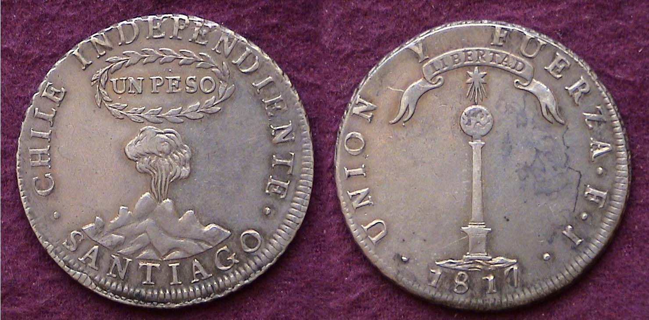

An 1817 Peso, a silver dollar-sized coin of the Republic of Chile
Struck at the Santiago Mint [Use 3X glass or magnify 200% to see details.]

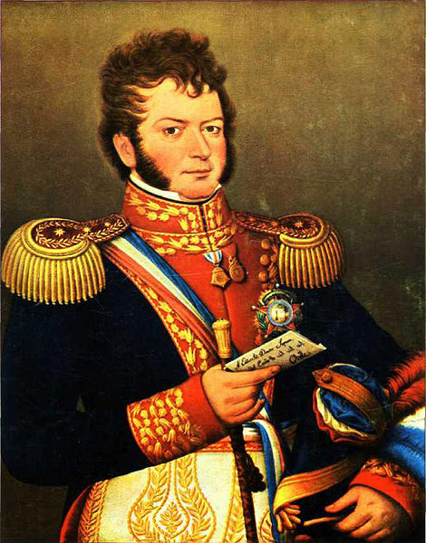
As a result of the Napoleonic wars during the first decade and a half of the 19th century, Chile was the first Latin American country to rid itself of Spanish rule. Led by Bernardo O’Higgins and San Martin, Independence was accomplished in 1818. The new republican government issued a silver dollar coin dated 1817 which many collectors today cherish for its fascinating design characteristics. The obverse depicts an erupting volcano with the denomination UN PESO surrounded by an oval-shaped wreath. The legend along the rim reads CHILE INDEPENDENTE. Below the mountain, the Mint’s location is spelled out, SANTIAGO, which is the Chilean capital. The reverse shows a monument with star atop and above that, an ornate ribbon with the inscription, LIBERTAD. Along the rim is another motto, UNION Y FUERZA, “United and strong” or “Strength in Utility”, similar to our original Latin motto, E PLURIBUS UNUM. In the example above a bold date -1817- lies below the base of the column. Bernardo O’Higgins
This type was struck from 1817 through 1834 excluding the years 1827 and 1829.
___________________________________________________________________________________________________________________________
(Continued on page 2, column 1)
The Early Silver Coins of the Republic of Chile
(Continued from page 1, column 2)

There are two varieties for the 1817 Chilean Peso, one showing the Y in the motto centered at 12:00 with the F in FUERZA towards the right side of the ribbon. The second and more common variety shows the Y nearer 11:00 with the F for FUERZA over the A in LIBERTAD.

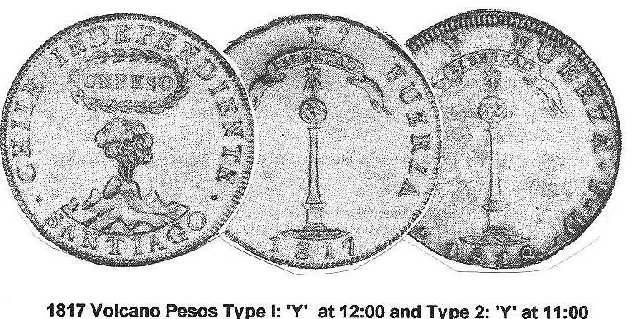

There are no mintage records for the 1817, the first date of the series. It is likely that none were actually struck that year as total victory over Spain was not yet secured. The 1818 issue has a reported mintage of 371,000 (according to the Standard Catalog of World Coins Spain, Portugal and the New World edited by Chester L. Krause and Clifford Mishler) and that presumably includes most of the 1817 dated pieces since the 1817 is the most common date of the series. The Volcano Peso was granted legal tender in the United States in 1834, coincidentally, the last year for the type.

The Volcano type was struck on the lower silver denominations; the 2 Reales and 1 Real but not until 1834, the only date that appears on them while the ½ Real was issued two years, in 1833 and 1834. As with the Central American Republic silver coinage described in the previous issue, no 4 Reales were issued by the Republican government in Chile.

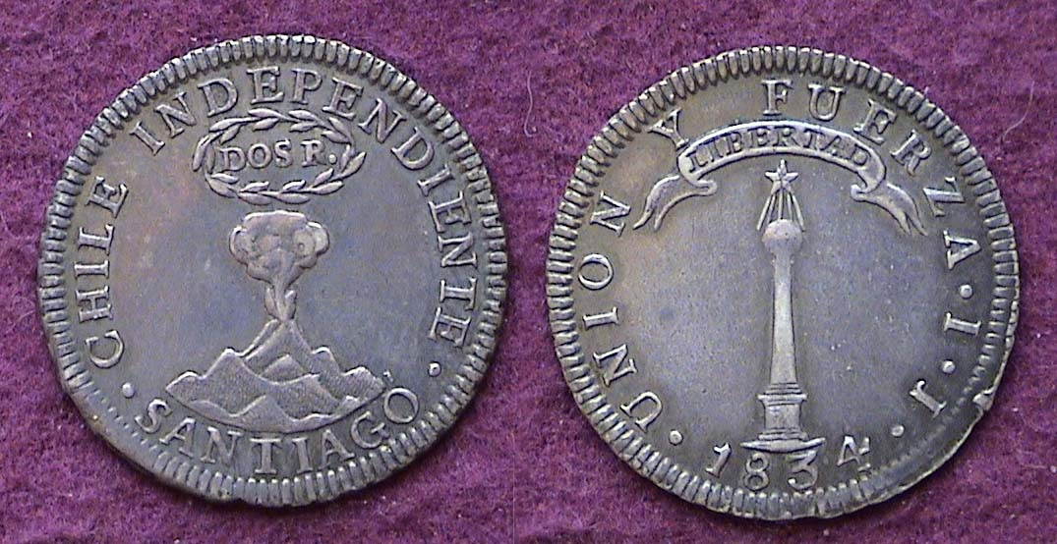

An 1834 Chilean Volcano Type 2 Reales struck at the Santiago Mint
[Use 3X power glass or magnify to 200% to view details.]

The reported mintage for the Chilean Volcano/ Monument 2 Reales is just 3,470 according to the Krause publication cited above. If this figure is accurate, the mintage is well below the 1796 US quarter-dollar with a reported figure of 6,146 and yet the author noticed one in a mail bid sale several years ago, bid only a nominal figure for the piece and was successful. Apparently demand for the minor coins of this series is not very strong. This lovely coin is about the same size as our early Bust quarter series (1815-1828) and was struck in .900 fine silver. Needless to say, it is a keeper for life.
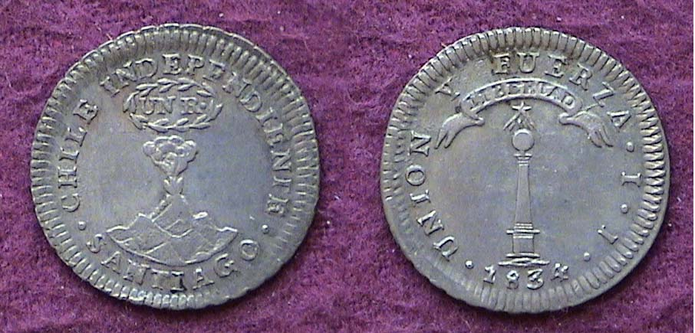

An 1834 Chilean Volcano/ Monument silver Real
The coin had a value equivalent to 12½ ¢
[Use 3X power glass or magnify to 200% to view details.]

Of the minor coinage the Real is the most available denomination of the Chilean Volcano/ Monument series. A specimen grading VF or even XF can be located at the larger coin shows where dealers specializing in foreign coins take tables. These are not very expensive.

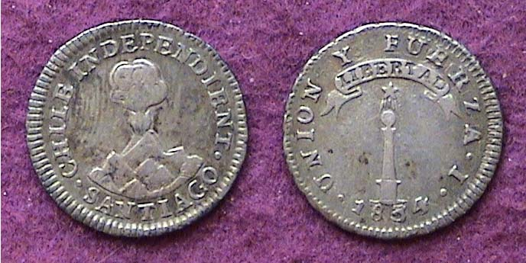

An 1834 Chilean Volcano/ Monument silver ½ Real
The coin had a value equivalent to 6¼¢
[Use 3X power glass or magnify to 200% to view details.]

The 1834 1/2 Real is more difficult to locate in high grade. These tiny silver coins were slightly larger than our half dime with a diameter of around 16 mm. They circulated heavily in Chile among the farmers and workers. Half reales were often holed after they left the Mint to be strung together in bracelets, not as jewelry but as money holders used by women in the marketplace.

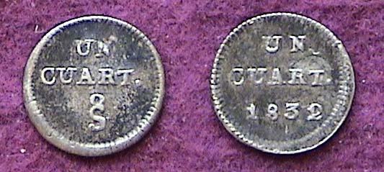

An 1832 Chilean silver quartillo ¼ Real).
The coin had a value equivalent to 3 & 1/8¢
[Use 3X power glass or magnify to 200% to view details.]

Since the 1790s Spain had been striking the silver ¼ Real for its colonies at the various Mints located in the New World and Chile was no exception. After winning freedom from the mother country some of the former colonies continued striking the denomination because it had sufficient monetary value to purchase needed goods. However, due to its small size the design was usually altered. Unlike the Central American Republic in which the number of mountains were reduced to one, the Chilean ¼ real was completely changed. Since there was no room on the coin for either the volcano or monument both the obverse and reverse were inscribed Un Quart. (for ¼ Real) with an oversized crude looking S for Santiago Mint placed underneath on the obverse and the date (in this case, 1832) placed below the denomination on the reverse.
Since all the silver coins were .900 fine those that reached the US circulated here. Like other Latin American series, the author acquired the crown-sized silver coin first, then went on to fill the smaller denominations.
________________________________________________________________________________________________________________
(Continued on page 3, column 1)
The Early Silver Coins of the Republic of Chile
(Continued from page 1, column 2)

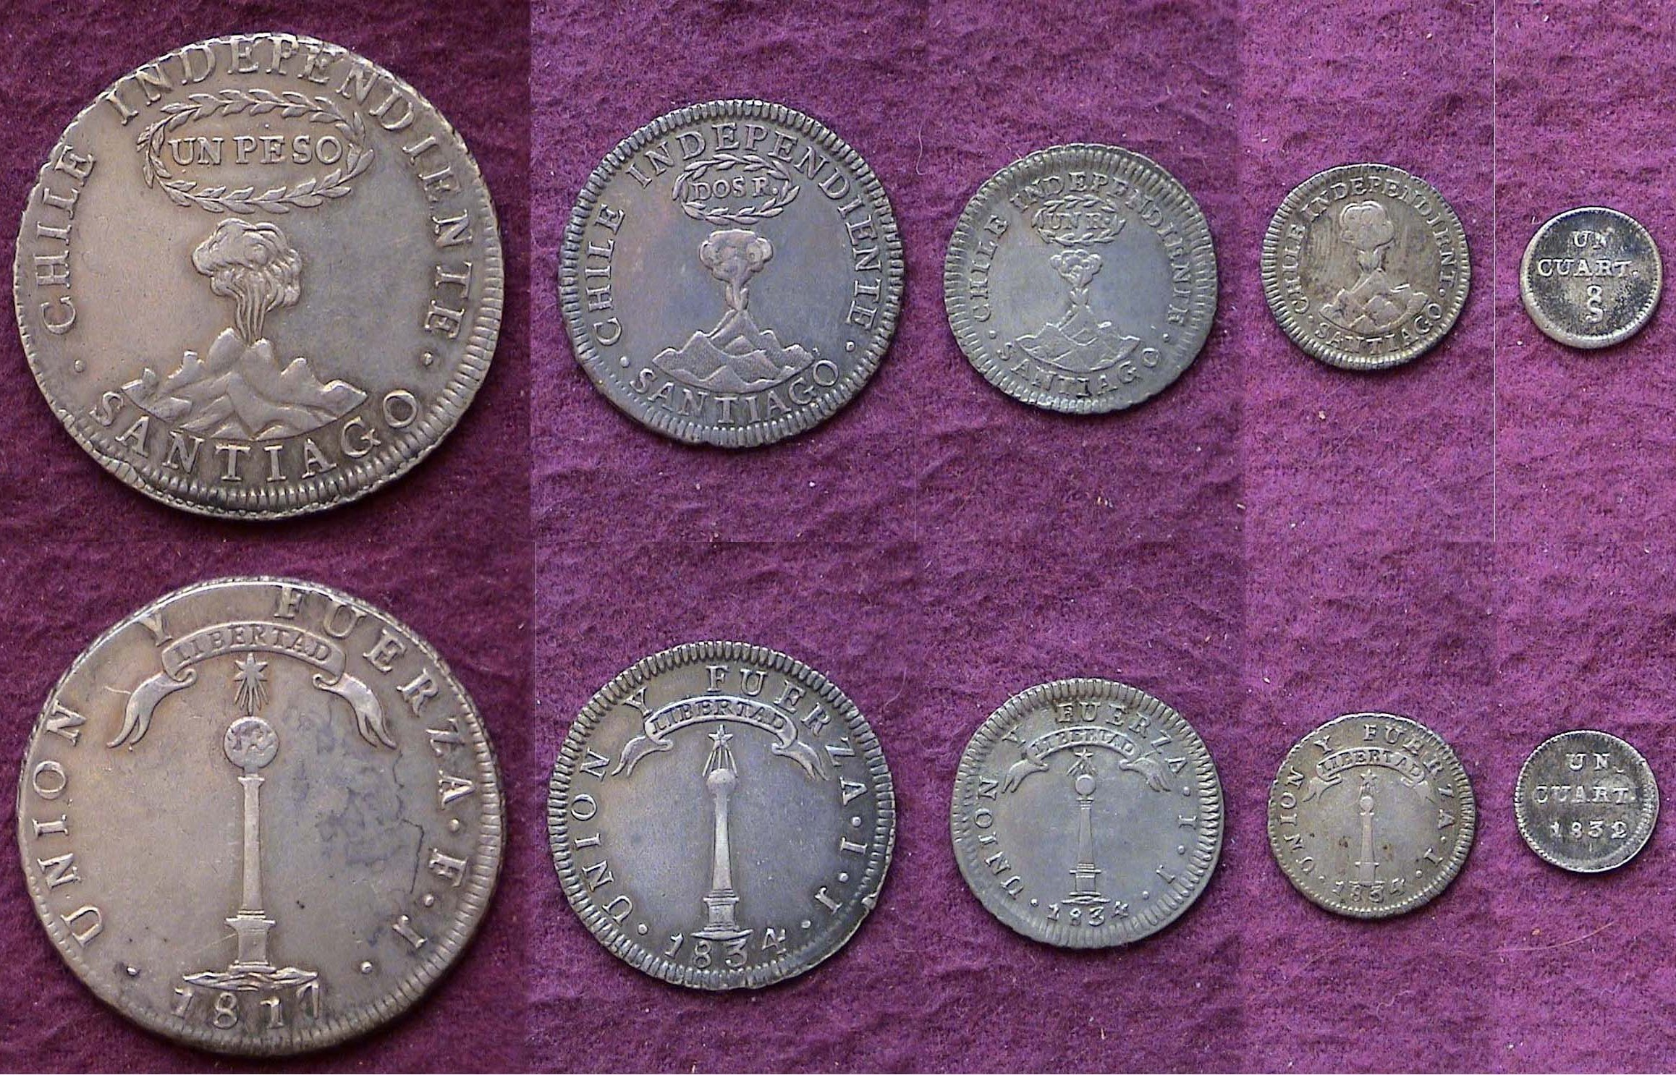

A denominational set of the first Republican Chilean silver coins
From left to right: Peso ($1.00), 2 Reales (25 ¢), Real, (12½ ¢),
½ Real (6¼ ¢) and ¼ Real (AKA quartillo), 3 & 1/8¢
The coins are shown less than actual size when printed]
[Use 3X power glass or magnify to 200% to view details.]

Despite being much less expensive than the crown-size dollar coin, all of the minor Chilean silver coins were somewhat challenging to find for a number of reasons:
,
1) Most were not saved being heavily circulated until well worn.
2) The minor coinage appearing in the Standard Catalogue of World Coins is listed at unusually low prices considering their true rarity due to lack of collector demand and
3) When inquiring about the lack of availability of the minor coinage, dealers explained that they left them home to make more room for the crowns and gold coins which brought a greater return.

While reason 3 is dubious, a collector wishing to complete a short set of the first silver denominations from the Republic of Chile is faced with questionable unavailability and true scarcity. The set pictured above took two years to complete.

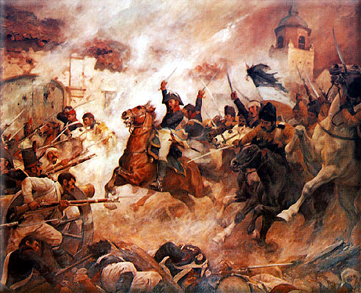

Painting showing the Charge of Bernardo O’Higgins leading
the Chilean Rebels to victory over the Spanish Loyalists
[Use 3X power glass or magnify to 200% to view details.]
(Courtesy of Wikipedia)
_____________________________________________________________

Club News
By Jim Mullaney and Arno Safran

President, Steve Kuhl, called the regular meeting of the club to order at 6:47 p.m.
Glenn Sanders reported that there were 18 members present (17 adults, 1 junior). There were no visitors. A quorum for the meeting was met. (15 regular members are required to conduct the business of the club.)
Glenn announced that upcoming coin shows in the area included a show in Anderson, SC, June 3-4, and the Metro-liner Tradeshow expo near Charlotte the following weekend. Guest speaker Tony Chibbaro indicated that a relic show was likely to include a few coins will be at the State Fairgrounds in Columbia June 11.
Rick Owen commented that he recently attended a coin show in Jacksonville, FL and found it to be more enjoyable than most shows he had attended recently due to a large number of dealers (around 85), many of which offered a better choice of material for the collector. It definitely exceeded his expectations.
A motion was made by Rick, seconded by Arno Safran, and passed to dispense with the reading of the May 2011 minutes. The treasurer’s report was read. The balance as of 5/31/11 was $1622.94.
Steve Kuhl and Arno Safran informed the club that Pat James had just undergone unexpected surgery about a week ago. She is recovering well at home and we look forward to seeing her at next month’s meeting.
The Program: Tony Chibbaro gave a PowerPoint program on The Tokens of Aiken County. His presentation displayed a wide variety of brass and aluminum tokens from his personal collection. The pieces shown ranged in value from 5¢ to $1.00. Tony explained that while tokens were not legal tender, they could be used by employees or customers towards purchases at places of manufacture, sawmills, pharmacies, soda-shoppes and restaurants that issued them. Tony reported that the Aiken County tokens covered in his presentation were struck between 1820 and 1940. The club thanks Tony for another fine program.
For the July 7 meeting, VP Pat James has reported that Howard Hillman will present a talk based on his lifetime experiences as a collector including the event which sparked his interest in coin collecting as a child. For August 4, Sec. Jim Mullaney plans to present a slide program for our annual club grading bee.
Show & Tells: Rick Owen brought in a 1919-D Lincoln cent housed in a PCGS MS-64 Red holder and Arno Safran displayed a modern 50 centavo cupronickel Nicaraguan coin that featured the same sun rising behind the five volcanoes type now placed on the reverse that originally appeared on the obverse of the Central American Republic silver coinage. Prize Winners: Congratulations go out to Rick Owen who took the door prize and John Meinhardt who won the 50/50 ($15.00).
________________________________________________________________________________________________________________________
Pics from the June 2, Meeting
(courtesy of Jim Mullaney)

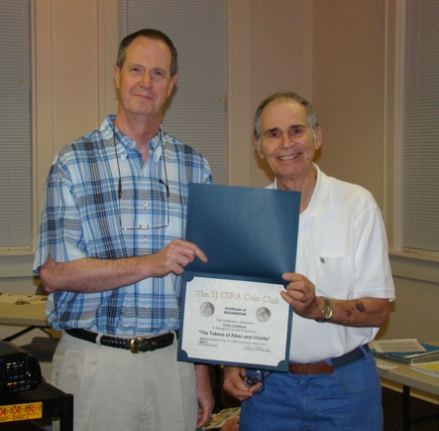

Tony Chibbaro being presented with an Appreciation Award
by acting program chair Arno Safran

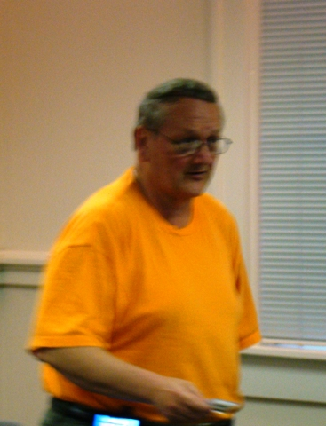

Rick Owen displaying a 1919-D Lincoln cent
Graded MS-64 Red by PCGS

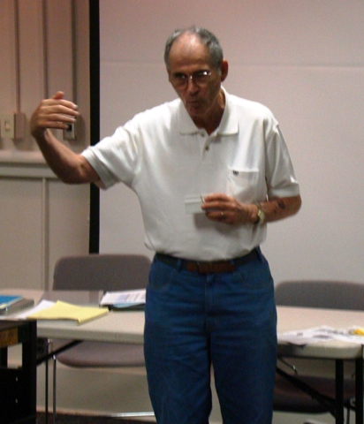

Arno Safran displaying a 1956 50 centavos Nicaraguan
cupro-nickel coin as part of an inexpensive modern five-piece set showing the same sun and mountains motif that appeared on the original Central American Republic silver coins (1824 -1850)
featured in the June, 2011 newsletter article.

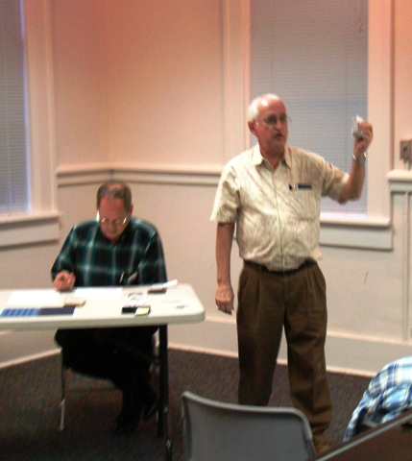

Club Auctioneer Glenn Sanders auctioning one of the lots with
President Steve Kuhl, recording the bids at the club’s June 2 meeting
_______________________________________________________________

Please Patronize Our Dealer Advertisers
