The Stephen James
CSRA Coin Club of Aiken
P.O. Box 11
New Ellenton, SC 29809
Web site: www.sjcsracc.org
The SJ CSRA CC of Aiken, SC meets on the 1st Thursday of the month at the Aiken Public Library

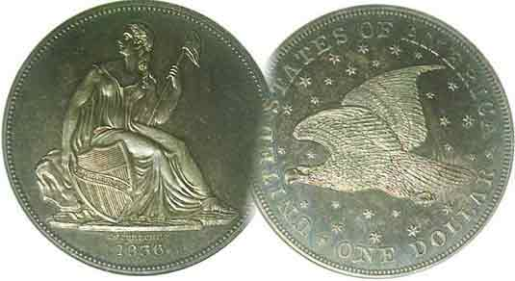
Pres. Steve Kuhl
V .P. Pat James
Sec. Jim Mullaney
Treas. Chuck Goergen
Sgt. in Arms: Jim Sproull
Programs: Pat James
ANA Representative: Jim Barry
Photos: Helen Barry
Publicity: Pat James
Newsletter: Arno Safran
E-Mail: arnosafran@comcast.net
Auctioneer: Glenn Sanders
Web site: Susie Nulty (see above.)

2013 Club Meeting Schedule
Volume 12, No. 7 the Stephen James CSRA Coin Club, Founded in 2001 July, 2013
Monthly Newsletter
Our next meeting will be held on Thursday, July 11, 2013 at the Aiken Public Library

Jan. 3 Apr. 4 July 11 Oct. 3
Feb. 7 May 2 Aug. 1 Nov. 7
Mar. 7 June 6 Sept. 5 Dec. 5

______________________________________________________________________________________________________

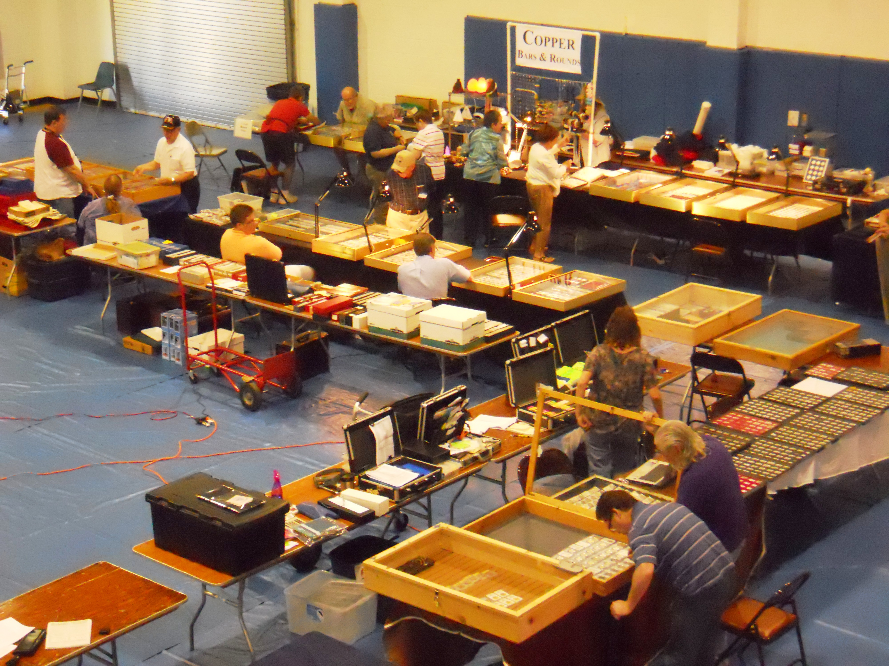

Attending shows offer the collector opportunities to observe, study, evaluate as well as buy, sell or trade

How often have you attended a coin show, occasionally, seldom, never? As with any pastime, the accumulation of knowledge far surpasses mere accumulation for its own sake. With Numismatics, there are books, auction catalogues, price sheets, the internet and finally shows that combine all of the forgoing. The last named is the most important because it gives the aspiring collector the opportunity to observe coins, tokens, medals, banknotes and scrip first hand, check the grading of each item whether “raw” or certified, evaluate the condition of an item (its eye appeal) and price. Even if one has only enough discretionary income to acquire better date coins in grades from AG-3 to Fine-12, “condition” is still the key to building a quality collection. I knew one such collector who loved early US type yet managed to obtain the finest problem-free low grade “original” looking pieces I had ever seen. Attending shows allowed him to make comparisons between coins graded similarly and he chose the best of the lot.
_____________________________________________________________________________________________________________________________

The US Coinage of 1793 – 220 years ago,
Attending Shows offer more options for collector
Part One: the Birth of the Large Cent
By Arno Safran

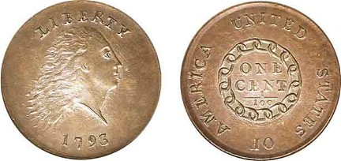

A 1793 Chain Cent, S-3 R3 graded AU-58 by PCGS
The reported mintage was 36,103.
(Courtesy of Heritage Auction Archives)

The US Coinage Act of 1792 authorized ten denominations; two in copper, the cent and half cent, five in silver, the half-disme, disme, quarter-dollar, half-dollar and dollar and three in gold, the $2.50 quarter-eagle, the $5.00 half-eagle and the $10.00 Eagle. Of these, only two denominations were issued in 1793, the first year of US coinage and both were copper, the large cent and half-cent.

There were three different designs for the cent. The first was the dubbed the “Chain cent”, which featured a circular chain surrounding ONE CENT with the legend UNITED STATES OF AMERICA inscribed along the circumference of the coin. The obverse portrayed a crude representation of Liberty appearing wild-eyed with disheveled hair. The coin was engraved by Chief coiner Henry Voigt but proved to be unpopular due to the distorted visage of Miss Liberty on the obverse and the misinterpretation by the public who assumed the chain on the reverse portrayed enslavement as opposed to unity.

As there was no Chief Engraver at the time, our first Mint Director David Rittenhouse prepared sketches for Asst. Chief Coiner Adam Eckfeldt to develop into an alternative design. This became known as the Wreath cent. The obverse, while similar, was improved slightly. A small sprig of three leaves was added below Miss Liberty just above the date. A wreath replaced the chain with the fraction 1/100 centered below. Some 63,353 of the second 1793 cent type was issued.
_______________________________________________________________________________________________________________________
(Continued on page 2, column 1)
The US Cents of 1793 – 220 Years Ago
(Continued from page 1, column 2)

]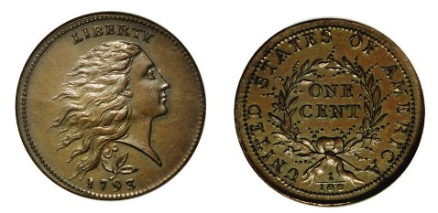
A 1793 Wreath Cent S-8, R3 graded PCGS-55 CAC
The reported mintage was 63,353.
(Courtesy of Heritage Auctions Archives)

J While a marked improvement over the Chain cent in all respects, Mint Director Rittenhouse was still not satisfied and chose Joseph Wright to become Acting Engraver. Wright was an accomplished miniaturist who was considered entirely competent in applying his skills to the engraving of coins.

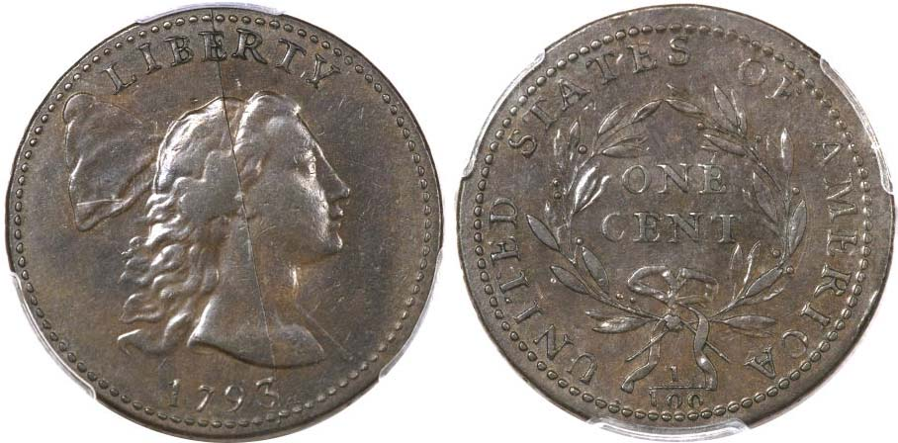

A 1793 Liberty Cap 1c, S-14, R5- graded AU-50 by PCGS CAC
(Courtesy of Heritage Auctions Archives)

Wright fashioned his Liberty Cap design after Dupre’s 1776 Libertas Americana medal. Despite being the more attractive design-type of the three 1793 cent types for that year, the reported mintage was only 11,056. As a result the coin is quite pricey, even when found in as low a grade as AG-3, (practically a cull), which the 2014 Red Book lists at $3,000. While 90% of the coin collecting fraternity is unlikely to afford any of the 1793 cent types shown above, there may be a silver lining for the budget conscious collector. Back in 1993, the Gallery Mint Museum located in Eureka Springs, Arkansas began striking replicas of the three 1793 large cent types in both business strike and proof formats, selling them for $8.00 apiece. These reproductions were actually engraved to the specifications of the original coins by Ron Landis, the founder of GMM using a specially designed Screw Press to strike the coins.

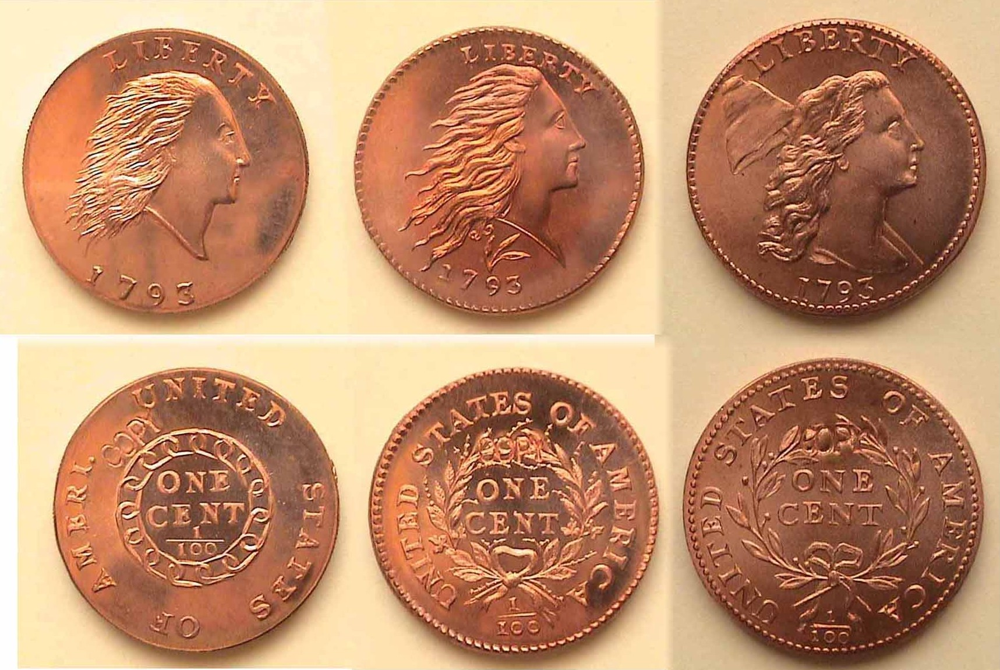

Imagine owning one of these in full Red MS-68 to 70. Regrettably, the GMM closed shop several years ago and the dies were supposedly destroyed but around 2,000 or more of these pieces survive today in collectors’ hands, and from time to time, come on the market. The word COPY appears on either the reverse or obverse but positioned in such a way as not to detract from the coin’s overall design characteristics.
_________________________________________________________________________________________________________________

The US Coinage of 1793 – Part 2, the ½¢s

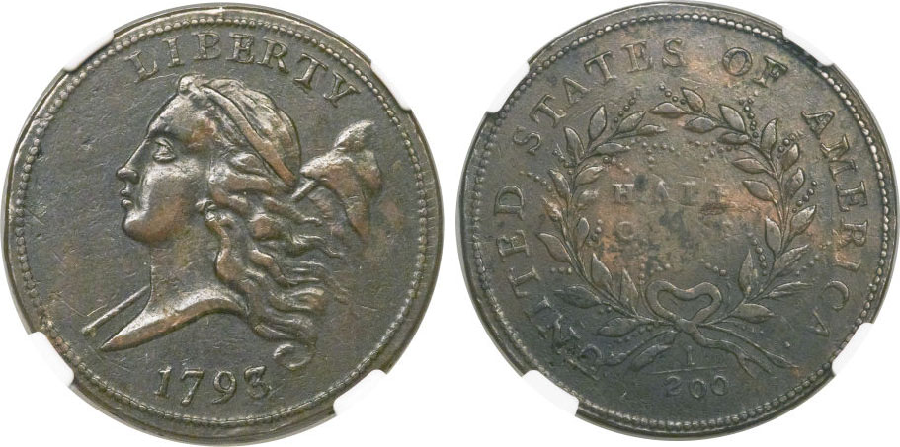

A 1793 Half-Cent, C-1, R3 graded XF-45 by NGC
Shown actual size, 22 mm)
[Courtesy of Heritage Auction Archives]
While the large cent underwent three changes in design, only one primary design was created for the 1793 half-cent and that was the Liberty Cap facing left. The late Roger Cohen, Jr., author of American Half Cents, the Little Half Sisters” (2nd Ed. 1982) believes the obverse design was created by artist and engraver Joseph Wright influenced by Augustin Dupre’s 1776 dated Libertas Americana Medal created at the Paris Mint in 1782.

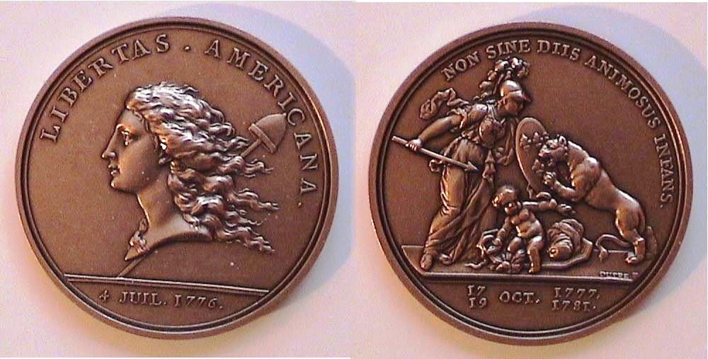
A Paris mint restrike of the Libertas Americana Medal
Shown in actual size, 47 mm
Cohen suggests that it was Joseph Wright who prepared the die for the first half cent but unfortunately, later succumbed to the Yellow Fever epidemic that swept through Philadelphia that summer. Cohen further believes that Adam Eckfeldt, a young machinist was entrusted by first Mint Director David Rittenhouse to continue Wright’s efforts, creating a second obverse variety known as the hooked-line caused by the sharp curve under the apex Liberty’s neckline appearing well above the 7 and 9 in the date. Chief coiner Henry Voigt was the engraver for all three acknowledged 1793 half-cent varieties.

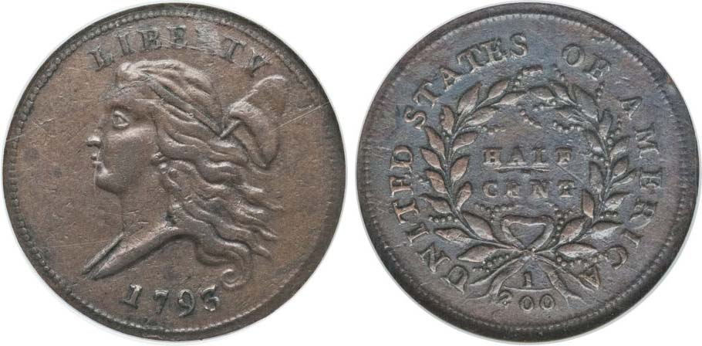
A 1793 Liberty Cap facing left Half- Cent, C-3 R3 [Hooked Bust line]
Shown actual size, 22 mm) graded XF-45 by NG
(Courtesy of Heritage Auction Archives)

The US Coinage of 1793 – 220 years ago, the ½¢s
(Continued from page 2, column 2)

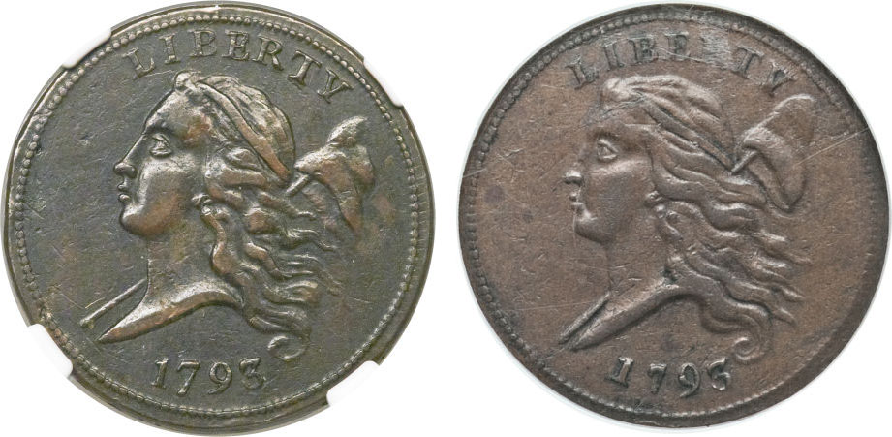

Enlargements of the obverses of the 1793 Half-Cent specimens
C-1, Obverse 1 and C-3, Obverse 2, (AKA the Hooked-Line variety) [Courtesy of Heritage Auction Archives]

The reported mintage for the 1793 half-cent was just 35,334 and survivors even in circulated grades are scarce and costly. The specimens shown above were each graded XF-45 by NGC with the C-1 selling for $18,000 and the C-3 for $20,700 in recent Heritage Auctions held in 2013 and 2012 respectively. Such prices are well beyond the budget of most serious coin collectors. However, in the mid 1990s, (as with the large cents of 1793,) the Gallery Mint created marvelous business-strike replicas for around $8.00 per coin. (See directly below.) They also struck proof versions at a cost of $17.00 to the collector.

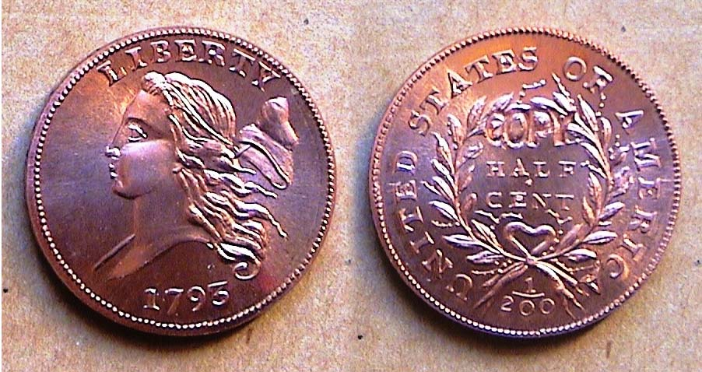

A Mint state Gallery Mint replica of the 1793 half cent
(Approximately actual size, 22 mm in diameter)
[Use 3 power glass or magnify page to 150% to view details.]

These replicas were engraved by Ron Landis and were made employing approximately the same alloy, weight and size as the originals, then struck on a screw press modeled after the one used to strike the originals at the Philadelphia Mint back in 1793. By law the word COPY had to appear on the coin with most collectors opting for its inclusion on the reverse. By 1997, both the business strikes and the proof 1793 half-cent issues were sold out, the dies supposedly destroyed. Today, these 1793 half cent replicas can only be attained on the secondary market but even at increased prices they will not cost anywhere near what even an original AG-3 specimen would bring at auction.

In 1793, George Washington began his second term as our first President. His did not want to see his portrait on the obverse of any US coin because he wished our coinage to emulate freedom and not the monarchies of Europe. Until 1909, no living or former President was featured on any US coin intended for circulation. Until 1851, (the first year the silver 3c piece was struck), the allegorical figure of Miss Liberty appeared on the obverse of all our coinage. Beginning in 1856, various motifs were used for our minor coinage (cent thru the 5c nickel) with Liberty appearing on our silver and gold issues.
____________________________________________________________________________________________________________________________

Club News

President Steve Kuhl gaveled the June 6 meeting to order at 6:45 PM. In addition to our regular members, Sgt. in Arms Jim Sproull reported an additional eight guests present. Among the upcoming shows, Jim mentioned one in Charlotte, NC, also the annual mid June Memphis Paper money show and a reminder of our own club show set for Saturday, Sept. 7. Treasurer Chuck Goergen reported a balance of $2,172.01. VP Pat James announced that the program for the July meeting-- moved back from July 4 to July 11--would be an ANA Video by former club member Bill Myers. Member Jim Barry mentioned that ballots for the bi-annual ANA election for President, VP and Board of Governors had to be in by June 30.. Newsletter Editor Arno Safran announced that member Chuck Goergen, our scheduled speaker for the evening would also be the guest speaker at the Augusta Coin Club on June 21 to present a PowerPoint program on Spanish Colonial Cobs from the sunken ship Atocha. VP Pat James arranged for Chuck to speak there.

Due to the time required for Chuck’s program on “Ancient Roman Republican Coins: An Overview”, the Show & Tell session was suspended. Chuck’s PowerPoint presentation included a well outlined review of the history of Rome along with portrayals of many of the coin types and denominations starting as far` back as the Classical Greek era of late 700 BC all the way thru the Byzantine Era which ended in 1453. Thank you, Chuck for a very interesting program.

The prizewinners at the June 6 meeting were Marion Engel who won the attendance drawing and Pat James who won the 50/50 - $22.50. Congratulations, Marion and Pat! Our next meeting will be on Thursday, July 11 at the Aiken Public Library starting at 6:45 PM, with early arrivals admitted at 6:00. Bring in a numismatic item for Show & Tell. Our regularly monthly auction will begin after Bill Myers’ American Numismatic Association DVD presentation.

______________________________________________________________________________________________________________________________

__________________________________________

Do you have a coin you would like to sell or a coin or coin you would like to acquire?
If so, please e-mail the information in 40 words or less to the editor at arnosafran@comcast.net at least two weeks before the following meeting.

______________________________________________________________________________________________________________

There are Lots of Inexpensive books available
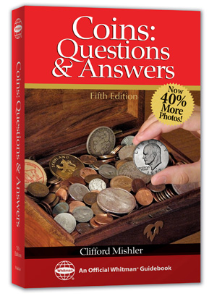
For the Young and Old Numismatist
One of the old adages of Numismatics is, ‘Buy the book before the coin”, and what better way to learn more about the hobby of coin collecting than becoming either a more informed collector yourself or buying a book for a member of your family who is interested in collecting coins. There are a large number of books priced at under $20 from which to choose. The book pictured at the left, Coins, Questions & Answers by former ANA President Clifford Mishler is one of them.
_

Other numismatic books within the $20 to $25 range feature a large number of volumes by renowned numismatic author Q. David Bowers such as his Guide Book series that include Morgan Silver Dollars, Shield and Liberty Nickels, and Washington and State Quarters for starters plus Grading Coins by Photographs. For the numismatic history buff, there is a wonderful book by David W. Lange called The History of the United States Mint. He too as authored a first rate ‘complete guides series’ on Lincoln cents, Buffalo nickels and Mercury Dimes; all moderately priced. Many of the past articles appearing in this newsletter could not have come to life without these and other numerous book sources housed in the editor’s personal numismatic library. For availability, the reader is advised to check out www.whitmanbooks.com or punch in Coin Books for Kids on Google.

_____________________________________________________________________________________________________________________________

The Editor is looking for more numismatic articles from members of our club or other collectors who may be receiving this off the Web site. If interested, please E-mail the editor a Microsoft Word readable copy at
arnosafran@comcast.net

and thanks in advance.

_________________________________________________

Kindly Patronize Our Advertisers

