The Stephen James
CSRA Coin Club of Aiken
P.O. Box 11
New Ellenton, SC 29809
Web site: www.sjcsracc.org
The SJ CSRA CC of Aiken, SC meets on the 1st Thursday of the month at the Aiken Public Library

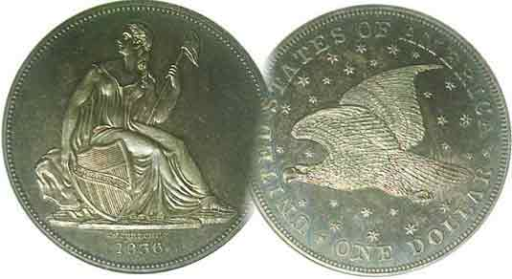
Pres. Willie Simon
V .P. Pat James
Sec. Jim Mullaney
Treas. Chuck Goergen
Sgt. in Arms: Jim Sproull

Programs: Pat James
ANA Representative: Jim Barry
Show Chairman: Steve Kuhl
Photos: Helen Barry
Publicity: Pat James
Newsletter: Arno Safran
E-Mail: arnosafran@comcast.net
Auctioneer: Jim Sproull
Web site: Susie Nulty (see above.)

2014 Club Meeting Schedule
Volume 13, No. 7 the Stephen James CSRA Coin Club, Founded in 2001 July, 2014
Monthly Newsletter
Our next meeting will be held on Thursday, July 3, 2014 at the Aiken Public Library

Why not tie in a weekend getaway with a Summer Coin Show
Jan. 2 Apr. 3 July 3 Oct. 2
Feb. 6 May 1 Aug. 7 Nov. 7
Mar. 6 June 5 Sept. 4 Dec. 4

Summer Coin Shows Offer Major collecting Opportunities

If you happen to be vacationing in or around Orlando, FL this summer, you may want to coordinate your arrival with the dates for the Summer F.U.N. Convention being held at the Orange Country Convention Center. on July 10 thru 12. While not nearly as large as the January extravaganza , the largest coin show of the year, there are still many major dealers set up at he Summer FUN which should offer the avid collector opportunities to acquire that elusive type coin. The acronym FUN stands for Florida United Numismatists. There city offers a number of sight-seeing experiences including Disney Land, the controversial Sea World, Universal Studios and many more attractions. The drive time to Orlando is roughly 7 hours from the CSRA


In August, it is the 55th Blue Ridge Convention which will be held on August 15-17. It’s regarded as the best show within a 4 to 5 hour drive from the CSRA . It will be held at the Northwest Trade and Convention Center, 2211 Dug Gap battle Road in Dalton, GA. Dalton is located at the north-western corner of Georgia, just 27 miles south of Chattanooga, TN where one can visit the marvelous aquarium or drive up to Lookout Mountain. From Dalton, one can also travel east to Ellijay via Rte 52 out of Chadwick over Fort Mountain which boasts one of the most scenic drives in the state.

Atop Fort Mountain along GA Rte. 52 between Chatsworth & Ellijay

Collecting a Basic Large Cent Type Set
By Arno Safran

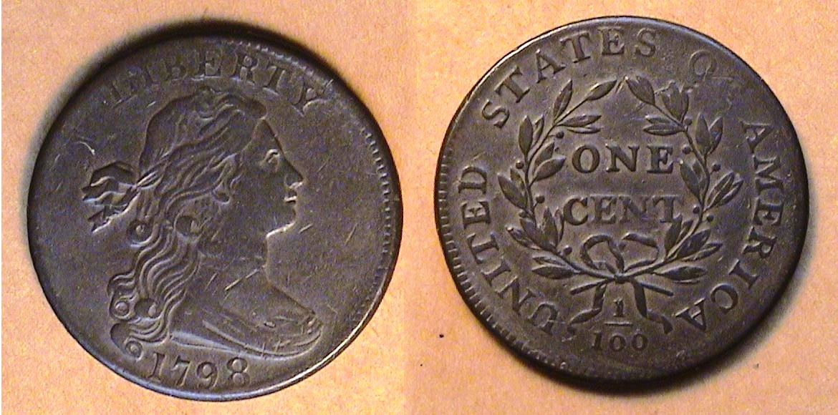

A 1798 Draped Bust Large Cent, S-167 graded Vf-30
The coin was 28-29 mm in diameter and weighed 10.89 grams
[Use 3x magnifying glass or magnify page to 200% to view details.]

If you travel other regions of the United States you will discover that coin collectors display interest in different series of US coins. Here in the south, Morgan dollars followed by Barber Liberty Head silver and gold coinage, (Dahlonega or Charlotte specimens if one can afford them) seem to be favored above most other US coin types. Before relocating in Georgia, I lived in an area where one could find many avid collectors of large cents who not only collected by design type or date, but by die variety as well. The large cent was initially patterned after the British half pence which was influenced somewhat by the Classical Roman Sertorius, a large copper coin with a diameter of 27 mm to 30 mm. The large cent was coined in the US from 1793 through 1857 with the exception of 1815. It had a diameter of between 28 and 29 mm. and was the workhorse of the economy for most of its 65 year lifespan.

There are basically five general obverse` types for the series, the Flowing Hair type of 1793, the Liberty Cap, struck from 1793 thru 1796, the Draped Bust (1796-1807), the Classic Head (1808-1814), and the Coronet (1816-1857) sub-divided into three sub-types, Matron Head (1816-39), Petite head (1839-1843) and Mature head (1843-1857). With the exception of the 1793 Flowing Hair, which is very expensive in all grades, it is possible for a collector of modest means to collect one example from each large cent type in grades from Good-4 thru AU-58 depending on the particular design-type.
_____________________________________________________________________________________________________________________________
(Continued on page 2, column 1)

Collecting a Basic Large Cent Type Set
(Continued from page 1, column 2)

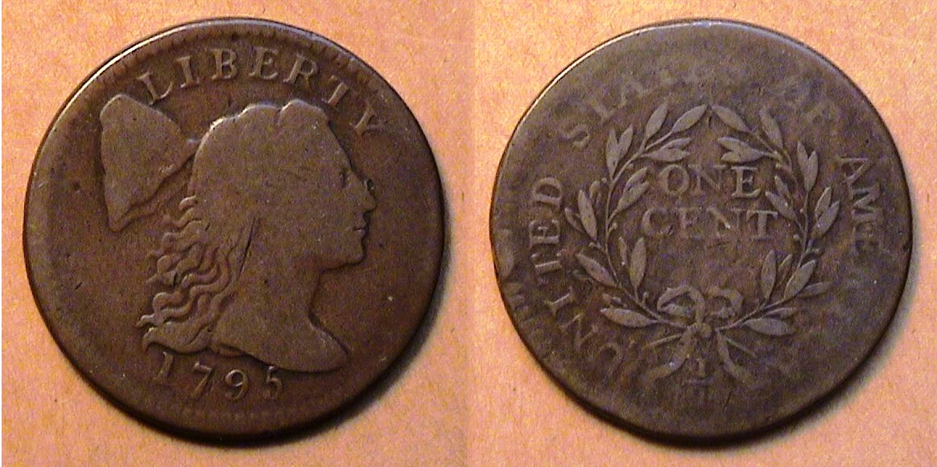

A 1795 Liberty Cap Large Cent, S-76b graded VG-8
[Use 3x magnifying glass or magnify page to 200% to view details.]

For most collectors, the first affordable type large cent is the Liberty Cap which was struck from the latter part of 1793 thru 1796. The 1795 S-76b cent variety shown above is the most common for that year and the least expensive. Despite the amount of wear on the specimen, the coin’s surfaces display natural copper color with even wear and are choice for the grade. It was removed from an NGC holder where it was graded VG-10. The reported mintage for the date was 501,500.

When it comes to copper coinage, both collectors and dealer members of the Early American Coppers Club (EAC) strongly believe that their grading standards are more stringent than the professional grading services. As a result, the large cent is the only US type coin that does not have to be certified in order for a collector to feel comfortable selling it. There are a number of coin dealers who specialize in early US copper coinage that will accept even a cleaned, retoned, buffed or polished large cent for payment or trade if the coin has eye appeal or is scarce as a date or variety.

Back in 1995, the writer realized that it might be possible to assemble a 200 year old denominational set of US coins (excluding gold) that were coined in 1795. Only copper issues were produced in 1793 and both the half cents and large cents made that year are extremely expensive. The same can be said for the first silver coin struck in 1794. Compared with 1795, the 1794 mintages for the` half dime, half dollar and dollar issues were very low and today bring huge prices at major auctions. By contrast the mintages for all 1795 denominations excluding gold were large enough to acquire lower grade pieces that still were attractive for the grade; (e.g., VGs or Fine). In 1995, coins dated, 1795 were still costly, so the writer decided to sell a number of common later-date pieces that one could always find again in order to acquire the 1795 issues.

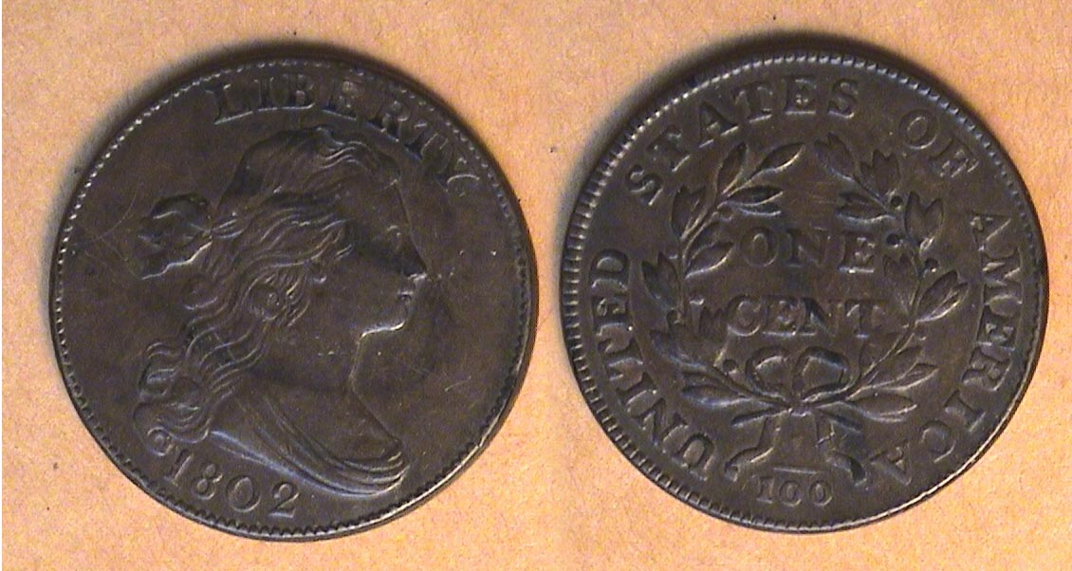

An 1802 Draped Bust Large Cent, S-237, R2 grading VF-35, Net 25
[Use 3x magnifying glass or magnify page to 200% to view details.]

The Draped Bust large cent was designed by our first Chief Engraver Robert Scot supposedly after a portrait by Gilbert Stuart of Lady Anne Bingham, a Philadelphia beauty. The type was issued from 1796 through 1807 (inclusive) with most dates being struck in large enough mintages to be affordable in the lower grades for collectors interested in the series. The earliest affordable date is the 1798 specimen (shown at the head of the article on page 1, column 2). That specimen was sold as a VF-25 and despite a few minor ticks on the surface has attractive color and eye appeal. The reported mintage for the 1798 cent was more than 1.8 million. The 1802 specimen shown on this page near the bottom of the preceding column was graded VF-35 by the dealer, but again, the minor tics on the surface net it down to a VF-25. The 1802 is a much commoner date than the 1798 with a reported mintage of over 3.4 million.

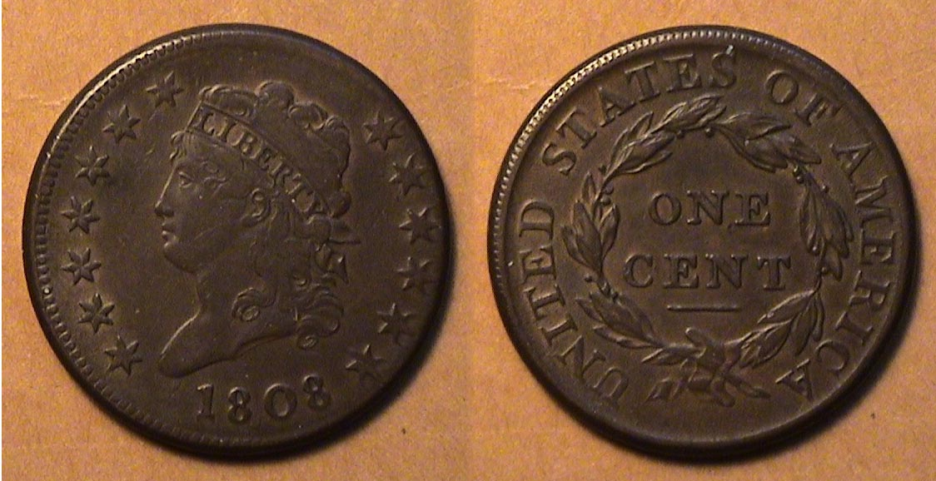

An 1808 Classic Head large cent, S-279, R1 grading VF30
[Use 3x magnifying glass or magnify page to 200% to view details.]

In 1807 John Reich, a highly skilled engraver from Germany was recommended to President Thomas Jefferson who asked Mint Director Robert Patterson to see what he could do to improve our nation’s coinage.. Reich was hired as Assistant Chief Engraver of the US Mint in Philadelphia for the annual sum of $600. He was assigned the task of redesigning all our coinage beginning with the half dollar in 1807 The following year, he redesigned the large cent fashioning Miss Liberty in a more elegant style. This type is called the Classic Head, (sometimes referred to as Turban Head). Reich completely re-designed the wreath on the reverse removing the fraction 1/100 below while enlarging the lettering of the legend UNITDED STATES OF AMERICA and the denomination ONE CENT within the wreath. The overall changes resulted in what is arguably considered our most elegantly crafted designs for the large cent. The Classic Series was produced from 1808 thru 1814 with the odd number years having lower mintages than the even numbered ones. The problem for the collector is finding an attractive chocolate-brown specimen free of porosity regardless of the mintage or grade listed on the flip or holder. The 1808 issue shown above is choice for the grade. It displays a natural brown color with problem-free surfaces and grades VF-30.

After 1807 relations between America and Great Britain deteriorated, eventually leading up to the War of 1812. In those days, the planchets (coin blanks) used for copper cents were manufactured in England. During the long sea voyages many of the copper blanks were stored in wooden kegs and improperly housed in the ship’s hull with the result that dampness seeped into the cartons causing the blanks to become porous or turn dark in color. Some historians believe the English shippers angry at Americans, may have intentionally placed inferior blanks under the shiny copper ones into the kegs. As a result, a small percentage of choice Classic Head cents surface today and these are more costly than average or Scudzy ones.
_________________________________________________________________________________________________________________
(Continued on page 3, column 1)

Collecting a Basic Large Cent Type Set
(Continued from the previous page)

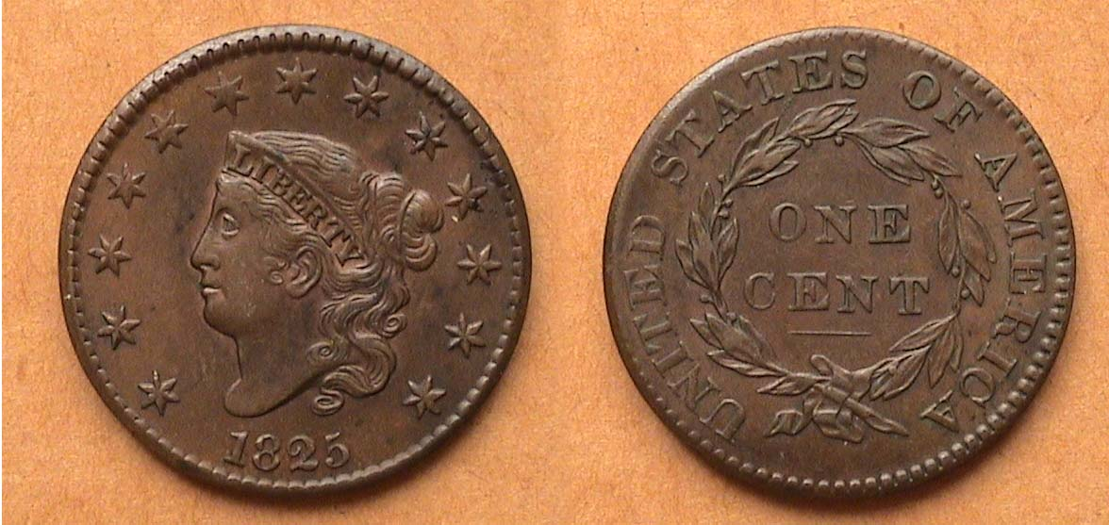

An 1825 Coronet (Matron Head) Large Cent N-6 R3n grading XF-45
[Use 3x magnifying glass or magnify page to 200% to view details.]

The Coronet type large cent was first issued in 1816. Many dates from this series are considered more affordable than the preceding types, especially those dated 1816-1820. Why these dates? Apparently, a large number of these dated coins were discovered by a Georgia baseman in a buried wooden keg a few years after the Civil War. According to the late numismatic scholar Walter Breen, the man sold the lot to a wholesaler to pay off some debts who in turn, resold them to a merchant named William H. Chapman, owner of a department store in Norwich, NY. Chapman began selling the hoard off as a promotion at, 90¢ for $1.00’s worth of cents but had few takers because people, unfamiliar with the large cent which had been terminated in 1857, believed the coins to be counterfeit. Finally, a collector named John Swan Randall purchased what remained of the hoard, gradually selling single specimens to collectors and dealers over a period of years. As a result, most of the coins in this cache, have come to be known as` the Randall Hoard and grade anywhere from AU-55 to mS-64.

At one time the 1825 dated cent was also considered to be a part of this hoard yet despite a reported mintage of 1,481,100, the date seldom surface very often in grades above VF. It has` been suggested by some numismatic researchers that a large number of 1825 cents may have been shipped to Venezuela as one of the reasons for the paucity of the date. The 1825 cent shown above was acquired as an XF-45 back in 1985 when large cent prices were much lower than they are today.

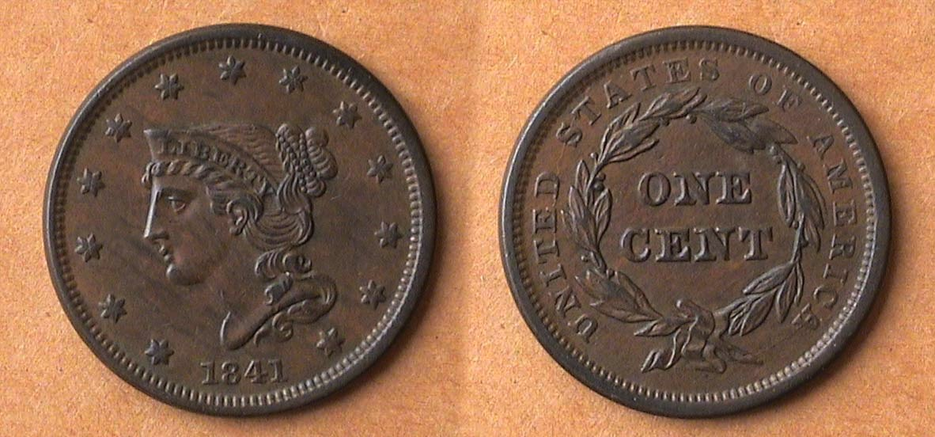

An 1841 Petite Head Coronet Large cent, N-3 R2, grading XF-45
[Use 3x magnifying glass or magnify page to 200% to view details.]

Starting in 1835 engraver Christian Gobrecht began refining the Matron Head Coronet cent design. For avid large cent collectors, there are no less than nine sub-types showing the gradual transition from the Matron Head to the Petite head, first issued in 1839. The 1841 represents the third year of the modified design type showing a more tapered Bust of Liberty tilted downward to the right as opposed to an upright position.

The mintage for the 1841 cent was 1,597,367, the lowest mintage since 1829. Still, the coin is not considered scarce or expensive listed in XF-40 at only $125 in the 2013 Red Book. That said most of the Petite Head large cents (1839-43) are listed in XF-40 are listed at only $75 to $85.

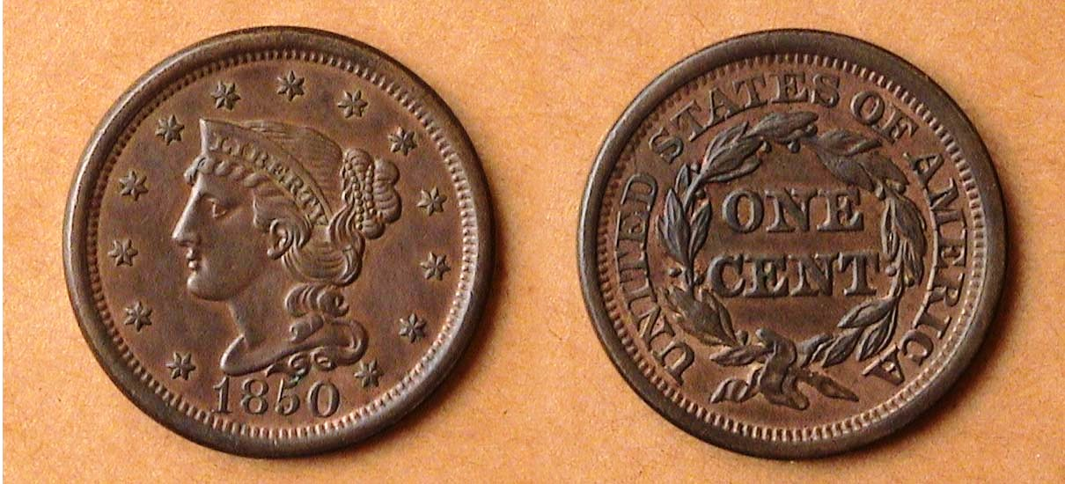

An 1850 Mature Head Large cent, grading AU-55
[Use 3x magnifying glass or magnify page to 200% to view details.]

With well over 4 million struck, the 1850 Mature Head large cent is one of the most common dates of the series. The 2013 Red Book lists an AU-50 at $125, and under the XF-40 column, only $60. When one compares the subtle changes in the obverse design between the 1850 and its two predecessors, the 1841 Petite Head and 1825 Coronet Matron Head shown, the design is arguably an improvement. The head has` been rendered smaller than the earlier version, the hair style, neater and in better balance to the head. The obverse design features are bolder featuring a clear larger date while the reverse displays a wider rim, stars placed further away from an upright Liberty facing left. The reverse shows a greater space between the larger rim and the Legend, UNITED STATES OF AMERICA which while smaller, displays clearer bold lettering around the wreath and larger lettering of ONE CENT inside it.

By the 1850’s the large cent, due to its size and weight was beginning to lose its popularity with the public and the series ended in 1857 being replaced by the Flying Eagle small cent. Since then, the large cent has attracted collectors through the ages. Advanced numismatists enjoy the challenge of locating hard to find die varieties. The series collector looks forward to the prospect of adding another date to their collection while the type collector requires just five to six basic examples.

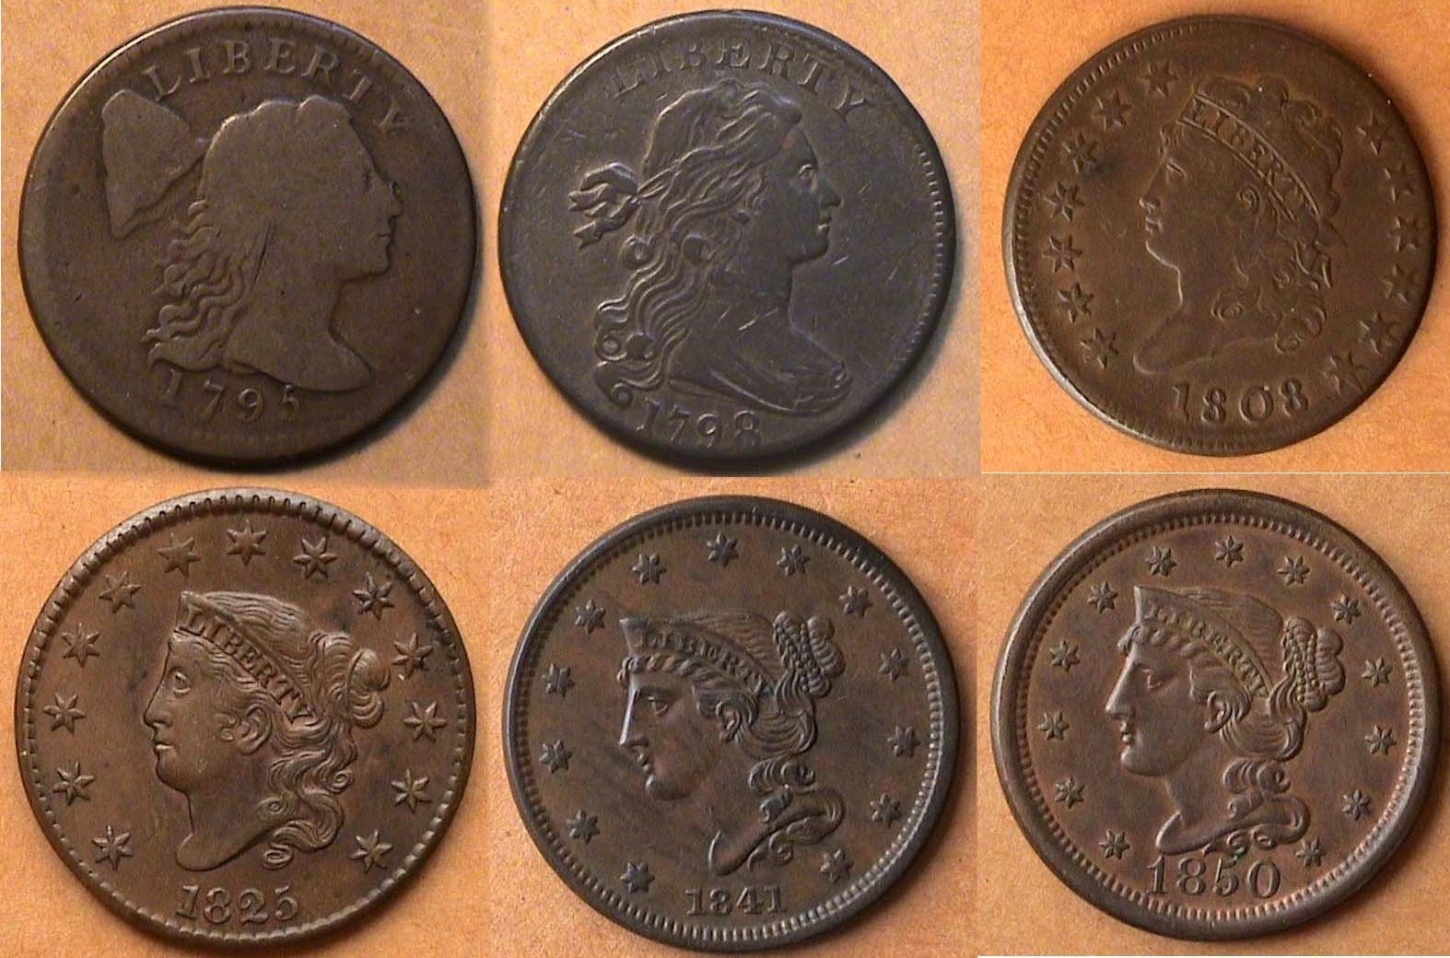

Obverses of 1795, 1798 & 1808 large cents, top row,
1825, 1841 & 1850 Coronet sub-types, bottom row
[Use 3x magnifying glass or magnify page to 200% to view details.]
__________________________________________________________________________

STEPHEN JAMES CSRA COIN CLUB
Minutes of the Regular Meeting
Aiken County Library - June 5, 2014
Vice President Pat James called the meeting to order at 6:45 p.m.
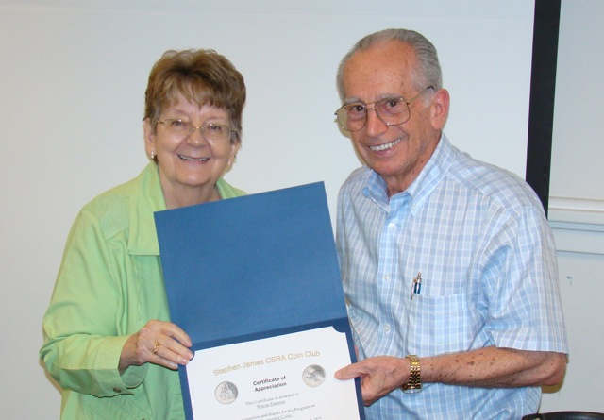
The meeting led off with a program on counterfeit coins by Wayne Damron. Wayne shared with us several key tips on how to spot some common indicators of counterfeit coins.

Sgt at Arms Jim Sproull reported there were 21 members and 5 guests in attendance. Jim also related information about the upcoming coin shows in the area.

Roger Seitz won the members’ door prize, a Franklin Half Dollar.
There was a motion by Mac Smith to waive the reading of the minutes of the May meeting. John Sanfratello seconded the motion, which was voted upon and carried. A copy of the minutes will appear in the Club Newsletter and are on file in the Club’s records.
Pat relayed a report from Treasurer Chuck Goergen that the June balance was $1672.63.
Bourse Chairman Steve Kuhl provided a brief update on the status of preparations for this fall’s coin show.
Roger Worpell reported that he had completed the annual audit of the club’s books and found them to be in good order.
Arno Safran stated that the Augusta Coin Club’s June 19 meeting would be a presentation on the Commemorative Coinage of the 1996 Atlanta Olympics by junior member Shelby Plooster.
There were several Show and Tell presentations, including Arno Safran sharing a 1944 year set from Philadelphia in recognition of 70th anniversary of D-day. David Amey shared coins from the Central American Republic in the early 19th century.
Pat James won the 50/50 - $20.
Jim Sproull conducted the club auction. The meeting was adjourned at 8:15 p.m.
Respectfully submitted,

Jim Mullaney, Secretary

Kindly Patronize Our Advertisers
Please note: Clein’s new ad below!

