The Stephen James
CSRA Coin Club of Aiken
P.O. Box 11
New Ellenton, SC 29809
Web site: www.sjcsracc.org
The SJ CSRA CC now meets at the South Aiken Presbyterian Church at 1711 Whiskey Road

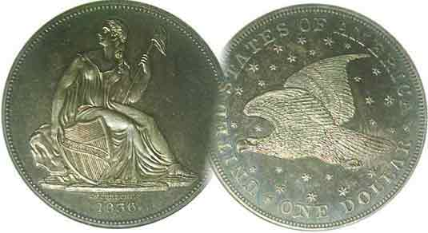
Pres. J.J. Engel
V .P. Pat James
Sec. Jim Mullaney
Treas. Chuck Goergen
Sgt. in Arms: Jim Sproull

Programs: Pat James
ANA Rep.: Glenn Sanders
Show Chair: Board members
Photos: Steve Kuhl
Publicity: Pat James
Newsletter: Arno Safran
E-Mail: arnosafran@comcast.net
Auctioneer: Jim Sproull
Web site: Susie Nulty (see above.)

Our next will be on Thursday, July 1 at 6:45 PM at the South Aiken Presbyterian church Gymnasium

2021 Club “Zoom” Meeting Schedule
Volume 20, No. 7 the Stephen James CSRA Coin Club, Founded in 2001 July, 2021
Monthly Newsletter
Grade Rarity Items Has been replacing better date rarity coins
Jan. 7 Apr. 1 July 1 Oct. 7
Feb. 4 May 6 Aug. 5 Nov. 4
Mar. 4 June 3 Sept. 2 Dec. 2

A 200 year old dollar from Cundinamarca,
a section of Bogotá, Colombia

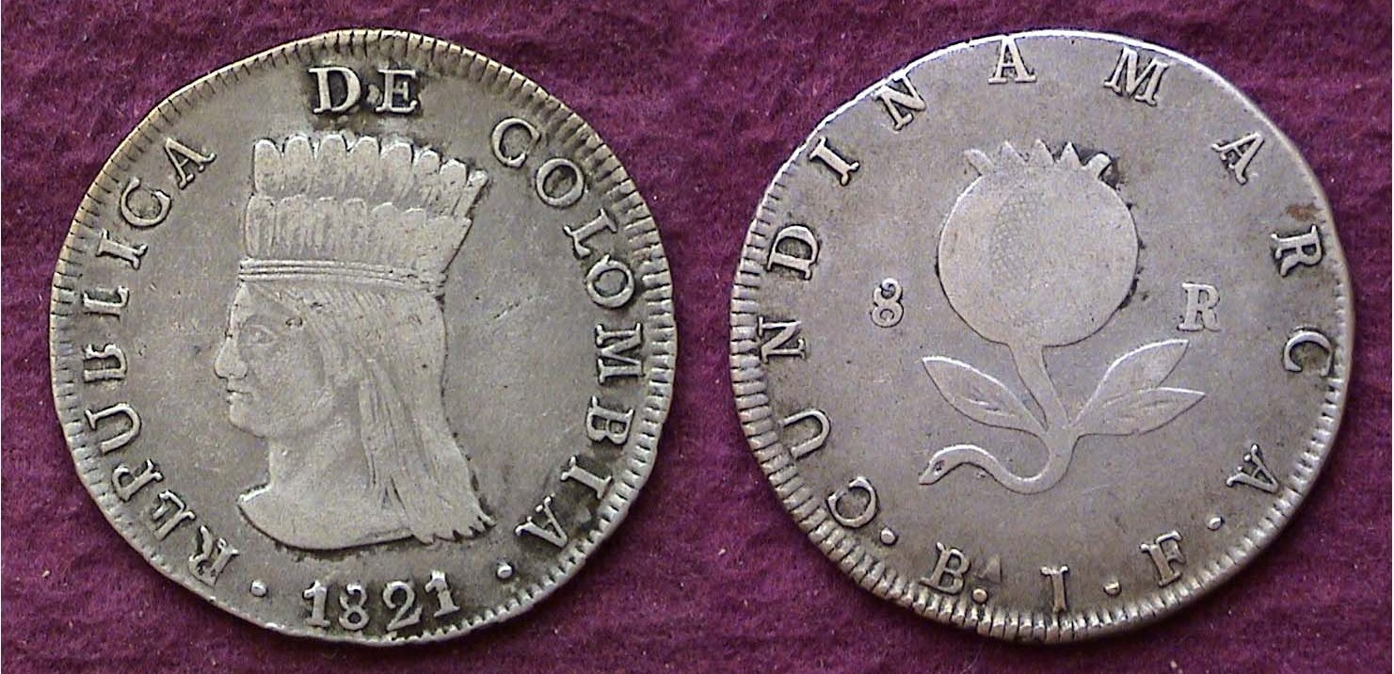

An 1821 2/3 silver dollar from the Cundinamarca,
a major province of Colombia

If the coin shown above looks somewhat familiar to the reader, it should because back in January, 2019 a smaller one-real version of the coin was shown in a slightly higher grade.

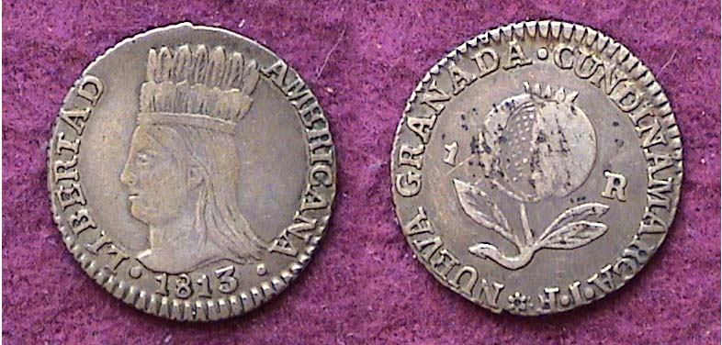

An 1813 silver Real from Cundinamarca, Colombia worth 12½¢
[[Magnify page to fill 150% or to fill monitor screen to view details.]

Both coins show the same image of an aborigine crowned chieftain on the obverse and a pomegranate on the reverse. Cundinamarca was located in the center of Bogotá’s, Colombia’s capitol city. The War of Independence from Spain ran from 1810 thru 1825. Until 1821; there were times when Colombia took over land striking the smaller Aborigine designed coin in 1813, such as the Real shown directly above, but by 1820, the state became independent from Spain and began to strike coins with the 1820 and ’21 dates. A quarter size 2 Reales coin (not shown) with the same features was also struck, but is somewhat scarcer. The author obtained the complete three piece type set at various major shows held in Central New Jersey during the 1990s.
Where have all the nice Barber quarters gone?
By Arno Safran

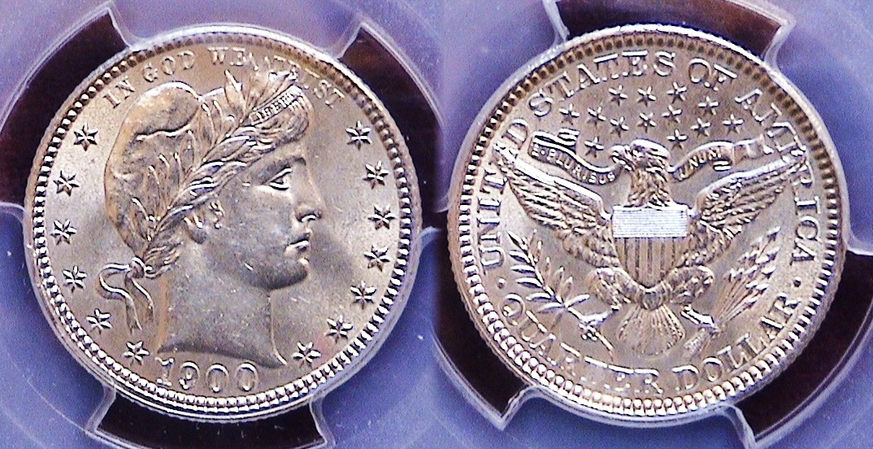

A 1900 Barber Quarter graded MS-62 by PCGS
[Enlarge page to fill monitor screen or 150% to view details.]

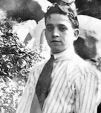
Shown directly above is an attractive 1900 Barber quarter certified MS-62 by PCGS In that year the Philadelphia Mint struck 10,016,000 quarters, the fourth highest mintage of the series. yet during the past fifteen years, the author has seldom seen an attractive 1900 quarter certified MS-63, MS-64, let alone, MS-65 at major shows, auctions or on line. The author was interested in assembling a 1900 century year set because his father was born on Christmas Day in 1900. He attained the specimen shown in 2014.
Saul Safran at 22,
The author’s father

The Barber quarter series was coined from 1892 thru 1916; and during that twenty-five year timeframe, the coin type was struck at four different mints; Philadelphia, New Orleans, San Francisco and starting in 1906, Denver. Of the four, only the Philadelphia Mint coined the Barber quarter every year. In 1906, the Denver Mint opened and began striking quarters in fairly large numbers in every year except 1912. The New Orleans Mint--which had reopened in 1879--struck Barber quarters annually as well until they closed forever after 1909. The San Francisco Mint usually coined the Barber quarter in lower mintages including extremely low mintages in 1896, 1901;”the key date” of the entire series, as well as in 1913, with none being produced in 1904, 1906, 1910 or 1916. As a rule, the Philadelphia Mint struck the largest annual mintages with the exception of 1908, when both the New Orleans and Denver Mints coined more and in 1913, with only 484.000 produced , a strongly sort after date by collectors a s well. So, with over ten million 1900 Barber quarters made, why is it so hard to find a beautiful AU-58 thru MS-65 specimen than just a few years ago?
__________________________________________________________________________________________________________________________
(Continued on page 2, column 1)
Where have all the nice Barber quarters gone?
(Continued from page 1, column 2)

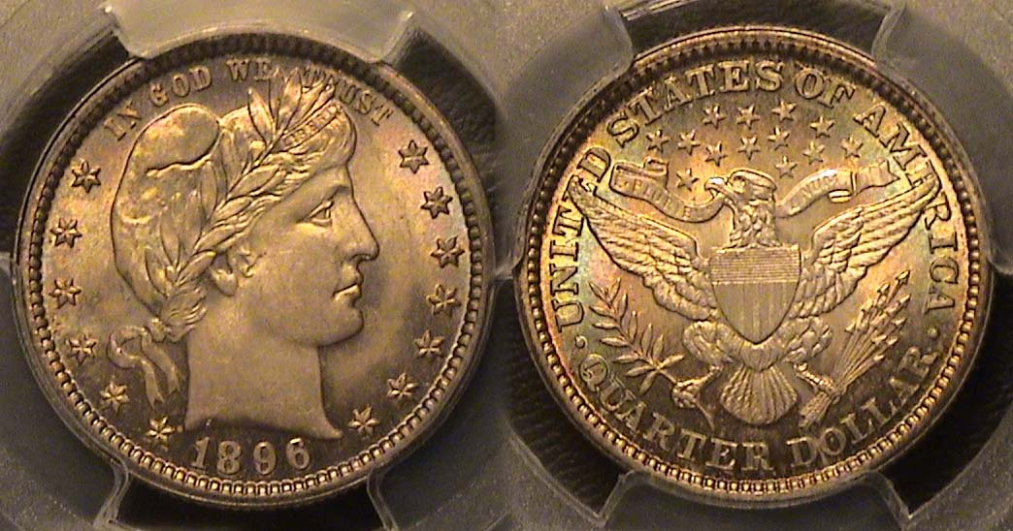

An 1896-P Barber quarter graded MS-64 by PCGS

The lovely toned 1896 Barber half was acquired by the author on line back in early March of 2018 from a national dealership that specialized in eye appealing coins. In that year, the Philadelphia Mint produced by far the largest number of coins with 3,874,000 reported followed by the New Orleans Mint with 1,484,000 issued while he San Francisco Mint struck only a paltry 188,039, and considered the third most scarce date of the series. The 1896 example is a beautiful specimen and was priced higher than normal for its grade--which has since dropped in price--but the author remains unconcerned because the effect of the coin market’s decision to reduce the prices for most Barber coinage has caused collectors to hold on to their better quality pieces rather than sell them at a loss. As a result, eye appeasing Barber coinage has become less available and remains off the market.

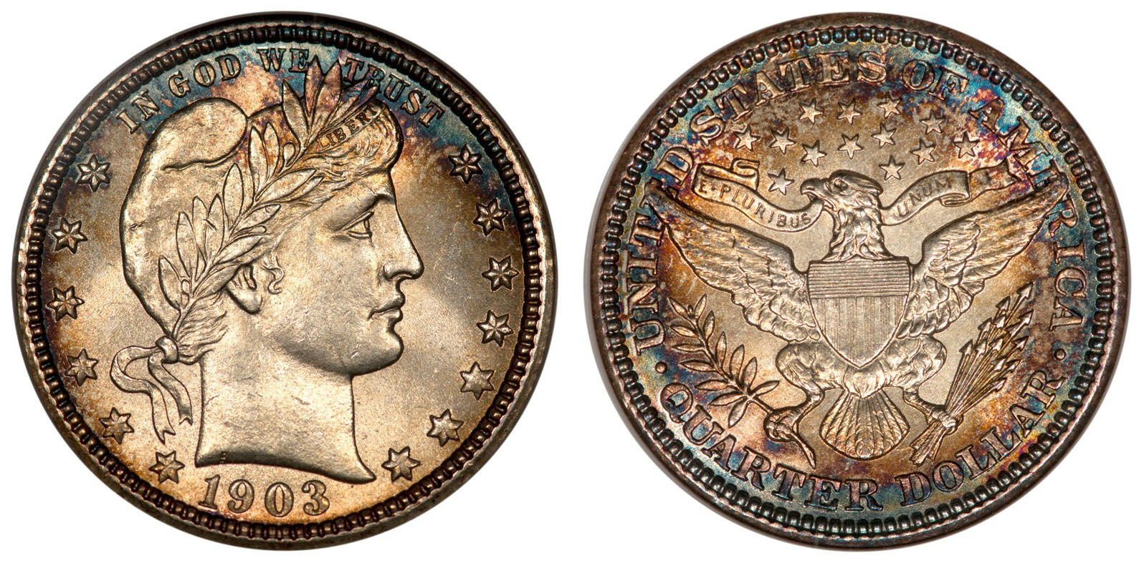

A 1903-P Barber quarter graded MS-64 by NGC


In December 2016, the author came across this gorgeous; russet toned 1903-P Barber quarter on a dealer’s website and since it was dated the year his mother was born, he texted the dealer whom he had done business with at past major coin shows to send him the coin “on approval”. He received the coin via three day priority mail and bought the coin as a “keeper for life!”
.The author’s mother
Hannah at 16

The mintage of the 1903-P Barber quarter was 9,.759,309, far higher than the two branch mints issues were produced in considerably lower numbers and far more expensive. Besides the extremely attractive toning, the coin had a super strike with smooth surfaces

High end Barber quarters can be vey expensive but needn’t have to be if the collector can locate choice examples certified AU-58; a grade that used to be considered as attractive as an MS-63 issue with just a tiny bit of “rub”. Away back in July, 1993, the author came across a lovely 1915 Barber graded AU-58 by PCGS at a major show held on the first Sunday of the month in a NJ town called Parsippany.
The site was situated on the western side of the Hudson river, not far from New York City near the George Washington Bridge. Each month, over eighty dealers from as far north as Bridgeport, Connecticut to Philadelphia, PA to the south would be set up at this show which attracted a huge number of collectors residing in what was referred to as the tri-state area.

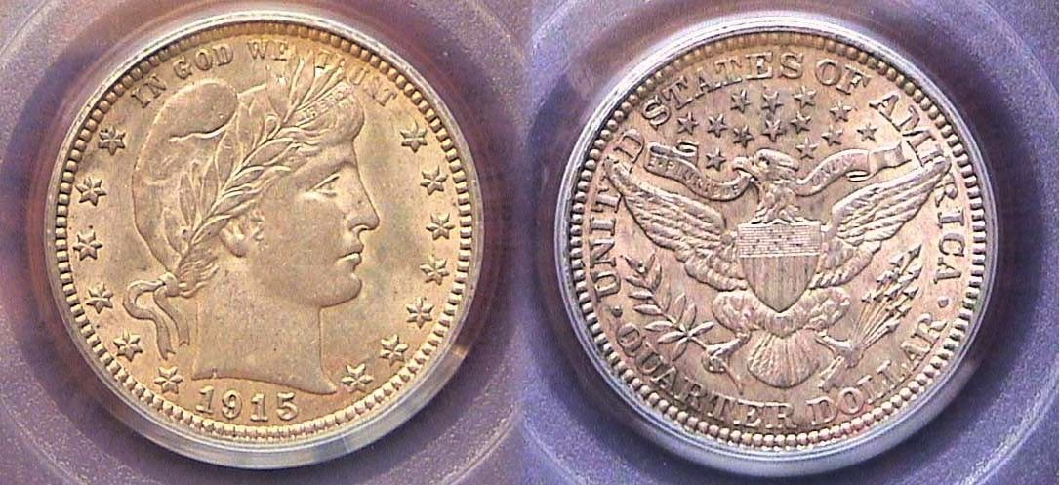

A 1915-P Barber quarter graded AU-58 by PCGS
[Magnify page to fill 150% or to fill monitor screen to better view details.]

The 1915 Barber quarter shown directly above displays a natural hue that is completely “original” with virtual no distracting marks on its surfaces. It was one of the earlier certified acquisitions in the author’s Barber quarter collection. The only wear on the coin can be identified by enlarging the photo to 500% where the observer might see a tiny bit of “rub” near the bottom of Liberty’s forehead while on the reverse, there is a little softness on the outer feathered wings of the eagle.

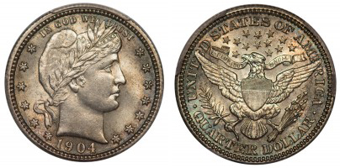

A 1904 Barber quarter graded MS-64, by PCGS, CAC stickered
[Magnify page to fill 150% or to fill monitor screen to better view details.]

On January, 2017, shortly after acquiring the 1903 Barber quarter shown on column, the author while surfing PCGS’s Collector’s Corner, on the internet spotted another gorgeous Barber quarter from the same dealer who specializes in eye appealing coins; this one, a beautiful mauve-toned Barber specimen dated 1904. (See above.!) That year, the Philadelphia Mint struck 9,588,143 compared with only 2,456,000 produced at New Orleans. None were coined at San Francisco. The author arranged with the dealer to send it “on approval” and finding no flaws, purchased the coin.

When the Barber coins were being struck, a great many immigrants were entering the United States from various part of Europe, the orient and south of the border. Many found work at extremely low wages in the factories, (known as sweat shops of the time). Laborers worked six days a week, ten hours a day and received a pittance for their efforts. The starting salary for a young woman entering the workforce was 3¢ an hour while men started at 5¢. Regulars earned up to 7¢ an hr. $4.20 a week which translates to around $17.00 a month, so the breadwinner of the family coming across a mint state specimen of a blast-white Barber quarter could hardly afford to put one aside since every “penny” was needed to maintain the family’s budget. As a result, most Barber type coins survive in grades no higher than VG-10 with AU-58 to MS-65’s, kept as family heirlooms by the rich being more available, for a price.
Where have all the nice Barber quarters gone?
(Continued from page 2, column 2)

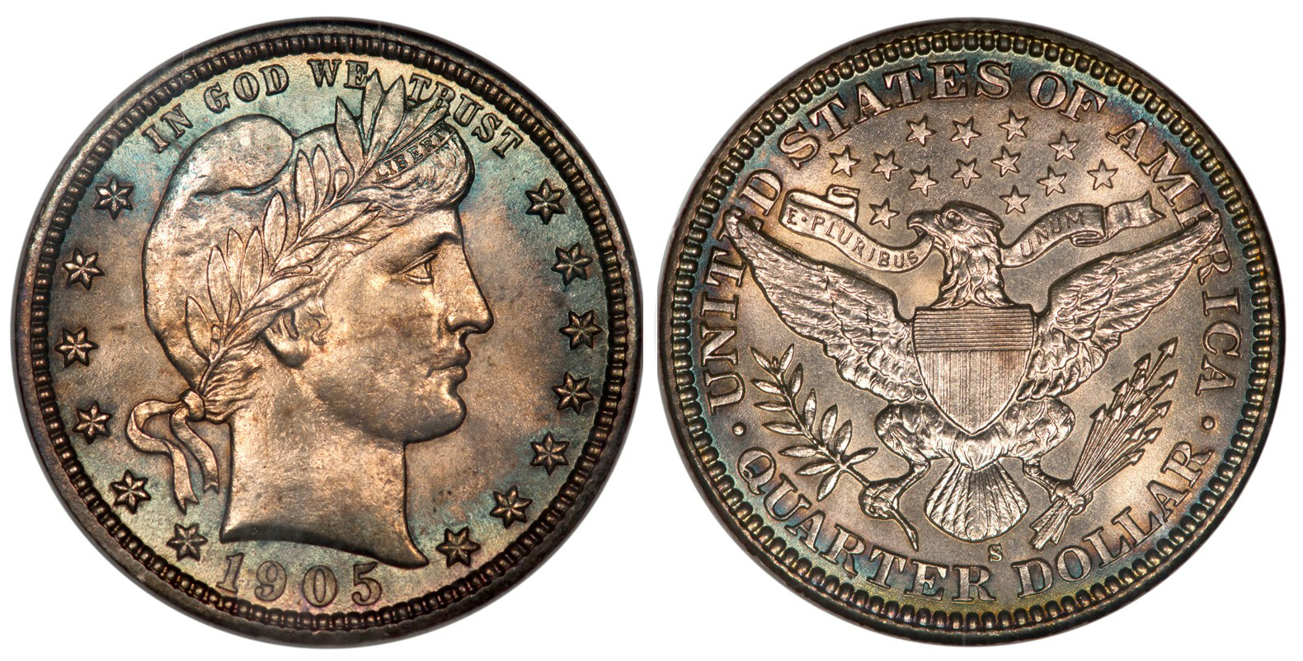

A 1905-S Barber quarter graded MS-64+ by NGC
[Magnify page to fill 150% or to fill monitor screen to better view details.]

This beautifully toned 1905-S Barber quarter was also acquired in early 2017 but in this instance, the writer went “deep” since the coin was struck at the San Francisco Mint with a mintage of just 1,884,000 compared with 4,967,523 at the Philadelphia facility. As it turned out, when the author was building his Barber coinage year sets, all three of the 1905–S silver denominations, the dime, quarter and half-dollar became available from different sources in close proximity to each other and despite the dime and quarter both being certified MS-64+ with the Barber half being certified only AU-58 by PCGS, the three denominations matched each other well together despite the different degrees of toning n the dime and quarter.

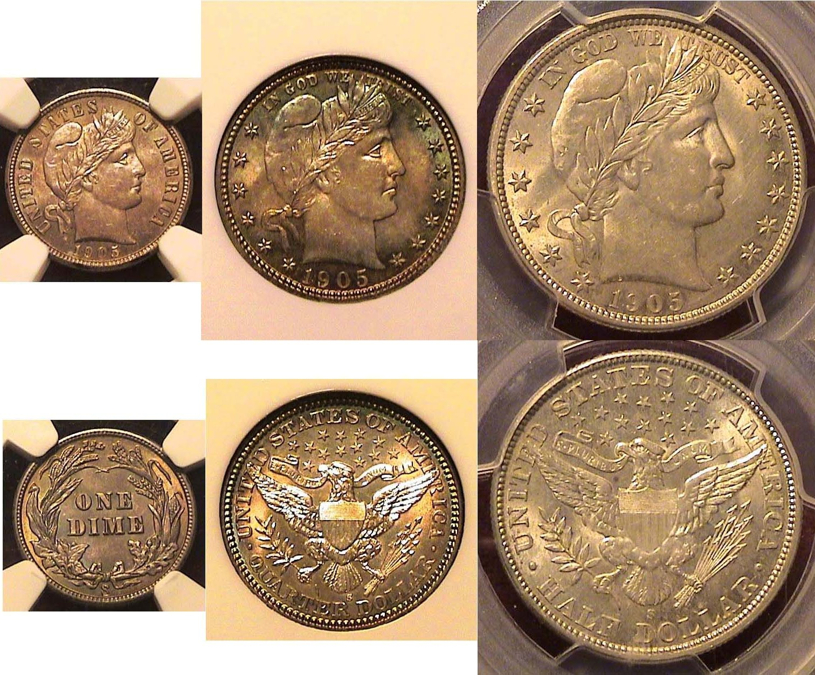

The Barber silver coinage of 1905-S
The 1905-S 10c, NGC-64+, 25c, PCGS-64+ & 50c PCGS-AU-58
[Magnify page to fill 150% or to fill monitor screen to better view details.]

Before 1965, the year clad coinage began replacing silver dimes, quarters and halves, (although from 1965 thru 1970 halves still contained 40% silver), collectors could find Barber coins out of circulation or in bank rolls with ease at face value although most specimens were probably no higher than AG to VG-10 because Barbers circulated so heavily. Before 1965, the pre clad era, collectors assembled lower grade to uncirculated specimens of Barber coinage at prices that were more affordable because before “slabbing” which began in 1986, a number of obsolete coin types were graded either circulated or uncirculated. During the past two years, since the prices of unc. Barbers were lowered there appears to be more certified examples of MS-66 and even MS-67 coming on line than MS-63s and MS-64s which suggests questionable grading practices regarding the super grades along with the increased hyping of grade-rarity over date-rarity coins.
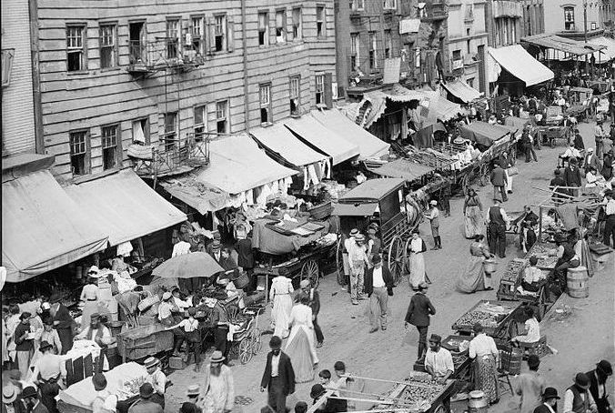

Laborers shopping at outdoor markets in NYC around 1900.
These folks couldn’t afford to put aside a brand new Barber quarter in their family heirloom because 25¢ had the purchasing power of $7.50 when this photo was taken. Such a sum represented 1/2 of the laborer’s monthly income!

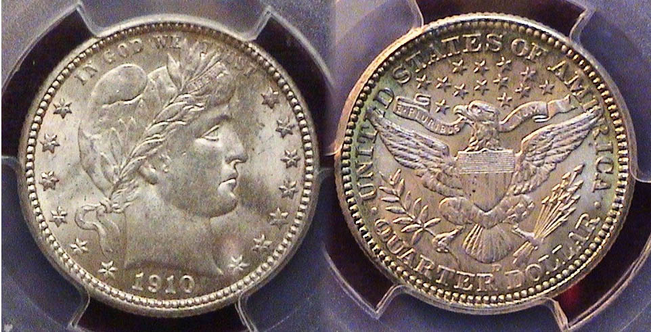

A 1910-D Barber Quarter graded MS-62 by PCGS
[Magnify page to fill 150% or to fill monitor screen to better view details.]

In August, 2016, the last major show the author and his wife, Vilma attended at the Dalton, GA Convention center, he came across this interesting Barber quarter dated 1910-D. That year 2,244,000 pieces were coined at the Philadelphia Mint with just 1,500,000 pieces struck at the Denver facility. While the date is not considered scarce, it doesn’t appear to be all that common either. As of this July, 2021 edition, only three 1910-D Barber quarters appeared on PCGS’ on-line Coin Collector’s Corner, one graded Fair-2 another, Fine-12 and a single uncirculated specimen certified MS-63 that appears brownish and far less attractive than the MS-62 specimen shown above.

In 2019, the market value of Barber coinage was reduced by about 20% and since then, far fewer examples have come on the market except “grade rarity” specimens certified MS-66 or higher, selling at auction for outrageous prices which may be grade inflated. As a result, finding choice AU-58, MS-62, MS-63 and MS-64 certified specimens are becoming more challenging today because collectors who were able to acquirer charming examples of Barber quarters certified in those grades a few years ago are holding on to them for a higher price return on their investment.
Below is another attractive AU-58 specimen which at first glance, looks uncirculated.

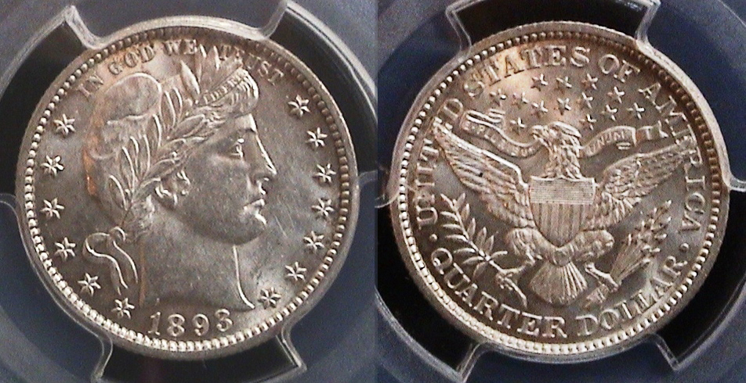

An 1893 Barber quarter certified AU-58 by PCGS
[Magnify page to fill 150% or to fill monitor screen to better view details.]
________________________________________________________
STEPHEN JAMES CSRA COIN CLUB
Regular Meeting Thursday, June 3, 2021

The Club held the June 3, 2021, meeting in person at Jim Mullaney’s barn with 15 members and one guest in attendance and via Zoom (arranged by Club Secretary, Jim Mullaney) with four members and one guest joining the meeting online. The breezeway of Jim’s barn, open air and a covered top, proved again to be a comfortable meeting venue, and President Engel thanked Jim for hosting the club there.
President J.J. Engel called the regular meeting of the club to order at 6:52 p.m. A motion was made and seconded to dispense with the reading of the May 2021 meeting minutes. A copy of the May Minutes will be on file with the other club records, and a copy will appear in the club newsletter. Treasurer Chuck Goergen reported the Club’s June 2021 bank balance was $1,134.39.
President Engel reported there was no change with the situation with the Aiken Library, and that Jim Mullaney’s barn is available for the summer, but alternate locations with air conditioning were being sought, and that Steve Kuhl has reserved the South Aiken Presbyterian Church for the summer meetings. Sonia Hillman also said her Homeowners’ Association had a room which might be a suitable site. Glen Sanders repeated his offer of space at his church in Graniteville.

President J. J. Engel reported on the status of a coin show for 2021. It was the opinion of Pat James, past Coin Show Coordinator, and concurred with by J.J., that weighing all the factors, the club should pass on attempting a coin show in 2021. The club will work toward holding a show in 2022, and needs another person to serve as Bourse Chair or Coin Show Coordinator due to Pat’s health issues. In prior years, there was a single Bourse Chairman or co-Chairs. However, in 2019, Pat coordinated a team that Including Board members and volunteers with a division of the tasks that worked very well to hold a very successful coin show. J.J. indicated a person willing to serve as Bourse Chair or Coin Show Coordinator would have strong support from the Board and coin club members. Anyone willing to serve should contact J.J. or one of the other officers.

The June program,
A Behind the Scene Look at the Paper Money Auction process was presented by noted numismatist Bob Moon who specializes in currency. Bob is one of Heritage’s 600 employees, and he deals primarily with paper money. Heritage Auctions is the largest collectibles auctioneer and third largest auction house in the world, as well as the largest auction house founded in the U.S. There are twelve international offices serving over 700,000 registered online bidder-members. Heritage Auctions offers a wide range of collectibles, however, numismatists are mostly familiar with Heritage’s famous currency auctions, with many collecting the Heritage catalogs themselves which are used by many as reference material and price guides throughout the industry. Bob spoke about the reasons for people to consign items to Heritage as a good avenue to sell collectibles and get fair market value, and also spoke of the reasons to buy from Heritage, including the lengthy process to confirm grades. Bob also provided some guidance for those looking to consign and/or buy items. He gave out some copies of Heritage’s “Intelligent Collector” for the coin club members to share. In it experts share advice and collecting strategies. The Aiken Coin Club members warmly appreciated Bob’s excellent and informative program.
​ The July 1st program will be by past President Steve Kuhl, who has also been elected Second Vice President of the South Carolina Numismatic Association. Steve’s presentation will be on The Dahlonega Mint and the Dahlonega Gold Museum.

Numismatist Randy Clark, president of the South Carolina Numismatic Association in 2020-2021, attended the meeting by Zoom. He said he visits many SCNA member clubs to see what is happening with them. Randy also reminded the members about the SCNA Convention to be held in Greenville, South Carolina, October 29th–31st and spoke of the speakers and programs planned for the Convention. He encouraged our local numismatists to attend not only as patrons but also as volunteers to work the huge coin show which generally has a 160+ table bourse area filled with Dealers buying, selling and trading all types of coins, tokens, medals, currency, and paper money.

Jimmy Widener won $17.00 in the 50-50 raffle drawing. An auction was held with items offered by Glenn Sanders and J.J. Engel, who encouraged others to participate.
President Engel reminded the members that the next meeting would be on July 1, 2021, and adjourned the meeting at 8:58 p.m.
Respectfully submitted, Jim Mullaney, Secretary
Club to m Meet in new Location

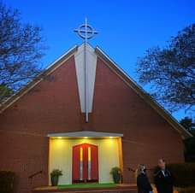

The South Aiken Presbyterian Church of Aiken

After almost twenty years of holding most of our club’s monthly meetings at the Aiken Public Library coupled with almost a year and a half of not holding any meetings there due to the Coronavirus preceded by Aiken Library’s decision to no longer allow our club to hold regularly scheduled meetings on the first Thursdays of each month--thanks to he efforts of Steve and Chrissy Kuhl--we will begin meeting at the South Aiken Presbyterian Church this coming Thursday, July 1, 2021. The newly available location is no stranger to us because it was at the South Aiken Presbyterian Church that we held one of our most well attended coin shows back in September. 2019 on a blazing hot summer day when the temperature reached 102 degrees Fahrenheit at around 3:00 PM. The church is situated diagonally across from our former H O. Odell Activity Center show site on Whiskey Road. Below is a map which Secretary James Mullaney sent to the newsletter editor which has the directions.

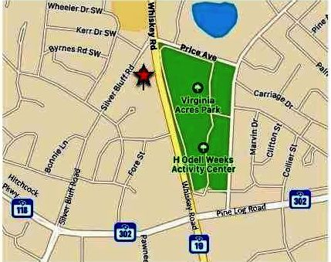

The star on the map shows the site of the church diagonally across from the H. O. Odell Weeks Activity Center

Little Coin of the Month Column Filler

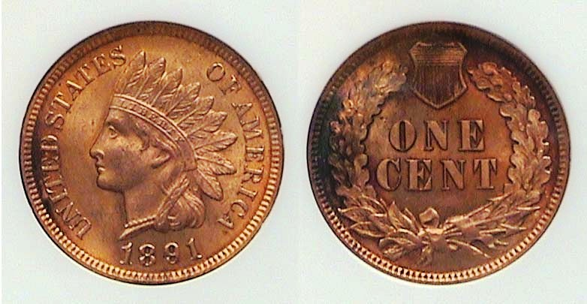

An 1881 Indian Heads cent graded MS-64 RB by NGC
[Magnify page to fill 150% or to fill monitor screen to better view details.]

The 1881 Indian Head cent shown above was struck 140 years ago and is considered a fairly common date. It had a mintage of 39,208,000, the second highest for a cent since the 1863 copper nickel issue when the Philadelphia Mint struck 49,840,000 not broken until 1890. What is significant about this coin is that it was acquired at the ANA fall show held at the Cobb Galleria in Atlanta in late February, 2020 shortly before the Covid-19 pandemic hit.
____________________________________________________________________________________________________________________

Kindly Patronize our advertisers

