Pres. Willie Simon
V .P. James Barry
Sec. Helen Barry
Treas. Pat James
Sgt. in Arms: J.J. Engel
Committees:
Auction: J.J. Engel
Programs: James Barry
Newsletter: Arno Safran
The Stephen James
CSRA Coin Club of Aiken
P.O. Box 1739
Aiken, SC 29802
Web site: www.sjcsracc.org
The SJ CSRA CC Now Meets on the 2nd Thursday of the Month at the Cedar Creek Community Center in Aiken, SC

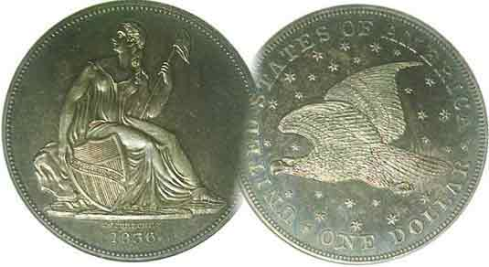

Volume 5, Number 8 the Stephen James CSRA Coin Club Monthly Newsletter August, 2006
Impressive Slide-Talk by Tony Chibbaro
Our Next Meeting is on the 2nd Thursday, August 10, 2006 at 7:00 PM
2006 Meeting Schedule - 2nd Thursdays at 7 PM
June 8, July 13, Aug. 10, Sep 14,
Show: Sept. 16 Oct 12, Nov 9, Dec 14_

Members See Program on “South Carolina Medals”

Those able to attend the July 13 meeting of the Stephen James CSRA Coin Club were treated to an impressive slide-talk by Tony Chibbaro on South Carolina medals. Tony began by making a distinction between coins, tokens and medals, citing that while a token could be accepted towards the value of a product--despite not having the legal tender of a coin--a medal was commemorative in nature. Tony explained that medals derive their value as collectibles by people who appreciate the persons or historic events being commemorated; also the subject matter and the art work. He went on to say that the differences between a medal, a medalette and medallion had to do with size. A medal could be from the size of a quarter (1”) up to 70mm. A medalette was smaller than a quarter and a medallion was usually 70mm or more.

Tony then showed a large number of slides featuring examples of South Carolina medalic art within each category. Subjects included SC officers who bravely served, medals commemorating significant SC historical events such as the first meeting of the SC General Assembly held in Columbia, the Civil War, various Award medals and from an aesthetic aspect, produced for the Brock Sculpture Gardens near Myrtle Beach and sold only to members. These were arguably the most artistic; many of contemporary design.

The club wishes to thank Tony for a most enlightening program.

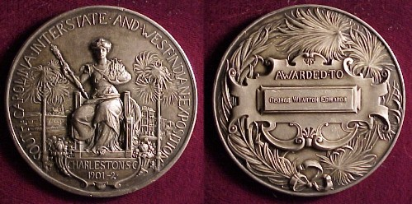

The Charleston, SC Award medal first presented 1901-02
Featured as medal of the Month in 2001-02

____________________________________________________________________________________________________
(Club News continues on page 3, column 2)
The Latin American Alternative
The Dominions of Spain Portrait Coinage of Charles III
By Arno Safran

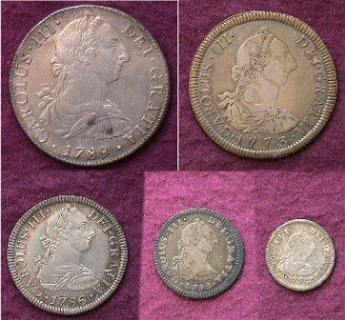

A five piece denomination set of Charles III Portrait coinage
From top left, 1789 8 Reales, right, 1773 4 Reales
At bottom, left to right: 1786 2 Reales, 1782 Real and 1776 ½ Real

Under the reign of Charles III (1760-1789) plans were made to place the portrait of the monarch on the obverse while combining aspects of the Pillar reverse and Coat of Arms obverse on the reverse of the new type. Some believe it was also a device to reduce the weight of the silver content from .917 fine to .903 fine. It would not be until 1772 when the Bust of King Charles of Spain would appear on the coinage of Mexico, Peru and Bolivia. The reduction in weight notwithstanding, the more than 90% silver content was acceptable as a trade coin the world over and circulated in the American Colonies to be known as the United States of America after the Revolutionary War. Like the Pillar types that preceded them, these coins would be struck in denominations of 8 Reales, 4 Reales, 2 Reales, Real and Medio-Real (½R) and would circulate here well into the 19th century.
______________________________________________________________________________________________________________
(Continued on page 2, column 1)
The Charles III Portrait Coinage of the Dominions of Spain
(Continued from previous page)

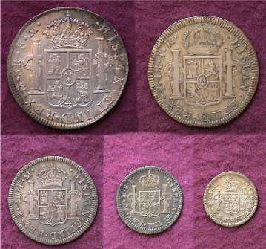

The reverses of the Charles III Denomination Set
Top: from l to r: 8R and 4 R. Below from l to r: 2 R, 1R and ½R
Showing the Pillars of Hercules surrounding Coat of Arms and crown.

While arguably, the visage of Charles III is not anywhere as attractive as the Pillar type; the 38mm dollar size coin is inexpensive when compared with the 1776 Continental dollar whose small numbers sell in the six figures when they appear at auction. In EF-40, the average price for a Charles III portrait dollar is listed at $150 to $200 in the Standard Catalog of World Coins.

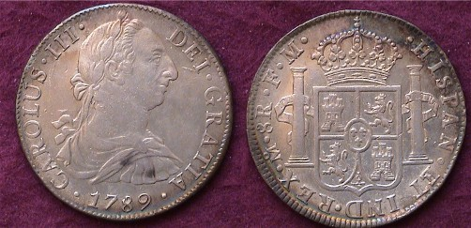

A 1789 8 Reales of Charles III, the last year of issue.

The obverse Latin inscription CAROLUS III (for Carlos), translates as Charles III, by the grace of God, King. The reverse legend starting clockwise at 1:00 translates as Spain and the Indies followed by the mintmark. [The small o over the M indicates Mexico City.] This is followed by 8R (for Eight Reales). The large FM stand for the first name initials of the assayers.

From the photos above, and those of the Pillar types in last month’s issue, the reader will recognize a pattern of similarity of design for all five denominations. This concept would later be incorporated into our silver design types from the Flowing Hair to the Draped Bust beginning in the last decade of the 18th century through the Liberty Seated types of the 19th.

Of the five denominations, the most common by far is the 8 Reales. The least common is the 4 Reales; equivalent to a half dollar value. From the group pictures shown it is the 4R that appears to be in the lowest grade; barely making VF if that.

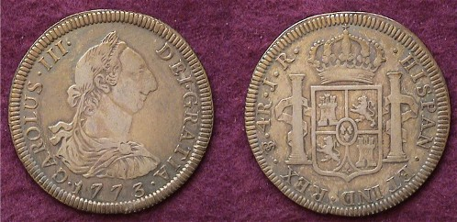

A 1773 4 Reales of Charles III struck at the Potosi Mint
The monogram PTS for Potosi, Bolivia appears at 8:00 on the reverse.
As the grade shows considerable wear, the reader is advised to
magnify the image up to 200% to observe the details more clearly.

If the 4 Reales denomination wasn’t needed as much in commerce as the other denominations, the 2 Reales, (AKA 2 bits or 25¢) had considerable spending power during colonial times. As such it enjoyed extensive circulation among the citizenry. This may be the main reason why the survival rate of mid to high grade specimens is far below the 8 Reales which were retained by banks as specie to cover large business transactions.

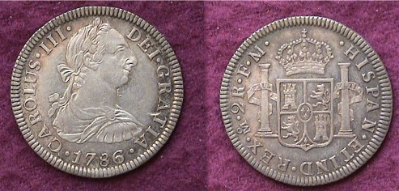

A 1786 2 Reales of Charles III struck at the Mexico City Mint
This is a high-end VF, possibly EF coin/ The Latin, Plus Ultra for “More beyond” is visible on the upper portions of the pillars.

In Colonial America, prior to the Declaration of Independence and subsequent Revolutionary War, the colonies were forbidden to strike silver or gold coins, but by the late 18th Century, especially after the War during the late 1780’s, some of the colonies began coining copper cents. Along side these circulated the Hispanic-American silver Real (1 bit equal to 12½¢) and the Half Real (worth 6¼¢) in silver. Since our first official US coinage would not begin until shortly after the reign of Charles III some goods may have been priced at these fractional levels. The Real had a diameter of about 20mm, just slightly larger than the 1796 dime which would be 19mm.

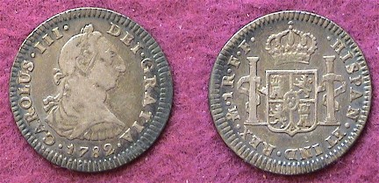

A 1782 Real of Charles III of Spain. This coin had the value of 12½¢
The capital F’s at 10:00 on the reverse represent the initials of the first names of the two assayers; Francisco de Ribas Augusto and Francisco Arance y Cobos.
__________________________________________________________
(Continued on page 3, column 1)
The Charles III Portrait Coinage of the Dominions of Spain
(Continued from page 2 column 2)

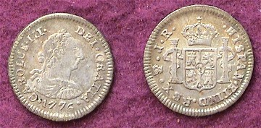

A 1776 ½ Real of Charles III of Spain
Magnified up to 200% one can observe the PTS mint mark monogram for Potosi, Bolivia on the reverse at 8:00. This specimen grades an EF-40 but due to the weak strike the Latin inscription, “Plus Ultra” on the two pillars--meaning “More beyond”--is barely discernable.

The silver Half Real of Charles III was about 17 mm in diameter. The coin pictured above was struck in .903 silver and had the value of 6¼¢. Between 1776, (the date on the coin) and the first US half dimes issued in 1794, its exact exchange rate for goods here is uncertain. After 1794, those Latin American Half Reales that reached the United States may have circulated at a half-dime’s value of 5¢ during the early days of our republic well into the 19th century.

Even a decade ago, assembling a complete silver denomination set of Charles III portrait coinage represented a challenge. Dealers specializing in foreign coins seldom brought the minor coinage to the larger regional shows. They insisted that their low numismatic value coupled to lack of collector interest made them impractical to carry. Today, finding quality half, one and two Reales comparable in quality to the dollar size eight Reales are even more difficult as dealers now admit to the scarcity of surviving specimens grading Fine-15 or better.

For years the Standard Catalog of World Coins edited by Chester Krause, Clifford Mishler and Colin Bruce II, Senior Editor has been considered the major price guide in US dollars for the Colonial Latin American series. This is still the case today though the massive telephone book size catalog has since been divided into less cumbersome soft cover volumes covering single centuries. The more available and less expensive Charles III series would be listed in the 18th century volume under Bolivia, Mexico and Peru.

Why make the case for collecting Latin American coins of the late 18th century? First, the silver and gold coins struck under the aegis of Spain were accepted by the Colonists and circulated freely here. While not struck in an American Mint they were used as if they were. Second, the overall mintages for most denominations were huge resulting in low prices for the survivors. The Charles III set pictured was not expensive. The total cost for all five purchased during the 1990’s came to just $433.50, broken down as follows:
Denomination Cost in 1990’s Commentary
½ Real XF-40 $120.00 scarce this nice
1 Real VF-30 13.50 more common
2 Reales XF-45 75.00 not as common in XF
4 Reales F-15 75.00 scarce denomination
8 Reales AU-50 150.00 common but in demand
_________________________________________________
-Next issue-the Portrait coinage of Charles IIII-
More Club News
(Continued from page 1, column 1)

In the absence of President Willie Simon, VP Jim Barry conducted the meeting. The reading of the Minutes of the previous meeting was waived, a copy placed on file by Secretary Helen Barry. Miss Pat gave the Treasurer’s Report stating a current balance of $704.13 with all expenses paid. Jim Barry recognized member Rich Baker who gave a eulogy on behalf of member Don Bitner who had passed away after a long illness. Rich knew Don more personally than most of those present stating that it was Don who helped him along with many other younger numismatists who were just getting started in coin collecting by advising him such key issues as grading and condition along with what and what not to buy. Show chairman J.J. Engel reported that as of the July 13 meeting ten tables had been sold for our September 16 coin show. Glenn Sanders won the door prize, a 2006 silver Eagle and Tony Chibbaro won the 50/50. Congratulations gentlemen.

In addition to his fine presentation Tony Chibbaro, a past president of the South Carolina Numismatic Association (SCNA) and currently the General Show Chairman announced that they are looking for two Board members to fill the seats for a two year term that starts the final day of this year’s convention in Greenville (Oct. 27-29). He also announced that SCNA will be one of the host clubs at next year’s ANA Money show being held in Charlotte, NC in March, 2007. They are looking for volunteers to help at the big three day show.

Show and Tell

Arno Safran brought in a five piece denominational set of milled silver coins showing the famed Pillars of Hercules supporting two orbs floating on the ocean on one side and the crowned Bourbon Coat of Arms on the other. The denominations consisted of the 8 Reales (dollar size), 4 Reales (half dollar size), 2 Reales (the size of our quarter) and two smaller denominations, the Real, (worth 12½¢) and the half real, (valued at 6¼¢). These were the first machine made coins (as opposed to the earlier hammered and irregular shaped cob issues) that were struck by Spanish mints in Mexico and Peru under the aegis of the Dominion of Spain.

Jim Barry brought in an Ides of March denarius showing a portrait of Brutus on the obverse and a helmet surrounded by two daggers on the reverse. Recently specimens have sold from 20K to 32K but Jim’s example cost him nothing. How did Jim come to “steal”, oops, I mean acquire this historic coin? Jim explained that this great rarity is now the subject of a new book entitled “Double Daggers” by James R. Clifford. By ordering “Double Daggers” at $12 per copy, the subscriber would receive a life-like replica of this very coin at no charge. The book describes how the lives of each of the four men who owned the Brutus double dagger denarius were affected; these being 1) Brutus, 2) a knight during the Crusades, 3) a SS Lieutenant in the third Reich and 4) a modern day Wall Street trader. For further information, contact the author via his own website at www.jrclifford.com or write to JR RUTHERFORD BOOKS, 30 Broad Street – Suite 200, Charleston, SC 29401.
_____________________________________________________________________________________________________________________________

The Washington Light Infantry Medal of 1860
By Tony Chibbaro

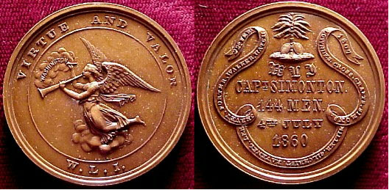

The medal pictured above is made of bronze and measures 39mm in diameter. It was issued in 1860 following the annual 4th of July parade in downtown Charleston, for which the Washington Light Infantry (WLI) turned out 144 men divided into two companies – A and B. This was a first for the premier militia unit of the city and was duly recognized by the issuance of this finely-made bronze medal.

The obverse of the medal features an excellent engraving of the WLI’s crest – an angel (or winged Victory) with horn flying above the clouds. The unit’s motto “Virtue and Valor” appears above the angel with the initials” W.L.I.” below. Immediately under the clouds in very small letters are the diesinker’s initials “R.L.” – Robert Lovett – and his address “Phila.” for Philadelphia.

The reverse of the medal features a rendition of the state seal of South Carolina above the following inscription. W.L.I., Capt. Simonton, 144 Men, 4th July, 1860. Around this inscription is a long ribbon with the date 22d. Feb, 1807 and the following names: Lowndes, Cross, Crafts, Simons, Miller, Gilchrist, Ravenel, Lee, Jervey, Porter, Walker and Hatch. The information presented is the names of the first twelve commanders of the WLI and the date of the WLI’s founding.

As with many other militia groups formed in the early 1800’s the W.L.I. was founded in response to a perceived threat from abroad. On June 22 of 1807 the British ship HMS Leopard fired upon the USS Chesapeake in which 21 American sailors were killed or wounded. Men from the Leopard then boarded the Chesapeake removing four alleged British deserters; three of whom were actually American. A public outcry was heard across America against such heavy handed tactics on the high seas, resulting in the formation of many local militias. In July, with American indignation still running high, several young men of Charleston met at Robinson’s Hotel and formed the Washington Light Infantry (presumably back dating their founding to Feb. 22 in honor of George Washington’s birthday.) Over the ensuing years the W.L.I. became Charleston’s premier militia group; its members performing many civic duties as well as military ones.

In the summer of 1860 (when the above medal was issued) anti abolitionist sentiment ran deep in the streets of Charleston. The Democratic National Convention had been held in the “Holy City” in April and May and had failed to nominate a candidate due to the abolitionist platform of the leading candidate, Stephen Douglas. Abraham Lincoln had just been nominated by the Republican Party which had prompted Robert B. Rhett’s Mercury to print blistering editorials against abolition, warning of dire consequences if Lincoln were elected.

Echoing the patriotic fervor of the state’s citizenry, the WLI stepped up its recruiting efforts during the year. One of the primary means by which the WLI kept its presence in the mind of the public was the annual 4th of July parade. And especially during the summer of 1860, the WLI wanted to put its best foot forward for the citizens of Charleston. Captain Charles H. Simonton, the group’s commander strove to muster as many men as possible for the parade. And he was successful as the WLI paraded 144 Rifles, divided for the first time into two companies – A and B. Simonton and the officers of the WLI must have been pleased as they had medals struck and presented to all who marched.

