Pres. Willie Simon
V .P. James Barry
Sec. Helen Barry
Treas. Pat James
Sgt. in Arms: J.J. Engel
Committees:
Programs: James Barry
Show Chairman: JJ Engel
Newsletter: Arno Safran
E-Mail: arnosafran@comcast.net
The Stephen James
CSRA Coin Club of Aiken
P.O. Box 1739
Aiken, SC 29802
Web site: www.sjcsracc.org
The SJ CSRA CC Now Meets on the 2nd Thursday of the Month at the Cedar Creek Community Center in Aiken, SC

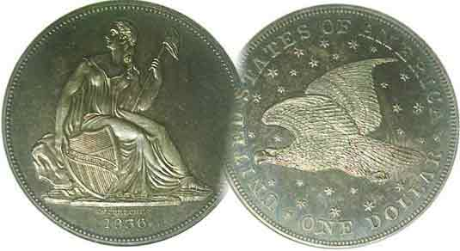

Volume 6, Number 8 the Stephen James CSRA Coin Club, Founded in 2001 August, 2007
Monthly Newsletter
SC clubs Do Well in ANA Publications Contest
Our next meeting is on the 2nd Thursday of the month, August 9, 2007 at 7:00 PM

2007 Club Meeting Schedule - 2nd Thursdays at 7 PM Jan. 11 Apr. 12 July 12 Oct. 11
Feb. 8 May 10 Aug. 9 Nov. 8
Mar. 8 June 14 Sep. 13 Dec. 6
Annual Club Show: Sat. Sept. 15, 2007
_____________________________________________________________________________________________________________________________

The SCanner & SJ CSRA CC Newsletter Win Awards

Every year, the American Numismatic Association sponsors an Outstanding Club Newsletter Contest. Among the several categories are the local club monthly newsletters and the state numismatic association quarterly journals. The entries are sent in from all over the country with the deadline of April 1 for the previous year’s numismatic club’s publications. Out of all the clubs which participates nationwide, the award is given to just the first three top finishers. This year the SCanner, quarterly journal of the South Carolina Numismatic Association (SCNA) took third prize out of the fifty state associations nationwide. Our own Helen Barry was at the time editor of the SCanner and earned the prestigious award. Congratulations Helen.

Closer to home, our club newsletter also took a 3rd place for the twelve editions published in 2006. It was back in February of last year that the newsletter became digitized and it is possible that the changeover may have had something to do with its being considered. Personally I believe that Bill Myers’ colorful Japanese Invasion Money (J.I.M.) notes accompanying his in his fine six part series certainly helped to raise the level of the newsletter’s quality. Speaking of Bill, he is on his way back to the States from serving in Iraq and should rejoin us soon.

Tony Chibbaro Presents Excellent Slide Show on
Charleston, SC World’s Fair Memorabilia

If you were present at the July 12 meeting you saw a fascinating slide program on the tokens and memorabilia associated with the 1901-1902 Worlds Fair in Charleston. It was held between Dec. 1901 and May, 1902. Despite it being poorly attended due to an unusually cold winter many fine examples of exonumia (tokens, medals and scrip) were produced and Tony’s presentation displayed a wide variety of interesting collectibles.
____________________________________________________________________________________________________________________________
(Club News continued on page 4, column 2)

Collecting Liberty Seated Quarter Sub-types:
Challenging and Still Affordable By Arno Safran

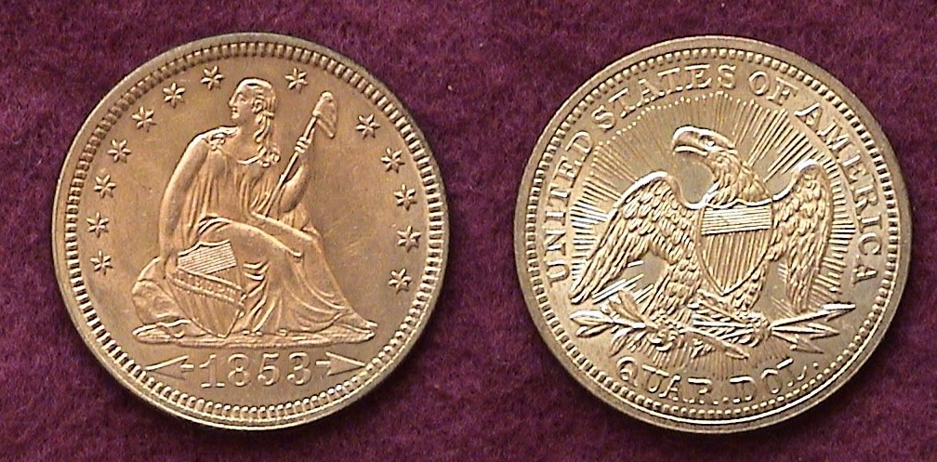

An 1853 arrows and rays Liberty Seated Quarter
Arguably the most popular sub type of the series
[Magnify to 200% to observe the beauty of this sub type]

After the short run of large Capped Bust quarters (1815-28) and the even shorter consecutive run of the small Capped Bust type (1831-38), the Liberty seated quarter was inaugurated in the latter half of 1838 and continued to be struck in consecutive years through 1891 for what was then a record tenure of 54 years.

While there is a serious collector base for Liberty Seated dollars and half dollars along with interest in the dimes and half dimes as well, the Liberty seated quarter denomination has never gained as much favor with collectors. Because of the type’s long tenure, the numbers who have assembled a complete date and mint mark set for any of these five denominations are small. On the other hand persons wishing to complete a sub type set should have little to no difficulty as there are enough common dates available. This is true for the quarter denomination as well. Since “completeness” is one of the aims of most collectors, such a challenge is worth the undertaking.

The major Liberty Seated quarter sub-types can be broken down as follows:
No motto above eagle on reverse (1838-1865)
With motto above eagle on the reverse (1866-1891)
No drapery on obverse (1838-1840)
With drapery on obverse (1840-1891)
With arrows and rays (1853 only)
With arrows at date (1853, 1854 and 1855); (1873 and 1874)
No arrows at date (1838-1853), (1856-1873), (1875-1891)
__________________________________________________________________________________________________________________
(Continued on page 2, column 1)
Collecting Liberty Seated Quarters by Sub-Type
(Continued from page 1, column 2)

In 1836 after a hiatus of 33 years, silver dollar coinage was resumed showing a Liberty Seated figure with no stars on the obverse and a soaring eagle in a sea of stars on the reverse. The coin was engraved by Christian Gobrecht after sketches by Thomas Sully (obv.) and Titian Peale (rev.) Only 1,600 were intended for circulation. Today the coin is considered one of our most beautiful and outstanding examples of coinage art.
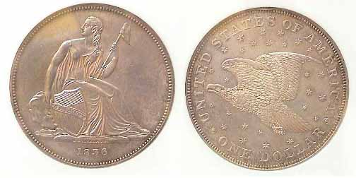
An 1836 Liberty Seated/ soaring eagle Gobrecht $1.00[
[Magnify to better see the details of the design]

In 1837, the dime and half dime were changed from Capped Bust to the new Liberty Seated no stars obverse. On the reverse the eagle was removed and replaced by a wreath.

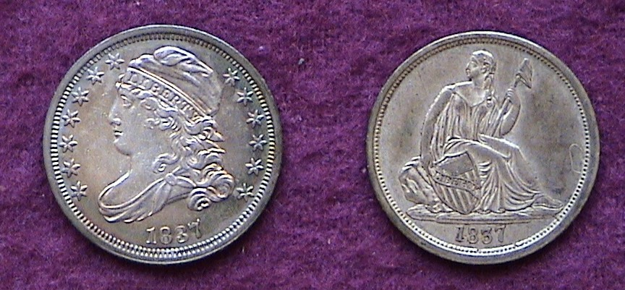
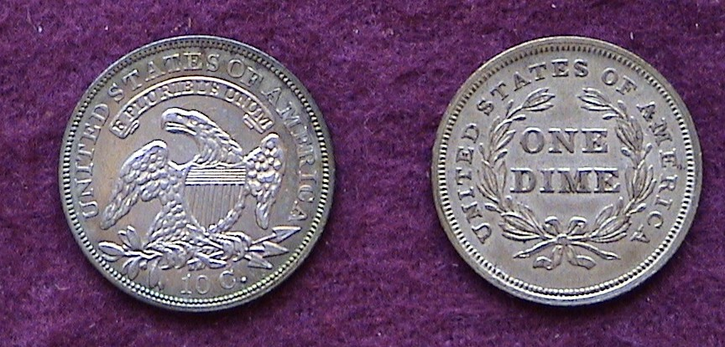

1837 transitional dime types

In 1838 it was the Quarter’s turn to undergo the transition from the Capped Bust to the new Liberty seated type. Apparently Mint Director Robert Maskell Patterson had second thoughts on the no stars obverse, so Gobrecht put back the thirteen stars on the obverse that were featured on the previous Draped and Capped Bust types; perhaps as a symbolic reminder of the original 13 colonies which formed our republic. While the seated Liberty can appear more dazzling in BU than its Bust counterpart, it loses much of its attractiveness below XF-40.

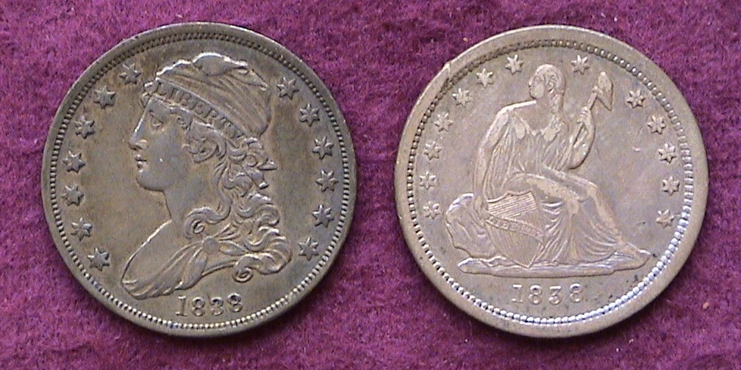

Obverses if the 1838 Capped Bust and Liberty Seated quarters
Notice the extensive wear on the high points of the Liberty seated example.
(Magnify to 200% for better viewing]
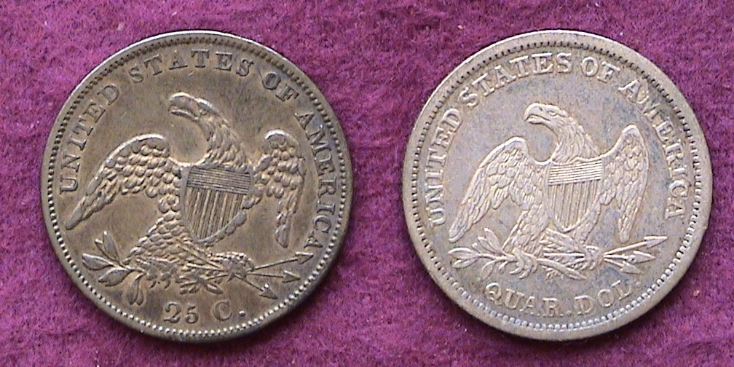

Reverses if the 1838 Capped Bust and Liberty Seated quarters
The same eagle of the previous type was retained albeit smaller
with QUAR. DOL replacing 25 C.
(Magnify to 200% for better viewing]

More difficult to understand was the decision to change the majestic reverse depicting the eagle soaring in a sea of stars seen on the 1836 Gobrecht $1. Instead John Reich’s pterodactyl-like eagle that appeared on the former Bust coinage going back to 1807 was retained. On the new type the eagle appears smaller and instead of 25.C the denomination now reads QUAR. DOL.

During the first three years of Liberty Seated silver coinage, Miss Liberty’s gown lacked drapery between her left elbow and upper leg above her knee, thus the nomenclature for the no drapery variety. Incidentally atop the pole held in her left hand is a Phrygian cap emblematic of freedom.

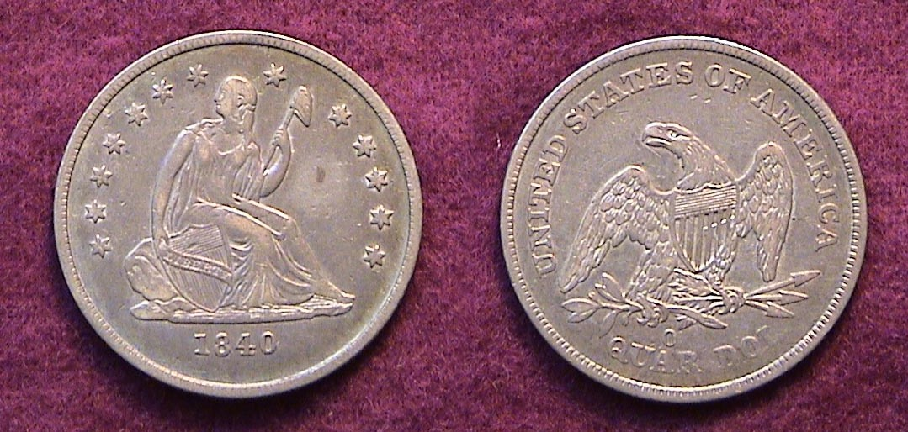

An 1840-O no drapery Liberty Seated quarter
The spot in the right field was caused by an attempt to remove
some corrosion. The coin, purchased at the FUN show in January was sold at the Charlotte ANA Money show in March for that reason. [Magnify to 200%/]

In 1840 Mint Director Patterson brought in Robert Ball Hughes to “improve” Gobrecht’s design but the result was less than an artistic success as some of the features of Miss Liberty were broadened along the head and arms making her appear less graceful. Additional drapery was added to her gown under her left arm. The new sub type was struck in smaller numbers than the preceding years; 188,127 at the Philadelphia Mint and just 43,000 at the New Orleans Mint which had coined 382,200 of the no drapery variety earlier that year.
[The New Orleans facility began operations in 1838 striking no stars half dimes and dimes and with stars quarters.]

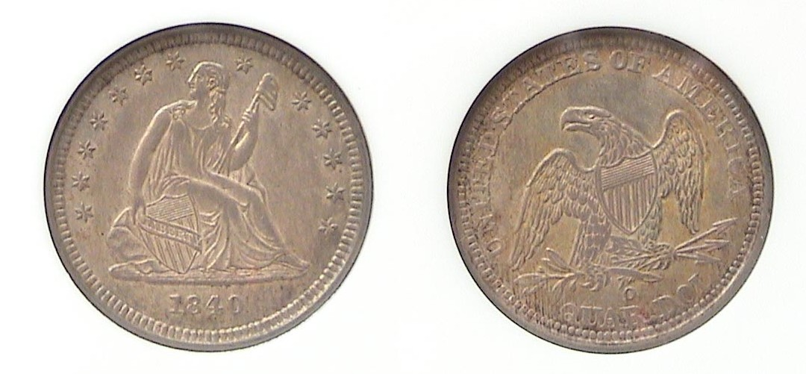
An 1840-O no drapery Liberty Seated Quarter

There are enough common date quarters that display the with drapery feature which are affordable in XF-40.
_____________________________________________________________________________________________________________________
(Continued on page 3, column 1)
Collecting Liberty Seated Quarters by Sub-Type
(Continued from previous page)

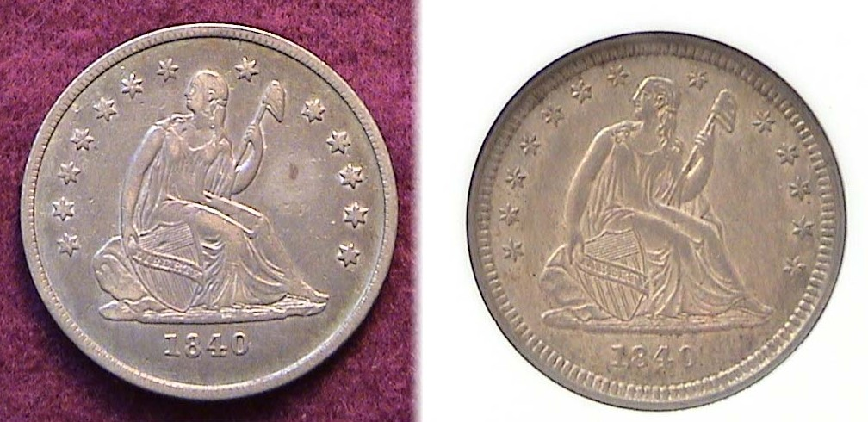

Obverses showing the 1840-O no drapery (l) and with drapery (r)
Liberty Seated quarter sub types side by side
Observe extra drapery under Liberty’s right elbow on the coin at right.
The rock she is sitting on is further away from the lowest right star.

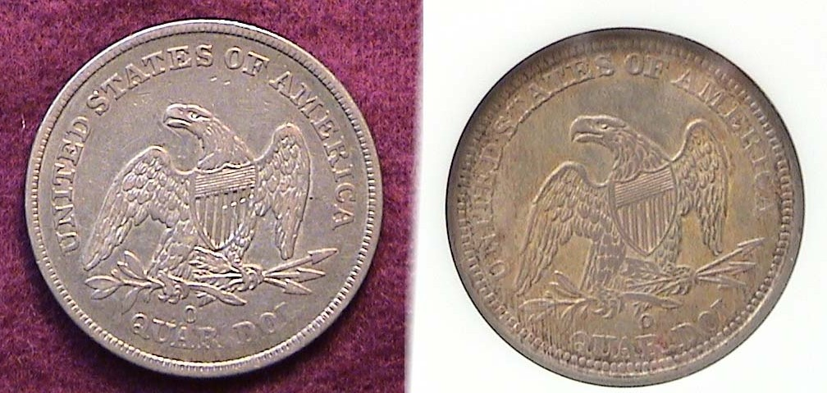

While the reverses of the two 1840-O quarter obverse sub-types appear to be the same despite the tilt of the coin at right, the mintmark O on the no drapery reverse is well to the left while on the with drapery reverse it appears more to the right.
[Magnify up to 200% to see the details more clearly.]

The next sub type for the quarter series occurred in early 1853. This was brought on by an event that took place some five years earlier. In 1848 gold was discovered in northern California at Sutter’s Mill just east of Sacramento. The event sparked the famous great Gold Rush of 1849. By 1851 gold mining had reached a feverish state. With so much new gold available the value of silver increased in relation to the yellow metal with the result that silver coins were being removed from circulation as soon as they left the Mint. By January of 1853, the coin shortage had become acute. On Feb. 21, 1853, Congress adopted a proposal by Mint Director George N. Eckert reducing the weight of all silver denominations with the exception the dollar. To indicate the change, Eckert ordered Chief Mint engraver James Barton Longacre (installed in 1849) to place arrows surrounding the date and add rays emanating outwards from the eagle on the reverse. 15,254,200 of the new sub type were struck at the Philadelphia Mint compared with just 44,200 of the no arrows and rays type produced in January; a record that would stand until 1876 when 17 million quarters were issued. Meanwhile an additional 1,332,000 1853-O quarters with arrows and rays were struck at New Orleans. The tactic proved successful and silver coinage circulated once again.

The 1853 arrows and rays quarter (as seen at the head of this article.)
More than 15 million were struck in Philadelphia but the demand for this popular sub-type has kept prices strong from AU-55 or better.
On March 4, 1853 Franklin Pierce was inaugurated as our 14th President succeeding Millard Fillmore who became our 13th upon the death of Zachary Taylor in 1850. With changes in the administration--even within the same party--many high officials of the government who serve at the will of the President opt to resign after the President who appointed him/her has left office. Whatever the rationale, Col. James Ross Snowden became the new Mint Director, succeeding George Eckert and for reasons still unknown decided to have the rays removed from the reverse of the quarter and half dollar while retaining the arrows at date for 1854 and 1855. While either date is collectible as another sub type, most collectors have a ho-hum attitude and neither year is expensive. By 1856, Snowden had the arrows removed altogether believing the public needed no further reminding of the reduction in silver content.

After the Civil War ended, there was an effort among religious leaders to insert some reverence for the almighty on our coinage. The first coin to bear the motto IN GOD WE TRUST was the 2¢ piece first struck in 1864. In 1865 a new copper nickel 3¢ piece was introduced to help reduce the coin shortage but it did not include the motto. The following year, 1866, the motto was placed atop the obverse of the new 5¢ Shield nickel. That same year the motto was inserted within a ribbon above the eagle on the reverse of the Liberty Seated quarter, half dollar and dollar thereby creating a new sub type. The motto would remain thru 1891, the end of the run for the quarter and half.

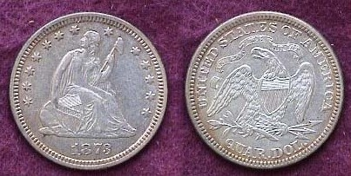

An 1873 25¢ with motto (no arrows)

In 1873 Congress authorized our silver coins to be struck in a new metric weight which translated into a miniscule increase in the silver weight of the quarter from 6.2 grams to 6.25. Since this did not go into affect until April, those struck after the changeover had arrows placed at the date for both 1873 and 1874 issues, thus creating still another sub type.

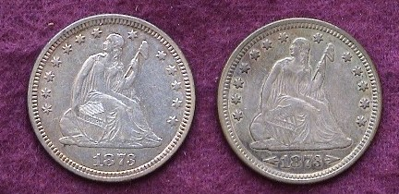

Obverses of 1873 25¢ no arrows (left) and with arrows (right)
[Enlarge to 200% to see details]

There are even more Liberty Seated quarter sub types for the collector to ponder such as the closed 3 and open 3 varieties for 1873 but it is sufficient to know that the aforementioned major sub types are collectible at modest prices from XF-40 thru AU-58 worthy of display thereby providing yet another aspect of the wonderful world of numismatics.
_________________________________________________________________________________________________________________________

NEW RIVER GORGE BRIDGE
By Bill Myers

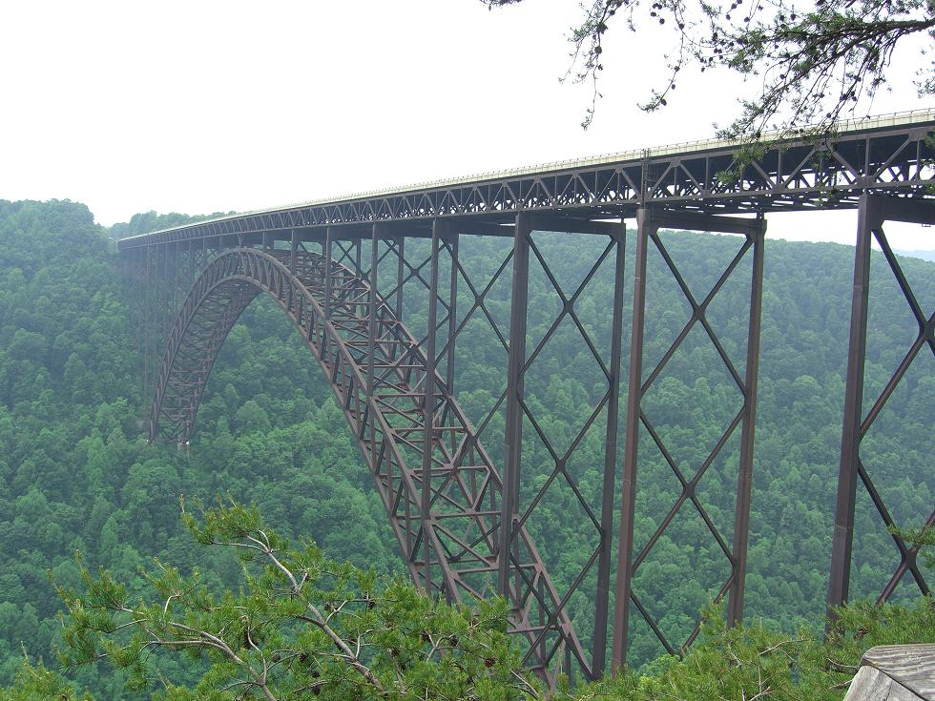

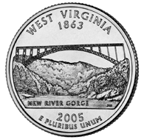
I was able to get a two week leave from my deployment to Iraq and spent half of it visiting family in Pennsylvania. On the drive from western Pennsylvania to Augusta I made an unscheduled numismatic stop. I came upon the New River Gorge Bridge in West Virginia. It is the bridge that is pictured on the reverse of the West Virginia state quarter. The bridge was opened 22 October 1977 and at the time was the world’s longest steel arch bridge (3030 feet). On 8 February 2003 it was surpassed by the Lupu Bridge in Shanghai which is 550 meters (32 meters longer). At 876 feet it is the second highest bridge in the United States, surpassed by the Royal Gorge Bridge over the Arkansas River in Colorado. The New River Gorge Bridge turned a 40 minute drive down and across the gorge to less then a minute. It was not very impressive when I drove over the bridge but there is a visitor’s center with a viewing area. I could see the extent of the bridge from the platform and that was impressive. The steel framework of the bridge is an engineering marvel. The rafts on the river below were mere dots. I was glad I had the chance to see one of the structures pictured on a state quarter. It was nice to take a numismatic break on an otherwise tedious drive.


More Club News
(Continued from page 1, column 1)

Tony reported that the Fair was actually called the South Carolina Interstate and West Indian Exhibition and featured thirty buildings. Its goal was to increase commerce in the area and to reintroduce the refurbished city of Charleston thirty-six years after the Civil War. 675,000 people attended the six month exposition. Among the various collectibles displayed were the official souvenir medals, another honoring Fort Sumter, also cotton exchange medals and a number of so-called dollars. Other collectible items included sterling silver and silver plated spoons, demitasse cups, elongated cents, encased cents, badges and postcards. Ticket passes including daily and seasonal, press passes and pass books are highly valued because some are rare. Thanks Tony for another fine presentation.

In other club business, Treasurer Pat James reported a treasury balance of $1,009.44. Thanks, Pat. Doug Moody won the door prize. Our next meeting is scheduled for Aug. 9. Arno Safran will present a Program on “The Coinage of 1837”. Hope to see you then.

Kindly Support Our Advertisers
