Pres. Willie Simon
V .P. James Barry
Sec. Helen Barry
Treas. Pat James
Sgt. in Arms: Glenn Sanders
Committees:
Programs: James Barry
Show Chairs: The Barry’s
Newsletter: Arno Safran
E-Mail: arnosafran@comcast.net
The Stephen James
CSRA Coin Club of Aiken
P.O. Box 1739
Aiken, SC 29802
Web site: www.sjcsracc.org
The SJ CSRA CC Now Meets on the 2nd Thursday of the Month at the Cedar Creek Community Center in Aiken, SC

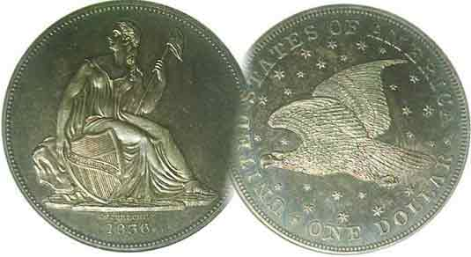

2008 Club Meeting Schedule
Volume 7, Number 8 the Stephen James CSRA Coin Club, Founded in 2001 August, 2008
Monthly Newsletter
ANA National Show in a word, “Overwhelming”!
Our next meeting is Thursday, August 14 from 6:15 to 9:00 PM
Jan. 3 Apr. 10 July 10 Oct. 9
Feb. 14 May 8 Aug. 14 Nov. 13
Mar. 13 June 12 Sep. 11 Sep. 13 Show
___________________________________________________________________________________________________________________________

ANA Baltimore: The Largest Bourse in the World

Several SJ CSRA CC members attended the ANA’s National Money Show; this time being held in Baltimore, MD. The show was open to the public at no charge from Wed. July 30 thru Aug. 3, 2008 and was held at the Baltimore Convention Center which is located in the resplendent Inner Harbor area. The charge for the hotels in the Inner Harbor area was another matter. Despite a substantial discount given to those attending the Show, the downtown area hotels charged extra for parking ($22 a day), breakfast (triple McDonalds and double Waffle House) and even hooking up your Laptop; (c. $10 a day for 12 hours use). With that in mind, this coin show had to be “big” and important. Fortunately it was, if a bit overwhelming. There must have been over a thousand dealers’ tables on the huge bourse. There were prominent numismatic dealers with huge inventories carrying high-end uncirculated material but also a wide range of dealers with less expensive coins along with paper money that was more common or if scarce, in lower grades. If you were seeking quality better date material, you were going to have to pay a premium over current retail prices because so much of the numismatic market has been invaded by foreign entrepreneurs looking to take advantage of the weakened American dollar. The trick was to select numismatic items not in high demand and in that respect; the show was successful from this observer’s standpoint.

The Exhibits were outstanding as usual but the temperature in that sector of the hall was about 20 degrees cooler than the rest of the bourse area, so unless you had a jacket, you really couldn’t devote the time to study each exhibit carefully. The numismatic theater programs were excellent and our own Bill Myers presented an excellent PowerPoint program on Propaganda Money used during World War II. Members seen on the bourse were Jim and Helen Barry, Dick and Sharon Smoot, Bill and Kathy Myers and Arno and Vilma Safran.
___________________________________________________________________________________________________________________________
(Club News appears on page 4, lower portion of column 1)

Collecting the Coins of 1900
By Arno Safran

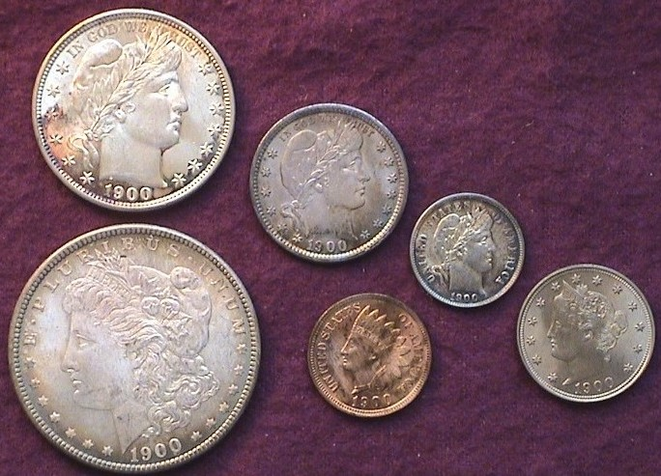

The obverses of an uncirculated 1900 Year set (excluding gold)
[The Century mark set was begun in 1978 and completed in 1982.]
[Magnify the page to 200% to see set more clearly.]

Back in 1982 I decided to assemble a 1900 year set (excluding gold) because I wanted to get a jump start on the year 2000 and didn’t want to risk waiting that long when a century mark year set of any kind might become too expensive to afford. Two years earlier the Hunt Brothers attempt to corner the bullion markets produced a spike in silver and gold prices that forced up the cost of virtually all US type coins well beyond their actual numismatic value. When the market crashed a year later many of the more common types fell in price and by 1982, a semblance of normality returned to the coin collecting hobby. I had always loved the Liberty Head design on our nickel and silver coins that as a youth one could still find in circulation, occasionally, even in grades as high as VF. In the 1940’s one did not refer to the 5¢ thru 50¢ coins of the turn of the last century as Barbers. We called them Liberty Heads and to this day, I consider this the only US coinage design that still looks attractive in as low a grade as VG-8.
______________________________________________________________________________________________________________________________
(Continued on page 2, column 1)
Collecting the Coins of 1900 (Continued from page 1)

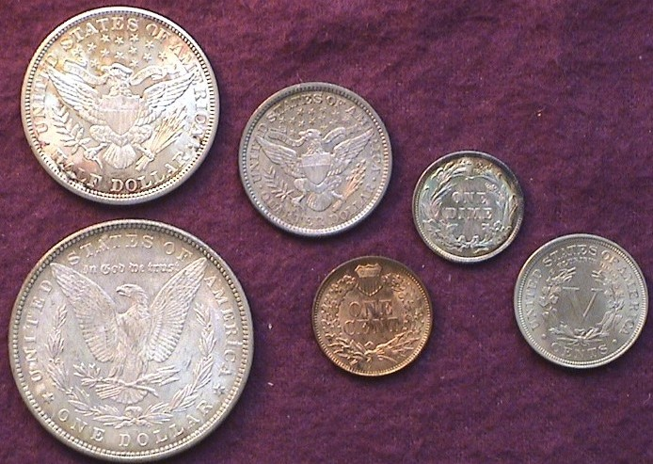

The reverses of an uncirculated 1900 Year set (excluding gold)
[Magnify to 200% to observe details.]

Despite these foregoing comments I endeavored to assemble the six coins in mint state or as close to it as possible; not MS-65s, which even in 1982, I could not afford but coins averaging around MS-63. This was an attainable goal since all six denominations were fairly common especially the Philadelphia Mint issues. In 1900 both the Indian Head cent and Liberty nickel were still being issued only in Philadelphia. While the 1900 Barber dime, quarter and half dollar were coined at all three operating Mints; Philadelphia, New Orleans and San Francisco, the Philadelphia issues were struck in prodigious numbers. Only the 1900-O Morgan dollar was more common than the 1900-P issues.

Back in the late 1970’s and early ‘80s, I occasioned a number of coin shops located in the Delaware Valley; an area much like the CSRA. The region included Trenton, New Jersey’s capital city with a population of around 110,000. Princeton was situated to the north and the towns of Ewing, Hamilton surrounding Trenton and Newtown and Levittown on the Pennsylvania side of the Delaware River all had coin shops. At one of these stores I was shown a 1900 Indian Head cent that appeared lustrous, full red and well struck. The dealer graded it MS-65 and priced it at $46.00. That was a lot for a common date Indian cent, but this was back in 1978 when the cost of living was far lower than it is today. It was also well before the third party certification companies began encapsulating the coins they graded and authenticated as genuine. Until 1986, all coins were sold by dealers based on their grading standards, not necessarily the buyers. I recall the 1900 cent making the grade but over the years it toned in a streaky fashion and lost some of its luster.

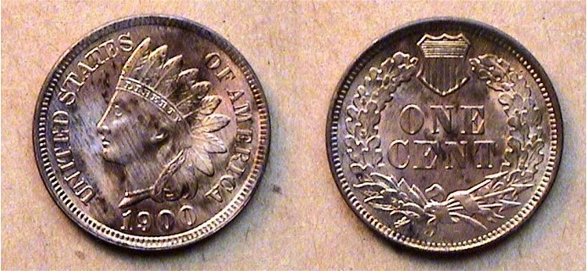

A 1900 Indian Head Cent. The mintage was huge, over 66.8 million.
[Magnify to 200% to see sharpness in lettering and feathers despite toning.]

Charles Barber was noted for his Liberty Head dimes, quarters and half dollars first released in 1892 but he is also the designer of the Liberty 5¢ V nickel which was first released in 1883. The 1900 coin shown below was sold as an MS-65 to the writer back in the summer of 1979 and it may just make the grade. It has superb luster, is free of marks and appears well struck.

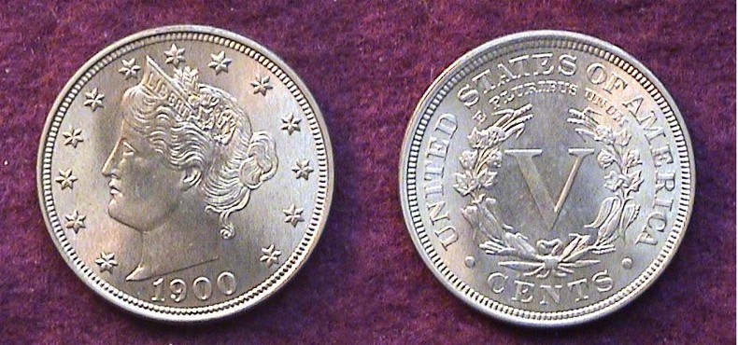

A 1900 Liberty 5¢ nickel. Over 27 million were struck.
[Magnify to 200% to observe details.]

Today, Barber Liberty Head silver coinage is one of the more popular collectible series among US numismatists but it wasn’t always so. Around the turn of the last century hobbyists derided the coin as appearing staid and lifeless in appearance. What changed this view? From 1870 thru 1914, a continual wave of immigrants entered the United States. The economy went through a number of downturns as the American labor force had to compete with the newly arrived masses for factory jobs. Starting wages were as little as 4¢ to 10¢ an hour for a six day work week, so any new Barber coinage including the half dollar that one may have received in their weekly pay envelope immediately went to pay for basics. As a result, virtually all dates are scarce in Fine or better. Only the wealthy could afford to put away an uncirculated specimen which account for the high prices nice Barbers bring today.

By 1900 the hubs on the Barber coins were beginning to wear down and new hubs were made for 1901 which is why the coins dated 1901-04 appear sharper. Still, the 1900 dime shown below is nicely toned and reasonably well struck.

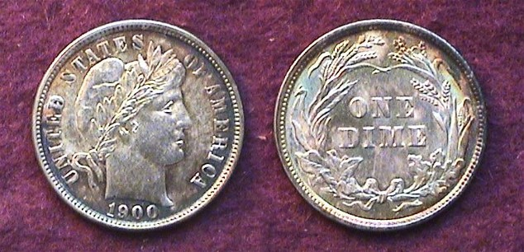

A 1900 Barber dime graded MS-63
[When magnified to 500% one can observe the toning streaks.]

The 1900-P Barber quarter received the third highest mintage, more than 10 million. It is considered a common date in AG-3 though VG-10, slightly tougher in Fine-12 and scarce in VF to XF. In mint state it is available for a price up to MS-64.

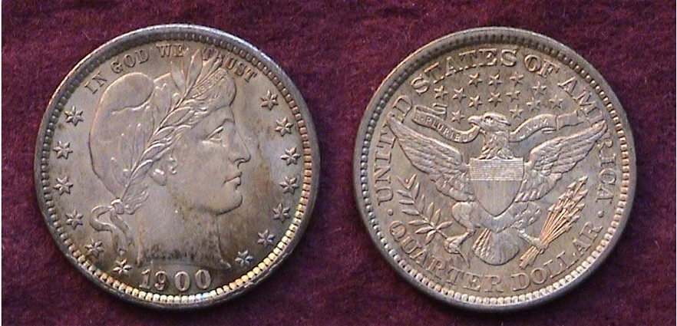

A nicely toned BU 1900-P Barber Quarter.
More than 10 million were minted. [Magnify to 200%.]
______________________________________________________________________________________________
(Continued on page 3, column 1)

Collecting the Coins of 1900 (Continued from the previous page)

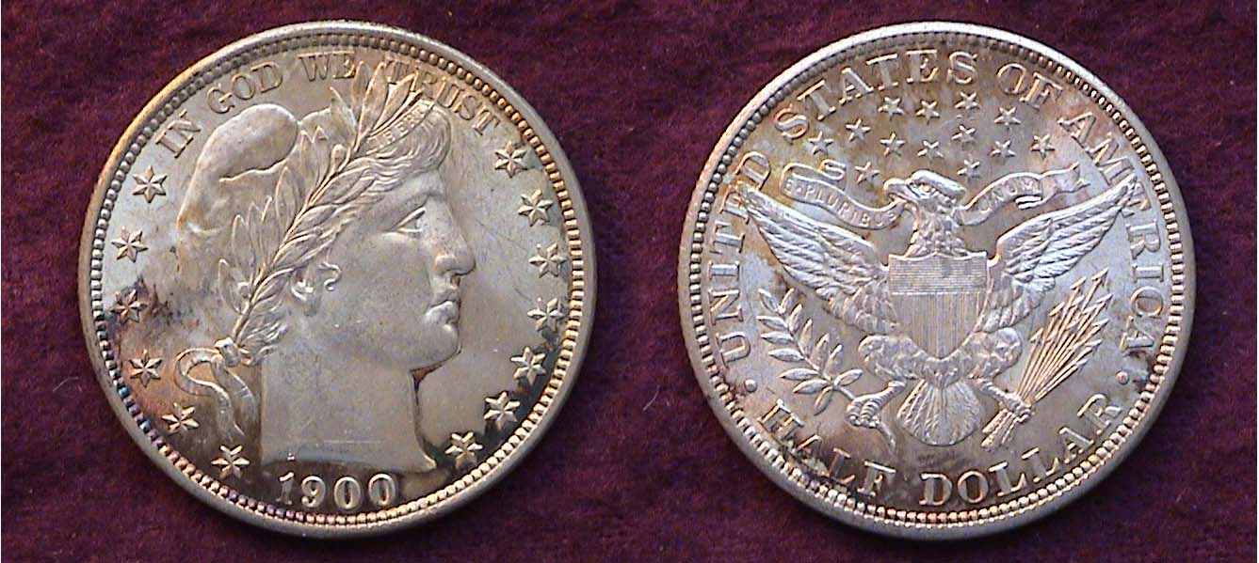

A Mint State 1900- P Barber Half Dollar
The mintage was 4,762,000 but well off the record set in 1899

In the opinion of many numismatists, the US half dollar denomination with a diameter of 30.6 mm represents the perfect size to display the coinage art of the engraver and the Barber Liberty Head half is no exception. The design exhibits a special majesty that is not as evident on the quarter (24.3 mm) and completely missing from the small size dime (17.9 mm) which to be fair, uses the legend, UNITED STATES OF AMERICA in place of the 13 stars on the obverse and a wreath instead of the eagle on the reverse. Today attractive BU specimens of the Barber half start at $800. Back in 1982, the coin pictured above cost only half that much. Housed in a Lucite holder along with the other 1900 coins in a Safe Deposit Box for 26 years it gradually toned to a beautiful russet color on both sides around the lower edge. I consider this the crowning piece of the set.

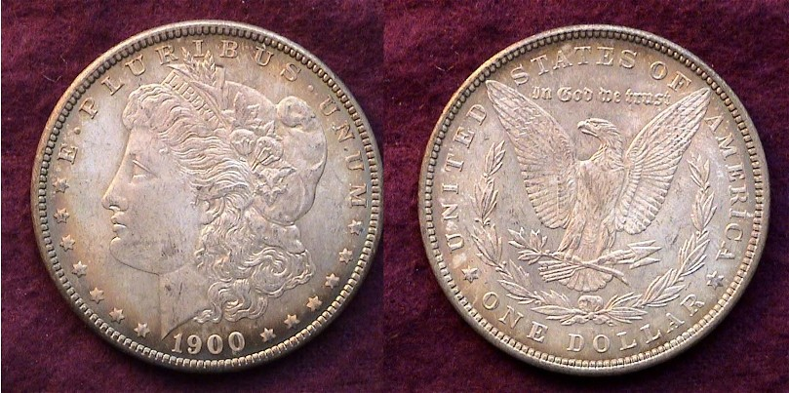

A lightly toned BU 1900-O Morgan $1.00.
12,590,000 were minted; well off the record of a number of dates.

When I was a twelve I discovered my first Morgan dollar while looking for a road map for my father in the top drawer of his dresser. Needless to say, I was intrigued and was told that if you wanted to collect any, just go to the nearest bank and ask if they had any to exchange for $1.00 bills. I was amazed that they went all the way back to 1878, older than all the Barber coins I had com across in circulation. Somehow, when the collecting “bug” hit me, I was never ‘turned on’ to Morgans, instead opting for earlier US type and Barber halves. I found these Amazonian cartwheels were all over the place in blazing MS-65 as most dates were struck in the millions; some in the tens of millions. They were simply too common as government hoard coins for me to take seriously. Still I needed one to complete my 1900 set but wanted it to match the overall appearance of the other coins. I eventually found this slightly toned 1900-O specimen at a local coin shop graded MS-63. It didn’t cost very much and provided closure. Now I began to wonder what it would take to assemble an 1800 set.
_____________________________________________________________________________________________________________________

The Year 1900: “Four more years of the full dinner pail”

In 2000, PBS aired a program called, ‘The 1900 House” It was one of the first “Reality” shows and depicted a contemporary family of four that included a teen age daughter who were chosen to experience what it would be like to live as a middle class family in the year 1900. Imagine a world with no automobiles or air planes, no radios or TVs, no computers or internet, no modern heating or cooling systems and having to deal with 19th century lead pipe plumbing and lead paint plaster walls. Still, mail was delivered regularly, sometimes twice a day and there were morning and afternoon newspapers. Public transportation by trolley cost a nickel. Doctors did make house calls at very modest fees.

Working class families also received very little. The average laborer worked a 10½ hour day six days a week at a wage of 13½¢ an hour. This translates to $8.50 a week, $38.25 a month or $450 a year. The basic goods were priced at a fraction of what they cost now. Beef cost 10¢ a pound, chicken, 7¢. Butter sold for 18¢ a pound and a dozen eggs was priced at 12¢. Rent in an urban tenement ranged from $12 to $15 a month, about a third of one’s wages. A 1900 half dollar in 1900 had the purchasing power of around $14.00; the equivalent of one month’s rent. Under such living conditions, the thought of putting aside a gem 50¢ piece on the odd chance it came in one’s pay envelope probably never entered the recipient’s mind.

Apparently the low pay of the wage earners did not affect the election of 1900. President William McKinley, 25th president of the United States--who had signed a law putting America back on the gold standard in March--was running for reelection to a second term. He chose Theodore Roosevelt as his Vice Presidential running mate although this Republican maverick campaigned on reining in the big trusts, thus alarming the party bosses. Using the slogan, “Four more years of the full dinner pail” McKinley would go on to defeat his Democratic opponent, William Jennings Bryan again as he did in 1896.

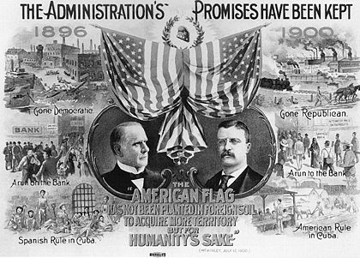

The Presidential Campaign of 1900
[Magnify to 200% to read the captions.]

1900 was a year in which America portrayed itself as an economically stable nation while on the brink of expansion. Our classical stylized coins seemed to symbolize that concept.
______________________________________________________________________________________________________________________

HAWAIIAN QUARTERS – AGAIN
By Bill Myers

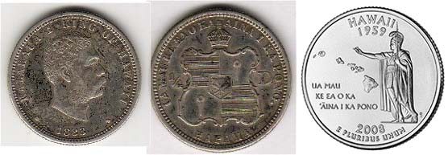

The 1883 Hawaiian Quarter and Rev. of 2008 Hawaii 25¢
[Magnify to 200% to observe details.]

The release of the Hawaii state quarter later this year completes the 10-year, 50-state coin program. For Hawaii, it is the second quarter it has released in the past 125 years.

In 1874, David Kalakaua became King Kalakaua I of Hawaii. In 1883, Claus Spreckels, a Hawaiian banker and sugar tycoon, proposed that the United States strike silver coins for the Hawaiian Islands. Charles Barber created the master dies and hubs. The original denominations were Dala (dollar), Hapalua (half-dollar), Kapaha (1/4 dollar) and Hapawalu (1/8 dollar). The last was changed to Umi keneta (one dime). All coins were struck at the San Francisco Mint. Each of the four coins corresponded to the planchet size for the U.S. coins of the same denomination.

After Hawaii became a U.S. Territory in 1900, the Hawaiian coins were withdrawn and replaced by U.S. coins. The original mintage of the quarter was 500,000, with half of that having been melted. The obverse of the quarter has a right-facing bust with 1883 below and “KALAKAUA I KING OF HAWAII” around his bust. The reverse has the royal coat of arms in the center with “1/4” on the left and “D” on the right. Around the crest is “UA MAU KE EAO KA AINA I KA PONO/KAPAHA” which is the motto of Hawaii and coin denomination – “The life of the land is perpetuated in righteousness/quarter dollar”.

Other states (Connecticut, Massachusetts, New Hampshire, New Jersey, New York and Vermont) have released their own coins in colonial times, and an even larger number of commemorative halves have been issued for states including Hawaii but none were of the quarter denomination. Only Hawaii has that honor.
__________________________________________________________________________________________________________________________

Reference:
Breen, Walter. “Complete Encyclopedia of U.S. and Colonial Coins”. 1988. p. 672-3.
The Silver Coinage of the Kingdom of Hawaii by Raymond F. Hanisco at http://www.bellaonline.com/articles/art42500.asp
__________________________________________________________________________________________________________________________

Club News

President Willie Simon called the July 10 meeting to order at 7:00 PM and welcomed Treasurer Pat James who had been ill but looking fully restored to her ebullient self. Secretary Helen Barry’s minutes of the June 12 meeting were waived by acclimation and placed on file as has been the custom, but one wonders how they might read just once since Helen takes copious notes at every meeting. Pat reported the current treasury balance at $8.03 with all expenses paid. Willie then called attention to our upcoming annual coin show scheduled for Saturday, Sept. 13 at the H. Odell Weeks Activity Center in Aiken on Whiskey Road across from the Home Depot. Jim Barry reported that 18 tables had been sold. Willie suggested that members start posting show fliers at the various retail outlets and sell those raffle tickets; $1.00 each or six for $5.00.

For Show & Tell Jim Barry brought in his latest acquisition, a Thessalian League Greek stater struck in Thessaly circa 196 to 27 BC showing Zeus facing right on the obverse and Athena facing similarly on the reverse. Arno Safran presented a PowerPoint program on Hard Times Tokens, illustrating the Political portion. The Attendance prize was won by Willie Simon, a 2008 silver eagle and the 50/50 was won by Steve Kuhl. Congratulations to the winners! The next meeting scheduled for Thurs., July 14 and will feature another grading bee. Bring in your certified coins. The grades will be masked.
___________________________________________________________________________________________________________________________

Kindly Patronize Our Advertisers

