Pres. Steve Kuhl
V .P. Arno Safran
Sec. Jim Mullaney
Treas. Sharon Smoot
Sgt. in Arms: Glenn Sanders
The Stephen James
CSRA Coin Club of Aiken
P.O. Box 11
New Ellenton, SC 29809
Web site: www.sjcsracc.org
The SJ CSRA CC of Aiken, SC meets on the 1st Thursday of the month at the Aiken Public Library

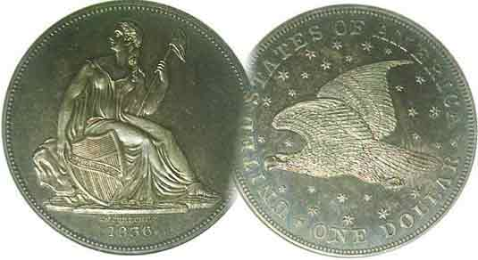
Committees:
Programs: Arno Safran
2010 Show: Jim & Helen Barry
Publicity: Jim Clapp
Newsletter: Arno Safran
E-Mail: arnosafran@comcast.net
Auctioneer: Glenn Sanders

2010 Club Meeting Schedule
Volume 9, Numbers 8 & 9 the Stephen James CSRA Coin Club, Founded in 2001 Aug. – Sept. 2010
Monthly Newsletter
Changing Coin Designs Parallel Aiken’s Proud History
Our next two meetings are Thursday, August 5, and Sept. 2, 2010 from 6:45 to 8:45 PM
[The next issue of the newsletter will arrive shortly before the October, 7, 2010 meeting.]
Jan. 7 Apr. 1 July 1 Oct. 7
Feb. 4 May 6 Aug. 5 Nov. 4
Mar. 4 Jun. 3 Sep. 2 Dec. 2

____________________________________________________________________________________________________________

Coins and Postcards provide portals to
Aiken’s History-III: the Hitchcock’s Legacy

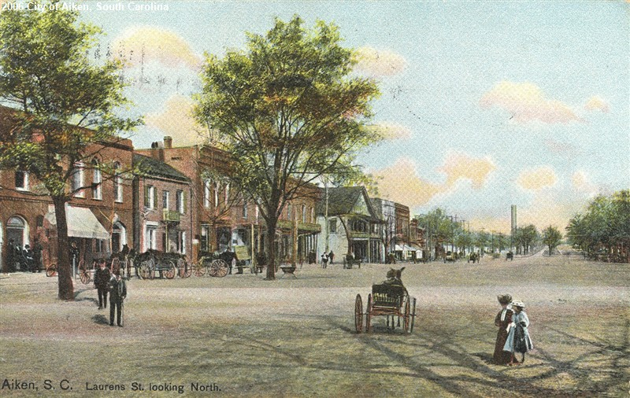

Laurens Street looking north in Aiken during the early 1890’s
[Use 3X glass or magnify to 200% to see details]

Shown above is a picture postcard depicting Laurens Street looking north as it appeared around 1891 and 1892. It was in 1891 that Louise Eustis a prominent Aiken socialite then living in New York was married to Thomas Hitchcock of Long Island, a wealthy horse trainer. After their marriage, she invited her husband to spend one winter in Aiken where she grew up. Realizing that the area was ideal for the training of horses, the Hitchcock’s would return each winter. In 1892, Hitchcock asked his friend William C. Whitney, a former Secretary of the Navy in President Grover Cleveland’s cabinet to visit them in Aiken. He too was impressed with the ideal climate and sandy soil and together with Hitchcock and Louise’s aunt Celestine Eustis, they purchased an 8,000-acre pine forest that would become renowned for foxhunting and other equine sporting events. In Numismatics, the year 1891 also represented the end of the era of Liberty Seated silver coinage and the following year, 1892, the beginning of Charles Barber’s Liberty Heads.
______________________________________________________________________________________________________
(The Hitchcock Legacy continued on page 3, column 1)

US Coin Transitions: 1891 & 1892 by Arno Safran

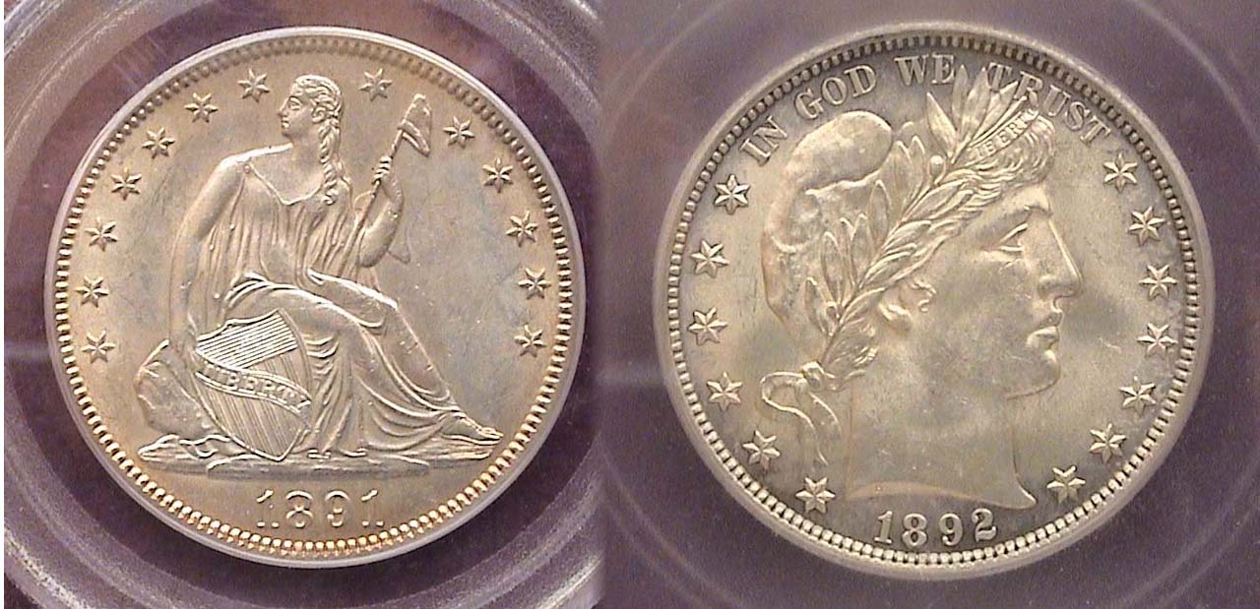

Obverses of the 1891 and 1892 half dollars in actual size
Each was graded MS-62 by PCGS & ICG respectively
[Use 3X glass or magnify to 200% to see details]

In 1890, a new law was passed allowing coin types to be changed after 25 years. As a result, the dime, quarter and half dollar became eligible for a face lifting. The following year a new design contest was announced. At first only ten leading sculptors were invited to participate but after they collectively refused because of lack of time and insufficient compensation, the contest was thrown open to the public. One of the judges was Chief Mint Engraver Charles Barber from 1880-1917 who was and would be strongly opposed to any outsiders involved in Mint creations or modifications. It is not surprising then that of the 300 who participated, no one entry was deemed worthy. An exasperated Mint Director Edward O. Leach decided to assign the task to Charles Barber himself. Ironically, after receiving the assignment, Barber used the same Miss Liberty as seen on the Morgan dollar, but facing right instead of left while cropping her hair under a laureate cap. Despite the harsh criticism Barber received his coinage is popular with collectors today.

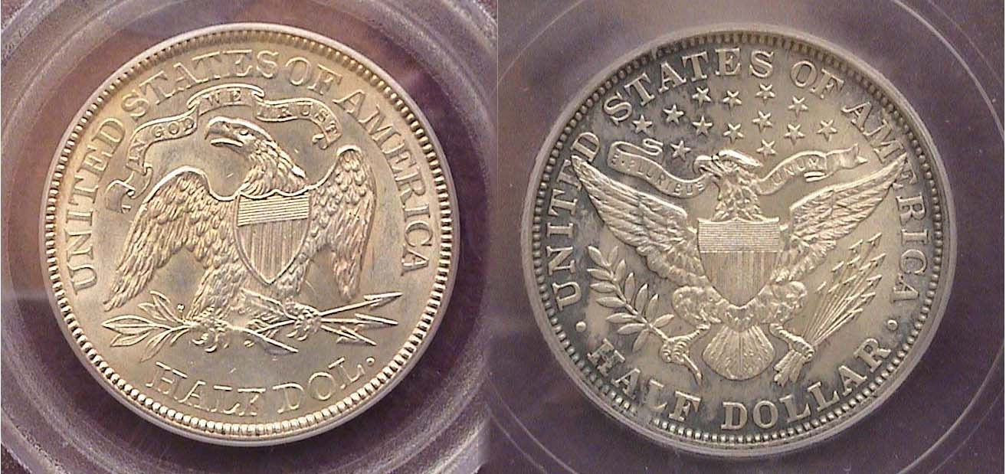
_
Reverses of the 1891 and 1892 half dollars in actual size
_____________________________________________________________________________________________________________________
(Continued on page 2, column 1)
Collecting the transitional US Coins of 1891 & 1892
(Continued from page 1, column 2)

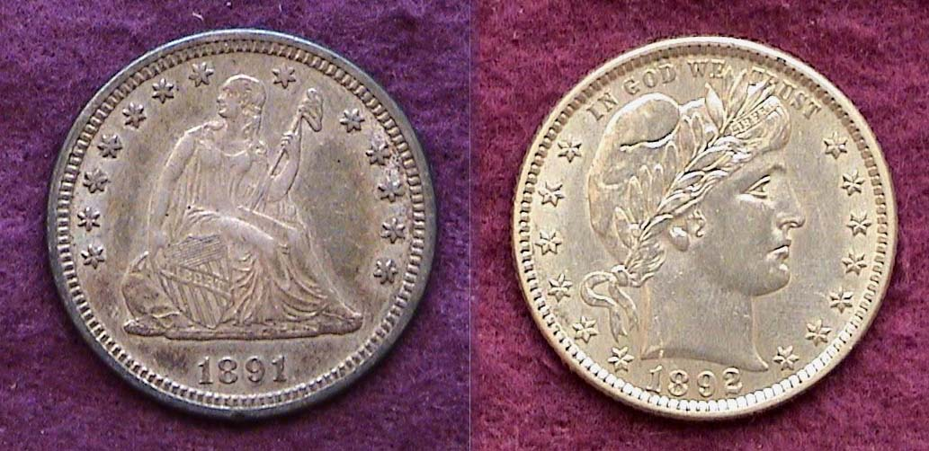

Obverses of the 1891 Liberty Seated 25¢ and 1892-O Barber 25¢
Both are graded AU-55 [Use 3X glass or magnify to 200% to see details]

One interested in the transitional denominations from 1891 to 1892 need concentrate only on the half dollar, quarter and dime. As a rule the Philadelphia Mint issues have the largest mintages, are the most available in the higher grades and the least expensive. The mintage for the 1891 Liberty seated half dollar was only 200,000 but it is priced as a common date up through MS-63. The mintage for the 1892 Barber half was 934,000. That is less than a million yet it too was saved and is priced as a common date throughout the grading spectrum. The 1891-P Liberty Seated quarter boasts a much larger mintage, 3.9 million and is considered one of the most common dates of the entire series. The 1892-P and O Barber quarters are plentiful with large mintages, the 1892-S less so.

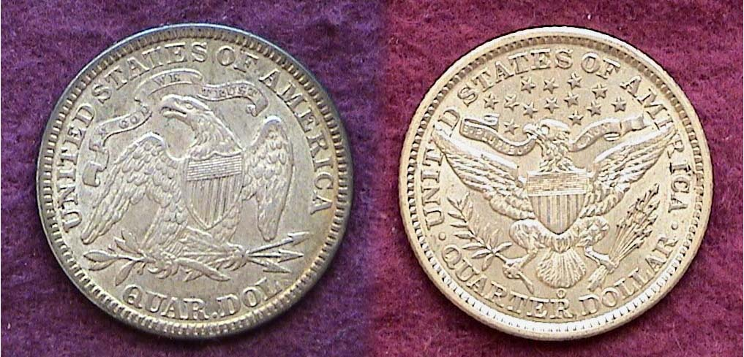

Reverses of the 1891 Liberty Seated 25¢ and 1892-O Barber 25¢
[Use 3X glass or magnify to 200% to see details]

According to the Guide Book of United States Coins, (AKA The Official Red book), none of the 1891 or 1892 denominations (excluding gold) are considered truly scarce, so it is possible for a collector of moderate means to acquire an attractive specimen of each at a moderate cost from FINE-12 through AU-58 depending on one’s income. Lower end Mint state coins such as MS-60 thru MS-62 will be more pricey with specimens grading MS-63 or higher a lot more expensive.

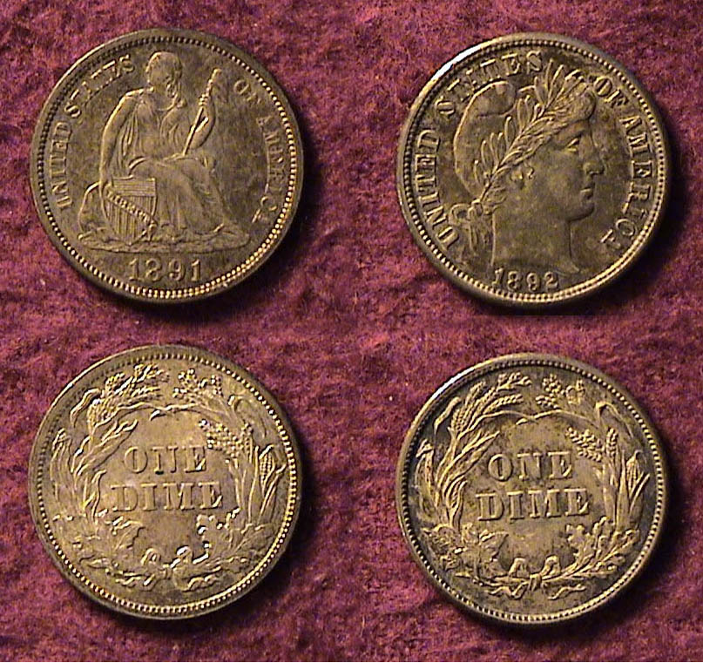
As for the dimes the 1891 P, O and S Liberty seated issues are common, especially the P Mint issue with more than 15.3 million Liberty Seated dimes struck in its final year. The 1892 P & O Barber dimes are readily available, the S, less so and more costly.

A naturally toned 1891 Liberty Seated 10¢ and 1892 Barber 10¢
matched pair. Both were graded AU-58.
Notice the reverses for both types are virtually identical.
[Use 3X glass or magnify to 200% to see details]

In comparing the inscriptions on the 1891 and 1892 dimes, the obverse for each type contains the Legend, UNITED STATES OF AMERICA but both the Liberty Seated and Barber reverses appear to be identical.
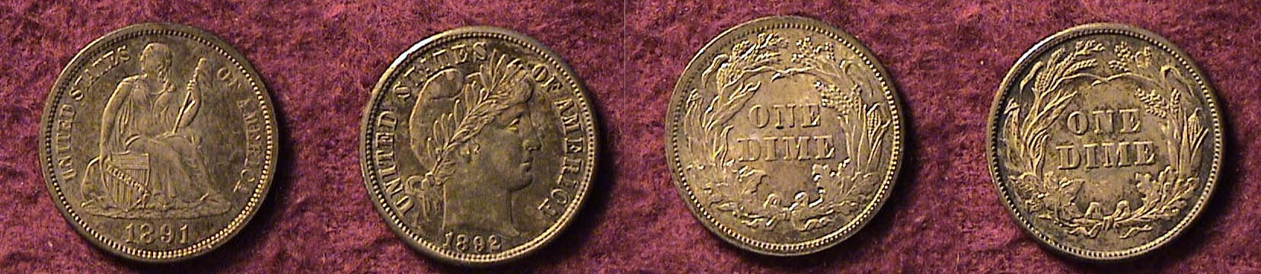
1891 and 1892 dime obverses (left), reverses (right)
Use 3X glass or magnify to 200% to see details]

Regarding the quarters and halves, both coin types display the 13 stars surrounding Miss Liberty on the obverse. The motto, IN GOD WE TRUST was moved from the reverse of the Liberty Seated type and placed on the obverse of the Barber type.

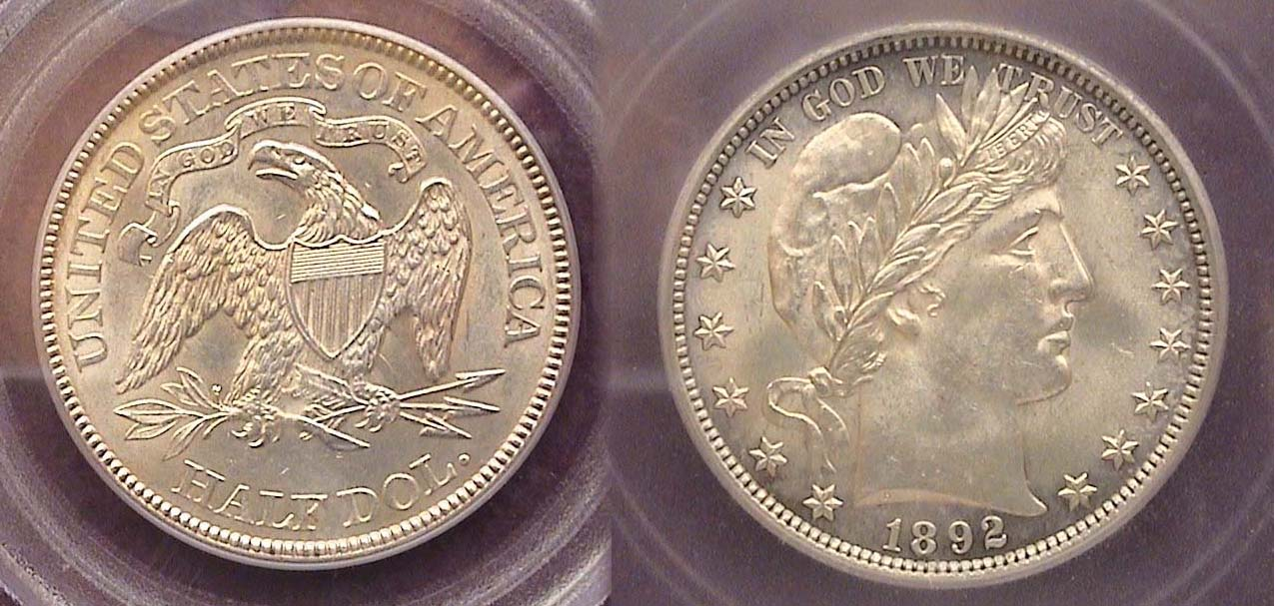

The motto, IN GOD WE TRUST appears on
the reverse of the 1891 50¢ (left) & the obv. of the 1892 50¢ (right)
[Use 3X glass or magnify to 200% to see details]

In adapting fellow engraver George Morgan’s silver dollar design created back in 1878, Charles Barber moved away from the slender full figure seen on the Liberty seated & Trade $1.00s to a return to the Bust type.

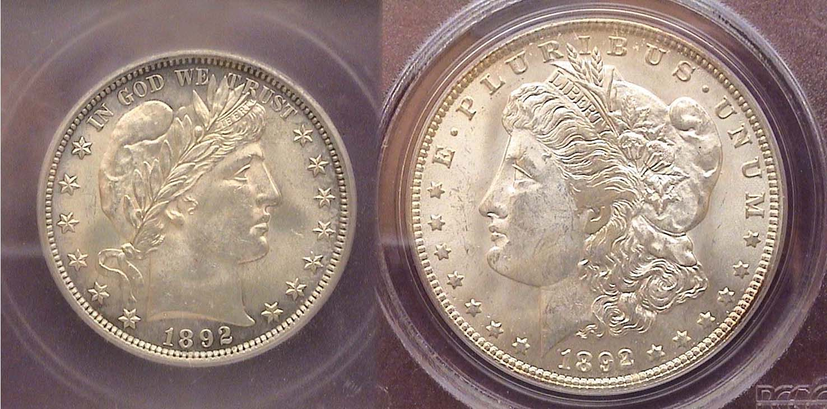

The obverses of the 1892 Barber half and 1892-O Morgan $1.00
[Use 3X glass or magnify to 200% to see details

However, this still begs the question; if Barber was so zealous in his desire to create new designs for the silver coins of 1892, why did he expend so little artistic effort when given the opportunity? He is alleged to have borrowed George Morgan’s portrait of Miss Anna Williams on the $1.00 seen facing left to facing right on the half dollar, quarter and dime and he left the reverse seen on the Liberty Seated dime intact. The best that can be said is he fashioned a new rendition of the eagle on the 25¢ and 50¢s reverses although some critics likened it to a moth.

For those interested in pairing the 1891 seated Liberty type with the 1892 Barbers opt for attractive “original” gray examples in VF or better from the Liberty seated and from Fine or better for the Barbers dimes, quarters and halves.
___________________________________________________________________________________________________________________
The Hitchcock’s Legacy
(Continued from page 1, column 1)

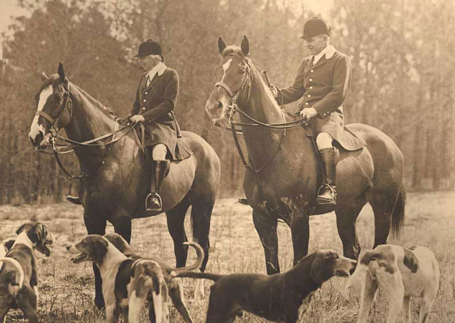

Louise and Thomas Hitchcock
[Photo presumably taken in the early 1930’s]
[Courtesy of Hitchcock Woods foundation]
Use 3X glass or magnify page to 200%]

The Hitchcock Woods has long been an Aiken landmark and the Hitchcock name is prominent in the annals of Aiken History. When one drives along the Aiken Bypass today, the Rte. Sign reads SC 118 but the actual road is called the Hitchcock Pkwy and in that name it extends south from the intersection of Rtes. 1 & 78, (AKA Jefferson Davis Hwy) past the Hounds lake Golf course towards Pine Log Road.

Back in the late 1880’s The Prince of Wales, later to become King Edward VII of Great Britain popularized the sport of Fox hunting and event that soon spread to the United States shortly thereafter. Between 1892 and 1898, the Hitchcock’s supported by William C. Whitney established the Palmetto Golf Course in Aiken and with added contributions by Louise Hitchcock’s aunt Celestine Eustis, they purchased an 8,000-acre tract of pineland, part of which would be used for foxhunting and horse shows. On Easter Sunday in 1934, after a tragic fall from a horse the day after Christmas the previous year, Louise Hitchcock passed away from her injuries. Her unexpected death left the pineland acreage in jeopardy but in 1939, her son Thomas Hitchcock Jr. and his sister Helen established a charitable corporate foundation. This brought in substantial contributions that saved and extended the pine tract’s acreage.

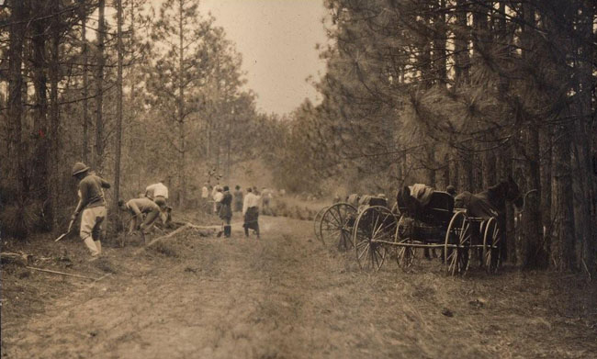

The Hitchcock family staff along with the original Axe Club volunteers working on the Hitchcock Woods project in 1939
[Courtesy Hitchcock Woods Foundation]
[Use 3X glass or magnify page to 200%]
The Hitchcock Woods is primarily used today for horseback riding and hiking along the many wooded trails and it is open from dawn to dusk. No motorized vehicles or biking is permitted. There are a number of entrances to the park. These are at the ends of South Boundary Ave, SW, Coker Spring Road from Berrie Road, where the Palmetto Golf course is located and Clark road. Coming from Augusta along Rtes. 1 & 78, turn right on Hitchcock Parkway light. After the very first traffic light, make the next left on to Dibble Road. There are three entrances to the Woods off Dibble. One is from the Stable on the Woods. Another is near the RR crossing and the third is across from Rhone Street. Whitney drive can be accessed near one of the Dibble Road entrances. The road is named after William C. Whitney who originally helped the Hitchcock’s fund the project beginning in 1892.

The new Barber coin types issued that year correspond to a new chapter of living within the Aiken, SC community.
________________________________________________________________________________________________________________________

Grade That Slab – Segment 2 - Mission Possible?

In last month’s issue, the reader was asked to grade three different coins via multiple choices. This month we are featuring two examples of the same date coin: an 1877-S Liberty Seated quarter. Each was certified by PCGS. Your assignment, should you wish to accept it, is to grade to grade both specimens based on the choices provided. For hard copy readers use a 3X power magnifying glass over the coin image; grade it then proceed to the second. For digital copy viewers, magnify page to 200%, then grade each coin. You will find the answers on the bottom of page 6. If you strongly disagree with the actual certified grades, please E-mail the editor at arnosafran@comcast.net and I will send you a picture of the coin in the slab.

Coin #1

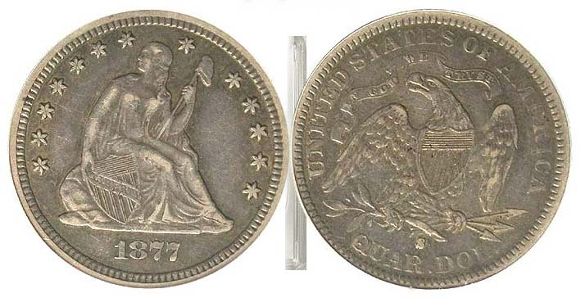

a. Fine-12, b. VF-20, c. VF-30, d. XF-40, e. AU-50

Coin #2

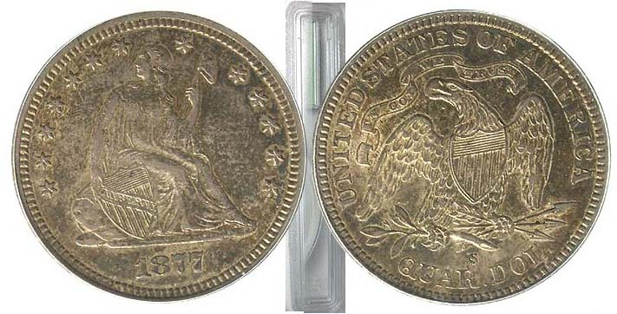

a. Fine-12, b. VF-20, c. VF-30, d. XF-40, e. AU-50

Coin #1: Your grade:__________________

Coin #2: Your grade __________________

___________________________________________________________________________________________________________
Numismatic Wonders in our National Museums
By Xavier Pique
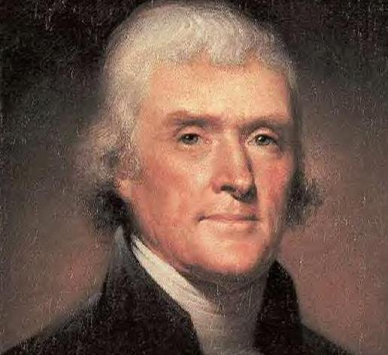
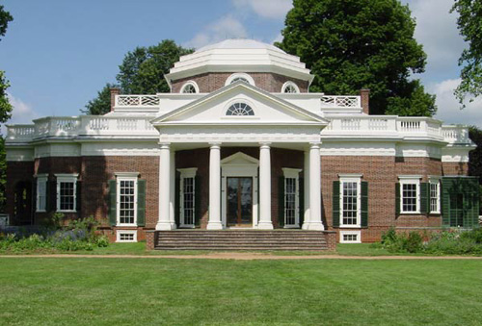
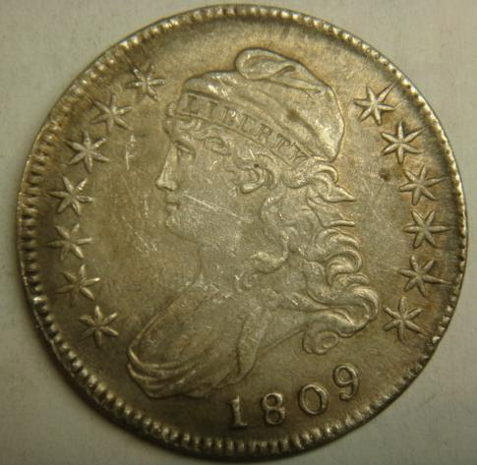
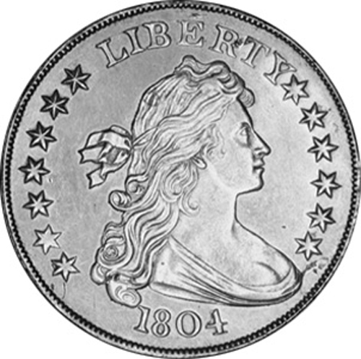
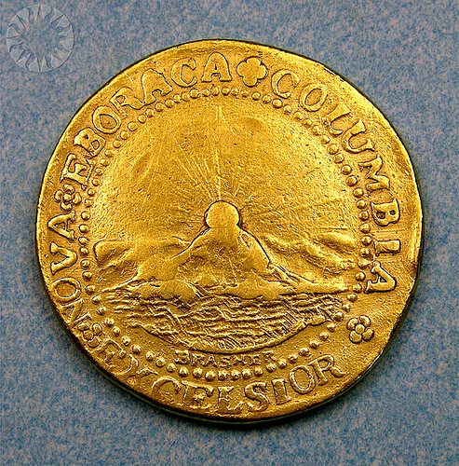
This week I am on vacation with my wife Edelma and on Gabriel and we are travelling north to Vermont with stops along the way. We stopped in Charlottesville, Virginia where we were awed by Thomas Jefferson's Monticello and admired his architectural design prowess that is evident in his hilltop home. We also visited the University of Virginia old campus, which Jefferson also designed. While at Monticello, it occurred to me to look for numismatic items in the places we visit. This column is about the wonderful coins we have seen so far.
In Jefferson’s, own bedroom suite at Monticello, an 1809 Capped Bust half dollar is on display. Also on display, a very badly corroded 1793 large cent with the chain reverse. The 1809 Half-dollar was perhaps an EF-40 condition, but it looked as if it may have been cleaned by overzealous servants.
We next moved on to Washington, DC, where museums abound and are free for the most part. We had to ask around a bit, but finally found a dazzling display of money items at the Museum of American History. Let me add that here in the national museums, only the best of the best and original items are on display. I had a difficult time convincing my son Gabriel that the big fossils and meteorites and paintings and coins on display were the genuine article- I suppose our children are so used to looking at pictures of things on the internet, that they think everything is a cast or a mere image of the real thing. Not so in D.C.!
Therefore, when we saw the display containing not one but three 1804 silver dollars, side by side, it was hard for Gabriel or for me to believe it but there they were. We know from the record that no Silver dollars were actually issued in 1804, so these surviving specimens were struck later to give as presents to world leaders and kings.
Another notable coin on display was a Brasher Doubloon. This coin has a sketchy past, it is not known why it was coined but there are hints that George Washington may have requested that these gold coins to be minted for his use as gifts.
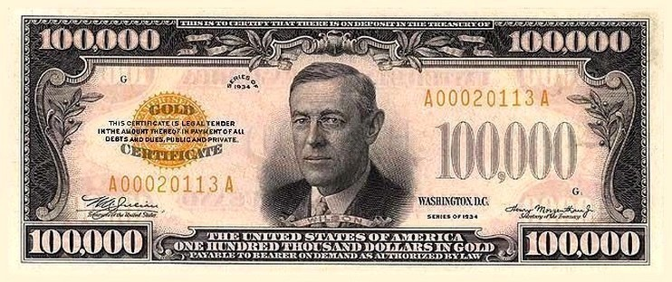

Now for banknotes: On display is a $100,000 bill. That is correct, a one hundred thousand dollar bill! This bill was issued in 1934 and was probably designed to settle very large financial transactions. Certainly, it did not circulate much! The bill features Woodrow Wilson on the face. It is a gold certificate and has an orange tinge in the fields on the front side. Unfortunately, they had only one, so that the reverse was not visible.
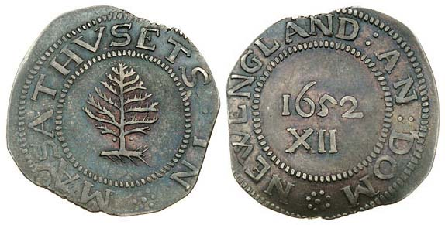
In the same display were a series of early colonial coins, including pine tree shillings (shown at right) and fugio cents.

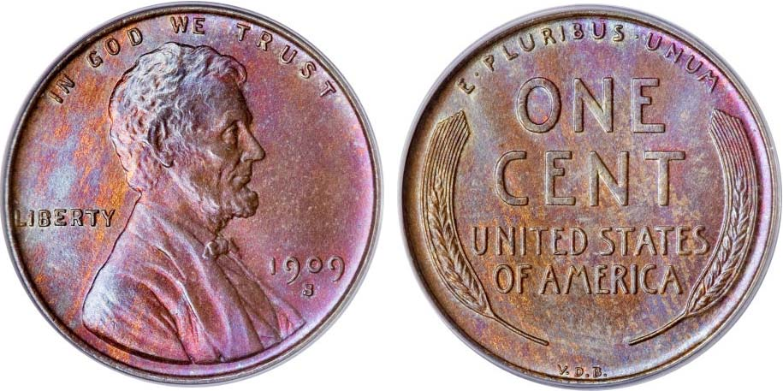
Also on display- two fabulously preserved Dekadrachms from ancient Greece, dated 260 and 350 B.C., also a 1909 S-VDB Lincoln cent, (shown at left) and numerous other coins and pattern strikes that were probably even more valuable than the aforementioned dollars and cents, but of which I have very limited knowledge. At least I know that I do not know.
In your travels, keep your eye open for rare coins and bills- they pop up in the most unexpected places. In addition, always ask the locals and the museum guards - they will guide you to knowledge and wonderment.
____________________________________________________________________________________________________________________

Club’s Annual Coin Show around the Corner

Our annual club show is scheduled for Sept. 11, 2010, a Saturday, the 9th anniversary a day America will never forget or forgive. This will be an enjoyable affair held in conjunction with Aiken-Makin’ Day. Co-chairpersons Jim and Helen Barry have been building up the dealer base and by show time; we are expected to have a varied representation of US, Foreign and Ancient coins along with tokens, medals, paper money and scrip for sale by a goodly number of dealers. Now it is up to us to help with the set up, at the welcoming desk during the show and with the break down. Hours are from 9:30 AM to 4:30 PM, Please let President Steve Kuhl know at our upcoming meeting Aug. 5 but no later than the Sept. 2 meeting of your availability. Those interested in taking a table at the show please contact Jim or Helen at 803-644-0761 or E-mail jrbarry1@bellsouth.net.
Other Club News

President Steve Kuhl warmly welcomed the sixteen present at 6:45 PM. Considering this was Thursday evening, July 1, before the Fourth of July extended weekend, it was gratifying to see that many members in attendance. Steve also reminded those attending that our upcoming show in September will be the last one Jim and Helen Barry will serve as co-chair persons and encouraged other club members to step up and think about taking this project on for September 2011. Treasurer Sharon Smoot reported a balance of $727.70 in the club coffers as of the July 1 meeting with all expenses paid. Thank you, Sharon! Glenn Sanders announced upcoming shows in Charleston, Aug. 6-7 and Rock Hill, SC in September. Austin Kuhl acquired a 1952-D Lincoln cent out of the Young Numismatist’s grab bag.

Show & Tell

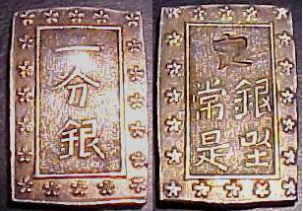

1837-54 Japanese Tempo Ko 1 Bu-Gin silver coin

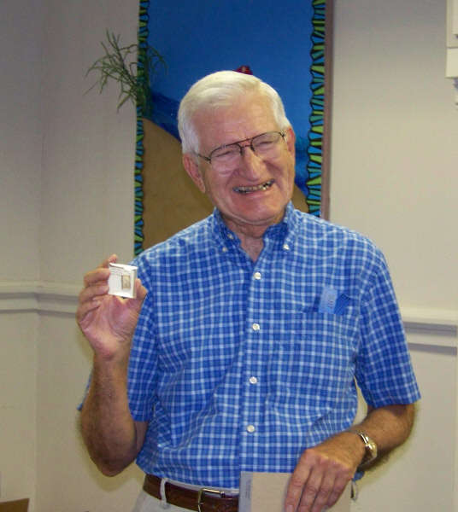
Jim Barry brought in an unusual Japanese silver coin known as an Ichibu Gin, a product of the Shogunate Tokugawa dynasty (Tempo period) issued from 1837 to 1854. It was a struck coin, not a cast piece, and rectangular shaped having rosettes surrounding the characters on both sides. The silver content was .991 fine and three of these could be exchanged for one Spanish-American 8 Reales Jim reported that Com-modore Perry visited Japan In 1854 and some of these rectangular coins and other interesting pieces wound up in the admiral’s coin collection, later auctioned by Bowers & Merena in 1995. [Another interesting jewel from the collection of Jim Barry]
Jim Barry displaying Japanese coin
Magnify to 500% to see rectangular shape.

The Program: For the past several years, our club has held an annual “Grading Bee”. Members were asked to bring in some of their certified coins for grading by fellow members. The grade on the “slab” was then hidden by removable sticker tape and the graders given a sheet with which to submit their appraisal for each coin entered. Afterward the certified grades were read aloud to the satisfaction or chagrin of each participant. This time we tried something a little different. At the July 1 meeting, VP Arno Safran presented a PowerPoint program called “Grading by the Numbers”. It featured many different US coin types in grades ranging from VF-20 to MS-65. These were projected on the big screen at the Aiken Public library meeting room.

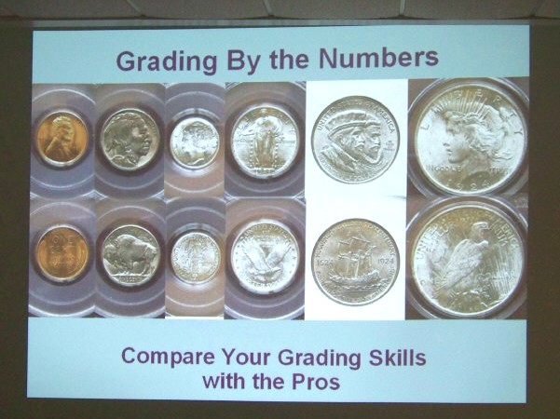

Title slide showing a certified BU 1924 Year set (excluding gold)
The grades were either MS-64 or MS-65 but which ones?
The answers were revealed on the final slide.
[The last two Photographs, courtesy of Helen Barry]

Each member was first given a sheet with the date and denomination of the coin to be shown. Most of the images projected were taken off the internet but with the certified grades hidden. Below each coin displayed was a caption revealing the date and coin type followed by a range of grading choices. The respondents were asked to opt for the one that matched their grading criteria. On the succeeding slide, the same coin appeared with the certified grade shown. The projection of each coin was equivalent to 10X magnification to the actual coin. The editor invites your comments. See examples below.

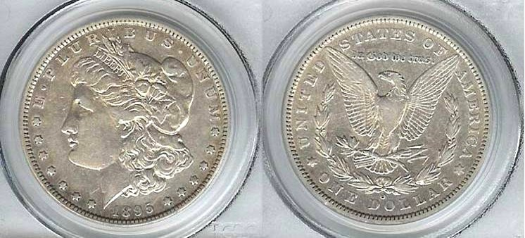

An 1895-O Morgan dollar (without certified grade shown)
[Use 3X glass or magnify page to 200%]

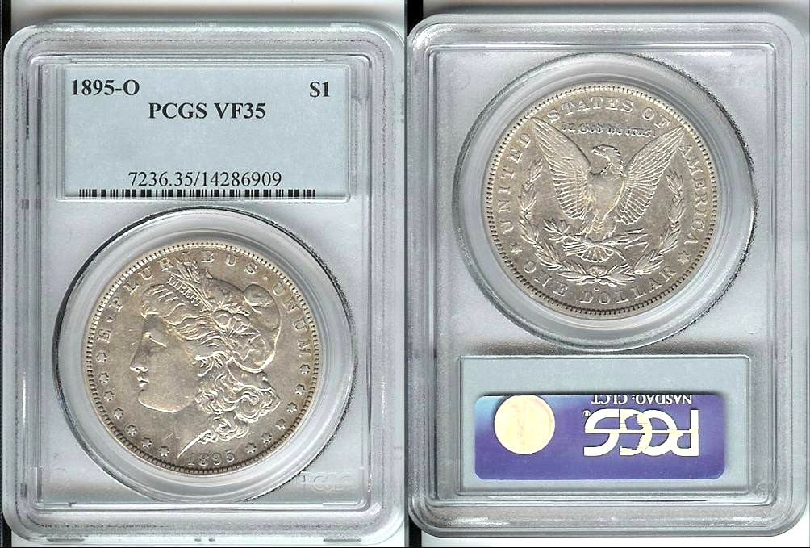

The same 1895-O Morgan dollar reduced in size with certified grade shown
[Use 3X glass or magnify page to 200%]
___________________________________________________________________________________________________________
More Club News
(Continued from previous page)

The program for our upcoming meeting, August 5 will be a DVD video on the “History of Wells Fargo”. President Steve Kuhl who is also an ANA member, has graciously volunteered to contact the American Numismatic Association Librarian in Colorado Springs to mail us the video in time for our August 5 meeting. Thank you, Steve.

The Prize Winners at the July 1 meeting were Doug Moody who won the silver eagle and John Ochrenyk who took the 50/50 - $22.00. Congratulations Doug and John!

Our forthcoming two meetings will fall on August 5 and September 2. The next issue of the newsletter will be dated, October 2010 and mailed before the October 7 meeting. There will be another guest speaker for September 2 and at our October 7 get together, Tony Chibbaro--who has given us many wonderful programs before--will return with a new PP program. Meanwhile please help to publicize our Sept. 11 show, sell raffle tickets and volunteer to help at the event. Thanks in advance from the all the members of the SJ CSRA CC Board.
______________________________________________________________________________________________________________________

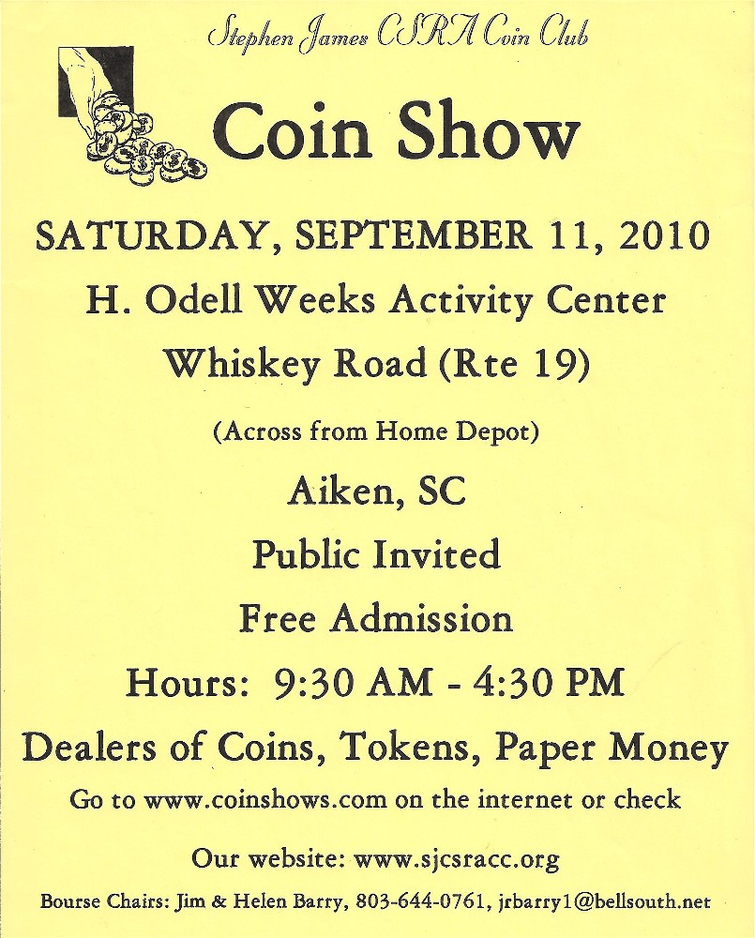

__________________________________________

Answers to Grading
of the two 1877-S Liberty Seated quarters on page 3.

Coin No. 1 was graded XF-40 by PCGS.

Coin No. 2 was graded AU-50 by PCGS.

For digitized newsletter readers, magnify to 200% To see answers.
__________________________________________________________________________________________________________________

Kindly Patronize our Dealers

