Pres. Steve Kuhl
V .P. James Barry
Sec. Helen Barry
Treas. Sharon Smoot
Sgt. in Arms: Glenn Sanders
The Stephen James
CSRA Coin Club of Aiken
P.O. Box 11
New Ellenton, SC 29809
Web site: www.sjcsracc.org
The SJ CSRA CC meets on the 2nd Thursday of the Month at the Cedar Creek Community Center in Aiken, SC

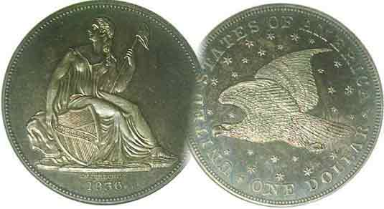
Committees:
Programs: James Barry
Show Chairs: The Barry’s
Newsletter: Arno Safran
E-Mail: arnosafran@comcast.net
Auctioneer: Glenn Sanders

2009 Club Meeting Schedule
Volume 8, Number 8 the Stephen James CSRA Coin Club, Founded in 2001 August, 2009
Monthly Newsletter
8th Annual Show coming up in One Month
Our next meeting is Thursday, August 13, 2009 from 6:15 to 9:00 PM
Jan. 5 Apr. 9 July 9 Oct. 8
Feb. 12 May 14 Aug. 13 Nov. 12
Mar. 12 Jun. 11 Sep. 10 Dec. 3

Annual Show scheduled for Saturday, Sept. 12
_ _________________________________________________________________________________________

It may be only August but September is not far behind and that has been the month for our annual coin, tokens, medals and paper money show. This year it is scheduled for Saturday, September 12, during the Aiken-Makin’ proceedings and as such it will be occurring during Aiken’s most festive weekend of the year. We expect to have 30 tables sold and will need the help of members with the set up, take down along with volunteers to serve at the welcoming desk for an hour or two. The show will be held at the H. Odell Weeks Activity Center located on Whiskey Road (Rte. 19) across from the Home Depot in Aiken. Hours are 9:30 AM to 4:30 PM. Admission is free and there are plenty of places to park on site. The raffle donations are $1.00 each or six for $5.00. The stubs must include the donor’s name and telephone number and be returned at our September 10 meeting or at the show before 3:00 PM on Saturday, Sept. 12. The prizes will include the following: 1st, an uncirculated gold bullion coin, 2nd, a certified BU Morgan dollar and 3rd, a 2009 silver Proof Set.

Vice President Jim Barry presided at the July 9 meeting in the absence of President Steve Kuhl who was on vacation with his family. Jim announced that our website www.sjcsracc,org has been updated and has many nice features including club photos thanks to our website coordinator, Susie Nulty. Jim also reported on a new scam. Apparently, common Presidential dollars are being slabbed in MS-69 or 70 holders at the advertised price of $20 apiece. Anyone can pick through a roll of 25 Brilliant Uncirculated Presidential dollars at a cost of $25.00 and find a number of specimens at close to or at these optimum grades for just $1.00 each.

Jim mentioned that our annual grading program will take place some time in the fall and at our August 13 meeting Xavier Pique, Treasurer of the Augusta Coin Club will be presenting a PowerPoint program on “Company Store Tokens”. (This program comes with a special soundtrack which may bring back nostalgic memories to some members; Ed.)
_______________________________________________________________________________________________________________________
(More Club News continues on page 4, column 1)
Collecting the Coins of 1824 – The USA 185 Years Ago
By Arno Safran

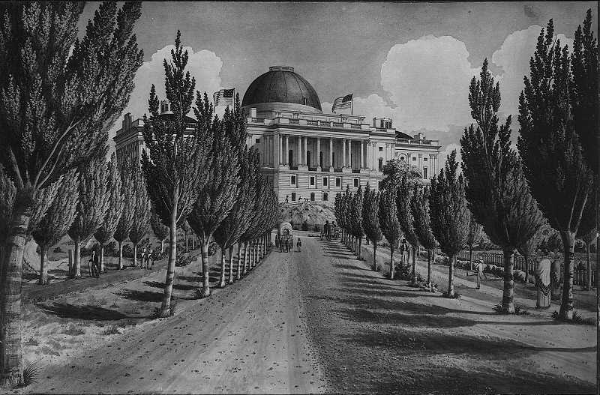

The Capitol Building as it looked in 1824

1824 was an interesting year in American history in both politics and our coinage. Many of the now famous 19th Century politicos were already inside the Capitol building debating on a variety of issues. These included Senators John C. Calhoun of South Carolina and Andrew Jackson of Tennessee along with Congressman Henry Clay of Kentucky. Two others were serving in the executive branch having been appointed by President Monroe; former Senator William H. Crawford of Georgia as Secretary of the Treasury and John Quincy Adams of Massachusetts as Secretary of State. All five men would become Presidential candidates in the amazing election of 1824.

In 1824, our coinage was going through a dip in production. Mintages for that year are uncertain for the cent, dime and quarter because the Mint report included them with either the 1823 or 1825 mintages. The gold coins are quite rare.

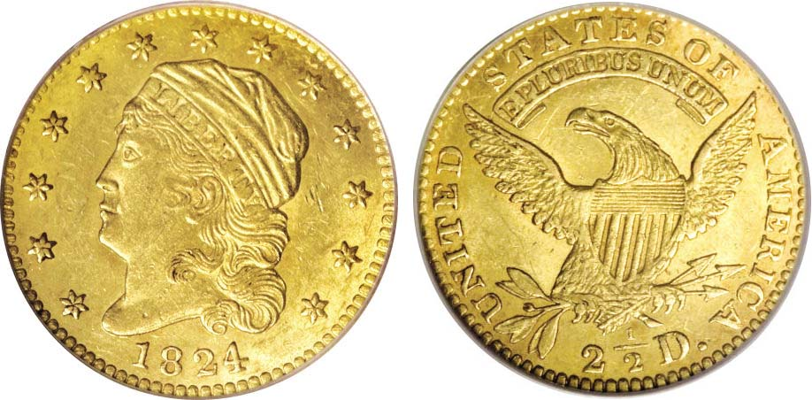

An 1824/1 $2.50 Quarter Eagle graded MS-61 by PCGS
[Courtesy of Heritage Auctions Archives]
________________________________________________________________________________________________________________________
(Continued on page 2, column 1)
Collecting the Coins of 1824 – The USA 185 Years Ago
(Continued from page 1, column 2)

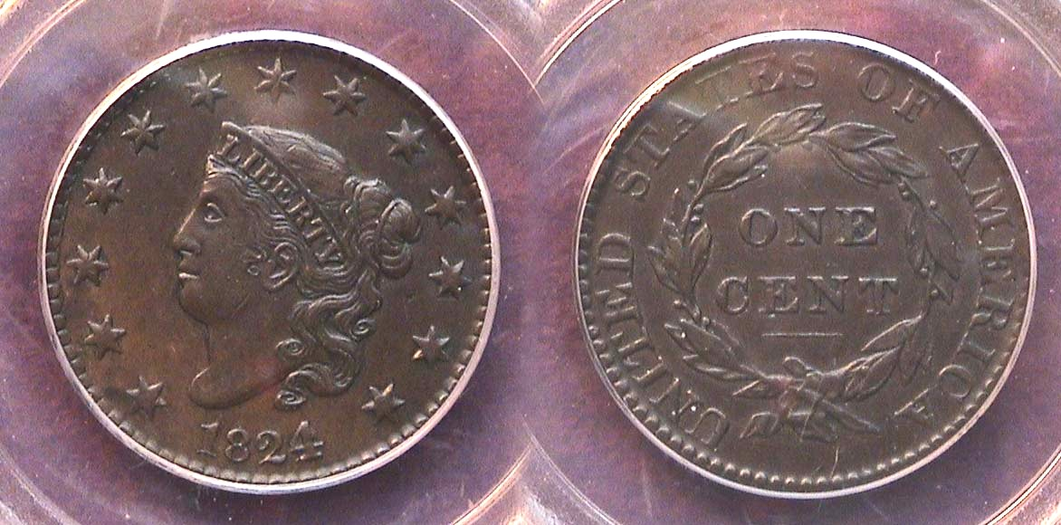

An 1824-2 1¢ N-1 R2 graded AU-50 by PCGS, actually an EAC-40
[Apply a 3x magnifying glass or magnify page to 200% to view details.]

As the half cent had been suspended after 1811; the half dime, after 1805, the silver $1.00 and $10.00 gold Eagle at the end of 1804 only six of the ten authorized denominations were struck at the Philadelphia Mint in 1824. These included the copper Coronet large cent, the silver Capped Bust dime, quarter and half dollar and the two Capped Head to left gold coins, the $2.50 quarter eagle (shown on the preceding page) and $5.00 half eagle; the last two being extremely expensive today. The four lower denominations are still collectible although scarce as a date, especially from Choice Very Fine or better and somewhat costly. The large cent shown above is the overdate variety.

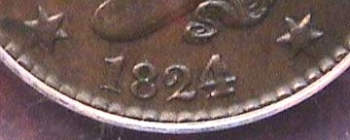

Detail showing the 4/2 overdate on the 1824 cent
The curve of the 2 is seen coming around the upper right side of the 4 and the front of the base of the 2 at the left of the stand of the 4.
[Apply a 3x magnifying glass or magnify page to 200% to view details.]

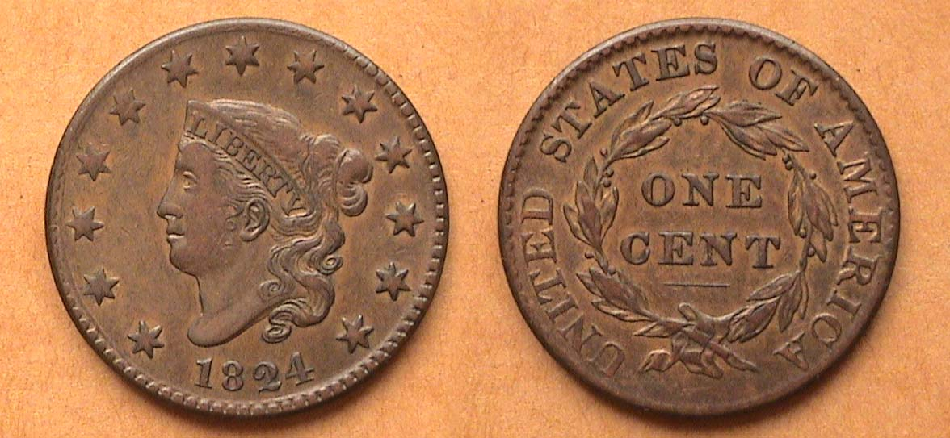

An 1824 normal date Coronet Large cent, N-3, R3, graded VF-35 by EAC
[Magnify to 200% to see details more clearly.]

The reported mintage for the 1824 large cent was 1,262,000. However, this also includes the 1823 dated cents which are scarcer still. The 1824/2 overdate is a popular Red Book variety and is priced higher than the normal date. When it comes to grading early US copper coins, there are two different grading standards applied in determining quality and price. One is called “market grading” used by the professional certification companies. The other is called “net grading” and is based on the Early American Copper Club’s more stringent standards regarding a coin’s overall appearance. The EAC takes into consideration the quality of the coin’s surfaces, its color, its rims and its strike in addition to the amount of wear present. For example, the 1824/2 cent at the top of the page was graded AU-50 by PCGS but only XF-40 by EAC.
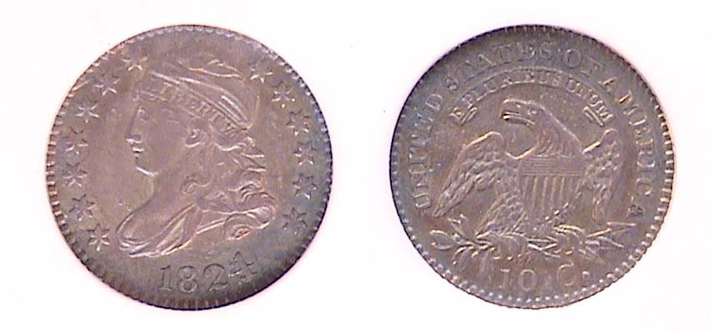
The 1824/2 Bust dime is one of scarcer date of its series.
[Apply 3X magnifying glass to coin picture or magnify page to 200%]

No reported mintage is given for the 1824/2 Bust dime but it is believed to have had a population of 100,000, according to Mint deliveries of the date released on August 22 of 1825. This should put it on par with the key date 1822 which has the same reported mintage. The 1824 surfaces more frequently, especially in VF or better. As a date, it is the fourth scarcest of the Capped Bust dime series after the 1822, 1809 and 1811.

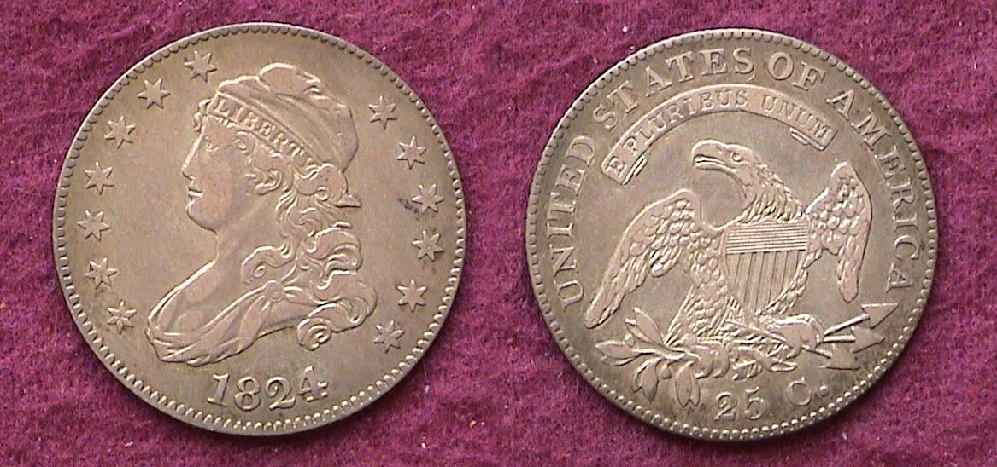

An 1824/2 large size Capped Bust quarter
[Apply a 3x magnifying glass or magnify page to 200% to view details.]

Back in the early 1990’s the author came across a dealer’s ad in one of the two major numismatic that described an 1824 quarter as problem free grading VF-35. The dealer was asking $550. This was long before the Internet so one had to be a little wary about buying coins sight unseen from dealer ads. I had been looking for this date for several years and hadn’t seen one in my discretionary income range at any major shows, so I took a chance and was pleasantly surprised when I opened the package and saw the coin for the first time. It had attractive surfaces, looked original and well defined. In the past three years I have observed the date priced at over $2,000 for lower graded specimens than shown above. After the very rare 1823 and 1827 issues, the 1824 is the scarcest of the collectible series.

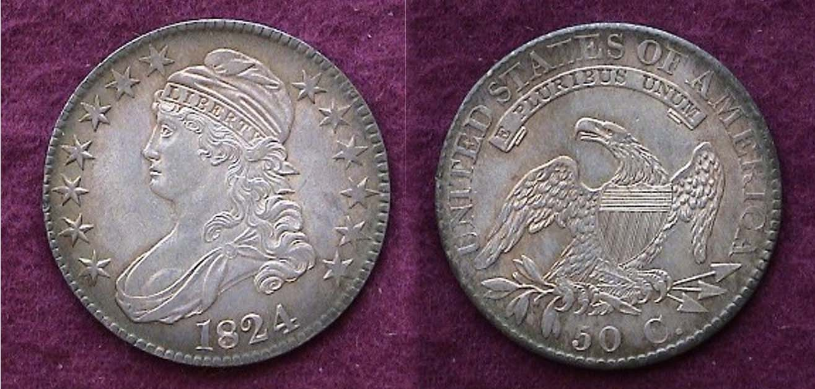

An 1824 50¢ normal date O-105, R2
At 32.5 mm it was America’s largest coin
[Apply a 3x magnifying glass or magnify page to 200% to view details.]

Of all the denominations struck in 1824, the Bust half is the most common and least expensive within comparative grades. Over 3.5 million were struck that year (for all varieties) which includes a number of overdates; the O-101, 1824/1, the O-103, 1824/4/2/1 and the O-110, an 1804 over a recut 4. The O stands for Albert Charles Overton (1906-1972) the first major attributor of US Half dollars from 1794 through 1836.
_________________________________________________________________________________________________________________
(Continued on page 3, column 1)
Collecting the Coins of 1824 – The USA 185 Years Ago
(Continued from page 2, column 2)

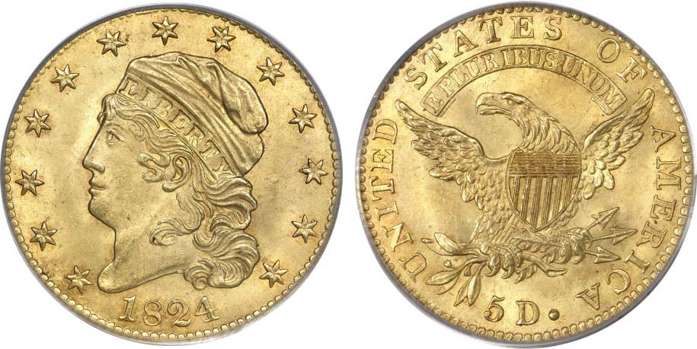

An 1824/1 $2.50 quarter eagle graded MS-61 by PCGS
along side an 1824 $5.00 half Eagle graded MS-63 also by PCGS
[Courtesy of Heritage Auction Archives]

When it comes to the two 1824 gold issues, no mintage figures exist for the $2.50 quarter eagle and while only 17,340 are reported for the 1824 $5.00 half eagle, the fact that the MS-63 specimen shown sold for $126,500 in February 5, 2009 at a major Heritage auction would indicate that very few survivors are extant today. The 1824/1 $2.50 quarter eagle shown next to it sold for $35,937.50 and that was for an MS-61, not a 63, so both these coins are rare and those that do surface occasionally are more for the rich or wellborn than your average collector. The $2.50 gold piece had the same diameter as the Bust dime; around 18.8 mm while the $5.00 gold piece is 25 mm, slightly smaller than the 1824 Bust quarter whose diameter is 27 mm.

While the coinage of 1824 is somewhat elusive price-wise today the collector should be able to assemble the four lower denominations (1¢ thru 50¢) averaging VG to Fine at more reasonable levels. In today’s numismatic market one is advised to seek out only certified examples that display just plain wear accompanied by attractive surfaces with natural color.
___________________________________________________________________________________________________________________

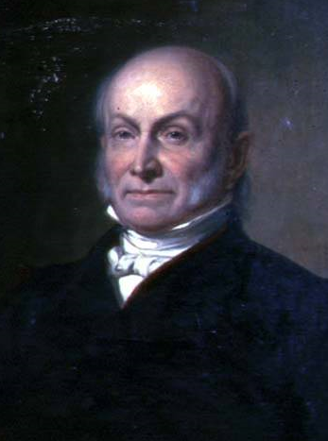
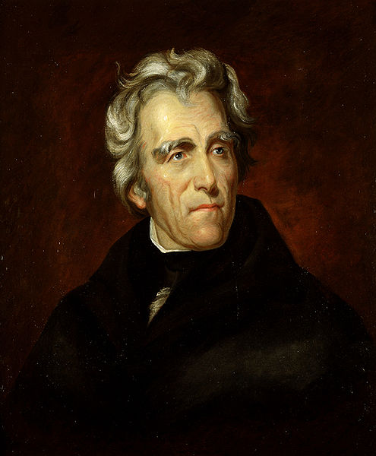
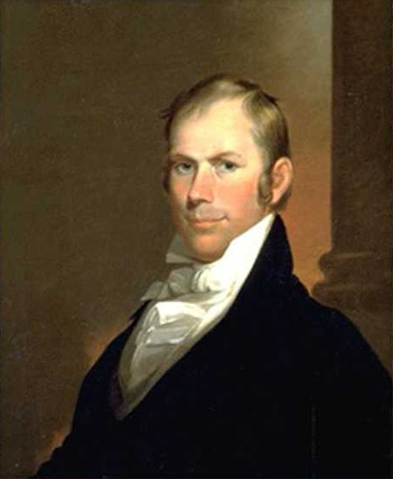
John Quincy Adams Andrew Jackson Henry Clay

As for the election of 1824, it had to be decided in the House of Representatives on February 9, 1825 because none of the Presidential candidates received a majority vote in the Electoral College. This did not affect the Vice Presidential race since John Calhoun, having moved from a Presidential to a Vice Presidential candidate, won a clear electoral majority.

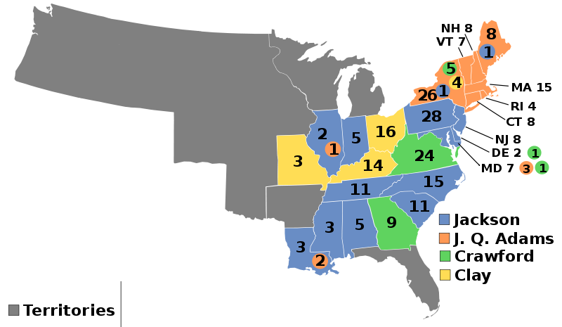
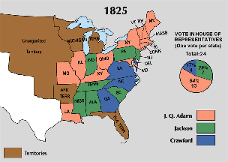
Though Andrew Jackson won the most states, he was defeated by John Quincy Adams because Clay, who had received the least votes, threw his support to Adams who immediately named him Secretary of State. Since the last three Presidential victors, Jefferson, Madison and Monroe had all served as Secretary of State prior to being elected President, this move did not sit well with the Jackson camp who claimed the two had made a “corrupt” bargain. Ironically, some of these opposing figures were once fellow War Hawks who cried, “On to Canada” at the onset of the War of 1812, yet by the war’s end, claimed, “Not one inch of territory lost!” Today, 1824 seems distant but it was an interesting year and our coinage keeps it alive.
__________________________________________________________________________________________________________________

The Dropped Letter
By Bill Myers

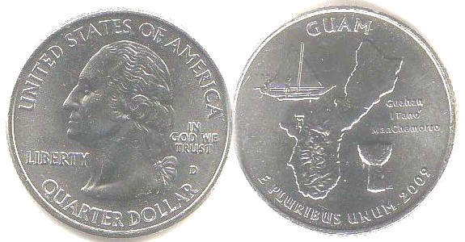

A 2009-D Guam Territorial Quarter

I have found that numismatic learning rarely goes to waste. I have been an avid reader of numismatic newspapers and journals for many years. I read about things that are not directly part of my collecting interests and this information has proven useful. It has allowed me to identify varieties or errors even though I have never seen them before. I was going through a roll of U.S. Guam state quarters and found a quarter with an incused O on the neck of George Washington. I have never seen a coin like this but remembered reading about dropped letter coins and I was sure this was one.

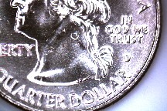
A dropped letter coin is an unusual error that occurs when the recess in the die becomes filled with debris. The repeated striking of the die against the planchets compresses the debris. Eventually the debris falls out of the recess and can end up between the die and planchet and this creates an incuse impression on the coin.

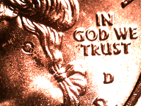
In my coin, the O of GOD filled with debris and when the debris fell out it landed on the area of the neck of Washington and an incuse O resulted. The debris then falls off the coin when it is ejected so only one error coin is created. I was very happy to find such an error, and to get this coin for face value.
_________________________________________________________________________________________________________
More Club News (Continued from page 1, column 1)

Jim Barry invited members to consider joining the American Numismatic Association. Membership for seniors in the ANA is now $41 a year and for that you receive “The Numismatist”, the ANA’s monthly journal each month. At the reduced membership rate of just $18.00 per year you receive the digitized version. ANA membership allows one to borrow numismatic books and pamphlets from their vast library at no charge except for the postage fee. Several of our DVD programs shown at the club’s meetings were prepared by the ANA and have been well received by club members. On a sad note, Jim also announced the passing of Past President Willie Simon’s father. A Sympathy card has been sent on behalf of the club.

In the Upcoming Shows department Glenn Sanders mentioned that the Low Country Coin Club would be holding their next coin show on August 8 & 9 in the Charleston area at the Exchange Park Fairgrounds off I-26 and Arno Safran mentioned the 50th Anniversary Blue Ridge Coin Club show scheduled for August 21 thru 23 in Dalton, GA.

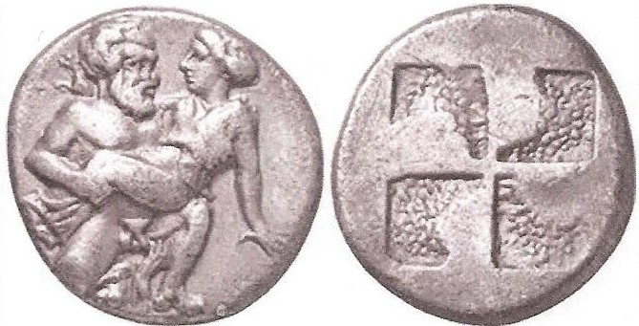

A Drachma of Thasos ca. 435 – 411 BC
The dime size coin shows a satyr and nymph on the obverse.
[Use 3x magnifying glass or magnify page to 200% to see details.]

There were three Show and Tells. Jim Barry brought in a small dime sized Greek silver drachma of Thasos from the late 5th century BC. This was a truly beautiful coin. Arno Safran displayed a Brilliant uncirculated 1949-S year set housed in a Capital Lucite holder. There was one other but member Chuck Braun couldn’t display it literally. Instead he brought in pictures taken from his latest Bird Watching tour from the Island of Yap which displayed examples of the Yap stone money.

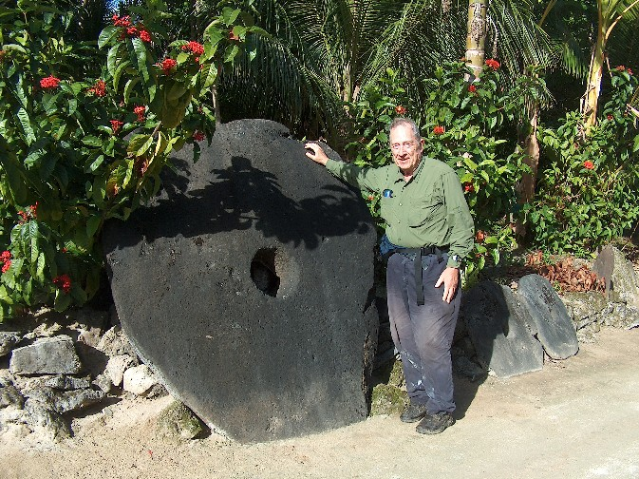

Member Chuck Braun standing aside his latest coin find
while vacationing in Micronesia

The Program: John Attaway presented an excellent program on the History of Hamburg, SC (now part of North Augusta) and the paper money issued during the 19th century there. John displayed survey maps of the area, sketches of the railroad built between Hamburg and Charleston and the enormous influence Henry Shultz, a German immigrant had on the town during the early years of the 19th century. Thanks, John!

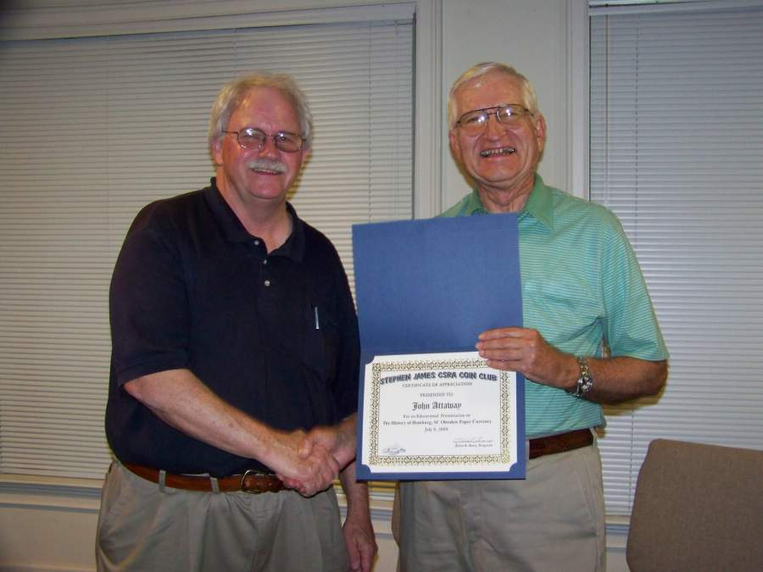

John Attaway, (at left) receiving Certificate of Appreciation
from VP Jim Barry (right) for his presentation on the Banknotes of Hamburg, South Carolina

After the meeting, Glenn Sanders ran the auction with the able assistance of Howard Black as bids recorder

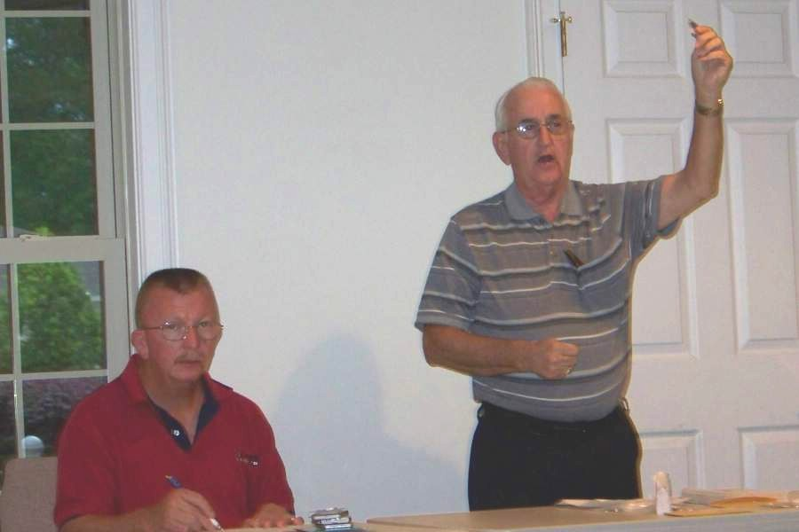

Glenn Sanders (at right), auctioneer taking bids from the floor with Howard Black recording the bids at the July 9 meeting

The Prize winners of the July 9 meeting were Jerry Axner who won the silver eagle door prize and Glenn Sanders who won the 50/50. Congratulations gentlemen. Our next meeting is on August, 13. Xavier’s talk is sure to delight!
__________________________________________________________________________________________________________________

Please post this Flyer and sell those raffles.

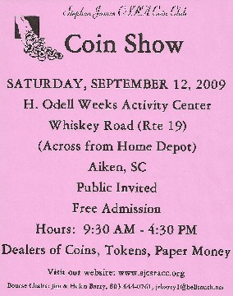
Numismatic Item of the Month

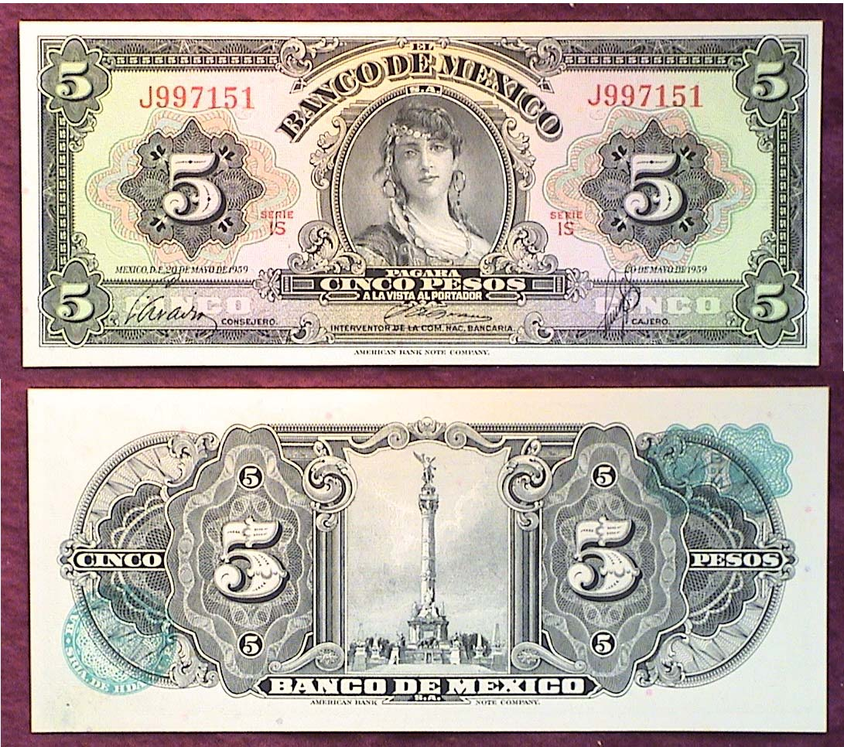

A 5 Pesos Mexican Banknote Series-1959

The 5 pesos bill was engraved by the American Bank Note Company for the Bank of Mexico during the 1920’s. During that era, Mexican notes were larger, like our own obsolete currency but from 1936 on the Mexican Treasury reduced the size of their notes just as we did in 1928. In a number of cases they retained the overall design and over the years this 5 pesos “Gypsy” note has become one of the most popular. This particular Gem CU note only cost $4.00.

Who was the woman on the Mexican 5 pesos note?

Over the years rumors persisted that the woman on the 5 Pesos note was Gloria Faure, an attractive Catalonian entertainer who was an active performer in 1925. She may have been the mistress of the Finance Minister, Alberto J. Pani and even that of then Mexican President Plutarco Elias Calles.
Gloria Faure?

In actuality, the engraving was based on Robert Savage’s “Ideal Head of an Algerian girl” in 1910.

Kindly patronize our Six Advertisers
