Pres. Steve Kuhl
V .P. Pat James
Sec. Jim Mullaney
Treas. Sharon Smoot
Sgt. in Arms: Glenn Sanders
The Stephen James
CSRA Coin Club of Aiken
P.O. Box 11
New Ellenton, SC 29809
Web site: www.sjcsracc.org
The SJ CSRA CC of Aiken, SC meets on the 1st Thursday of the month at the Aiken Public Library

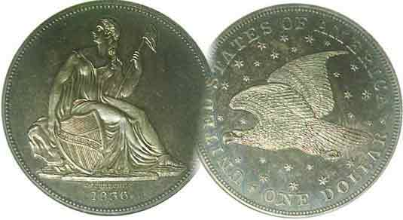
Programs: Pat James
Show: by Committee
ANA Representative: Jim Barry
Publicity: Jim Clapp
Newsletter: Arno Safran
E-Mail: arnosafran@comcast.net
Auctioneer: Glenn Sanders
Web site: Susie Nulty (see above.)

2011 Club Meeting Schedule
Volume 10, Number 8 the Stephen James CSRA Coin Club, Founded in 2001 August, 2011
Monthly Newsletter
Annual Grading Bee on the Docket for August
Our next meeting is on Thursday, August 4, 2011 from 6:45 to 8:45 PM

Jan. 6 Apr. 7 July 7 Oct. 6
Feb. 3 May 5 Aug. 4 Nov. 3
Mar. 3 Jun. 2 Sep. 1 Dec. 1

____________________________________________________________________________________________________________

Coin Grading Program
Scheduled for August 4 Meeting

One of our more popular club programs over the years has been our annual grading bee. These have taken various forms from members bringing in “raw” or “certified” coins from their collections to digital images of certified coins projected on the large screen in the Aiken Public Library. In each instance, the grades were hidden either by removal tape or in the first of two images projected on the screen. Our club Secretary Jim Mullaney will be presenting the 2011 installment of Grade-a-Coin at our upcoming meeting, Aug. 4. Once again, the members will not have to bring in anything except a pen or pencil in order to participate.

At last month’s meeting member Howard Hillman related his numerous experiences as a coin collector and coin club member going back to his childhood. Back in 1943 with the issuing of the steel cent during the midst of WW II, he recalled as a youngster, that folks referred to the new version of the Lincoln cent as “silver pennies”. He and some friends started hunting for them to trade to others for more desirable Lincoln cent dates. After graduating high school Howard joined a coin club which he described as the largest in the state of Pennsylvania. Lots of wheeling and dealing went on and Howard learned to acquire better date coins by often trading with members or by mail to fellow collectors in different parts of the country. The goal was to complete a set by acquiring the most attractive looking coins one could afford but the better date pieces didn’t have to be uncirculated, merely attractive to the eye. Howard mentioned that during the 1950’s and early 1960’s one could still find better date obsolete types including silver coins out of circulation. Because quarters and halves had lots of spending power, he concentrated more on cents, nickels and dimes. The club thanks Howard for his interesting commentary on the way things were before the age of “slabbing”
_____________________________________________________________________________________________________________
The Early Silver Coins of the Republic of Peru
that were legal tender in the US until 1857
By Arno Safran

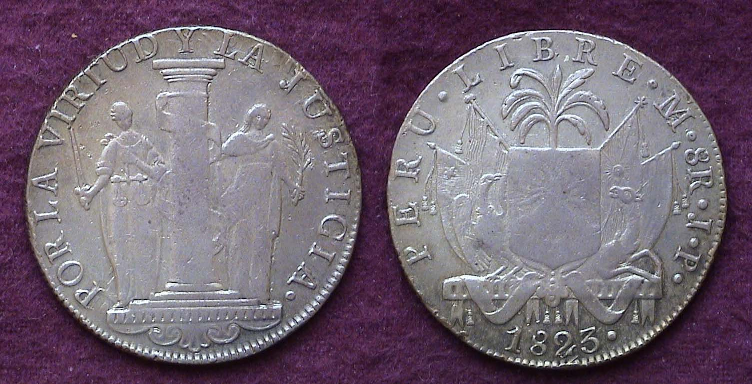

An 1823 8 Reales silver coin of the Republic of Peru
Showing Virtue and Justice and known as the Peso of San Martin
[Use 3X glass or magnify 200% to see details.]

This majestic silver coin was issued by the Provisional government of the new Republic of Peru shortly after Spain was defeated. It is also known as the Peso of San Martin, the hero of the War of Independence against Spain and the first President to preside over the Provisional government of Peru. One of his first actions was to establish a new coinage for the young Republic. After striking some crude copper pieces in 1822 known as the quartillo (AKA ¼ Real), the government decided to issue a new silver dollar with a design emblematic of freedom rather than continue to use the silver on hand to produce coins with the older colonial portrait type. In July, 1822 the first of the new silver pieces were released. These dollar-sized coins (about 38 mm in diameter), were struck in .903 silver. One side portrayed two standing allegorical figures; one representing Virtue (at the right of the large pillar) and the other, Justice (at the left.) The other side featured the Provisional Republic’s Coat of Arms showing a tree behind a large shield bearing a sun face at its center. (Unfortunately, many of these coins were weakly struck on the shield making it difficult for one to discern the sun face.) According to Horace P. Flatt, author of The Coins` of Independent Peru (1821-1857), (the period when foreign silver coins were considered legal tender in the United States), some 75,000 Pesos were struck in 1822 with a lower estimated amount coined in the 1823.
______________________________________________________________________________________________________________________
(Continued on page 2, column 1)
The Early Silver Coins
Of the Republic of Peru
(Continued from page 1, column 2)

The beautiful coin-type shown atop the previous page was short-lived due to the temporary reoccupation by the Spanish royalists in July 1823 while San Martin and his forces were fighting elsewhere in the country. When Simon Bolivar finally ousted the Spanish from Peruvian soil a new and more durable Liberty Standing design type would appear on Peruvian silver coins. By then Mints were established in both Lima and Cuzco.

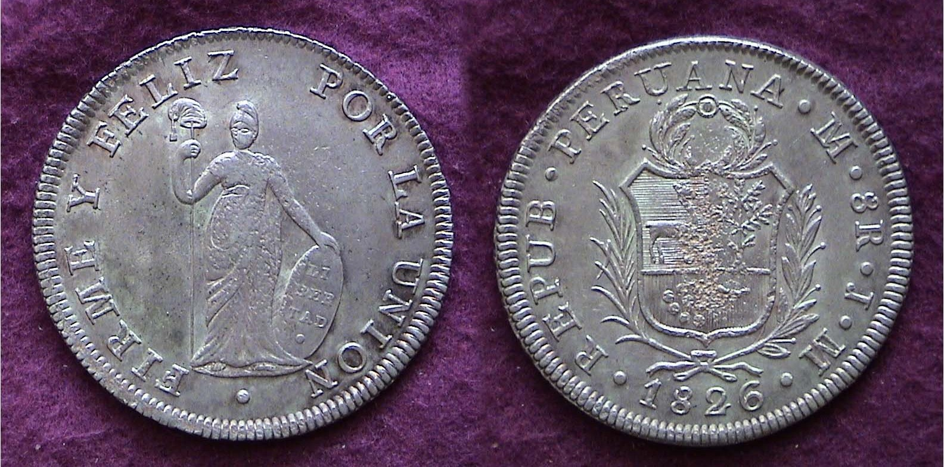

An 1826 Rep. of Peru LIBERTAD 8 Reales struck at the Lima Mint
[Use 3X glass or magnify page to 200% to view details.]

Most of Peru was free of Spanish rule by mid 1824 but it was not until April of the following year that Simon Bolivar was able to declare that upper Peru was in control by the insurgents. The first regular Republican issues were struck at the Lima Mint in 1825 and at the Cuzco Mint the following year. The design features a small slender standing figure of Liberty holding a staff with a Phrygian cap and tassel in her right hand with her left hand resting on a shield tilted slightly downwards toward the right The legend reads, FIRME Y FELIZ POR LA UNION meaning Strength and prosperity through unification. The other side of the coin displays an ornate shield displaying three symbols of national riches; above left, a vicuna, above right, a cinchona tree and centered in the larger third segment directly below, a cornucopia with coins tumbling from it. The entire Shield is placed within an ornate wreath. The legend surrounding it reads REPUBLICA PERUANA (for Republic of Peru) followed by the monogram M for LIMAE, (Lima). These are followed by the two assayers’ initials, J. M. and at the bottom, the date. The Libertad 8 Reales shown above was struck in 1826 at the Lima mint.

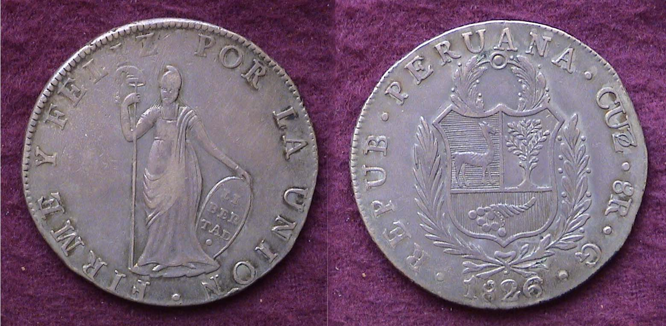

An 1826 Rep. of Peru LIBERTAD 8 Reales struck at the Cuzco Mint
[Use 3X glass or magnify page to 200% to view details.]

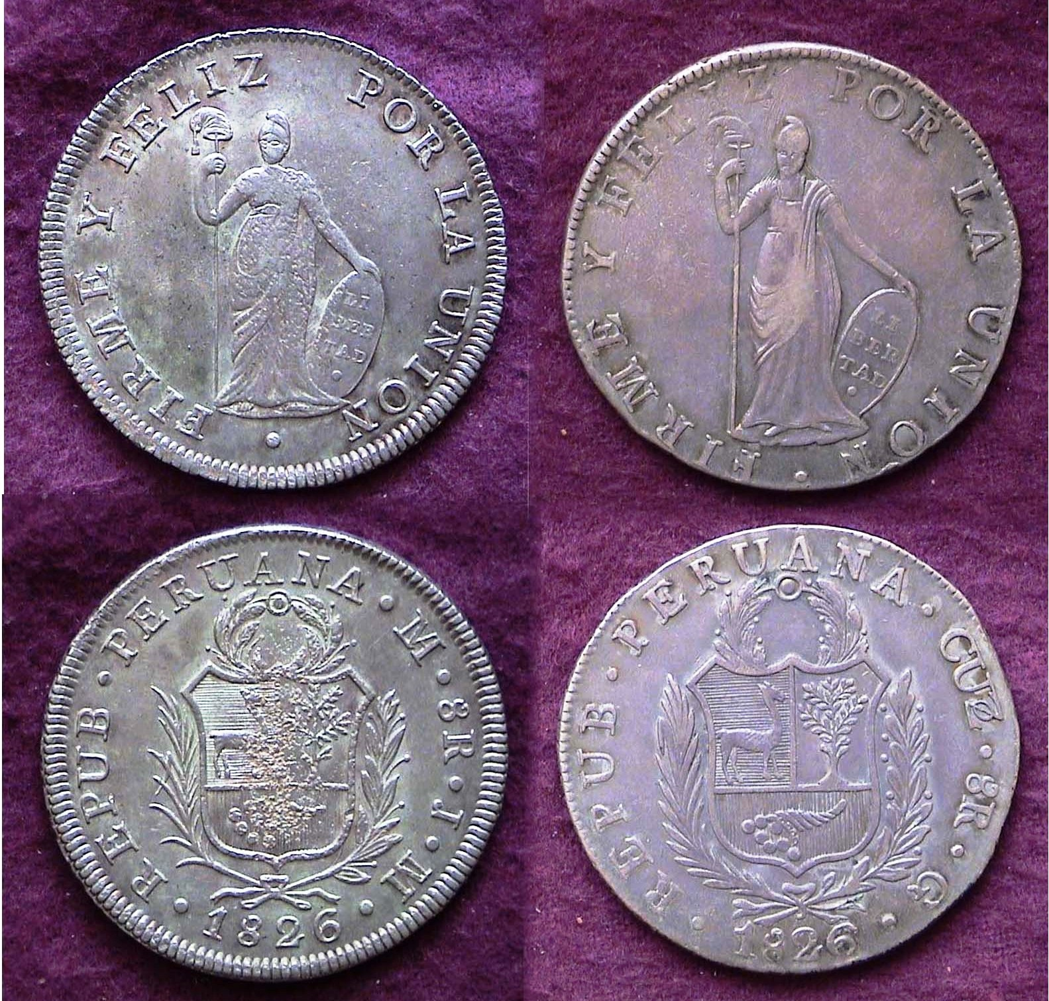

1826 Rep. of Peru 8Rs struck in Lima (l) and Cuzco (r) side by side
[Use 3X glass or magnify page to 200% to view details.]

A different engraver must have fashioned the 1826 8R struck at the Cuzco mint as the Liberty Standing design displays some noticeable differences from the Lima Mint product. The coin produced at the Lima Mint (left) show a larger Liberty with a smaller tassel and Phrygian cap than the Cuzco specimen shown at right. The wreaths are different in a number of ways as is the lettering; cruder on the Cuzco piece. This has nothing to do with the obvious damage to the surfaces on the Coat of Arms of the Lima piece.

By 1835 the Libertad design would appear on five of the six silver denominations; the ½R, 1R, 2R, 4R and 8R. A tiny .903 fine silver ¼R, roughly 12 mm in diameter was also coined beginning in 1826. It displayed a llama on one side and the fraction ¼ above the date on the other side.

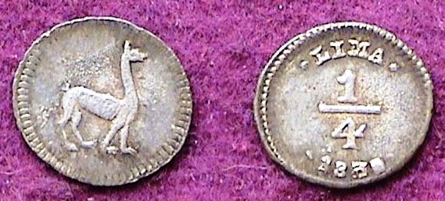

An 1830/28 ¼ Real struck for the Rep. of Peru at the Lima Mint
[Use 3X glass or magnify page to 200% to view details.]

While a collector will usually have no difficulty finding inexpensive yet attractive 8 Reales pieces from the Republic of Peru, locating choice specimens in the lower denominations can be quite challenging. A difficult denomination to obtain is the 4 Reales. The half-dollar size coin was struck in small numbers compared with the dollar-size 8 Reales. The 2 Reales was about the size of our large Capped Bust quarters (1815-1828) and as such had tremendous purchasing power for the general Peruvian population. These seldom surface in high grades. The same can be said for the dime-sized Real, worth 12½¢. VF pieces for the above are still moderately priced when found. The ½ Real (6¼¢) and the tiny ¼ Real appear more often but some were holed for coin-bracelets by the Peruvian women when marketing.
____________________________________________________________________________________________________________
(Continued on page 3, column 1)

The Early Silver Coins of the Republic of Peru
That were legal tender in the US until 1857
(Continued from the previous page)

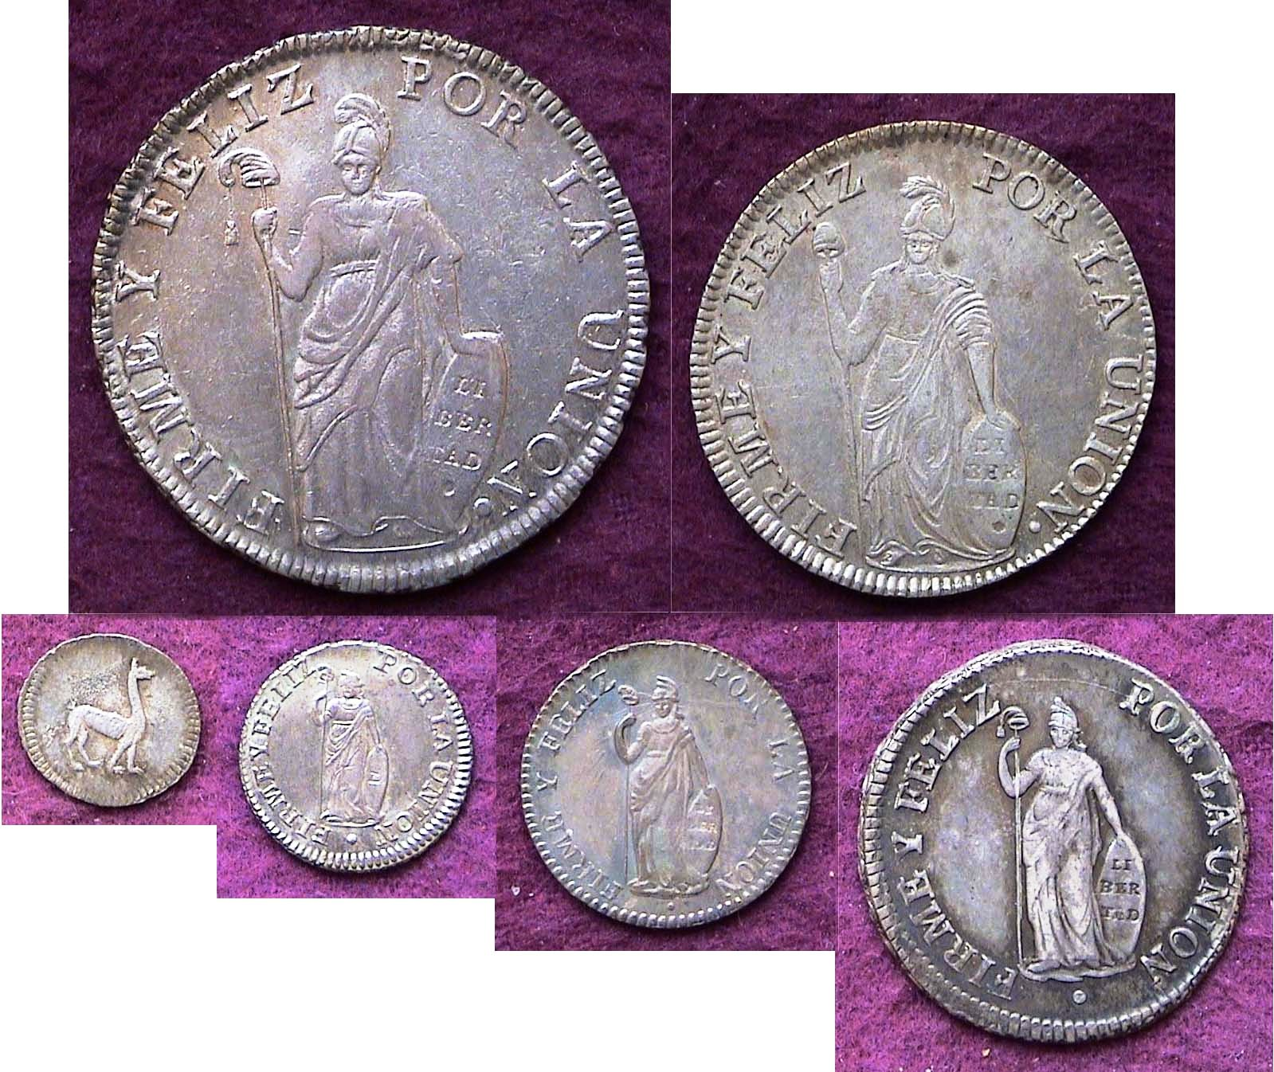

The Libertad side of the Republic of Peru Silver coins
Top row: 8R & 4R; Bottom row from left: ¼R, ½R, 1R & 2R
[Use 3X glass or magnify page to 200% to view details.]

The reader will perhaps wonder why the author has refrained from using obverse and reverse when either identifying or describing the featured coins in this article. During the early years of US coinage the allegorical figure of Liberty appeared above the date on the obverse with a wreath or Shield on the reverse. Many foreign coins are reversed with the shield or Coat of Arms side bearing the date\ is considered the obverse while the allegorical figure appear on the reverse. Technically the photos of the two sides of all the Republican Peruvian coins should have been reversed.

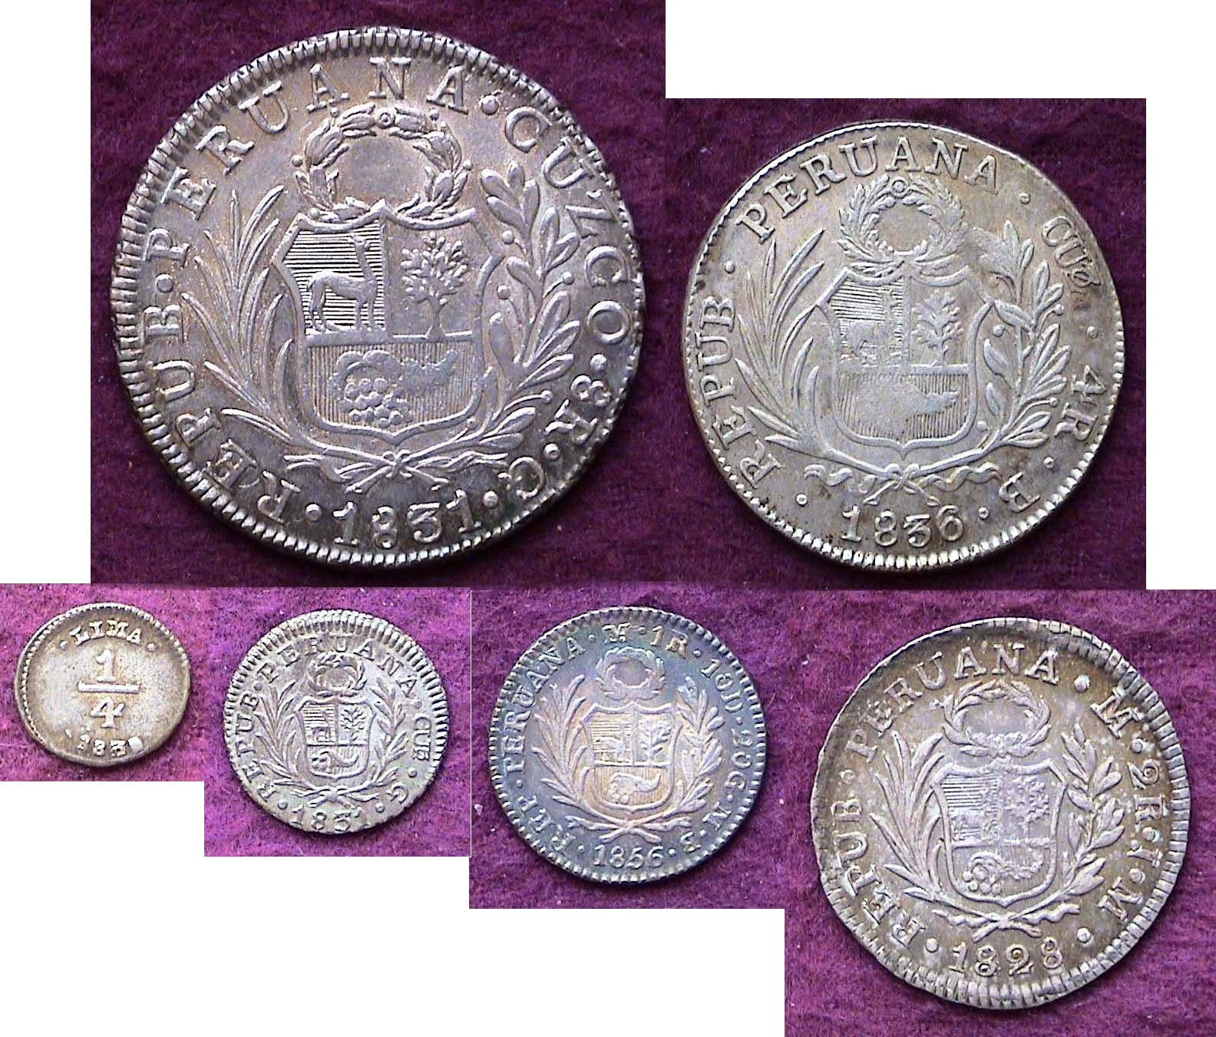

The Coat of Arms with date side of the Republic of Peru Silver coins
Top row: 8R & 4R; Bottom row from left: ¼R, ½R, 1R & 2R
[Use 3X glass or magnify page to 200% to view details.]
_________________________________________________________

Club News
Minutes of the July 7 meeting

President, Steve Kuhl, called the regular meeting of the club to order at 6:50 p.m.
Glenn Sanders reported that there were 20 members present (20 adults, 0 junior). There were four visitors: Richard Herold, Sonia Hillman, Charlie Neill, and Peggy Neill. A quorum for the meeting was met. (15 regular members needed to conduct the business of the club.)
Glenn announced that while there were few upcoming coin shows in the immediate vicinity, there are several within a 3-4 hour drive. Raleigh NC July 15-17, Hendersonville NC July 16-17, Rock Hill SC July 22-24, Warner Robbins GA July 29-30, and Charleston SC August 5-7.
Marion Engel won the door prize.
A motion was made by Jim Barry, seconded by Pat James, and passed to dispense with the reading of the June, 2011 minutes.
The treasurer’s report for June 30 was not available and will be provided at the August meeting.
It was announced that the August program would be a grading exercise developed by Jim Mullaney.
Arno Safran and Jim Barry shared Show & Tells with the club. Arno had a Brazilian 320 Reis coin from 1695 while Jim had a coin issued by Alexander Balas of the Seleucid Dynasty (150 – 145 BC).
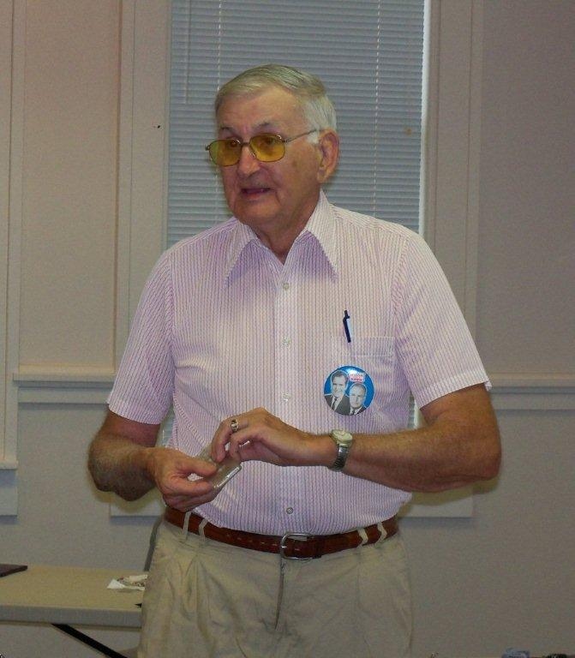
Howard Hillman presented a program on his personal coin collecting experiences over the last 68 years. In addition to particular events, Howard shared an interesting perspective on coin collecting. He observed that coin collectors were stewards of coins, taking care of them during the time that we have them so that they are preserved for others to enjoy in the future.
Jim Mullaney won the 50/50 ($22).
Respectfully submitted,
Jim Mullaney, Secretary
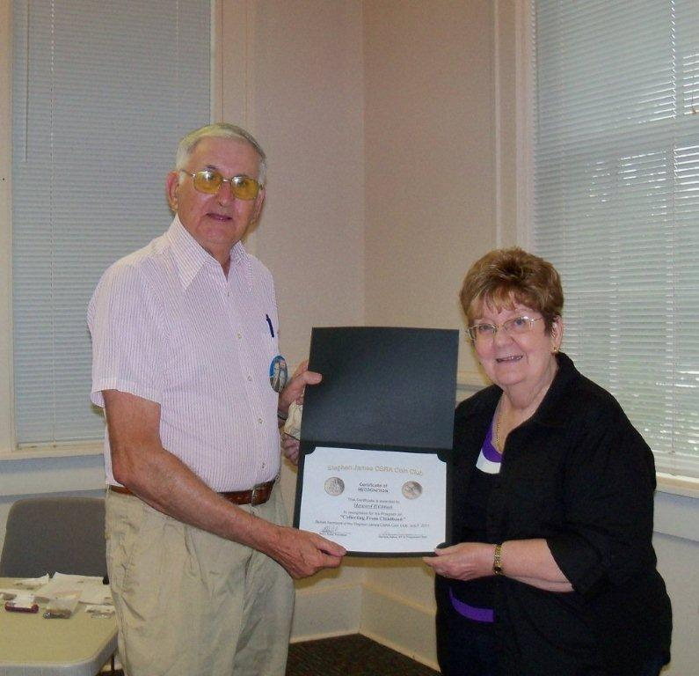
Howard sharing anecdotes
Photo, courtesy of Helen Barry
numismatic anecdotes

Howard Hillman receiving
Appreciation Award from
VP Pat James
Photo by Helen Barry
More Club News – July Picture Gallery
Images, courtesy of Helen Barry

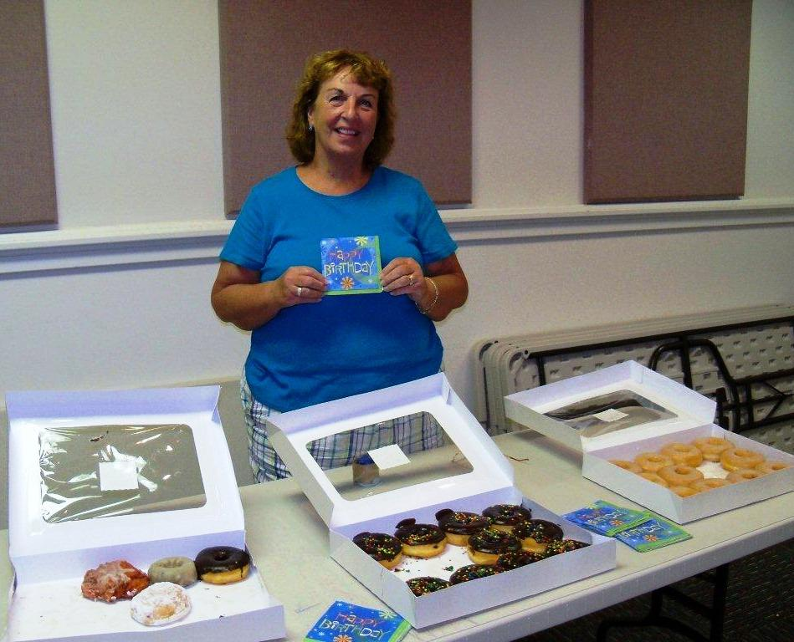

Club Treasurer Sharon Smoot celebrates Her Birthday
By bringing in delicious donuts for members to share
(Thanks, Sharon and Congratulations!, Ed.)

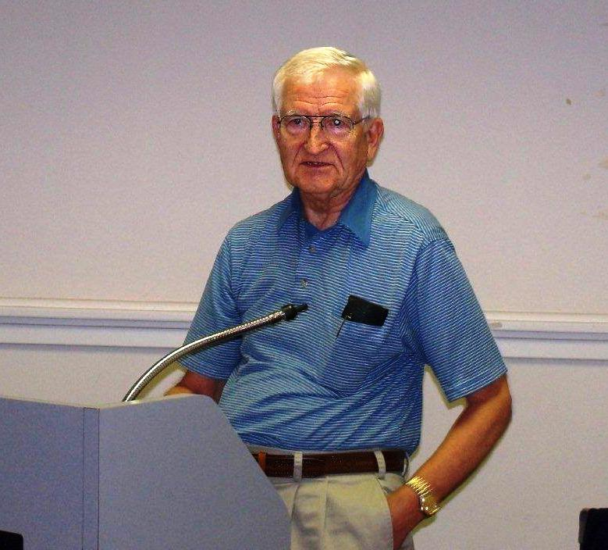

Jim Barry describing a tetradrachm issued by Alexander Balas of the Seleucid Dynasty (150–145 BC) for Show & Tell.
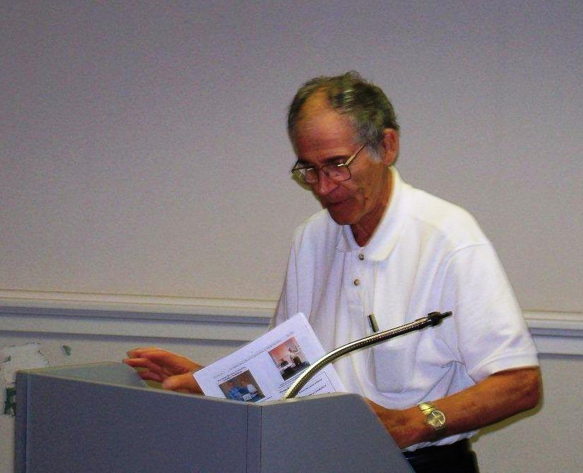

Arno Safran describing a 1695 Brazilian 320 Reis

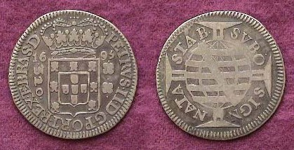

This thin half-dollar size silver coin had a value of 33 &1/3¢
It was good to see member Dick Smoot at our July 7 meeting looking in fine fettle. Welcome back, Dick!

Club’s Upcoming Show, Sept. 10 Not Far Off
Our club will be putting on its annual pre-Fall show on Saturday, Sept. 10. That is less than five weeks from our upcoming Aug. 4 meeting. The goal is to sell 30 tables at $40 for one or $75 for two. Any member interested in taking a table should contact President Steve Kuhl at PO Box 11, New Ellenton, SC 29809 or by E-mail at Stvk1989@gmail.com. The show is being held at the H. Odell Weeks Activity Center located on Whiskey Road (SC Rte. 19) across from the Home Depot. Hours are from 9:00 AM to 4:00 PM. Raffle tickets featuring one three numismatic prizes including one gold coin are being sold at $1.00 each or six for $5.00. If every member either sells or purchases 10 tickets this will add $400 towards defraying costs for the event.
_______________________________________________________________________________________________________________________________

Kindly Patronize Our Dealer Advertisers
