The Stephen James
CSRA Coin Club of Aiken
P.O. Box 11
New Ellenton, SC 29809
Web site: www.sjcsracc.org
The SJ CSRA CC of Aiken, SC meets on the 1st Thursday of the month at the Aiken Public Library

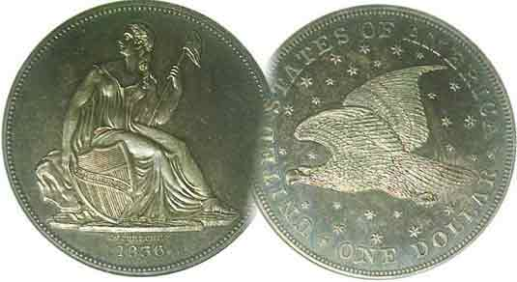
Pres. Steve Kuhl
V .P. Pat James
Sec. Jim Mullaney
Treas. Chuck Goergen
Sgt. in Arms: Jim Sproull
Programs: Pat James
ANA Representative: Jim Barry
Photos: Helen Barry
Publicity: Pat James
Newsletter: Arno Safran
E-Mail: arnosafran@comcast.net
Auctioneer: Jim Sproull
Web site: Susie Nulty (see above.)

2013 Club Meeting Schedule
Volume 12, No. 8 the Stephen James CSRA Coin Club, Founded in 2001 August, 2013
Monthly Newsletter
Our next meeting will be held on Thursday, August 1, 2013 at the Aiken Public Library

Jan. 3 Apr. 4 July 11 Oct. 3
Feb. 7 May 2 Aug. 1 Nov. 7
Mar. 7 June 6 Sept. 5 Dec. 5

______________________________________________________________________________________________________

Some P Mint Lincoln cents , Buffalo nickels and Mercury Dimes are not easily found in Mint State

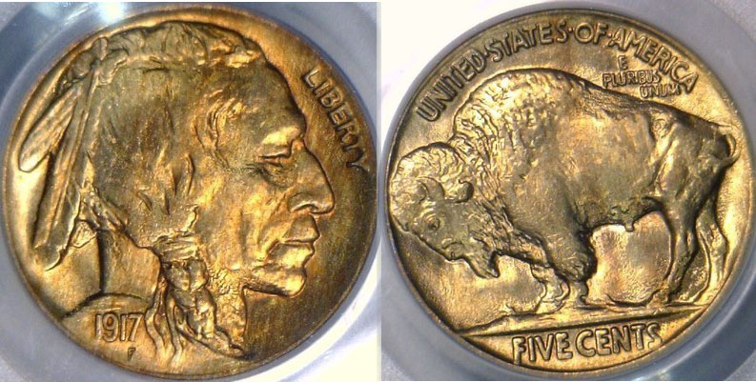

A 1917-P Indian Head/ Buffalo nickel graded MS-65 by PCGS

Recently, I completed a BU set of certified P Mint Standing Liberty quarters from 1917-1930 with virtually no difficulty. Most of the coins were graded MS-64. I decided to attempt the same task with other early 20th Century denominations opting for P Mint issues for Lincoln cents from 1909 thru 1933, Buffalo nickels from 1913 thru 1930 and Mercury dimes from 1916 thru 1931-P. Cents and dimes struck at the Philadelphia Mint are extremely common in Mint state from 1934 on and may not warrant the expense of certification. Back in the 1970s thru the 1990s, one could still assemble a complete date set of uncertified Buffalo nickels averaging MS-63 by procuring all the dates from 1913 struck at the Philadelphia Mint including the 1931-S and 1938-D, and voila, the set was completed at a modest cost to the collector. The mini “keys” were the 1918-P, 1921-P and 1924-P; these being the most difficult and expensive to acquire in MS-63 or better. Today, it would not be quite so easy. The once common P Mint dates among early Lincoln cents, Buffalo nickels and Mercury dimes averaging MS-64 have become surprisingly difficult to find. Take 1917 as an example. Although no gold coins were struck that year, the P Mint issues for the lower denominations are large compared with the branch Mints. However, the date does not surface in BU among cents, nickels and dimes as often as it once did, and the prices dealers are asking reflect this trend.
________________________________________________________________________________________________________________________

Common US Coins that Are Costly
By Arno Safran

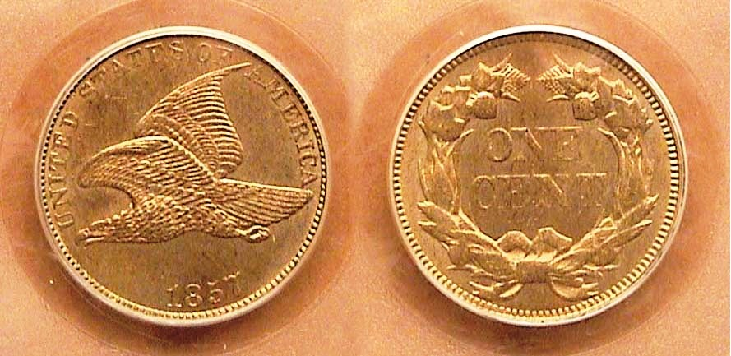

An 1857 Flying Eagle small cent graded MS-63 by PCGS
Where are the P Mint dates from the teens, ‘20s and ‘30s?

Collecting rare coins can be an expensive proposition but the fact that such items usually have very low mintages, often justifies the expenditure. It has been well documented that key date or better date type coins rise in value much faster than common coins do. If this is so, how does one explain the high value of some US type coins boasting unusually large mintages?

In 1857, the Philadelphia Mint struck two US cent types. It was the final year for the Braided hair large cent with a reported mintage of only 333,546 and the first year of the small cent bearing the new Flying Eagle obverse design struck in copper-nickel where a record 17,450,000 were produced, yet under the MS-63 column, the 2014 Red Book shows the prices of the two types to be virtually identical, around $800.

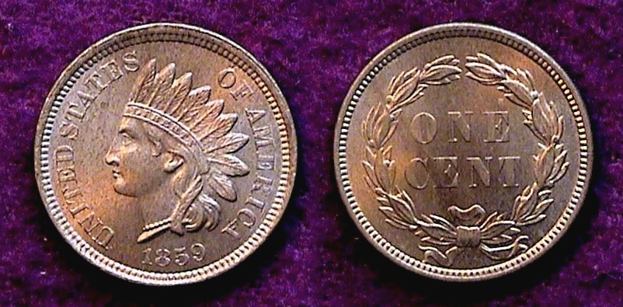

An 1859 Indian Head copper-nickel cent graded MS-65 by ICG

In 1859, Mint Director James Ross Snowden asked Chief Engraver James Barton Longacre to create a new design for the copper-nickel small cent because of striking problems with the Flying Eagle design. For the obverse Longacre created a female figure of Liberty wearing a Native American headdress, (allegedly of his daughter Sarah, although there are some doubts as to whom the actual source may have been). For the reverse, Longacre replaced his agricultural wreath originally placed on the Type 2 & 3 gold dollars and $3.00 gold pieces with one made of laurel.
______________________________________________________________________________________________________________________
(Continued on page 2, column 1)

Common US Coins that Are Costly
(Continued from page 1, column 2)

The 1859 Indian Head with laurel wreath reverse produced another record mintage of a 36,400,000 yet in MS-63, it is listed at the relatively high figure of $600 according to the 2014 Red book. The 1861 Indian cent with a mintage of 10,100,000 (less than 1/3 that of the 1859) is shown at $300 in MS-63 (or one-half of the value of the 1859.) There has to be a reason but before any explanation is tendered let us examine some other similar instances where a date with a large mintage is priced higher than those with smaller mintages in the same series.

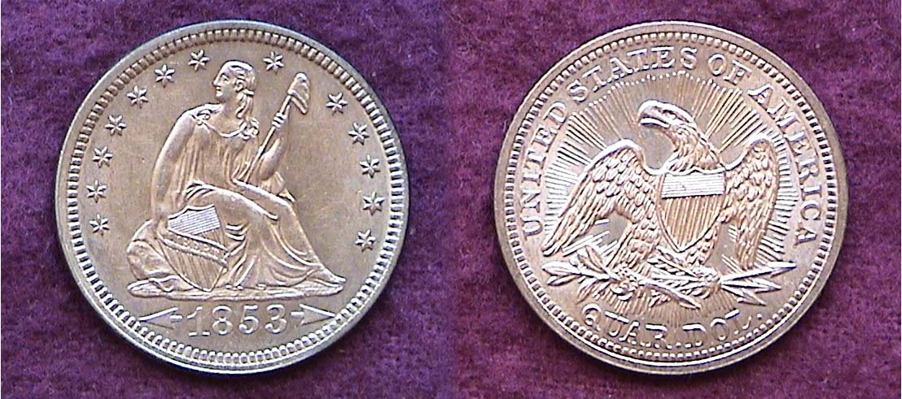

An 1853 Liberty Seated Quarter with arrows & rays graded MS-61

After gold was discovered at Sutter’s Mill, along the American River near Sacramento, CA in 1848 and the subsequent gold rush that followed, the value of silver began rising in relationship to gold. Soon all silver coins were being removed from circulation as soon as it left the Mint with the result that a severe coinage shortage soon developed. By 1853, the situation became dire and Congress enacted legislation to reduce the weight of the quarter from 6.68 grams to 6.22 grams. Since a small number of 1853 quarters were produced before the legislation was passed the Mint, authorized Longacre to place arrows extending out from the date on the obverse and rays emanating out from the spread-eagle on the reverse denoting the lowering of the weight to the denomination. A record 15.2 million of the 1853 arrows and rays quarters were struck at the Philadelphia mint alone with another 1.3 million being coined at the New Orleans facility. According to the latest Red book, an 1853-P quarter with arrows and rays is priced at $900 in MS-60 while an 1856 with the arrows and rays removed having a mintage of 7.2 million, (less than half of the 1853-P issue) is priced at just $325 in the same grade.

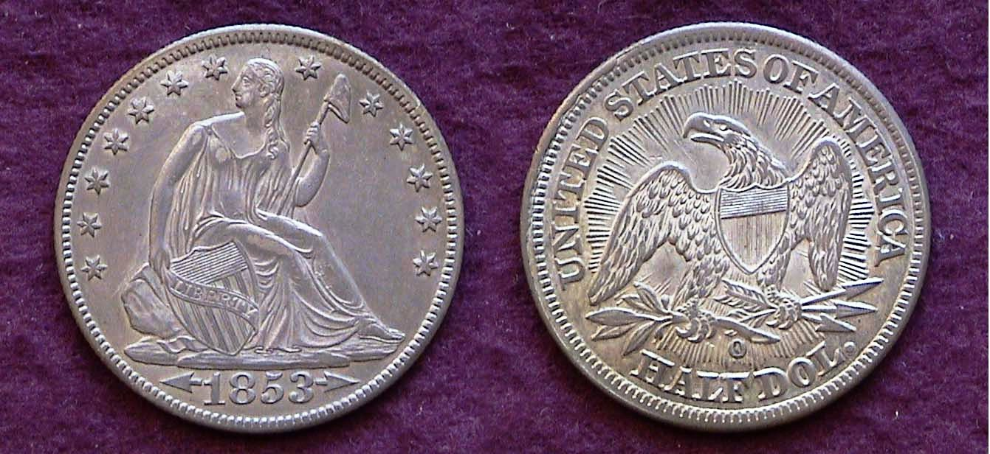

An 1853-O Liberty Seated Half-dollar with arrows & rays
graded AU-55

The same situation occurs with the 1853 arrow and rays Liberty Seated half-dollars. The 1853-O had a mintage of 1.3 million and in AU is listed at $875 while the 1856-P with a mintage of 938 thousand is priced in at only $225 in AU.

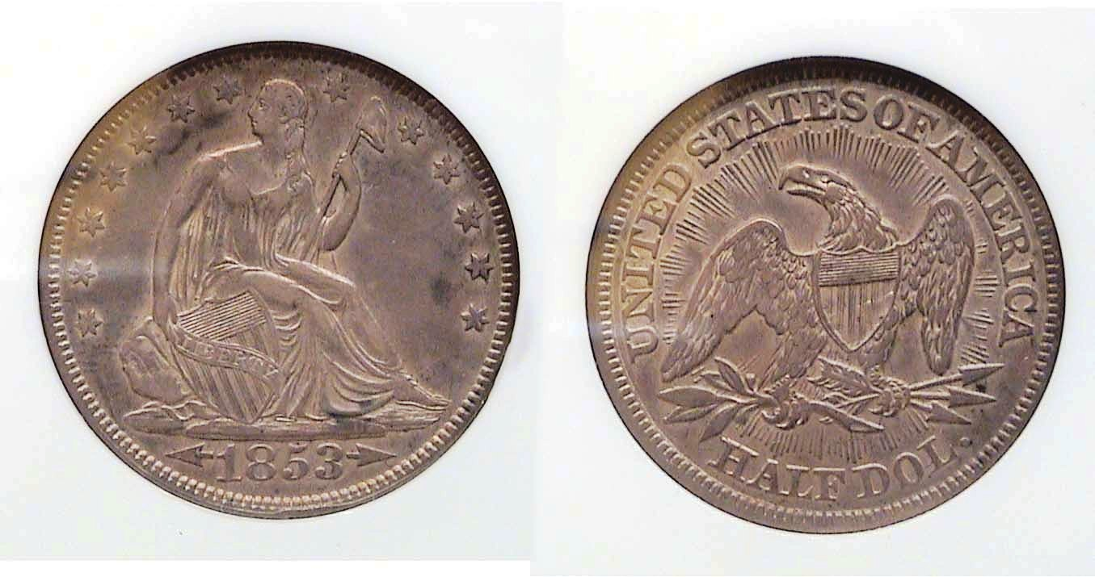

An 1853-P Liberty Seated half-dollar with arrows & rays
graded XF-45 by NGC

The 1853-P issue of the arrows and rays half dollar had a mintage of 3.5 million and in XF is listed at $265 while the 1856-P issue alluded to earlier in XF is priced at just $130.

Suggested Reasons for the Price Anomalies

Obsolete coins are valued by a number of criteria, these being scarcity, grade, condition, design-type and demand. The dominant factor of the five is “demand”. A coin can be rarer than another in the same series yet lack the popularity of the higher mintage issue. The 1909-S Indian Head cent with a mintage of 309,000 has less than half the mintage of the 1877 with 852,500 struck but lacks the popularity possibly because one needs the 1877 more to complete a date set inasmuch as the 1909-P with over 14 million struck is available at a common date price; the 1885 Liberty nickel vs. the 1912-S for the same reasons. The extremely common 1912-P completes the date set.

Demand also plays a part on why collectors will pay good money to buy a popular key date such as the 1916-D Mercury dime in a very low grade despite the fact that the vast majority of specimens that surface grade only AG-3. Because of the date’s popularity as a “key”, the demand is high although at that grade level the date is no longer rare.

Another reason that creates strong demand is the short duration of a particular type, especially if it attractive.

The 1857 Flying Eagle cent was in essence a two-year type coin. For most collectors, the estimated low mintage of 2,000 for the 1856 Flying Eagle proof cent make this date virtually impossible to acquire for most collectors leaving only the 1857 and 1858 dates available for type. As a result, the demand for the 1857 is very strong as a first year issue especially for specimens grading AU-58 or better

The 1859 Indian Head cent is essentially a one-year type. In 1860, a wreath of oak with the addition of a shield centered atop replaced the simple laurel wreath on the reverse. The new design type remained intact through 1909 despite the change in alloy from copper-nickel to bronze during 1864. As a result, the 1859 is in far greater demand as a one year type and especially difficult to locate above MS-63.

The 1853 arrows and rays quarters and halves have always enjoyed high demand as an attractive one-year type. Regrettably, the rays were removed in 1854 rendering the type less alluring resulting in decreased interest. Once the arrows were removed in 1856, the demand dropped altogether.
_____________________________________________________________________________________________________________________

Club News

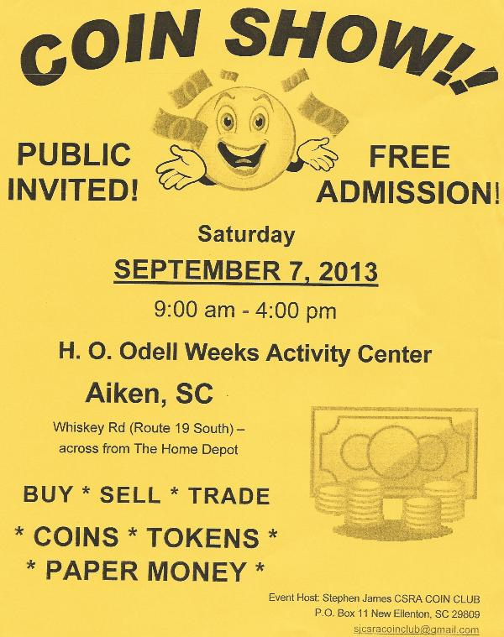
President Steve Kuhl called the July 11 meeting to order at 6:50 PM. Sgt. In Arms Jim Sproull announced that there were 16 members with five visitors. Jim also announced that the Low Country Coin Club would be holding a show on August 2-4 near Charleston, SC and reminded the members that our own club show is scheduled for Saturday, Sept. 7 at the H. O. Odell Weeks Activity Center located on Whiskey Road (SC Rte. 19) across from the home Depot. President Kuhl announced that as of now, seven dealers have signed up but usually by show time, the club sells on average 30 or more tables.

VP President Pat James announced that she and Secretary Jim Mullaney are preparing a Numismatic Trivia activity for a future meeting program. For those that are familiar with the game, “Trivial Pursuit”, this should be both challenging and enjoyable.
For Show & Tell, Arno Safran brought in two early US type coins recently acquired at the big Whitman Show held at the Baltimore Convention Center located along the famed Inner Harbor. One was an 1818 large Capped Bust quarter graded VF-35 by PCGS and the other was an 1826 lettered edge Capped Bust half-dollar graded AU-53 by PCGS, thus completing the available collector dates for both sets.

Jim Barry brought in a Roman Coin struck by the Caligula during his early years as emperor that featured his two older brothers riding together on horseback. He relayed the history that led to the striking of the coin, which apparently occurred before the illness that rendered Caligula unbalanced.

For the program, Secretary Jim Mullaney ran a PowerPoint presentation by former member Bill Myers on “Collecting coins, tokens, medals and paper money featuring hands”. As an orthopedic surgeon specializing in hand injuries, Col. Bill Myers currently deployed in Kuwait, has put together over the years an extensive collection of numismatic items displaying a variety of hand positions, the most common being the clasped hands often seen on peace medals and coins commemorating pacts between two nations. The August program will be a PP presentation on “The Origins of Liberty Seated Coinage” by Arno Safran
The prizewinners at the July 11 meeting were new member Zack Richardson who won the door prize drawing and Helen Barry who won the 50/50 - $12.00. Congratulations Zack and Helen. Our next meeting is scheduled for Thursday, Aug. 1 at the Aiken Public Library starting at 6:45 PM.
__________________________________________________________________________________________________________________

Kindly Patronize Our Advertisers

