The Stephen James
CSRA Coin Club of Aiken
P.O. Box 11
New Ellenton, SC 29809
Web site: www.sjcsracc.org
The SJ CSRA CC of Aiken, SC meets on the 1st Thursday of the month at the Aiken Public Library

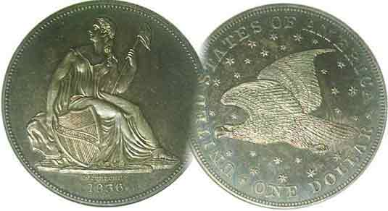
Pres. Willie Simon
V .P. Pat James
Sec. Jim Mullaney
Treas. Chuck Goergen
Sgt. in Arms: Jim Sproull

Programs: Pat James
ANA Representative: Jim Barry
Show Chairman: Steve Kuhl
Photos: Helen Barry
Publicity: Pat James
Newsletter: Arno Safran
E-Mail: arnosafran@comcast.net
Auctioneer: Jim Sproull
Web site: Susie Nulty (see above.)

2014 Club Meeting Schedule
Volume 13, No. 8 the Stephen James CSRA Coin Club, Founded in 2001 August, 2014
Monthly Newsletter
Our next meeting will be held on Thursday, August 7, 2014 at the Aiken Public Library

Eye Appeal is Buy Appeal when it comes Coin Collecting
Jan. 2 Apr. 3 July 3 Oct. 2
Feb. 6 May 1 Aug. 7 Nov. 7
Mar. 6 June 5 Sept. 4 Dec. 4

Stay Away from “Ugly” Coins no matter how rare

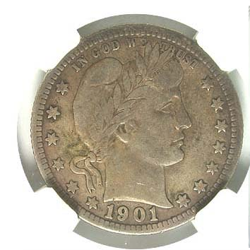
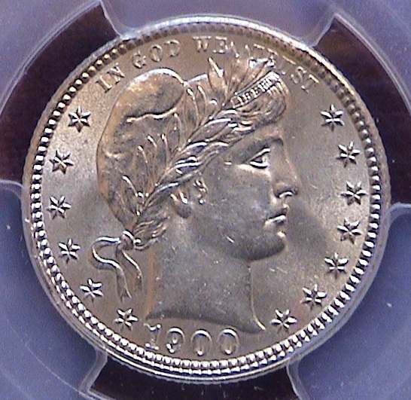
One of the tenets of coin collecting is to acquire the “key date before the common ones of a particular series. Sound advice? Yes and no! It depends on the series. Let’s say you have been attracted to Barber quarters having acquired a lovely 1900 graded MS-62 for your type collection. You decide it might be fun to compile a complete set only to find that the 1896-S, 1901-S and 1913-S are “stoppers”, so expensive that even in VG-8, the three keys are priced at well over $1,000. Even if you could afford them at those` grades each coin would probably have little eye appeal due to extensive wear possibly accompanied by other detractions such as rough surfaces, discoloration or scratches. Better off to attempt putting together a date set of Barber quarters matching your 1900 in appearance from AU-58 thru MS-63.

Thee are some series` in which the key date is not considered a “stopper” but still expensive out of proportion to the rest of the coins of the set. The best advice, especially for a novice collector is` to avoid completing a date set from a particular series altogether and concentrate more on a specific type set either from a specific denomination, decade, generation or entire century. It is possible to complete a 20th Century type set (excluding gold) with attractive pieces. Depending on one’s budget you might consider collecting specimens within the following grade ranges, Fine-12 to VF-20, VF-30 to XF-40, XF-45 to AU-55 or AU-58 thru MS-63. By staying within any one of these grade ranges, your type set will appear balanced and pleasing to the eye.
_____________________________________________________________________________________________________________________

70 Years since the Normandy Invasion
Collecting the US Coins of 1944
By Arno Safran

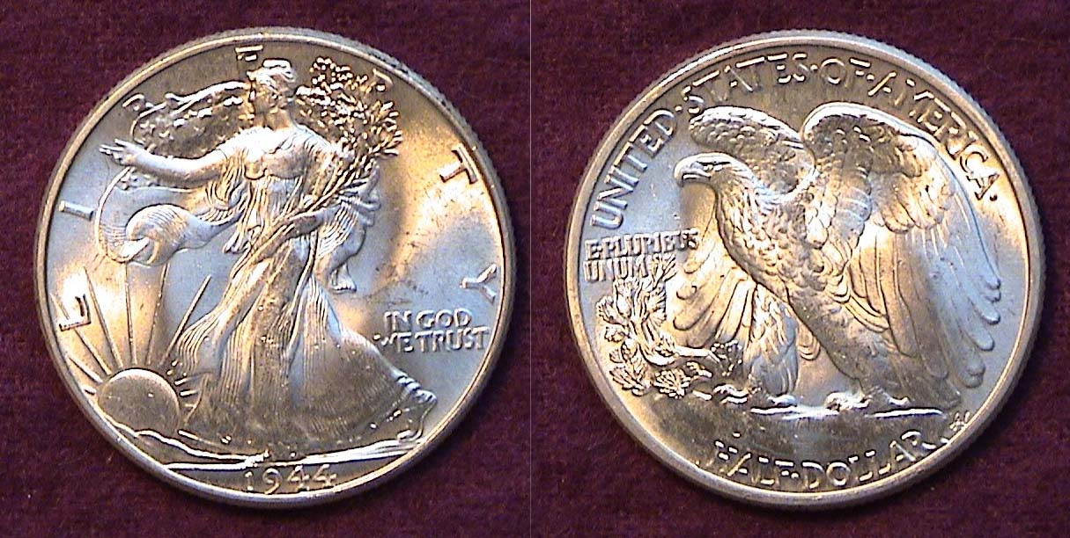

A mint state-65 1944 Walking Liberty Half dollar
[Magnify to 200% to see details.]

The late Bennie Bolgla and past president of the Augusta Coin Club was among the crack troops that landed on Omaha Beach along the Normandy coast in the early dawn hours as part of the Allied invasion force on June, 6, 1944. That was 70 years ago. The area comprised a fifty-mile stretch between the Continental Peninsula and Orne River. Despite the heavy air and battleship bombardment of Nazi positions along the shoreline, the first wave of soldiers to reach the French coast at Omaha beach were met by stiff resistance from the German fortresses perched some 170 feet along the bluffs beyond the landing area. When Bennie told me he was one of the many men who landed there on that historic day, I mentioned that my wife and I had recently seen the then movie, “Saving Private Ryan” starring Tom Hanks and asked him whether the situation he and his fellow soldiers encountered was that bad. He replied, “It was a heck of a lot worse” or words to that effect. As children and grandchildren of that generation we owe much to members like Bennie and the other brave GI’s and their commanders who remained steadfast during the day long battles finally securing the beachhead that was to eventually alter the course of World War II.

The beautiful 1944 Walking Liberty Half dollar shown above was designed by Adolph Weinman, a Jewish born sculptor and disciple of Saint-Gaudens. It signifies the freedom our country and its allies were fighting for during the still dark days of 1944.
_____________________________________________________________________________________________________________________
(Continued on page 2, column 1)
Collecting the US Coins of 1944
(Continued from page 1, column 2)

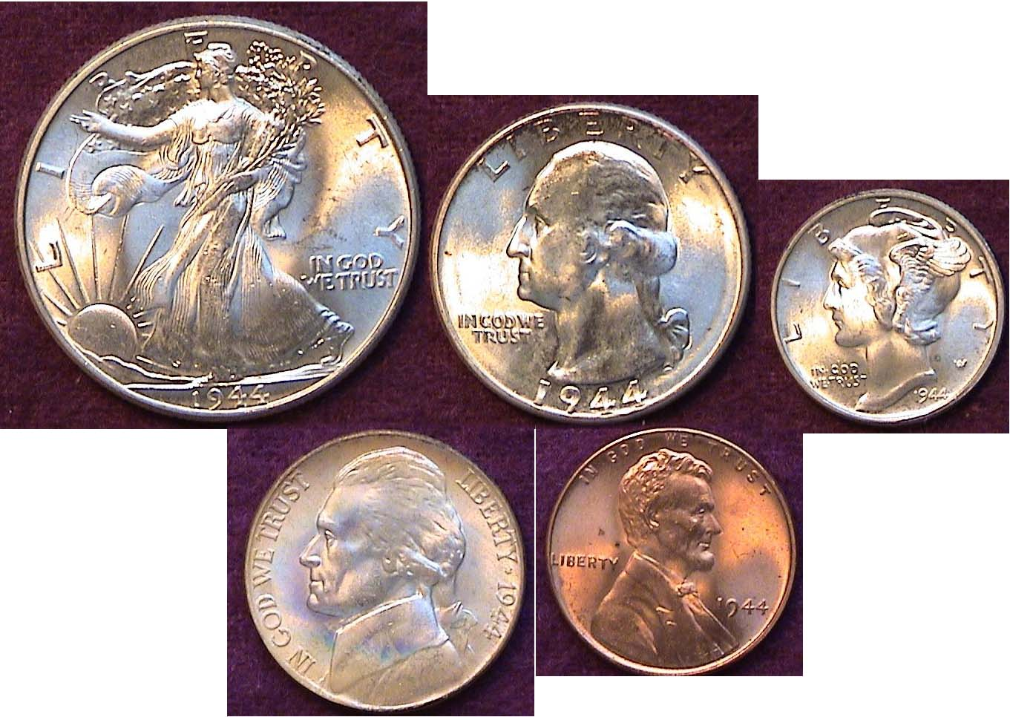

The obverses of an uncirculated 1944-P Year Set
[Magnify to 200% to see details.]

The United States had been on a war footing since the Japanese attack at Pearl Harbor on December 7, 1941. By 1944 the Great Depression was ostensibly over as factories were fully employed, many building ships and turning out weaponry for our soldiers fighting on two fronts overseas.

With nickel needed for the war effort, starting in October of 1942, the Jefferson 5¢ alloy was changed from 75% copper and 25% nickel to 56% silver, 35% manganese and 9% copper. A large Mintmark was placed over the dome of Monticello on the reverse and that included the P for Philadelphia. In 1943, the cent’s alloy was completely changed to steel coated with zinc. People started confusing it with the dime, so in 1944, the Mint began using salvaged cartridge cases made of bronze that had an alloy of 95% copper and 5% zinc. These were struck through the 1946 cent coinage.

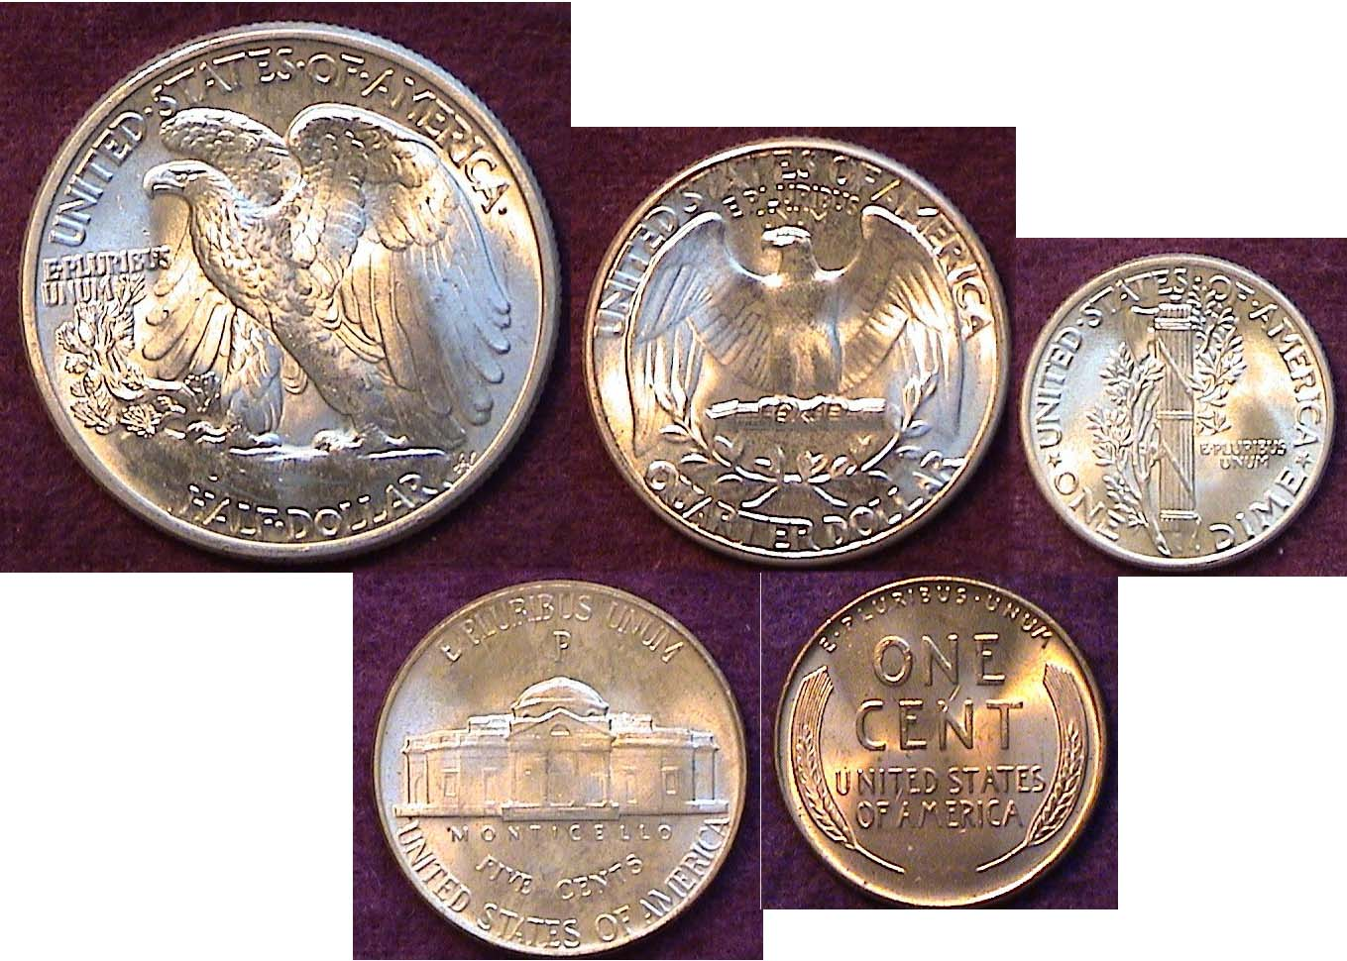

The reverses of an uncirculated 1944-P Year Set
[Magnify from 200% to 500% to view details.]

With a mintage of 231,400,000, the 1944-P Mercury dime is common in all grades but specimens showing fully split bands on the reverse are second in scarcity to the rare 1945-P issue of those coined during the 1940’s. Under magnification the 1944 Mercury dime shown above has fully split bands. The 1944-P Washington quarter also had a prodigious mintage, 104,956,000. In MS-65 the 2010 Red Book lists it at $35 but only $9.00 in MS-63. While the 1944-P half had a mintage of only 28,206,000, the large size 30.6 mm coin seldom saw much circulation and is considered a common date even in MS-65.

1944 Prices and Wages

In 1944 the 50¢ piece had the purchasing power of what $6.12 could buy today. Back then a loaf of bread cost 10¢. A can of Campbell’s tomato soup was 9¢. Milk was around 16¢ a quart. Margarine was priced at 18¢ a pound. A fresh chicken at the butcher shop would require one Walking Liberty Half dollar or two Washington quarters plus a Jefferson nickel.

A new home cost between $3,450 and $8,600 depending on location. If one couldn’t afford a house, the average monthly rent was around $50.00. The cost of a family sedan on average came to $1,220 with a gallon of gas ranging in price from 15¢ to 21¢, again depending on location. How did Americans afford any of this? The average yearly wage was $2,400 or around $48.00 a week. This translates to $1.00 an hour if you worked a six day week and most Americans still did back in 1944. The minimum wage at the time was 30¢ an hour.

The Two other Mints in 1944

As for most years, coin production from the branch mints--Denver and San Francisco--were substantially smaller than that of Philadelphia. This is reflected somewhat in the General Election results of 1944 in which Franklin D. Roosevelt won an unprecedented 4th term as President narrowly defeating Thomas E. Dewey by 3 million in the popular vote but sweeping his opponent 432 to 99 in the number of electoral votes by state. The number of votes apportioned in the Electoral College is based on the population of each state and the Mints reflected this in their annual output.
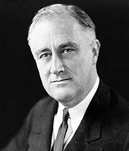
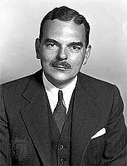
Franklin Delano Roosevelt Thomas E. Dewey
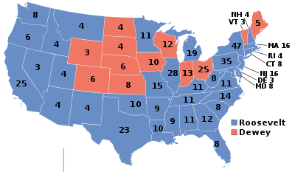

___________________________________________
(Continued on page 3, column 1)
Collecting the US Coins of 1944
(Continued from page 2, column 2)

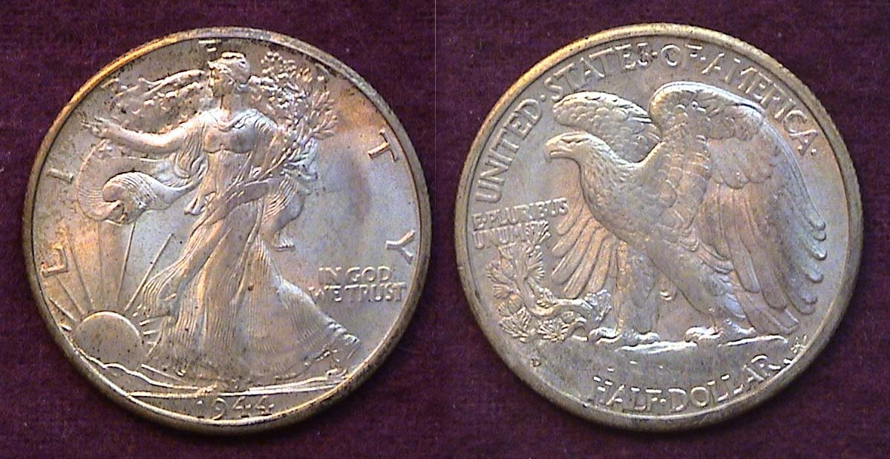

A nicely toned 1944-D Walking Liberty Half dollar grading MS-64
[Magnify to 200% to see details.]

The 1944-D half dollar had a mintage of only 9,769,000 compared with 28,206,000 for the 1944-P while the 1949-S shown below had slightly less at 8,904,000. Despite these lower figures neither coin is scarce because far too many were saved by the roll in “new” condition. The 2010 Red Book does not list an MS-65 grade but in MS-63 the 1944-P is shown at $45 with the 1944-D & S at $55.00 and $65 respectively.

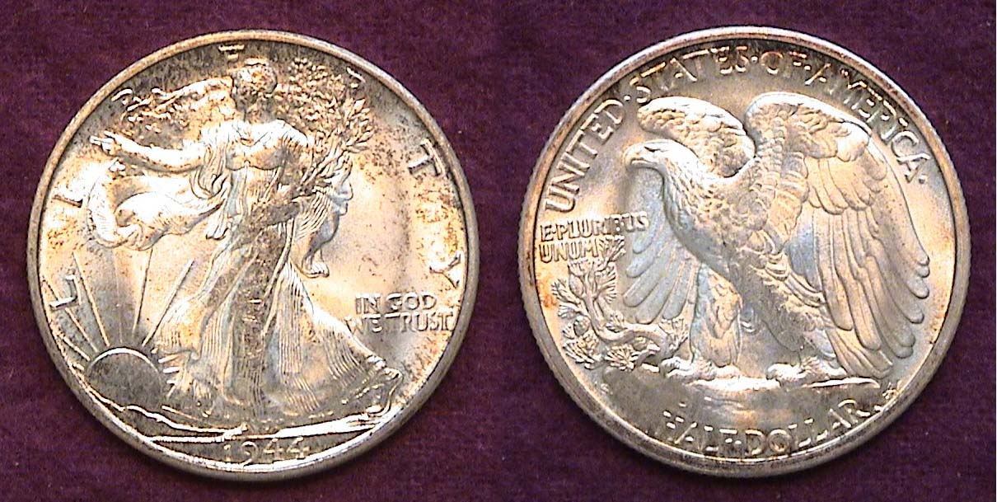

A 1944-S Walking Liberty Half dollar grading MS-64
Noticed the weaker strike across the central portions of the coin.
[Magnify to 200% to see details.]

As a rule the coins struck at the San Francisco Mint during this period received weaker strikes than Philadelphia or Denver and the 1944-S Walker shown above is no exception. A well struck 1944-S half that appears comparable to a 1944-P is a scarce coin and could be priced as high as $600 according to the latest Coin World monthly issue of Coin Values.
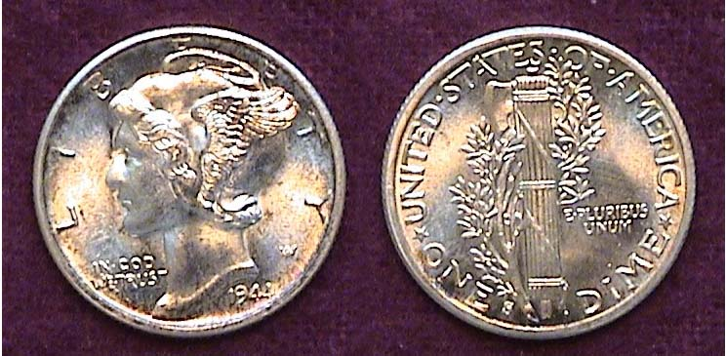

A BU 1944-S Mercury dime showing fully split bands
[Magnify to 500% to see details.]

Only 49,490,000 1944-S Mercury dimes were minted compared with 231,410,000 for the 1944-P yet even in MS-65 specimens showing fully split bands on the reverse grade is still priced as a fairly common date. On the other hand, a 1944-P showing fully Split bands and grading MS-65 is worth a lot more despite the greater mintage.

All 1944 P, D & S cents, nickels and quarters are plentiful and inexpensive in BU. As the 5¢ coin still had a lot of spending power back in 1944, a bogus 1944 nickel struck at the so-called “Henning” Mint in NJ became the undoing of the counterfeiter because he omitted the P above the dome of Monticello. Indeed, 1944 was a memorable year in US history.
____________________________________________________________________________________________________________________________
ARCHES NATIONAL PARK UTAH
By Bill Myers

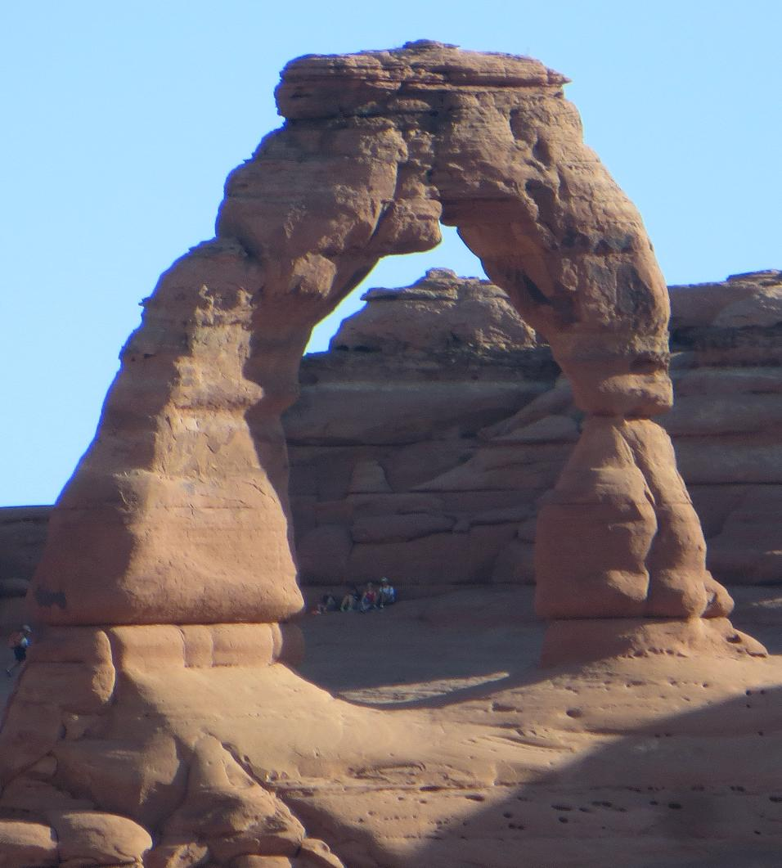

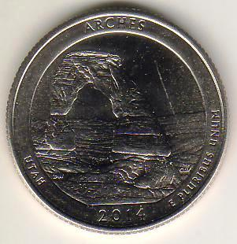

Kathy and I have been trying to explore the sites in and around Arizona since we moved here. We recently completed a trip to southeastern Utah to visit the parks located there. One of the parks we visited is Arches National Park. One of the big attractions is Delicate Arch which is on the Utah America the Beautiful quarter.

The quarter release for Arches was a month before our visit so we just missed it. There are 3 options to see Delicate Arch, as it cannot be seen from the road. One is the lower viewpoint which is about 200 yards from the parking lot. The other is the upper viewpoint, a 0.8 mile walk that is rugged, involves going up in elevation and there are crude stairs. The last option is 3 mile round trip walk to the arch that is rugged and climbs 280 feet. It was a sunny day and the temperature was in the high 90s. We did the lower viewpoint and with the zoom on my camera we could get a nice picture of the arch.

I then started to walk to the upper viewpoint and had to quit but Kathy was able to finish it and the pictures from there were no better than the lower viewpoint. We did not attempt to walk to the arch. The view I had of the arch is different then what is on the quarter in that it is from the other side of the arch.

There are other rock formations behind the arch from the view I had. To get the view on the quarter you have to walk to the arch and take the picture. Kathy and I were each able to get 4 of the arches quarters at the gift shop in the visitors center and they are from the Denver Mint.
There are many beautiful natural formations in Utah and it was nice to see one that has a numismatic connection.
_________________________________________________________________________________________________________________
Bill Myers is a former member of the Stephen James CSRA Coin Club and a past president of the Augusta Coin Club. He is an orthopedic surgeon with the US Army who served two deployments to Iraq. He specializes is military Exonumia and coins and currency featuring hands. (Ed.)
STEPHEN JAMES CSRA COIN CLUB
Regular Meeting - Aiken County Library
July 3, 2014
Vice President Pat James called the meeting to order at 6:51 p.m. Sgt at Arms Jim Sproull reported there were 16 members and 2 guests in attendance. Jim also related information about the upcoming coin shows in the area. Roger Seitz won the members’ door prize, a Franklin Half Dollar.
There was a motion by Kelly Nordeen to waive the reading of the minutes of the June meeting. Roger Seitz seconded the motion, which was voted upon and carried. A copy of the minutes will appear in the Club Newsletter and are on file in the Club’s records.
Treasurer Chuck Goergen reported that the June balance was $1,652.63.
Pat reminded everyone that the club has current Red Books on sale for $10. She also reminded the club that the Augusta Coin Club will meet on July 17th. The program for July was not known.
The August program for our coin club will be “World's Columbian Exposition Elongated Coins” by Garry Naples
There were several Show and Tell presentations, including Chuck Braun who shared a Persian coin from the time of Timur, or Tamerlane, founder of the Timurid dynasty who conquered much of western, southern, and central Asia before his death in 1405. Timur had attempted to restore the Mongol empire created by Genghis Khan about 150 years earlier. Historians estimate up to 17 million people died as a result of the wars of Timur, amounting to about 5% of the world population at the time.
Chuck Goergen shared an ancient coin from Greece. Chuck noted that shortly after 500 BC the Athenians discovered a lode of silver that they minted into coins that became known as Athenian owls. These coins were initially minted from 480BC to ~300 BC. The mining and minting of these coins funded most activities for Athens including the building of the Parthenon and the construction of the fleet that defeated Xerxes. The coin Chuck had was produced in a later period after Greece was subjugated by the Romans. It was a silver tetradrachm with a quadriga containing Helios the sun god on the obverse made in 119/118 BC.
Roger Seitz won the 50/50 - $20.
Jim Sproull conducted the club auction. The meeting was adjourned at 8:10 p.m.
Respectfully submitted,

Jim Mullaney, Secretary
________________________________________________________________________________________________________________________

Kindly Patronize Our Advertisers
Please note: Clein’s new ad below!

