Pres. Steve Kuhl
V .P. Pat James
Sec. Jim Mullaney
Treas. Chuck Goergen
Sgt. in Arms: Glenn Sanders
The Stephen James
CSRA Coin Club of Aiken
P.O. Box 11
New Ellenton, SC 29809
Web site: www.sjcsracc.org
The SJ CSRA CC of Aiken, SC meets on the 1st Thursday of the month at the Aiken Public Library

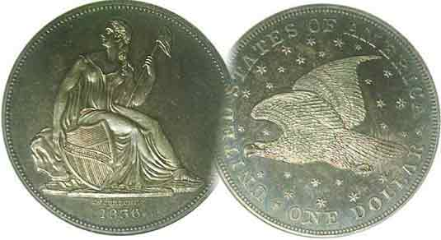
Programs: Pat James
Show: by Committee
ANA Representative: Jim Barry
Publicity: Pat James
Newsletter: Arno Safran
E-Mail: arnosafran@comcast.net
Auctioneer: Glenn Sanders
Web site: Susie Nulty (see above.)

2012 Club Meeting Schedule
Volume 11, No. 8a, Special Edition the Stephen James CSRA Coin Club, Founded in 2001 August, 2012
Monthly Newsletter
Another Interesting Meeting Coming Up Aug. 2
Our next meetings is on Aug. 2, 2012 at the Aiken Public Library

Jan. 5 Apr. 5 July 5 Oct. 4
Feb. 2 May 3 Aug. 2 Nov. 1
Mar. 1 Jun. 7 Sep. 6 Dec. 6

______________________________________________________________________________________________________

Summer Issue #2

Originally, the editor thought he would be out of town and unable to produce an August issue but a last minute schedule change has made it possible for a Special Edition to be published prior to our upcoming August 2 meeting.

Upcoming Club Programs

As it happens VP and Programs Chairperson Pat James has arranged for some interesting future programs for the next three months. On tap for our upcoming meeting on August 2, is the return of Walter Kublius who will present a program on Latin American Banknotes. Walter’s interests have centered around foreign coins and banknotes, having made excellent presentations on the Coins of late 19th and early 20th Century Italy and the Banknotes of the Mexican Revolution. For the September 6 meeting, Pat has arranged for Jim Barry to give a program on the Olympics. At the October 4 meeting, Steve Damron of Clein’s Rare Coins will present a program on the “Coins of the 15 Caesars”. President Kuhl and VP Pat are currently working on the Sept. 8 Show as part of he Aiken-Main’ Day festivities.

Blue Ridge Numismatic Association Show Coming up

A Show worth attending is the 53rd Blue Ridge Numismatic Association’s Annual Convention. The three day 200 table’s bourse event will be held on Aug. 17-19 (Fri-Sun) at the spacious air conditioned Northwest Georgia Trade and Convention Center overlooking the lovely small city of Dalton where there are lots of great restaurants, shops and friendly Georgians to serve you. Directions: I-20 west to Atlanta to I-85/75 northbound and stay with I-75 at the split continuing past Marietta, Kennesaw Mountain and beyond to Dalton, At Interchange 333. Make left at ramp light and go up the hill to Conv. Ctr. that is on the left. There are plenty of motels nearby. Hours are 10 AM to 6 PM on Fri. & Sat. For further information, call 321-427-6474). or Email forvm@comcast.net.
_____________________________________________________________________________________________________________________

Collecting the US Coins of 1937: 75 years Ago
By Arno Safran
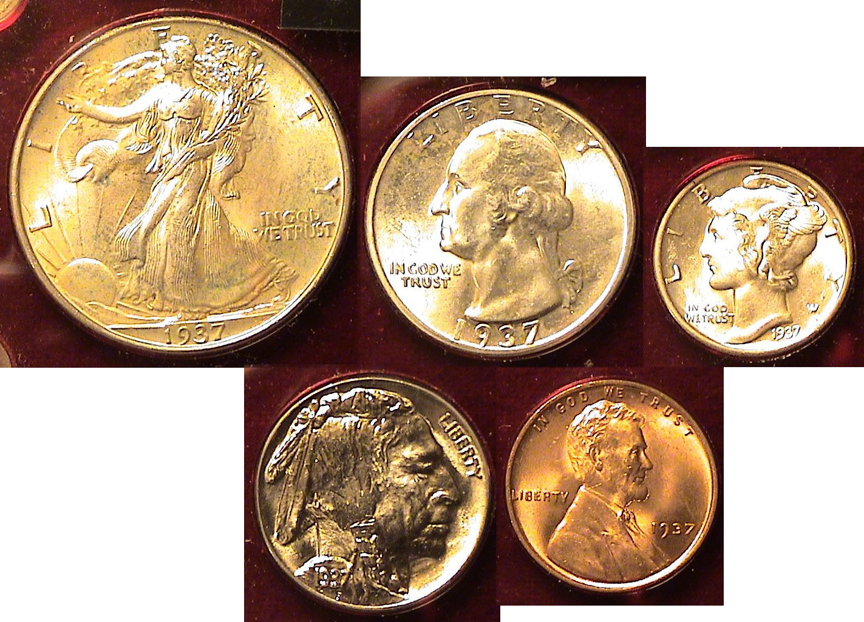

The obverses of a BU 1937-P Year Set in actual size when printed

The US Coinage of 1937 continued to reflect a combination of past artistic grace along with allegorical history and political statesmanship begun in 1909. With the suspension of all gold denominations after 1933 and silver dollar coinage after 1935, only five denominations intended for circulation out of the original ten authorized by Congress in 1792 remained. These included the cent, nickel, dime, quarter and half dollar.

In 1937, our nation was still in the throes of the Great Depression although it had risen somewhat from its depths that confronted Franklin Delano Roosevelt when he took the oath of office as President on March 4, 1933. In that year, 25% of America’s workers were unemployed. By 1937, unemployment had dropped to 14% but was still high. Despite this, FDR was re-elected in 1936 by the greatest plurality and electoral majority up to that time. When he stepped before the microphones to give his second inaugural address on Jan. 20, 1937 he intoned, “I see millions denied education, recreation, and the opportunity to better the lot of their children…I see one-third of a nation ill-housed, ill clad, ill nourished…”
During bad economic times, coin mintages drop severely. but by 1936, the mintages of our five coins almost reached record levels with only slightly less being produced in 1937.
______________________________________________________________________________________________________________________
(Continued on page 2, column 1)
Collecting the US Coins of 1937: 75 years Ago
(Continued from page 1, column 2)

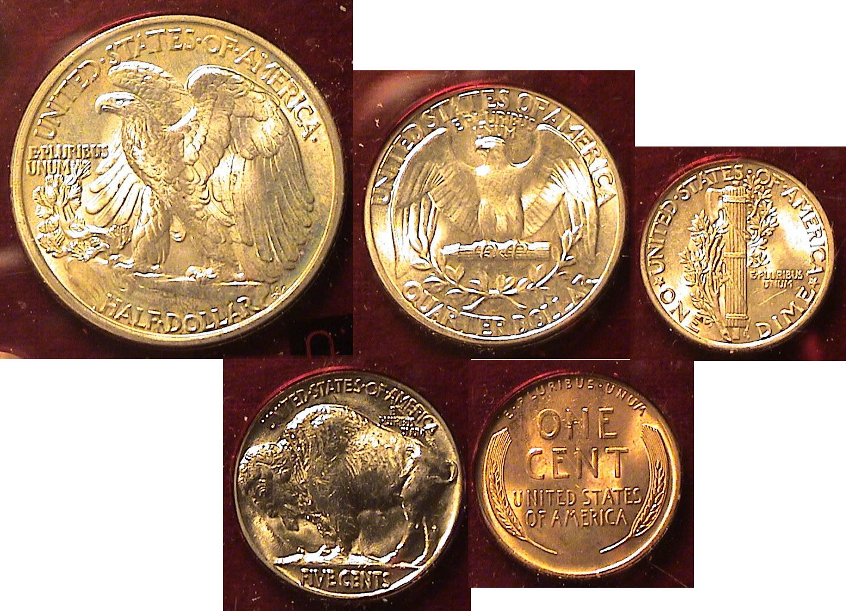

The reverses of a BU 1937-P Year set in actual size when printed
[Use 3X glass or magnify to 200% to view details]

In 1937, all five denominations were struck at Philadelphia, Denver (D) and at San Francisco (S). There are no rarities among the fifteen coins dated for the year. The Philadelphia Mint issues grading up to MS-65 are the most common and least expensive across the board with the Denver pieces priced only slightly higher. Depending on one’s discretionary income, most collectors could afford some of the 1937-S pieces up through MS-64. For the purposes of thrift, this article will concentrate mostly on the Philadelphia Mint issues.

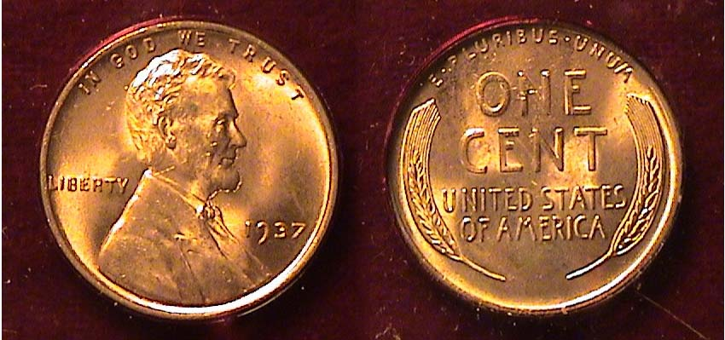

A 1937-P Lincoln Wheat cent grading MS-65 Red
[Use 3X glass or magnify to 200% to view details]

In 1937, the Philadelphia Mint produced 309,170,000 cents, almost as many as in 1936 but still a far cry from the record 392 million struck in 1919, a record that would subsequently be broken in 1941, 1942. 1943 and finally in 1944 when over one billion cents were coined for the first time. Compare these figures with the paltry number of cents coined in Philadelphia during the height of the Depression, 19 million in 1931, only 9 million in 1932 and just 14 million in 1933. With such a large mintage for its time, a 1937 cent graded MS-65 Red 1937-P cent should not be expensive to acquire. It is listed at a wholesale Bid of only $5.00 in the latest Coin Dealer Newsletter and retailing for around $9.00 according top Numismatic News latest Coin Market values.

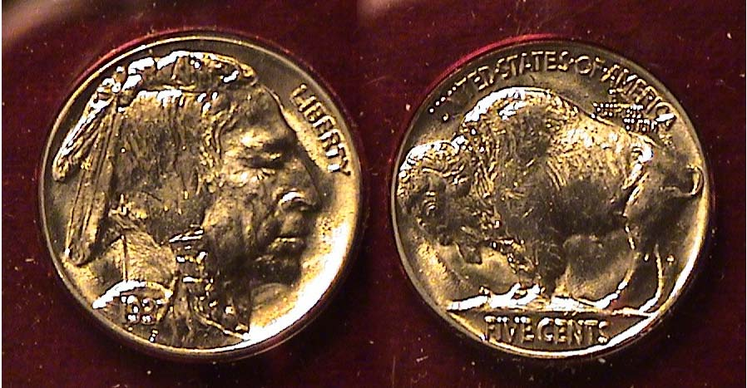

A 1937-P Indian Head/ Buffalo nickel grading MS-65
[Use 3X glass or magnify to 200% to view details]
The Indian Head// Buffalo (Bison) nickel was created by engraver James Earle Fraser and has been often regarded as “our most American of coins”. It had a 25 year tenure being produced from 1913 thru 1938. One could assemble a date set averaging MS-64 from 1913-1937 for the Philadelphia issues concluding with the 1938-D and not have to lay out a lot of cash in the bargain. The branch mint issues struck before 1928 are another matter. No nickels were made in 1922, 1932 or 1933.

With a mintage 79,480,000, the 1937-P issue is one of the most common dates. It is Bid priced at $41.00 in MS-65 according to the Coin Dealer Newsletter. It retails for around $69 according to Coin Market while a MS-63 is listed at $34.
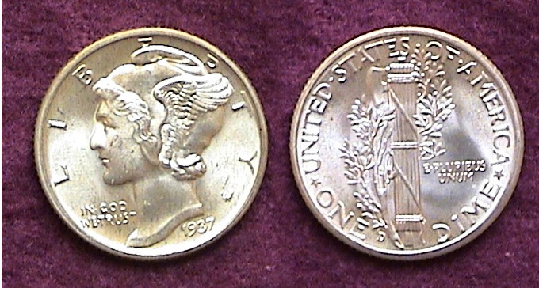
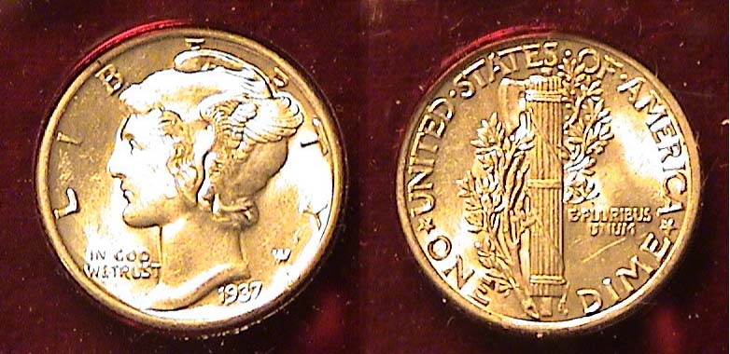
1937-P & D Mercury dimes grading MS-62 and 63
[Use 3X glass or magnify up to 500% to view details]

With the exception of the 1921-P issue, most Mercury dimes (1916-1945) struck at the Philadelphia Mint are common, especially those struck from 1934 on and are not expensive even grading MS-65. According to the 2013 Red Book a 1937-P 10c, grading MS-65 is listed at just $30.00. The reported mintage for the date was 56,860,000. Some years ago I acquired the coin shown above “raw” (i.e., uncertified because the date was too inexpensive to have certified.) Upon magnification, one will observe a scratch on the reverse. The bands are not fully split further diminishing the coin’s value, which is why the assumed grade at the time of purchase was later downgraded to MS-62. The 1937-D specimen is a tad nicer despite some minor scuff marks It has full bands on the reverse, evidence of a better strike. The mintage for the ‘37D dime as 14,146,000 and valued at $30.

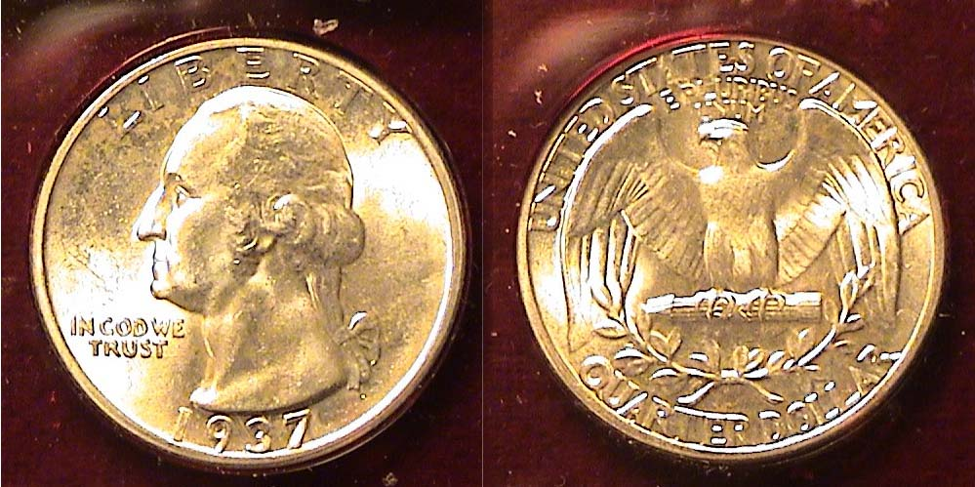

A 1937-P Washington quarter grading MS-63
[Use 3X glass or magnify to 200% to view details]

Now celebrating its eightieth anniversary, the Washington quarter is arguably the possessor of the dullest obverse design type for all US quarter types. The reverse of the original issue is far more interesting while the ongoing series of commemorative reverses for the quarter denomination--beginning with the statehood series in 1999--has unquestionably had a strong positive influence on coin collecting in America. With a mintage of 19,696,000, the 1937-P quarter is considered a common date. It is listed in the 2013 Red Book with a value of $30.00 in MS-63. One can easily assemble a P Mint silver set of Washington quarters from 1932 thru 1964 grading MS-63 to MS-65 at a modest cost. The tougher dates for the series are the 1932-D & S, the 1934-D, 1935-D, 1936-D and 1937-S.
__________________________________________________________________________________________________________________
(Continued on page 3, column 1)
Collecting the US Coins of 1937: 75 years Ago
(Continued from the previous page)

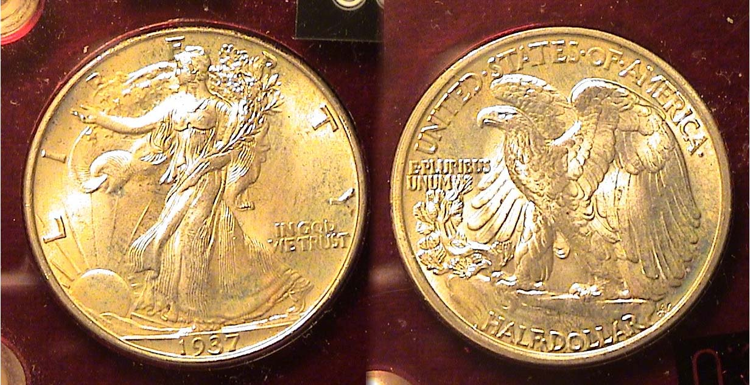

A 1937-P Walking Liberty Half-dollar grading MS-64
[Use 3X glass or magnify to 200% to view detail]

If the Washington Quarter obverse is considered one of the least interesting design types on our coinage then by contrast both sides of the Walking Liberty half-dollar are arguably the most exquisite. Engraver Adolf Weinman’s creation of 1916 in the view of many numismatic scholars equals Augustus Saint-Gaudens’ 1907 design for the $20.00 Double eagle as America’s most beautiful coin

The 1937 WL half was produced at all three Mints. The Philadelphia Mint struck the most, 9,522,000, the Denver Mint, the least with only 1,676, 000 and the San Francisco facility with 2,090,000. In terms of value the 2013 Red Book under its MS-63 column lists the 1937-P at $70, the 1937-D at $300 (2012 edition) and the 1937-S at $210.

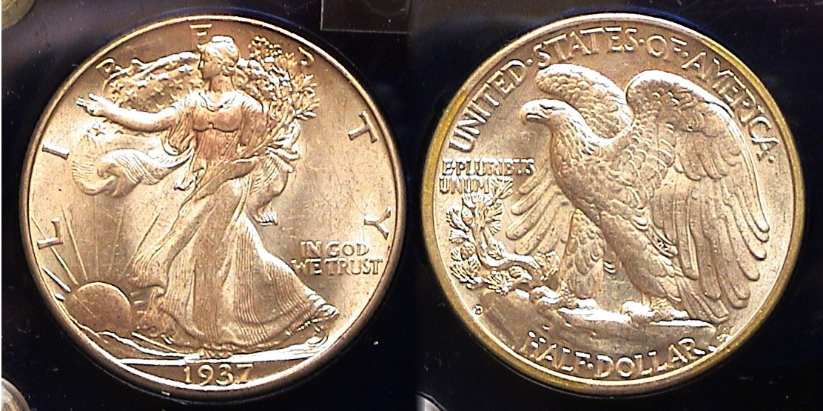

A 1937-D Walking Liberty Half-dollar grading MS-64
[Use 3X glass or magnify to 200% to view detail]

The WL half represented our nation’s 50c denomination from 1916 thru 1947, a span of 32 years. yet during its tenure it had an uneven existence. It was issued at all three Mints from 1916 thru 1921 inclusive. None were coined in 1922. the SF Mint produced halves in 1923, ‘27, ‘28 and ‘29. After 1921, no halves were coined at the Denver until 1929. The Philadelphia Mint had an even longer hiatus as the coinage of 50c pieces wasn’t resumed until 1934, a lapse of fourteen years. Half dollar production ceased altogether in 1930, ‘31 & ‘32. Once resumed the coin was struck at the Philadelphia Mint in consecutive years thru 1947, to the end of the run.
A collector interested in building a 1937 year set today has several options depending on one’s budget. Since none of the coins are rare, one could attempt to acquire a set from all three Mints. The 15 coin set is probably doable in grades averaging between AU-58 and MS-63. Another option is to acquire a set from one of the three Mints averaging MS--64 , the Philadelphia Mint issues being least costly. but with this caveat, Buy only certified specimens. For those` attempting to acquire a balanced circulated set, say averaging XF-45 to AU-58, one could look for problem-free “raw” coins and insert them into five-denomination slotted Lucite holder similar to the one shown below. Some are still available at dealer’s shops.

After ¾ of a century, one would think a 1937 Year set of BU coins would be beyond the reach of most collectors but this is not the case because starting in 1934 dealers began stocking mint state rolls of uncirculated coins that they could purchase at face value.. Despite the Depression or because of it, a new wave of collectors began to emerge and dealers found a ready market for the latest year sets as they left the Mints.

A roll of BU Lincoln cents and Mercury dimes consisted of fifty coins, a roll of BU Buffalo nickels and Washington quarters, 40 coins and a roll of BU Walking Liberty halves, 20 coins.
a Bu roll of Lincoln wheat cents cost 50c,
a BU roll of Buffalo nickels, $2.00,
a BU roll of Mercury dimes, $5.00
a BU roll of Washington Quarters cost $10.00 and
a BU roll of Walking Liberty halves cost $10.00

Apparently the supply of these uncirculated coins from the 1930s and later years was sufficient to keep the prices within the affordable range of moderate income collectors. This includes the Walking Liberty half dollar which had the purchasing power then of what $7.60 can buy today. Since the mid 1970s most of the scarcer uncirculated Branch Mint Walking Liberty halves have risen in value disproportionately to the P Mint issues with the result that dealers submit uncirculated 1937-D and S halves for certification in order to realize the higher prices they bring in today’s numismatic market.

Year sets represent a time capsule of history and 1937 was a memorable year .It was the year of the Hindenburg disaster when the Zeppelin exploded in flames killing 36 people at Lakehurst, NJ on May 6. On the other side of the country, he Golden Gate Bridge spanning the San Francisco Bay opened on May 27. In Chicago, Joe Louis became the new Heavyweight Champion knocking out Jim Braddock in the eighth round on June 22. On July 2, Amelia Earhart’s plane was `reported missing over the South Pacific. She had been the first woman to fly across the Atlantic Ocean. Big labor made gains when the Supreme Court upheld the Labor Relations Act but FDR lost his attempt to pack the high court with an additional judge once a sitting justice reached the age of 70 when the Senate rejected his plan by a whopping 70 to 20 margin.

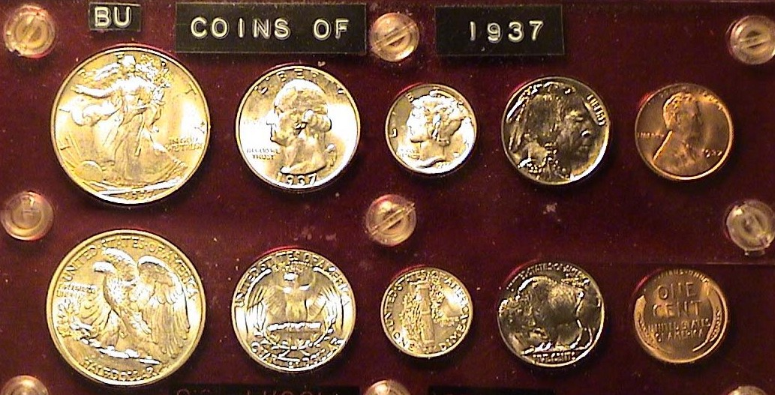

A 1937-P Year set housed in a Capital Lucite holder (reduced in size)
[Use 3X glass or magnify to 200% to view details.]
______________________________________________________
A Brief History of Sasanian Coinage
By James R. Barry

[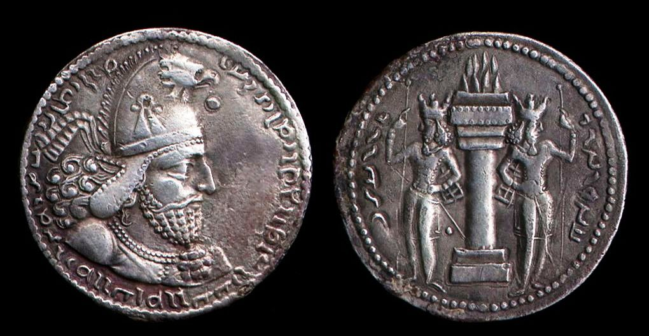
___________________
_Shapur I drachm ruled from241-272 AD
[Use 3x glass or magnify to 200% to view details]

In 224 AD, the Sasanians`replaced the Parthians in the area that is now largely Iran. Like their predecessor the Parthians, the Sasanians continued to threaten the Eastern Roman frontier. After Alexander, the Great’s military successes in the region during the third century BC, the Parthian people who replaced Greek rule, borrowed their coinage from t5he Greeks. The Parthians apparently chose not to return to the coinage of the earlier Persian Empire.

In fact, the Sasanians continued to strike coins that were called drachms. However, the Sasanian coins bore little resemblance to their earlier Greek counterparts. While these Sasanian drachms are interesting in their own right, the classic beauty of their Greek counterparts is nowhere to be found.

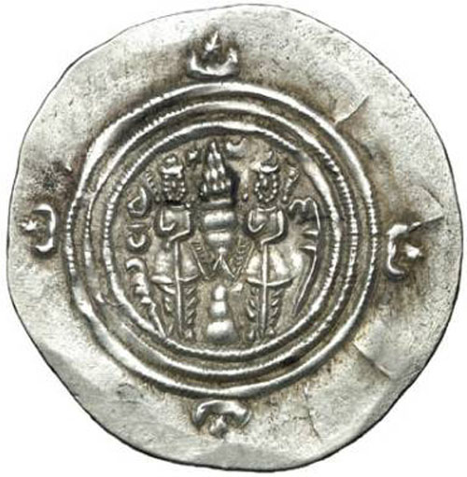
Typical Sasanian coins usually illustrate the Bust of the king on the obverse, usually in eastern adornments characteristic of the period. The reverses of Sasanian coins depict a fire alter with two attendants. The Sasanians were worshipers who practiced a religion called Zoroastrianism. As with both earlier and later peoples, their coins reflected their religion’s practices. The ornamentation of their drachms tended to be highly stylized and the coins were produced on thin planchets.

Thin planchet rev.

During the rule of Shapur I (241-271 AD), numerous battles were fought between the Roman legions and the Sasanians. In 260 the Roman Emperor Valerian was defeated by Shapur I and Valerian was` taken captive. It is believed that the treasury that was carried with the Roman emperor as payment for his troops was also taken by Shapur. The Roman coins were supposedly melted down and made into Sasanian drachms.

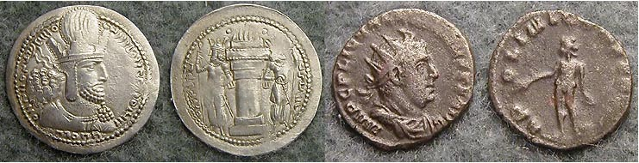

Shapur I drachm (left) & Valerian Roman antoninianus (billon)
(Or double denarius) (right)
[Use 3x glass or magnify to 200% to view details]

While Valerian lived, he was subjected to personal humiliations. Among these was being forced to act as a footstool when Shapur mounted his horse.

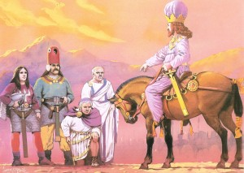

The defeated Valerian kneels before the victorious Shapur I

Upon his death Valerian was flayed and stuffed with straw and paraded as a trophy of war,

Eventually, the Sasanian empire weakened after Shapur's successor Varahran II was forced into a humiliating peace with Rome.

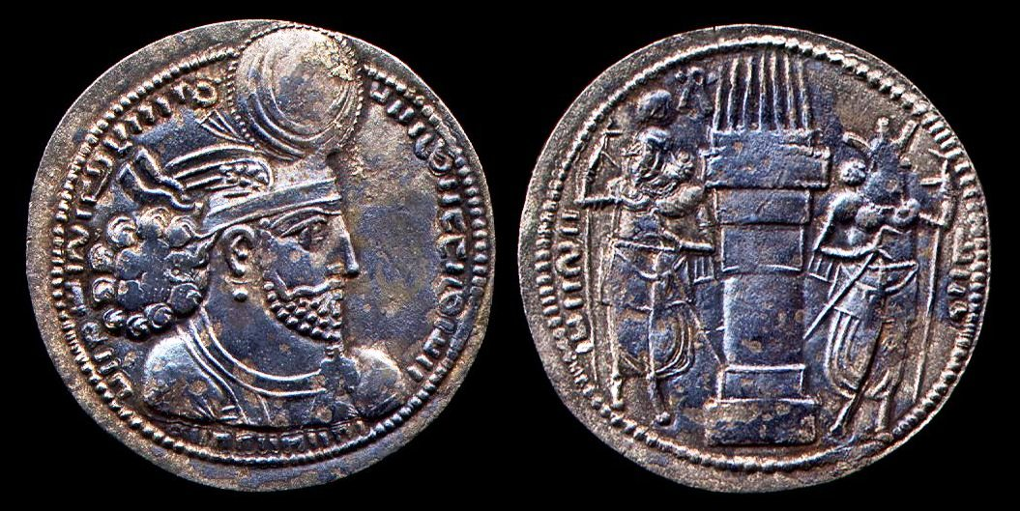

Drachm of Varahran II

The Sasanians recovered under the rule of Shapur II and during further conflict with Rome, the humiliation of Sasanian kings were wiped out. Because of continuous warfare with their neighbors and` excessive taxation of its citizens, the Sasanian empire eventually fell to the Moslem Arabs in the 7th century.

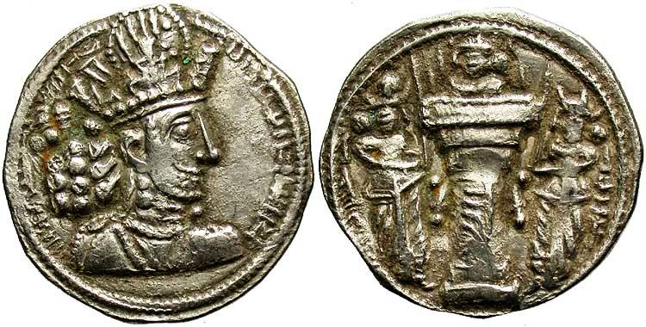

Drachm of Shapur II

Among the coins of the early people of this region, namely the Baktrians, Parthians and Sasanians, the Sasanian coinage seem to be the least popular today. As a result, they can usually be purchased by collectors for a modest sum. Nevertheless, as ancient coins attract more collectors--both here and abroad--Sasanian pieces may prove to be “sleepers” among today’s ancient coins.
________________________________________
(Jim Barry is primarily a collector of Ancient coins and
does research on less well-known periods of antiquity.
Thanks, Jim for sharing this fascinating topic with the members, ED.)

More Club News

The July 5, 2012 meeting was called to order at 6:45 PM by President Steve Kuhl. Secretary Jim Mullaney’s Minutes for the previous meeting were waived, a copy placed on file. The Club Treasury balance was reported at $1,645.33. The transition from our outgoing treasurer to our incoming one is still a work in progress as signatures for bank transactions have to be switched.

Jim Barry gave a report on the upcoming ANA World Money Show scheduled for August 7 thru 11 in the City of Brotherly Love, Philadelphia. A number of SJ CSRA CC members are planning to attend and are expecting to take in a tour of the Philadelphia Mint while there.

For those unable to attend the ANA extravaganza, the Blue Ridge Show held in Dalton, GA scheduled for Aug. 17-19 was a recommended alternative. Meanwhile President Kuhl reported that our own club show scheduled for Sat. Sept. 8 at the H. Odell Weeks Activity Center is moving along nicely.

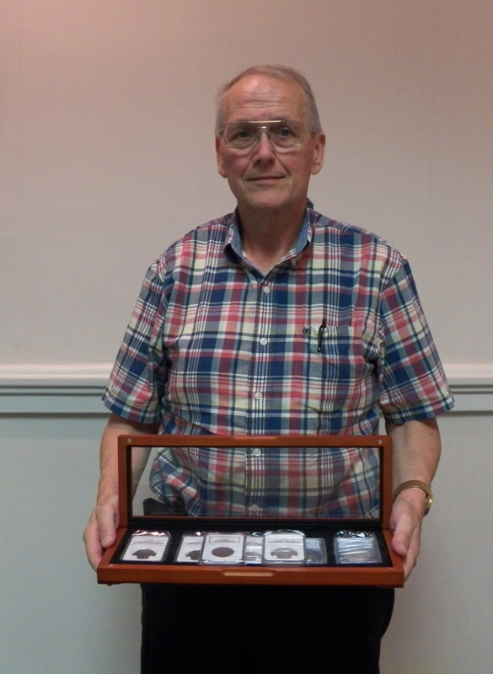
There were three Show & Tells: Rick Owen started putting together a set of US coins from 1846, a century before his birth. These included an 1846 large cent, Liberty Seated Quarter, half dollar and dollar.

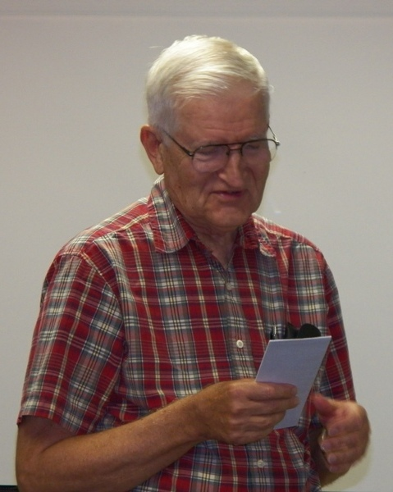
Jim Barry brought in Roman coin of the Emperor known as Caracalla, the Gladiator who ruled Rome from 198 to 217 AD. He introduced the copper double-denarius that came to be known as the antoninianus.
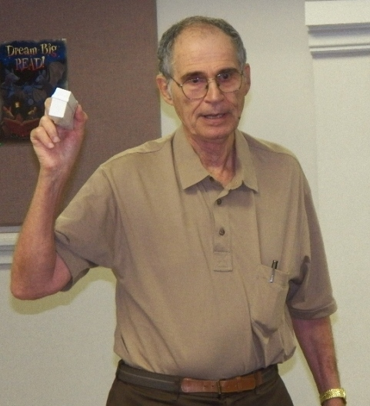
In honor of the “Fourth of July” holiday, Arno Safran brought in four Gallery Mint replicas of our nation’s first crown-sized coin, the 1776 Continental dollar, each struck in a different alloy, silver, pewter, copper and brass.

The program: VP Pat James obtained a video from the ANA Library called “Old Man Dodge and His Coins” Charles “Bud” Dodge was born in 1930 and died in 2006. As a young man, he joined the Navy and served as a Chief Petty Officer during World War II. During his travels, he became interested in World Coins and began assembling sets from different countries (including the United States). By the time of his death, several rooms in his home were filled with albums, cases and cabinets of thousands of coins from all over the world. He was an excellent cataloguer and knew where every item was.

The photographs depicting club activities are an important part of this Newsletter and the editor thanks Helen Barry for providing this service on a regular basis. The Prize- winners at the July 5 meeting were Liz Goergen who won the door prize, a 1957 Proof Franklin half-dollar and Rick Owen who won the 50/50 - $9.00. Congratulations Liz and Rick. Our next meeting is Thursday, Aug. 2. There will be a program by Walter Kublius, (See page 1, column 1). Show & Tells are always welcomed and Glenn Sanders, returned from his well-earned vacation will be on hand to conduct our monthly auction. Hope to see you there.
_________________________________________________________________________________________________________________________

Kindly Patronize our Advertisers
