Pres. Willie Simon
V .P. James Barry
Sec. Helen Barry
Treas. Pat James
Sgt. in Arms: J.J. Engel
Committees:
Programs: James Barry
Show Chairman: JJ Engel
Newsletter: Arno Safran
E-Mail: arnosafran@comcast.net
The Stephen James
CSRA Coin Club of Aiken
P.O. Box 1739
Aiken, SC 29802
Web site: www.sjcsracc.org
The SJ CSRA CC Now Meets on the 2nd Thursday of the Month at the Cedar Creek Community Center in Aiken, SC

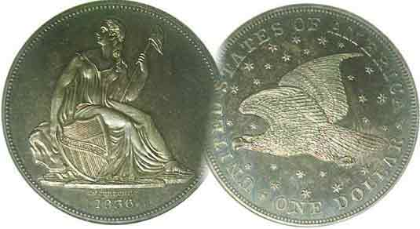

Volume 6, Number 9 the Stephen James CSRA Coin Club, Founded in 2001 September, 2007
Monthly Newsletter
Annual Club Show is Saturday, September 15
Our next meeting is on the 2nd Thursday of the month, Sept. 13, 2007 at 7:00 PM

2007 Club Meeting Schedule - 2nd Thursdays at 7 PM Jan. 11 Apr. 12 July 12 Oct. 11
Feb. 8 May 10 Aug. 9 Nov. 8
Mar. 8 June 14 Sep. 13 Dec. 6
Annual Club Show: Sat. Sept. 15, 2007
_____________________________________________________________________________________________________________________________
Club Show Arrives two days after Next Meeting

As with every club show there is a lot of preparation. Most of the effort is borne by the General Show Chairman, in our case, J.J. Engel who is serving nobly for the second year in a row. His main task is to attract dealers to take tables; send out contracts and arrange for Security. Another all important requirement is publicizing the event in the national coin weeklies and local press and media. A third is to have enough club volunteers available to help with the set up, manning the welcoming desk during the event and take down afterwards. There is a fourth way every member can help and that is selling raffle tickets $1.00 each or six for $5.00 for the three big prizes; the $5.00 gold commemorative, the latest available silver proof set and a certified BU Morgan dollar. Members should turn in the sold stubs along with the unsold tickets & stubs to the meeting on Sept. 13 or the show, Sept. 15 before 2:00 P.M. Prospective volunteers, please contact our President, Willie Simon by Email at wsimon1234@bellsout.net and thanks.

Jim Barry brought in a double denarius of Postumus. After victories in Spain and Germany, the soldiers under his command declared Postumus emperor of that portion of the Roman Empire known as Gaul, Spain and Britain. Between 259 to 268 AD, Postumus ruled these regions with distinction. Unfortunately, his ethical bearing brought about his own downfall. When he refused to allow his troops to sack the defeated army of the rebel Laelianus he was assassinated by his own men. The double denarius of Postumus was struck in Germany as a billon coin. Its silver content was only 5% yet it is rare and Jim was grateful to have acquired an attractive example at a modest cost.

Arno Safran presented a PowerPoint program featuring the US coins of 1837 continuing the transition of Capped Bust to the Liberty Seated no stars half dimes and dimes.
___________________________________________________________________________________________________________________________
(More Club News on page 4, column 1)

Are low grade Key Dates Good Investments?
By Arno Safran

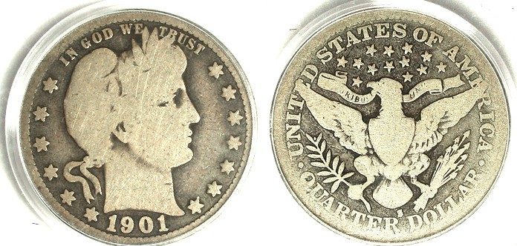

A 1901-S Barber Quarter graded Good-4 by PCGS priced at $5,795
(Courtesy of J. J. Teaparty’s Website)

Many a coin collector was lured into Numismatics by hearing stories of great rarities such as the 1913 proof Liberty nickel. With only five known specimens of this allegedly clandestine issue accounted for, people now realize their chances of finding a sixth are probably zero. But what of the many collectible key date rarities out there? Isn’t acquiring one or more still the ultimate dream of most collectors? From the 20th Century alone, there are a number of extremely popular rarities. Beginning with the Barber quarter, there’s the 1901-S and the 1913-S. Then there is the 1916 Standing Liberty Quarter and the 1918/17-S of the same type; even rarer still. Of the long running Washington Quarter series, the two scarcest are the 1932-D and S followed closely by the 1936-D. The most popular 20th century dime rarity is the 1916-D. In recent years, all these popular key date coins have soared in price across the grading spectrum and this has created a new conundrum for collectors. Is the 1901-S quarter shown above in the extremely unattractive grade of Good-4 worth the current asking price of $5,795, assuming one has the discretionary funds to afford it? The question is legitimate one when you think of the number of far more attractive obsolete US type coins that a collector can assemble for the same amount of money.

The Barber Liberty Head Quarter series (named after Charles Barber, the Chief Engraver at the US Mint from 1879-1917) was struck from 1892 through 1916 inclusive. The two most common dates for type are the first (1892-P) and last (1916-D) with Mint State-63 specimens retailing from $325 to $375.
____________________________________________________________________________________________________________________
(Continued on page 2, column 1)
Are low grade Key Dates Good Investments
(Continued from page 1, column 2)

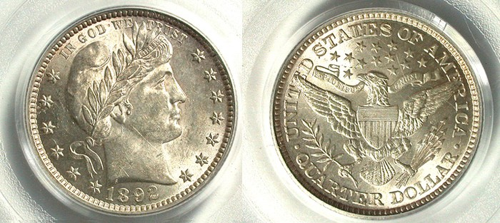

An 1892 Barber Quarter graded MS-63 by PCGS priced at $359
[Magnify to 200% for clear details.]
(Courtesy of J.J.Teaparty’s website)

The 1892 Barber quarter shown above is the second most common survivor from AU to Mint State among the relatively short series, so it is virtually the opposite of a key date in terms of desirability. Its recorded mintage was 8,236,000. As a first year issue, a large number were saved in Mint State (MS-63 or better) down to About Uncirculated (AU-50-58) which would account for so low a retail asking price of $359 in MS-63. On the other hand, specimens grading Fine to VF are quite difficult to locate. As one can see from magnifying the above photo up to 200%, an MS-63 Barber Quarter is quite attractive because all the details appear sharp and well proportioned to each other as part of Barber’s overall design.

At the other end of the spectrum, the 1901-S with a mintage of just 72,664 is scarce in all grades from Fine or better. The date is still somewhat challenging to find in problem-free condition even in as low a grade as VG-8 but below that the coin loses most of its artistic character and eye appeal. The asking price for the PCGS-Good-4 specimen shown above is a whopping $5,795 and therein lies the rub. A G-4 coin is arguably “ugly as sin” and to make matters worse, most 1901-S quarters are found in AG-3 to G-4; where the date isn’t all that scarce, let alone rare. So, here’s the question! Assuming you had the discretionary funds to purchase a 1901-S quarter at the quoted figure of $5,795, would you be willing to part with that amount of cash for such an “unattractive” G-4 coin that--in reality-- isn’t all that scarce.

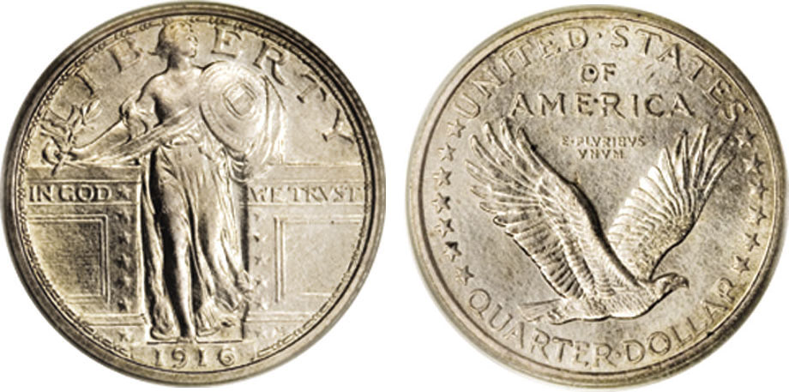

A 1916 SL Quarter graded MS-63 by PCGS
It sold for $17,250 at Heritage’s Signature auction held May 28, 2006
(Courtesy of Heritage Auctions Archives)
[Magnify to 200% to view better the details.]

Another example of questionable valuing can be found with the 1916 Standing Liberty Quarter. Grading AU-58 or better, this key date is considered as one of the most magnificent artistic design types of our nation’s coinage program. Designed by Hermon MacNeil, a disciple of Augustus Saint-Gaudens the mintage of this first year issue was a scant 52,000. A decade ago, a MS-63 SL quarter retailed for around $6,900 but due to the tremendous influx of new collectors over the past eight years, the prices realized for MS-63s have soared to $17,250 and higher such as the piece shown. The price range for an MS-63 specimen may seem exorbitant to some but compared with far lower grade examples grading VG selling in the $4,000 to $5,000 range and FINE-12’s listed over $8,000, perhaps not.

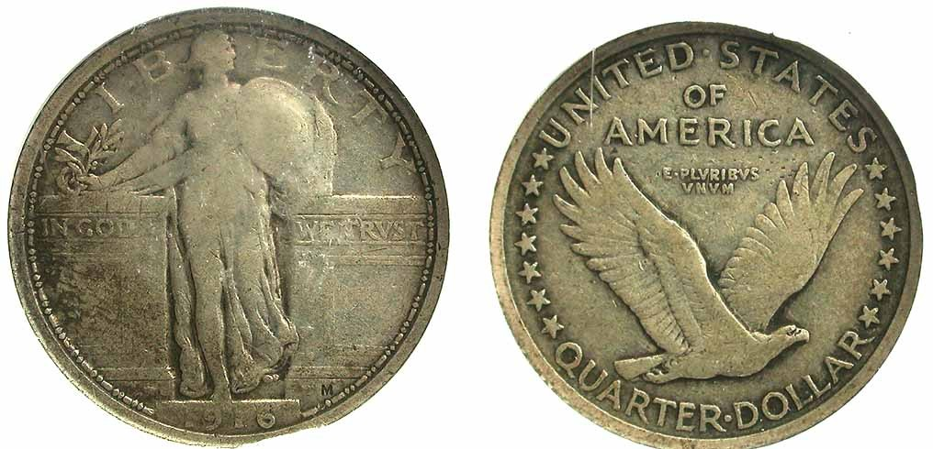

A 1916 Standing Liberty Quarter graded Fine-15 by NGC
This example was listed for sale at $8,250.
(Courtesy of J.J. Teaparty web site)

This FINE-12 grade example pictured above is currently listed at $8,250. It is priced well above what an MS-63 sold for in 1997. Besides exhibiting a tremendous amount of wear; (for example, the date is weak), the coin’s entire luster is gone and with it, it’s once resplendent beauty; what numismatists refer to as “eye appeal”. Furthermore, the 1916 SL quarter’s availability increases incrementally the lower the grade. Despite this fact, AG-3 to Fine-12 examples are currently selling in the four figures because people want to have a key date and are willing to pay whatever is necessary to obtain one.

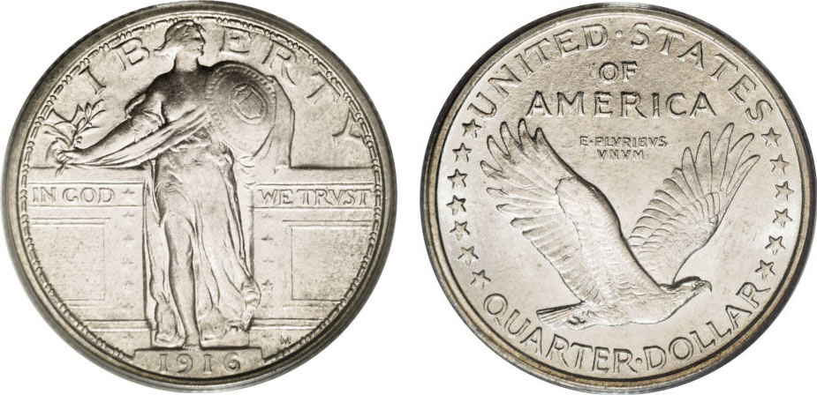

A 1916 SL Quarter graded AU-58 by PCGS
It sold for $13,800 at Heritage’s Signature auction held May 30, 2007
The coin still displays tremendous eye appeal.
(Courtesy of Heritage Auctions Archives)
[Magnify to 200% to view better the details.]

With AU-58’s priced as low as $13,800 like the specimen shown above (almost indistinguishable from the MS-63 at left) is paying as much as $4,000 to $10,000 for 1916 SL‘s grading VG to VF a smart buy?
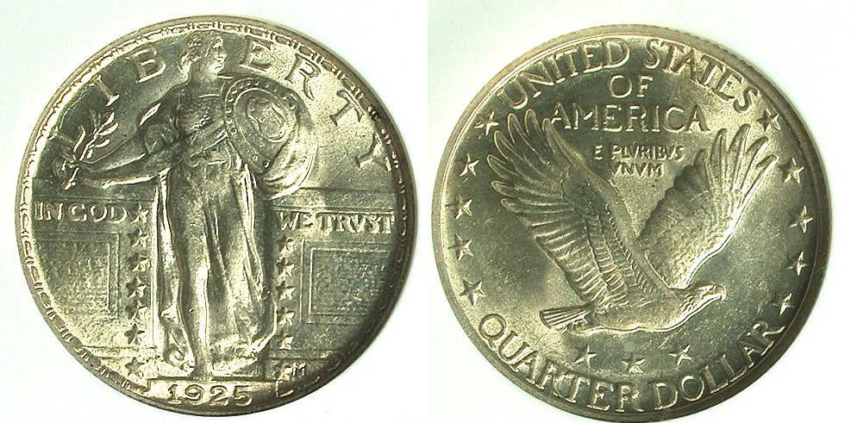

This 1925 SL Quarter graded MS-62 by NGC is listed at only $299 because its reported mintage is fairly large; 12,280,000
(Courtesy of J.J. Teaparty’s web site)

With a mintage of over 12 million, the 1925 SL quarter coin pictured directly above is undoubtedly quite common. 1925 interestingly enough represents the first year of the recessed date type known as Type III. Both the Types I and II Standing Liberty quarter sub-types were engraved with raised dates and they wore down quickly. (See the Fine-12 example of the 1916 above.) In 1925, the quarter was minted only in Philadelphia. This particular MS-62 example is very attractive at that price.
__________________________________________________________________________________________________________________________
(Continued on page 3, column 1)
Are low grade Key Dates Good Investments?
(Continued from previous page)
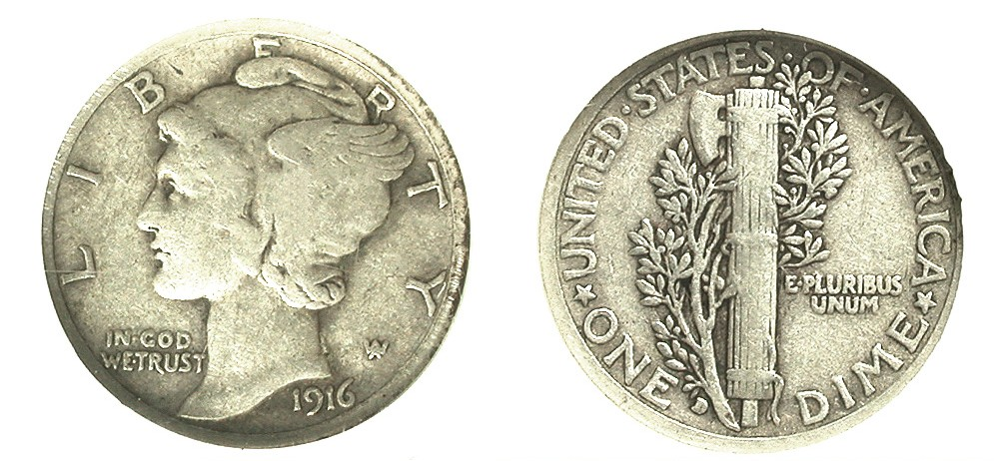

A 1916-D Mercury dime grading VF-20 by NGC
(Courtesy of J.J. Teaparty web site)

Only 264,000 Mercury dimes were struck at the Denver mint in 1916 but despite being a first year issue, not too many were saved in mint state as most went into circulation and remained so for years and years. As a result, when specimens of the ’16-D dime turn up they appear in grades ranging anywhere from AG-3 to Fine-12 at best. Many a youth of the 1930’s thru 1950’s hoped to find a 1916-D Mercury dime in circulation but few were rewarded for their efforts. Similar to Hermon MacNeil’s magnificent Standing Liberty quarter design, Adolph Weinman’s realization of the Winged Liberty dime when seen in Brilliant Uncirculated condition is a gorgeous work of art. The model for Miss Liberty was Elsie Stevens, the wife of poet Wallace Stevens who were then young tenants of the engraver.

For some reason the Mercury dime series--unlike the Barber dines type that preceded it--do not fare well below XF-45. By VF, the Winged Liberty portrait appears wan and faded; the details looking similarly vague on the reverse. As a true rarity in the higher grades, one can understand why an XF-45 to uncirculated example of the 1916-D dime might command pretty high prices. On the other hand paying in the upper three figures for an AG-3 to $4,000 for a lackluster VF-20 specimen which appears downright lifeless just to have a key date seem to be questionable judgments. Like the Stock Market, the Coin Collecting Industry runs in cycles. Super mint state grade common date modern coins have been falling in recently and when the next serious downturn occurs, low grade key date coins are likely to plunge in value as well. There are simply too many examples out there to support those kinds of prices. On the other hand, if one had purchased a 1931-S Mercury dime with fully split bands in Mint State-65 at a cost of $95 fifteen years ago its value today would have realized $2,500.

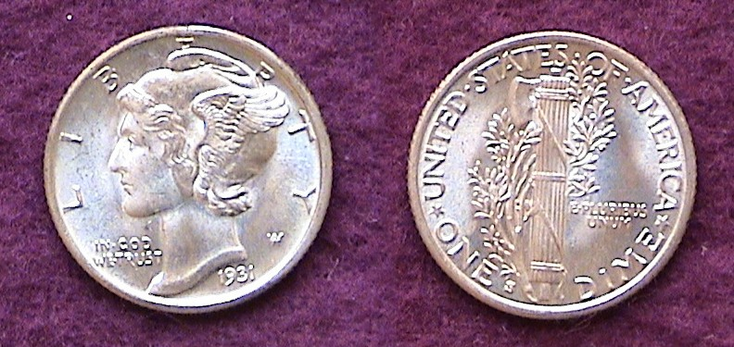

A MS-65 Full Bands 1931-S Mercury dime with brilliant luster.
While not anywhere as near as rare as the 1916-D, the 1,800,000 mintage for the date represents the sixth lowest of the series

Key date coins have another downside since they serve as “stoppers” to many collectors who endeavor to complete a series run. Imagine putting together an attractive grouping of Barber Quarters in F-15 to VF-20 except for the 1896-S, 1901-S and 1913-S which grade only AG-3; that is if one is fortunate to be able to afford the three keys.
More on other popular key dates in the next installment.
________________________________________________________________________________________________________________________
-To be continued-

Are US Mint Products flooding the market?

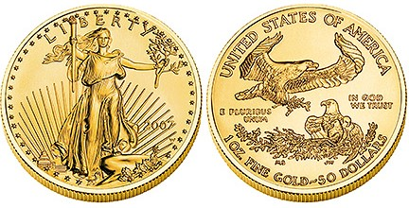
A 2007 Gold 1 oz. Eagle priced by the Mint at $749.95
[Photo, courtesy of US Mint web site]

Back in the 1960’s collectors complained about the dearth of new coin types and woeful mint offerings consisting of only the standard five piece proof and government packaged mint sets issued once a year. In 1982 with the inauguration of the George Washington 250th anniversary commemorative silver half dollar, the situation began to change. The following year, 1983, the prestige set was introduced. This consisted of a regular proof set plus the latest commemorative silver $1.00 and half dollar (if available) at a considerable increase in price over the regular clad proof set. In 1986, the four denominational gold (the 1 oz, ½ oz. ¼ oz & 1/10 oz) and $1.00 silver eagle bullion series began. The obverses for these coins were not new but drawn from Saint-Gaudens’ resplendent $20.00 Double Eagle (1907-1933) for the gold offerings and Adolf Weinman’s exquisite Walking Liberty half dollar (1916-1947) for the one ounce silver dollar coin. In 1992, silver proof sets were added at a higher cost along side the clad. In 1997, the Statue of Liberty obverse proof platinum multi denominational coin series was introduced along side proof issues featuring different reverses each year. In 1999, the statehood quarter program was begun; arguably, the most significant piece of coinage legislation enacted since the Coinage Act of 1965 as it reenergized the hobby industry. From 1999 on five statehood quarters have been coined each year. Meanwhile a whole plethora of commemorative issues continued to be issued in clad, silver and gold ($5.00 or $10.00). In 2006, the Mint produced a new $50.00 gold bullion coin replicating James Earl Fraser’s Indian Head/ Buffalo designs that once appeared on the 5¢ nickel (1913-1938). Finally, in 2007, the Presidential “golden” dollar series was introduced accompanied by the First Spouse $10.00 Gold bullion issues; four coins to be offered annually.

With the bullion issues attached to the higher prices precious metals have been enjoying in recent years, the amount of money required for one to collect all of the Mint’s yearly offerings has reached exorbitant heights. As a result, most Americans have been priced out of acquiring the $10 First Spouse and the $50 gold Indian Head/ Bison reverse bullion coins, not to mention the regular annual gold and platinum four denomination sets. The First Spouse coins will undoubtedly rise in value due to their limited mintage. It matters not whether one is a conservative or a liberal to recognize that these offerings are a boondoggle for the wealthy and the US Mint. So, with all these annual Mint products being thrust on the people, how much discretionary income is left to acquire the obsolete type coins that attracted many to enter the hobby in the first place?
_________________________________________________________________________________________________________________________
More Club News
(Continued from page 1)

The Program: Arno’s presentation consisted of images depicting sketches leading to the final realization of the 1836 Gobrecht dollar; the coin that initiated changeover to Liberty Seated silver coinage from the previous Capped Bust design type. Among the images shown were the two major 1837 Coronet sub-types; plain and beaded hair cord, the Capped Bust and Liberty Seated no stars half dimes and dimes, the reduced size no motto 1837 Bust Quarter and Reeded edge half dollar, the two 1837 Classic head gold $2.50 and $5.00 (courtesy of Heritage’s Auction Archives web site collection) and the 1837 ½¢ Hard times token; an unofficial issue featuring a Spread Eagle on the obverse with the inscription ONE HALF CENT OF PURE COPPER on the reverse.

Treasurer Pat James reported a balance in the club’s treasury of $1,133.45. Thanks, Pat! The prize winners were Jerry Axner who won the silver eagle attendance drawing and Jack Seech who won the 50/50. Congratulations gentlemen. The next meeting will be on Thursday, September 13 starting at 7:00 PM. Bill Myers, who recently returned from a year long tour of duty in Iraq, will present a PowerPoint program on Iraqi Numismatics: Part One. Earlier arrivals can check out some of the coins and paper money, dealers have brought in and the auction lots. Hope to see you all then.
__________________________________________________________________________________________________________________________

Coin of the Month
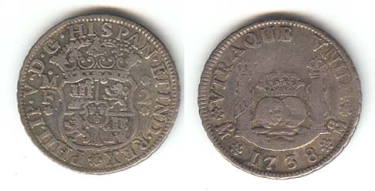
A 1738 Pillar 2 Reales of Philip V of Spain struck
at the Mexico City Mint. The coin was sold as a VF-20

Back in the early 1990’s I began collecting 18th and 19th century colonial Latin American crown size coins that were legal tender in the United States because even then, Bust dollars from the late 18th and early 19th century were so expensive by comparison. After a while I began to search out the availability of the minors (coins whose legal tender were 25¢ or less) and discovered that despite their low retail prices, dealers seldom brought them to shows. I asked why and was told that most foreign coin collectors like the crowns size coins much the way many US collectors prefer Morgan dollars and it wasn’t practical to load up on minors. Of course, that explanation turned out to be partially true because minor Latin American coinage circulated heavily among the Hispanic American countries during colonial times and high grade survivors have become very hard to find. The 2 Reales piece shown above has ostensibly the same design as the famed Pillar dollar known by a number of names; milled dollar, Piece of Eight, 8 Reales and Peso. It was graded VF by the dealer and while the coin does not fall within the Choice VF category; (e.g., US VF-30 or 35), it appears “original” and attractive considering the price was $90.
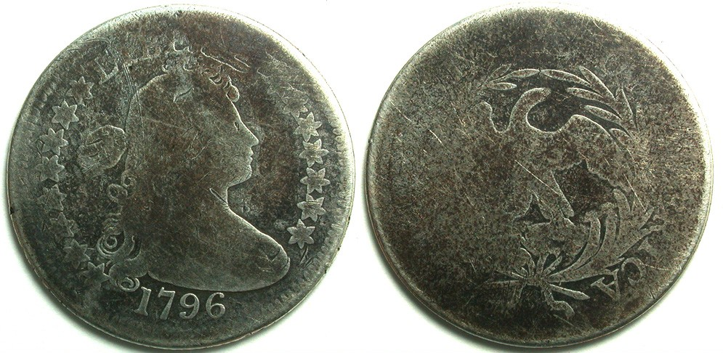

A 1796 Draped Bust Quarter graded AG-3 listed at $6,995
(Courtesy of JJ Teaparty’s web site)

By contrast, the 1796 Draped Bust quarter had a reported mintage of just 6,146, so there is no question regarding its rarity. It is in high demand which accounts for the exorbitant price of $6,995 being asked by one of the major national coin retailers. The problem is, the coin looks downright hideous. It’s black, corroded and graded AG-3, has little detail; wholly lacking in eye appeal. So, would you rather own the 1796 specimen for almost 7K or the VF-20 1738 2 Reales that was also legal tender here at a cost of a mere $90. Of course, some might answer, “neither! But that’s what makes this hobby great.

Kindly Support Our Advertisers
