Pres. Willie Simon
V .P. James Barry
Sec. Helen Barry
Treas. Pat James
Sgt. in Arms: Glenn Sanders
Committees:
Programs: James Barry
Show Chairs: The Barry’s
Newsletter: Arno Safran
E-Mail: arnosafran@comcast.net
The Stephen James
CSRA Coin Club of Aiken
P.O. Box 1739
Aiken, SC 29802
Web site: www.sjcsracc.org
The SJ CSRA CC Now Meets on the 2nd Thursday of the Month at the Cedar Creek Community Center in Aiken, SC

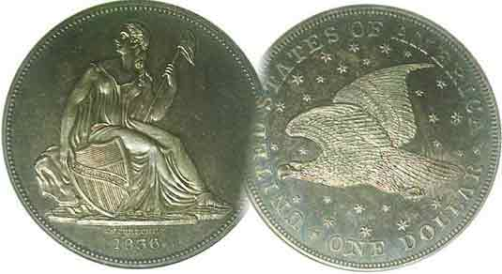

2008 Club Meeting Schedule
Volume 7, Number 9 the Stephen James CSRA Coin Club, Founded in 2001 September, 2008
Monthly Newsletter
Our Annual Club Show is coming Up Sept. 13
Our next meeting is Thursday, September 11 from 6:15 to 9:00 PM
Jan. 3 Apr. 10 July 10 Oct. 9
Feb. 14 May 8 Aug. 14 Nov. 13
Mar. 13 June 12 Sept. 11 Sept. 13 Show
___________________________________________________________________________________________________________________________

Show is Scheduled for Saturday, Sept. 13 in Aiken
At the H. Odell Weeks Activity Center
On Whiskey Road across from the Home Depot

Once again it is time for our annual Show. This year it will be held on Saturday, September 13 just two days after our upcoming meeting on Sept. 11. If you haven’t picked up your raffle tickets just yet Thursday’s meeting will be the last time to do so. Each raffle ticket donation is $1.00 but if you buy a packet of six; the cost is only $5.00. First prize is a Gold commemorative coin. The 2nd prize is a silver proof set and the 3rd prize is a certified uncirculated Morgan dollar. Bring in the sold ticket stubs with names including the accompanying ten digit phone number along with the cash collected either to the meeting on Thursday--if already sold--or to the show on Saturday no later than 2:30 PM and thanks in advance.

30 tables have been sold as of this writing. The bourse space in the Odell Weeks Activity Center is large enough to accommodate a number of additional dealers, so for those interested in taking a table, the cost is just $40 for one or $35 each for two. Contact Jim or Helen Barry by phone at 803-644-0761 or by E-mail at jrbarry@bellsouth.net. The public is invited at no charge and the show hours are from 9:30 AM to 4:30 PM with ample free parking on the premises.

Help Wanted: The center will be open at 7:00 on the morning of Sept. 13 for volunteer members who wish to help with the dealer set up. During the Show we need members to take turns for an hour or two at the welcoming table to greet arrivals and sell raffle tickets. Aside from our $10 yearly membership dues that have remained the same since the club’s inception in 2001, our annual show is our only major fund raiser. So come one, come all to our meeting on Thursday, Sept. 11 and bring family and friends with you to the show on Saturday, Sept. 13.
_____________________________________________________________________________________________________________________
(More club News continued on page 4, column 1)

Collecting Short Sets by Type: Capped Bust Silver
By Arno Safran

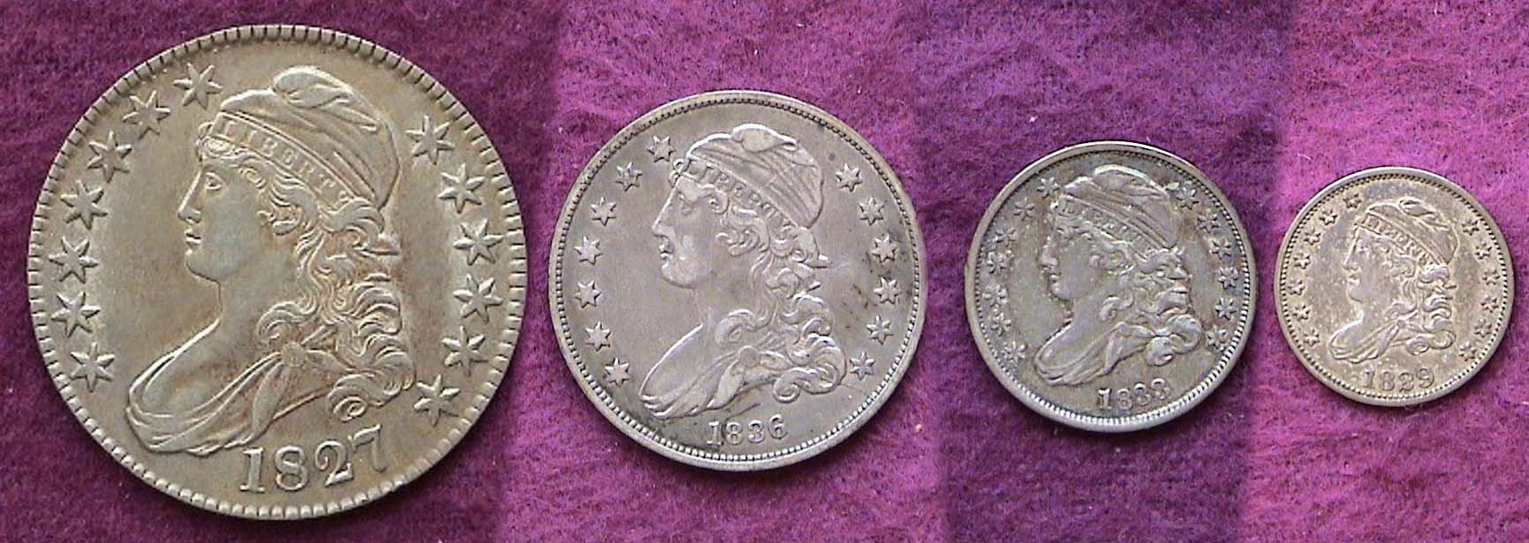

The obverses of an affordable Capped Bust Silver Type Set
From left to right; 1827 50¢, 1836 25¢, 1833 10¢ and 1829 5¢
John Reich was the primary engraver. [Magnify to 200% to view details.]

Collecting Short Sets are an affordable way to build a type set. Rather than attempt to acquire an entire 19th Century US type collection, hobbyists on a modest discretionary income would be better served by focusing in one denominational short set at a time featuring a same type as the four piece Capped Bust silver grouping shown above.

Between 1807 and 1839 the Cap Bust obverse design reigned supreme on our silver coinage. After the silver dollar was suspended in 1804 the half dollar served as our largest circulating silver coin. The lettered edge Capped Bust 50¢ (at 32.5 mm) was struck from 1807 through 1836 with the exception of 1816. Like the Morgan dollars three generations later, Bust halves were minted in the multi-millions at a time when the US population was much smaller. While they underwent more circulation than the Morgan dollar, many Bust halves survive in large numbers and in the EF range are listed from $150.

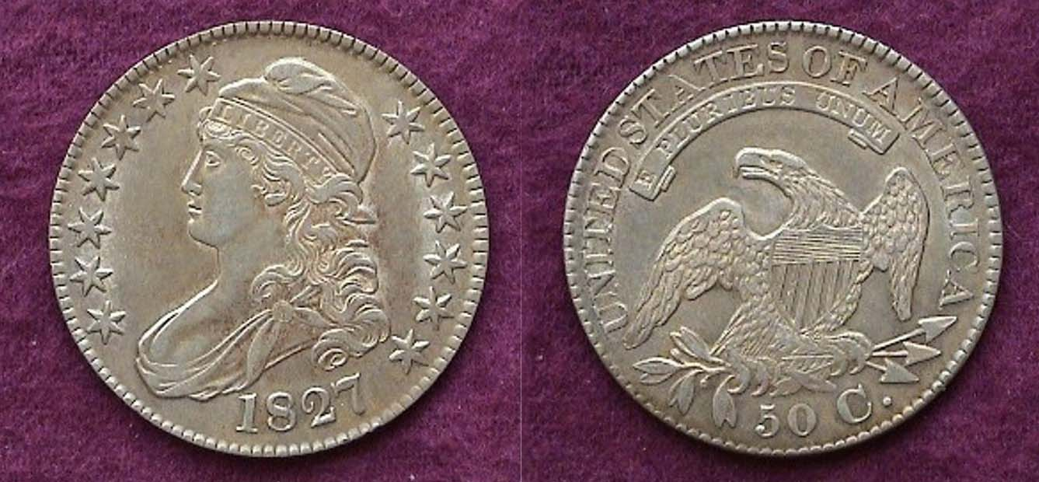.
An 1827 Capped Bust Half dollar in EF. 5,493,400 were minted.
A Capped Bust Silver Short Set
(Continued from the preceding page)

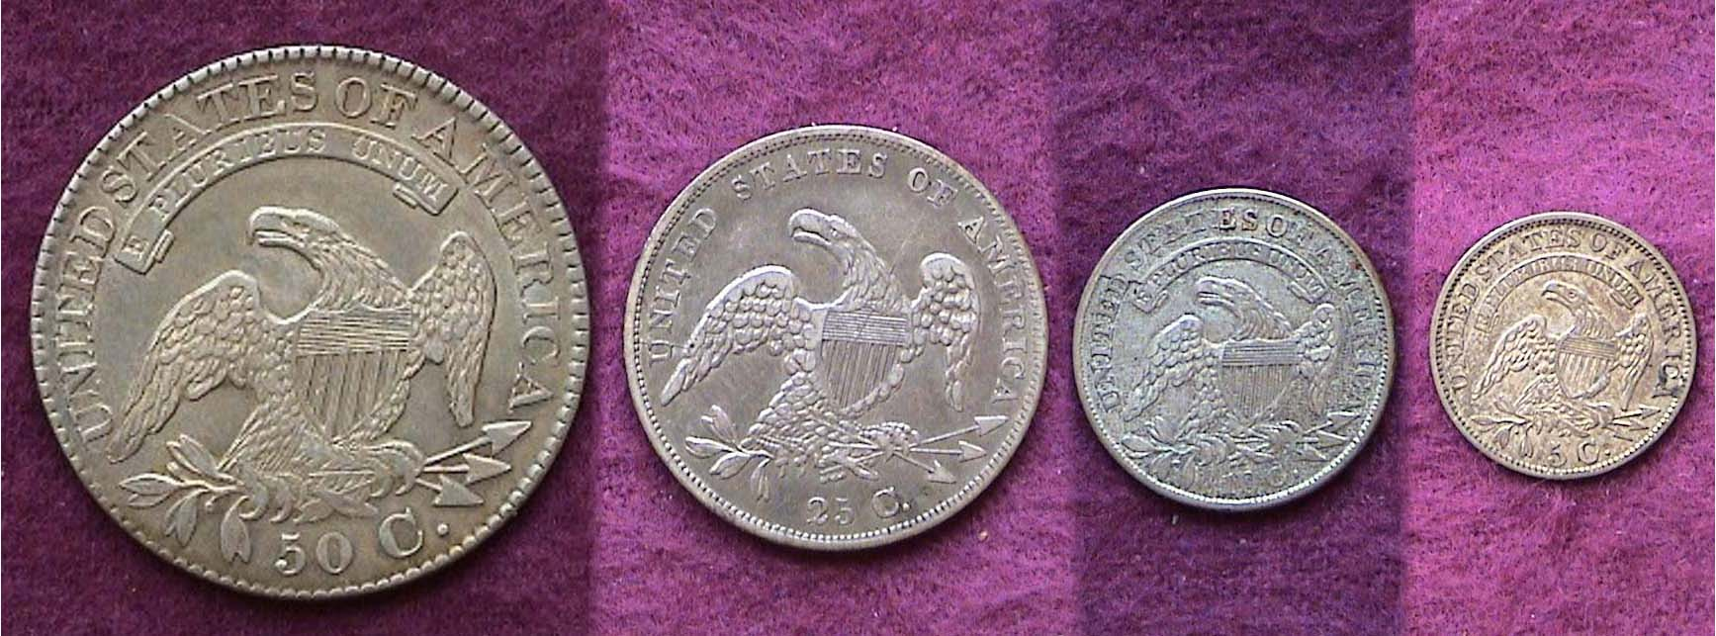

The reverses of an affordable Capped Bust Silver Type Set
From left to right; 1827 50¢, 1836 25¢, 1833 10¢ and 1829 5¢
[Magnify to 200% to view details.]

Until 1837, the eagle appeared on the reverse of all our silver coins. This spread eagle rendering of our national bird was first engraved by John Reich in 1807 and the same basic reverse design continued to appear on the Liberty Seated quarter and half dollar types through 1891; a total of 85 years.

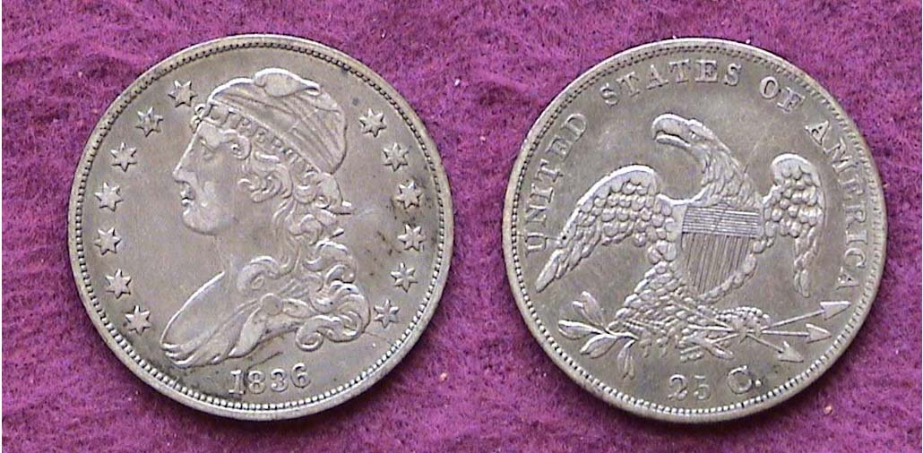

An 1836 Bust Quarter, B-2 R4, grading XF-40.
The mintage was 472,000. [Magnify to 200% to view details.]

The Capped Bust 25¢ piece can be grouped into two sub-types; the large size (1815-1828) with a diameter of 27mm and the small size (1831-1838 inclusive) that had a diameter reduced to 24.3mm, (about one inch), the same as now. Of the former, the 1818, 1819 and 1820 along with the 1825 surface more often than the 1815, 1821, 1822, 1824 and 1828. The 1823 and 1827 are extremely rare. No quarters were struck in 1816, 1817 and 1826. All dates from the reduced size quarters grading VF are priced about one-third of the large size quarters. The 1836 piece shown above was purchased a while ago but the date is still moderately priced in the VF grade range at around $140 according to the 2009 Red Book.

For those with slightly deeper pockets, one may wish to acquire a large Bust quarter grading VF-25 like the 1820 shown. Prices range from $275 to $400 (VF-35) which is why the reduced size sub-type was selected for this particular Short Set.

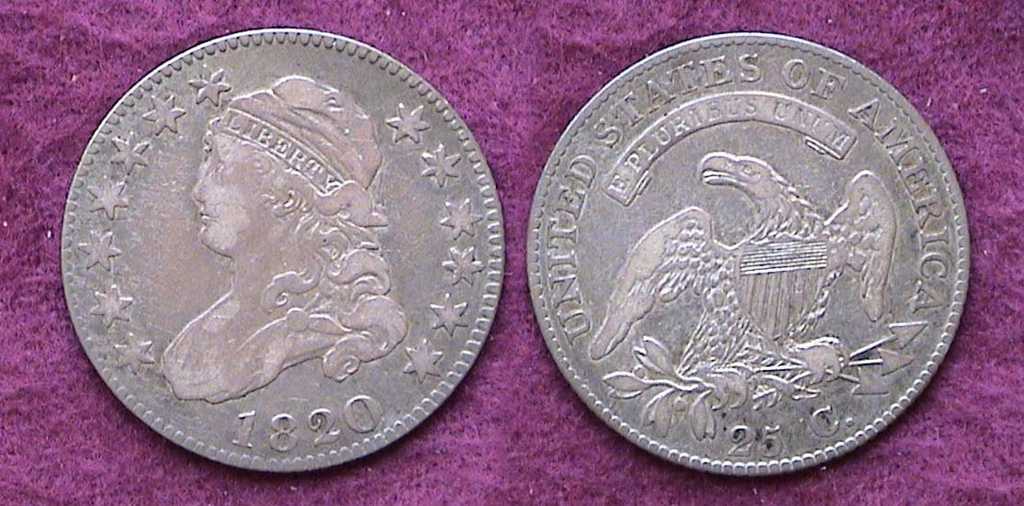

An 1820 Large size Bust quarter B-3 R4 grading VF-25
The reported mintage was 127,444 for all die varieties.
While wear is noticeable, the coin still appears original and distinctive.
[Magnify to 200% to view details.]

To see a clearer picture of the large and reduced size quarters, the two coins that were portrayed separately in column 1 are shown together directly below.

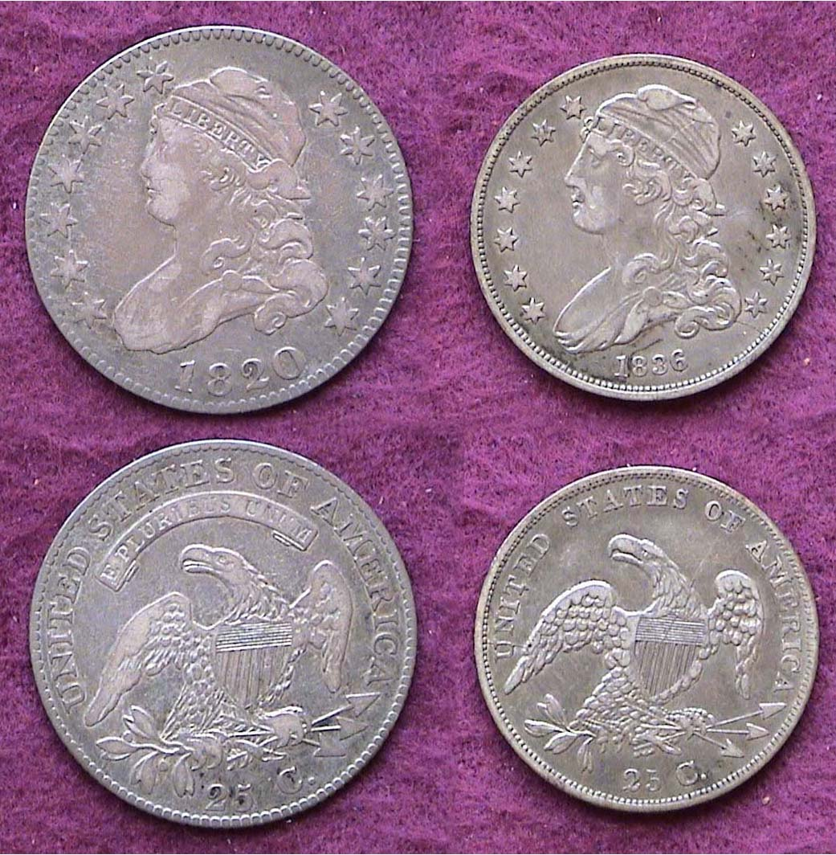

The large and reduced size quarters are shown side by side.

There are a few noticeable differences, the most obvious appearing on the reverse of the reduced size sub-type with the removal of the motto E PLURIBUS UNUM. Long before the reduced size quarter was introduced in 1831, engraver William Kneass had replaced both Robert Scot and John Reich and it was he who was asked to modify the design. The original John Reich obverse is arguably the more attractive of the two.

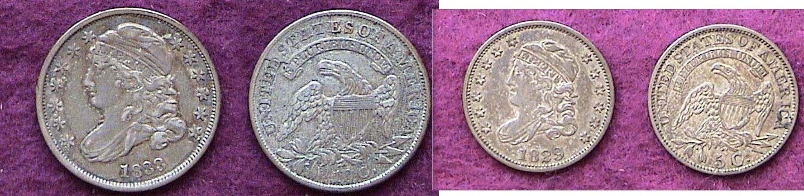

A VF 1833 dime and XF 1829 Bust half dime [Magnify to 200%]

The Capped Bust dime (1809-1837) and half dime (1829-1837) are among the best bargains in numismatics due to low demand. The 1833 dime shown had a mintage of 485,000 and the 1829 half dime next to it a whopping 1,230,000. Like the quarter, the dimes produced from 1809 through the first part of 1828 were slightly larger (18.8 mm to 19.0 mm in diameter). Those coined afterwards were struck in a close collar that was intended to produce all dimes in the same diameter. They are slightly smaller in size (about. 18.3 mm) and are less expensive (around $80 in VF).
After 1805 the half dime was suspended and was not resumed until 1829. The later type was engraved by Kneass and struck through 1837 with no changes. Most dates are equally common and affordable in VF (c. $90) and in XF (at $150.)

The Capped Bust silver series offers the collector the opportunity to assemble a short set that can still display eye appeal in grades as low as VG as long as the coins appear natural gray with a minimum of contact marks and no rim damage; in other words, just plain wear. The important thing is to form a balanced set either grading VF to EF or VG to Fine whether one opts for the reduced size quarter, the large size or both sub-types. Finally, since no key dates are involved in type collecting, completion of such a set is definitely attainable. Happy hunting!
!_________________________________________________________________________________________________________________________
2008 ANA Money Show in Baltimore, MD
By James Barry

The Baltimore ANA convention was without doubt an exciting and interesting venue for coin collectors and history buffs. As the bourse was filled with coins, paper money and exonumia, it proved to have something for all collecting interests. Naturally, there were many high end pieces for those with “deep pockets”. There was also an abundance of moderate pieces for the general collector. However, the ANA’s World’s Fair of Money has much more to offer than just coins. The opportunity to renew friendships with other collectors is a reason to attend one of these shows. Oftentimes you may not have seen some of these friends in person for more than a year.

Not to be missed are the numerous seminars and field trips that are available to attendees. Helen and I were able to visit the USS Constellation anchored in the Harbor and just across the street from our hotel. For anyone interested in the naval history of our country this was an especially informative morning adventure as there were numerous volunteers aboard the ship to share the details of the Constellation’s history. We did, however, miss getting a copper medal from the gift shop as they were completely sold out of them. I guess they had not expected so many numismatists to be in town!

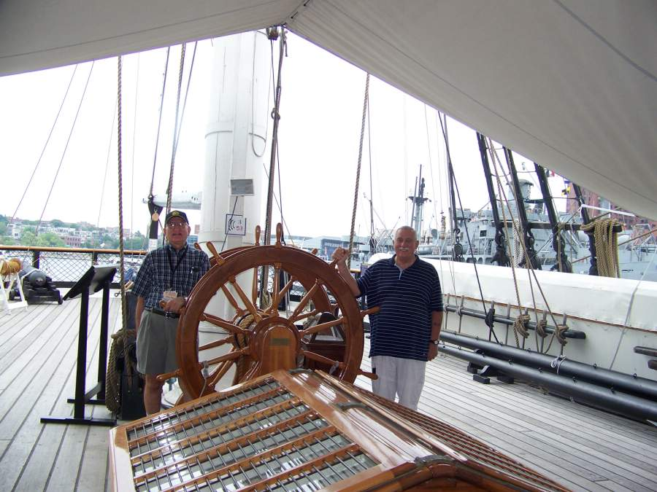

Members Jim Barry and Dick Smoot at the helm of the Constellation

Another trip offered by the ANA was to Fort McHenry. It is quite inspirational to visit the site made famous by Francis Scott Key and the birth of the “Star Spangled Banner”. The view from the fort looking out towards Chesapeake Bay was breathtaking as it must have been during the War of 1812 when British forces unsuccessfully attacked Baltimore.

Back at the Convention Center I was able to attend a session of the “Ancient Coin Collectors Guild”. This was an informative meeting that shed significant light on how the politics and bureaucracy of our country have done very little to defend the legitimate rights of collectors and, in fact, often work against us. Without help from collectors and the efforts of ACCG many dealers and collectors would be seriously harmed.

While I attended the ACCG meeting, Helen visited Jamie Franki’s program on “The Unknown Life of Edgar Allen Poe”.
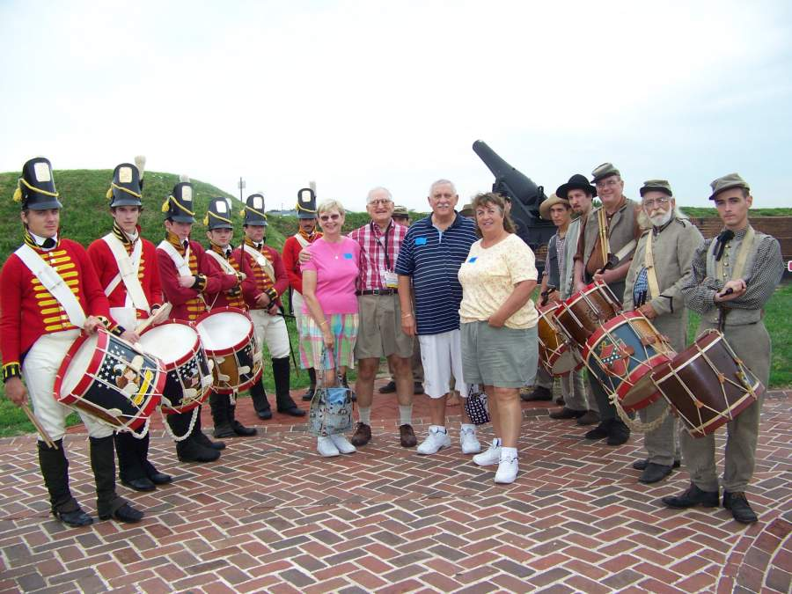

The Barry’s and Smoot’s at Fort Henry

Jamie is the designer of the convention medal. Jamie Franki, a North Carolina illustrator and teacher at UNC Charlotte had designed the new American bison nickel as part of the Westward Journey series of nickels.

Another reason to attend large shows is to take advantage of the extensive offering of numismatic books both out of print and new offerings. Since many of the authors of recently published books also attend these shows it offers a great opportunity to have them autograph a copy of their recent works. I managed to get two recently published books by Wayne Sayles signed by him. Coin supplies are another staple found in abundance at these shows.

Of course, the main reason to attend the “World’s Fair of Money” is coins or other numismatic items. With limited resources, which most of us have, it is necessary to focus on those items that we feel will meaningfully add to our collection. In such a large show this usually requires a collector to know in advance what dealers are likely to have the coins that would be of interest. In my case, I was able to find a rare coin from the reign of Severus III, 461-465 A.D. Severus was nothing more than a puppet emperor who was really under the control of Visigoths and the small gold coin I purchased appears to be struck by them. Later I also found an outstanding silver coin of Ptolemy II, 288-246 B.C... This coin will make a nice addition to my collection of Greek coins.

Helen on the other hand, made some fine additions to her collection of 18th Century Conder Tokens and modern Canadian Silver Commemorative dollars. She also picked up a couple of interesting “love” tokens.

As you might expect, we were busy all four days at the convention including evenings when we were able to dine with collector friends and share some of our daytime experiences. The reception and banquet on Saturday evening for most is the final time for collectors to gather, share their stories from previous days and honor those who receive some of the various ANA awards for their contribution to numismatics. Next year a new venue in a new city - Los Angeles.
_________________________________________________________________________________________________________________________
All photos accompanying this article and on the next page by Helen Barry, Ed.

SJ CSRA CC Members at the ANA Banquet in Baltimore

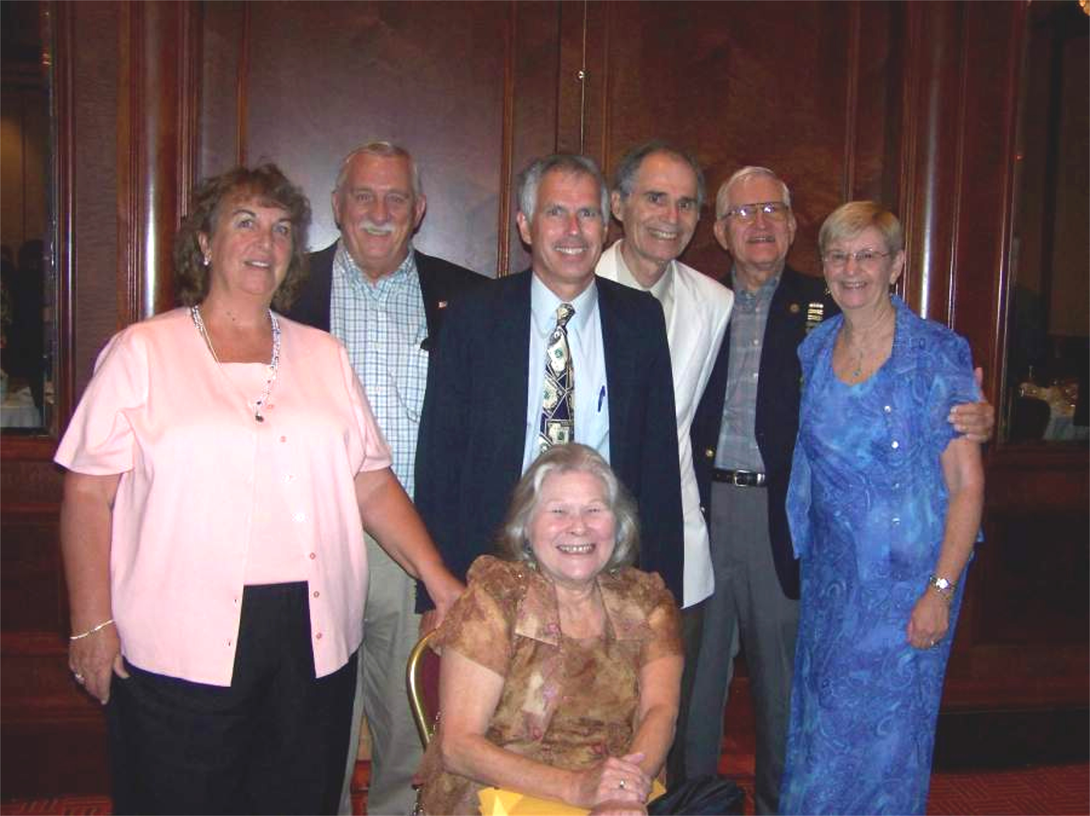

Seated is Vilma Safran. Standing, front row are Sharon Smoot, Bill Myers and Helen Barry. In the back row are Dick Smoot, Arno Safran and Jim Barry.
__________________________________________________________________________________________________________

More Club News
(Continued from page 1, column 1)

Whether it was the pleasant mid summer evening or the annual Grading Bee scheduled as the featured program, twenty-eight members and one guest were in attendance as President Willie Simon gaveled the meeting to order at 7:00 PM on August 14. That total represented a new attendance record since the club moved from the Aiken Public Library to the Cedar Creek Activity Center.

President Simon mentioned that the club newsletter won a third prize in the ANA’s Outstanding Club Publications contest for the third time and the second year in a row. Treasurer Pat James reported a balance of $1,120.52, much of the fresh income coming from dealers doing our show. Bourse co-chairpersons, Jim and Helen Barry reported twenty-one dealer tables sold as of Aug. 14 but expected the number of tables sold could go as high as thirty. Willie made another pitch to the members to post flyers for our show in various department stores and other facilities where large numbers of people congregate and to sell those raffle tickets in order to help sustain our club.

On a sad note, member Bill Myers, who is also President of the Augusta Coin Club, mentioned that he and his wife Kathy were retiring to Tucson, AZ and will be leaving the CSRA in October. No one has to be told what a loss Bill’s departure means to our club. He has presented many outstanding programs over the years along with numerous Show & Tells and is always on hand to help out at the club auction.

The Show & Tell session produced a number of interesting numismatic items. Marjorie Simons displayed two national bank notes (Series 1903 large) and (Series 1929 small) from her hometown on Vincent-town, NJ that were found in a bible; also a Bank Ledger. Young Numismatist Austin Kuhl who has been collecting for eight years brought in his 1987 thru 2000 set of uncirculated American silver eagles and Jim Barry brought in a 2008 USA Olympic dollar.

The night’s program was one in which all the members could participate. A large number of certified coins were brought in to be graded. The grades were hidden by a removable tape that VP Jim Barry brought in. A sheet was distributed for members to list the grade of each coin examined. The results were given later in the evening. Unlike previous club grading bees it was apparent from the members’ positive responses this time that many appeared to have “nailed” the grades to the exact numerical grade on most of the coins examined. This continues to be one of our more popular club meeting activities.

The prize winners for the evening included Willie Simon who won the door prize and Jack Shultz who won the 50/50. Both Austin Kuhl and Pat James won the ANA Souvenir cards that the Barry’s donated. Congratulations winners all!
_________________________________________________________________________________________________________________

Kindly Patronize Our Advertisers

