Pres. Steve Kuhl
V .P. James Barry
Sec. Helen Barry
Treas. Sharon Smoot
Sgt. in Arms: Glenn Sanders
The Stephen James
CSRA Coin Club of Aiken
P.O. Box 11
New Ellenton, SC 29809
Web site: www.sjcsracc.org
The SJ CSRA CC meets on the 2nd Thursday of the Month at the Cedar Creek Community Center in Aiken, SC

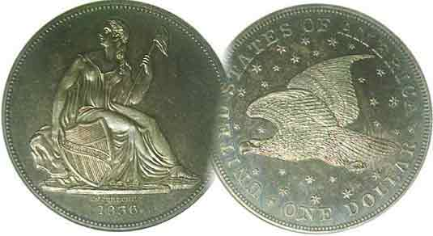
Committees:
Programs: James Barry
Show Chairs: The Barry’s
Newsletter: Arno Safran
E-Mail: arnosafran@comcast.net
Auctioneer: Glenn Sanders

2009 Club Meeting Schedule
Volume 8, Number 9 the Stephen James CSRA Coin Club, Founded in 2001 September, 2009
Monthly Newsletter
Meeting to hold 4th Certified Grading Session
Our next meeting is Thursday, September 10, 2009 from 6:15 to 9:00 PM
Jan. 5 Apr. 9 July 9 Oct. 8
Feb. 12 May 14 Aug. 13 Nov. 12
Mar. 12 Jun. 11 Sep. 10 Dec. 3

Annual Show scheduled for Saturday, Sept. 12
_ _________________________________________________________________________________________

Club to Hold Fourth Certified Coin Grading Program

With so much controversy regarding coin grading, a number of coin clubs have decided to have members bring in coins for grading by fellow members from time to time. Our club has found this to be one of our more popular numismatic programs. As a result, we are asking members to bring in either certified or “raw” coins for grading to the Sept. 10 meeting. Here is how it works. Most certified coins are inserted in hermetically sealed plastic holders that include a grade on the label which is arrived by consensus from three independent professional graders. Our program Chair, VP Jim Barry covers the assigned grade on the holder with a removable tape to hide the grade. A sheet is distributed to the member participants which include the dates and denominations of the coins submitted. The coins are then passed around and the members write next to each coin the grade they think it is. This can also be done with the few “raw” coins members choose to bring in as the removable tape can be placed over the area on the flip or stapled holder covering the grade. The “fun” comes when the actual assigned grades by either the certification companies or the consigner of the “raw” coins are revealed. How close did one come? Right on, a grade higher or lower or away off? In a few instances from past grading sessions the consensus by the club members’ appeared to show a stricter standard by assigning a lower grade than the professional grading company did. Hopefully, some time can be put aside to review some of the more controversial grading decisions made by the pros when the consensus by the members disputes their findings.
____________________________________________________________________________________________________________________

8th Annual Show at hand – Sat. Sept. 12

The annual show is the major fund raiser for our club. Please sell those raffle tickets and volunteer to help out with the set up, take down or the welcoming Desk and thank you!
_____________________________________________________________________________________________________________
(Show info and more Club News continued on page 4, column 1)

Collecting the US Coins of 1939 by Arno Safran

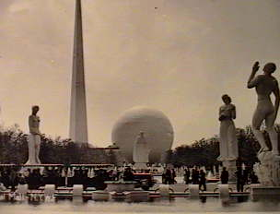

The Trylon and Perisphere at the 1939 New York World’s Fair

My brother Dan turned 70 in February of this year and my cousin Judy arrived at the same milestone in July. They don’t remember the World’s Fair of 1939 but I do. So does my older cousin Len and my late cousin Ralph who was 13 at the time when he took us to the unbelievable and futuristic NewYork City World’s Fair. The Second World War had not yet begun in Europe and our nation was still 2½ years away from Pearl Harbor but to youngsters somewhat innocent growing up during the Great Depression and politically unaware of Hitler and Nazi Germany, the fair was nothing short of awesome. So were some of our nation’s coins back then as well.

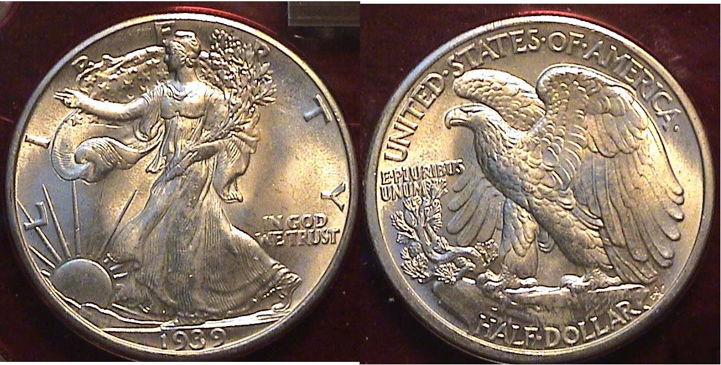

A 1939-P Walking Liberty Half dollar
[Use a 3x glass or magnify to 200% to see coin’s details.]
_______________________________________________________________________________________________
(Continued on page 2, column 1)
Collecting the US Coins of 1939: 70 years ago
(Continued from page 1, column 2)

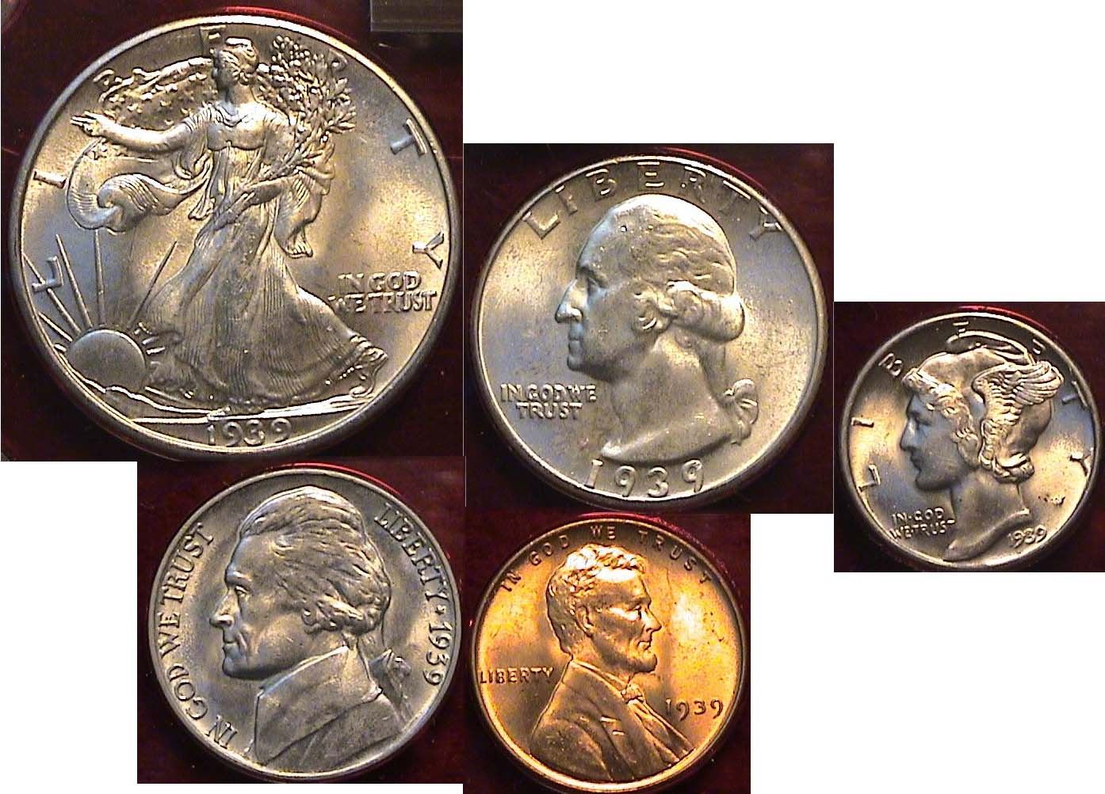

The obverses of a Brilliant uncirculated 1939-P Year Set
Despite its 70 years, this is an affordable set in BU as millions were struck for each denomination as many were saved by the roll.
[Apply 3x glass or magnify to 200% to view details,]

After 1933 the US stopped producing gold coins and with the striking of the Peace dollar in 1935, silver dollar coinage also came to an end leaving only five denominations; the cent, nickel, dime quarter and half dollar. These coins were struck at all three Mints located in Philadelphia, Denver and San Francisco and from 1936 on, most of the denominations were struck in fairly large numbers, especially those in Philadelphia. As such, most 1939 coins are inexpensive through MS-64.

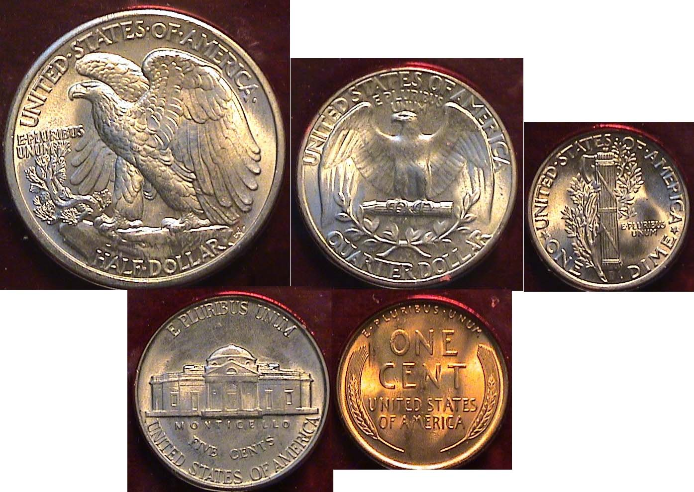

The reverses of a Brilliant uncirculated 1939-P Year Set

Looking at both sides of the Walking Liberty half dollar and Mercury dime one has to admire the artistry of Adolph A. Weinman, the sculptor who engraved both coins back in 1916. The model for these two coins was the young wife of the poet Wallace Stevens who was said to be quite beautiful. Shortly after the Stevens were married they rented an apartment in New York City whose landlord just happened to be Weinman. The sculptor needed a model to sit for his rendition of the new dime and half dollar competition of 1916 and Elsie posed for him to help defray the cost of the rent. Her husband Wallace Stevens later became a successful Insurance Company executive and wrote poetry as a means of escape from the stringent requirements of business. Along with Carl Sandburg and Robert Frost, Wallace Stevens became one of the most renowned American poets of the first half of the 20th century but it was his lovely young attractive wife Elsie whose countenance adorned the Winged Liberty Mercury dime from 1916 to 1945 and Walking Liberty half dollar from 1916 to 1947.

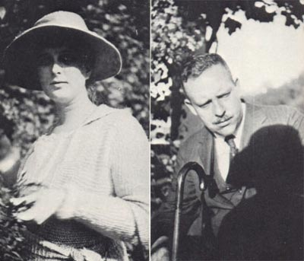

Mrs. Elsie Stevens and her husband, the poet Wallace Stevens

In 1939 the Lincoln cent turned 30. The Mercury dime and Walking Liberty half dollar celebrated their 23rd birthdays. The Washington quarter was seven and the Jefferson nickel, just one. The latter was struck in two subtle reverse varieties that year; the types of ’38 and ’40. The first variety features the steps of 1938, rounded and not very well defined while those of 1940 are framed in a narrow rectangle and appear to be sharper

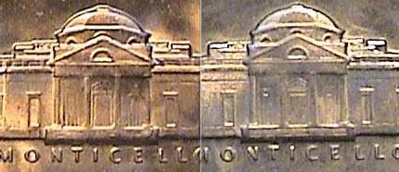

Detail of 1939 Jefferson nickel reverse subtypes
Left: steps of ’38, rounded; Right: steps of ’40, rectangular framed
[Apply 3 x glasses or magnify to 200%]

While there are no known rarities for this date, the 1939-D Jefferson nickel is still considered the key date for a regular issue of that series while the 1939-P error variety featuring the doubled Monticello on the reverse (not shown) is one of the more popular double dies in all of numismatics. Collectors may still be able to find a low grade example in dealers’ junk boxes.
A nickel had the purchasing power of almost 80¢ in 1939.

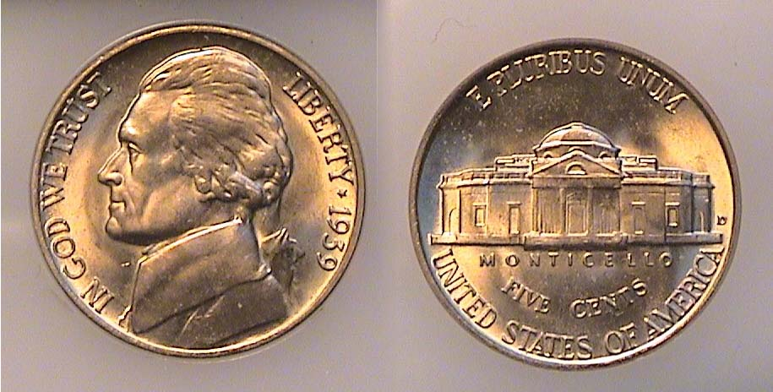

The “key” date 1939-D Jefferson nickel is a $100 coin in MS-65
[Apply 3 x glasses or magnify to 200%]
______________________________________________________________________________________________________________
(Continued on page 3, column 1)

Collecting the US Coins of 1939: 70 years ago
(Continued from the previous page)

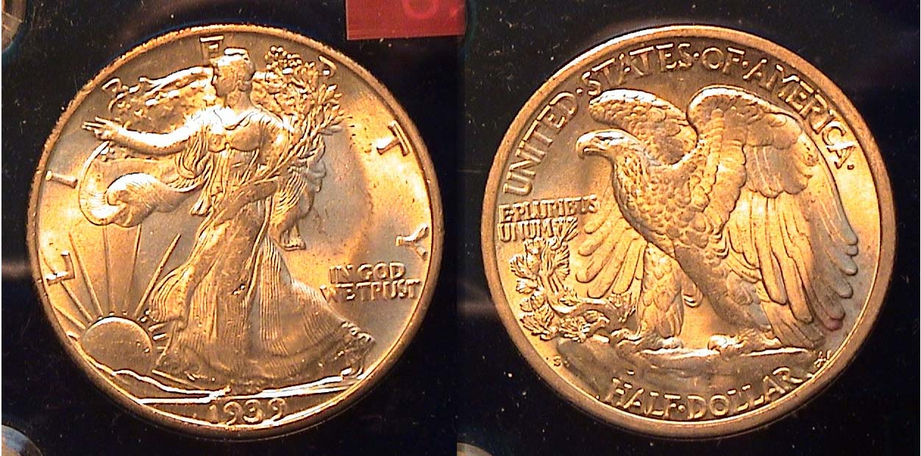

A Mint state 1939-S Waling Liberty Half dollar grading MS-63
[Apply 3 x glasses or magnify to 200%]

The 1939-S half dollar had a mintage of 2,552,000 but it is not scarce as it ranks 24th from the lowest mintage of the series. According to the 2010 Red Book a 1939-S ranging from Good-4 through XF-40 rises from $7.00 to just $16.00 but the next grade higher, AU-50 it is listed at $80, then $150 in MS-60 (not considered an attractive grade) and finally $190 in MS-63. The only two recommended Red Book grades in the writer’s opinion seem to be the XF-40 for collectors who assemble sets of circulated coins or the MS-63 for those who prefer mint state specimens. In 1939 fifty cents had the purchasing power of what $7.75 could acquire today.

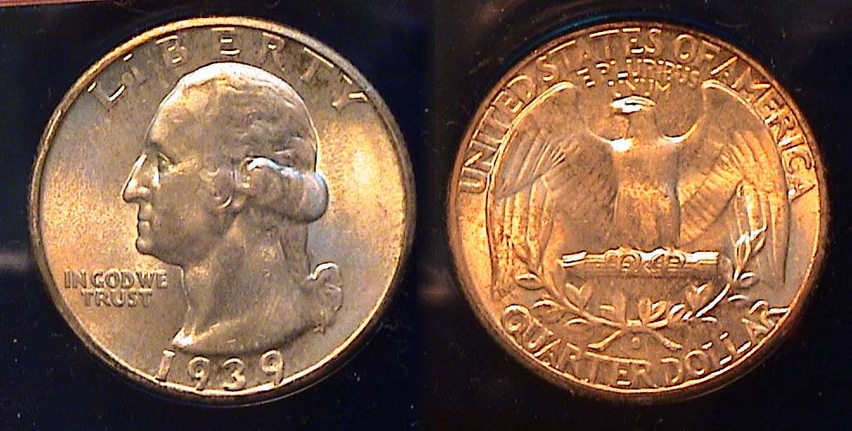

A Mint state 1939-S Washington Quarter grading MS-63
[Apply 3 x glasses or magnify to 200%]

The 1939-S quarter’s mintage was 2,628,000. Unlike the half dollar it had the fourth lowest mintage of the entire Washington quarter series behind only the 1937-S with 1,652,000, the 1932-D with 436,800 and the 1932-S with just 408,000 struck. Despite this, it is not regarded as a rare date although in MS-65 the 2010 Red Book lists it at a suggested retail price of $340 with an MS-63 considerably lower at $135. Some dealers think this date could be considered a “sleeper”. A 1939-S quarter had the purchasing power of near $4.00 today.

At 3:30 PM on April 30, 1939 the New York World’s Fair opened. President Franklin Roosevelt viewed it as “a world of tomorrow…open to all mankind”. In addition to the Trylon and Perisphere other highlights included the General Motors “Futurama” building, NBC’s experimental television and Kodachrome slide film pictures. In July, the dying NY Yankees star Lou Gehrig announced his retirement from baseball in front of thousands of fans, exclaiming he was ‘the luckiest men alive”. The two major movies of the year may have been the two greatest flicks of all time, “Gone with the Wind” and “The Wizard of Oz”. The population of the United States was around 130 million and the country was beginning to show signs of coming out of the Depression. Our artistic coinage of the period represented symbols of hope and future prosperity.
___________________________________________________________________________________________________________________________
A HOLED COIN IS NOT ALWAYS DAMAGE
By Bill Myers

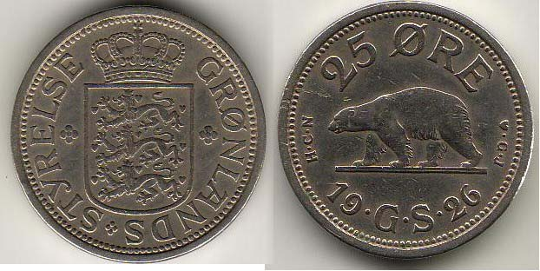

Most collectors have a few damaged coins in their collections and some of those will have holes punched in them. This may be because they were used as jewelry. Collectors shy away from these coins unless they are such rarities that it is better to have a holed example then none at all. Having a hole punched in a coin usually decreases its value significantly. I recently sought out a coin that had a hole punched in it and I was willing to pay three times more for that coin then the same coin without a hole in it. Either I am crazy, or I have a story to tell - or both.

The coin is the 1926 copper-nickel 25 ore coin from Greenland. It is listed as KM #5 in 2010 Standard Catalog of World Coins (SCWC) and is listed with a 310,000 mintage. The story starts about 15 years after the coin was issued. The United States took over the defense of Greenland after the fall of Denmark during World War II on 9 April 1941. U.S troops were stationed on the island and they found the 25 ore coin was the size of a US quarter but had about ¼ of its value. Prior to that there were probably very few U. S. citizens passing through Greenland so the similarity of the coins sizes was not an issue. For the troops stationed in Greenland it became a problem, so the 25 ore coins were withdrawn from circulation and sent to New York where a hole was punched in the center of the coins. According to SCWC the new holed coin is listed as KM #6, with a mintage of 60,000. SCWC notes the hole was punched due to its resemblance to the 1 krone coin of Denmark.\

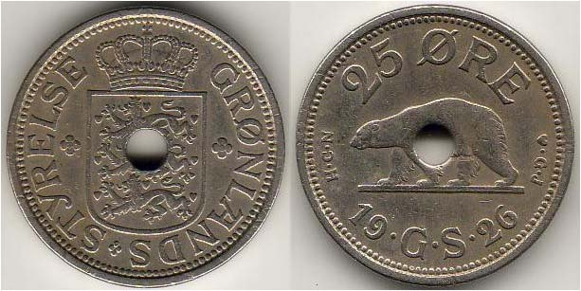

Oddly, this contradicts other information I have. I question that statement because if this was true why did it take 15 years to do something about the similarity? Also, at the time the hole was punched in the 25 ore coin, Denmark was under the control of Germany and there would not be coins traveling from Greenland to Denmark. I think the coin was holed because soldiers were shipping them home to be used as quarters. I believe that the holed 1926 25 ore coin may be missing some metal, but it is filled with history and worth the premium I paid.
_____________________________________________________________________________________________________________________
Schwan, CF, Boling JE. World War II Remembered. History in your hands – a numismatic study. 1995. BNR press. Pg 85.

Cuhaj, GS. 2010 Standard Catalog of World Coins 1901-2000. 37th ed. Pg 986.
\______________________________________________________________________________________________________________________
Another fascinating article from the pen of Bill Myers, Thanks, Bill, Ed.!
More Club News (Continued from page 1, column 1)

As of the August 13 meeting the Barry’s announced that 24 tables had been sold for our Sept. 12 show. Treasurer Sharon Smoot reported the current balance at $1,128.27. Thanks, Sharon. President Steve Kuhl said the Executive Committee is preparing a special form for members to fill our regarding programs and activities as well as suggestions as to how our club can grow in membership and raise funds. At the meeting President Kuhl presented member Paul Simons with a silver eagle for helping out at our 2008 show. Glenn Sanders donated a 2009 silver Proof Set as one of the three prizes to be raffled off at our upcoming show. Thanks, Glenn! The club bylaws are being revised and members of the Executive Committee are looking into possible sites for future club meetings closer to the Aiken town center.

There were three Show & Tells: YN Austin Kuhl brought in examples of the two varieties of the 1879 SBA dollar coin; one with the near date and the other with the far date. The far date appears above a narrow rim while the near date is above a wider rim. Arno brought in a 1959 P and D BU year set and explained due to large mintages and lack of circulation of the Franklin half dollar, even after half a century the set is worth slightly more than bullion. Jim Barry brought in example of a Classic Greek Olympiad drachm that was struck at the Temple of Zeus for the 134-143 Olympiads (244-208 BC). The obverse shows an eagle tearing at a hare; the reverse, a thunderbolt with wings and fire beneath.

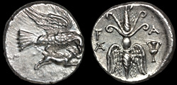

Elis, Olympia AR drachm/ Eagle and hare/Winged thunderbolt

For the program, Xavier Pique returned as guest speaker to give another outstanding PowerPoint presentation; this time on “Company Store Tokens”.

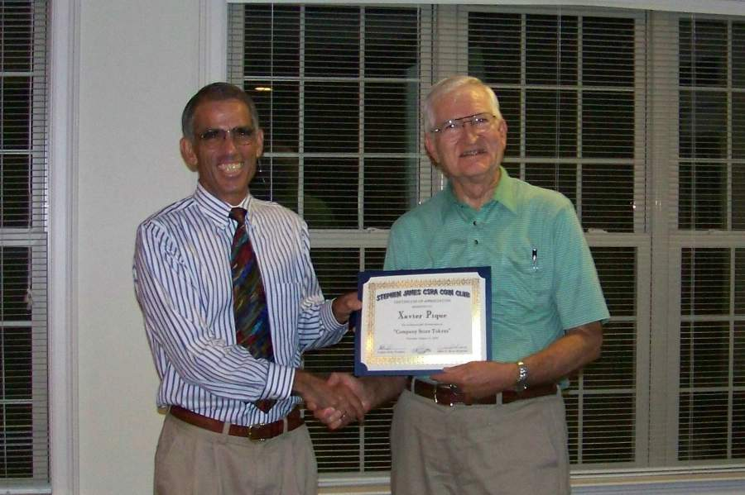

VP Jim Barry, right presenting Xavier Pique (left) club appreciation award for his presentation on “Company Store Tokens”

Prize winners at the Aug. 13 meeting were Jim Clapp who won the attendance drawing and Doug Moody who took the 50/50. Congratulations gentlemen.

Next Meeting and Show Requests: Our next meeting is Sept. 10. Please remember to bring in sold raffle ticket stubs with names and phone numbers as well as the cash collected. If you have some back issues of Coin weeklies or monthlies that you would like to donate to patrons attending our show, please consider bringing them in to the meeting or to the show itself and thanks in advance.
___________________________________________________________________________________________________________________

Kindly Patronize our Advertisers

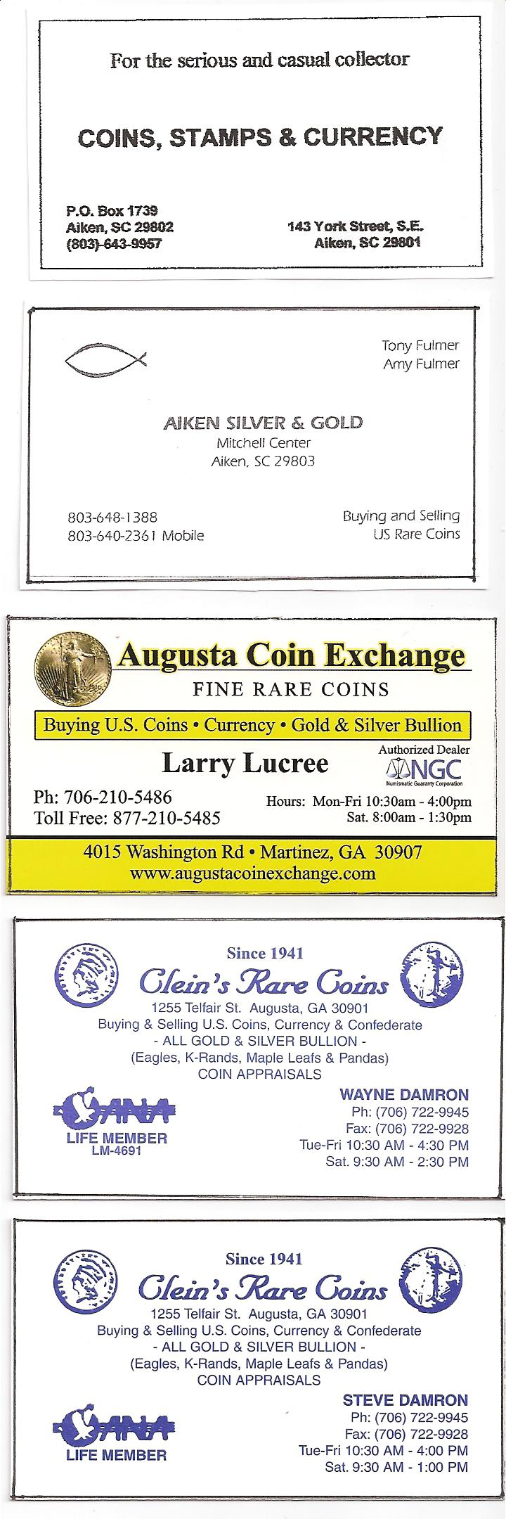
Numismatic Item of the Month

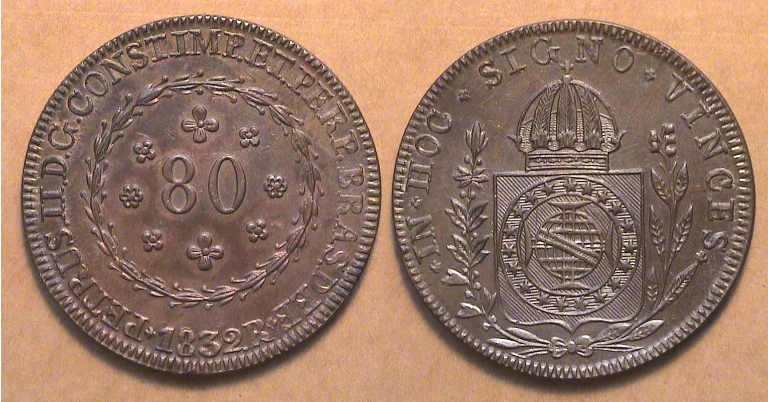

An 1832 80 Reis copper struck at the Rio de Janeiro Mint, Brazil
Under the auspices of King Pedro II of Portugal
[Use 3X glass or magnify to 200% to view details]

The large copper coin shown directly above when printed on 8½” x 11” paper is the actual size of the coin. It is approximately 42 mm in diameter and weighs eight Portuguese oitavos which is equal to 28.69 grams. The Portuguese Reis, (pronounced Hais), like the Spanish Real means Royal but that is where the similarity ends because it took a total of 960 Reis to equal the Hispanic-American 8 Reales or Spanish Peso which was equivalent in value to the US silver dollar during the first six decades of the United States’ coinage program. One can assume that the Brazilian 80 Reis copper cartwheel was equivalent in value to around 8 1/3 cents at the time it was struck, but unlike many foreign silver coins that circulated here until 1857, foreign copper coins probably did not.

The copper coins produced in Brazil during first three decades of the 19th Century were for the most part in the denominations of 80, 40, 20 and 10 Reis, so the 20 Reis comes closest to the value of our large cent and the 10 Reis to our half cent, both US denominations struck from 1793 to 1857. By the late 1840’s and throughout the 1850’s, the large cent was becoming increasingly unpopular in our country because of its size and weight. Imagine then what the Brazilians must have felt when handling the 40 Reis and 80 Reis pieces in daily commerce. In those days, men strapped pouches over their shoulder or attached them to their belts the way women carry purses and the weight of these large coppers may not have been as bothersome. The fact that I was able to acquire this brilliant uncirculated Brown cartwheel for a very reasonable price indicates that many of the 6.19 million 80 Reis struck at the Rio Mint in 1832 probably didn’t see much circulation.
____________________________________________________________________________________________________________

Please patronize our advertisers
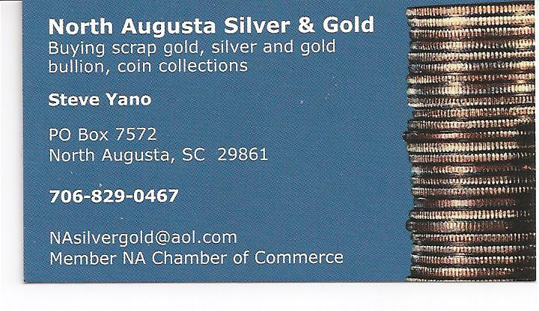

Our Coin Show is Coming up fast!

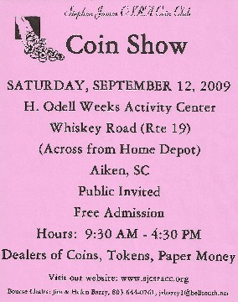

Memorabilia from the 1939 New York World’s Fair – Postcard & Coin

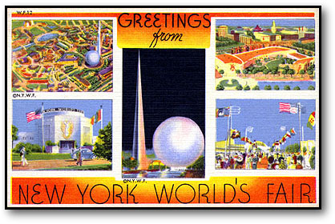
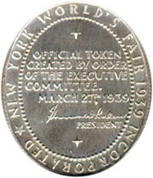
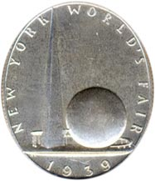

Obv: Trylon and Perisphere; around New York World’s Fair;
below 1939, Rev: In field, within beaded oval, + / Official Token / Created by Order / of the Executive / Committee. / March 27th, 1939

