Pres. Steve Kuhl
V .P. Pat James
Sec. Jim Mullaney
Treas. Sharon Smoot
Sgt. in Arms: Glenn Sanders
The Stephen James
CSRA Coin Club of Aiken
P.O. Box 11
New Ellenton, SC 29809
Web site: www.sjcsracc.org
The SJ CSRA CC of Aiken, SC meets on the 1st Thursday of the month at the Aiken Public Library

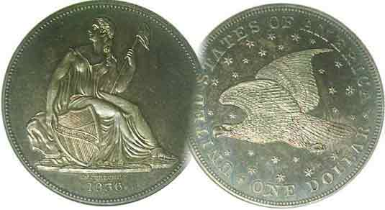
Programs: Pat James
Show: by Committee
ANA Representative: Jim Barry
Publicity: Jim Clapp
Newsletter: Arno Safran
E-Mail: arnosafran@comcast.net
Auctioneer: Glenn Sanders
Web site: Susie Nulty (see above.)

2011 Club Meeting Schedule
Volume 10, Number 9 the Stephen James CSRA Coin Club, Founded in 2001 September, 2011
Monthly Newsletter
2011 Show Coming Up Fast – Sat. Sept. 10
Our next meeting is on Thursday, September 1, 2011 from 6:45 to 8:45 PM

Jan. 6 Apr. 7 July 7 Oct. 6
Feb. 3 May 5 Aug. 4 Nov. 3
Mar. 3 Jun. 2 Sep. 1 Dec. 1

____________________________________________________________________________________________________________

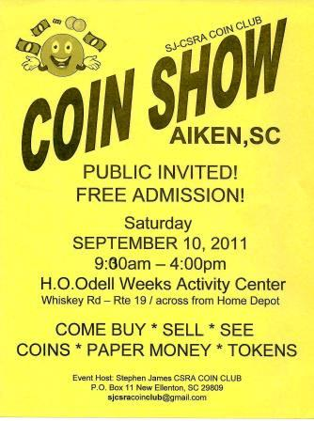

The 2011 Show Flyer says it all! This is our club’s major fund raiser for the year. Please volunteer to help out setting up, manning the Welcoming Desk or taking down. If every member sells ten raffle tickets we will more than defray the cost of the raffle prizes. Any member wishing to be a dealer for a day, please contact Steve Kuhl at stvk1989@gmail.com.

The 2/3 Silver Coins of the Pre-Republican
Government of Cundinamarca, Columbia
By Arno Safran

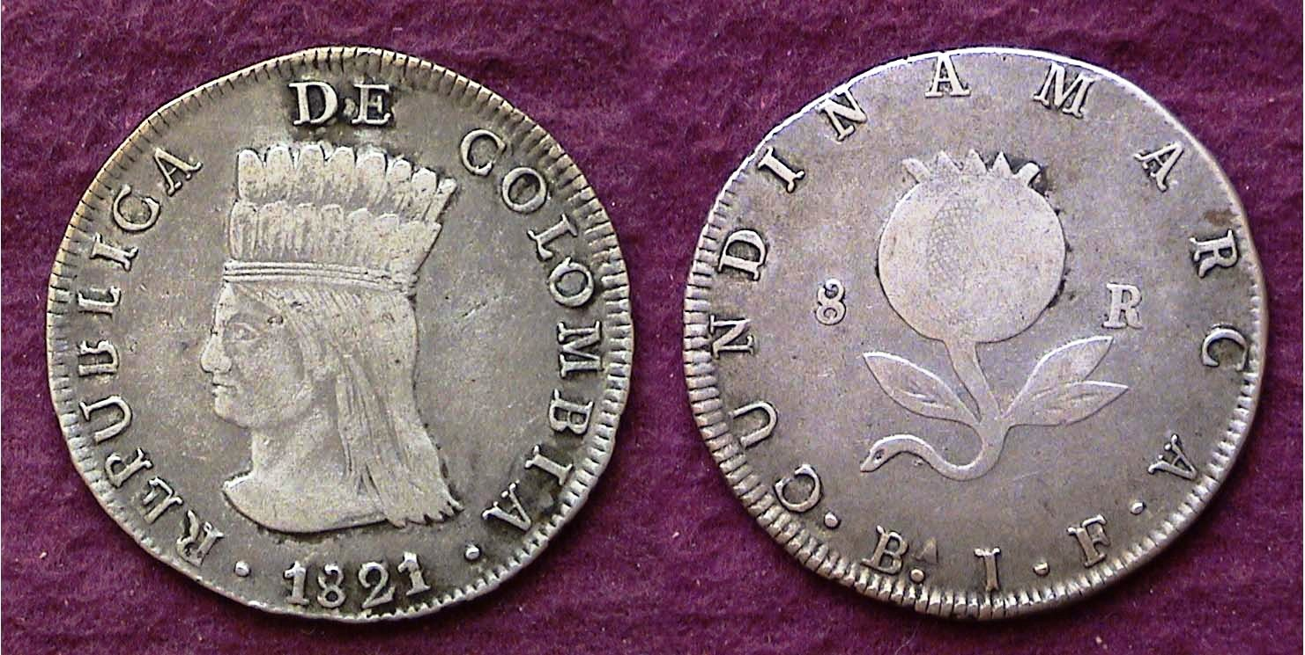

An 1821 8 Reales silver coin of Cundinamarca, Colombia
Showing an native maiden in headdress and Pomegranate
[Use 3X glass or magnify 200% to see details.]

The War of Independence from Spain began in Mexico in 1810 and soon spread to the other Latin American countries in Central and South America finally ending in 1825. During the conflict coins were struck by both the Royalists, (those loyal to Spain) and the Republicans, (the Rebels). As early as 1813 the Colombian province of Cundinamarca began striking their own silver coinage but it was not until 1819 in Nueva Granada (Bogota today) and Cundinamarca Province in 1820 that the unusual design portraying a native maiden (china) with headdress on the Obv. and Pomegranate on the Rev. would appear on the dollar-sized 8 Reales denomination. The Peso type shown above was 37 mm in diameter and struck in an alloy of .667 fine silver bonded to .333 copper. While still considered a silver coin by definition, it contained too little silver to be exchanged for a dollar’s value in the United States. In fact, all of the silver coins of Colombia bearing this design; the 8 Reales, 2 Reales, 1 Real and ½ Real; the last named being very difficult to locate despite its relatively low value as a numismatic collectible, were struck in the same alloy content and probably did not circulate in early 19th Century America at all. A coin containing less than 50% fine silver is considered billon. Even a rich country such as the US has issued billon coins; the 40% silver Kennedy halves from 1965 thru 1970 and 40% silver “Ike” dollars from 1971-1976.
_____________________________________________________________________________________________________________________________
(Continued on page 2, column 1)
The 2/3 silver Coins of the Pre-Republican
Government of Cundinamarca, Columbia
(Continued from page 1, column 2)

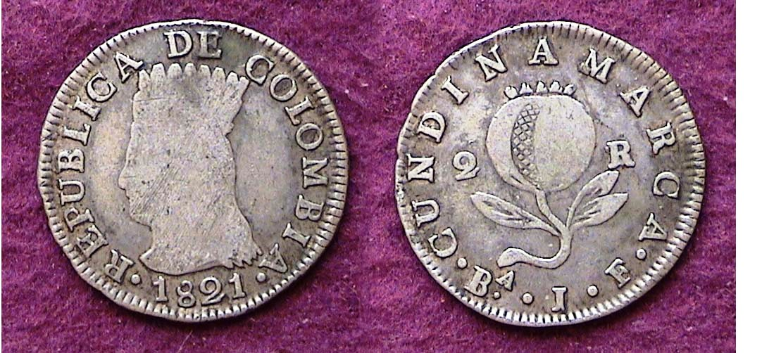

An 1821 2 Reales of Cundinamarca, Colombia
Showing a native woman in headdress and Pomegranate
[Use 3X glass or magnify 200% to see details.]

The second denomination of Cundinamarca silver coinage of the same design-type that a collector may encounter is the 2 Reales. It contained an alloy of 2/3 silver and 1/3 copper, weighed .1066 oz. (5 grams) and had a diameter of 24.5 mm, just slightly larger than our quarter-dollar. The 1821 dated coin seen above grades FINE and is the most common date and variety of this short series struck in 1820, 1821 and 1823.
2 Reales of this type grading XF or better are scarce to rare.

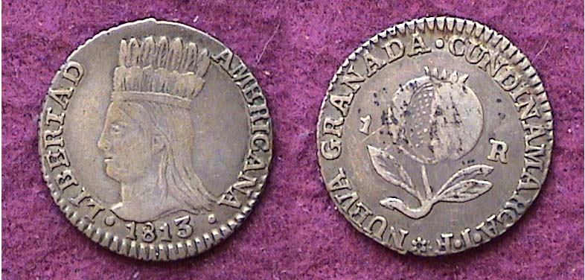

An 1813 Real of Nueva Granada/ Cundinamarca, Colombia
Showing a native woman in headdress and Pomegranate
[Use 3X glass or magnify 500% to see details.]

The 1813 dime-sized coin, (19.5 mm) shows the same basic design of the native maiden in a headdress on the obverse and a pomegranate on the reverse but the inscription on the circumference of the obverse reads Nueva Granada at the left and Cundinamarca along the right. These pieces were struck by the Republican insurgents in 1813 when the two provinces were still united against the Loyalist forces of Spain. Like the others of this series the real contained only 2/3 silver bonded to 1/3 copper. Despite the discoloration on the reverse of this particular example, this VF graded coin displays considerably sharper features than the others shown. It was discovered some years ago amidst a bunch of well circulated Barber and Mercury dimes in a dealer’s junk box at a large Regional show.

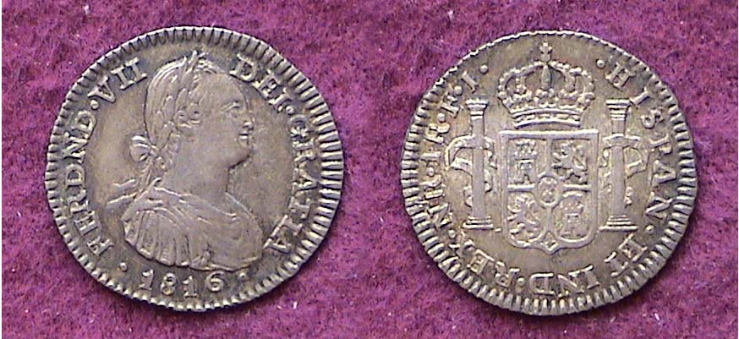

An 1816 Royalist issue of the Real
inscribed as Ferdinand VII while showing the portrait of Charles IV
[Use 3X glass or magnify 500% to see details.]

During the War of Independence the Royalists in Colombia continued to strike coins bearing the portrait of the Spanish monarch. In 1808 Charles IV had ceded his authority as King of Spain to his son Ferdinand VII. During the conflict the South American countries did not have access to a portrait of the new King and the Royalists who still had control of the Spanish run Mints and much of the silver lode continued to issue coins bearing the figure of Charles IV while inscribing his son Ferdinand VII around the perimeter.
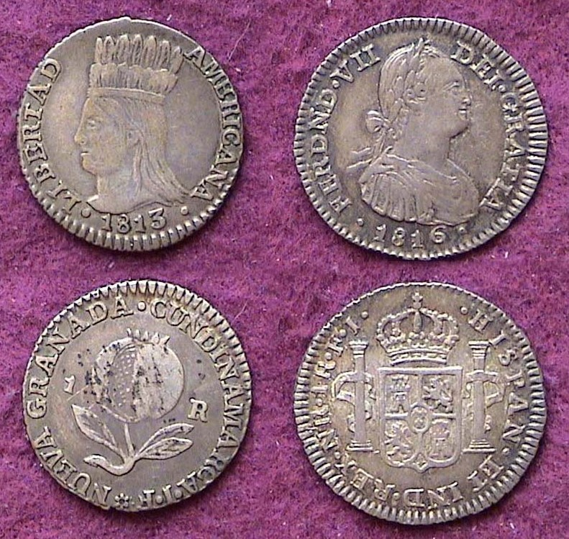
As for the reverse, the upper part of the left side of the 1816 Real shown at the lower portion of column 1 bears the inscription 1R NR and JF. 1R stands for the denomination, 1 Real. According to the Standard Catalog of World Coins: Spain, Portugal and the New World edited by Krause, Mishler and Colin R Bruce II the mintmark NR represents Cartagena, Colombia. The J F represents the initials of the sir names of the two assayers. The silver coinage issued by the Royalists still contained .8960 fine silver and as such were accepted in the value of 12½¢ in trade in early 19th Century America.

1813 Republican and 1816 Royalist Reales
[Use 3X glass or magnify 200% to see details.]

Over the years the author has tried to find the tiny Cundinamarca ½ Real but even at the major shows such as the ANA’s World Money Show held every summer or the FUN show held in January usually in Orlando, Florida none of the dealers in Foreign coins ever seem to have one in their cases.

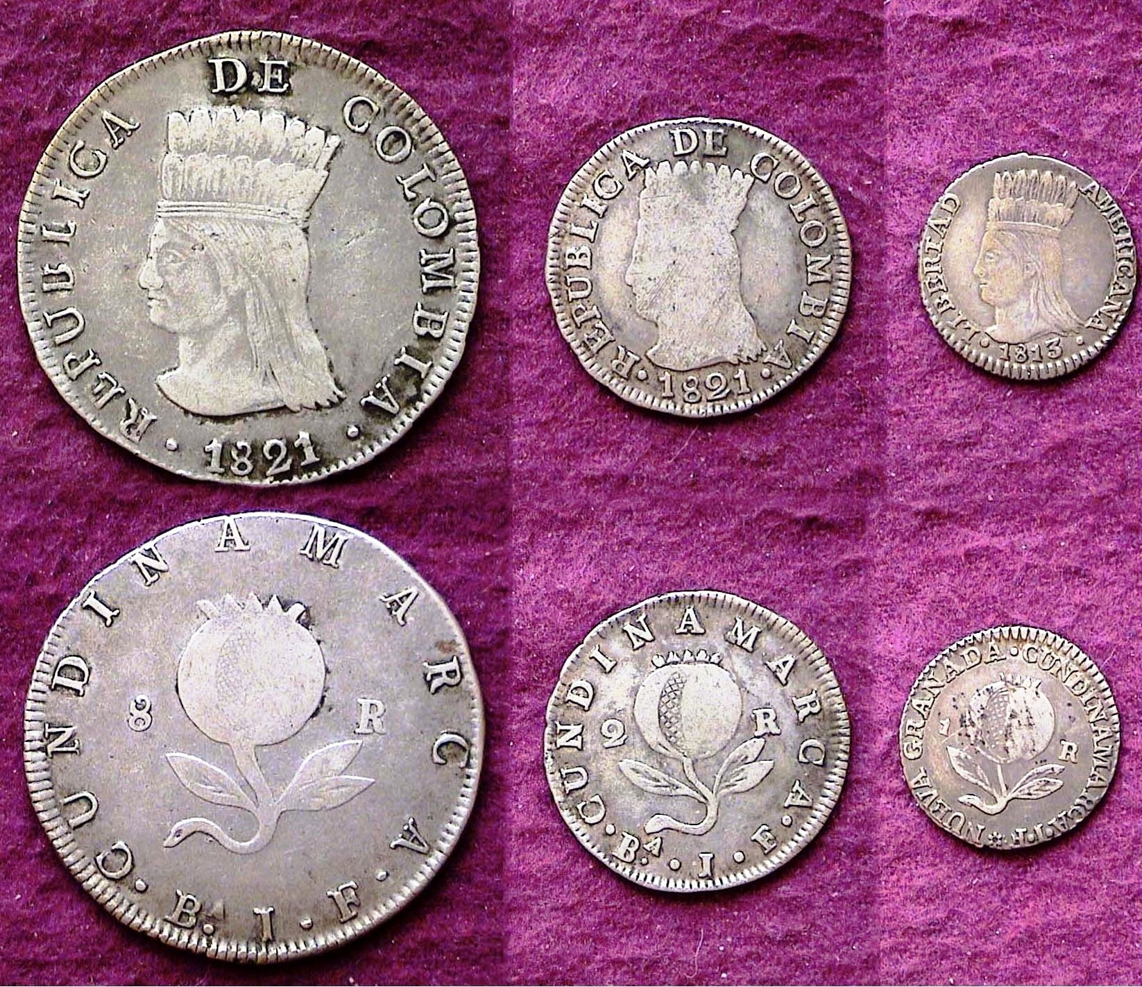

The Cundinamarca 8 Reales, 2 Reales and 1 Real shown as a set
[Use 3X glass or magnify 200% to see details.]

In the grades shown, the three Cundinamarca silver denominations are relatively inexpensive compared with US coins of the same vintage. The design-type is both attractive and unusual adding to the variety of artistic examples of coinage available to the collector of modest means.
___________________________________________________________________________________________________________________________

The Dr Richard Sorge Medal
By Bill Myers

Actual size of the 60 mm Dr. Richard Sorge Medal struck in East Germany (From the Bill Myers Collection of WWII Memorabilia)
[Use 3X glass or magnify 200% to see details.]

During a recent vacation to Europe, I purchased an interesting medal. It is 60 mm silver colored (not silver) medal with a bust of a man on the obverse with “Dr. Richard Sorge 1895-1944” around it. The reverse has a hand with raised index and middle fingers and thumb inside a triangle in the middle and the East German arms at the top, and all of is surrounded by a wreath. The hand caught my eye and the price was reasonable so I bought it.

When I got home, I researched Dr. Richard Sorge. He was born in Baku, Russia on 4 October 1895. His father was German and moved the family to Germany in 1898. Sorge was in the German Army during World War I and was wounded in both legs. While recovering he met the Marxist father of one of his nurses and adopted the communist ideology. He joined the German Communist Party. He then moved to the Soviet Union and joined the Comintern Intelligence Division and later the Red Army’s Fourth Department (military intelligence). Undercover as a journalist, he was sent to various countries as a Soviet Spy. He started out in England and then was sent to Germany where he was instructed to join the Nazi Party. He travelled to China in 1930 and Japan in 1933. He supplied the Soviet Union with intelligence including information about the attack on Pearl Harbor and the launch date of Operation Barbarossa (Germany’s invasion of the Soviet Union), the latter, which Stalin ignored.

Sorge was arrested by the Japanese on 19 October 1941. Japan offered to trade Sorge to the Soviet Union for one of their spies. The Soviets denied that they knew Sorge. He was hanged on 7 November 1944. This probably satisfied the Soviets, as Sorge was a witness to the mistake Stalin had made when he ignored Sorge’s information about the German attack in 1941, which would have been a great embarrassment to the Soviets.

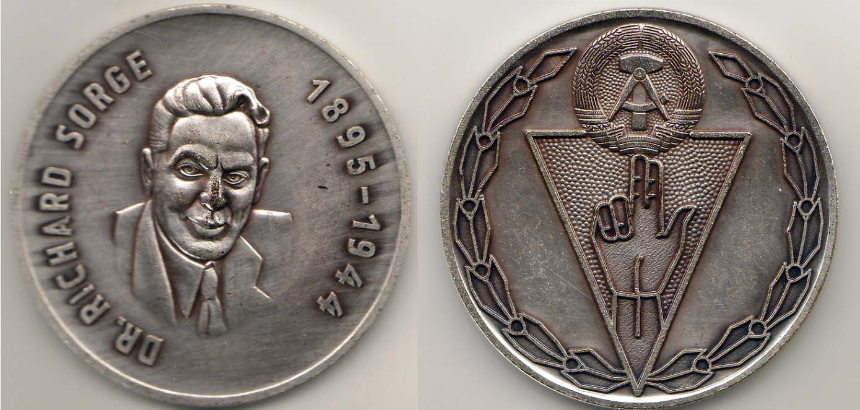
Sorge’s service to the Soviet Union has been recognized in several films. In 1964, Sorge was posthumously awarded the title of Hero of the Soviet Union by Khrushchev. The East German medal I have recognizes the services of Sorge. I have not been able to determine when or why the medal was released but I assume it was done between the time the Soviet Union recognized Sorge in 1964 and the fall of 1989. The hand on the back has the index and middle fingers and thumb extended and the ring and fifth fingers flexed. This same symbol appears on the 1929 German Weimar Republic 3 and 5 Reich mark coins celebrating the 10th anniversary of the Weimar Republic (K 63 & 64 respectively). I have not been able to determine the exact meaning of this symbol but one reference traces it back to representing the holy trinity

With a little research, I found this medal to be packed with history. I was not aware of Dr. Richard Sorge and his participation in World War II. This medal has a special spot in two of my collecting interests - items with hands on it and World War II commemoratives.
_______________________________________________________________________________________________________________________
References:
Dactlys at http://matriarchy.info/index.php?option=com_content&task=view&id=29&Itemid=113
Sorge, the Spy on a Stamp at http://timegun.org/sorge.html
Richard Sorge at http://en.wikipedia.org/wiki/Richard_Sorge
Richard Sorge at http://www.spartacus.schoolnet.co.uk/GERsorge.htm

____________________________________________________________________________________________________________________________
Anyone interested in World War II History should find Bill’s latest article positively fascinating. Thanks, Bill!, Ed.
_________________________________________________________________________________________________________________________

Gold Between $1,700 & $1,800
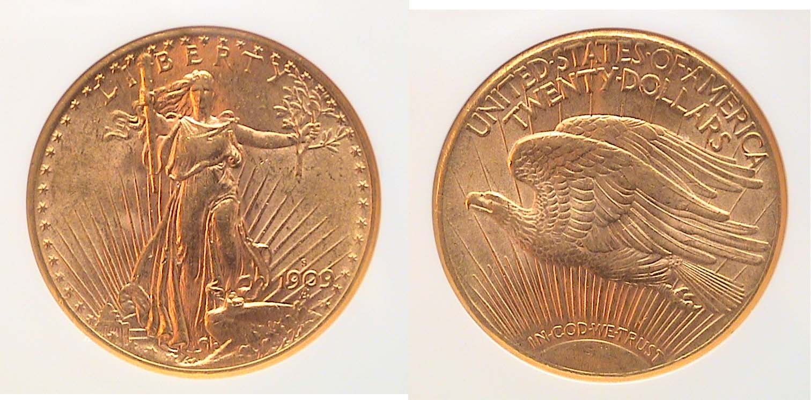
A 1909-S Saint-Gaudens with motto $20.00 Gold Double Eagle
Graded AU-58 by NGC
[Use 3X glass or magnify 200% to see details.]

The 1909-S Saint-Gaudens Double eagle pictured above is an extremely attractive example of what an AU-58 coin should look like; an MS-63 or 64 with a little surface friction. The coin was acquired back in November, 2007 for $860 at the Baltimore Convention Center when gold was trading just under $800 an ounce. With gold currently trading at between $1,700 and $1800 the coin has so far proved to have been a good investment. Back in 1999 gold was selling for $255 an ounce; in 2005, at around $475. In January, 2010 the yellow metal finally passed the $1,000 an ounce mark to stay and on August 10, 2010 it peaked at $1807.50. How high do you expect gold to climb?
___________________________________________________________________________________________________________
STEPHEN JAMES CSRA COIN CLUB
Regular Meeting Minutes
August 4, 2011

President, Steve Kuhl, called the regular meeting of the club to order at 6:52 p.m.
Glenn Sanders reported that there were 22 members present (21 adults, 1 junior). There were three visitors: Richard Herold, George Clary, and Charles Douglas. A quorum for the meeting was met. (15 regular members needed to conduct the business of the club.)
Glenn announced that there were several upcoming coin shows in the vicinity. There is a show this weekend by the Low Country Coin Club near Charleston, in Ladson SC (~100 tables). The Blue Ridge Numismatic Assoc show is in Dalton GA August 19-21 (approx 300 tables). There is a coin show in Fletcher NC (near Hendersonville) August 20-21.
John Meinhardt won the door prize.
A motion was made by Rick Owen, seconded by Arno Safran, and passed to dispense with the reading of the July 2011 minutes.
The treasurer’s report was read. The balance as of 7/31/11 was $1901.15.
It was announced that the September program would be on coins from the era of Alexander the Great, presented by Jim Barry.
Howard Hillman, Arno Safran, Jim Barry, and Rick Owen shared Show & Tells with the club. Howard had a 1955 double-die cent, that he felt was even less frequently seen at coin shows than a 1909-S VDB. Howard had actually found a double-die in circulation in poor condition. He sold that coin to upgrade to an AU double-die. Jim Barry brought a Bactrian coin (near current day Afghanistan), c. 225 BC. The coin was issued by St. Demetrius the first who had extended Bactrian rule to near Kabul. The coin was considered a Greek coin since it came from one of the provincial governments originally set up by Alexander the Great. The obverse had an elephant with a bell while the reverse had a caduceus of Hermes. Arno had a set of copper coins from Brazil struck between 1818 and 1822. Rick shared a 1914-D he had obtained at the FUN show that completed his MS set of wheat pennies.
Jim Mullaney presented a program on Grading Coins that included a Grading Bee where members could see how their evaluations lined up with those of professional graders.
Dick Smoot won the 50/50.
Austin Kuhl drew from the junior grab bag.
Respectfully submitted,
James Mullaney
Kindly Patronize Our Dealer Advertisers
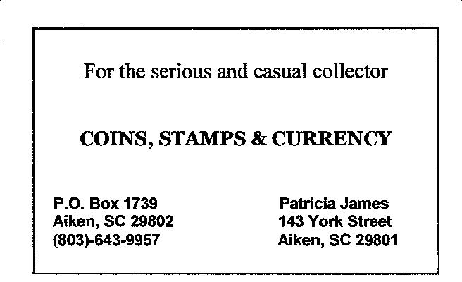
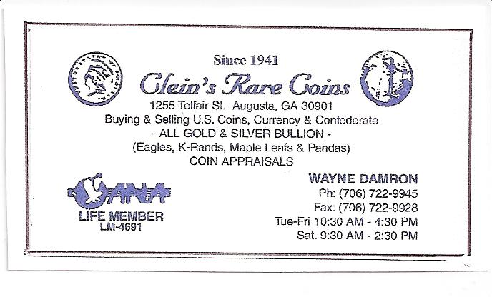

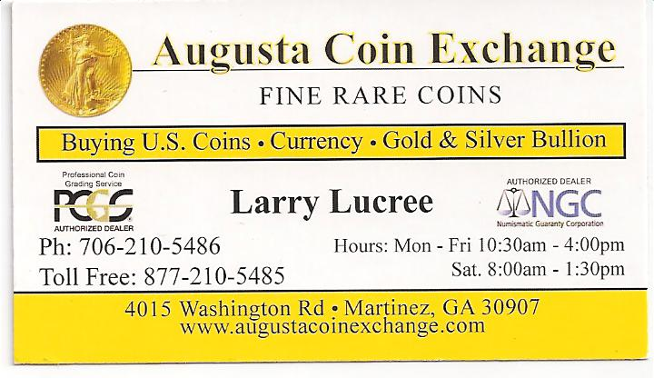
Pictures from Aug. 4 Meeting
(Courtesy of Helen Barry)

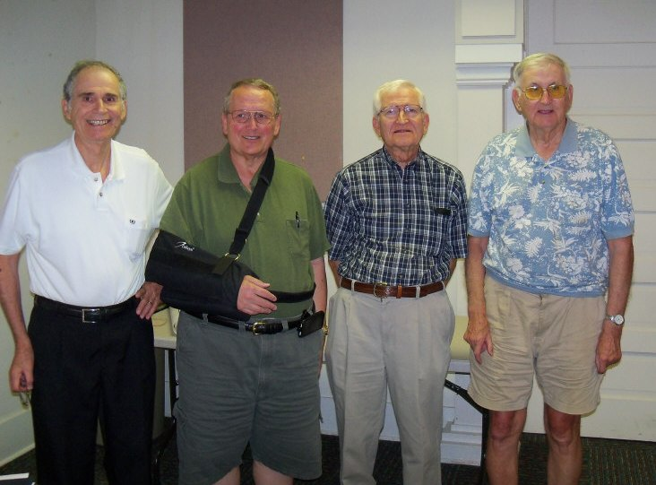

Show & Tell Exhibitors from left to right:
Arno Safran, Rick Owen, Jim Barry & Howard Hillman
More Show & Tell Photos

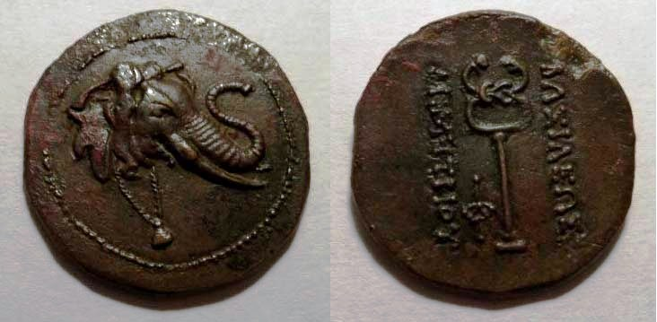

A Bactrian coin c. 225 BC displayed by Jim Barry
It was considered a Greek coin since it came from one of the provincial governments originally set up by Alexander the Great. The obverse had an elephant with a bell
while the reverse had a caduceus of Hermes.
[Use 3X glass or magnify to 200% to view details.]

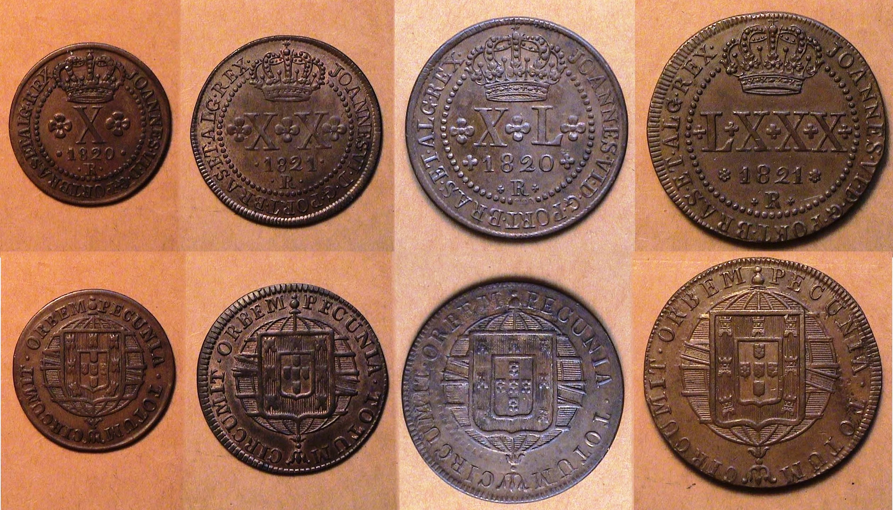

A set of copper Brazilian coins dated 1820-21 displayed by Arno Safran. From left to right, 1820 10 Reis, 1821 20 Reis, 1820 40 Reis and 1821 80 Reis. Since 960 Reis was the standard silver unit equal to the US dollar, the largest of the copper coins were equal to 8 1/3¢.
[Since the coins are pictured smaller than actual size, use 3X glass or magnify to 200% to view details.]

Regrettably not photographed were two more attractive rarities from the Lincoln Wheat-back series (1909-59), Howard Hillman showed a 1955 double die cent he acquired back in the 1960’s and Rick Owen brought in a 1914-D Lincoln cent graded MS-63+ by PCGS. This famous Lincoln cent key date was one of the most attractive specimens the author had ever seen.
__________________________________________________________________________________________________________

The August 4 Program

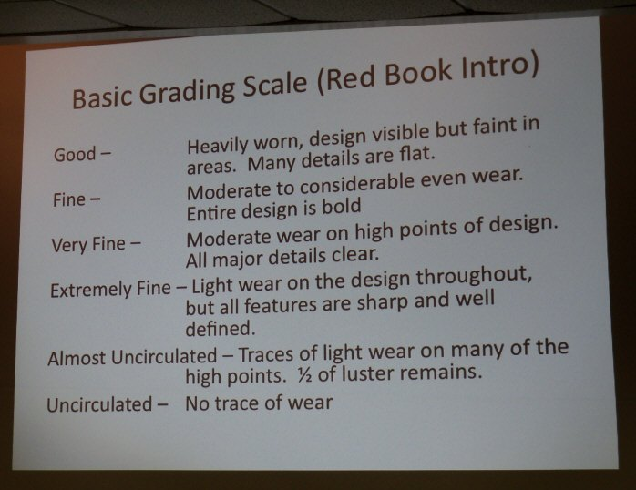

Jim Mullaney presented a PowerPoint program on Coin Grading that covered a wide range of coin-types and denominations. The various slides projected on the large screen in the Aiken Public Library meeting room afforded the viewer and opportunity to really hone in on their grading skills as the grades of the various examples shown ranged from AG to BU. Before members actually started to grade the various examples, Jim presented a mini-course in coin grading. The club thanks Jim for an excellent and enjoyable presentation.

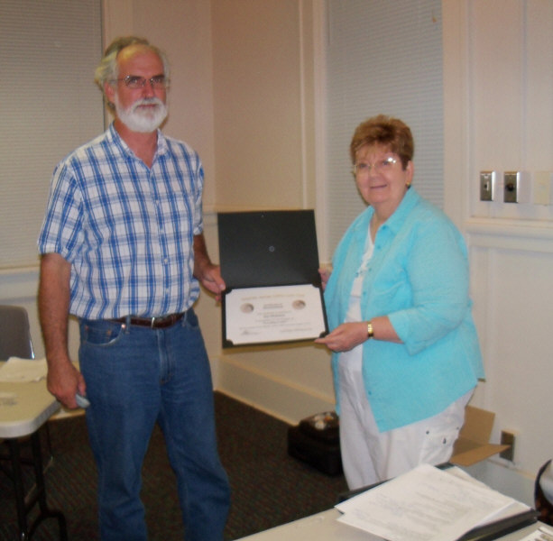

Jim Mullaney being presented an Appreciation Award by VP and Programs Chair Pat James for his program on Grading US Coins
[Photo, courtesy of Helen Barry]

___________________________________________________________________________________________________________________

Our Next Meeting

Our next meeting is Thursday, September 1 at the Aiken Public Library, starting time, 6:45 PM. Jim Barry will be presenting a program on the life of Alexander the Great and the coinage associated with his reign. Show & Tells are always welcomed. Also, bring in numismatic items for our monthly auction as well as the cash and stubs from sold Raffle tickets sales. Each booklet contains six raffle tickets sold at either $1.00 for a single raffle or $5.00 for all six. Let our Bourse Committee know what you can do to help out at the show and thanks in advance. See you on September 1st and at the Show on the 10th.
___________________________________________________________________________________________________________________________

_

