The Stephen James
CSRA Coin Club of Aiken
P.O. Box 11
New Ellenton, SC 29809
Web site: www.sjcsracc.org
The SJ CSRA CC of Aiken, SC meets on the 1st Thursday of the month at the Aiken Public Library

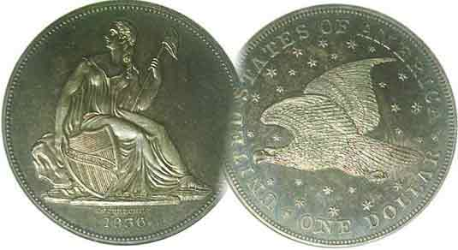
Pres. Steve Kuhl
V .P. Pat James
Sec. Jim Mullaney
Treas. Chuck Goergen
Sgt. in Arms: Jim Sproull
Programs: Pat James
ANA Representative: Jim Barry
Photos: Helen Barry
Publicity: Pat James
Newsletter: Arno Safran
E-Mail: arnosafran@comcast.net
Auctioneer: Jim Sproull
Web site: Susie Nulty (see above.)

2013 Club Meeting Schedule
Volume 12, No. 9 the Stephen James CSRA Coin Club, Founded in 2001 September, 2013
Monthly Newsletter
Our next meeting will beheld on Thursday, Sept. 5, 2013 at the Aiken Public Library

Our annual Club Show is Coming up Fast
Jan. 3 Apr. 4 July 11 Oct. 3
Feb. 7 May 2 Aug. 1 Nov. 7
Mar. 7 June 6 Sept. 5 Dec. 5

______________________________________________________________________________________________________

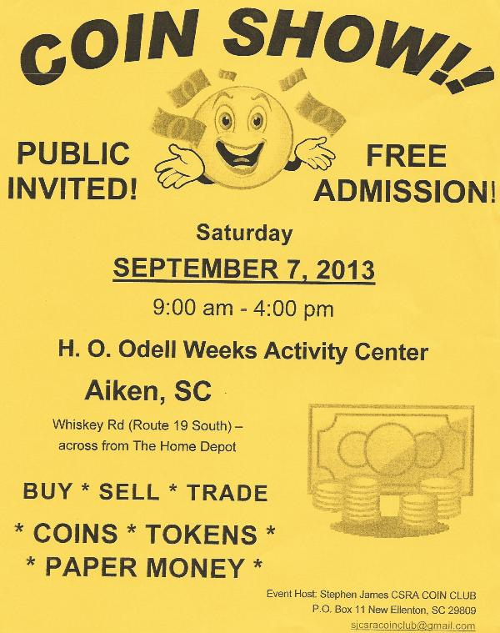

, Our flyer says it all! Our annual show is less than one week away. We will need help from club members with the set up before the show, at the welcoming desk during the show and with the take down after the show as well as arranging for the lunch packs for club volunteers. By now most of this has been arranged (See page 2, column 1). For those who still would like to help out, contact President Steve Kuhl if you can be of service in any of the categories mentioned above and thanks in advance. .The annual show is our club’s primary fund-raiser for the year, so please make every effort to attend.
______________________________________________________________________________________________________________________
(Club News continued on page 2, column 1)

Attending a Show is a good way
to add to one’s collection

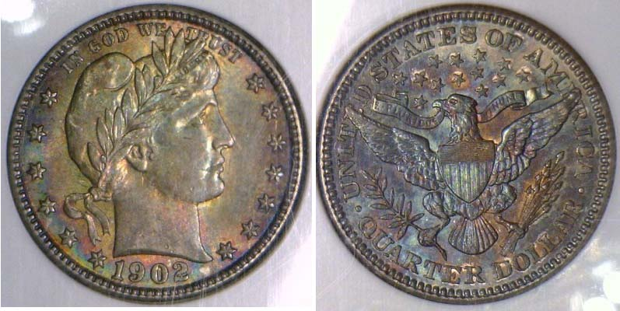

A nicely toned 1902 Barber Liberty Head Quarter
graded MS-62 by NGC
[Use 3 power glass or magnify page to 150% to view details.]

Each year, for well over half a century now, the Blue Ridge Numismatic Association (BRNA) holds its annual three day coin show near the end of August at the Georgia Northwest Trade Convention Center in Dalton, GA. Our regional area consists of these five bordering states, South Carolina, North Carolina, Tennessee, Georgia and Florida but dealers will come from as far away as Texas and California to take tables. If you are serious about adding quality items to your collection, consider combining next summer’s vacation with the BRNA annual coin and paper money show. Dalton is a lovely small city located just 27 miles southeast of Chattanooga, TN which features a marvelous Aquarium, Lookout Mountain and other marvelous nearby sites to explore. Dalton is also located near the base of the beginning of the Appalachian mountains which begins at nearby Chatwick, GA where Fort Mountain rises to 2,800 feet offering tremendous views at the top.

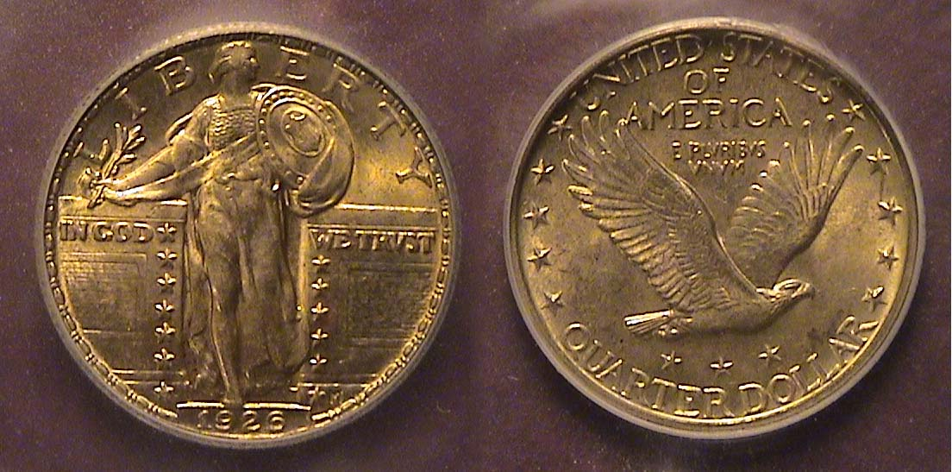
At a show the size of the BRNA, one can find many numismatic treasures at moderate prices such as the beautifully toned 1902 Barber quarter PCGS graded MS-62 shown above or the lovely toned 1926-P Standing Liberty quarter graded MS-64 shown at right..

[Use 3 power glass or magnify page to 150-%}

______________________________________________________________________________________________

Club News and Update on the Show

President Steve Kuhl writes: “As of now, we have 24 tables reserved by twelve dealers. We have several old friends returning to our show, and two new dealers making their first visit. Unfortunately due to other commitments, some of our regulars will not be able to attend. Last year we had several last minute sign-ups, and we even had a walk-in on the day of the show.
We have 11 people (8 members, 3 family members) that have volunteered to work the show. Hopefully other members will volunteer. Especially at the start of the show - to help with dealer set-up, and at the end of the day, to help the dealers pack up and to clean the gym so that we are assured of getting our deposit back.

This year, as in years past, a lunch for the dealers and volunteers has been arranged by Sharon Smoot. A sub sandwich, from Pat's Sub Shop, along with chips, cookies and a bottle of water will be available for $8. Alternatively, several choices of salads, with cookies and water, are available ranging in price from $5 - $9, depending on the type and size of salad ordered.
We are making and completing the last minute preparations.”
______________________________________________________________________________________
Thanks, Steve for this important update.

News of the August 1 Meeting

Show & Tell: There was one Show & Tell: Andrew Goslin showed us his recent acquisition: an 1855-O Liberty Seated Half-dollar in VG condition.

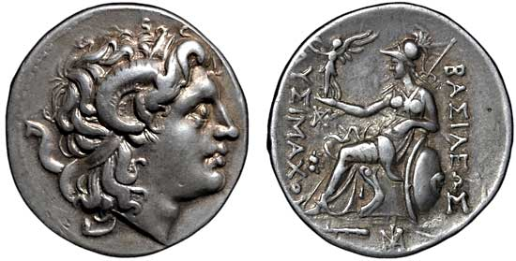
The Program: At the August 1 meeting, Arno Safran gave a PowerPoint presentation on “the Origin of Liberty Seated Coinage”. The program featured pictures of coins going back to the Classical Macedonian tetradrachm from the Seleucid Kingdom of Lysimachus (c. 305-281 B.C.) showing the horned head of Alexander on the obverse with the allegorical figure of Athena seated resting on shield on the reverse.
At our September 5 meeting, VP Pat James and program chair has arranged for Chuck Goergen to be our speaker. He will present a PP program on "The Ptolemy Kingdom: The Coins of Ancient Egypt".

The prizewinners at the August 1 meeting were new member Kelley Nordeen who won the door prize, and Jim Sproull won $17.50 from the 50-50 drawing. Congratulations, Kelley and Jim.
Please bring in a numismatic item for Show & Tell and our monthly auction, which will follow Chuck’s presentation. Hope to see many of you at our September 5 meeting and the September club Show.
_______________________________________________________________________________________________________________________

Kindly Patronize Our Advertisers

