The Stephen James
CSRA Coin Club of Aiken
P.O. Box 11
New Ellenton, SC 29809
Web site: www.sjcsracc.org
The SJ CSRA CC of Aiken, SC meets on the 1st Thursday of the month at the Aiken Public Library

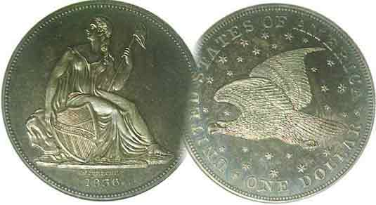
Pres. Steve Kuhl
V .P. Pat James
Sec. Jim Mullaney
Treas. Chuck Goergen
Sgt. in Arms: Jim Sproull
Programs: Pat James
ANA Representative: Jim Barry
Photos: Helen Barry
Publicity: Pat James
Newsletter: Arno Safran
E-Mail: arnosafran@comcast.net
Auctioneer: Jim Sproull
Web site: Susie Nulty (see above.)

2014 Club Meeting Schedule
Volume 13, No. 1 & 2 the Stephen James CSRA Coin Club, Founded in 2001 Jan.-Feb, 2014
Monthly Newsletter
Our next meeting will be held on Thursday, Feb 6, 2014 at the Aiken Public Library

2014 FUN in Orlando Show a Buzz all four days
Jan. 2 Apr. 3 July 3 Oct. 2
Feb. 6 May 1 Aug. 7 Nov. 7
Mar. 6 June 5 Sept. 4 Dec. 4

______________________________________________________________________________________________________

FUN, JANUARY, 2014, Another Awesome Show

Every year the Numismatic Bulls and Bears measure the state of the numismatic marketplace by the attendance and amount of action at the F.U.N. Show which is usually held in Orlando, FL at the massive Orange County Convention Center. The acronym FUN stands for Florida United Numismatists, that state’s numismatic association. The group has been holding this annual winter event for 59 years and many believe it has become the bell weather for the coin collecting hobby.

The reason for this is the show’s enormous size. Upon entering the spacious hall, the collector is greeted by fifteen rows, some two city blocks deep manned by dealers on both sides of each aisle. Dealers from all over the United States and a number from foreign lands set up at this show touting type coins, paper money, tokens, medals and scrip from all over the world. Prices may range from as little as $1.00 for an obsolete crisp uncirculated Ecuadorian banknote to tens of thousands of dollars for a single rare item. .There are many outstanding exhibits and numerous educational programs held during the convention. If that were not enough, major auctions are held usually in the evenings before, and during the event.

It has been often said, that if one cannot find a particular coin at FUN it probably doesn’t exist. More accurately, if such is the case it is currently unavailable, For more than two generations, coin rarity has been described in two categories; date rarity and grade rarity but there is also another type of rarity; the unavailability of once considered common date pieces. This phenomenon is caused by a new wave of collectors entering numismatics as was the case during the first decade of the 21st century. In such a case, strong demand overcomes availability and dates once thought to be common, especially in the more attractive circulated and uncirculated grades begin to vanish. When some of these surface ,they command higher prices.
________________________________________________________________________________________________________________________

The 1914-P Barber half-dollar
By Arno Safran

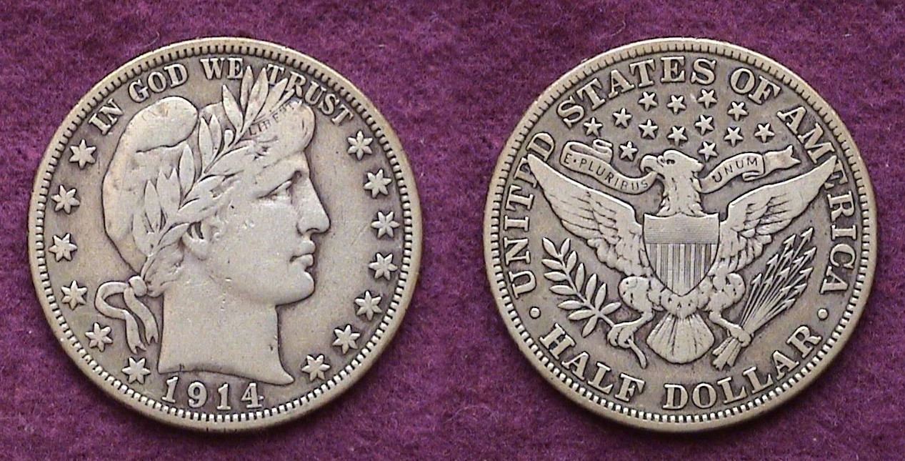

A 1914 Barber Half-dollar graded Fine
[Use 3x magnifying glass or enlarge page to 150%]

In 1914, only 124,230 Barber half dollars were struck at the Philadelphia Mint, the lowest mintage of the 73 dates and Mints of the series begun in 1892. The coin has always been considered one of the key dates of the series; (certainly among the Philadelphia Mint issues) and today, it is listed in the 2014 Red Book at $315 in Fine-12. Considering its low mintage, the price must still be regarded as a bargain when one compares the coin with some of the other key dates of the period.

The 1909-S VDB Lincoln cent had a mintage of 484,000, almost four times the mintage of the 1914 Barber half, yet is listed at $1,000 n Fine-12. The 1916-D Mercury dime. with a mintage of 264,000, more than twice the 1914 Barber half’s output, it is listed at an exorbitant $2,600 in Fine-12. Another popular rarity of 100 years ago is the 1914-D Lincoln cent. Despite a mintage of over one million, a specimen grading Fine-12 today could cost the collector $385.00 according to the 2014 Red Book. Lastly, there’s the 1885 Liberty “V” nickel. With a mintage of 1,472,700, (or almost 12 times higher) it is priced at $850 in Fine-12 or over $500 more than the 1914-P Barber half. Why is there such a disparity between the values of these other keys and the 1914-P Barber half issue?

Despite its size and elegance of design, the 1914-P Barber never achieved the popularity or demand from collectors the other keys received. Furthermore, in comparison with the smaller denominations, a half-dollar had tremendous buying power during that timeframe and saw less circulation.
______________________________________________________________________________________________________________________________

Coin Collecting: Through the Eyes of a Young Numismatist
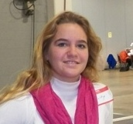
By: Shelby Plooster

Collecting coins is a great hobby and is loved by many. When you first begin, it is important to get some kind of price guide such as The Official Red Book; a Guide Book of United States Coins. When I first started collecting, I purchased this book and it was a great help to me once I understood what grading was.
Collecting coins efficiently takes a lot of reading and research. As a young numismatist, there were many things at the start that are intimidating, such as buying from dealers that you do not know. When I go to coin shows, it always means a lot to me when a dealer makes an effort to talk to me and find out what I am looking for. When I began, I was nervous at first because I was unsure of what coin collecting was, and I also did not know how to properly handle coins. This is important to learn, because dealers do not want hands making the coins get tarnished.
There was a lot for me to learn and still is. Once I had been collecting for about a year I had purchased a lot of different coins. I had Wheat pennies, Buffalo nickels, and many other small denomination type coins. I was told by a wise dealer that when collecting coins in a set, it is important to save your money for the key date coins first. This is because the key date coins normally go up in value, as well as price. This was a good lesson for me to learn because I was mainly buying coins that had a substantially low value. Now I realize that it is smarter to buy the key dates in the highest grade you can afford at first, and then work your way to the other easier and less expensive coins in the set.

Currently I am working on a Walking Liberty half dollar collection, and a WW II nickel collection. I have already purchased two key date coins in the Walking Liberty set; I have a 1921D and a 1938D both in the highest grade I could afford. To buy these coins, I had to save my money.

Money saving is also a very important lesson to learn about collecting coins. All of my life I have saved my money, mostly because I was unsure of what to purchase. The process of saving money can be difficult, but in the end, it pays off to save your money.

The lessons I have learned from collecting coins have been incredible, and it is a hobby that I will be involved with my entire life. and I hope that generations of young people to come will collect coins as well. As some kids play video games as their hobby, I on the other hand collect coins. I am incredibly grateful that I found this hobby because coins are the coolest thing in the world!
__________________________________________________________________________________________________________________________
Shelby Plooster is a Young Numismatist and is a regular member of the Augusta Coin Club. With her Mom, Stacy, she enjoys attending regional shows and recently won an Honorable Mention award at the South Carolina Numismatic Association Convention in Greenville, SC this past October for her Exhibit on “Centennial of a Lost Treasure: the Titanic and Coins of 1912”.Her article first appeared in the Augusta Coin Club Newsletter. [ED.]
_________________________________________________________________________________________________________________________________

STEPHEN JAMES CSRA COIN CLUB
Minutes of January 2, 2014 – Aiken Public Library

Pre4sident Steve Kuhl called the regular meeting of the club to order at 6:53 p.m. Sgt. In Arms Jim Sproull reported that there were 14 members present (13 adults, 1 junior). There were also 2 guests, Barbara Zirps and Tom Zirps (15 regular members needed to conduct the business of the club, so no official business can be decided in this meeting.) Jim also announced information concerning several upcoming coin shows in the vicinity, especially the Show for the Augusta Coin Club. Jim Mullaney won the door prize, a Franklin Half Dollar.
A motion was made by J.J. Engel, seconded by Glenn Sanders, and passed to dispense with the reading of the November minutes. (This will need to be confirmed next month since we lacked a quorum in January)
The treasurer’s report prepared by Chuck Goergen was presented. The January, 2014 balance was $2145.81.
President Kuhl thanked Chuck Goergen for coordinating last month’s holiday dinner. He also thanked J.J. Engel and the Knights of Columbus for making their facility available for our dinner. Jim Sproull indicated that several members had commented that they appreciated the increased number of gift drawings that we were able to have this year compared to the last several years.
Chuck Goergen stated that Roger Worpell had completed the annual audit of the club books that was originally scheduled for last Spring. Roger concluded that the books were in good order
President Kuhl reminded members that the election of club officers is coming up in a few months. He asked anyone interested in running for an office to get in contact with him. He also requested that anyone willing to participate in a nominating committee to let him know.
Show & Tells were presented by Jim Sproull, Jim Barry, Chuck Goergen, and Arno Safran. Jim Sproull shared a set of coins including a 1883 (no cent) V nickel, and a “racketeers” 1883 nickel that had been gold plated to pass off as a Liberty Five dollar half-eagle, and a 5-dollar gold coin of the period. Jim Barry shared an ancient coin from the Kushan empire in southern Asia. Chuck brought in a tetradrachm from 57 – 16 BC produced by the Romans in charge of Antioch. It was an example of the Greek coinage system being used in the Eastern part of the Roman Empire, where Alexander-type coins circulated for ~400 years. Arno displayed four souvenir cards – produced for the ANA Conventions of 1971 thru 1974. These were based on engravings of $1.00, $2.00, $5.00 and a proposed but never released $10.00 silver certificate produced as the Series of 1896 but without serial numbers or signatures.
The program was a video entitled: Room 319 at the US Mint: Concept to Coinage. Dick Lasure won the 50/50 ($10.50).
Respectfully submitted,
Jim Mullaney, Secretary
______________________________________________________________________________________________________________________________
Show & Tell Pics

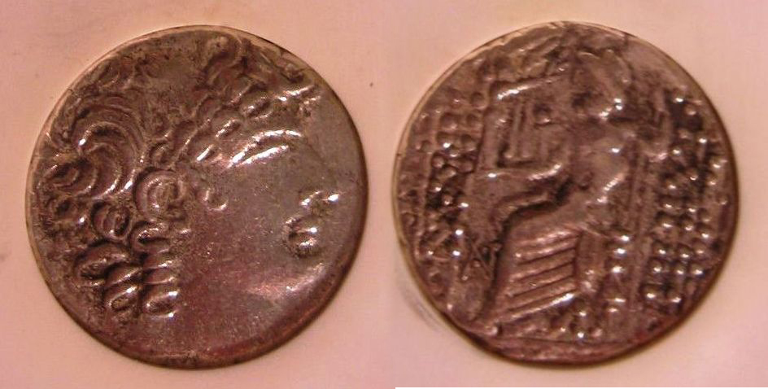

57-16 BC Tetradrachm from Antioch, Syria
Money of the Bible piece
Brought in by Chuck Goergen

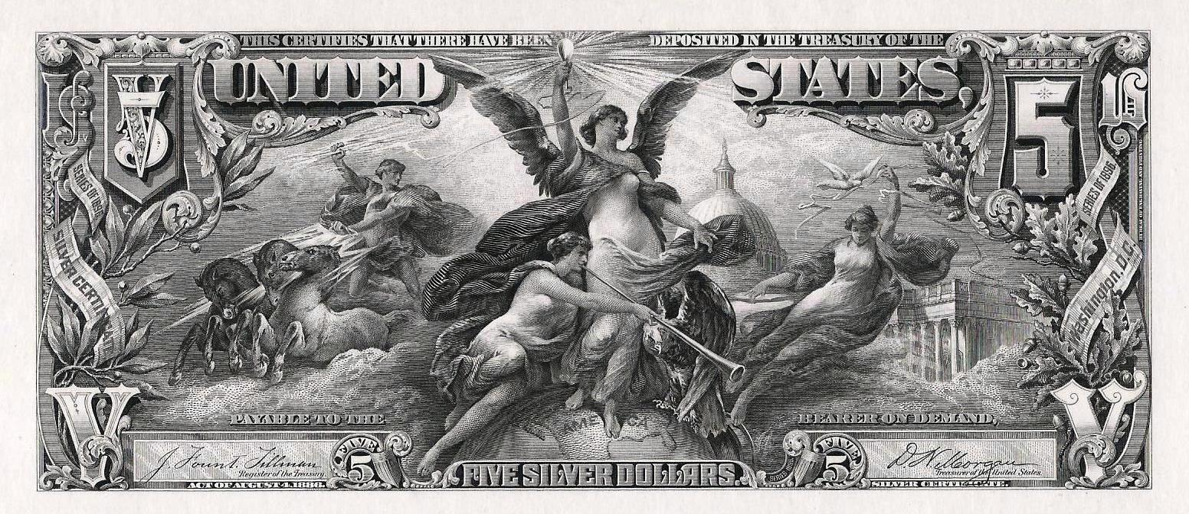
Facsimile of Series of 1896 Silver Certificate
$5.00 Education al Note from Souvenir Card
denoting Electricity as the power of the future
From the 1973 ANA Convention Souvenir Card
Displayed by Arno Safran

Member’s Efforts Praised with respect to Year’s programs, pre-holiday Dinner and Club Audit
]
The club wishes to thank Secretary, Jim Mullaney who was responsible for the individual members' gifts presented at the Club holiday dinner held at the Knights of Columbus back in December, 2013. The "S" 2013 quarters were beautifully packaged and made a great hit.

Our Treasurer, Chuck Goergen, along with JJ Engel are also to be thanked for contributing to making it a special night. at the Knights of Columbus and President Steve Kuhl who served as our congenial host and MC.

Not to be overlooked are the efforts of VP Pat James for providing a year of interesting educational programs at our meetings. Our appreciation goes out to member Roger Worpel who took the time to prepare our annual audit, finding the club account books prepared by Treasurer Chuck Goergen entirely in order. Our next meeting is scheduled for Thursday, Feb. 6 at the Aiken Public Library. Zach Richardson will present a PowerPoint program on the controversial Liberty dollar. You won’t want to miss this one!
____________________________________________________________________________________________________________________________

Kindly Patronize Our Advertisers

