Pres. Willie Simon
V .P. James Barry
Sec. Helen Barry
Treas. Pat James
Sgt. in Arms: J.J. Engel
Committees:
Auction: J.J. Engel
Programs: James Barry
Newsletter: Arno Safran
The Stephen James
CSRA Coin Club of Aiken
P.O. Box 1739
Aiken, SC 29802
Web site: www.sjcsracc.org
The SJ CSRA CC Now Meets on the 2nd Thursday of the Month at the Cedar Creek Community Center in Aiken, SC

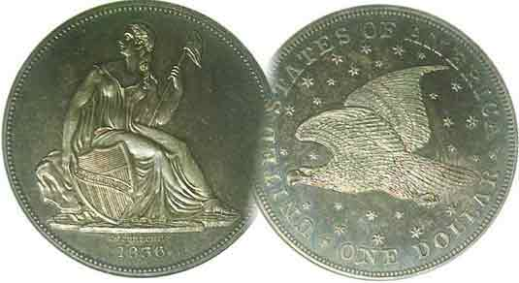

Volume 5, Number 10 the Stephen James CSRA Coin Club Monthly Newsletter October, 2006
Club Holds 5th Annual Coin Show
Our Next Meeting is on the 2nd Thursday of the month, October 12, 2006 at 7:00 PM
2006 Meeting Schedule - 2nd Thursdays at 7 PM
June 8, July 13, Aug. 10, Sep 14,
Oct. 12 Nov 9, Dec 14_

Club Holds Fifth Annual Coin Show

Thanks to the efforts of J.J. Engel, this year’s Show Chairman, our fifth annual club show may be deemed another financial success. At the September meting, JJ reported that he had sold 29 tables at $40 per or $75 for two which roughly translates into around $1,100 to $1,200 income depending on how many dealers took two or just one. That plus raffle tickets sales, thanks to our members, and those manning the Welcoming Desk--especially Walter Ferrari—our income may have been as high as $1,400 to $1,500. Of course, there were expenses for the hall, tables, raffle prizes, advertisements and security which must be figured into the mix and we shall learn the final net tally from our renowned treasurer Ms. Pat at the upcoming Oct.12 meeting.

Show & Tell: At the September 14 meeting Merle Davis, Jr. displayed a flag that was flown in Iraq in his honor on his birthday (Aug. 18). He also showed some other numismatic items sent to him by a friend from the Vietnam War days. Bill Myers displayed a New Zealand silver dollar to go with one from Australia and Canada that he had assembled.

The Program: Arno Safran presented a PowerPoint program entitled, “Coins of the Sixes”: 1806, 1816 and 1836. He chose the three years as significant in US Numismatic history; the first because it represented a 200 year old type set; the second – 1816, as the year when only one coin was issued with that date; the Coronet large cent. Arno chose 1836 as significant because it represented a sort of Renaissance in US coinage. It was the year the steam press was introduced--as evidenced by the changeover of the half dollar from the lettered edge to closed collar Reeded Edge--along with the resumption of dollar coinage with the introduction of the majestic Gobrecht Liberty Seated dollar. 1836 was a year when ten different coins were struck for the first time since 1796. Arno showed pictures of all of them including a Mint medal commemorating the first use of the Steam Press.
_______________________________________________________________________________________________________________________
(Continued on page 5, Column 1)_
The Latin American Alternative: The Dominions of Spain
The Portrait Coinage of Ferdinand VII
By Arno Safran

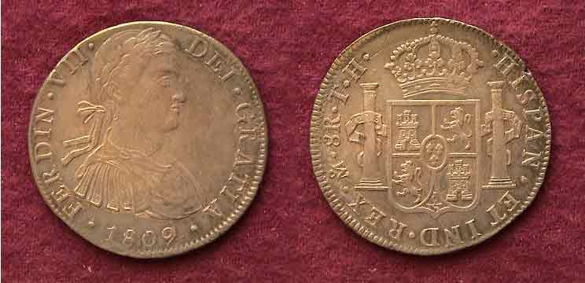

_An 1809 8 Reales (Peso) struck at the Mexico City Mint
Showing the Armored Bust of King Ferdinand VII; KM-110

When one comes to the Latin American coinage of King Ferdinand VII we arrive at a very unsettling period in the history of Spain and its colonies. In 1808, Charles IV abdicated the throne to his son Ferdinand VII due to the influence of the Queen’s lover Manuel de Godoy but as a consequence, rioting followed and Godoy fled. At the time Napoleon’s armies were ravaging southern Europe with the result that both Charles IV and his son Ferdinand VII decided to meet with the French general. Big mistake! Napoleon compelled Ferdinand to cede the crown back to his father, sending the son to a French prison. He then removed the crown from the hapless Charles exiling him to Italy while placing the Spanish affairs of state in the hands of his brother, Joseph Bonaparte. For the time being, the colonies of New Spain remained loyal to the Spanish throne. On Mexican coins struck from 1808-1811, Ferdinand VII appears in an armored Bust looking youthful, strong and heroic as shown above. In 1811 thru 1825, Ferdinand in shown in a Laureate Draped Bust appearing more worldly and benign. As it turned out he was neither. Upon being freed in 1814 upon the defeat of Napoleon, Ferdinand VII returned to a chaotic situation in his native Spain and severe unrest in the colonies.
___________________________________________________________________________________________________________________________
(Continued on page 2, column 1)
The Latin American Coinage of Ferdinand VII
(Continued from page 1)

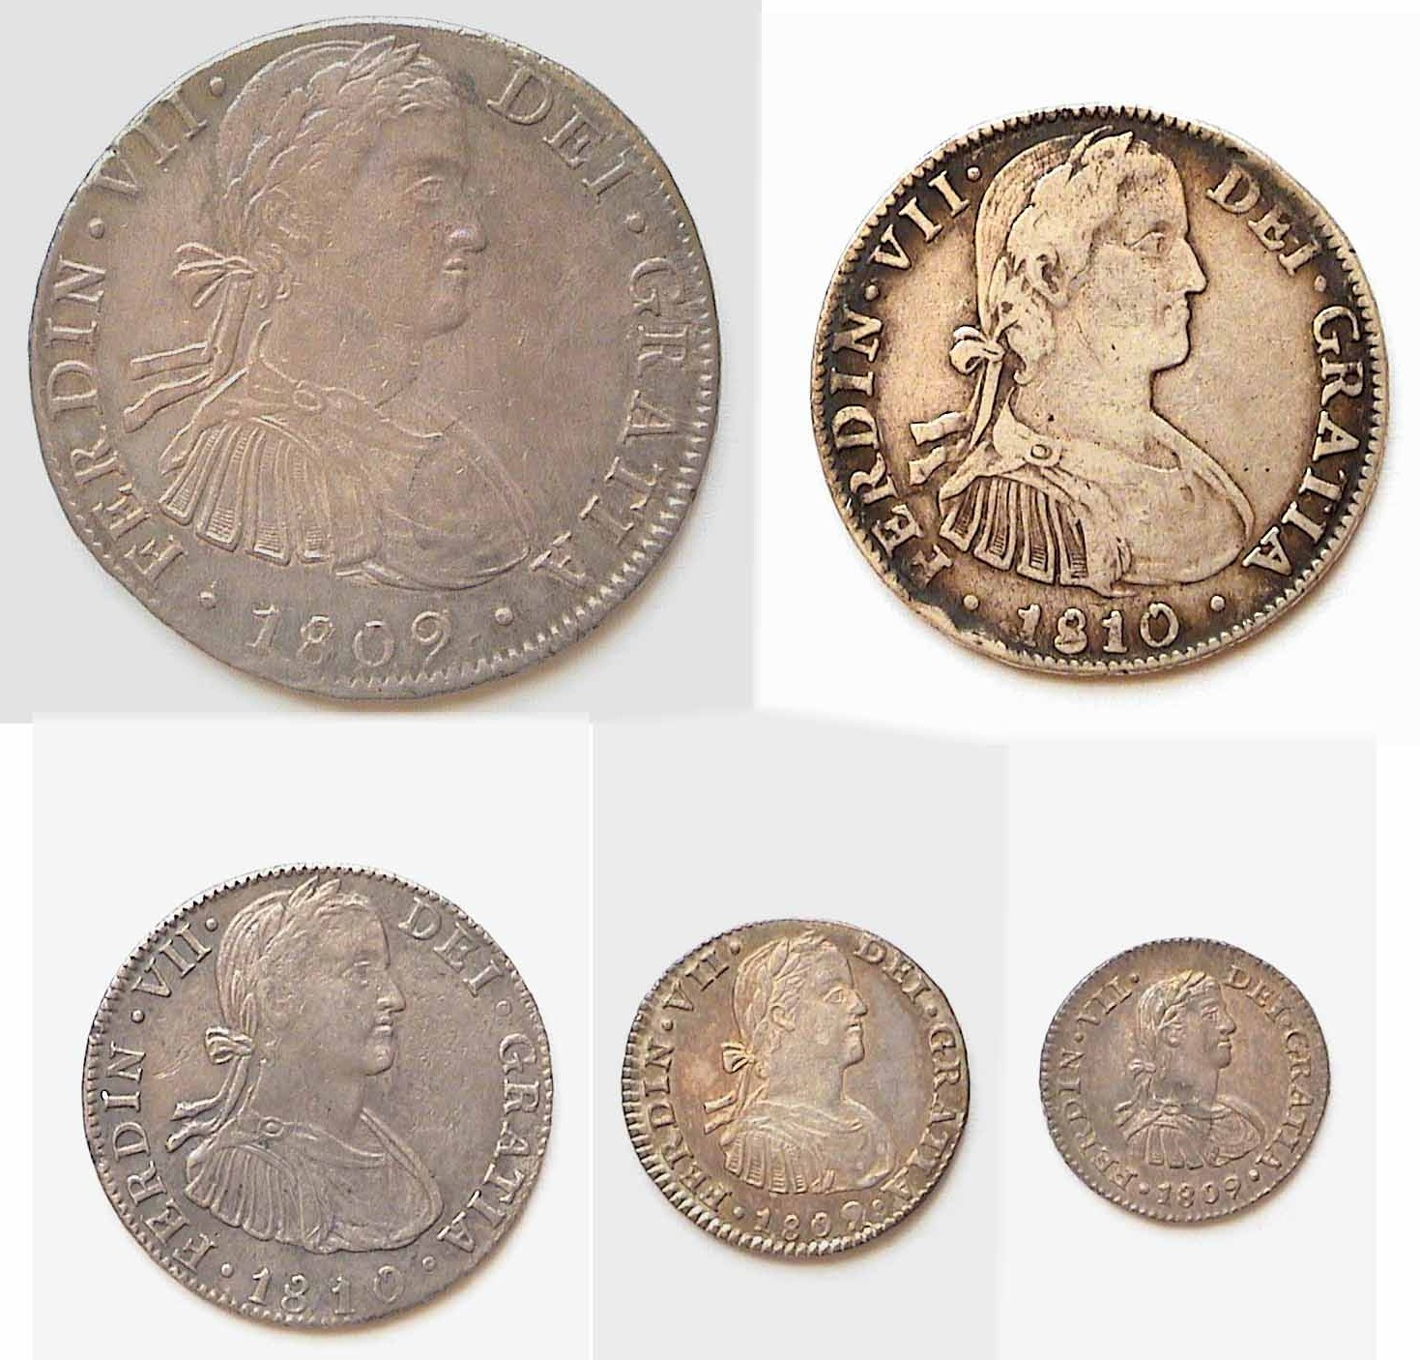

A five piece denominational set of Ferdinand VII
Showing the Armored Bust obverses
Above left and proceeding clockwise is the
1809 8 Reales, 1810 4 Reales, 1810 2 Reales, 1809 Real and 1809 ½ Real

The reverses of all five coins portrayed the standard crowned Bourbon Coat of Arms with pillars.

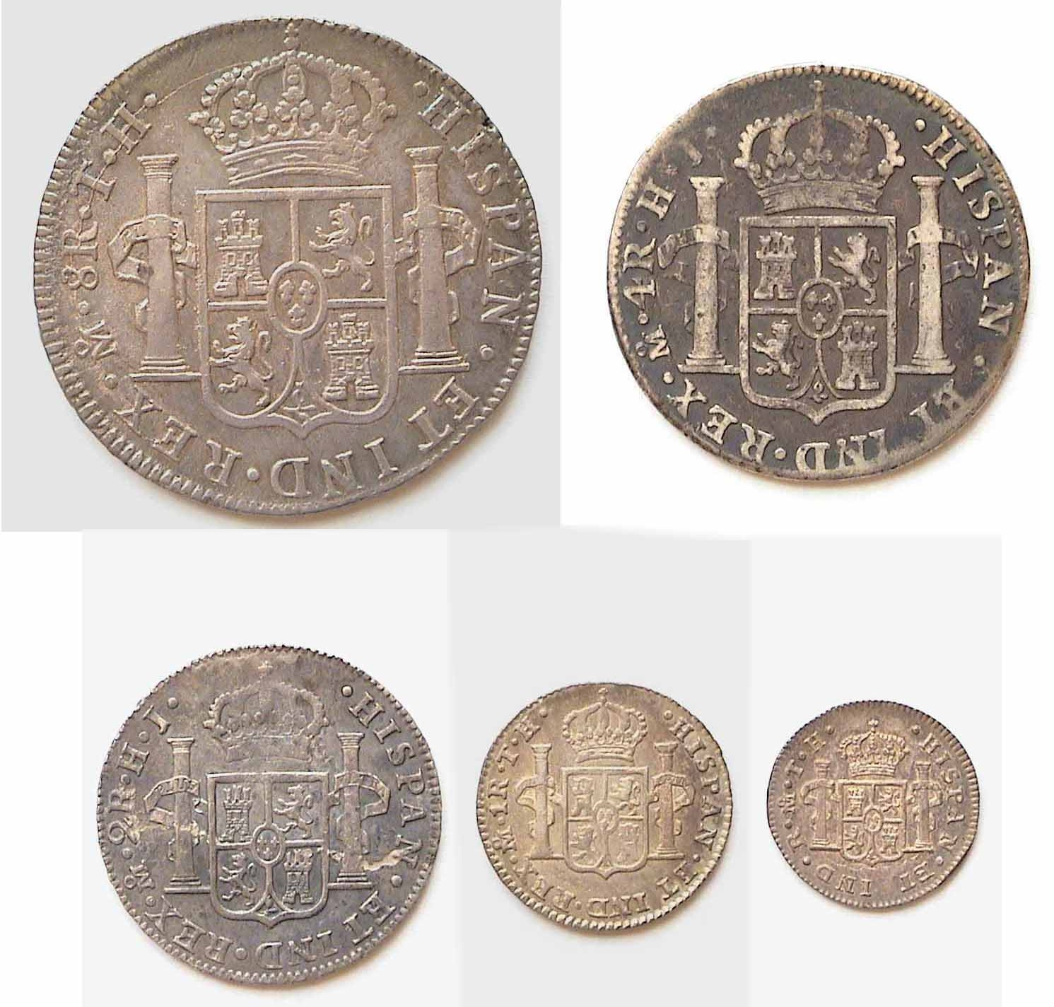

The reverses of the Ferdinand VII set

Of the five armored Bust denominations the 8 Reales is by far the most common and was struck in the multi-millions as a world trade dollar. The 4 Reales–on the other hand–is the scarcest, followed by the 2 Reales; especially within the Mexican armored Bust sub-types. The Real and ½ Real are more available but are becoming harder to find in the higher grades; (e.g., XF or better.)
Early fantasy portraits of Ferdinand VII were struck on the 8 Reales of Peru and Chile between 1809 and 1811. Later that same year, the Laureate Bust sub-type replaced the Armored Bust in Mexico, Guatemala and Peru. The new visage shows Ferdinand VII dressed in a toga with a wreath across his forehead. The silver coinage of Bolivia during this period shows Ferdinand VII in the laureate Draped Bust style on the 8 Reales dated as early as 1808 and 1809 (presumably back dated) and from 1813 thru 1825 inclusive. Bolivian minor silver coinage of Ferdinand VII begins in 1813 with the Laureate Bust sub type.

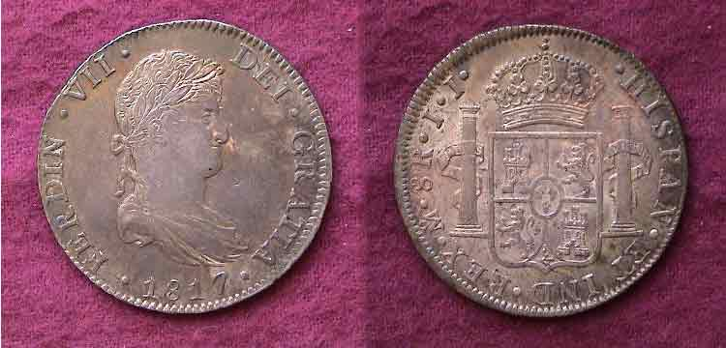

An uncirculated example of an 1817 8 Reales showing Ferdinand VII in the Draped Bust style struck at the Mexico City Mint.

When Ferdinand VII returned to reclaim the Spanish throne in 1814 he was not particularly sympathetic to those of his countrymen espousing the Era of “Enlightenment”. Many of Spain’s intellectuals had sided with Napoleon in the misguided belief that the French general would rid their country from despotic rule while establishing democratic governance. Across the Atlantic a Mexican priest by the name of Hidalgo had begun to preach for independence from Spain and as early as 1810 the insurgency was well under way in that country. The king, frustrated by six years of imprisonment, finding unrest at home and abroad began to take extreme measures which may have realized some success in Spain but only served to intensify the passions of the revolutionaries in the new world.

During all this time there was one small silver coin that continued to be struck in Latin America going back to Charles IV through the reign of Ferdinand VII. This was the ¼ Real (or Quartillo) that had been in circulation since 1796. It featured a Castle on the obverse with the mintmark at the left and the fraction ¼ to the right with the date below. On the reverse was a lion. The coin was struck in .896 silver, weighing slightly less than .05 oz. and was about 11mm in diameter. It was issued in all six of the major Hispanic colonies but the most common survivors today appear to be from Mexico or Peru. Assuming any of these tiny coins reached America; its circulating value would have been equivalent to roughly three large cents.

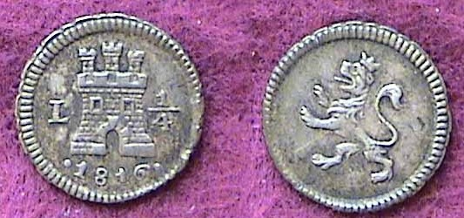

An 1816 Quartillo of Ferdinand VII struck at the Lima, Peru Mint
_________________________________________________________________________________________________________
(Continued on page 3, column 1)
The Latin American coins of Ferdinand VII

During the Mexican War of Independence, (1810-1821) coinage was being minted by both the Mexico City Mint and private mints that had sprung up in the various regions of the country either in sympathy with the insurgents or the Royalists. Private tokens known as tlacos were also being issued by a number of hacienda owners, mining companies and merchants for goods sold in the Company stores. Many of these copper pieces were crudely struck and debased. Under the aegis of Ferdinand VII, the government minister Viceroy Calleja authorized all Mexican tlacos and their parts to be struck at the same copper fineness as the Spanish maravedis while demonetizing all privately issued hacienda tokens. These copper coins were minted between 1814 and 1821 and portrayed the Crown and legend on the obverse with essentially the same reverse as the Spanish maravedis that featured the Castle and Lion as part of a pinwheel design surrounded by a wreath and berries. There were three copper tlacos issued; the ¼ Real named a 2/4 tlaco, (about the same size as our large-cent) a 1/8 Real or ¼ tlaco (closer in size to the British farthing than our half cent) and a tiny 1/16 Real. The last named was called a pilon and was about 16.5 mm to 14 mm in diameter. About ten years ago, one might find an attractively graded example of the two larger tlacos at an International coin show but today these coins are scarce, seldom surfacing above VG. The pilon is un-plated in Krause.

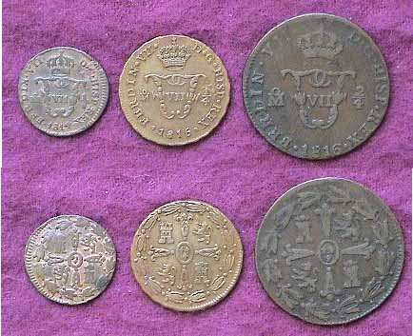

Pictured above from left to right are the tiny Pilon (1/16 Real,
the ¼ tlaco (1/8 of a Real and the 2/4 tlaco (¼ Real).
The obverses are shown above their corresponding reverses.
Magnify to 200% for greater clarity.

Despite the numerous insurgencies against Spanish rule spreading all across Central and South America, the Draped Bust silver coinage of Ferdinand VII continued to be issued in all five denominations—from the ½ Real to the 8 Reales ending in 1825 with Bolivia. The 4 Reales has also been difficult to find above the grade of Fine but today, even quality ½ Reales and Reales are disappearing from the American numismatic scene. By 1825, shaky Republics had been established in the former Spanish colonies, all issuing their own coinage; (the subject for another series.) King Ferdinand VII continued to rule Spain until his death in 1833 when his daughter, Isabella II became queen.
___________________________________________________________________________________________________________________________

Book Review
“Double Daggers” by James R. Clifford
By Bill Myers

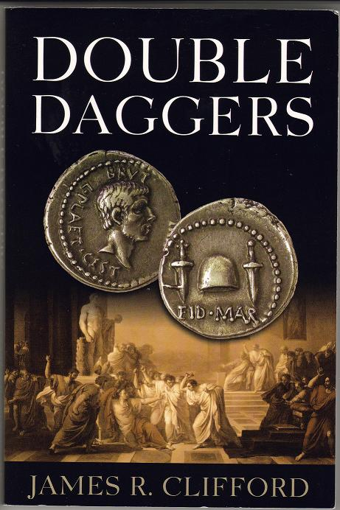

I have not had the time to sit down and read a novel for over 25 years, but my deployment to Iraq has allowed me the opportunity. I spent many hours waiting in line in Ft Bliss and a long flight to Kuwait. I also had a lot of “downtime” in Kuwait getting ready to fly to Mosul, Iraq.

On fellow member Jim Barry’s recommendation I bought a copy of Double Daggers (196 pages). The novel consists of four “books”, and the common thread throughout is the possession of the Eids (Ides) of March denarius that Brutus had minted after the assassination of Julius Caesar. The first Eids of March denarius was given to Brutus and marked with the Roman numeral I and it ends up in the possession of each of the characters through the four books. It maintains its mint luster and shows no wear and is considered cursed and it is this aspect that holds true throughout the four books.

Book I gives the account of how Brutus came to kill Julius Caesar and created the coin in 44 B.C. It also accounts for the coins rarity as Marc Anthony defeated Brutus and had most of the Eids of March coins melted. Book II follows the Gaul Michael Claudien on his reluctant quest to Jerusalem as a Crusader who wins the coin gambling. Book III is about Colonel Maxwell Von Studt, a Nazi SS officer and a member of Hitler’s inner circle who takes the coin from the Louvre. Book IV is set in New York and follows the life of Jack Weston, a very successful Wall Street trader, who buys the denarius as a status symbol, not because of its numismatic history.

I found the book enjoyable and wanted to see how each character’s life would be altered by possession of the coin. If you are looking for an authoritative text on ancient coins, this may not be the book for you. It is, however, an easy reading novel based on a numismatic theme. It can be put down and picked up later without difficulty. As the cold weather approaches, if you are looking for a good book to read, I would recommend Double Daggers.
_____________________________________________________________________________________________________________

The Palmetto Regiment Medal
By Tony Chibbaro

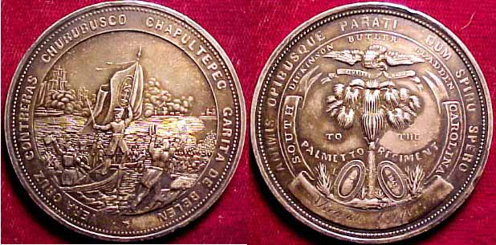

A specimen of one of the most historically important medals issued by the state of South Carolina is pictured above. Authorized by the state legislature in late 1848, specimens of the Palmetto Regiment medal were struck by Charleston silversmiths Gregg, Hayden & Co. in early 1850 from dies cut by William J. Keenan. Gregg, Hayden & Co. was a prominent silversmith firm in Charleston in the 1840s and 1850s and Keenan was a Charleston engraver and lithographer who were also in business during the same time period.
The medal was most adequately described in the May 16th, 1850 issue of the Charleston Courier as below:
- “On one side is represented the landing of the American troops at Vera Cruz, the gallant leader of the Palmetto regiment, Col. Butler, having sprung from the boat that bore him to the shore, and with drawn sword, is calling on his command to follow – a figure, bearing the beloved Palmetto Flag, is on the prow of the boat, about to leap on shore, and plant the Standard, around which all appear eager to rally. To the right, are serried columns of troops on the line of march towards the Castle of San Juan; while in the distance is seen the American fleet, covering the landing of more troops, which are approaching the shore in boats. Around the edge of this side of the medal, in raised letters, are the names: “Vera Cruz,” “Contreras,” “Churubusco,” “Chapultepec,” and “Garita de Belen.”

- On the reverse, is delineated a beautiful Palmetto Tree, resting against the trunk of which recline two shields, bearing the dates 1846 and 1847. Hovering over the tree is a spread eagle, from whose beak floats the motto of the Union, “E Pluribus Unum;” immediately above which, in a circle, is inscribed the names of “BUTLER,” “DICKINSON,” and “GLADDEN.” On the outer rim are the State mottos, “Animis Opibusque Parati” – “Dum Spiro Spero.” In the center of the medal in curved lines, are the words “To the Palmetto Regiment,” and at the foot and lower edge is a blank scroll, for inserting the name of the recipient.”
The pictured medal is made of silver, measures 49 mm in diameter and weighs approximately 44 grams. It is believed that 882 specimens were awarded – 68 gold medals (awarded to commissioned officers) and 814 silver medals (awarded to non-commissioned officers and enlisted men). The specimen above was awarded to Private Micajah Cooper of Company K (Barnwell District), who died during the Mexican war at Puebla, Mexico on July 10, 1847.
Private Cooper’s fate was no different than many other members of the Palmetto Regiment. Of the 1027 men that were mustered into service, 292 lost their lives. Most of these 292 died from disease (234), as only 56 were killed in action or died later from wounds received in action. The staggering number of men lost to disease attests to the horrifying conditions that the volunteers were subjected to during the course of the campaign. Had they known what lay in store for them in Mexico, most would never have signed up for such hardships in all probability.
Even the highest-ranking officer would not return to his home state alive. Colonel Pierce Butler, a former governor of South Carolina and the officer pictured on the medal rallying his men to shore, was killed by enemy fire during the battle of Churubusco. Butler’s body was returned to South Carolina by ship in January 1848 and a large funeral took place in Columbia. Butler was laid to rest in Trinity Cathedral’s graveyard, but was moved in 1853 to a churchyard in Saluda.
Despite all the hardships encountered, the Palmetto Regiment brought honor to the state by performing admirably in battle. There were five battles in which the Palmettos participated, and each one is delineated on the obverse of the medal. The battles of Vera Cruz, Contreras, Churubusco, Chapultepec, and Garita de Belen all involved the Palmetto Regiment to one degree or another. Perhaps the Palmetto Regiment’s highlight of the war was the planting of the regimental flag atop the castle at Chapultepec, effectively ending Mexican resistance to the advancing American forces and paving the way for the capture of Mexico City.
_____________________________________________
Thanks go out to Tony Chibbaro for another illuminating article in his ongoing series of South Carolina Medals. (Ed.)
______________________________________________________________
More Offerings Wanted for Newsletter
The Executive Board of the Stephen James CSRA Coin Club welcomes more contributions by its members and other interested parties to its monthly newsletter. If you have items of interest you would like to contribute, please send via E-mail to the editor at arnosafran@comcast.net and thank you.
_____________________________________
More Club News

At the September 14 meeting Treasurer Pat James reported a balance of $1,084.59. Vice President Jim Barry mentioned that the book, “Double Daggers” by James R. Clifford has been increased to $15 since its initial offer of $12.00 two months ago, so those who took advantage of the original offer have already garnered a net value of $3.00. At that time, the author was offering a free coin replica struck in base metal of the notorious silver denarius that is the subject of the novel.
Regarding the club Show, President Willie Simon asked members attending to wear their club shirts. Marion Engel once again offered to arrange for lunch for club workers attending the show. Thank you, Marion. Walter Ferrari, Vilma and Arno Safran and Jim and Helen Barry said they would take turns manning the Welcoming table at the show.

Member Bill Myers Leaving for Iraq

Bill Myers bade a temporary farewell to the members explaining he has been reactivated to duty in Iraq and would be unable to attend the show. Bill is an orthopedic surgeon assigned to the Medical corps with the Army reserves. In the past, Bill’s tour of duty has not exceeded four months. Let’s hope Bill will rejoin us in four months time in early February, ’07. Despite his departure, Bill continues to contribute articles and items of interest to the newsletter. See his book review appearing on page 3, column 2. Thanks, Bill!

Prize Winners

Winner of the silver eagle attendance prize was Paul Simons. Jack Seech won the 50/50 drawing - $$21.50. Congratulations gentlemen.

Next Meeting’s Program

The program for our next meeting will be a video entitled “Collecting US Paper Money”. We have some paper money enthusiasts in our club, so this should be of interest not only to them but to others as well. Hope to see you all there on Oct. 12.

SCNA Show coming up at end of October

Jim Barry announced that the South Carolina Numismatic Association (SCNA) would be holding its annual three day Convention on October 27 thru 29, 2006; a Fri., Sat. and Sun. Around 80 dealers will be in attendance. The site is the Embassy Suites Hotel, 670 Verdae Blvd. in Greenville, SC. The convention is open to the public at no charge and the hours are Fri. 10:00 AM to 6:00 PM, Sat., 9:00 AM to 6:00 PM and Sun. 10:00 AM to 3:00 PM.

Directions from Aiken: Rte. 19 north into Rte. 25, then north on 25 continuing past Greenwood to the outskirts of Greenville, bearing right on to Rte. 291. Shortly thereafter take a right onto I-85 towards Spartanburg. Take the northbound entrance onto the I-385 interchange and go to Exit 37 turning left at the light at the end of the exit ramp. Drive about one mile to the Embassy Suites hotel which will be on your left. The estimated drive time is 1¾ hrs.
___________________________________________________

Sleeper? of the Month

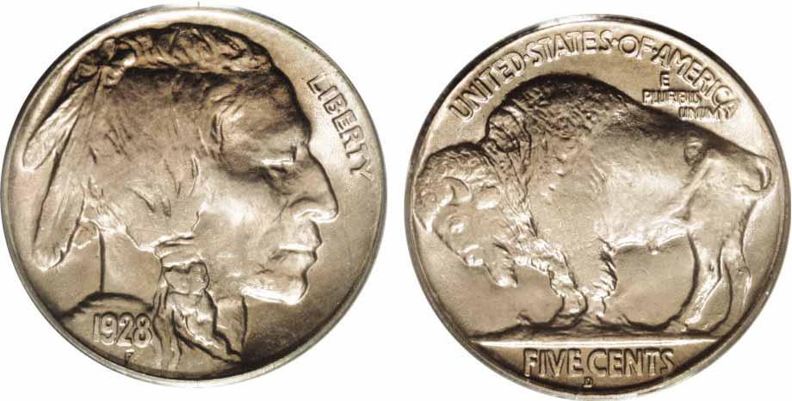

A 1928-D Buffalo Nickel

With a mintage of just 6,436,000 the 1928-D Buffalo nickel is listed at just $50 in MS-63 according to the 2007 Red Book.

