Pres. Willie Simon
V .P. James Barry
Sec. Helen Barry
Treas. Pat James
Sgt. in Arms: J.J. Engel
Committees:
Programs: James Barry
Show Chairman: JJ Engel
Newsletter: Arno Safran
E-Mail: arnosafran@comcast.net
The Stephen James
CSRA Coin Club of Aiken
P.O. Box 1739
Aiken, SC 29802
Web site: www.sjcsracc.org
The SJ CSRA CC Now Meets on the 2nd Thursday of the Month at the Cedar Creek Community Center in Aiken, SC

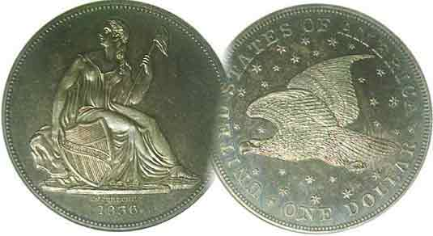

Volume 6, Number 10 the Stephen James CSRA Coin Club, Founded in 2001 October, 2007
Monthly Newsletter
Our Club Show, Another Successful Event
SCNA Convention Set for Oct. 26-28 in Greenville
Our next meeting is on the 2nd Thursday of the month, Oct. 11, 2007 at 7:00 PM

2007 Club Meeting Schedule - 2nd Thursdays at 7 PM Jan. 11 Apr. 12 July 12 Oct. 11
Feb. 8 May 10 Aug. 9 Nov. 8
Mar. 8 June 14 Sep. 13 Dec. 6

_____________________________________________________________________________________________________________________________

Club Show Seen as another Success as 150 attend

For a coin club to balance its annual budget, it almost assuredly has to hold at least one show a year. Membership dues alone will not sustain a club--even without such monthly expenses as meeting hall rental (which is not applicable in our case)--or the publishing of a monthly newsletter. With slightly less than fifty paid members, most of them adults, our annual income from dues falls between $425 and $500. We may raise anywhere from $12 to $15 each meeting from the 50/50 drawing which averages out to an additional $175 per year, but as we only hold eleven monthly meetings; the twelfth being given over to our annual Christmas diner paid in part by the membership, an annual income of $600 will not sustain the SJ CSRA CC. Since the club was founded in 2001, six shows have been held; four run by the Barry’s and the last two by J.J. Engel. All have been successful from a financial base thanks to the fine efforts of these bourse chairpersons and the many fellow members who have assisted them. The club has considered expanding the show to a two day affair in order to attract more dealers, (including some with material for the more advanced collector) but thus far an affordable and large enough overnight facility has yet to be found in the Aiken area.
Winners of the show’s three raffle prizes were Steve Shuford who won the $5.00 commemorative gold piece, Vickie Reynolds who won the 2007 silver proof set (inc. the four Presidential dollars) and Darcy Mabry who won the uncirculated Morgan dollar. Congratulations to the three winners.

The South Carolina Numismatic Association (SCNA) will be holding their three day annual convention at the Embassy Suites in Greenville on Oct. 26-28; Fri. thru Sun. It is open to the public at no charge and worth the 2 hour trip.
_______________________________________________________________________________________________________________________
(More Club News on page 4, column 1)
Are low Grade Key Dates a Good Investment? Part 2
By Arno Safran

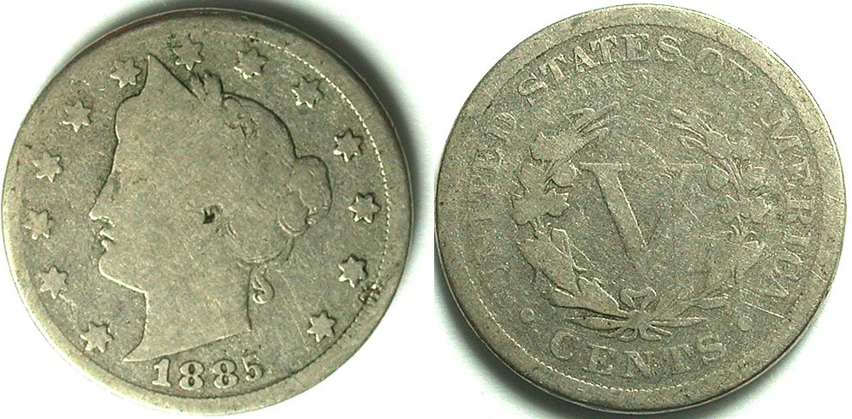

The key date 1885 Liberty Head 5¢ nickel graded Good-6 is listed
for $569.00 (Courtesy of J.J. Teaparty’s Website)

In 1996, I was fortunate to acquire an 1885 V nickel graded AU-50 for $525. As a youth, I remember coming across an incredibly low grade “V” nickel in which all that one cold make out on the date was 188_ and a blurred upper portion of the last digit which looked as if it were a 5. In those days, only two grades were listed in the catalog, VF and Unc. An 1885 5¢ VF was $12.50 and the unc, $25.00. Common dates were listed at $0.50 and $2.50 respectively. My possible 1885; grading only a Poor-1 had to be worth something. It was! 15¢! Back then, an average circulated Liberty nickel sold for 15¢ apiece and if the grade of a key date was in doubt, that coin was still worth 15¢. The coin pictured above was listed for sale at $569. It is a better specimen than my Poor-1 but not that much better. Listed as a Good-6, it is only five points higher on the Sheldon grading scale of 1 to 70, with MS-65 to 70 representing a pristine Gem BU specimen. The 2008 Red Book lists an AU-50 at $1,500.

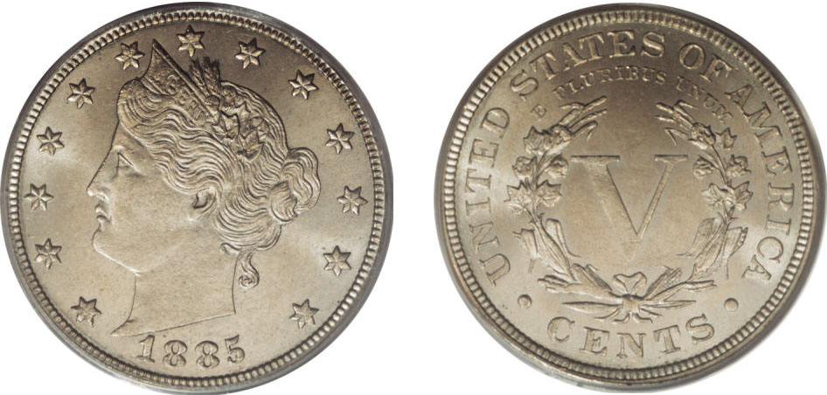

This 1885 Liberty 5¢ graded MS-65 by PCGS realized $9,200.

An MS-65 1885 V nickel as pictured just above is extremely scarce. Out of 50 lots, only two MS-65s appeared in Heritage’s auctions in one year, the vast majority, grading AG-3 to VG-8.
____________________________________________________________________________________________________________
(Continued on page 2, column 1)
Are Low Grade Key Dates a Good Investment? (II)
(Continued from page 1, column 2)

The upshot of the above price comparisons for low and high grade 1885 “V” nickels are illuminating. Strong AU to high-end gem Mint state specimens exhibit great eye appeal, are scarce to rare and command strong prices due to high demand for those with the discretionary income to afford them. By contrast, examples grading as low as AG-3 to VF-20 usually appear lackluster, are often found with numerous problems such as corrosion, scratches or rim damage. Not only are they extremely unattractive for the most part but they are also much more common. Out of the fifty lots of 1885 “V” nickels offered by Heritage’s live and on line auctions in a single year, thirty were graded between AG-3 and VF-35 with most being of the extreme lower end. Five lots grading AU-50 up to MS-60 were listed as corroded, retoned or whizzed yet still realized just under $1,000 and just fifteen were graded AU-58 to MS-65 with the majority of the better examples grading no higher than MS-62. So, the question remains, why are so many willing to pay $500 to $1,000 for blemished or unattractive examples found in the described states when they are not rare at all.

Let’s take a look at another popular key date coin; the 1909-S. The situation is almost a direct reversal from the preceding 1885 Liberty “V” nickel example.
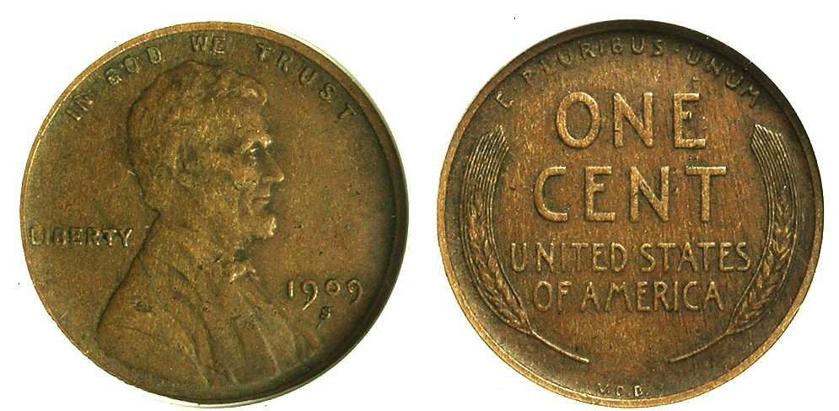

A 1909-S VDB Lincoln Wheat Cent graded VF-35 by Anacs
The coin is currently listed at $1,139 on J.J. Teaparty’s Web site
[Magnify up to 500% to view the coin’s essential details.]

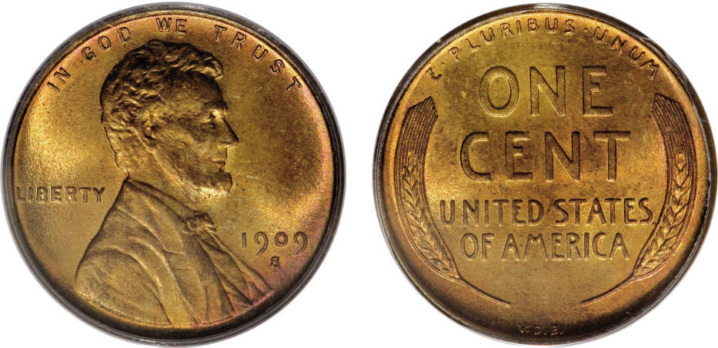

A 1909-S VDB Lincoln Wheat Cent graded MS-65 by PCGS
The coin realized $5,405.00 in the just held Heritage Long Beach, CA sale
[Magnify up to 500% to view the coin’s essential details.]

The two 1909-S VDB cents pictured above are both pricey. The first coin was assigned a grade of VF-35 by ANACS but considering the asking price of well over $1,000, would a key date with this appearance be worth this much outlay of cash? While the PCGS-65 full Red coin shown directly below is almost five times the expense, it is so superior an example that the expenditure of such a sum is rewarded by the high numismatic quality as well as rarity since very few 1909-S VDBs surface in full Red MS-65 or higher. The problem with the 1909-S VDB Lincoln cent is the frequency at which this date surfaces at major numismatic auction houses. In less than three months (July thru Sept. 2007,) the 1909-S VDB cent has appeared fifty times in a Heritage auction. While there were a number of low grade examples that still brought close to $1,000 per lot, most of the entries for this date were MS-60 thru MS-64. As a rule, Mint state coins in full Red (usually only grading from MS-63or better) bring better prices than those described as Red/ Brown or merely Brown. Still, the 1909-S VDB surfaces perhaps more than any other US key date coin, so the question is, if it’s that common, why is it so expensive in all grades? The answer is in its extreme popularity. Among collectors, there is probably no other US key date coin that is in greater demand. Having said that, does acquiring a scudzy well circulated example for over $1,000 represent a good investment?

There is one another key date coin that has had an interesting history and that is the 1921-S Walking Liberty Half dollar.
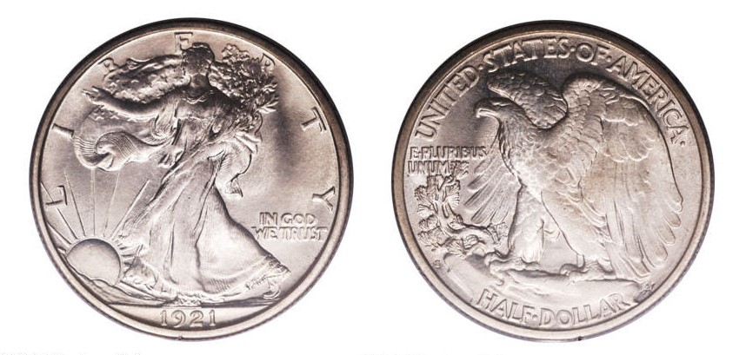
A 1921-S Walking Liberty Half dollar graded MS-65 by PCGS
This major rarity realized $109,250 at Heritage’s Signature sale on May 4, 2004

Very few collectors can afford such a rare beauty as shown above. Despite a mintage of just 548,000, the 1921-S the date is only rare in XF-40 or higher. Looking over the Heritage Auction Archives web site, the writer had to go back to May 5, 2004 before he found the appearance of a MS-65 specimen. Of the last fifty coins auctioned off by Heritage from June, 2006 thru October, 2007 only four were graded MS-64, one MS-63, five between AU-53 and AU-58 and only one was graded XF-40 and that was certified by ANACS as “cleaned” yet still managed to realize $862.50. Of the thirteen examples that fell into the VF 20 thru 35 column, one problem-free certified VF-30 realized a lofty $1,092.50. The 25 remaining coins out of the 50 ranged from Fine-15 down to AG-3, most of them grading no better than G-4 to VG-8 while realizing no more than $35 to $60. Price wise this appears to be the only key date within the survey in which buyers get what they pay for.

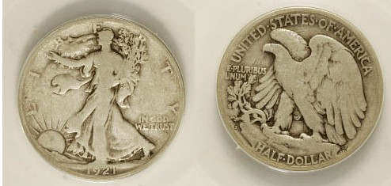

A 1921-S Walking Liberty 50¢ certified VG-8 by ANACS
When magnified to 500% one can see the mint mark S at the lower left rim between the H in HALF DOLLAR and the U in E PLURIBUS UNUM
(Courtesy of heritage Auction Archives)

One would not choose the coin shown above as an example of engraver Adolf Weinman’s art. All of the aesthetic qualities disappeared by the time the coin wore down to VF-30 but at least the price seems right at $60 since VG’s are fairly common. Even with key dates, grade rarity still plays an essential role in determining value. Most low grade key date coins are in reality, not scarce at all.
___________________________________________________________________________________________________________________________
STATEMENTS ON NOTES
By Bill Myers

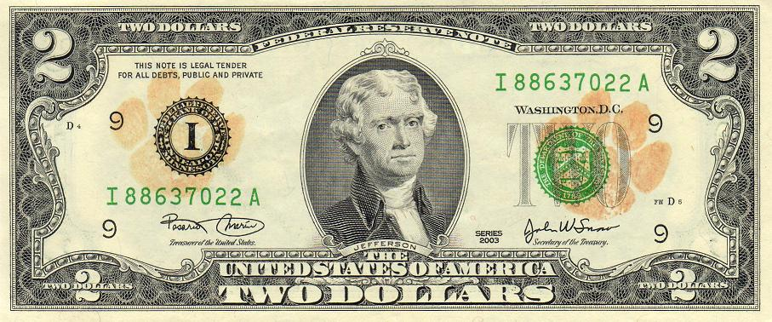
A “Cat’s Paw” $2.00 Note
[Magnify to $200 % to see details more clearly.]

I recently acquired two notes in circulation with “graffiti” stamped on them. This inspired me to pull out a third note from my collection that also had a form of graffiti stamped on it. The perpetrators of the graffiti even went to the effort to have a stamp made to spread their message.

The first note had a stamp that contained two lines that state “www.wheresgeorge.com” and “BUY AMERICAN” between them. This promotes a website that is part of the U.S. Currency Tracking Project designed by Hank Eskin, which tracks bills of all denominations as they travel across the country. When the bill’s serial number is loaded into the site, past reporting of that note can be found.

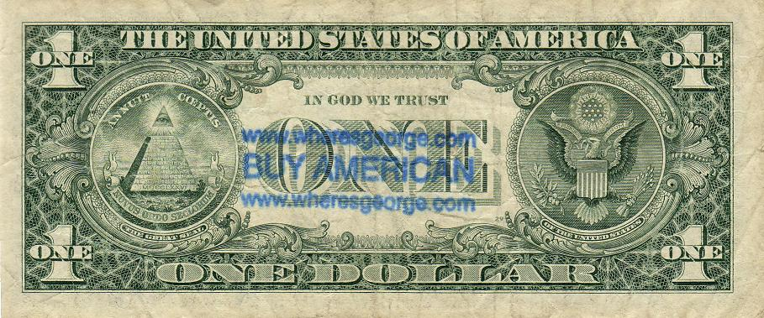

[Magnify to $200 % to see details more clearly.]

The next note states “IF YOU LIKE GOLDEN DOLLAR COINS, ASK FOR THEM AT A BANK. IF THEY’RE OUT, TELL THE MANAGER TO ORDER THEM!” This person is obviously a supporter of the dollar coin, though I am not aware of an organization with the agenda of promoting the dollar coins.

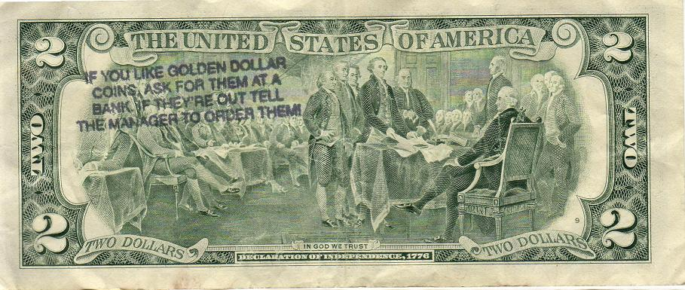

[Magnify to $200 % to see details more clearly.]

The last set of notes I have is a series of $2 notes with orange cat paws stamped on them. I assume these were used at an event promoting a sports team, possibly the Clemson Tigers. The notes were spent (for beer?) and thus released into circulation and came into my possession
Depending on your view, stamps on banknotes can be considered a defacement of U.S. currency or a free method of spreading your message. Either way, it is yet another interesting niche in numismatics.
_____________________________________________________________________________________________________________________________
Another “food or ‘drink’ for thought” article from the pen of the redoubtable Bill Myers who always has something interesting to share with our readers; Ed.)

Keeping Up With the Hobby

There are a number of ways collectors can learn more about numismatics while staying informed about the latest retail coin prices, new developments regarding laws and taxes along with reading articles on specific rarities, even undervalued numismatic items and obsolete coin types. One of the best sources is Numismatic News; a weekly newspaper devoted to the coin collector that has been published since 1952. This year it celebrates its 55th anniversary. The publication offers a special pull-out monthly price supplement with the first issue of each month. Below is the front piece taken off their internet website www.numisMasster.com.
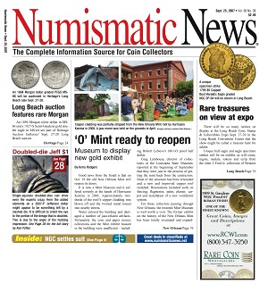
Almost every issue has interesting articles by renowned numismatic scholars, listings of upcoming coin shows, major auction news, club events, a Coin Clinic in which the venerable numismatic researcher and past ANA governor Alan Hebert answers readers’ questions. There is one spot I particularly enjoy reading on the inside back page called “Item of the Week” by the late Paul Green. The man obviously loved coins and wrote a weekly column going back over two decades with the result that editor David Harper still has a yearly supply of posthumous articles awaiting print. All of the coin articles are accompanied by enlarged easy to observe coin photos. The yearly subscription price is just $35.99. That’s only 70¢ per issue. Highly recommended reading for the coin collector.
_____________________________________________________________________________________________________________________

More Club News (Continued from page 1, column 1)

. Show & Tell: Jim Barry displayed a 2006 commemorative Canadian hologram-type three dimensional silver proof coin struck for the 30th anniversary of the Toronto Tower completed in 1976. It was billed as the tallest building in the world at the time. The coin had a mintage of 15,000.

The Program: Bill Myers presented a PowerPoint program on “Numismatics in Iraq”: An Introduction. He showed examples of the latest 5¢, 10¢ and 25¢ P.O.G.s, also some of the new and old Iraqi coins and banknotes that included some counterfeits. He also discussed the three areas of supply, the local shop keepers, black market and military PX stores.

The club welcomed new member Sharon Smoot who attended her first meeting with member husband Dick Smoot, already a coin and paper money enthusiast since joining almost two years ago. Treasurer Pat James reported a healthy balance in the club treasury of $1,042.91. The increase was due in part from income raised from dealers who took tables at our Sept. 15 show. J. J. Engel, our Show Chairman reported that 17 dealers paid for 26 tables. Way to go, J.J.! The show--as reported earlier--was an important financial success for our club. The club also appreciates the help of President Willie Simon and members Gene Riggins, Arno and Vilma Safran who manned the Welcoming Desk and all the others who helped with set up and take down. Prize Winners at the September 13 meeting were Glenn Sanders who won a 2007 silver eagle and Jack Seech who took the 50/50. Congratulations go out to both.

Christmas Dinner unveiled: VP Jim Barry reported that our annual pre Christmas dinner meeting will once again be held at EeJays on Richland Ave (Aiken-Augusta H’wy) on Dec. 6, a first Thursday. Member Bill Myers who is President of the Augusta Coin Club announced that the ACC will be holding its annual holiday dinner bash on Dec. 13, the second Thursday at Logan’s Roadhouse. Come one and all, let’s drink, eat and be merry! Our next meeting is next Thursday, Oct. 11. Hope to see you there. Bring in something for Show & Tell.
__________________________________________________________________________________________________________________

Coin of the Month

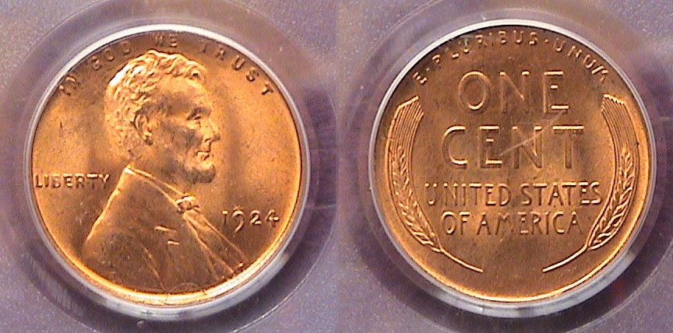

A 1924-P Lincoln Wheat Cent graded MS-64 Red by PCGS
[Magnify the page up to 500% to see details.]

As mintages go, the 1924 P Lincoln Wheat cent--with a mintage of 75,178,000--is not all that large. Compared with most P Mint dates of the 1909-1958 portion of the series one finds far fewer high end mint state 1924-P’s than in all the years that followed, save for the Depression years of 1931, 1932 and 1933. This particular coin was acquired over 16 years ago when third party certification was in still its infancy and grading was arguably a lot stricter than it seems today. It cost $60 then yet regrettably, it’s wholesale bid at only $50 today. So, as an investment, it’s gone absolutely nowhere. I have wondered that with today’s relaxed standards in certified grading if the coin were cracked out and resubmitted, might it possibly come back as a MS-65 where its bid is just under $300. Upon 500% page magnification, the only noticeable blemish is a streak across the window of the slab on the reverse, not on the coin. The coin itself is full red, with virtually no distracting marks of any kind. With this thought in mind, I brought this coin to our last grading bee back in May (in which the certified grade is taped over), but as it turned out, we have a lot of “tough” graders in this club. Not one of the members who participated graded it higher than MS-64 but in the low lighted meeting room, did anyone think the scratch across the slab was on the coin? Perhaps! Perhaps, not! Regardless of the coin’s ultimate value, I have always considered the ’24-P Lincoln cent a somewhat elusive date.
_________________________________________

Kindly Support Our Advertisers

