Pres. Willie Simon
V .P. James Barry
Sec. Helen Barry
Treas. Pat James
Sgt. in Arms: Glenn Sanders
Committees:
Programs: James Barry
Show Chairs: The Barry’s
Newsletter: Arno Safran
E-Mail: arnosafran@comcast.net
The Stephen James
CSRA Coin Club of Aiken
P.O. Box 1739
Aiken, SC 29802
Web site: www.sjcsracc.org
The SJ CSRA CC Now Meets on the 2nd Thursday of the Month at the Cedar Creek Community Center in Aiken, SC

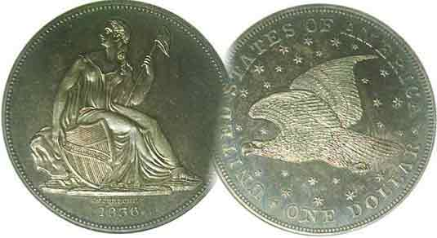

2008 Club Meeting Schedule
Volume 7, Number 10 the Stephen James CSRA Coin Club, Founded in 2001 October, 2008
Monthly Newsletter
September Show a Strong Showing for our Club
Our next meeting is Thursday, October 9, 2008 from 6:15 to 9:00 PM
Jan. 3 Apr. 10 July 10 Oct. 9
Feb. 14 May 8 Aug. 14 Nov. 13
Mar. 13 June 12 Sept. 11 Dec. dinner
___________________________________________________________________________________________________________________________

31 Tables Sold: Over 180 Attended

Despite gasoline prices reaching all time highs due in part to the aftermath of Hurricane Ike and some big time area price gauging at the pump, the attendance at our annual show was better than last year’s. Bourse co-chairpersons Jim and Helen Barry were generally pleased with the results as were the dealers. President Willie Simon thought there was sufficient help with both the setting up, taking down and at the Welcoming Desk thanks to the number of members who volunteered. Indeed, it was Mr. Willie who was one of the more active participants providing assistance when and where needed. Thanks to the Barry’s efforts, the bourse featured a wide variety of collector items that included U.S., Foreign, Ancients, bank notes, scrip, tokens and medals; the last two a favorite with several area collectors. According to Treasurer Pat James, the net profit for the show totaled $777.98, a pretty healthy figure considering our expenses came to $137 more this year than in 2007. This ensures our club of a sound working budget for the remainder of this fiscal year and into the next.

Winners of the three raffle prizes were: 1st Prize - Art Ludwig – Gold Commemorative Coin, 2nd Prize – David Pratt (one of our show dealers), a 2008 Silver Proof Set and 3rd Prize - our own hard working Glenn Sanders, a Certified BU Morgan dollar. Congratulations to all the winners.

The club appreciates the work of the Barry’s and all the members who helped to make the show a success.
_____________________________________________________________________________________________________________________

South Carolina Numismatic Association (SCNA) Convention Coming Up –Oct. 24-26 in Greenville

The SCNA will be holding its 36th Annual Coin & Currency Show on Oct. 24-26 (Fri thru Sun.) at the Carolina First Center, 1 Exposition Drive in Greenville, SC. The hours are 10 AM to 6 P.M. Fri & Sat; 10 AM to 3 P.M Sunday.
________________________________________________________________________________________________________________
(More Club News continued on page 3, column 2)

Collecting Short Sets by Type – Liberty Seated
By Arno Safran
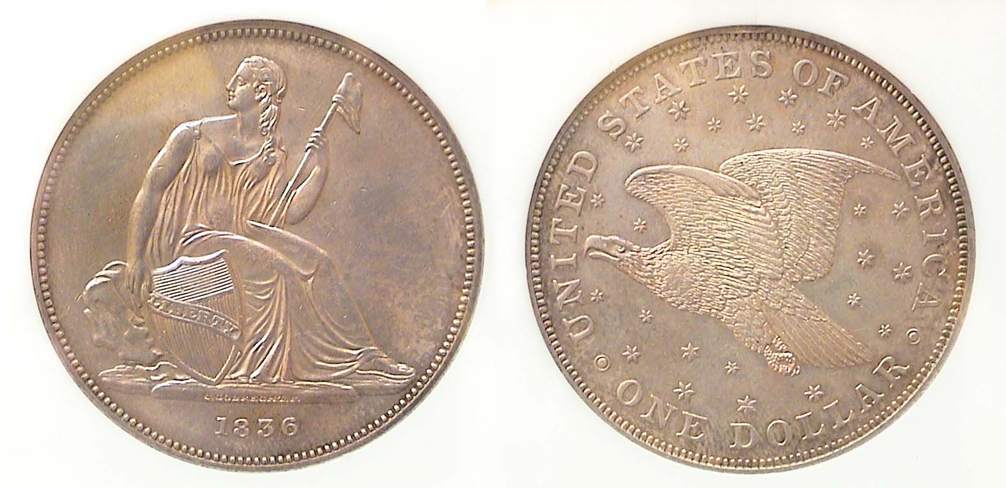

An 1836 Gobrecht Dollar J-60 Original [Magnify to 200%]

The genesis of the Liberty Seated type silver coins goes back to 1835 when Mint Director Robert Maskell Patterson asked then Chief Engraver William Kneass to prepare a pattern for the resumption of a new silver dollar. Patterson wanted the new coin type to be modeled after the Britannia motif used on English coinage. Painters Thomas Sully and Titian Peale were invited to prepare sketches along the lines Patterson desired but before Kneass got very far, he suffered a “debilitating” stroke and was replaced by his assistant Christian Gobrecht. The new Chief engraver made a number of patterns based on the sketches of Sully and Peale that produced a Liberty Seated figure within an open field for the obverse and a soaring eagle in a sea of stars with the Legend UNITED STATES OF AMERICA on the reverse. 1,000 proof Gobrecht dollars were released on December 31, 1836 and another 600 on March 31, 1837 still with the 1836 date but under a different alignment. President Andrew Jackson and other dignitaries were given presentation pieces with the rest placed into circulation. During 1837 the same Gobrecht obverse type was used for the dime and half dime but the eagle was removed from the reverse and replaced by a laurel wreath. When the Liberty Seated design was introduced on the quarter in 1838 and on the half dollar the following year, the design was again modified. Stars were placed around the central device but inexplicably, the old John Reich Spread Eagle type was restored replacing the soaring eagle on the reverse. Finally, in 1840, these same changes were added to the dollar denomination.
__________________________________________________________________________________________________________
(Continued on page 2, column 1)
Collecting a Short Set of Liberty Seated Types
(Continued from previous page)

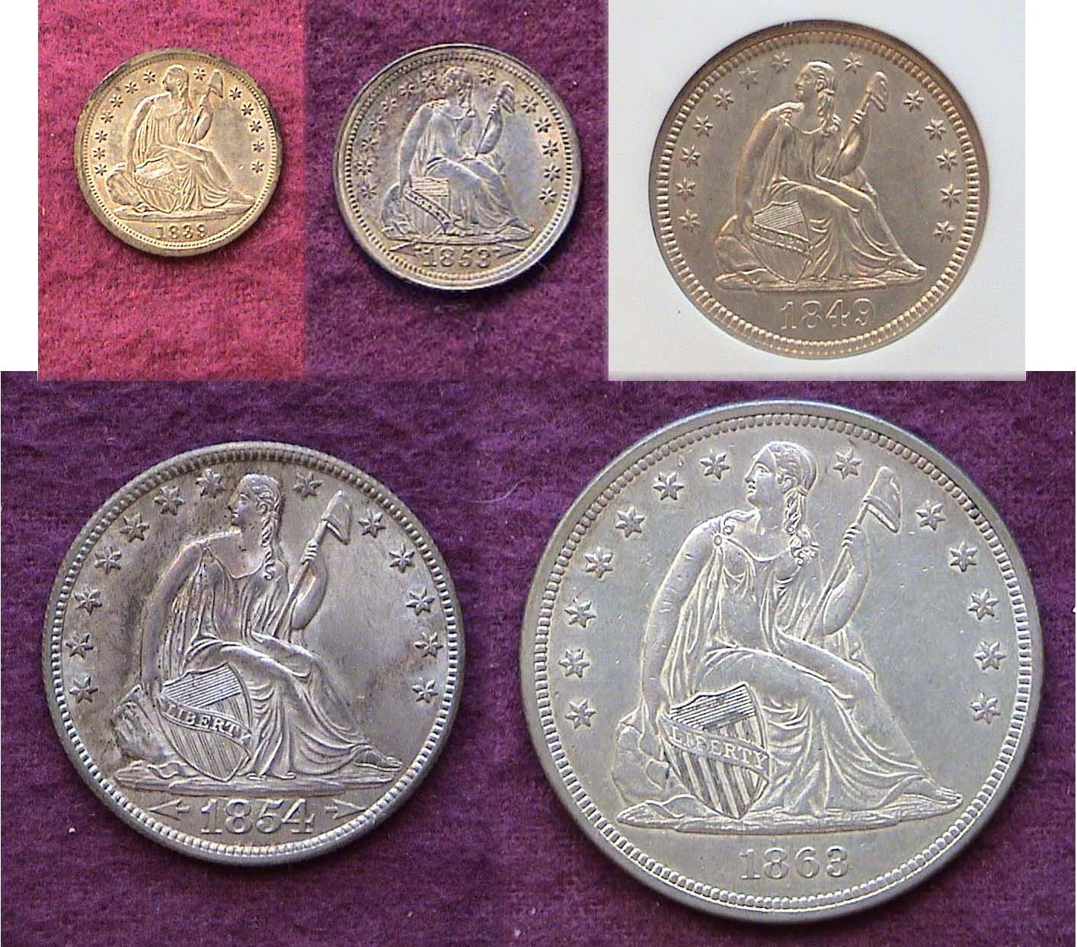

A Short Set comprising the first phase of Liberty Seated obverses
1839 5¢, 1853 arrows at date 10¢, 1849 25¢ no motto
1854-O arrows at date-no motto 50¢ & 1863 $1.00 no motto
[Magnify to 200% to see details.]

It is a pity that Gobrecht’s outstanding original design type was not left as it was. While the no stars design is arguably more attractive than the with stars surrounding Miss Liberty on the obverse, the removable of the majestic soaring eagle in a sea of stars on the reverse in favor the old Spread Eagle design was inexcusable and more likely due to functionality triumphing over aesthetics. Shown above and directly below are the basic major types of the first phase of Liberty Seated coinage.

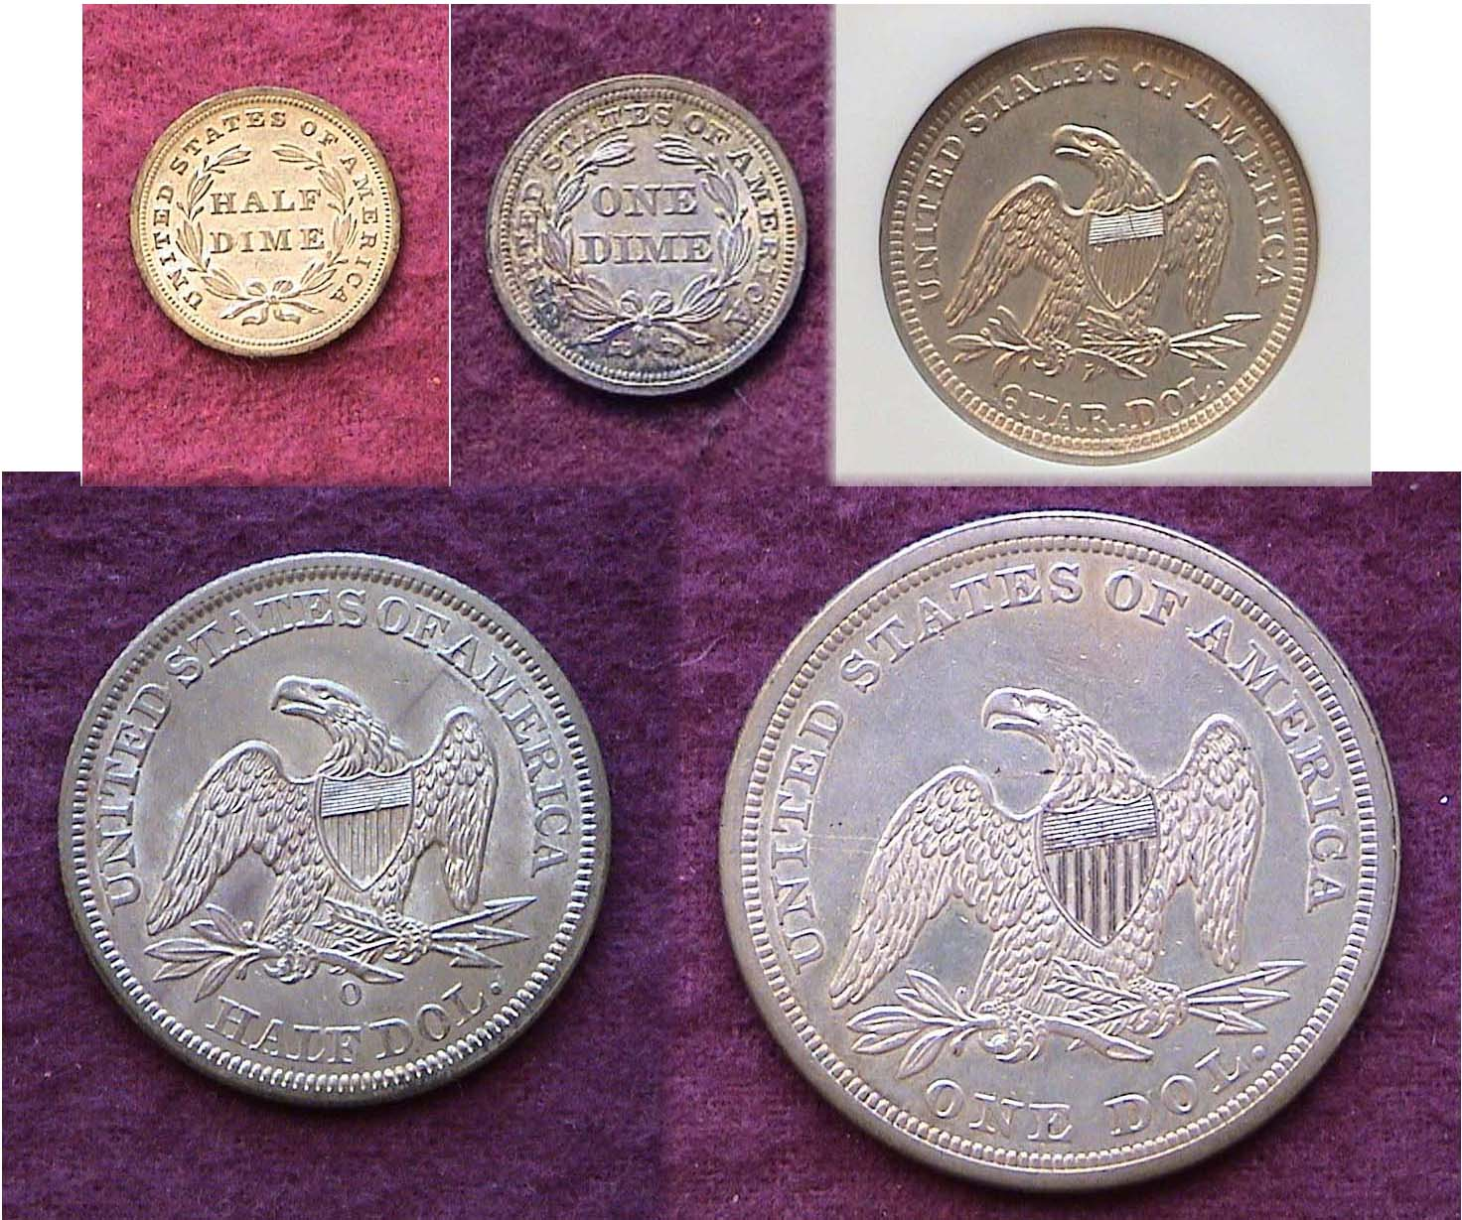

A Short Set comprising the first phase of Liberty Seated reverses
1839 5¢, 1853 arrows at date 10¢, 1849 25¢ no motto
1854-O arrows at date-no motto 50¢ & 1863 $1.00 no motto
[Magnify to 200% to see details.]

The first phase of Liberty Seated coinage ran from 1837 thru 1860 for the half dimes and dimes and from 1838 through 1865-66 for the quarters, half dollars and dollars. The obverses of the minor silver denominations display the 13 stars around Liberty and a laurel wreath on the reverse. The first phase of the three larger denominations is represented on the reverses by the absence of the motto, IN GOD WE TRUST. There were numerous sub-types introduced along the way but for one on a modest discretionary income, the five Liberty Seated coins shown on column one feature relatively common dates grading AU-50 to AU-58 and are still modestly priced in that range.

Liberty Seated Phase 2 Coinage

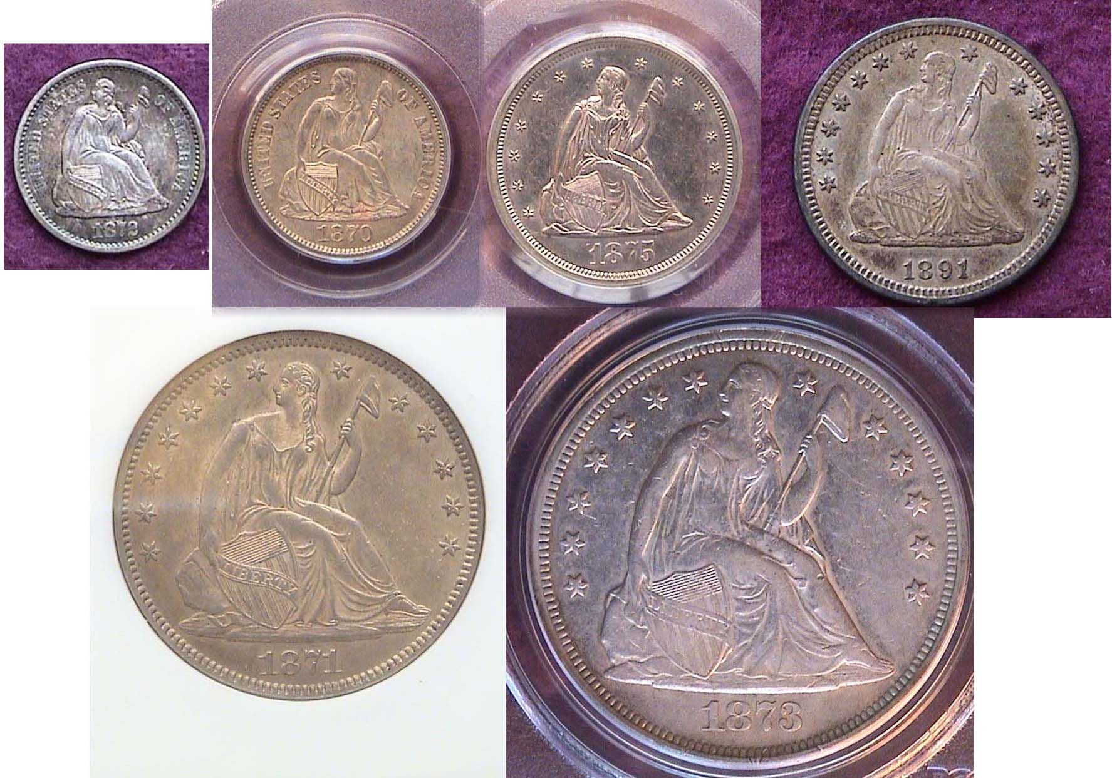

The Obverses of the with legend obverse and with motto reverse
1872-S 5¢, 1870 10¢, 1875-S 20¢, 1891 25¢, 1871 50¢ and 1873 $1.00
[Magnify to 200% to see details]

In 1860, the half dime and dime received a partial face lifting. The 13 stars were removed from the obverse and replaced by the legend UNITED STATES OF AMERICA. The laurel wreath was supplanted by a wreath comprised of corn, cotton, tobacco and wheat. In 1866, the motto, IN GOD WE TUST was inserted above the eagle on the reverse of the three larger coins and in 1875, a new 20¢ piece denomination was struck to enable merchants in the western territories to make change using silver rather than nickel. (The 5¢ nickel was not popular in this area.) It was short lived but represents a particular place in US coinage lore.

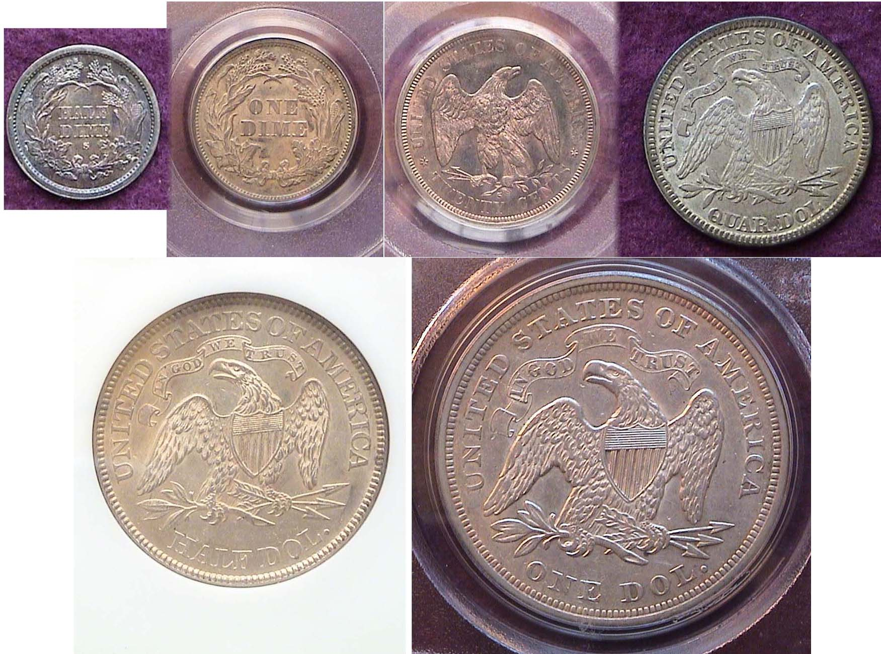

The Reverses of the with legend obverse and with motto reverse
1872-S 5¢, 1870 10¢, 1875-S 20¢, 1891 25¢, 1871 50¢ and 1873 $1.00
Notice the differences between the John Reich and William Barber 20¢ piece versions of the Spread Eagle [Magnify to 200% to see details]
________________________________________________________________________________________________________
(Continued on page 3, column 1)
Collecting a Short Set of Liberty Seated Types
(Continued from page 2, column 2)

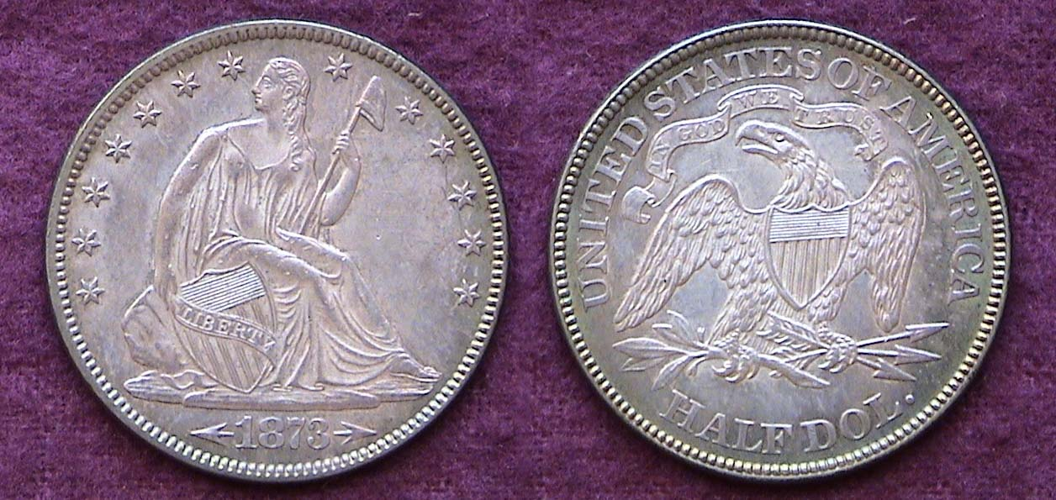

An 1873 Liberty Seated 50¢ with arrows grading AU-58
[Magnify to 200%]

Of the six Liberty seated denominations, it is the half dollar that comes closest to realizing Gobrecht’s original artistic conception as it appears to have been little altered except for the 13 stars being added to the obverse field.

In 1840 Robert Ball Hughes an engraver from England was brought into the Philadelphia Mint to help “improve” the original designs Gobrecht prepared. Many numismatists share the opinion that he actually weakened the design by enlarging the head while widening (or flattening out) the appearance of the seated figure. Other questionable changes involved reducing the size of the rock at the lower left while increasing the size of the scroll across the shield. Besides adding drapery to Miss Liberty’s gown (between her left elbow and waist) on the half dimes and dimes of 1840, Hughes also rearranged the shield from a slanted to an upright position further weakening the design. Ironically it is these very questionable modifications that have created numerous obverse and reverse sub-types for the more ardent collectors of Liberty Seated coinage to consider.

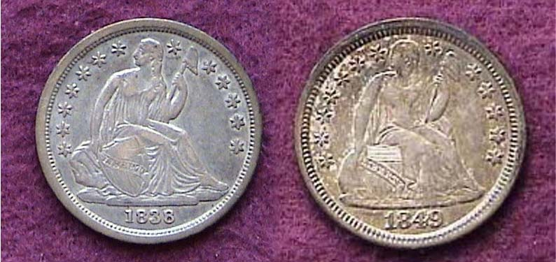

Obverses of an 1838 dime and 1849 dime (actual sizes) compared.

When magnified to 200% (or up to 500%), first, notice the shield positions, second, the sizes of the head, third, the lack of drapery under Liberty’s left arm on the 1838 and the added drapery on the 1849, and finally the date sizes of each coin.

Unlike Bust and Barber Liberty coinage, the slender Seated Liberty type does not look particularly attractive in the lower grades. Wear is first noticeable along the upper leg just above the knee where flatness can be observed over a long area on specimens grading as high as AU-50. Below VF-30 the type looses much of its eye appeal. Problem-free common date coins grading EF-40 to AU-58 are considered “Best Buys”.

For years collectors shunned the Liberty Seated series in favor of the Bust types that preceded it or the Barber silver and Morgan dollar issues that followed. Today there is a very large collector base supported by a national organization called the Liberty Seated Collectors’ Club. It produces a prize winning quarterly publication called the Gobrecht Journal that has published over 100 issues since its founding.
__________________________________________________________________________________________________________________________

Merle Davis Jr. Presents program on Military Tokens

At the Sept. 11, 2008 meeting, Merle Davis Jr. presented a program on Military tokens and medals of Vietnam and south East Asia. Merle, a Vietnamese War veteran, gave a short history of events leading up to our involvement in the Vietnam War going all the way back to the Pacific Theater of Operations during WW II when the Japanese were ousted by the Vietnamese. During his tour of duty Merle related how brass tokens manufactured by slot machine companies were issued in denominations of 5¢, 10¢ and 25¢were used for specific items such as sodas and ice. He related that the Vietnamese didn’t really hate the Americans. He also displayed a number of service medals that were quite impressive.

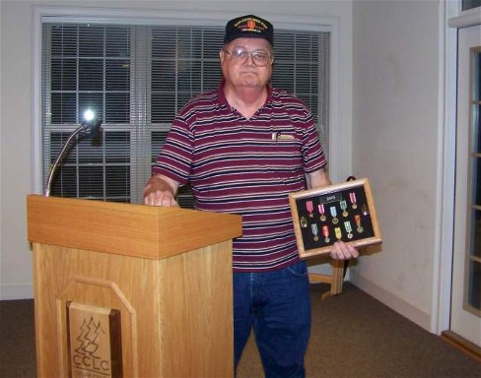

SJ CSRA CC Member Merle Davis, Jr. displaying Military Medals
Received while serving in Vietnam

Bill Myers Presents PowerPoint Program on
“Money Used as a Propaganda Tool during Times of War”

Bill covered primarily the Pacific Theater of war during World War II and how the Japanese used replicas of money from Malaya, the Dutch East Indies, Burma, Oceana and the Philippines as propaganda notes in an attempt represent themselves as liberators from western imperialists. Bill’s photos displayed many examples of these bills showing some remarkable vignettes which the Japanese had incorporated not only from the regions they occupied but also mistakenly from Central and South America in an effort to encourage circulation among the natives.

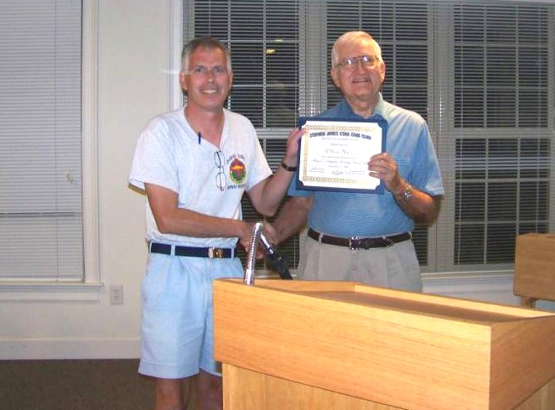

SJ CSRA CC Member Bill Myers receiving Certificate of Appreciation from VP Jim Barry at the Sept. 11 meeting
More Club News

As the meeting occurred on September 11, President Willie Simon asked for a minute of silent prayer in memory of the almost 3,000 victims who died in the terrorist attacks on the World Trade Center, the Pentagon and in Pennsylvania seven years earlier. With the club show scheduled two days later, Willie made another strong pitch for membership help in selling raffle tickets, posting fliers in public places and helping out with the show. Pat James presented a treasury balance of $1,273.33. Jim Barry won the door prize, a 2008 silver eagle and Sharon Smoot won the 50/50. Congratulations winners. President Simon made a special presentation to Bill Myers who announced at the August meeting that he and his wife Kathy are retiring to Tucson, AZ in October and the September meeting would be his last in the CSRA. Bill will be missed!

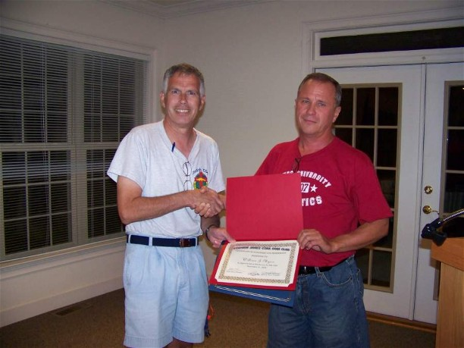

President Willie Simon, (at right) presenting a Certificate of Merit
to outgoing club member Bill Myers, (at left.)

Some Club Show Photos

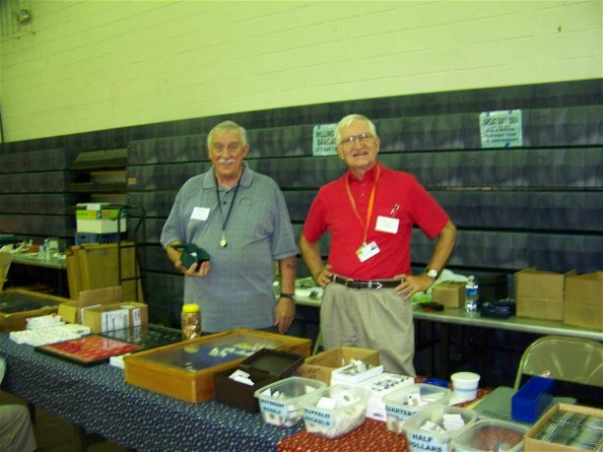

Dick Smoot and Jim Barry at Smoot’s Coins

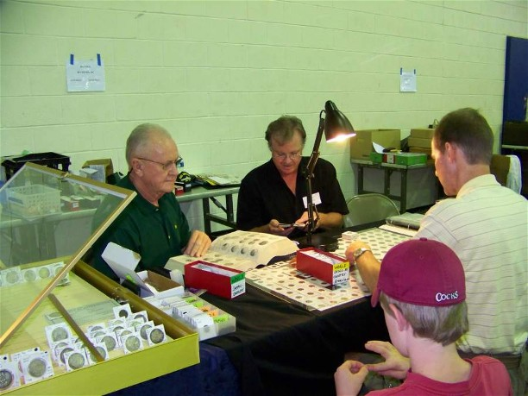

At Dealers John and David Pratt’s table
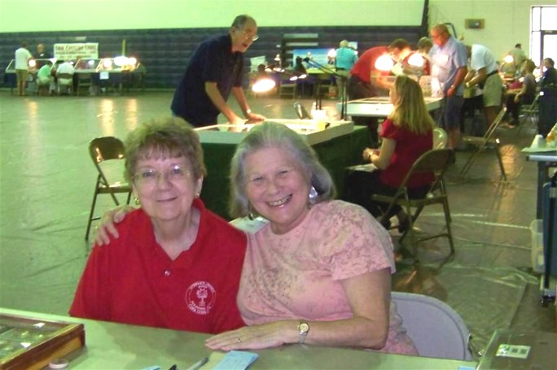

Welcoming Desk Lovelies, Pat James and Vilma Safran

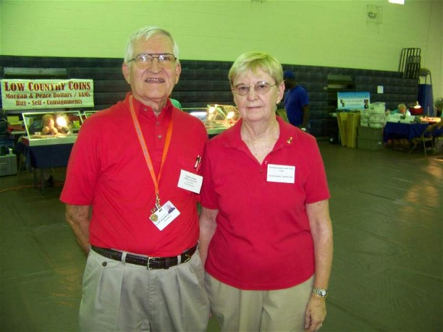

Chairpersons of the Bourse - Jim & Helen Barry

Kindly Patronize Our Advertisers
