Pres. Steve Kuhl
V .P. James Barry
Sec. Helen Barry
Treas. Sharon Smoot
Sgt. in Arms: Glenn Sanders
The Stephen James
CSRA Coin Club of Aiken
P.O. Box 11
New Ellenton, SC 29809
Web site: www.sjcsracc.org
The SJ CSRA CC meets on the 2nd Thursday of the Month at the Cedar Creek Community Center in Aiken, SC

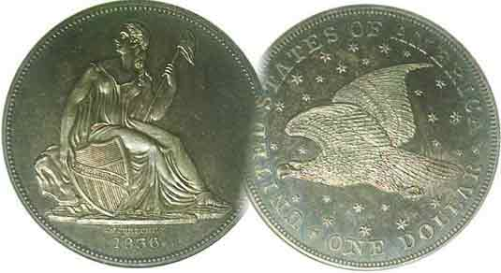
Committees:
Programs: James Barry
Show Chairs: The Barry’s
Newsletter: Arno Safran
E-Mail: arnosafran@comcast.net
Auctioneer: Glenn Sanders

2009 Club Meeting Schedule
Volume 8, Number 10 the Stephen James CSRA Coin Club, Founded in 2001 October, 2009
Monthly Newsletter
Despite Recession, Club Show Has Record Turnout
Our next meeting is Thursday, October 8, 2009 from 6:15 to 9:00 PM
Jan. 5 Apr. 9 July 9 Oct. 8
Feb. 12 May 14 Aug. 13 Nov. 12
Mar. 12 Jun. 11 Sep. 10 Dec. 10

_________________________________________________________________________________________

Sept. 12 Club Show Receives Record Turnout

Our co-Chairpersons Jim and Helen Barry took a calculated risk that holding our club show in the midst of “Aiken Makin” Weekend would bring out more folks. Apparently their hunch proved correct as around 200 persons attended the event held at the H. Odell Weeks Activity Center in Aiken on Saturday, September 12; breaking all previous records for our one day shows. After a slightly slow start, more and more people starting coming through the door beginning around 10:30 AM stopping at the Welcoming Desk to register. Most purchased raffle tickets before browsing the bourse. There was a continuous buzz in the hall which lasted until almost 2:30 PM as more and more persons with families arrived at the show. Dealers seemed happy with the results and so did the club members, of which a goodly number were on hand to help out.
As for the raffle donation drawings the prize winners were: 1st prize: Gold coin was won by Paul Widener. The second prize, the 2009 Silver Proof Set was won by John Niland and the third prize, a certified Uncirculated Morgan dollar was won by Mickey Hadden. Congratulations go out to the three winners and to Helen and Jim Barry for their outstanding efforts to make our annual fundraiser so successful.

4th Coin Grading Session Most Enjoyable

Instead of a guest speaker or audio-visual program, the club held another “Grade that Slab” night at its regular meeting of Sept. 10 and it was the most enjoyable of the previous three. What made the difference? In the past, members remained in their seats as the list of type coins were distributed, followed by the coins for grading, their certified grades hidden. When the actual grades were later read aloud there wasn’t enough time for each member to check their grading against the certified grade. This time, members in groups of four sat around Bridge tables set up around the room. There was ample time to grade the coins
___________________________________________________________________________________________________________________________
(Club News continued on page 4, column 1)

Collecting 20th Century Transitional Date U.S. Gold Coins
By Arno Safran

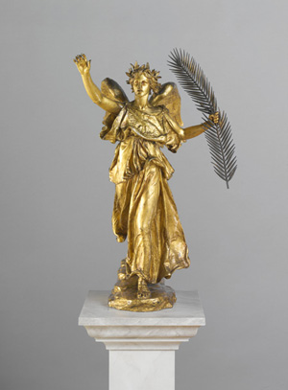

Saint-Gaudens’ sculpture of Victory holding feather

In the early 20th Century President Theodore Roosevelt asked Augustus Saint-Gaudens, America’s foremost sculptor to help improve the designs of our coinage. The highlight of the sculptor’s efforts was the majestic Striding Liberty which first appeared on the $20.00 double eagle in 1907. The first version was struck in high relief with a Roman numeral date and even today is one of the most highly sought after coins, although expensive. Notice the similarity of the sculptured “Victory” above with the Striding Liberty on the coin shown below.
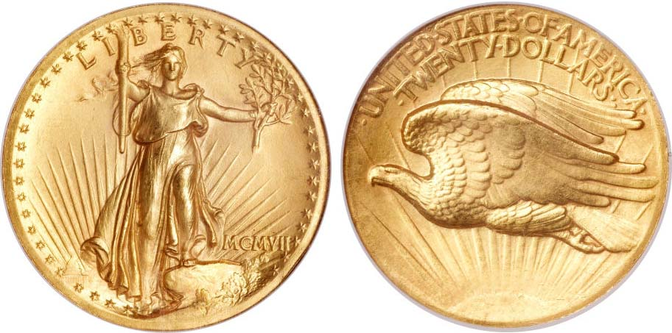

A 1907 High Relief $20 Saint-Gaudens with Roman numeral date
The coin was graded MS-64 by NGC and sold for $24,500.
(Courtesy of Heritage Auctions Archives 09-09) [Magnify to 200%]
_______________________________________________________________________________________________________________
(Continued on page 2, column 1)
Collecting 20th Century Transitional Date U.S. Gold Coins
(Continued from page 1, column 2)
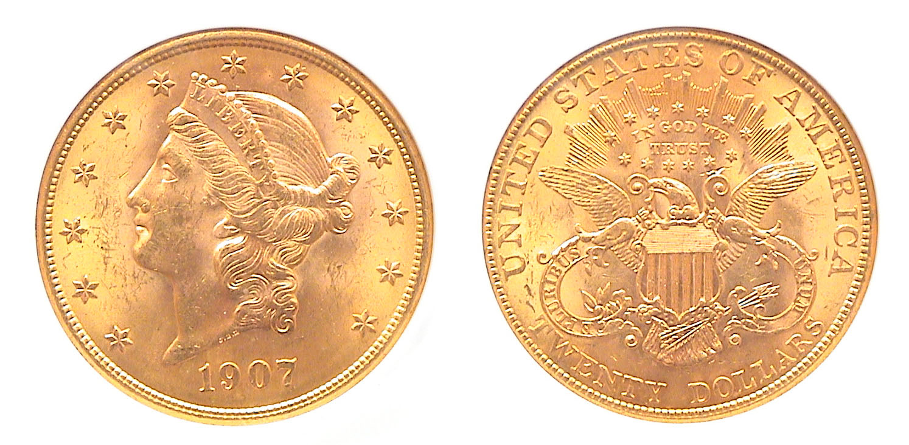
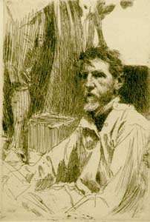
A 1907 Coronet $20.00 Gold Double eagle
Certified mS-63 by NGC [Use 3x power glass or magnify to 200%]

The coin that the Saint-Gaudens type replaced was the Coronet Liberty design type originally crafted in 1849 by then Chief Mint engraver James Barton Longacre. It underwent a number of minor modifications during its 58 year run and is a rather handsome design but lacks the exquisite artistry of the coin that replaced it. After the initial release of the Saint-Gaudens type, the Mint decided to lower the relief, replace the Roman numerals with Arabic and it is this version that most collectors of moderate means have been able to afford.
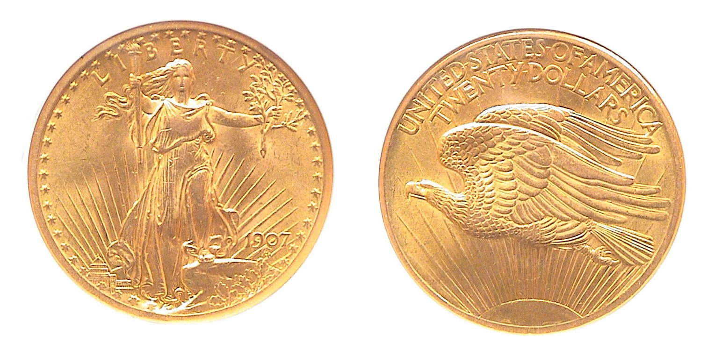
A 1907 Arabic numeral Saint-Gaudens $20.00 Gold piece
The coin was graded MS-62 by NGC [Magnify to 200%]

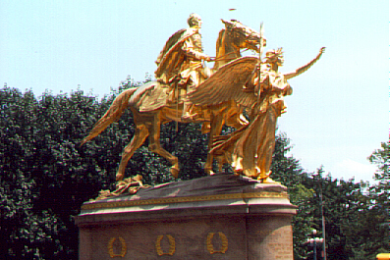

Saint-Gaudens’ Sherman Monument guided by “Victory”
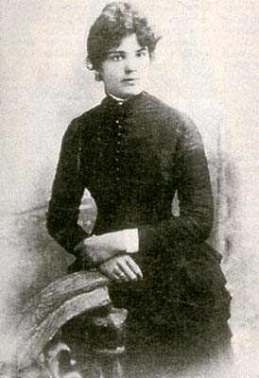
Who was the woman who became Miss Liberty on the Saint-Gaudens’ $20.00 Double Eagle? By 1897 the sculptor had achieved international prominence and chose Harriette Eugenia Anderson, then age 24 as his model for the allegorical portrayal of Victory which heads the statue of General Sherman on horseback. The monument can be seen in New York City at the corner of Central Park south (59th Street) and 5th Avenue. Miss Anderson--who was born in South Carolina in 1873--was described by some as “goddess-like” and was known to friends and admirers as Hettie. When Theodore Roosevelt invited Saint-Gaudens to redesign our coinage in the early 20th Century, the sculptor again used Hettie Anderson as his source for the allegorical figure of Liberty on the new $20.00 gold coin of 1907. Many consider the design to be the finest of US coinage.
Hettie Anderson

Once in New York, Hettie Anderson became a successful model despite being part Afro-American descent. Her lovely countenance and beautiful complexion made her ideal as a subject for a number of important artists of the period. Saint-Gaudens also made two studies of her in bronze for his “Head of Victory” and the “Sherman Monument”, one of which was later used on the new $10.00 Indian coin. (See below.)
Augustus Saint-Gaudens
Etching by Anders Zorn

Saint-Gaudens also designed the 1907 Indian head $10.00 Eagle that replaced Christian Gobrecht’s Coronet Liberty the same year thereby creating a second pair of transitional dates. Like the $20.00, the first adaptations were revised after a small number were released and it is the adopted version along with the outgoing 1907 Liberty $10.00 that are still relatively affordable up to MS-62 because both types were saved.
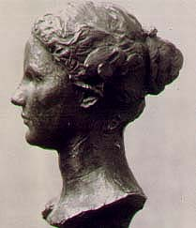
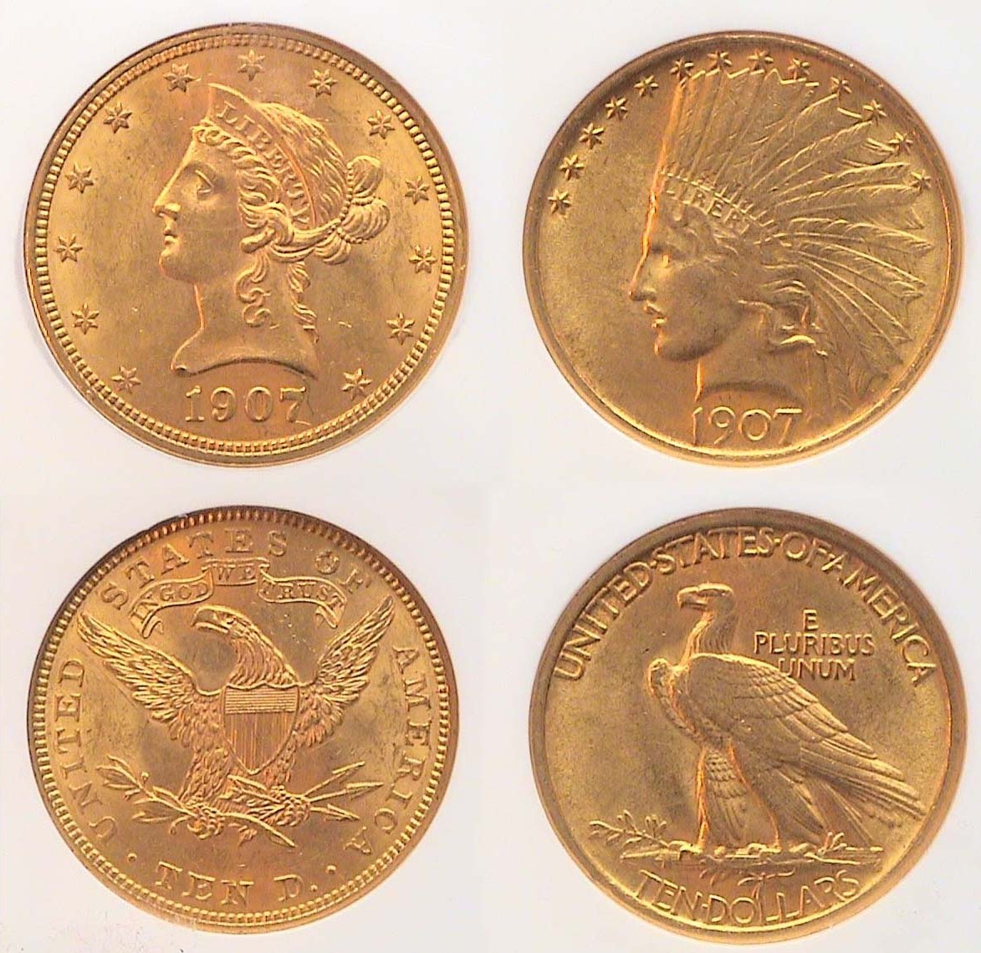

The two Gold $10.00 Eagle types of 1907 and Bust of Hettie
[The Liberty was graded MS-62 and the Indian Head, MS-61, both by NGC].

A decade ago one could purchase both 1907 $10.00 gold types averaging MS-61 for around $775 for the pair, but with gold close to or above $1.000 an ounce today the 1907 $10.00 Indian alone will cost closer to $900 in that grade.
_______________________________________________________________________________________________________________________
(Continued on page 3, column 1)
Collecting 20th Century Transitional Date U.S. Gold Coins
(Continued from previous page)
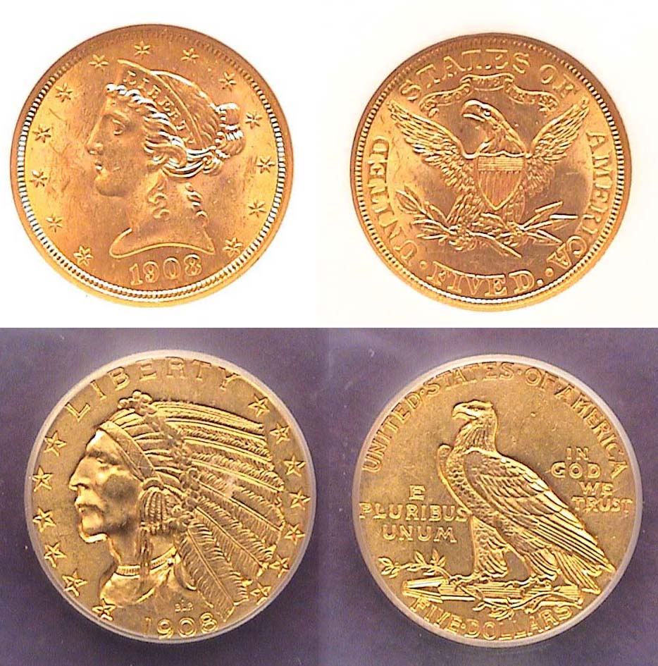

A 1908 $5 Liberty atop a 1908 $5 Indian, both MS-61
These coins are still reasonably priced up through MS-62.
[Use 3x glass or magnify to 200% to see details.]

In 1908, it was the $5.00 gold denomination’s turn to receive a face lifting. The new design type was fashioned by Bela Lyon Pratt, a disciple of Saint-Gaudens. The central devices, (the Indian Head obverse and Eagle reverse) were incused (i.e., grooved) causing them to appear indented on the coin. As with 1907, the outgoing $5.00 Liberty design was replaced later in 1908 by the new Indian Head design providing for another set of transitional types. Despite a 150,000 larger mintage, the 1908 $5.00 Indian costs about $200 more than the Liberty $5.00 in MS-61. A big price jump occurs for both types in MS-63.

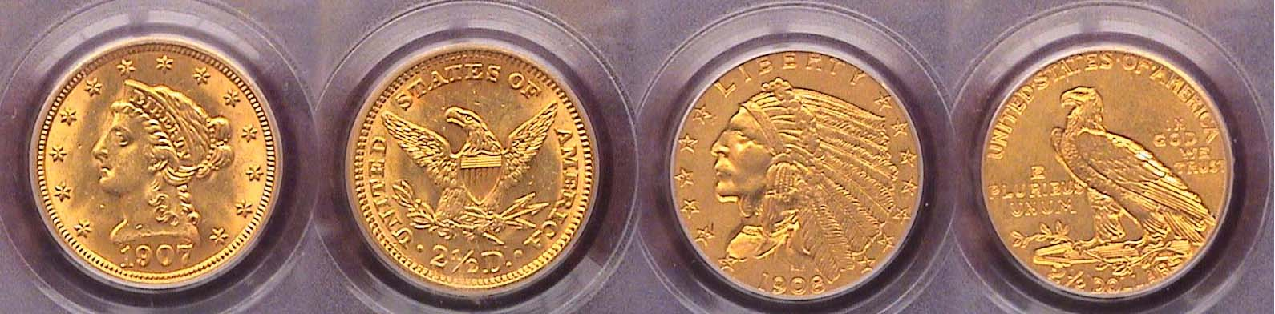

The 1907 Liberty and 1908 Indian $2.50 Quarter Eagles
The Liberty was graded MS-62 and the Indian type AU-58
[Use 3x glass or magnify to 200% to see details.]

The Liberty Head design was last struck on the $2.50 gold quarter eagle in 1907 but the new incuse Indian Head type of Bela Lyon Pratt didn’t replace the Liberty until the following year, 1908, so one cannot claim either year as a transitional date. Despite this, many collectors like to put together the last and first years of a coinage design and since the prices for each among both the $2.50 types are modest up to MS-62 I decided to include both in the early 20th Century gold type set. Again, above the MS-62 grade there is an extraordinary jump in price.

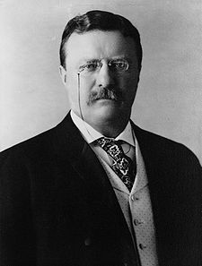
For the esoteric collector there are two other transitional pairings to consider. On the 1907 and early 1908 issues all versions of the Saint-Gaudens $20.00 and the $10.00 omitted the motto IN GOD WE TRUST. Congress strongly requested the motto be placed on both coins. President Theodore Roosevelt objected on the grounds that it was sacrilegious to associate God with money but he later relented and in mid 1908 the motto was restored.

As a result, there are two transitional sub-types for 1908. These can be included as part of the early 20th Century gold transitional dates set, but acquiring any of four coins now will be difficult due to the scarcity of the two low mintage varieties and the high price of gold for the two common ones. The 1908-P no motto $20.00 Saint-Gaudens has a mintage of over 4 million and is one of the most common dates of the entire series. When gold was priced at just $255 an ounce in mid 1999 one could obtain a MS-63 example for just $400. Today, it would cost around $1,600 retail. On the other hand, the 1908-P $20 Saint with motto has a mintage of just 156,258. It is 27 times scarcer than the no motto variety and one in MS-63 would cost only slightly more. A best-buy for the latter would probably be within the grade range of AU-58 through MS-62 but finding attractive specimens below MS-63 will be hard to find.
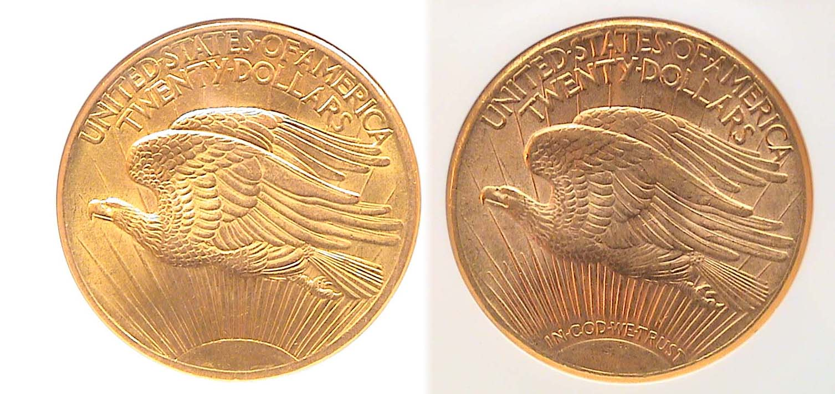
The motto is absent from the reverse on the coin at left. It is located between the rising sun and its extended rays on the coin at the right. From AU-58 through MS-63 the 1908 with motto sub-type is priced only slightly above the extremely common no motto variety and could be considered a “sleeper”.
[Use 3X power or magnify to 200% to see details.]

When it comes to the 1908 $10.00 sub-types, the situation is reversed as the with motto which is scarce on the $20.00 is very common on the $10.00 while the no motto, common on the $20.00 is much scarcer on the $10.00 Eagle and seldom surfaces at even the largest coin shows.

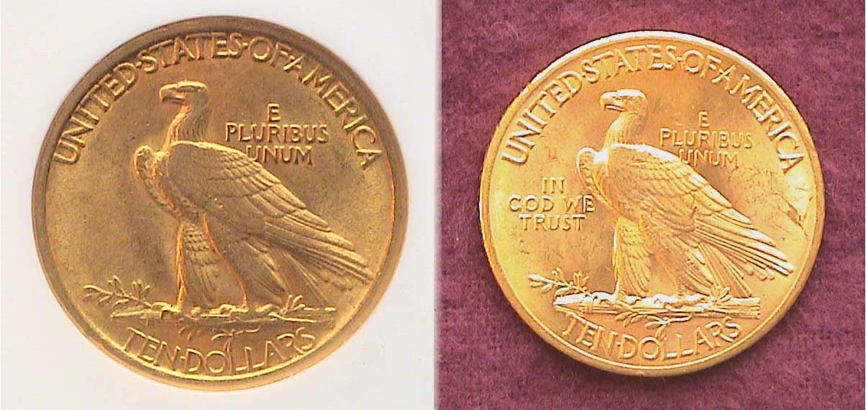

The reverses of the $10.00 Eagle gold coin. Left; no motto, scarce on the 1908 $10; right, with motto, common on the 1908 $10.00
[Use 3X power or magnify to 200% to see details.]

Postscript: Speculating about gold coinage
As a collector I have twice assembled a set of the six transitional date gold types shown above. I sold the first set before moving to the CSRA in 2000; the wrong time to liquidate gold. I acquired the second set between 2007 and 2008 as yellow metal was peaking; the wrong time to buy gold. I have always appreciated the beauty of these gold coins and wanted them to be a part of my collection once more. So far, even the second set would net me a considerable profit should I decide to sell them now as wholesale prices for generic gold coins are currently at record levels. Early this year I found a 1908-P Saint with motto in a MS-61 holder. It too has increased in value. Gold may be volatile. The beauty of our gold coinage is eternal.
_________________________________________________________________________________________________________________
Club News
(Continued from page 1, column 1)

individually but also collectively if one or two in the group wished to explain how they graded a particular coin. After discussing our grading criteria, some of us decided to peel off the tape in order to see the actual certified grade. Thus, we were able to compare our limited grading skills against the professional graders. We then replaced the tape on the holder before sending it on to the next table. Our group came pretty close on a large number of “slabs”, exact on about half of the submissions and away off on a few including a couple of “raw” coins that were thought to be severely overgraded. The experience was both challenging and rewarding with each enjoying a sense of camaraderie as a result.

In other club business, President Steve Kuhl reported that he received fifteen responses from members on the recently distributed club survey. He also brought up the issue on whether we should change our club meeting location and asked members if they knew of alternative meeting sites closer to the center of Aiken. There was an extensive discussion on the issue but it was difficult to arrive at a consensus because all the suggested alternative sites seemed to have greater drawbacks compared with the Cedar Creek Activity Center. Most of the members present agreed that despite its distance (about 7 miles from the Public Library where we used to meet), the Activity Center at Cedar Creek offers the best all around accommodations; a safe location, a clean commodious and quiet meeting room, a state of the art audio-visual system and a consistent monthly meeting schedule; something we were unable to get from the Library.

Treasurer Sharon Smoot reported a balance of $1,063.89. Thanks, Sharon. VP Jim Barry thanked members Roger Worpell and Jim Clapp for their help on advertising for the Sept. 12 show. Jim also announced that the program for the Oct. 8 meeting will be an ANA produced DVD on the History and Coins of Ancient Rome but the DVD topic has since been changed to “Collecting US Coins by Type”.

The Prize winners at the Sept. 10 meeting were Steve Kuhl who won the silver eagle and guest, Jim Teale who took the 50/50. Congratulations gentlemen. The next meeting will be held at the Cedar Creek Activity Center on October 8, early arrivals 6:15 PM meeting time 7:00. Hope to see you there!
_____________________________________________________________________________________________________________________________

Kindly Patronize our Advertisers

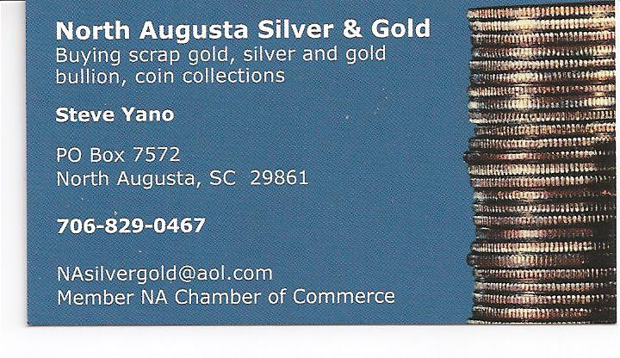

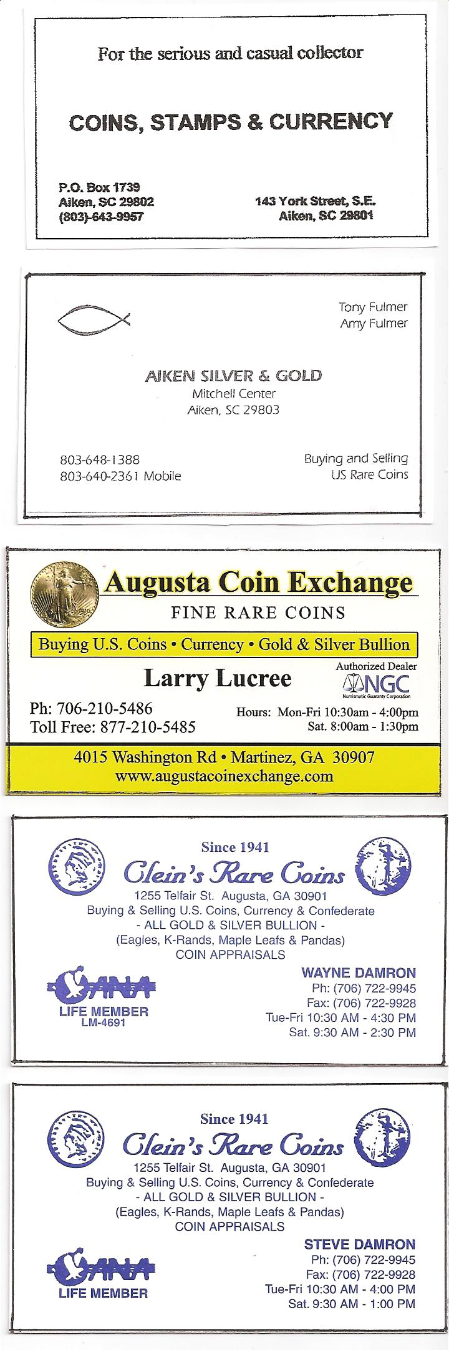
Don’t miss the 37th Annual SCNA Convention scheduled for Oct. 30. 31 and Nov. 1
At the Carolina First Center,
1 Exposition Drive in Greenville. SC.
Click www.sc-na.org, then Convention Information

