Pres. Steve Kuhl
V .P. Arno Safran
Sec. Jim Mullaney
Treas. Sharon Smoot
Sgt. in Arms: Glenn Sanders
The Stephen James
CSRA Coin Club of Aiken
P.O. Box 11
New Ellenton, SC 29809
Web site: www.sjcsracc.org
The SJ CSRA CC of Aiken, SC meets on the 1st Thursday of the month at the Aiken Public Library

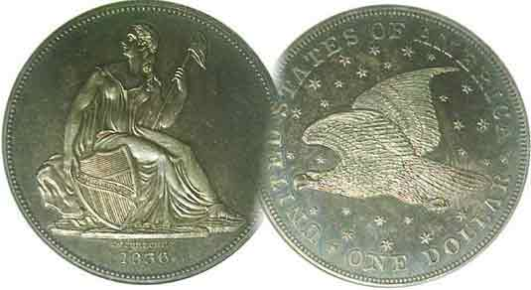
Committees:
Programs: Arno Safran
2010 Show: Jim & Helen Barry
Publicity: Jim Clapp
Newsletter: Arno Safran
E-Mail: arnosafran@comcast.net
Auctioneer: Glenn Sanders

2010 Club Meeting Schedule
Volume 9, Number 10 the Stephen James CSRA Coin Club, Founded in 2001 Oct. 2010
Monthly Newsletter
Postcard pic shows Aiken thriving in 1950
Our next meeting is on Thursday, Oct. 7, 2010 from 6:45 to 8:45 PM

Jan. 7 Apr. 1 July 1 Oct. 7
Feb. 4 May 6 Aug. 5 Nov. 4
Mar. 4 Jun. 3 Sep. 2 Dec. 2

____________________________________________________________________________________________________________

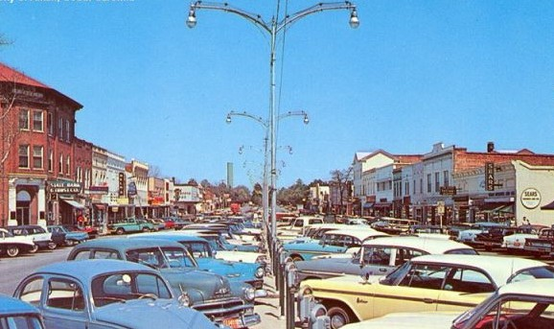

An early Kodak-color postcard showing
Laurens Street in Aiken, SC in 1950

Pictured above is a view of a bustling downtown Aiken which appears to have been taken sometime during the 1950’s. It was during this decade that Aiken’s growth began to skyrocket, in part due to the construction of the Savannah River Site.

After the Soviet Union successfully detonated its first atomic bomb in 1949, President Harry Truman decided that it was time to increase the development of our nuclear arsenal to include hydrogen bomb capability. Therefore, in November 1950 the DuPont Company was awarded a major contract by the Atomic Energy Commission to build a massive nuclear production facility to be named the Savannah River Plant. To make room for the plant the towns of Ellenton and Dumbarton had to be moved. Ellenton was relocated to an area along Rte. 19 just north of the intersection of Rtes. 278 and 19 and renamed New Ellenton.

During the past sixty years, the nuclear facility--now owned by Westinghouse and renamed the Savannah River Site (SRS)--has employed around 17,000 people with many choosing to reside in or around the city of Aiken. As a result, Aiken offers many of the benefits of a large city, good schools including a branch of the University of SC, a fine library and museum, theaters, shopping malls and restaurants, even a coin club without the congestion associated with urban life unless you are driving between 5:00 and 6:00 PM on Whiskey Road.
______________________________________________________________________________________________________________

Collecting the Coins of 1950 some sixty years ago
By Arno Safran

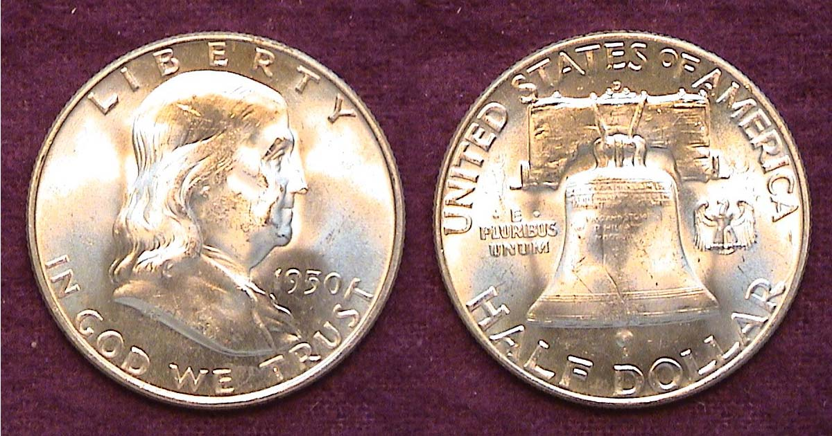

A BU 1950-D Franklin Half dollar with full bell lines
[Use a 3X glass or magnify up to 500% to see details.]

For collectors who enjoy putting together sets ending in zeroes, 2010 represents a banner year as one can go back ninety years and still complete year sets from Fine-12 through MS-63 at a moderate cost. Shown above is a 1950-D Franklin half that today after sixty years is still inexpensive. The tiny mintmark appears directly above the Liberty Bell. The reported mintage for the 1950-D half dollar was just slightly over 8 million but long before 1950, the 50¢ coin ceased to circulate due to its size and the fact that the vending machine contained no slot for the coin. As a result, an attractive specimen grading MS-63 can be acquired at only $35.00 according to the 2011 Red Book and only slightly more in MS-64.

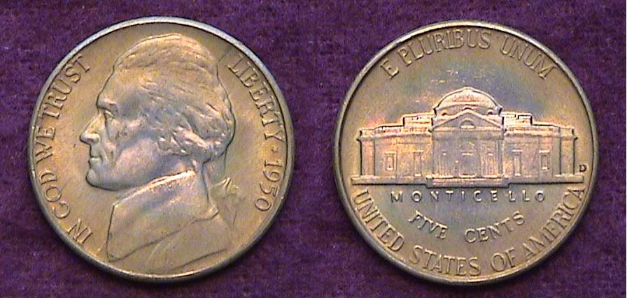

A BU 1950-D Jefferson nickel
[Use a 3X glass or magnify to 200% to see details.]

Only 2.6 million 1950-D Jefferson nickels were struck compared with the just under 10 million for the 1950-P but almost immediately dealers began hyping the record low mintage date as a potential rarity. So, the date was saved by the roll, mostly in BU condition, far more than the ’50-P which is a lot harder to find in Brilliant Uncirculated condition.
(Continued on page 2, column 1)
Collecting the US Coins of 1950: Sixty Years Ago
(Continued from page 1, column 2)

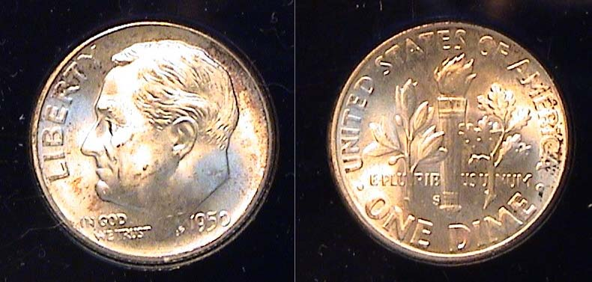

A BU 1950-S Roosevelt Dime showing full torch bands
[Use a 3X glass or magnify up to 500% to see details.]

In 1950, the San Francisco Mint did not strike nickels or half dollars. The three denominations they did produce, the Lincoln Wheat back cent, the silver Roosevelt dime and Washington quarter were all coined in much smaller numbers than their Philadelphia and Denver counterparts. Only 20.4 million dimes were struck at the San Francisco Mint in 1950 compared with 50.1 million at Philadelphia and 46.8 million at Denver. Today the 1950-S is priced considerably higher in MS-63; $36.00 to just $6.00 for the 1950-D and $12.00 for the 1950-P, the last named having a lower survival record in Mint state than the 1950-D issues. Locating a 1950-S with full torch bands on the reverse (similar to full bands on Mercury dimes) is a challenge. This detail is now beginning to attract the same attention the Mercury dimes series has enjoyed over the past thirty-five years.

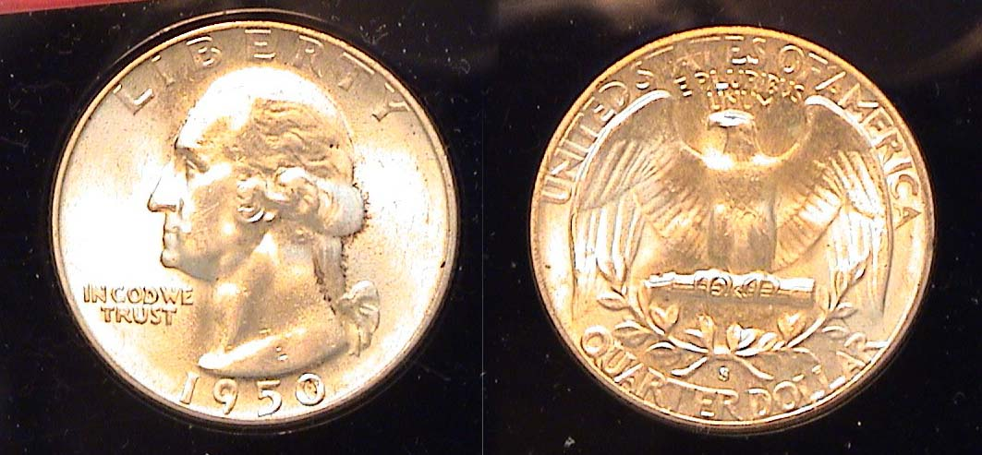

A BU 1950-S Quarter dollar
[Use a 3X glass or magnify up to 500% to see mintmark clearly.]

The 1950-S Washington quarter had a reported mintage of 10.2 million compared with 24.9 million for the 1950-P and 21 million for the 1950-D. By comparison, clad quarters have been produced in the hundreds of millions to one billion annually going back to 1965. Despite the much lower mintages, 1950 P, D & S quarters were saved by the roll in Mint State and are considered common today. In MS-65 the 1950-P & D are listed at $35 each with the 1950-S at $45 according to the 2011 Red Book. In 1950, a silver quarter had the purchasing power of around $2.25 or nine times what a clad one can acquire today. There are a couple of anomalies for the date however and they are rare; the 1950 D/S and the 1950 S/D. Starting in XF-40 they are priced at well over $100 apiece. [Through 1964, the mintmark on Washington quarters was placed under the ribbon on the reverse.]

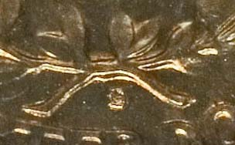

Detail of reverse of 1950-S/D Washington Quarter
[Use a 3X glass or magnify up to 200% to see S/D more clearly.]
The coin was graded MS-64 by PCGS and sold for $431.25
at a Heritage Internet auction held January 18, 2009.
[Courtesy of Heritage Auction Archives]

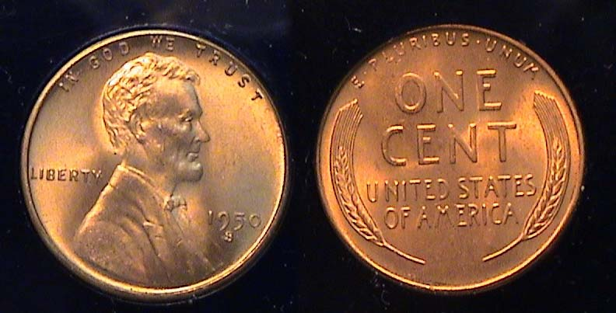

A BU Red 1950-S Lincoln Wheat cent
[Use a 3X glass or magnify up to 500% to see mintmark clearly.]

In 1950, a candy bar, an ice cream cone or carfare still cost a nickel. The daily tabloid newspaper was priced at 2¢ to 3¢ so even a “penny” had meaningful purchasing power in 1950. That year, 118.5 million Lincoln cents were struck at the San Francisco Mint alone with the result that sufficient numbers of BU rolls were stored over the past sixty years to keep the price of a MS-65 1950-S Lincoln down to just $4.00 today. A full Red MS-65 1950-P is listed at $2.00 and the 1950-D at $3.00.

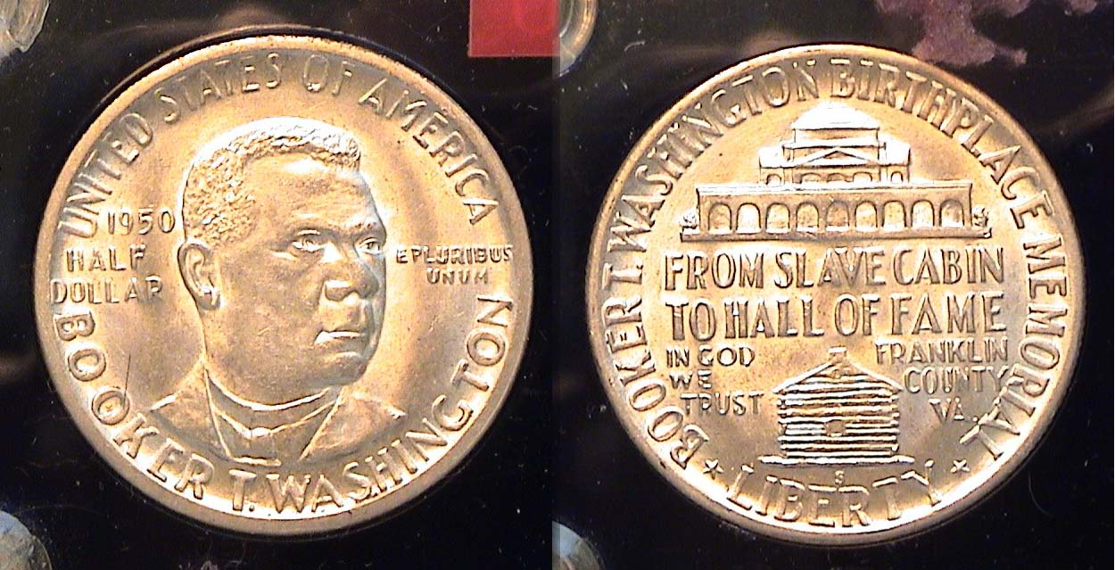

A BU 1950-S Booker T. Washington Commemorative 50¢
[Use a 3X glass or magnify up to 500% to see details.]

Franklin half dollars were struck only at the Philadelphia and Denver Mints in 1950, so if collectors wanted to fill the 50¢ slot for San Francisco Mint offerings, they could insert a choice BU 1950-S BTW commemorative half into their year set. The above BU specimen is attractive and adds variety to an otherwise ordinary set in this writer’s view. More than 500,000 1950-S BTW halves were struck compared with only 6,000 each for the P & D issues, yet only 62,091 1950-S were distributed and that is the mintage reported in the official Red Book. In US Coin publications however, the BTW P, D and S year sets are priced as a group, around $170 for MS-63s and $250 for MS-65s. On occasion, one can find a single 1950-S in a dealer’s stock that should cost less than one-third of the price of a set since it is ten times more common. The mintmark on the BTW half is located below the Log cabin on the reverse.

Proof Sets

Proof sets production was suspended at the end of 1942 due to WW II. In 1950, the Government resumed the striking of annual Proof Sets increasing the price from $1.90 to $2.10. By then the Roosevelt dime and the Franklin half dollar had replaced the Mercury dime and Walking Liberty half dollar, both arguably superior designs created by Adolph Weinman back in 1916. In 1950, the Philadelphia Mint struck 51,386 proof sets, a record up to that time. In the late 1990’s one could still acquire the set averaging Proof 63 to 64 for around $250. Today the five-piece 1950 Proof Set is priced at $750 according to the 2011 Red Book. It is listed at between $575 and $626 in the Gray Sheet, the coin dealer’s source
__________________________________________________________________________________________________________________
(Continued on page 3, column 1)

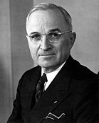
Collecting the US Coins of 1950: Sixty Years Ago
(Continued from preceding page)

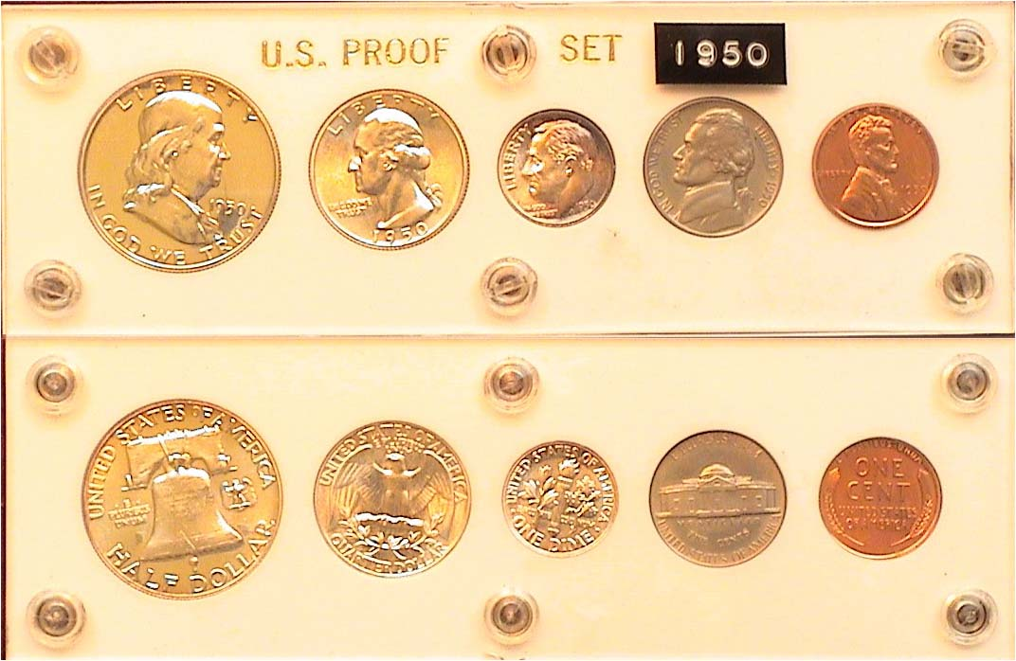

A 1950 Proof set housed in a Capital Lucite holder (reduced in size)
[Use a 3X glass or magnify up to 200% to see details.]

Unlike the full cameo-proof sets the Mint strikes today, most of the 1950 Proof sets appeared unusually bland despite their mirror finish. A large number of the 1950 Proof sets showed only slightly more definition than one might expect from a government prepared Mint set although no official US Mint sets were actually released that year.

The Franklin half is the “key” to the 1950 proof set. Full cameo proofs are scarce to rare and worth a premium equal to the rest of the set itself. The 1950 set shown above is average. Below is an example of a Cameo proof 1950 Franklin half.

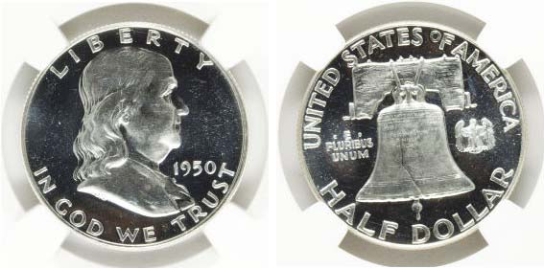

A 1950 Proof Franklin Half Dollar graded PF-65 Cameo by NGC
[Use a 3X glass or magnify up to 200% to see mintmark clearly.]
[Courtesy of Heritage Auctions Archives]

The Franklin half dollar pictured above was graded Proof-65 Cameo by NGC and sold for $690 at a Heritage Internet auction a little more than a year ago. The 1962 Franklin halves are common with a cameo finish and sell for around $25 to $30 but one from 1950 is quite rare indeed.

The Year 1950 and some Statistics

In 1950, the population of the USA reached 150.6 million, virtually doubling that of 1900’s total. For the first time, a credit card that could be used in more than one facility went into circulation. The brainchild of Frank X. McNamara, he gave 200 of the cards to friends that were accepted by fourteen New York City restaurants. The new charge concept was called the Diner’s Card and by year’s end, more than 20,000 were issued.

President Harry S. Truman was in the second year of his first elected term of office and things weren’t running all that smoothly. The Cold War between the United States and the Soviet Union started to heat up and the Korean War began. In January 1950, the President gave the go ahead to develop the Hydrogen bomb.

1950 Cost of Living: A loaf of bread averaged 14¢; a quart of milk was 23¢. Meats was priced from 55¢ to 75¢ a pound. It would be the last year postage would remain at 3¢ and public transit at 5¢. The minimum wage was 75¢ an hour or $30.00 for a standard 40 hour five day work week. In 1950, the Philadelphia Phillies won their first National League pennant since 1915 and were then summarily clobbered four games to zero by the New York Yankees of the American League. A single series game ticket cost $8.75.
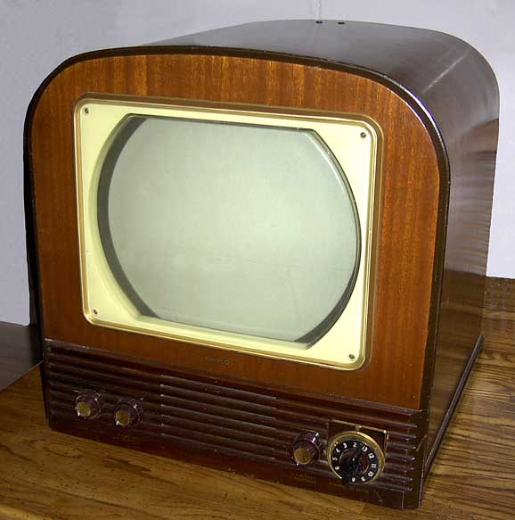
The average price of a new car was $1,500 in 1950 and gas to fill it, just 18¢ per gallon. The median cost of a modest suburban home was priced at $8,450 with apartment rentals going for around $50.00 to $60.00 per month and that included heat. The average annual income in America at the time was $3,210. Prices for a 12” B&W TV set ranged from $199 to $499 for the Philco model shown at the right. Based on the above statistics it would seem that our coinage system functioned more effectively in 1950 than it does today. If any club members are celebrating their 60 birthday in 2010, the writer extends his congratulations and perhaps you owe it to yourself to acquire some nice BU examples of 1950 coinage.
___________________________________________________________________________________________________________________________

Club News

Aug. 5 meeting: As the editor was out of town, Recording Secretary Jim Mullaney provided him with information on the of the August 5 meeting. Here are some of the details. There were18 members in attendance. The Treasurer’s report showed a balance of $964.25 as of Aug. 1. Jim Barry brought in two Show & Tells and President Kuhl ran a DVD entitled, “The History of Wells Fargo”. Glenn Sanders won both the door prize, a silver eagle and the 50/50 - $24.00. Congratulations, Glenn. And thanks for the information, Jim, Ed.)

Sept. 2 meeting: With most members back from summer vacation and the upcoming club show approaching, President Steve Kuhl reported an attendance of 28 members with two guests at the September 2 meeting. This was the largest attendance since 2006. Jim Barry stated that 26 tables had been sold for the show and Treasurer Sharon Smoot reported a balance of $1,240.40. Thanks, Jim and Sharon.

In other news, Helen Barry asked people to sign a special greeting card in honor of Honorary life member Walter Ferrari’s 90th birthday. Walter, who moved to the Atlanta area several years ago, was extremely helpful to our club in arranging for St. Mary’s church in Aiken to hold our show. He also served almost exclusively at the Show welcoming desk.
____________________________________________________________________________________________________________________________
(More Club News continues on page 4, column 1)
Club News (Continued from previous page)

Helen also announced that the club’s annual Pre-Christmas holiday club dinner would take place at the Hounds Lake Country Club on Thursday, Dec. 2, details to follow later in this edition.

As there was no scheduled guest speaker or recorded program planned, members were asked to bring in numismatic items for a special Show & Tell session. In the past, there were seldom more than four. At this meeting, we had an all time record of nine presenters with four waiting in the wings when time ran out to make room for the auction. The Club will work out the logistics to prevent such a situation from happening again but it is an encouraging sign that our club appears to have set an all time record for numismatic displays at a meeting in the CSRA and considerably beyond

Show & Tell Presenters
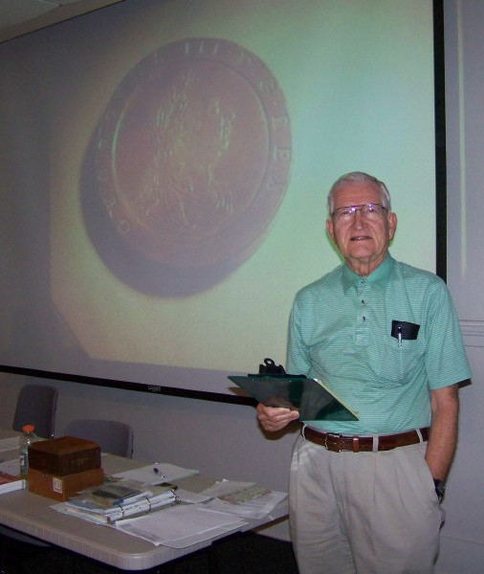

Jim Barry, at left displayed a 1797 British copper 40 mm cartwheel 2 Pence of George III and a classical Greek silver tetradrachm c. 297-281 BC struck for Lysimachos of the kingdom of Thrace showing the head of Alexander on the obverse and a seated Athena holding a Nike on the reverse. (Coin pics on page 5)

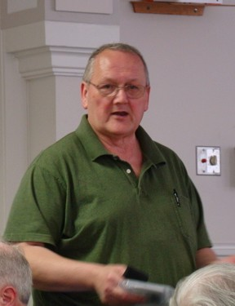
At right, Rick Owen displays his latest early 20th century US Proof Set; this one from 1910. The century old five-piece grouping includes the Lincoln cent, Liberty “V” nickel, Barber dime, quarter and Half Dollar.

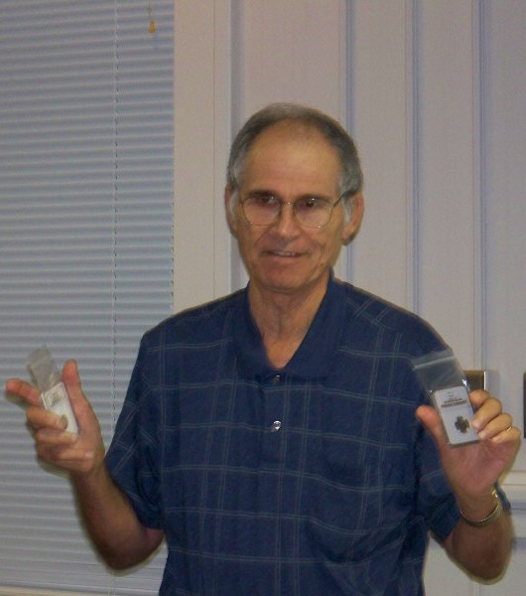
At left, Arno Safran displays an 1888 Proof 3¢ and 5¢ he acquired at the recently held BRNA Show in Dalton, GA. He related how his maternal grandfather at age 12 was given a brand new nickel by a saloonkeeper in NYC for shoveling the sidewalk after the Blizzard of 1888 but instead of spending it, he gave it to his mother.
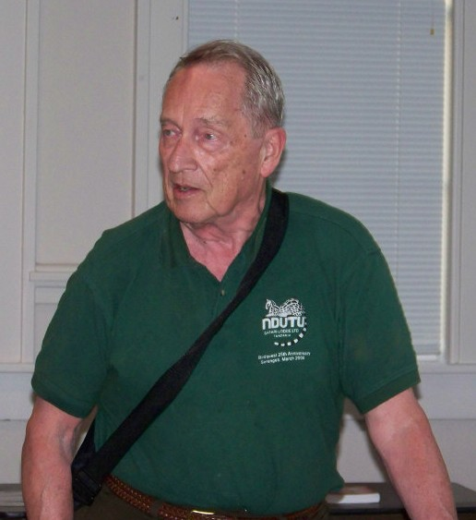
At right, Chuck Braun discusses coins and other numismatic artifacts he acquired during his travels to New Guinea and other areas in Indonesia while pursuing observations of exotic birds. He brought in a set of coins from New Guinea and a Python vertebrae necklace.

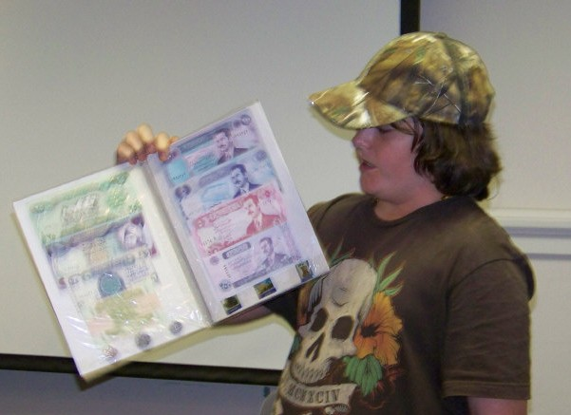

YN Austin Kuhl displaying his album of Iraqi Banknotes

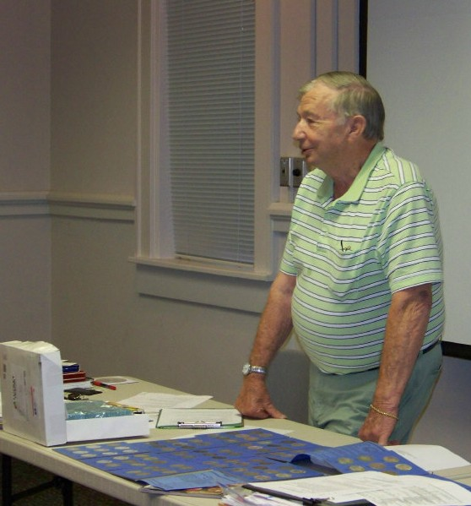

Paul Simon, at right showing his almost complete
set of Morgan dollars.

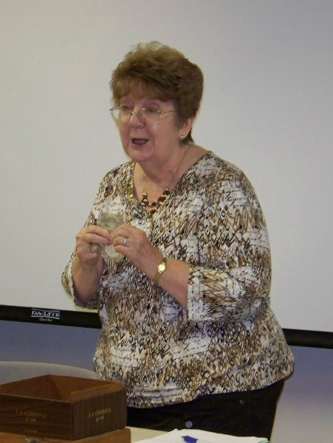
Pat James at left with close-up below displays a two-piece 1,100 anniversary commemorative silver proof set from Iceland.
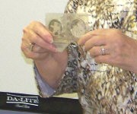

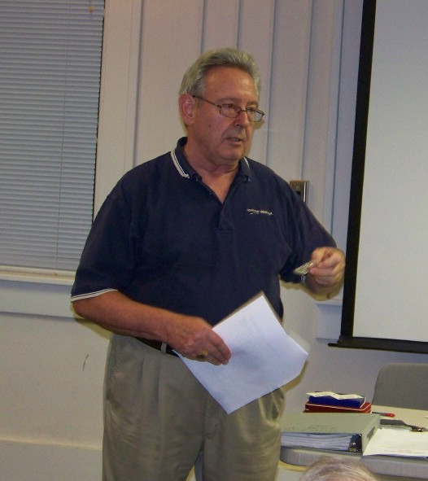
At right, John Meinhardt holds
a 1936 dated silver piece with the portrait of Edward VIII facing left. Other than some rare proofs, no portrait coins of Edw. VIII were ever released into circulation. As there was no legend anywhere to be seen on the piece, he was wondering whether the coin was legitimate, possibly a pattern or silver round, or merely a curiosity piece of no intrinsic value.
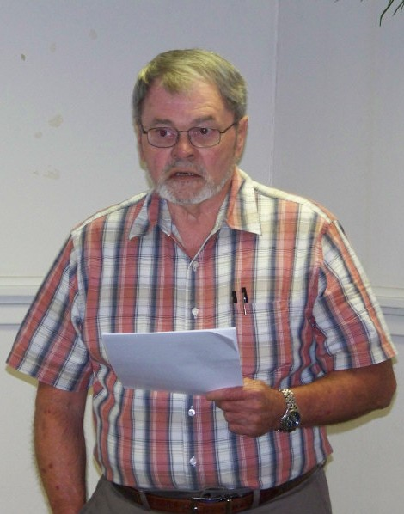

Jim Clapp, at left, brought in some
1975-76 Bicentennial coins and other related items and presented a summary of the US Bicentennial coin and medal program.

Photographs of presenters were taken by Helen Barry.

Show & Tell Presenters
(Continued from previous page)

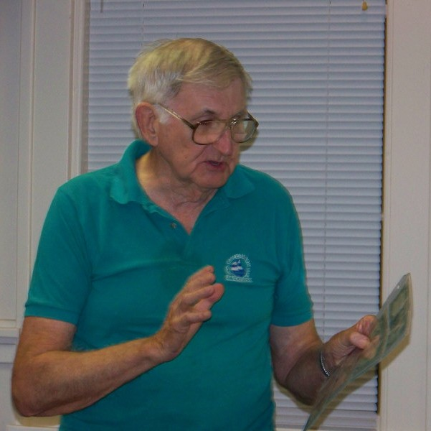
Howard Hillman, at left displayed US banknotes intended for Hawaii and North Africa during World War II. The backs of the Hawaiian notes were stamped H A W A I I while the serial numbers and seal on the North African notes were printed in a rusty-brown hue. Howard explained that these refinements were used to prevent their use by the Japanese and Germans.

Show & Tell Gallery of Exhibits

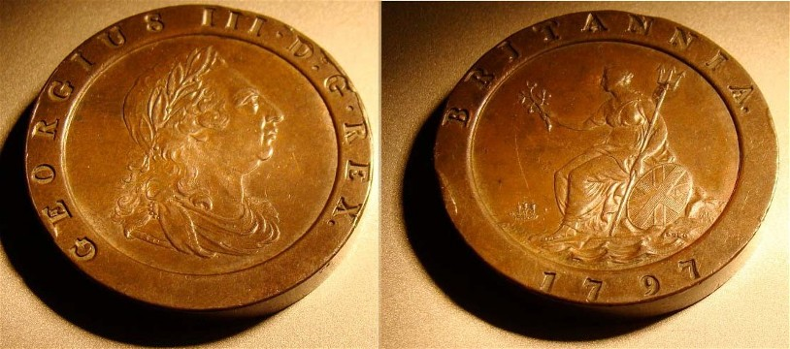

Great Britain - 1797 2 pence copper of King Geo. III

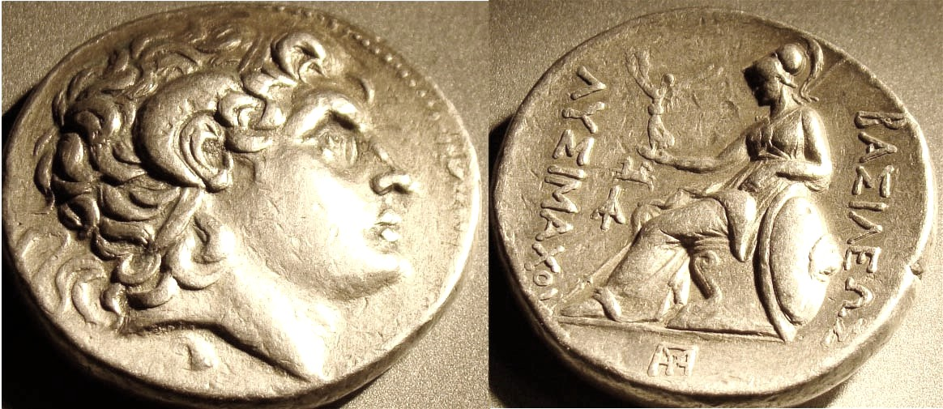

Lysimachos, Kingdom of Thrace Tetradrachm Kingdom,
297-281 BC silver tetradrachm
Head of Alexander, obv, Athena seated holding Nike on rev.

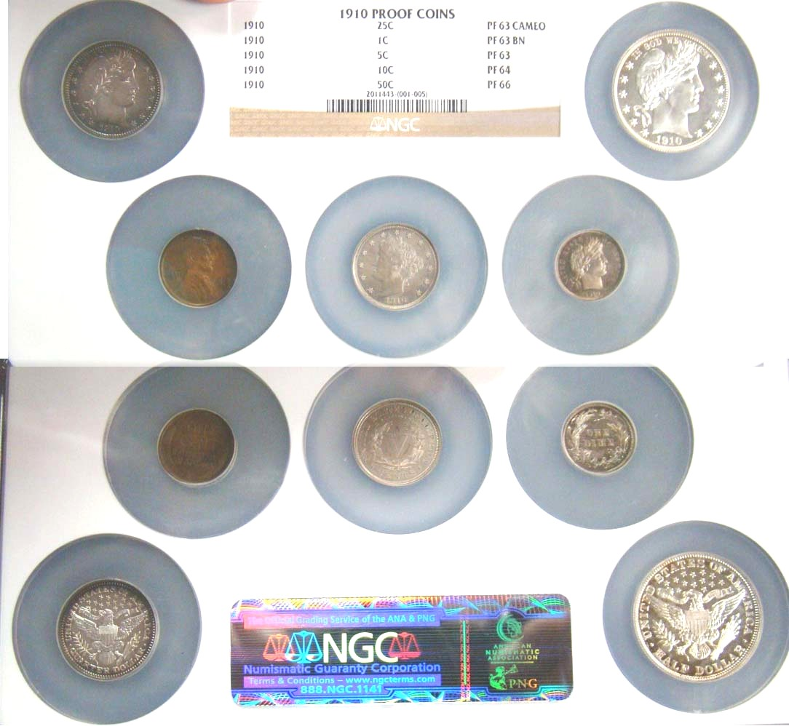

A 1910 US Proof Set certified by NGC

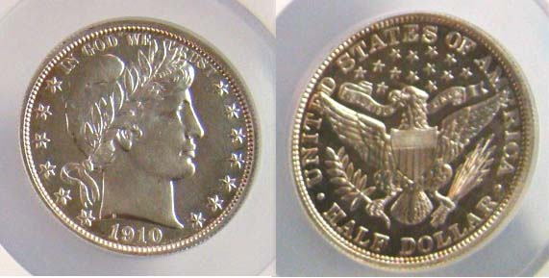

Detail of 1910 Proof Set showing
1910 Barber Half graded Proof 66 by NGC
Approximately actual size.

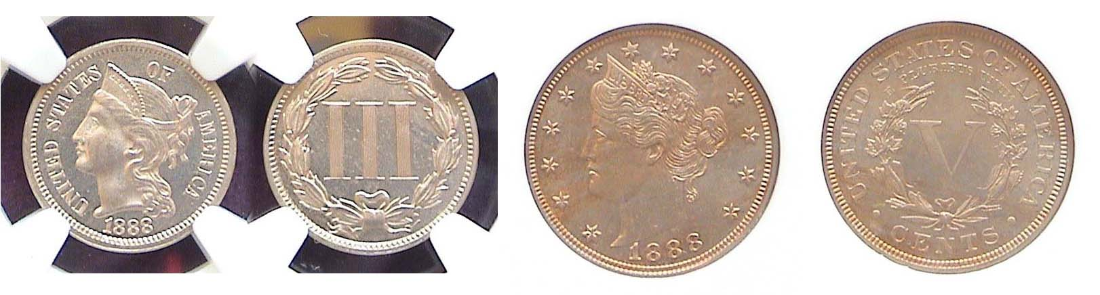
An 1888 Coronet 3¢ and Liberty 5¢ graded Proof-64 by NGC

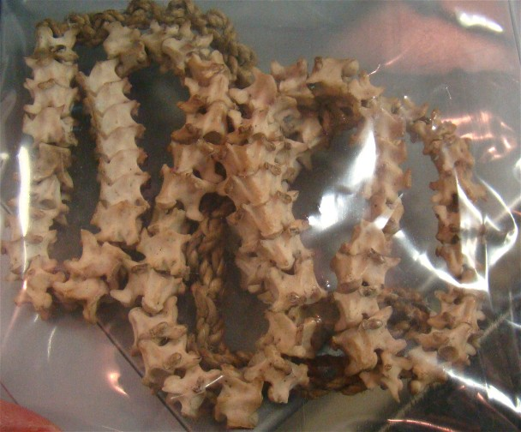

A Python vertebrae necklace
______________________________________________________________________________________________________________

The editor would like to thank those members who shared their hobby interests with the membership along with Helen Barry and Jim Mullaney who brought in their cameras to take the numerous pictures shown above. The battery ran out on the close-up camera before all the presenters’ coins could be photographed or projected on to the large screen in the library meeting room. Despite this, our club has now reached a point where the use of digital technology can provide a substantive numismatic record of some of our proceedings.

More Club News

The Prizewinners at the September 2 meeting were Helen Barry who won the silver eagle door prize and Jim Barry who took the 50/50 - $24.00. Congratulations to the Barry’s.

At our next meeting, October 7, our guest speaker will be noted numismatist Tony Chibbaro. He will present a PowerPoint program entitled, “The World’s First Coins”. Most of us know Tony as a collector who specializes in the tokens and medals of South Carolina and he has written an outstanding book followed by several updated pamphlets on the subject. He is also a dealer who stocks tokens and medals from all over the United States and the World. Anyone who knows Tony has come to realize that his numismatic interests are extensive and he always gives an interesting presentation, so you won’t want to miss our October 7 meeting at the Aiken Public Library. Also, consider bringing in a 2 minute Show & Tell.
_________________________________________________________________________________________________________________________________
(Continued on page 6, column 1)
Club Dinner Information

As reported earlier our pre Christmas holiday party is scheduled for Thursday, December 2 to be held at the Houndslake Country Club, 901 Houndslake Drive in Aiken. The time is 6:30 p.m. Social – Cash Bar, dinner starting at 7:00.
The menu options are 1. Beef tips with Gravy, 2. Chicken Picatta, 3. Grilled Salmon and 4. Rib eye steak. The complete dinner includes a house salad, standard veggies, a dessert buffet, coffee or tea. The entrée price for members is $16.00; $20 for the Rib eye steak. For non-members, the charge is $20.00; $26.00 for the steak. The deadline is Monday, Nov. 23. Checks should be made out the SJ CSRA CC. There will be no refunds after Nov. 23. The attached reservation form with choices should be sent with remittance to Helen Barry, P.O. Box 11, New Ellenton, SC 29809. One other important reminder: Although dinner jackets and ties are not required, no Jeans or denims are allowed in the club house.
______________________________________________________________________________________________________________________________

The Copper Corner

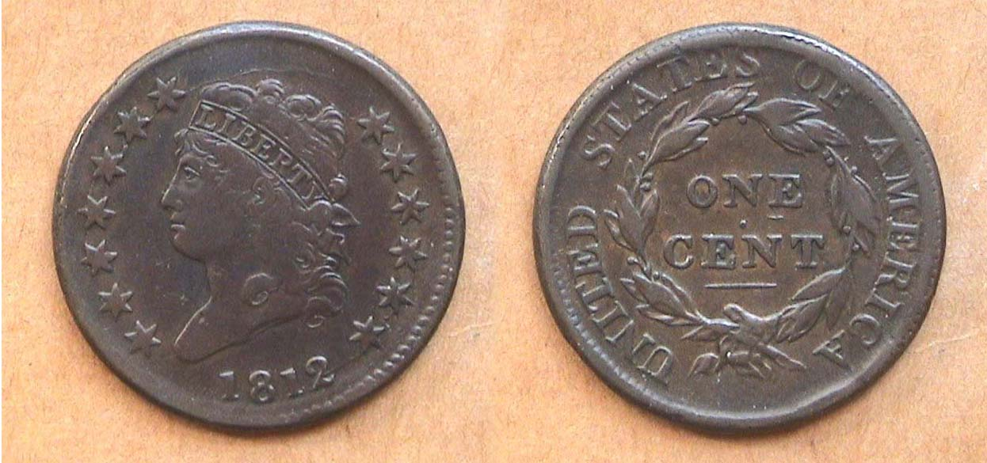

An 1812 Classic Head large cent grading VF-25, S-291 R3
[Use 3X glass or magnify to 200% to view details more clearly.]

The Classic Head large cent design was engraved by John Reich and coined between 1808 and 1814 inclusive. During this period in our nation’s history our copper planchets were ordered from the firm of Matthew Boulton in Soho-Birmingham, England. Boulton’s manufactory produced the finest copper blanks and was used by the Royal Mint and private coiners for making farthings, half pennies, pence and tuppence in Great Britain. It took weeks for the cargo of coinage blanks to reach the US Mint in Philadelphia and as the planchets were housed in wooden chests stored in the damp holds of the merchant ships carrying them, many of the blanks arrived porous, discolored or black. Finding a chocolate-brown colored Classic Head cent specimen with smooth surfaces free of unsightly corrosion can be quite a challenge for the collector.

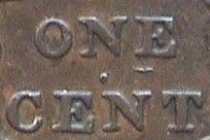
The S-291 variety is one of four die varieties for the date catalogued by early Large cents specialist, Dr. William Sheldon and happens to be the scarcest. It can be recognized immediately if one examines the reverse of the coin. Directly under the vertical bar of the letter E in ONE is a short horizontal bar. This same characteristic appears on the reverse of the even scarcer 1811/10 Sheldon 287 cent variety. Apparently the same reverse die remained in use to coin the 1812 S-291.

1812 1¢ rev. detail
________________________________________________________________________________________________________

Kindly Patronize our Advertisers

