Pres. Steve Kuhl
V .P. Pat James
Sec. Jim Mullaney
Treas. Sharon Smoot
Sgt. in Arms: Glenn Sanders
The Stephen James
CSRA Coin Club of Aiken
P.O. Box 11
New Ellenton, SC 29809
Web site: www.sjcsracc.org
The SJ CSRA CC of Aiken, SC meets on the 1st Thursday of the month at the Aiken Public Library

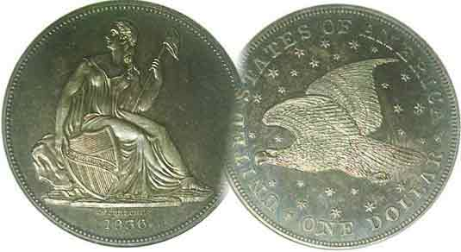
Programs: Pat James
Show: by Committee
ANA Representative: Jim Barry
Publicity: Jim Clapp
Newsletter: Arno Safran
E-Mail: arnosafran@comcast.net
Auctioneer: Glenn Sanders
Web site: Susie Nulty (see above.)

2011 Club Meeting Schedule
Volume 10, Number 10 the Stephen James CSRA Coin Club, Founded in 2001 October, 2011
Monthly Newsletter
Club’s 10th Show, a Great Success
Our next meeting is on Thursday, October 6, 2011 from 6:45 to 8:45 PM

Jan. 6 Apr. 7 July 7 Oct. 6
Feb. 3 May 5 Aug. 4 Nov. 3
Mar. 3 Jun. 2 Sep. 1 Dec. 1

____________________________________________________________________________________________________________

President’s Message
WHAT A STELLAR SHOW!!
By Steve Kuhl

Our Club hosted its tenth annual coin show at the H. O’Dell Weeks Recreation Center in Aiken SC on Saturday, September 10th, 2011. By all measures, this was the most successful show in our Club’s history, befitting our 10th Anniversary! In fact, this show set records in four measures: Dealer participation, Public participation, Drawing tickets sold, and net Profit. And of course, the Show wouldn’t have been successful without the active participation and support of the members who volunteered their time, money, and goods in support of our Club. So let’s start there.…

17 members of the Club supported the planning and implementation of the show. To prepare for the show these workers made and distributed flyers, bourse applications, and letters to the dealers; they contacted newspapers, magazines, TV and Radio stations to advertise our show; they coordinated with O’Dell Weeks, Sizemore Security and prospective dealers; and they developed administrative controls for accounting, table layout and other functions necessary to manage the show. On the day of the show, these Volunteers helped the dealers to set up and break down their displays as well as greet the public, sell raffles, prepare refreshments, watch tables, and do any task that was needed to keep things running smoothly. Many of the members stayed at the show well beyond the time to which they had signed up for, and as one dealer remarked, our show is very well respected by them because of the service our members provide. In addition to supporting the show, some volunteers even donated drawing prizes, food, postage, and other expenses that would have been borne by the Club if not for their largesse. The commitment of our Volunteers to making the Show successful, and by extension our Club, is greatly appreciated by your President and the Executive Committee.
________________________________________________________________________________________________________________
(Continued on page 3, column 1)
Collecting Colonial Hispanic Silver Coinage
Part V of Latin American Coins that were Legal Tender in the United States until 1857 By Arno Safran

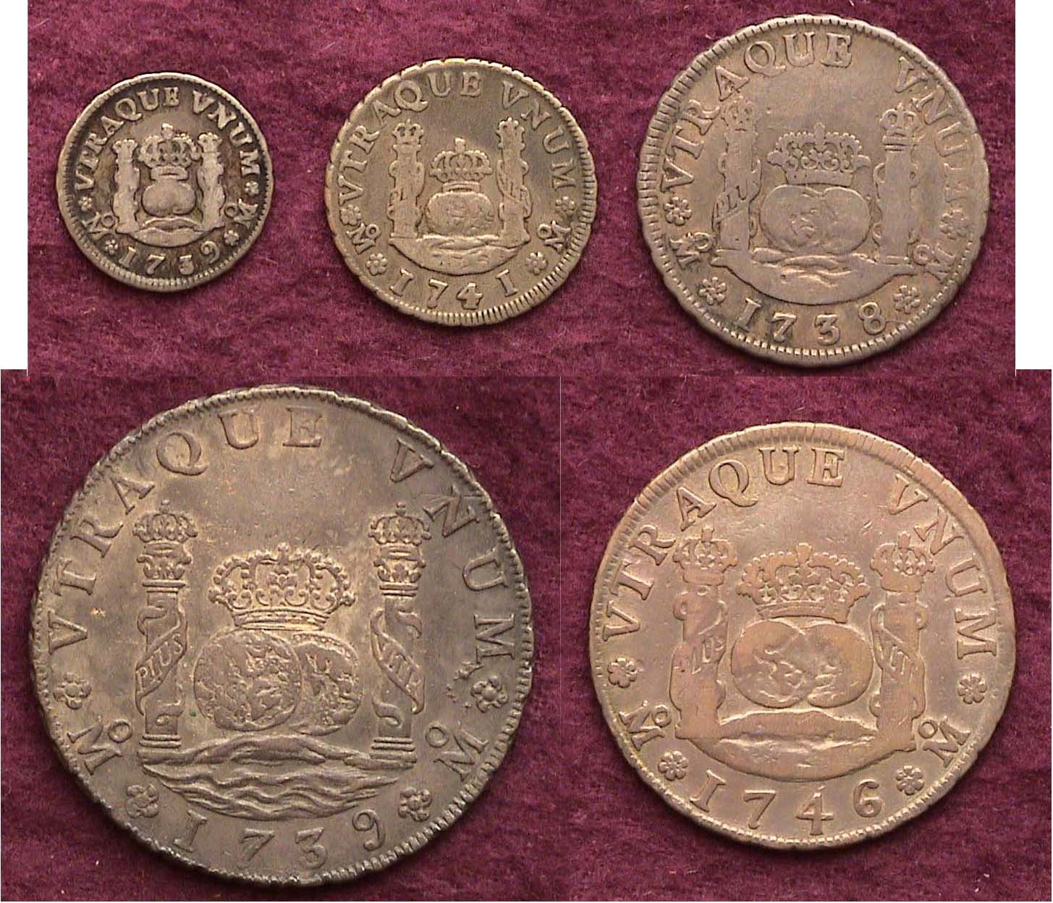

A Complete Set of Pillar Coinage of King Philip V of Spain
The date side- Top: 1739 ½ Real, 1741 1 Real and 1738 2 Reales
Bottom: 1739 8 Reales and 1746 4 Reales
[Magnify this and the following coin images to 200% to observer details.]

Upon opening A Guide Book of United States Coins (affectionately called “The Red Book”) the very first coin the reader will encounter is the Spanish Milled Dollar; the largest coin of the five shown above. This 8 Reales silver coin was the most commonly used trade dollar in the world and in colonial America it was accepted as legal tender long before the United States Mint began striking coins in 1793. In fact, it was still considered legal tender until early 1857. Before England began to rule the seas, the armadas of Spain had developed colonial power bases in Mexico, Central America and virtually all of South America. Spain established Mints in Mexico, Guatemala, Columbia, Bolivia, Peru and Chile and began striking hammered coins in the Western Hemisphere during the reign of Carlos I and Johanna. In 1732, the Screw press was installed which operated from the power of a water mill or horsepower, ergo the term “milling” to produce fully rounded shaped coins.
____________________________________________________________________________________________________________________________
(Continued on page 2, column 1)
Collecting the Pillar Coinage of Latin America
(Continued from page 1, column 2)

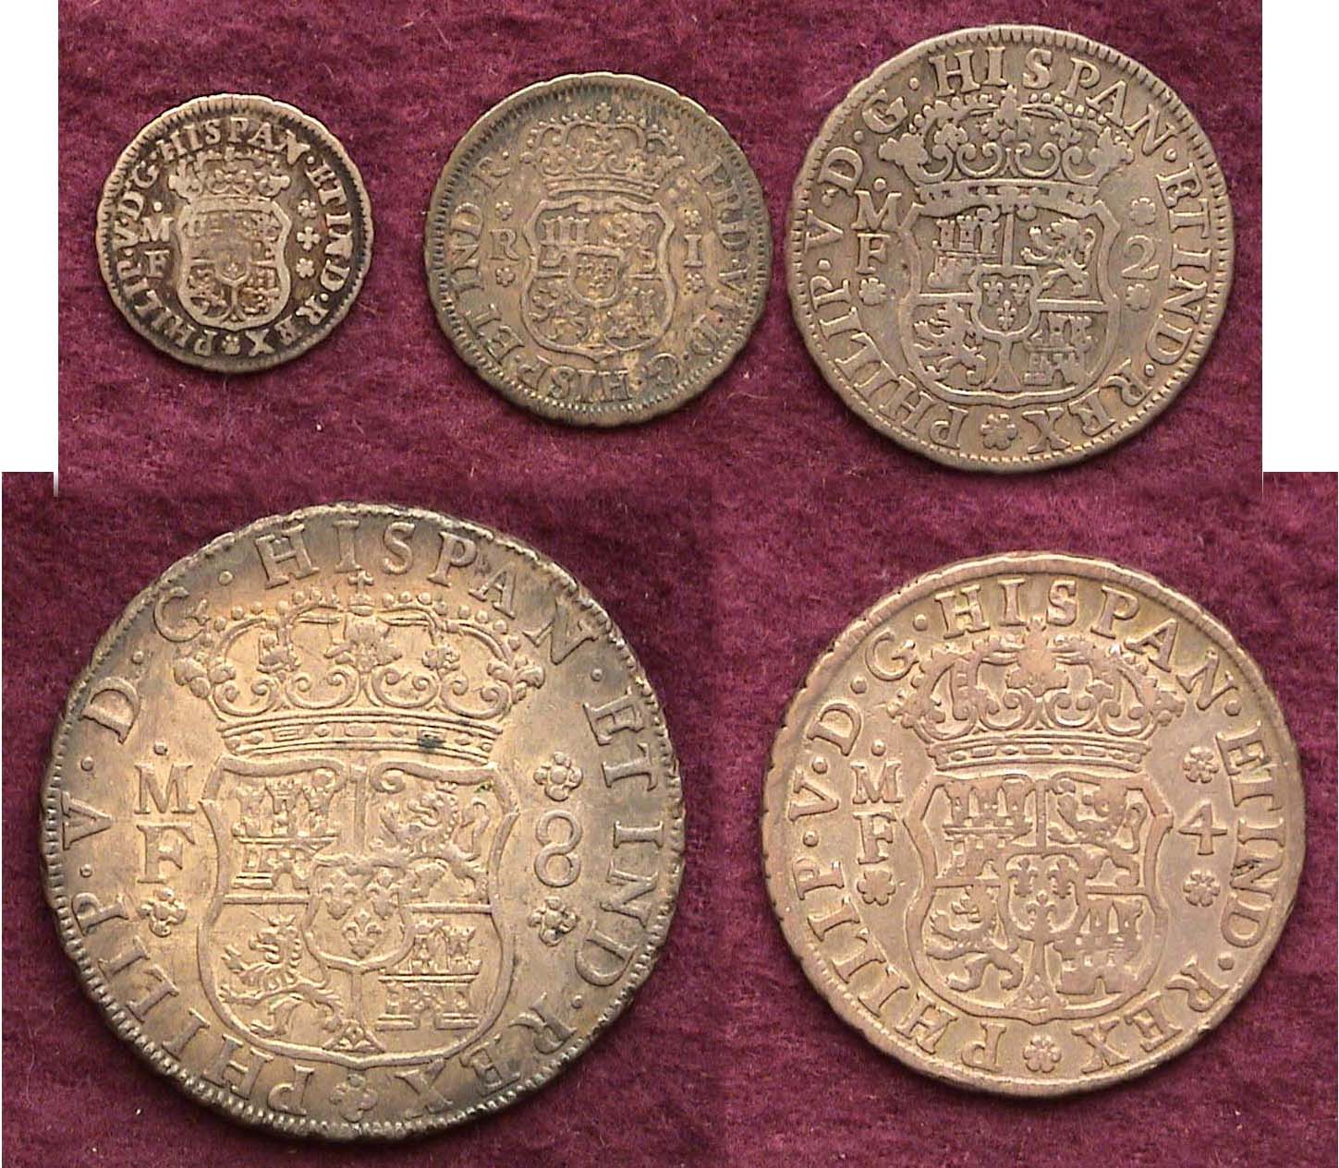

A Complete Set of Pillar Coinage of King Philip V of Spain
– Coat of Arms side- Top: ½ Real, 1 Real and 2 Reales
Bottom: 8 Reales and 4 Reales

Philip V, King of Spain ruled from 1700 until his death in 1746 (interrupted by a nine moth reign in 1824 by his son Luis I). He was the founder of the Bourbon dynasty. The Pillar coinage (also referred to as the “Two Worlds” type) which bears his name dates from 1732 through 1747. The Coat of Arms side is significant because for the first time the fleur-de-lis appears. This Bourbon escutcheon is centered between the upper Castle (for Castile) and Lion (for Leon and Granada) with the same symbols reversed below.

Hispanic American coinage was divided into eight parts to the dollar or “Pieces of Eight” (in U.S. terminology). The Peso or 8 Reales was the standard upon which all other Hispanic-American denominations were based. Translated into later US coinage parlance; the 8 Reales equaled $1.00; the 4 Reales, 50¢, and the 2 Reales, 25¢. (So far, no change from our three largest silver denominations.) The Real however was valued at an exchange rate of 12½¢ and the ½ Real at, 6¼¢. After 1793 when our own US denominations were beginning to circulate the two lowest silver denominations; the disme (10¢) and half disme (5¢) were sometimes exchanged at face for the Real and medio-real pieces respectively although it is more likely that two large cents and a half cent were required to make change for the real for a disme’s worth of goods. Colonial assayers found that the silver content in the Pillar coinage was .917 fine, higher than any other world nation. As there was no national Mint in Colonial America and since Great Britain forbade its colonies to strike silver or gold coins, Latin American 8 Reales and their parts were accepted as a medium of exchange for goods and business transactions and circulated freely on these shores.

Note: Americans tend to shy away from collecting coins struck in other nations because of the language barrier but at one time Latin was the foreign language of choice in the curriculum of our secondary schools and most of our high school graduates entered college with an understanding of some Latin. Many obsolete European foreign coins use Latin inscriptions and a return to a basic understanding of Latin in the curriculum might encourage more Americans to collect foreign coins.

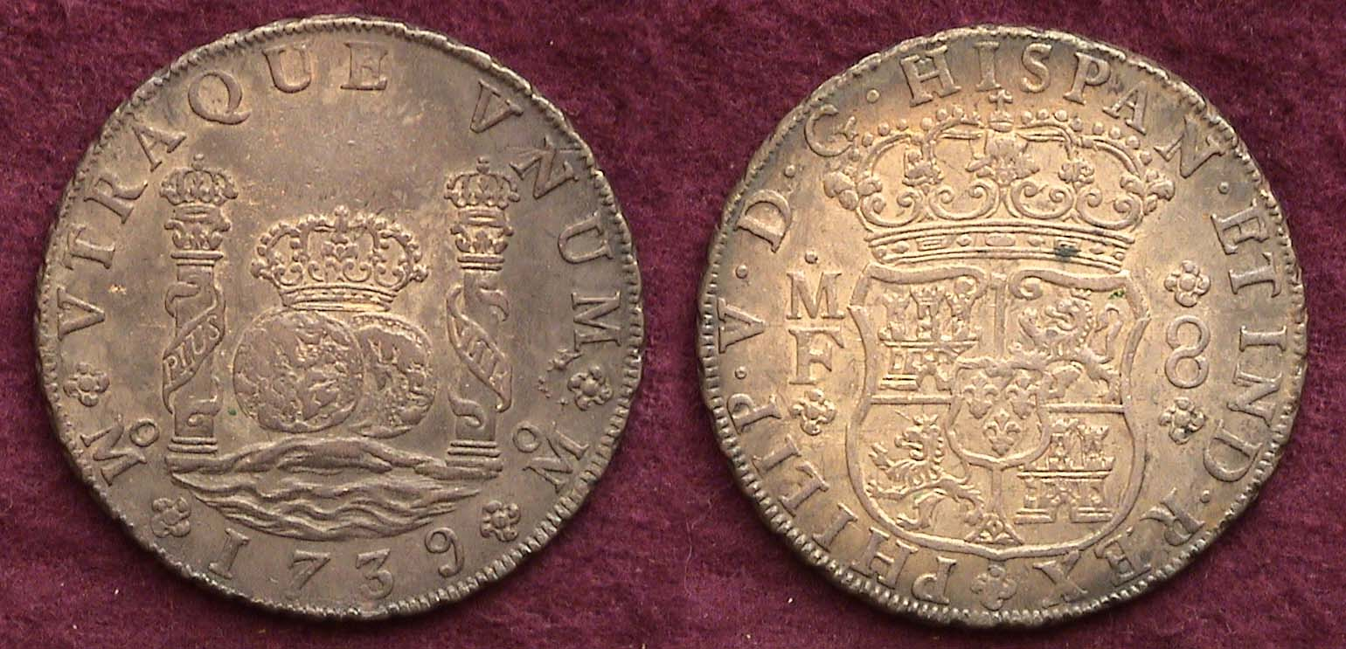

A 1739 Pillar dollar (8 Reales) grading AU

On the date side of the Pillar dollar one will notice the motto UTRA QUE UNUM positioned along the upper periphery of the coin. It is inscribed in Latin meaning “Both are one” and refers to the two spheres representing the east and western hemispheres as unified by Spain. The slogan, PLUS ULTRA is split within the ribbon of each pillar meaning “More beyond”, a reference to the New World. The tiny o over M at the lower left and right of each pillar represents the mint mark for Mexico City. The majestic central device shows two crowned ornate pillars in the ocean surrounding two globes (hemispheres) topped by a regal crown. The large date appears directly below.

The legend on the Coat of Arms side starting from the lower left reads PHILIP V D.G. HISPAN. Et REX, which means Philip the Fifth, by the grace of God, King of Spain and the Indies. At the left of the crowned Coat of arms are the initials M over F that stands for the sir names of the two assayers. At the right, the large number 8 represents the denomination, 8 Reales.

The 8 Reales pictured above is almost 275 years old yet in AU-50, it would sell for around $500 today. By comparison a common date 1799 Bust dollar in the same grade would retail for $8,000. Despite its origin, the Spanish Pillar dollar was used in the thirteen colonies and is collectible as an additional silver dollar type as shown in the 2012 Red Book.

Of the four lower denominations, the 4 Reales was not used much in international commerce resulting in much smaller mintages making it the scarcest denomination of the series.

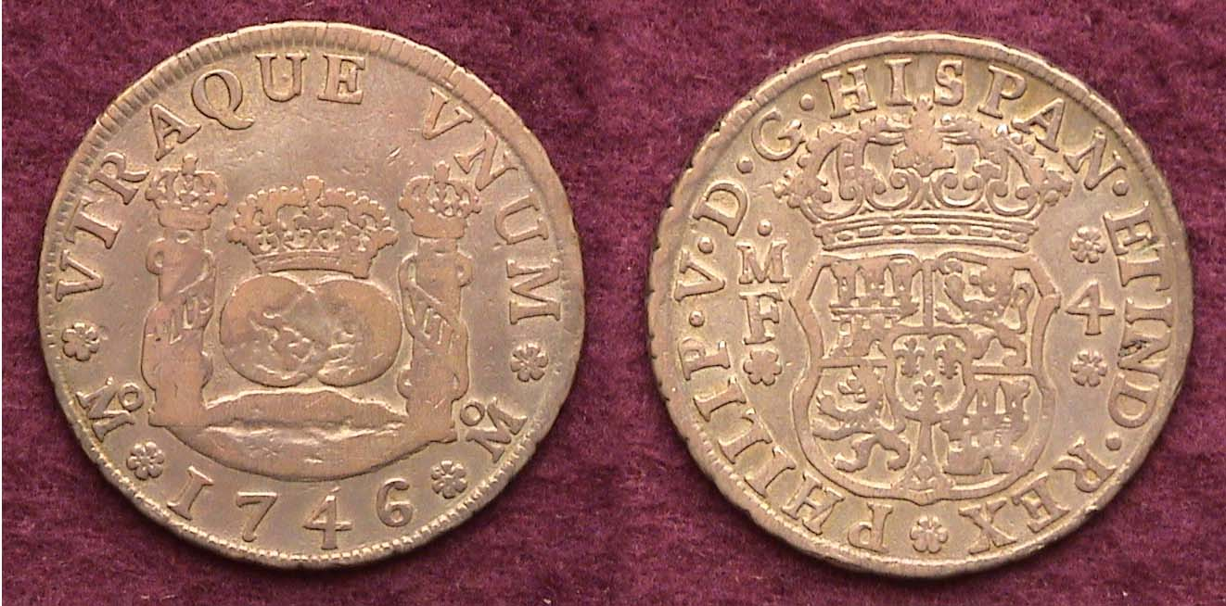

A 1746 4 Reales of Philip V struck at the Mexico City Mint

The Pillar 2 Reales down to the ½ real circulated much more heavily since their purchasing power was far greater during the 18th century than now. As a result most survivors surface in VF or lower. Dealers seldom bring them to shows because they are not worth very much due to low collector demand but it is these very denominations that are actually far scarcer than the resplendent crown-size 8 Reales.
_____________________________________________________________________________________________________________________
President’s Message and Show Report
(Continued from page 1, column 1)

The members who helped deserve recognition for their efforts, so our thanks are given to the following Volunteers:

Jerry Axner, Jim & Helen Barry, Jim Clapp, Chuck & Lizabeth Goergen, Pat James, Jim Jewett, Steve & Austin Kuhl, Doug Moody, Jim Mullaney, Arno & Vilma Safran, Glenn Sanders, Willie Simon, and Sharon Smoot.

The Show day started early – 7 a.m., as Dealers and Volunteers began arriving at the O’Dell Weeks center to set up the displays. It was a gorgeous day, and by 8 o’clock most of the dealers had arrived and were well on their way to completing their set-up. This was a good thing too, because although the official opening was at 9 a.m., we were entertaining guests by 8:15! We didn’t even have the coffee made yet!! Fifteen dealers participated in the show, and they purchased 32 tables from the Club – one of our new records. By the time the set-up was complete, we used practically every available table that O’Dell Weeks had!

Participating dealers included many tried and true friends from South Carolina and Georgia; dealers that support us year after year, and to which we are very grateful. We also had new participants, and six of our Club members also purchased tables to ply their wares.

Thanks go out to John & Elaine Attaway, Tony Chibbaro, Tony Fulmer, Howard & Sonya Hillman, John & Nancy Meinhardt, and Dick & Sharon Smoot for filling up our show with their quality merchandise!

A wide variety of items was available at the show - the selection was great! To name a few categories, there were American coins – from 1798 to modern times; American currency, World coins and currency from several dealers, Tokens, Medals, and of course, all the reference books and supplies a collector would need to further their collection.

As was mentioned earlier, members of the public began arriving well before the opening bell, and by the time, 9 a.m. rolled around things were really getting busy. The morning hours simply flew by as droves of people came to our show to talk, trade, buy, and sell with the Dealers. Several people came in to get answers to their questions about coins or to have their items appraised. A Reporter from the Aiken Standard arrived and interviewed several people about the event, and was given a quick primer on how coins are graded – apparently the Reporter had always been curious about this, but no one had ever really explained it to her. She wrote a very nice article and it was published in the newspaper on the Monday following our show.

As the Public entered, Club members would welcome them and ask them to sign in, and of course show them the wonderful drawing prizes that they had a chance to win if they purchased a drawing ticket or two, or six for five dollars (I am still hearing that phrase in my sleep, two weeks hence….) A total of 244 people signed in to the show – another record! - although actual attendance was probably a bit higher considering some people did not sign in, especially when there was a log jam at the registration table.
Speaking of the Prize Drawings, the Club had three excellent prizes to give away: First prize was a 1997 1/10th ounce gold bullion American eagle, second prize was a 2011 Silver Proof Set, and the third prize was an 1886 MS-62 PCGS Morgan Dollar.
Special thanks are due to Glenn Sanders for his donation of the second prize, and to Pat James for her providing first and third prizes at cost. A very special thanks goes to Jim Mullaney for taking the time, and bearing the financial burden, to create additional ticket booklets.
We had a very limited amount of tickets to sell, so Jim figured out how to make more on his home computer. He then provided us with extra tickets, gratis, and I am so glad he did, because we sold all the tickets we had, and almost all of the ones that Jim made for us. Between these three members, we saved the Club significant money, so please thank them the next time you see them – let them know that you appreciate their dedication to our Club.

In case you are wondering, the ticket sales generated revenue of $820, another Club record by the way! Erin Reilly of Aiken won the first prize, Ken Lake of Aiken won the second, and Lizabeth Goergen, our Club member, won third! All the winners were very thankful and surprised. Congratulations, all!

The fourth record set by this show was in the revenue generated. While some outstanding charges remain, the current tally is expected to be very close to the final accounting. The Club incurred expenses of $1475, but received revenue of $2413, so the net profit is anticipated to be approximately $938! Again, this record would not have been set had it not been for the generosity of several of our Club members by them dipping into their own pockets to donate supplies, refreshments, prizes, and administrative expenses.

The show officially ended at 4 p.m., although the buying, selling, and trading continued for a short while as the Vendors packed up their displays. By 6 p.m., the room had emptied and the dealers were all on their way home. It was a good day for them – some mainly bought coins, some sold, and all left satisfied with their decision to do the show. It was a wonderful and satisfying day, and I for one, look forward to our show next year. Thanks again to everyone that helped make this show the best ever – a stellar show it was indeed!
_________________________________________________________________________________________________________________________________
And on behalf of our club, thank you Mr. Steve for all the work you did in coordinating the event; ED.
____________________________________________________________________________________________________________________

An Extended Show and Tell and Grading Bee
Is Scheduled for our October 6 Meeting

Our VP and program chair, Pat James has planned another enjoyable program for our upcoming meeting. It will be in two parts. Jim Mullaney will conclude his Grading Bee program during the first portion, and inasmuch as President Kuhl reported on the success of our recently held show, Ms. Pat is encouraging members to bring in some new numismatic acquisitions from that event or recently acquired. As examples, appearing on the following page, see what our resident young numismatist Austin Kuhl acquired at the Sept. 10 show.
_________________________________________________________________________________________________________________
Austin’s Bank Notes from Show

At our recent show, YN Member Austin Kuhl acquired two examples of German Notgeld issued on April of 1921. Observe the magnificent colorful vignettes and details on both banknotes.

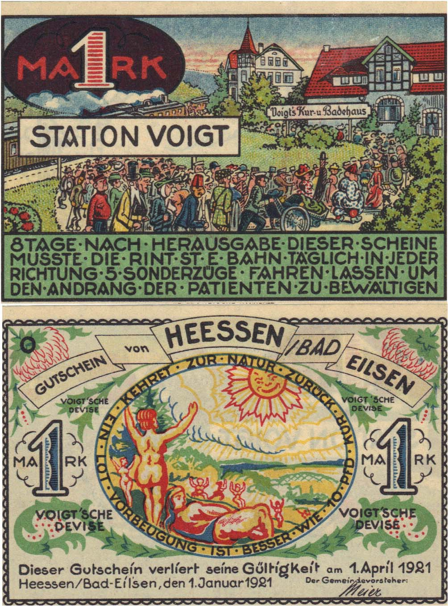

A 1 Mark Notgeld

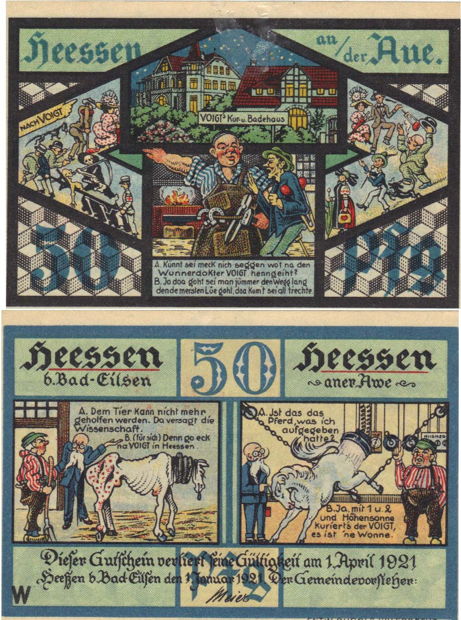

A 50 Pfennig Notgeld
____________________________________________________________________________________________________________________________

STEPHEN JAMES CSRA COIN CLUB
Minutes from the Regular Meeting
Aiken County Library
September 1, 2011

President, Steve Kuhl, called the regular meeting of the club to order at 6:45 p.m.
Glenn Sanders reported that there were 23 members present (22 adults, 1 junior). There were no visitors. (15 regular members needed to conduct the business of the club.)
Glenn announced information concerning several upcoming coin shows in the vicinity.
Todd Starbuck won the door prize.
A motion was made by J.J. Engel, seconded by Arno Safran, and passed to dispense with the reading of the August 2011 minutes.
The treasurer’s report was read. The balance as of 8/31/11 was $2593.35.
It was announced that the October program would be Show & Tells by club members, and if any time is available the completion of the coin grading exercise by Jim Mullaney.
Jim Barry announced that our club newsletter had received 3rd prize among North American numismatic club newsletters. The award had been announced at the ANA Chicago show. Congratulations to our editor, Arno Safran.
Jim Barry presented a program on Coins from the era of Alexander the Great.
Chuck Goergen shared a Show and Tell with the group displaying two Classical Greek gold staters, one a recent acquisition. Both fit in nicely with the topic of the night’s program.
Helen Barry won the 50/50 ($14).
Austin Kuhl drew from the junior grab bag.
Respectfully submitted,

Jim Mullaney, Secretary
_______________________________________________________________________________________________________________________

Pictures from September 1 Meeting
(Courtesy of Helen Barry)

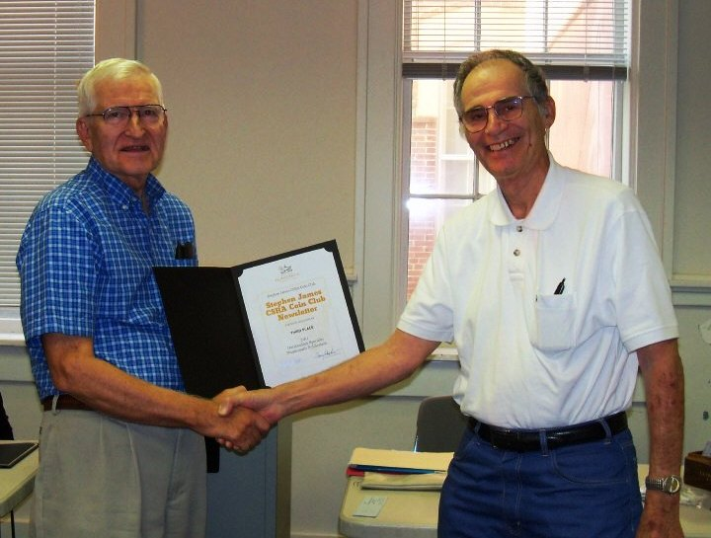

Jim Barry, the Club’s ANA Representative (left)
Presenting Arno Safran, Newsletter Editor (right) with one
of the 2011 ANA’s Outstanding Club Publication Awards

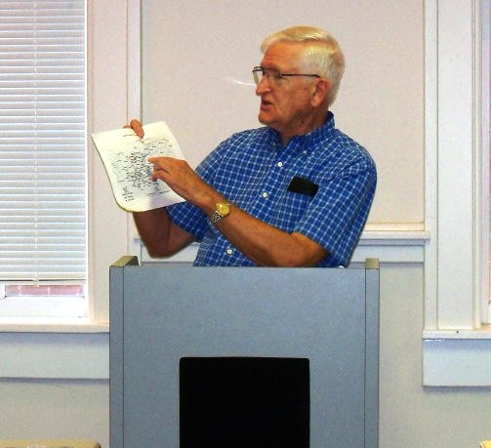

Jim Barry displaying map of dominion of Ancient Greece in his preface to the Influence of Alexander, the great on the Coinage of Classical Greece and Early Roman Empire

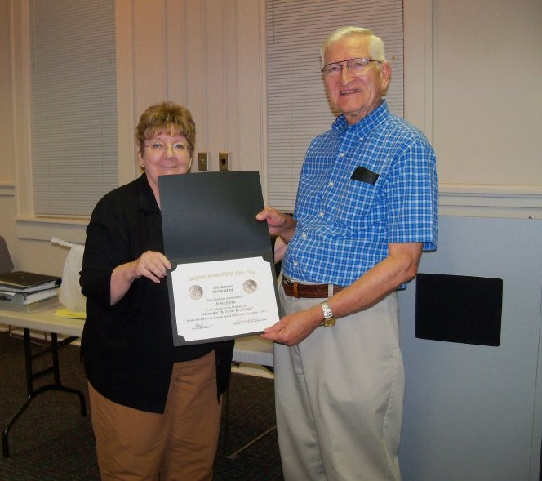

VP Pat James presenting a Certificate of Appreciation to Jim Barry
For his program on the Legacy of Alexander, the Great on the Coinage of Greece and Early Roman Empire
Show & Tell
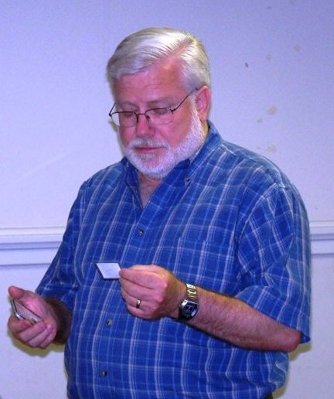

Member Chuck Goergen displaying a magnificent gold stater
before the members of the Stephen James CSRA Coin Club
___________________________________________________________________________________________________________
Kindly Patronize Our Dealer Advertisers
