The Stephen James
CSRA Coin Club of Aiken
P.O. Box 11
New Ellenton, SC 29809
Web site: www.sjcsracc.org
The SJ CSRA CC of Aiken, SC meets on the 1st Thursday of the month at the Aiken Public Library

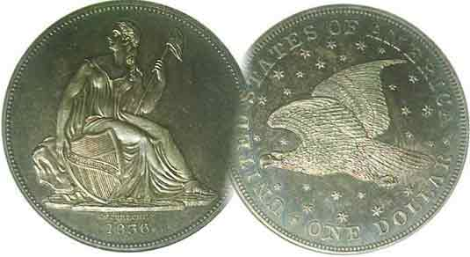
Pres. Steve Kuhl
V .P. Pat James
Sec. Jim Mullaney
Treas. Chuck Goergen
Sgt. in Arms: Jim Sproull
Programs: Pat James
ANA Representative: Jim Barry
Photos: Helen Barry
Publicity: Pat James
Newsletter: Arno Safran
E-Mail: arnosafran@comcast.net
Auctioneer: Jim Sproull
Web site: Susie Nulty (see above.)

2013 Club Meeting Schedule
Volume 12, No. 10 the Stephen James CSRA Coin Club, Founded in 2001 October, 2013
Monthly Newsletter
Our next meeting will be held on Thursday, Oct. 3, 2013 at the Aiken Public Library

SCNA Club Show Scheduled for Oct. 25-27 in Greenville
Jan. 3 Apr. 4 July 11 Oct. 3
Feb. 7 May 2 Aug. 1 Nov. 7
Mar. 7 June 6 Sept. 5 Dec. 5

______________________________________________________________________________________________________

SCNA Convention Arguably Best SC Show of the Year

When was the last time you attended a major regional show? If it has been a while or never, members of the SJ CSRA CC should seriously consider spending a day or two at the upcoming 41st South Carolina Numismatic Association Convention, which will be held Fri., Sat. & Sun. Oct. 25, 26 and 27 at the TD Convention Center (formerly Carolina First Center) located at 1 Exposition Drive in Greenville, SC. Around 100 to 110 tables have been sold for this major numismatic event. The hours of the show are 10:00 AM to 6:00 PM Fri. & Sat. and 10:00 AM to 3:00 PM on Sun. The estimated drive time from Aiken is around 2 hours and 15 minutes allowing one to make a round trip the same day.

Over the years, SCNA has been in the forefront of encouraging and guiding young collectors by featuring a number of YN exhibits at their conventions, many of which have been outstanding. SCNA has also provided numismatic programs based on a wide range of topics. At the upcoming SCNA show, Tony Chibbaro--who has given a number of programs at our meetings over the years--will present a PP presentation on “Pre 1900 South Carolina Trade tokens” beginning at 12:00 noon on Sat. Oct. 26. This will be followed at 1:00 by a special YN meting. At 3:00, there will be a program on Hobo Nickels--an extremely popular collectible series for the young and old alike--by collector Doc Yancho. These will all take place at Exhibit Hall 2 in the Convention center.

For those so inclined to attend, directions will be discussed at our Oct. 3 meeting.
_____________________________________________________________________________________________________________________

The Importance of Attending Regional Shows: Part 2
“Six ‘finds’ from the South Carolina Numismatic Association Conventions” By Arno Safran

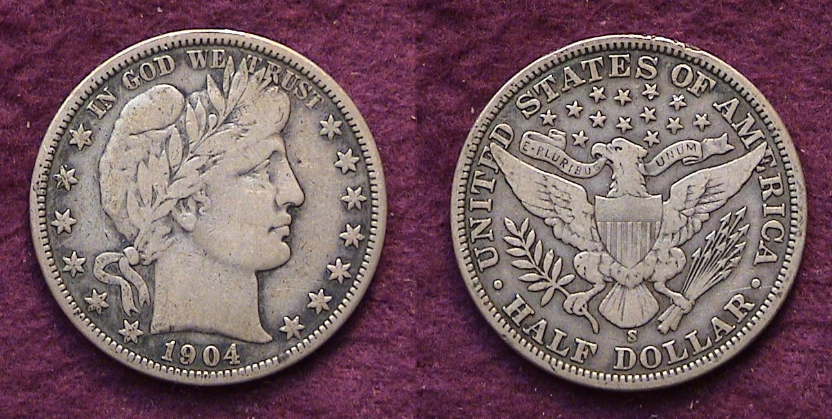

A 1904-S Barber Liberty Half-dollar grading Finbe-12
[Use` 3 X glass or magnify page to 200%]

In last month’s feature article on Attending Regional Shows: (Part 1), the author pointed out that branching out from one’s local area is often necessary to procure specific hard to find numismatic items for your collection. By example, two recent acquisitions from the Blue Ridge numismatic shows held in Dalton, GA were prominently displayed. With the upcoming South Carolina state show scheduled near the end of the month in Greenville, the author would like to share with his fellow members some of the harder to find coins he acquired at previous SCNA conventions.

The 1904-S Barber half dollar pictured above is one such coin. With a mintage of only 553,038, it is one of the key dates of the entire 73-piece set (1892-1915). It is scarce to rare in virtually all grades but especially so from Fine-12 or better. The author first began assembling his set back in 1992. The main criteria was that each specimen had to be graded at least, Fne-12. At that time, for a Barber coin to be considered FINE, all seven letters in Miss Liberty’s tiara had to be “completely readable but not sharp.” With the publication of the 2006 Red Book, the standard has been loosened slightly to read, “LIBERTY nearly completely legible, but worn”. It was back in 2003, the second year the author attended the SCNA show that the author found this elusive specimen. A nearby dealer overhearing the transaction offered the collector $65 more than he had just paid which, after an eleven-year search, he refused.
_______________________________________________________________________________________________________________________
(Continued on page 2, column 1)
Regional Shows: 2, the late October SCNA
(Continued from page 1, column 2)

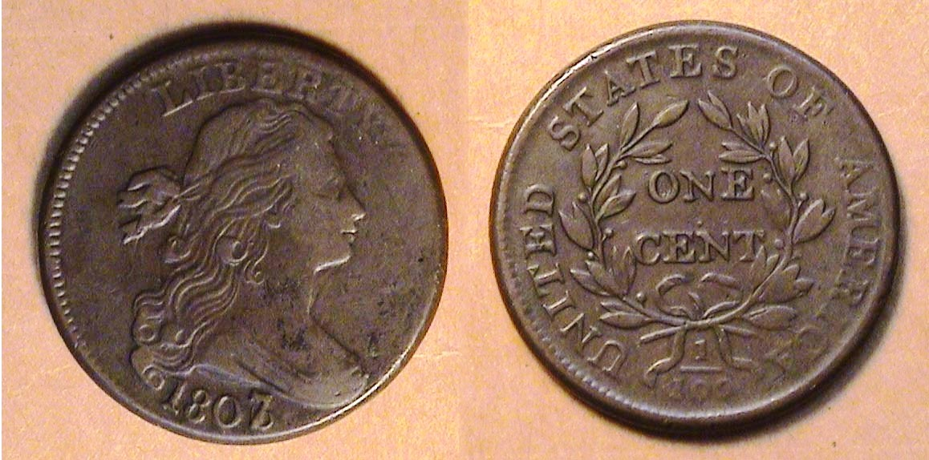

An 1807/6 Draped Bust large cent, S-273, R! graded VF-30
[Use 3 X glass or magnify page to 200%]

Over the years the author had been assembling a date set of large cents (1793-1857) that included the overdates. At the 2006 SCNA convention he unexpectedly came across this 1807/6 specimen. While not particularly scarce, it is nevertheless an important variety. Despite some spotting, the coin had decent copper color and is considered average for grade.

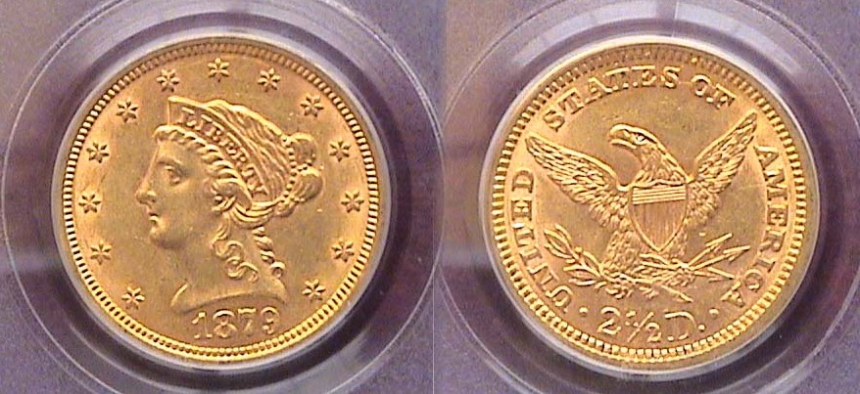

An 1879 $2.50 Liberty Quarter eagle graded AU-58 by PCGS
[Use 3 X glass or magnify page to 200%]

This lovely example of the 1879 Quarter eagle was acquired at the 2007 SCNA convention. At the time, the collector was not assembling a date and mintmark set of $2.50 gold Liberties, not that he ever intended to do so, nor was the date considered scarce despite a mintage of only 88,990 pieces. If so, what was the reason for its acquisition?

In 1999, gold was trading at just $255 an ounce. In 2005 gold began to stir and by late October of 2007, the yellow metal had risen to over $790 an ounce and the author decided, that if he ever intended to build a late 19th century, early 20th century US gold type set, he had better not wait to long to do so. Back in 2007, many certified US coins graded AU-58 tended to look virtually undistinguishable from Choice MS-63s having only the slightest bit if rub yet such pieces were priced under the MS-60 quote.

(An MS-60 coin generally appears baggy, having a few scuffmarks or some scrapes, sometimes seeming slightly lackluster despite being uncirculated and is usually less desirable than a coin grading AU-58.
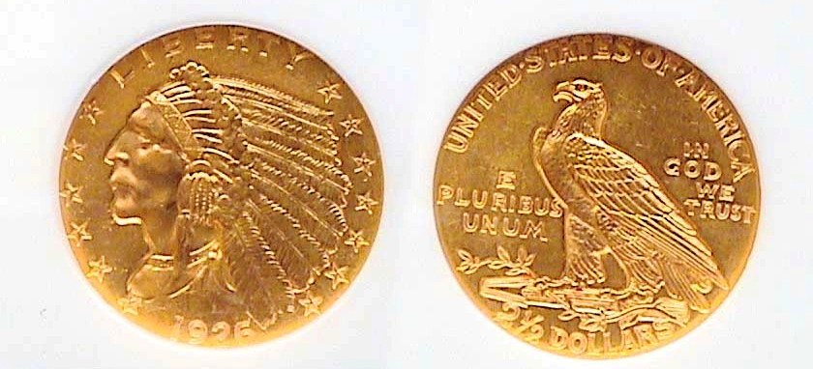

A 1926 $2.50 Indian quarter eagle graded MSA-61 by NGC
[Use 3 X glass or magnify page to 200%]

At the same event, the author also acquired the later type quarter eagle completing the $2.50 portion of the late 19th, early 20th century gold type set.

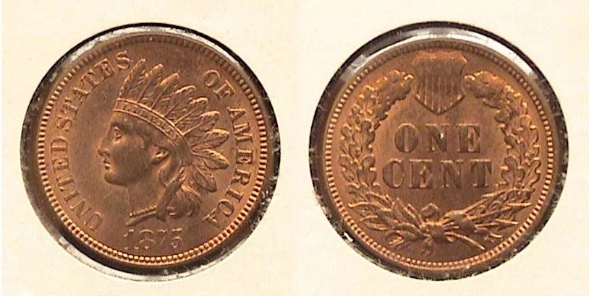

N 1875 Indian Head cent graded MS-64 Red
[Use 3 X glass or magnify page to 200%]

At the 2009 SCNA show the author was attempting to complete a 19th Century three-quarter century set that would include the US coins of 1875 excluding gold. While 1873 holds the record for the most denominations and major varieties the US Mint ever produced, there were still a large number of denominations produced in 1875. Excluding gold, these included the Indian Head cent, 3c nickel, Shield nickel, also the Liberty Seated dime, 20c piece, quarter, half dollar and Trade dollar.

The author discovered an attractive uncirculated example of the scarce 1875 cent housed in a stapled 2x2 holder. At the show, he showed the piece to Randy Campbell of ICG (Independent Coin Grading Company). Randy graded the coin MS-64 Red and that is the way it actually came back certified.

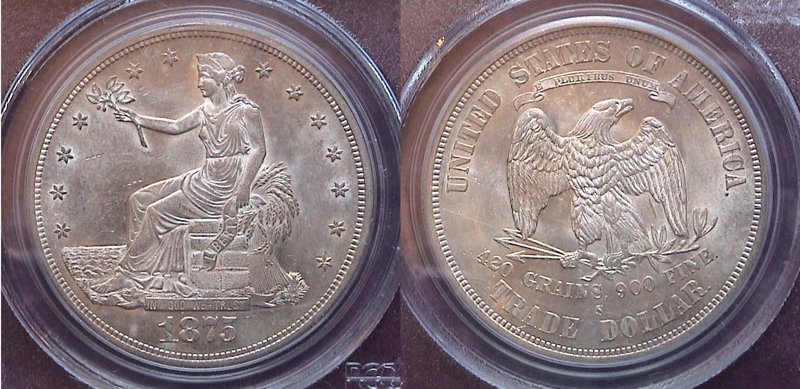

An 1875-S Trade dollar graded MS-61 by PCGS
[Use 3 X glass or magnify page to 200%]

The history of the Trade dollar is not a happy one as special interest groups filled it with political pork barrel legislation. The coin was authorized as part of the Coinage act of 1873 which discontinued the striking of the US Liberty Seated dollar for domestic circulation along with the half dime, 3c silver piece (AKA “trime”), and bronze`2c piece. The Trade dollar was ostensibly struck for trade in the Orient and could be considered legal tender up to $5.00 here in the US. Between 1873 and 1878, the coin saw some circulation but the merchants residing in the Far East, most notably in China, did not have much confidence in the issue. After 1878, a decreasing number of Trade dollars were struck for US collectors only in Proof with just ten issued in 1884 and five in 1885 making those instant rarities. For collectors, the most common dates are the San Francisco Mint issues of 1874 thru 1878 up thru AU-58. They are scarcer in mint state however. The PCGS certified MS-61 1875-S Trade dollar shown above was acquired at the SCNA convention in October of 2009. It is an attractive example for type. In every instance, each coin acquired at these SCNA conventions was selected with a particular purpose in mind, towards the completion of a series, a particular type set or year set.
________________________________________________________________________________________________________________

Club News and Highlights from our Recent Show
[Photographs taken by Helen Barry]
[Use 3 X glass or magnify page up to 200%]

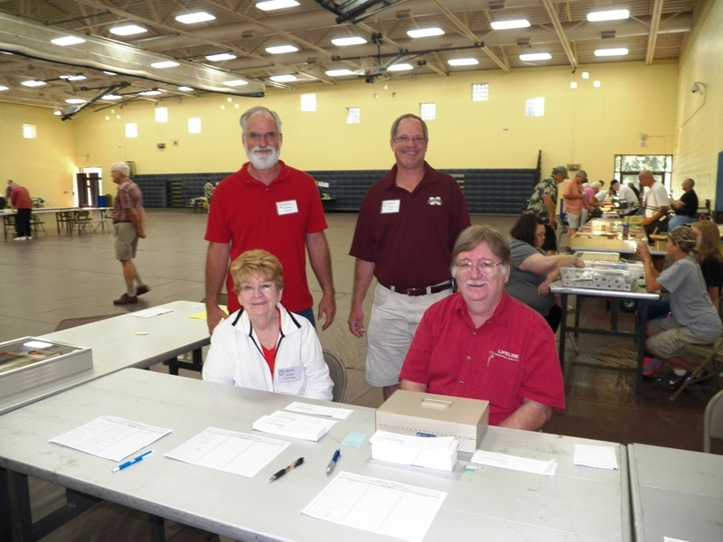

At the welcoming Desk: Seated VP Pat James and member Robert Sandborn, Standing Sec. Jim Mullaney and Pres. Steve Kuhl

President Steve Kuhl called the Sept. 5 meeting to order at 6:45 PM. Sgt. in Arms Jim Sproull reported that there were 24 members with 3 guests present. He then reported on the upcoming shows for the month, which included our own followed by those in Charlotte, Raleigh and Greensboro, NC.

Treasurer Chuck Goergen reported a Treasury balance at $1,975.30. President Kuhl mentioned that as of the meting date, 24 tables had been sold for the upcoming club show. He also mentioned that there were still some 2014 Red Books available to members at the discount price of $8.00.

There were three Show & Tells. Jim Barry displayed a silver tetradrachm of Ptolemy V (205-180 BC) showing the king on the obverse and an eagle’s head and thunderbolt on the reverse.. Chuck Goergen displayed a tetradrachm of Lysimachus (c. 305-281 B.C.) and Arno Safran brought n two coins he recently acquired from the BRNA show held in Dalton, GA, an 1832 Coronet large cent and a 1902 Barber quarter.

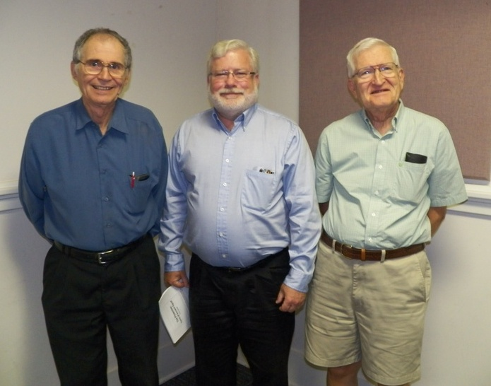

Show & Tell presenters at the Sept. 5 meeting
From l to r: Arno Safran, Chuck Goergen & Jim Barry

The Program

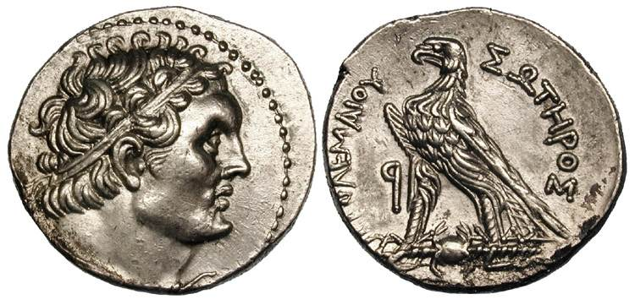
Ptolemaic Kingdom of Egypt, Ptolemy VI Philometor, (180-145 BC), AR Tetradrachm. Aradus mint,
(Courtesy Wildwinds.com)

Chuck Goergen presented a PowerPoint program on “The Coinage of the Ptolemaic kingdom” which lasted almost 300 years. Chuck covered all fifteen Ptolemy monarchs during his interesting 45-minute presentation. The dynasty began shortly after the death of Alexander, the Great around 305 BC when Ptolemy I, a bodyguard to Alexander, claimed Egypt. It ended under the reign of Ptolemy XV and Cleopatra VII with the defeat of Egypt in 34 BC by Rome under Octavius, later to be crowned Augustus. The speaker displayed slides of Bronze, silver and gold coins struck during the three centuries of Ptolemaic rule but most were of the large silver tetradrachm denomination that featured a Bust appearing like Alexander on the obverse with a Spread eagle over a thunderbolt on the reverse. The members of our club would like to thank Chuck for his` extensive research on the coins of the Ptolemaic kingdom and sharing it with us.

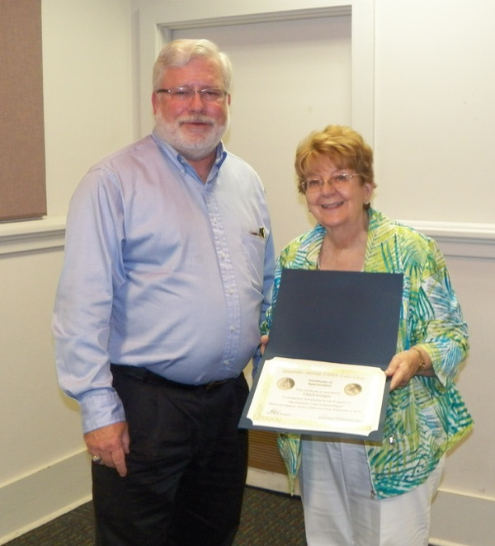

VP and Program chair Pat James ® presenting speaker Chuck Goergen with a Club Appreciation Certificate

The prizewinners at the Sept. 5 meeting were Robert Sandborn who won the door prize and Dick Lasure who won the 50/50. Congratulations, gentlemen!

Our next meeting is this coming Thursday, Oct. 3. Our guest speaker will be Tony Chibbaro entitled ‘My Favorite Tokens” Tony is the author of the book on South Carolina tokens. As a former collector of US Hard Times token series, the editor has come to appreciate the area of Exonumia related to token collecting. Every program Tony has presented during the twelve years the SJ CSRA CC has been in existence has been interesting and rewarding.
____________________________________________________________________________________________________________________

Please open the 2nd attachment
to read President Steve Kuhl’s
report on our September Show
It is a colorful document.

There is also a 3rd attachment with Secretary Jim Mullaney’s
Minutes of the Sept. 5 meeting.
_______________________________________

Kindly Patronize Our Advertisers

