The Stephen James
CSRA Coin Club of Aiken
P.O. Box 11
New Ellenton, SC 29809
Web site: www.sjcsracc.org
The SJ CSRA CC of Aiken, SC meets on the 1st Thursday of the month at the Aiken Public Library

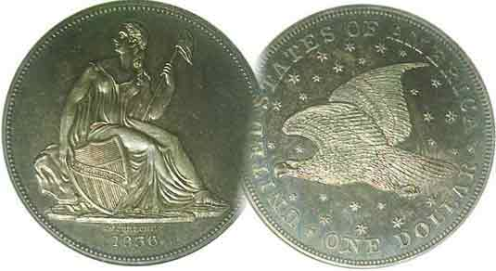
Pres. Willie Simon
V .P. Pat James
Sec. Jim Mullaney
Treas. Chuck Goergen
Sgt. in Arms: Jim Sproull

Programs: Pat James
ANA Representative: Jim Barry
Show Chairman: Steve Kuhl
Photos: Helen Barry
Publicity: Pat James
Newsletter: Arno Safran
E-Mail: arnosafran@comcast.net
Auctioneer: Jim Sproull
Web site: Susie Nulty (see above.)

2014 Club Meeting Schedule
Volume 13, No. 10 the Stephen James CSRA Coin Club, Founded in 2001 October, 2014
Monthly Newsletter
Our next meeting will be held on Thursday, Oct. 2, 2014 at the Aiken Public Library

SCNA annual Convention in Greenville Oct. 24 - 26
Jan. 2 Apr. 3 July 3 Oct. 2
Feb. 6 May 1 Aug. 7 Nov. 7
Mar. 6 June 5 Sept. 4 Dec. 4

SCNA to hold 42nd convention at
TD Convention Center in Greenville
Friday – Sunday Oct. 24 -26, 2014

If you enjoy collecting and are looking for opportunities to add something to your collection this fall, you owe it to yourself to attend the 42nd South Carolina numismatic Association (SCNA) Convention which will be held in Greenville towards the end of the month. Bourse Chairman Tony Chibbaro does a superb job of attracting coin dealers not only from South Carolina but from many neighboring states along with some from far away places. As a result, the collector is more likely to observe a wide variety of numismatic items not seen locally. The SCNA show is held at the height of Autumn each year and has grown from a 75 table event to over 100 in the last three years. There are numerous exhibits by adults and young collectors alike with a special YN meeting to be held on Saturday, Oct. 25.

Greenville is a beautiful city located in the piedmont region of South Carolina not far from the magnificent Blue Ridge mountains and is about a two hour drive from Aiken. There are plenty of fine restaurants and reasonably priced motels near the convention center should you decide to stay overnight. The convention hours are 10:00 AM to 6:00 PM Friday and Saturday and 10:00 AM to 3:00 PM Sunday Both parking and admission is free.
___________________________________________________________________________________________________________________

SJ CSRA CC Celebrates another successful annual Show
On Sept. 6, the SJ CSRA CC held its 14th annual show and despite having conflicts with another SC club, the event was successful in public attendence and to the club financially. We received a lot of help from our members with the set-up, welcoming desk, take down and such services as providing lunch to the members and dealers. Show Chairman Steve Kuhl is to be congratulated on organizing the event with special help from VP Pat James, publicity, President Willie Simon, Treasurer Chuck Goergen, Secretary James Mullaney and Sharon Smoot.
________________________________________________________________________________________________________________________
Collecting the US Coins of 1919: 95 Years Ago
By Arno Safran

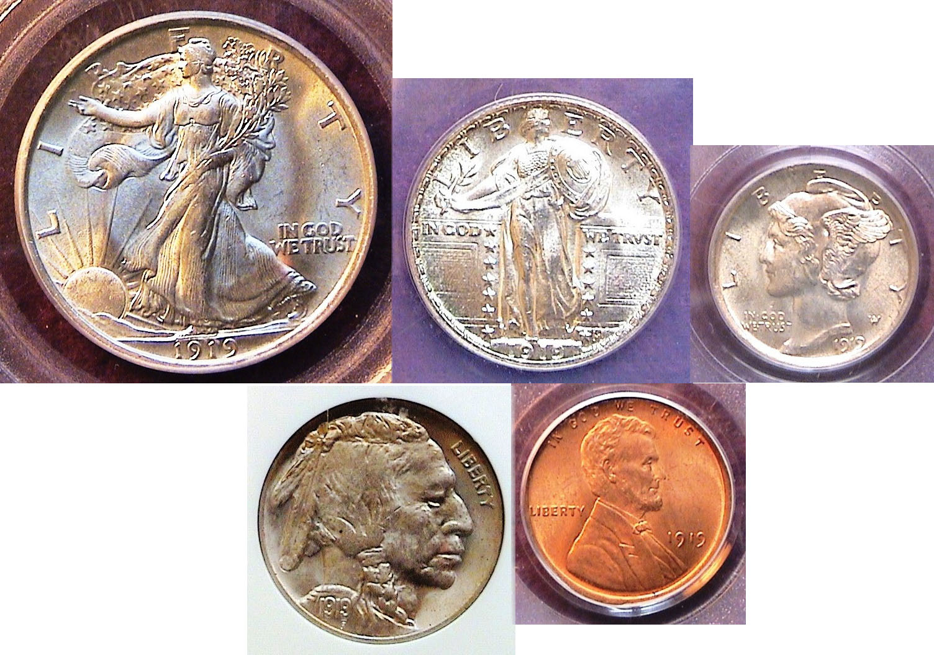

The obverses of a certified 1919 year set
From Left to right: top Walking Liberty half, Standing Liberty quarter,
Mercury dime, Indian Head nickel and Lincoln cent
[Use 3x magnifying glass or enlarge page to 150%]

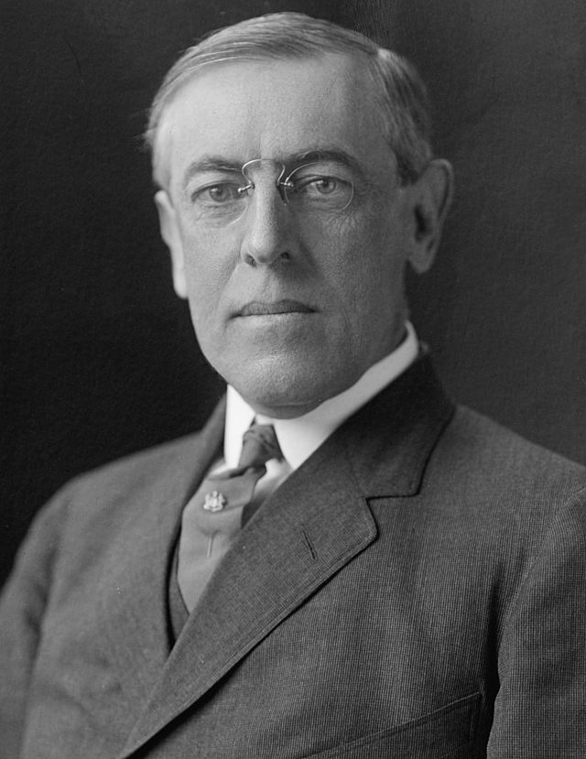
The year 1919 began with President Woodrow Wilson being extolled here in America and` by the victorious nations of Europe following World War I. From late January on the President would be met with one disappointment after another, first from the European leaders’ opposition of Wilson’s 14 points that allowed for a conciliatory position towards Germany and later here at home with the refusal of the US Senate to ratify America’s entrance to the League of Nations, this despite approval by over two-thirds of the American people. In late September, President Wilson suffered a debilitating stroke and was never the same. The US coinage of 1919 reflects more America’s optimism for peaceful relations with other nations than the post war politics of the times. The five denominations struck that year were represented by some of the finest artistic design types the world had ever seen, the superb Walking Liberty half-dollar, Standing Liberty quarter and Mercury dime along with, the Indian Head/ Buffalo nickel referred to as “the most American of coins” and finally the Lincoln cent.
___________________________________________________________________________________________________________________
(Continued on page 2, column 1)
Collecting the US Coins of 1919: 95 Years Ago
(Continued from page 1, column 2)

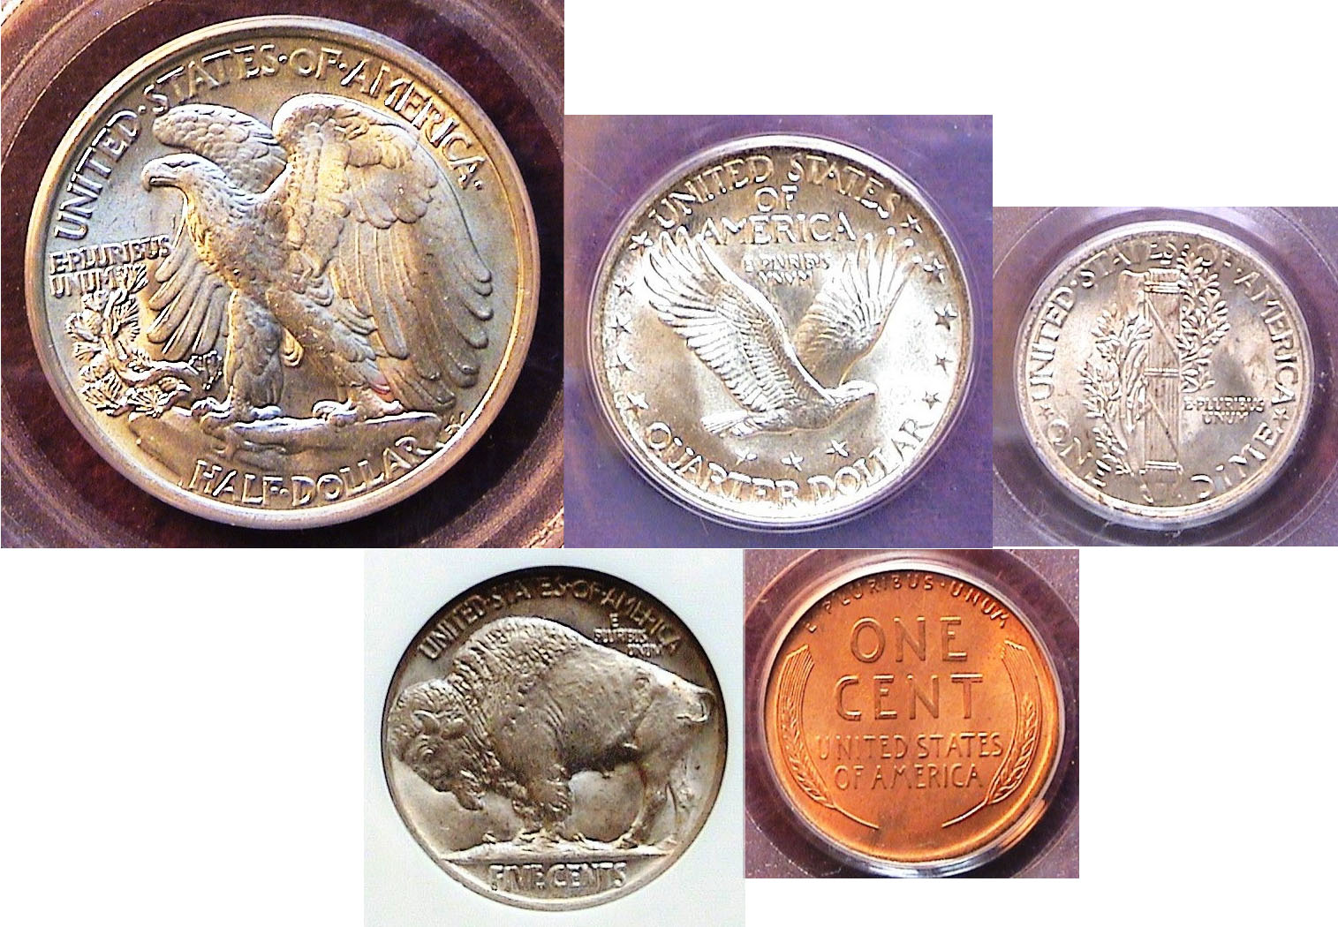

The reverses of a certified 1919 year set
From Left to right: top Walking Liberty half, Standing Liberty quarter,
Mercury dime, Buffalo nickel and Lincoln cent
[Use 3x magnifying glass or enlarge page to 150%]

Due to America’s entry into World War I in 1917, all gold coinage was suspended for three years, 1917, 1918 and 1919. As a result, for those collectors wishing to assemble year sets from this period, only five denominations are required, the cent thru the half-dollar. Of the Philadelphia, Denver and San Francisco mints then in operation, the largest mintages usually came from the Philadelphia facility with occasional exceptions depending on the denomination. In 1919, all but the half dollar received huge mintages at the Philadelphia Mint but despite a mintage of only 962,000 for the 1919-P Walking Liberty half compared with 1.1 million for the Denver and 1.5 million for the San Francisco issues, the 1919-P is the least expensive of the three Mints in all grades.

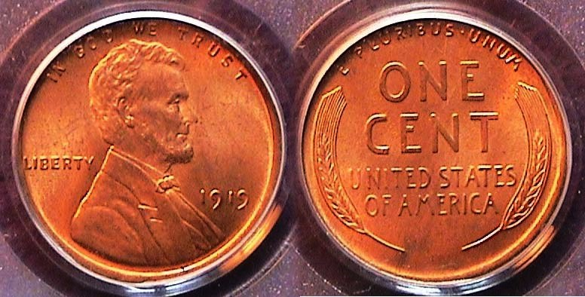

A 1919-P Lincoln cent graded MS-65 Red by PCGS
[Use 3x magnifying glass or enlarge page to 200%]

One would think that the 1919-P Lincoln cent, with a whopping mintage of over 392 million pieces--a record for the denomination that would not be surpassed until 1940--would be one of the most available and least expensive cents to acquire in uncirculated condition. Until recently it was, but with the record number of serious collectors that became attracted to coin collecting since 1999 due to the state quarter release, examples of certified MS-65 RD 1919-P Lincoln cents surface a lot less frequently--even at the major shows--than they once did. For the many years, rolls of 1919-P uncirculated cents have been “cherry picked” by dealers with the result that finding individual high-end MS-64 or 65 Red gems are no longer as plentiful as` they were a quarter of a century ago. The specimen shown above was acquired at the South Carolina Numismatic Association Convention held in Greenville, SC back in October, 2013. In 1919, a cent had the purchasing power of 14 cents.

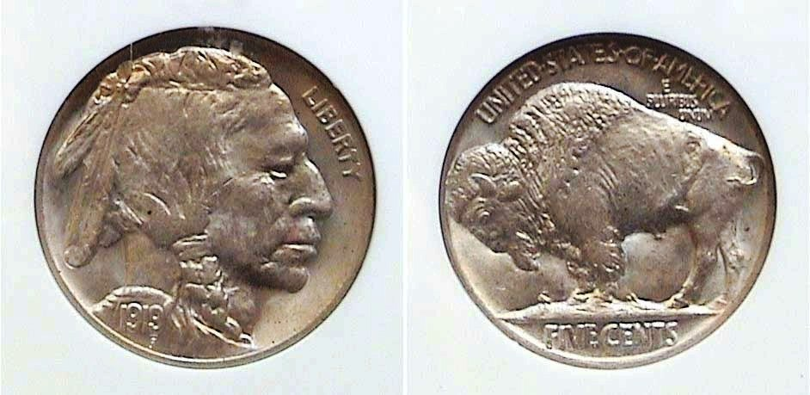

A 1919-P Indian Head/ Buffalo nickel graded MS-64 by NGC
[Use 3x magnifying glass or enlarge page to 200%]

The 5c nickel was the workhorse of the US economy for about 100 years, from the last 35 years of the 19th century thru the first 65 years of the 20th. For almost that length of time, one way carfare for most urban transportation was a nickel as were a number of other items such as a candy bar, a one-scoop ice cream cone, or a Coke or a Pepsi, (examples that immediately come to mind.) In the early years of the 20th Century, before the movies became the new ‘”rage” people would insert a nickel into the nickelodeon to watch the “flicks” (which is probably how the synonym for picture show originated.) Looking through a small double lens of the nickelodeon, viewers would literally see the moving pictures flick by. The 5c nickel coin could buy so many things during the early 20th century that today; most of the branch mint issues of early Buffalo nickels have become extremely scarce and expansive in uncirculated grades. Fortunately for the collector, the large mintages of Buffalo nickels produced at the Philadelphia mint make it still possible to acquire many dates up thru MS-64. With a mintage of well over 60 million, the 1919-P nickel shown above is still moderately priced today.

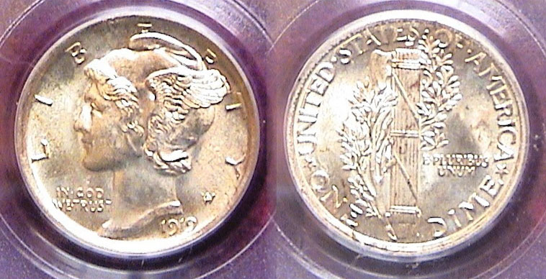

A 1919-P Mercury dime graded MS-64 Full Bands by PCGS
[Use 3x magnifying glass or enlarge page to 200%]

As with the 1919 Buffalo nickel, the 1919-P Mercury dime is considered a common date, even with full bands on the reverse. The reported mintage was 35.7 million as compared with just under 10 million for the 1919-D and 8.5 million for the 1919-S. In the lower grades, (from Good-4 to Fine-12), the prices between the three Mints are still fairly low at no more than several dollars apart. From VF-20 to AU-50 however, the branch mint issues begin to pull away due to their greater scarcity resulting in much higher prices than the 1919-P. At the upper end of the grading scale, (from AU-58 thru MS-65) the price gap between the two branch mint issues and Philadelphia Mint output are enormous leaving the 1919-P as the only moderately priced option for moderate income collector to consider.

In 1919, a dime had the purchasing power of $1.35 today. It was post war inflationary year. A dime could buy one a loaf of bread, two oranges or 3 bananas. Two dimes could get you half a pound of bacon. Three dimes were needed to purchase 2 lbs. of flank steak.
________________________________________________________________________________________________________________
(Continued on page 3, column 1)
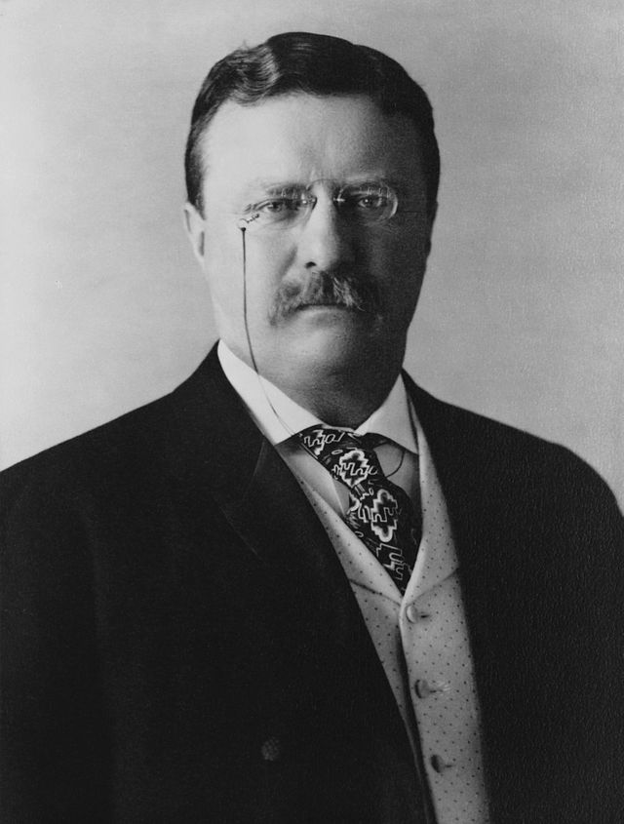
Collecting the US Coins of 1919: 95 Years Ago
(Continued from previous page)

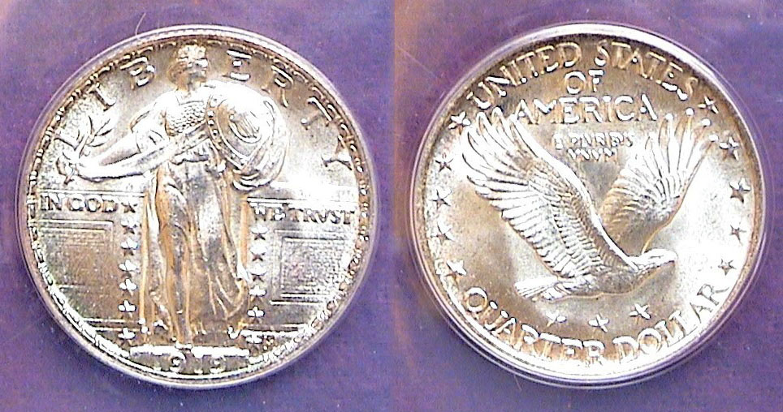

A 1919-P Standing Liberty quarter graded MS-64 by Anacs
[Use 3x magnifying glass or enlarge page to 200%]

Slightly more than 11 million quarters were struck at the Philadelphia Mint in 1919 compared with only 1.9 million produced at the Denver Mint and 1.8 million at the San Francisco facility. These figures all pale when compared with the almost 670 million quarters featuring our national parks produced at the Philadelphia Mint in 2013. As with the cent, nickel and dime, the survival rate for the branch mint quarters have been poor with the result that the higher grade issues are` expensive. This leaves the 1919 P as the only affordable choice because it is a fairly common date. The coin usually boasts a sharp strike in the bargain and is affordable for many collectors up thru MS-64 similar to the example shown above.

In 1919, a quarter had the purchasing power of almost $3.50 today. When I was` a boy, my maternal grandfather used to give me a quarter if I answered his question, “Have you been behaving yourself?“ in the affirmative, With a quick nod in the head I usually received a Washington quarter. I don’t recall ever got a Standing Liberty one except, a few years later, I noticed one in my mother’s large glass jar filled with lots of coins. Gleaming through the jar was this obsolete, piece. It turned out to be a 1920, a fairly common date.

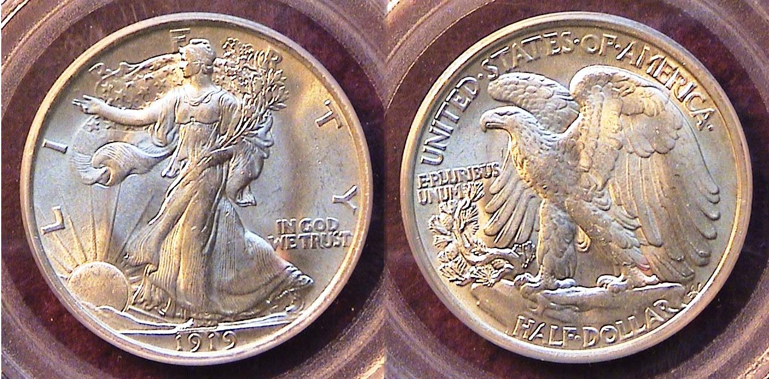

A 1919-P Walking Liberty Half-dollar graded MS-63 by PCGS
[Use 3x magnifying glass or enlarge page to 150%]

The Walking Liberty Half-dollar designed by Adolph A. Weinman is arguably one of our three most beautiful silver coins. In 1919, a half dollar had the purchasing power of $6.75 and it circulated. That year, the Philadelphia Mint actually struck the fewest halves of the three US Mints, only 962 thousand. It would be one of only nine dates from the entire series (1916-1947) with less than a million struck. In 1919, the Denver Mint produced 1,165,000 and the San Francisco Mint, 1,552,000 but despite these slightly higher mintages, uncirculated examples are even scarcer than the low mintage 1919-P and extremely pricey. Even the 1919-P half in MS-63 is expensive. The example shown was acquired at the 2013 BRNA Convention held in Dalton, GA by selling a number of other coins of lesser value.

When Theodore Roosevelt was President (1901-1909) he found our coinage designs rather dull and desired that they reflect a more artistic quality. He asked Augusta Saint-Gaudens, America’s most renowned sculptor at the time to redesign our two highest coinage denominations, of which` the birth of the $20.00 double eagle in 1907 was praised as one of the finest coins in world history. Sadly, Saint-Gaudens died that year but he had plenty of worthy disciples, among them, Bela Lyon Pratt, designer of the $5.00 and $2.50 gold Indian coins (1908) Victor David Brenner, designer of the Lincoln cent, (1909), James` Earle Fraser, designer of the Indian Head/ Buffalo nickel in 1913, Hermon MacNeil, designer of the Standing Liberty Quarter (1916) and Adolph A. Weinman, who created both the Mercury dime and Walking Liberty Half-dollar, (also 1916). With the addition of the Peace dollar designed by Anthony de Francisci in 1921, the era from 1907 thru 1935 came to be known as America’s golden age of coinage.

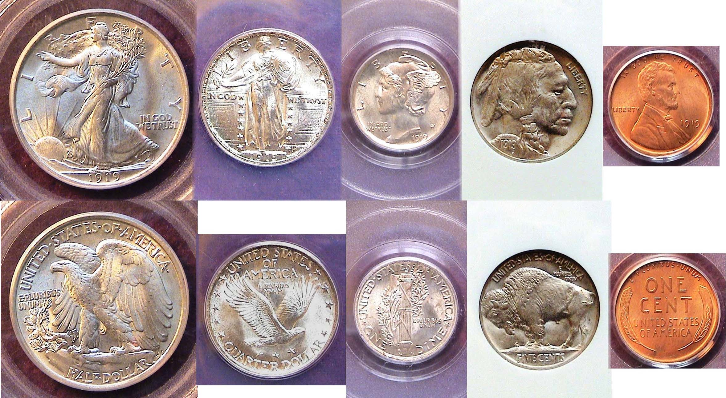

A 1919 certified year set showing the obverses above
the reverses from the half-dollar to the cent
[Use 3x magnifying glass or enlarge page to 150%]

1919 was a year of transition between the Victorian era styles and mores towards a more independent social life. The year provided the transition to the “Roaring Twenties”. Jazz was fast becoming the new musical style that excited a war weary nation. By 1919, rapid transit, with trolley cars, elevated trains and subways were fast replacing the horse and buggy, especially in the larger urban areas. The automobile was becoming a new way of life throughout the nation. An inexpensive car cost $500. Unions were beginning to test their power in the work force with a number of strikes.

In sports, 1919 was the year that Jack Dempsey became heavyweight champion of the world by defeating big Jess Willard in a` 4th Round TKO. The most shocking sports event of the year was the defeat of the favored Chicago White Sox by the Cincinnati Red in the World Series which would be exposed in 1920 as the notorious “Black sox Scandal”. It ended the career of Shoeless Joe Jackson of “Say, it a’int so, Joe” fame, who was considered at the time as great a player of Ty Cobb.
Collecting a US year set of certified uncirculated 1919 coinage was a challenge but extremely rewarding.
_____________________________________________________________________________________________________________________

Club News

President Willie Simon called the Sept. 4 meeting to order at 6:45 PM. Sgt, in Arms Jim Sproull reported on the attendance, guests and upcoming shows. Thanks, Jim. Member J.J. Engel made a motion to waive the reading of the Minutes of the August 7 meeting seconded by m Sharon Smoot, a copy to be placed on file. Treasurer Chuck Goergen reported a Treasury balance of $1,802.87. Thanks, Chuck. Willie asked Bourse Chairman Steve Kuhl to update the members on the upcoming Sept. 6 show. Steve told the members that as of the meeting date, 28 tables had been sold with 18 dealers paid. Steve indicated that he expected the show to produce a net profit in the neighborhood of $500.00. President Simon praised Steve for his efforts as show chairman.

There were two Show & Tell exhibitors. Chuck Goergen displayed an Estonian coin he got on his cruise. The coin was made with a sledge hammer. J. J. Engel shared a group of admission tickets to the 1893 World Columbian Exposition related to the previous month’s program by Garry Naples which covered the elongated coins of 1893 produced at the same event. These were followed by a PowerPoint Program by Arno Safran on “US Transitional date coins of the 18th & 19th Centuries” Due to the unavailability of any speaker for the October 2 meeting, Arno said he would do a program on the “US Coins of 1860 and the Election of Abraham Lincoln”.

The prizewinners at the Sept. 4 meeting were Dick Lasure who won the door prize, a Proof 1957 Franklin half-dollar and Pat James who won the 50/50 – $23.00. Congratulations, Dick and Pat. Our next meeting will be Thursday, Oct. 2. Please consider bringing in numismatic items for Show & Tell and to sell at the auction.
___________________________________________________________________________________________________________________________
(The editor wishes to acknowledge and thank VP Pat James for supplying much of the information relative to the Sept. 4 meeting.)
_____________________________________________________________________________________________________________________________

Coin of the Month

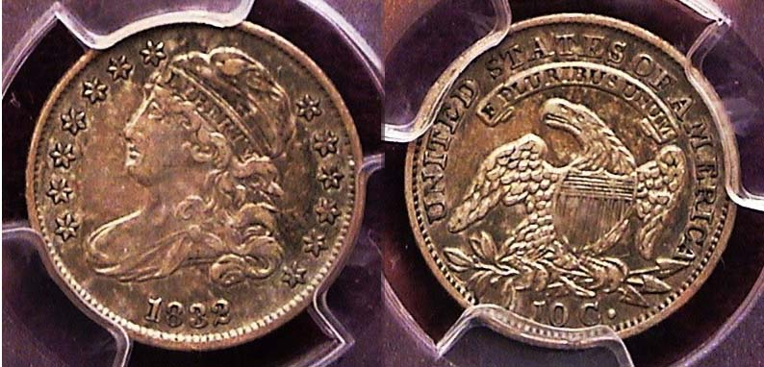

An 1832 Capped Bust dime graded XF-45 by PCGS
Magnify page to 150% or click Maximize square on PDF doc to view details.]

Before 1837, all US silver coins bore a version of the eagle on the reverse. This included the dime and half dime. The Capped Bust dime type was produced from 1809 thru 1837 but after 1828 dimes were struck in a close collar which allowed for the exact sizing of reeded edge coins, recently reduced from 18.8 mm to 18.5 mm. The 1832 issue had a reported mintage of 522,500 and while half a million pales compared with the number of clad dimes being struck today, the date is not considered scarce, let alone rare. One of the reasons for this is due to the heavy circulation of the Latin American Spanish Real which was valued at 12½¢. A collector can acquire an attractive piece grading Fine-12 to XF-45 at a moderate price.
___________________________________________________________________________________________________________________________

Kindly Patronize Our Advertisers

