The Stephen James
CSRA Coin Club of Aiken
P.O. Box 11
New Ellenton, SC 29809
Web site: www.sjcsracc.org
The SJ CSRA CC of Aiken, SC meets on the 1st Thursday of the month at the Aiken Public Library

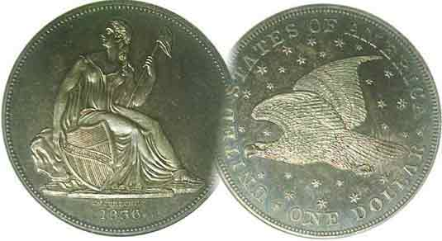
Pres. J.J. Engel
V .P. Pat James
Sec. Jim Mullaney
Treas. Chuck Goergen
Sgt. in Arms: Jim Sproull

Programs: Pat James
ANA Rep.: Glenn Sanders
Show Chair: Board members
Photos: Steve Kuhl
Publicity: Pat James
Newsletter: Arno Safran
E-Mail: arnosafran@comcast.net
Auctioneer: Jim Sproull
Web site: Susie Nulty (see above.)

Our next “Zoom” meeting will be held on Thursday, Oct. 1 starting at 6:45 PM
rather than at the Aiken Public Library which is closed due to the Coronavirus Pandemic

2020 Club “Zoom” Meeting Schedule
Volume 19, No. 10 the Stephen James CSRA Coin Club, Founded in 2001 October, 2020
Monthly Newsletter
The US Coinage of 1840 had lots of varieties
Jan. 2 Apr. 2 July 2 Oct. 1
Feb. 6 May 7 Aug. 6 Nov. 5
Mar. 5 June 4 Sept. 3 Dec. 3

Our smallest denomination Reawakened

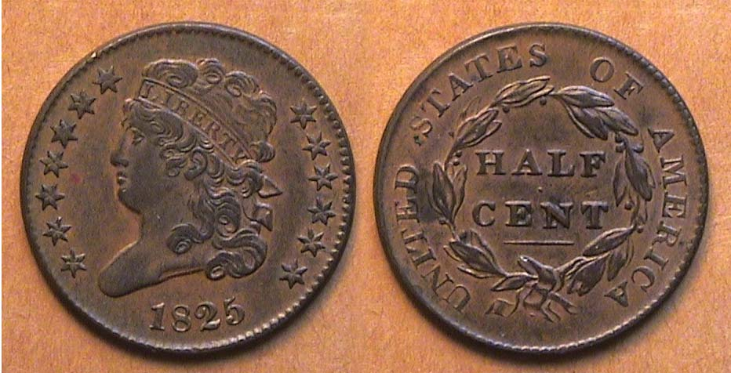

An 1825 Classic Head half, C2, R1 grading XF-40
[Enlarge page to fill monitor screen to view details.]

Unlike the Classic Head large cent, which was struck between 1808 and 1814 in every year of the short run series, the Classic head version of the half cent series had a long and uneven mintage. The coin was struck between 1809 and 1836 but not in every year. In fact there were numerous gaps when none were produced at all. Due to the Latin American Real which was a silver coin slightly larger than our early dismes worth 12½¢, the half-cent was useful in making change. The coin was also required because there were a number of items that were priced at 2½¢ such as books, so the small denomination could be practical.
The Classic Head type was struck erratically; from 1809 thru 1811; then suspended for fourteen year when it reappeared in 1825, supposedly due to the needs of Baltimore businessmen. It was struck in 1825 & ’26, 1828 &’29, again in 1831 but with few known, mostly proofs, and finally from 1832 thru 1835 in larger mintages before the type was struck for the last time with a tiny number of proof-only issues in 1836.

The 1811, with a mintage of 63,140 is regarded as the key date of the series but the 1825 shown above, with a mintage of just 63,000--actually 140 less--is considered a common date and available at a modest price in the grade shown. That coin was acquired “raw” before certification by the author away back in 1985 from a dealer who owned a small Coin Shoppe in Newtown, PA, the cost, just $40.00. Today it retails for $200.
______________________________________________________________________________________________________________________
Collecting the US coins of 1840 (excluding gold)
(180 years ago) By Arno Safran

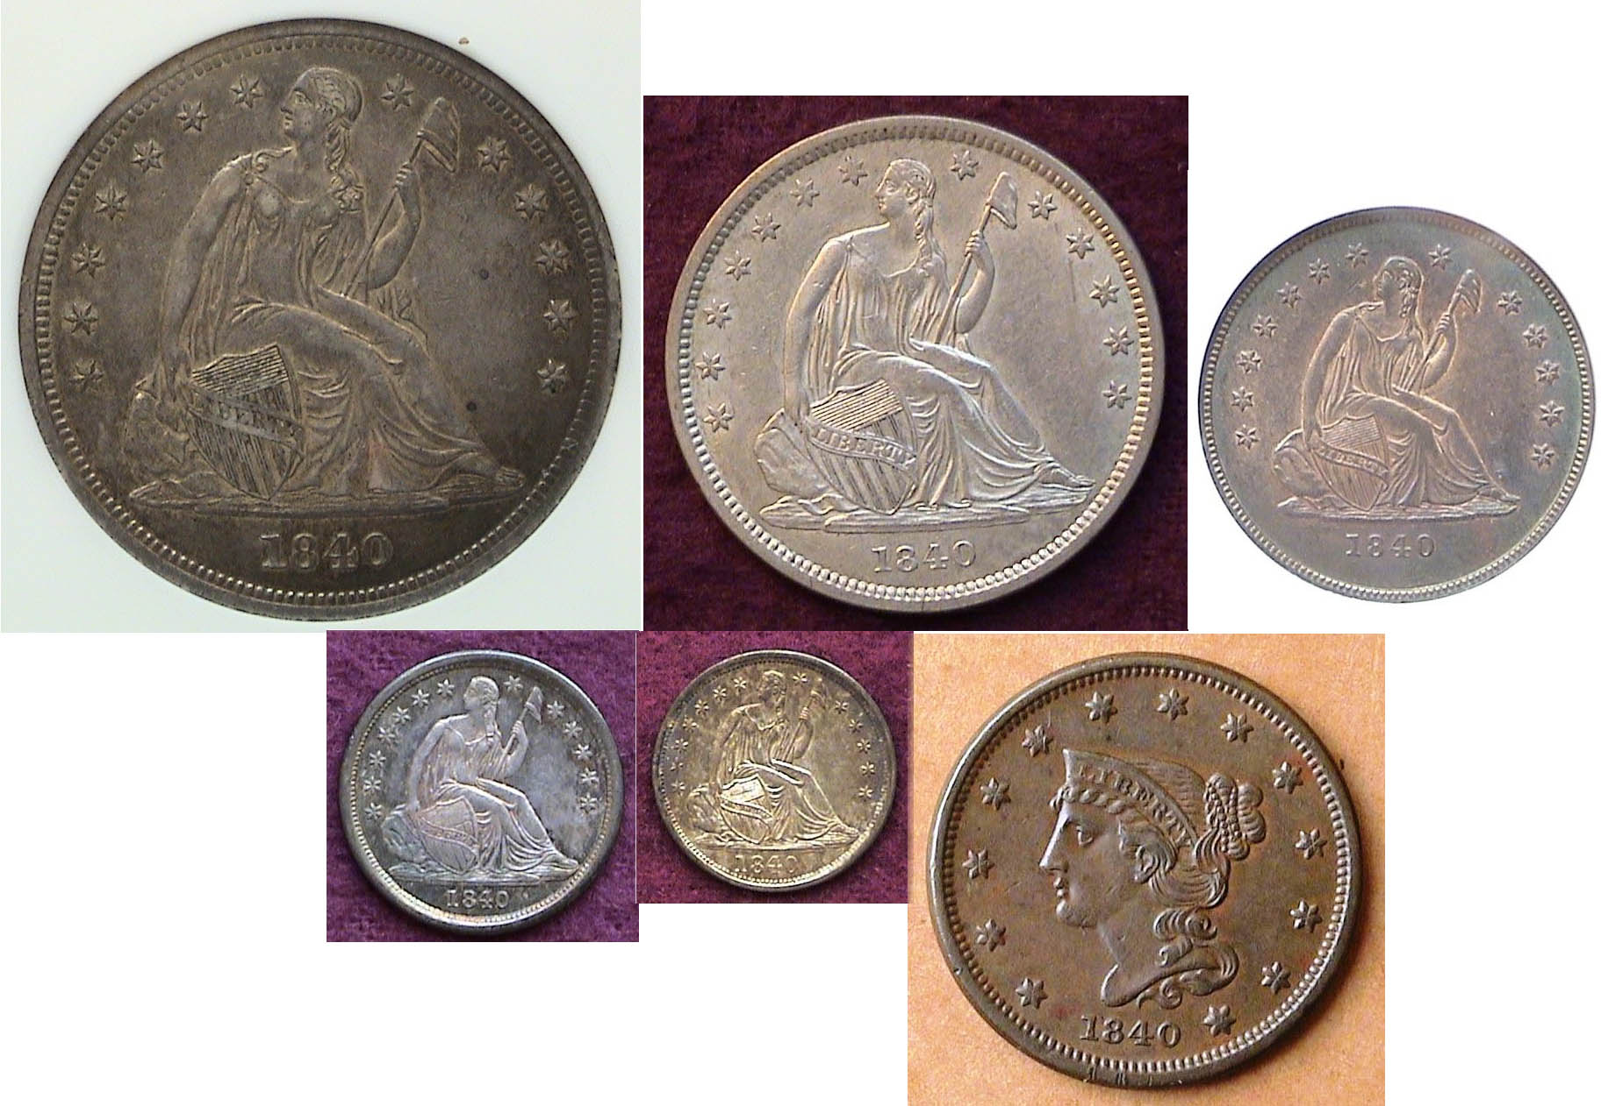

The obverses of the US Coins of 1840 (excluding gold)
$1.00, 50c, 25c over dime, half-dime and large cent
[Enlarge page to fill monitor screen to view details.]

1840 is regarded as a significant year in United States numismatic history because after 3½ years of revising our coinage by our third Chief Engraver, Christian Gobrecht, the design type of our Liberty Seated silver coinage was finally completed--although in the opinion of many numismatists--artistically compromised from Gobrecht’s original 1836 dollar. From then through the end of the Liberty Seated run in 1891, the central Liberty Seated figure remained unchanged. Many of the alterations leading up to this were subtle and probably went unnoticed by the public. These included the no drapery change-over to with drapery under Miss Liberty’s gown--where her arm is holding the pole with the Liberty Cap atop--, also, the slanted shield being raised to a vertical position on both the half-dime and dime denominations. Regarding the cent, Gobrecht had been making subtle changes since 1835, continuing through the end of the decade when the Petite Head version of cent first appeared. It would be struck in that form from 1840 thru 1843.
_________________________________________________________________________________________________________________________________(Continued on page 2, column 1)
Collecting the US coins of 1840 (excluding gold)
(180 years ago)
(continued from page 1, column 2)

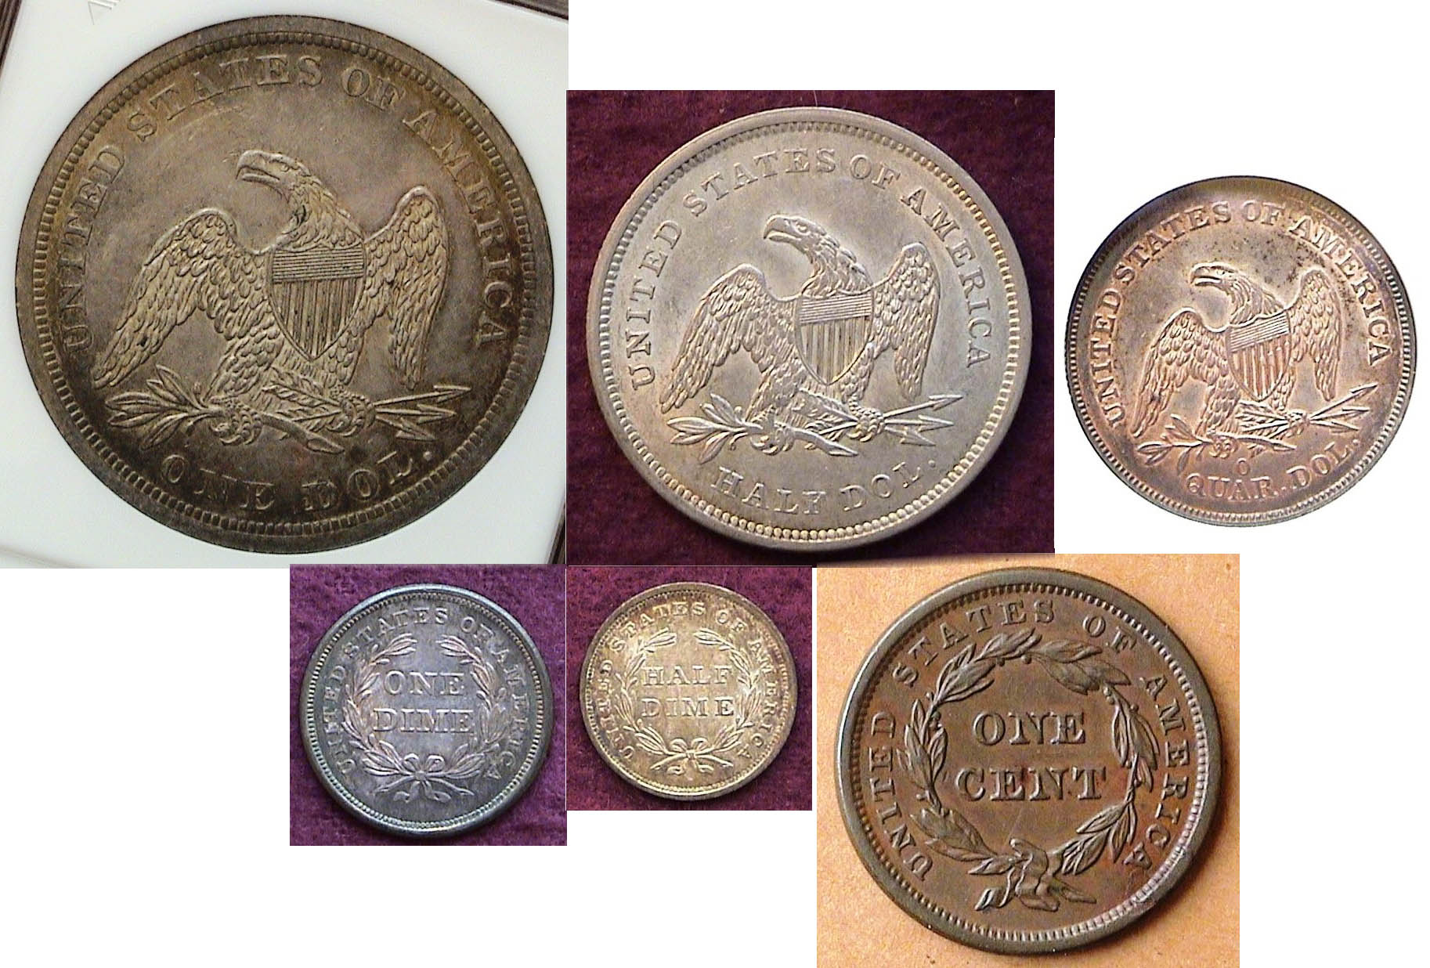
The reverses of the US Coins of 1840 (excluding gold)
$1.00, 50c, 25c over dime, half-dime and large cent
[Enlarge page to fill monitor screen to view details.]

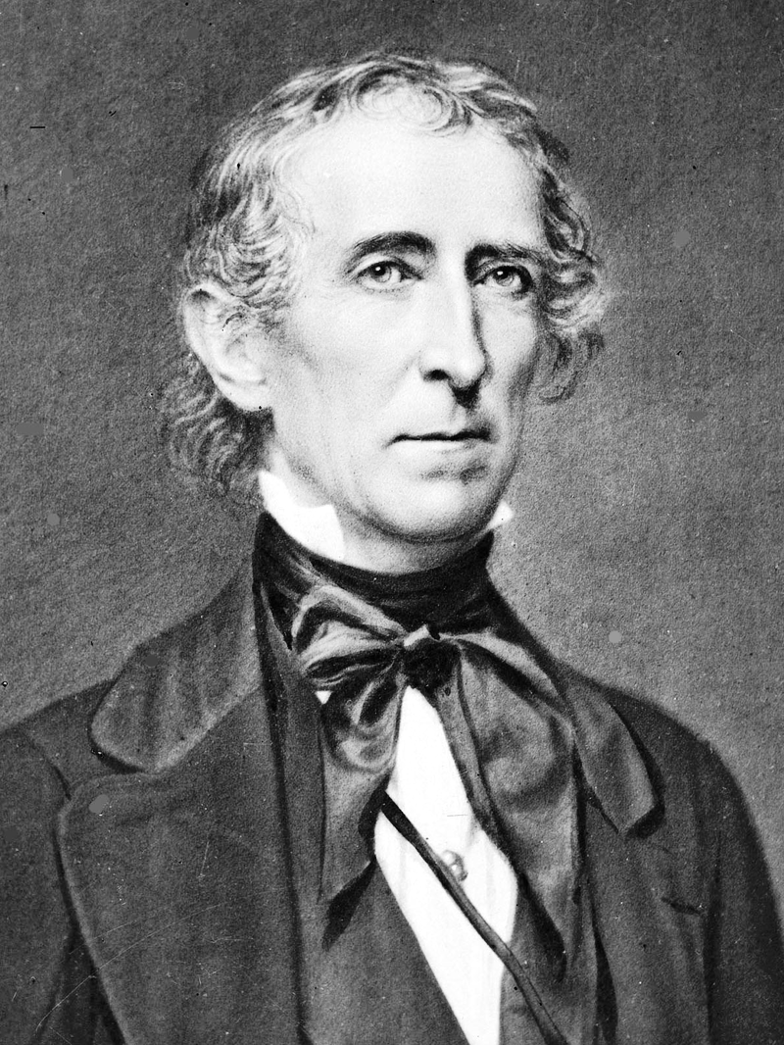
Until March 4, 1840, Martin Van Buren was serving as our eighth president but due to second greatest depression in U.S. history known as the “Panic of 1837” (which actually didn’t end until 1844), Van Buren was defeated by William Henry Harrison. As a result of Harrison’s long inauguration speech given during a cold damp day outdoors on March 4, 2020, he caught pneumonia and died a month later to be replaced by V.P. John Tyler who was inaugurated as our tenth president on April 4.
John Tyler, 10th President
From an early photograph

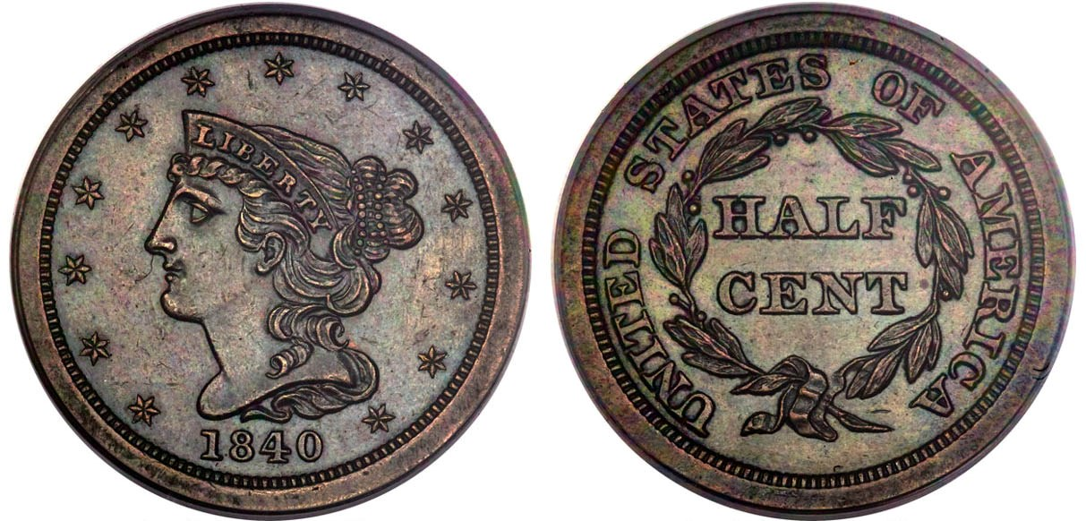

An 1840 original Proof half-cent graded MS-63 by PCGS
view details.] [Enlarge page to fill monitor screen to

After 1835, no half-cents were coined for circulation until 1849 when it reappeared with the Braided Hair Mature head design. Before 1849 however, a small number of proof-only specimens were produced from 1840 thru 1848. The 1840 half-cent proof piece shown above is one such example of that type. Only 18 are known which is why this particular coin sold for $7,200 at a Heritage auction in Sept. 2019. It used to reside in the Jules Reiver collection, an outstanding numismatist from Delaware that the author once knew. The problem with half–cent proofs made from 1840 thru 1843 is that during those years Chief Mint Director Christian Gobrecht’s Mature Head design-type didn’t yet exist until it replaced the Petite Head design on the large cent in 1843, so it is now believed that the first three dates of the proof-only ½¢ series must have been back-dated. However, since an 1840 half-cent exists, it can be considered part of the coinage of 1840.
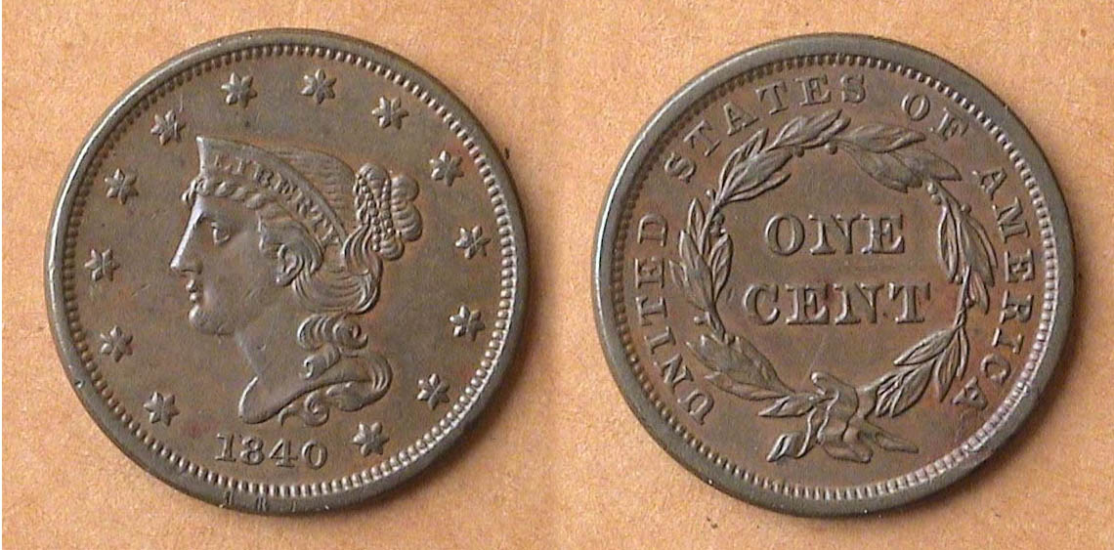

An 1840 Braided Hair large cent, N-1, R2 small date graded XF-40
[Enlarge page to fill monitor screen to view details.]

The Coronet large cent, sometimes referred to as the “Matron Head” was first coined in December, 1815 but with the 1816 date and believed to be the brainchild of either John Reich--who left the Mint in 1817--or our first Chief engraver, Robert Scot. who remained active until his death in 1823. At the time, the Coronet large cent had a diameter of 28 to 29 mm. When the close color device was first attached to the minting press in 1828 to assure each denomination would have its own specific diameter, it was applied to the large cent in 1835 when its diameter was reduced to 27.5. By then, Christian Gobrecht--as Asst. to Chief Engraver William Kneass--was tinkering with improving the design of the Coronet Cent. In 1839, he came up with five different varieties with the final one known as the Petite head which carried over into the 1840 thru 1843 large cents, now referred to as the Braided Hair-Petite head type.

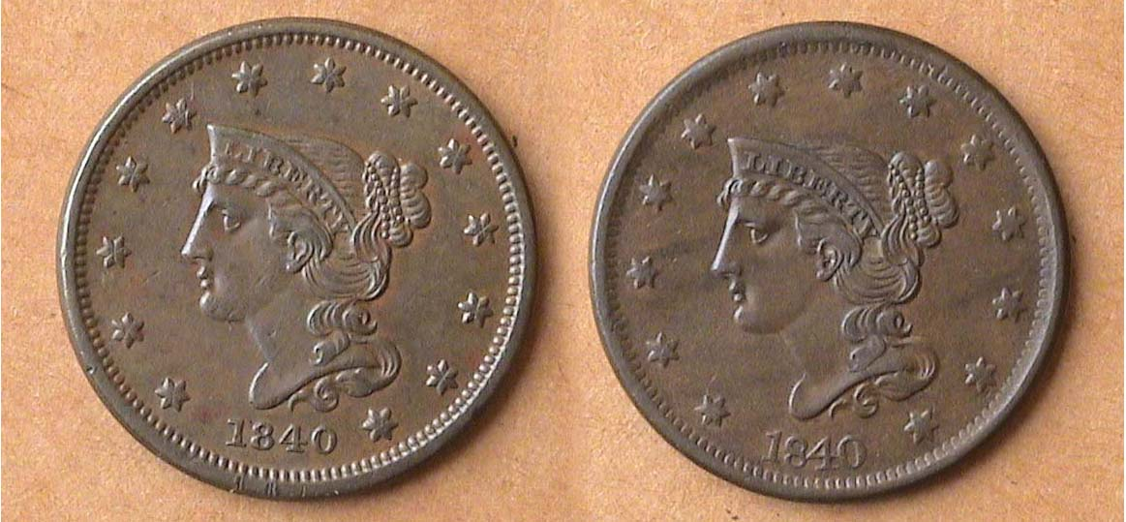

The obverses of both the small and large date versions
of the 1840 large cent
[Enlarge page to fill monitor screen to view details.]

In 1840, the reported mintage of large cents were plentiful at 2,462,000, although nowhere near the record set in 1838 when 6.3 million were reported to have been struck. The 1840 large cent was coined with a small date and a large date with both varieties considered equally common and affordable in mid circulated grades similar to the examples shown.
In 1840, a cent had the purchasing power of 31¢.

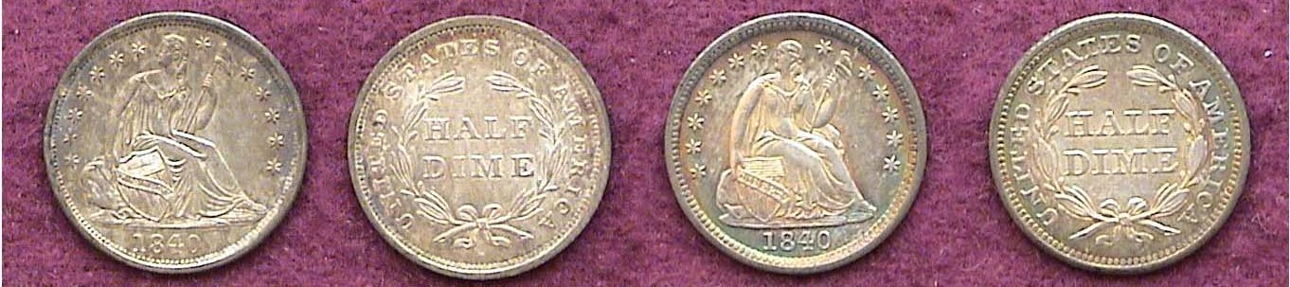

An 1840 Liberty Seated half-dimes with no drapery and with drapery [Enlarge page to fill monitor screen to view details.}

This was a period in our coinage history when Gobrecht was asked to make a number of minor changes in the Liberty Seated designs, thereby bringing about numerous transitional date sub-types for collectors to assemble in later years. In 1840, on both the half-dime and dime, drapery was added in-between Miss liberty’s gown and below her elbow. The large rock on which she us seated was reduced in size and the shield was changed from a slanted position to an upright one.
___________________________________________________________________________________________________________
(Continued on page 3, column 1)
Collecting the US coins of 1840 (excluding gold)
(Continued from the previous page )

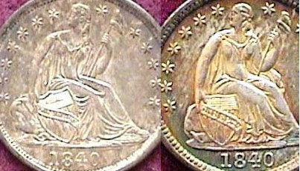

An enlargement showing the details
of the no drapery and with drapery half-dimes

From the enlargement of the two 1840 half-dime sub-types shown directly above, the reader can better observe the areas of changes Gobrecht made. The more common no drapery/ slanted shied specimen on the left was certified MS-61 while the scarcer with drapery upright shield variety was graded lower at AU-53. The enlargements of the obverses also points out the subtly in the grading of these coins. Despite the fact that the 1840 with drapery appears brighter and more colorful than the 1840 with no drapery, one will observe wear on the leg nearest the shield down to the knee cap where there is no sign of wear in the same area on the coin on the left. Today, the no drapery specimen might grade AU-55. The mintage for the 1840 no drapery half-dime was 1,034,100 while the 1840 with drapery had a mintage of just 310,085 Both versions of the 1840-O (New Orleans) had proportionately lower mintages than the Philadelphia mint output.
In 1840, a half-dime had the purchasing power of $1.53.

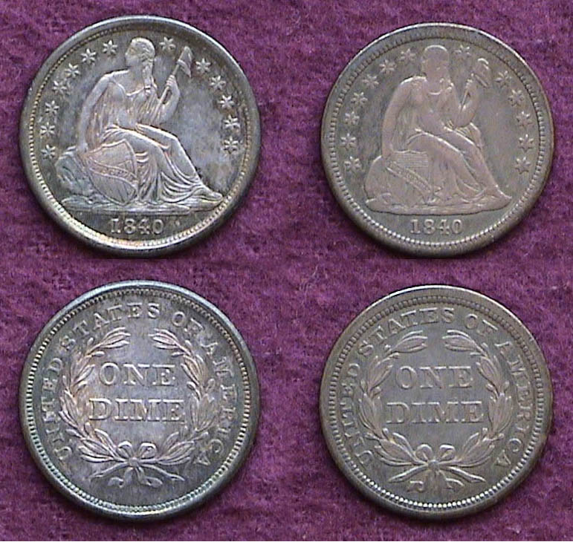

The 1840 dimes with no drapery (Left) and with drapery (Right)
[Enlarge page to fill monitor screen to view the details/]

In 1840, 981,500 no drapery dimes were struck at the Philadelphia Mint compared with 1,175,000 at New Orleans yet the Philadelphia issue is far less expensive across the grading spectrum. The 1840-P dimes with drapery had a far lower mintages of just 377,500 with none of that sub-type struck at the New Orleans Mint that year. Both these coins were acquired “raw” away back in 1994 when they were far less costly than they are now. The two examples were sent out for certification in 2013 with the more common no drapery sub-type graded MS-62 and the low mintage with drapery, XF-45. During the more than a quarter of a century, the value of the no drapery has quadrupled in value while the scarcer if lower graded with drapery sub type having doubled in value.
In 1840, a dime had the purchasing power of $3.05.
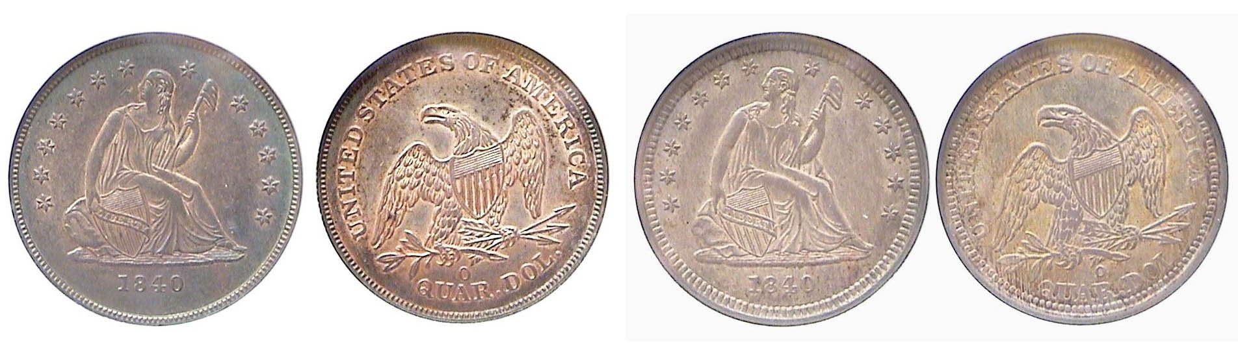
The 1840 no drapery and with drapery Liberty Seated quarters
Both were certified and graded AU-58 by NGC when AU-58’s
looked like MS-63’s with a tiny bit of “rub”.
[Enlarge page to fill monitor screen to view the details/]

In 1840, the Liberty Seated quarter with no drapery on Miss Liberty’s gown were struck only at the New Orleans Mint with a mintage of 382.200 while those with drapery that were coined later in the year--this time at both mints--were coined in even lower numbers; 188,129 at Philadelphian and just 43,000 at the New Orleans facility. Despite the lower mintages, neither sub-type are considered scarce, let alone rare today.

In the case of the 1840 quarters, the alterations appear to be a little more noticeable than on the half-dime and dime due to the larger size of the coin, however, the shield remains slanted.
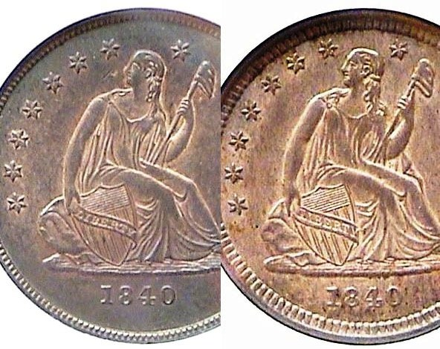
Enlarged details showing the no drapery (at left) and the
with drapery at right of the two 1840 Liberty Seated quarters

One can also observe the slight amount of flatness (rub) on the upper portion of Miss Liberty’s legs which are why both examples were certified AU-58 and not uncirculated..

During the period leading up to 1840, Mint Director, Robert Maskell Patterson brought in English engraver, Robert Ball Hughes to craft subtle changes to Gobrecht’s original obverse design in order to make them more durable during the coin’s striking process. Ball flattened out Miss Liberty’s head and torso which resulted in a less attractive rendition of the Seated Liberty figure, but functionally, when it came to the production of the obverses on the quarters and especially on the coining of the dollar, the strikes were successful. The only Liberty Seated denomination that retained Gobrecht’s original obverse design was the half-dollar. The original reverses on the 1836 thru 1839 dollars featured a soaring Flying eagle created by artist Titian Peale which Gobrecht originally chose to be used to replace Reich’s spread eagle but that too failed when it came to striking which is why the spread eagle was retained

In 1840, a quarter had the purchasing power of $7.63.
_________________________________________________________________________________________________________________-
(Continued on page 4)
Collecting the US coins of 1840 (excluding gold)
(Continued from the previous page )

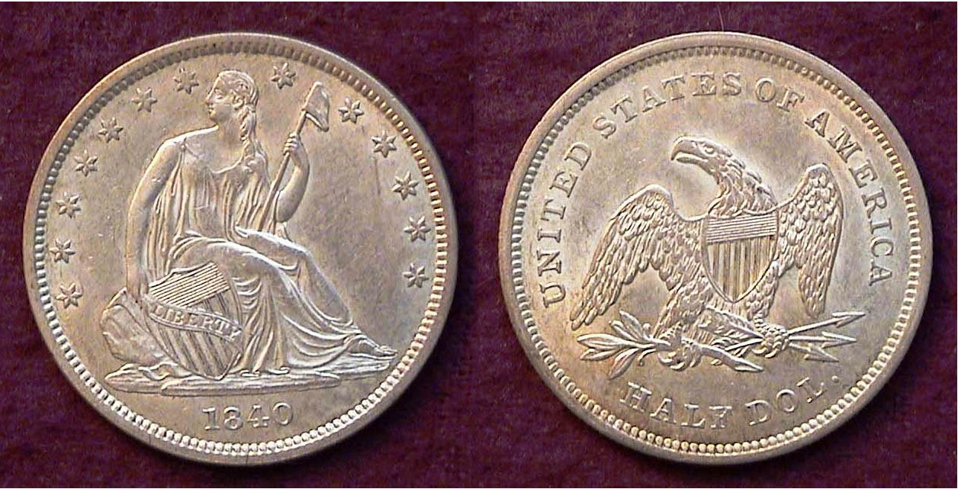

An 1840 Lib. Std. half-dollar WB-101, R3- certified AU-58
[Enlarge page to fill monitor screen to view the details]

This lovely coin was acquired at a Middle Atlantic Numismatic Association Convention held in Cherry Hill, NJ back in October, 1996. It was certified AU-58 when similarly graded coins of that period looked closer to an MS-63 in terms of eye appeal with just a touch of wear. If the reader magnifies the page even slightly, you will see some slight flatness along the upper leg of Miss liberty on the obverse of the coin. Otherwise the coin appears well struck with decent surfaces.
Despite a large mintage of 1,435,008, the coin is considered common only in the lower circulated grades but is much scarcer grading XF or higher according to Randy Wiley and Bill Bugert, authors of The Complete Guide to Liberty Seated Half-Dollars published in 1993. The author already owned the book when he attended the convention three years later which is why most seasoned numismatists advise the burgeoning collector to “Buy the book before you buy the coin”

The curious New Orleans Mint 1840 Lib. Std. half-dollar
Once attributed to the Philadelphia Mint

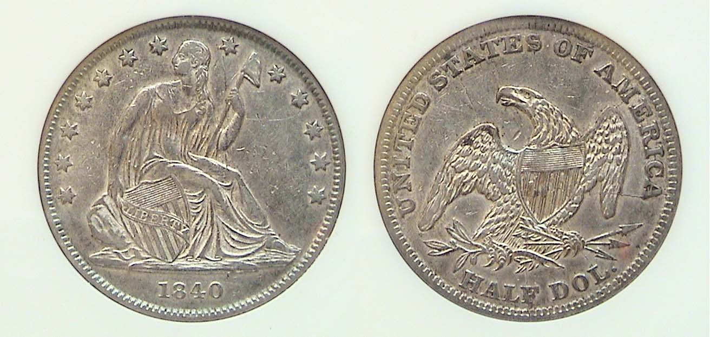

An 1840 (O) Liberty Seated Half-dollar WB-101, R5
graded XF-45, by Anacs

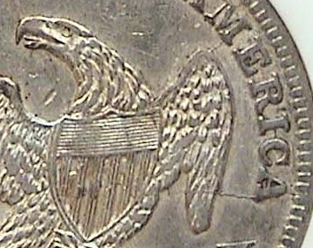
For many years the coin directly above was thought to be a product of the Philadelphia Mint because it lacked the “O” mintmark on the reverse but today it is considered an interesting anomaly and a variety that is coveted by many Liberty Seated coin collectors. It is also known for its numerous die cracks, one obvious one seen on the reverse from the second A in AMERCA going strait into the eagle’s wing and a smaller one from the right side of M in America to the top right wing of the eagle. Enlarge to see die cracks

In 1840, a half-dollar had the purchasing power of $15.30
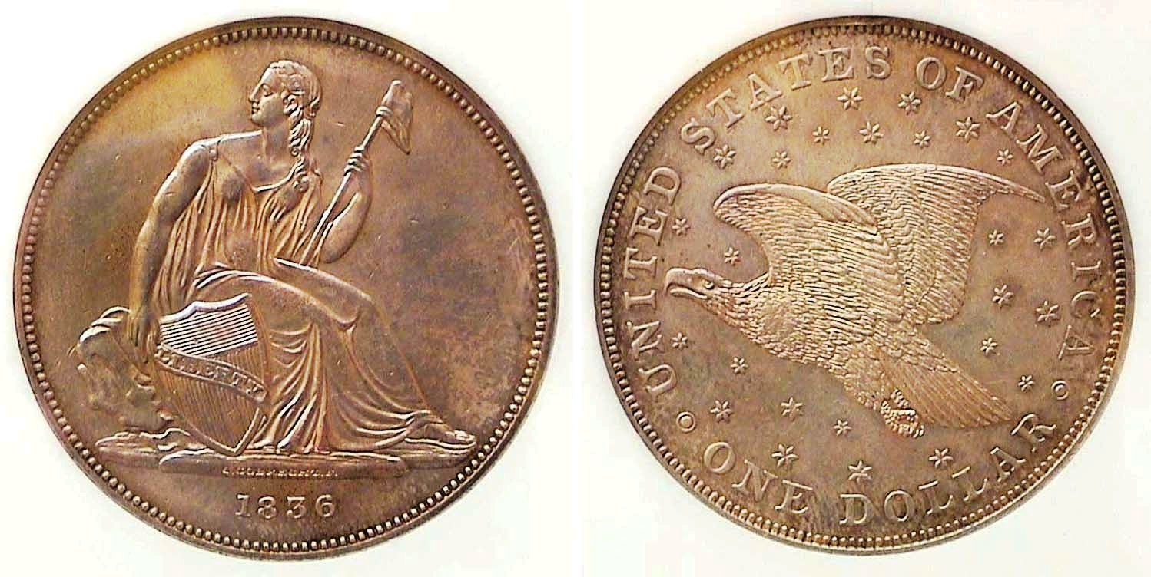
The original 1836 Gobrecht $1.00 graded AU-58 by NGC
[Enlarge page to fill monitor screen to view the details]

After four years of trying to improve the striking capability of the original 1836 Gobrecht dollar shown above, Mint Director Patterson decided to approve Gobrecht’s assistant, Robert Ball Hughes’ revisions.
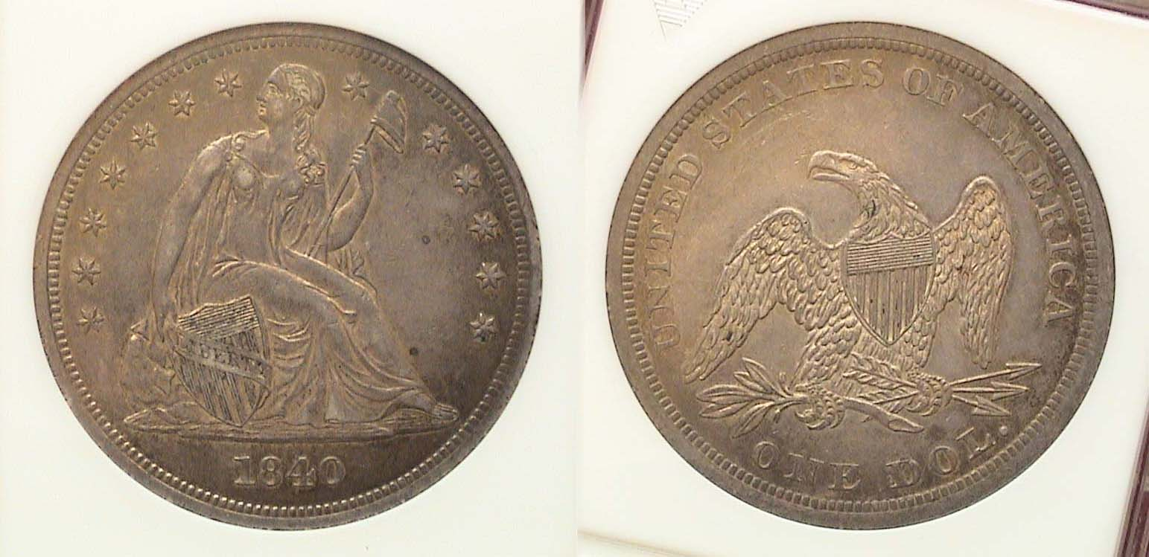

An 1840 Liberty Seated $1.00 graded AU-50 by Anacs
[Enlarge page to fill monitor screen to view the details]

Admittedly, the 1840 specimen is three grades lower than the original Gobrecht example shown above but Hughes’ replacement leaves much to be desired aesthetically speaking. Gobrecht’s engraved obverse--which is a work of art--was originally based on renowned painter Thomas Sully’s sketch and is far more aesthetically appealing than Hughes’ bland and flatter looking portrait of Miss Liberty, but in that altered form, the coin was able to be struck without problems, which is why Director Patterson chose it. Worse, still, was Patterson’s decision to revert back to Reich’s spread eagle design on the reverse which cannot begin to compare with the beauty of artist Titian Peale’s soaring eagle concept--which Gobrecht had chosen. There were also examples struck with the eagle in a horizontal position on some early attempts between 1836 and ’39, which were later used by 5th Chief engraver James Barton Longacre for the obverses of the 1856. ’57 and ‘58 Flying eagle cents, in which there were no problems with the striking.

Returning to the 1840 Liberty Seated dollar, shown directly above, it was acquired by the author back in March, 1997 at a small commercial show and at a much lower price then the date receives today but even then, an AU-58 or MS-63 specimen was well beyond the author’s discretionary income.

In 1840, a dollar had the purchasing power of $30.50.

The three gold coins of 1840 included the $2.50 quarter eagle, $5.00 half-eagle and $10.00 eagle all with Gobrecht’s Liberty Head obverse and the original spread eagle with wings pointed upward reverse by Reich going back to 1807. The mintages at all mints were are fairly low and scarce to rare today.
________________________________________________________________________________________________________________
Collecting the US coins of 1840 (excluding gold)
(Continued from the previous page )

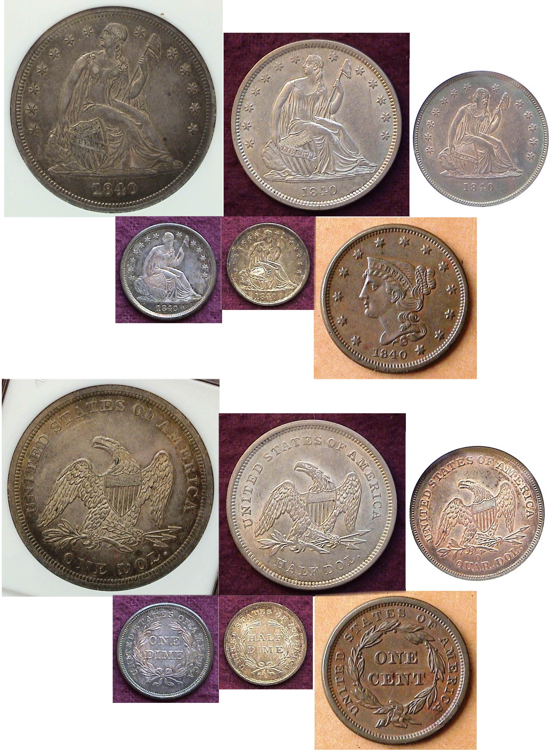
A basic set of the US Coins of 1840
(Excluding Gold)

_____________________________________________________________________

Message from Club President J.J. Engel

The Stephen James CSRA Coin Club would like to welcome two new members to our group, Claude O’Donovan and his wife. I would also like to remind our members that we will be having a pre-Christmas Holliday dinner and the Columbus Club meeting house (same as last year) off Spaulding Road. The cost will be $30.00. The choices are either Steak (grilled to your preference) or chicken-crab cake. The meal also includes a salad, potatoes and vegetables.
Please let the club know no later than the November 5, 2020 “Zoom” meeting if you plan to attend and if so, your choice of meal preference as I have to let the preparers know by November 10 how many people will be attending.
___________________________________________________________________________________________
STEPHEN JAMES CSRA COIN CLUB
Regular Meeting Thursday,
September 3, 2020 VIA Zoom

The Club held an August meeting via a Zoom session. President J.J. Engel called the regular meeting of the club to order at 6:46 p.m. There were 15 members who joined the Zoom session. Garry Naples won the members’ attendance door prize, a 2020 Silver Eagle, and Pat James will mail him the coin.

A motion was made by Jim Sproull, seconded by John Kolmar, and passed, to dispense with the reading of the August 2020 meeting minutes. A copy of the minutes will be on file with the other club records, and a copy will appear in the club newsletter.

Treasurer Chuck Goergen reported that the bank showed the Club’s bank balance was $1,379.99. Chuck noted that Dealer Joe Thompson will be sent a $75 refund for the table he reserved for the Coin Show. Chuck also said he had a 2021 Red Book for the club to donate to the Library along with Tony Chibbaro’s new edition of his volume on SC tokens the Club bought earlier in the year for $85.

Pat James said Tony Chibbaro had sent his book to her and that she would deliver it to the Library when it re-opened for business, and that she could also take her new copy of the 2021 Red Book when she made the trip to the Library, with Chuck providing the Club’s copy to her sometime later. So far, there is no change with the situation regarding the Aiken Library or finding a new venue for coin club meetings; thus, meetings will continue on the internet.

President Engel confirmed that he had reserved the Columbus Hall for the Club’s holiday party on Thursday, December 3, 2020, with a menu choice of steak or chicken and crab-cake. The prices for dinner should not increase much from last year. He also reported that the Board had not determined what subsidy the Club could make for the members’ dinners. In the past, revenue from the coin shows funded the dinner subsidies, and the Board wanted to consider what could reasonably be done this year in view of the coin show being cancelled and loss of membership dues revenue.

President Engel recognized Editor Arno Safran for the Club’s Newsletter winning 3rd Place nationally by the ANA. Steve Kuhl, Editor or the SCNA’s SCanner quarterly, was also recognized and congratulated on that publication placing first in the ANA Electronic on-line Division. J.J. reported that he had been asked for two Membership applications, which was welcome news in light of the reduced club membership during the pandemic and no club meetings in April and May.

___________________________________________________________________________________________________-

(Club Minutes continued on page 6, column 1)
Minutes from the September 3, “Zoom” Meeting
(Continued from the previous page)

Show & Tells:
There were several Show & Tell Presentations.

1) Tim Stirrup shared two Buffalo nickels that he had come across in an antique shop in Columbia, SC.

2) Chuck Goergen shared a Roman Republic C. Allius Bala, 92 BC, dime-sized, silver Denarius, weighing just less than 4 grams. On the obverse was the head of Diana, with BALA behind it, and the reverse depicted Diana driving galloping stags and holding spear, reins and torch, with a scorpion below the stags, C.ALLI in exergue, all within a laurel wreath. It was a rare find for him to add to his collection.
​
3) Jim Mullaney, as a follow up to his suggested Monthly mini-grading program on just a couple of coins, invited the members to examine the wear on the headband and wings and grade three slabbed Barber quarters. President Engel had no problem quickly determining the 1907 and 1895 quarters were both VF, and the 1892-O coin was an XF. Pat James said she would have graded the 1907 a VF+, since it had a little less wear and more detail than the 1895 quarter, and she proved to be right as it was revealed to be a VF-35 and the 1895 had a lower VF-20 grade.

The Program:
Roger Seitz presented an excellent power-point program on Austrian coins, focusing on the Maria Theresa Thaler. He first became interested in the silver bullion coin some years ago when he visited a coin shop while living in Vienna, Austria. Roger explained that Empress Maria Theresa succeeded her father, Charles VI, as ruler of the Kingdoms of Austria and Hungary in 1740 and reigned successfully over her empire for forty years. The silver thaler had become the most important trade coin in Europe following the resurgence of silver coinage in the 15thcentury, and it was the currency of the empire and its dominions. Roger related that the Austrian Thaler and the Spanish 8 Reales were the forerunners of the Silver dollar which was adopted by the United States, and the word "dollar" was derived from the German/ Austrian word "thaler", pronounced, TALER with a soft A. The coin weighed about an ounce and had a silver content of .833 and a copper content of .166, and was approximately the size of a modern U.S. one-ounce Silver Eagle, and contained a little over 23 grams of silver, although the silver content changed in 1750. The coin had a raised edge to make it more difficult to counterfeit, but such a widely used coin was often counterfeited.

The Maria Theresa Thaler was first minted in 1741 and depicted Maria Theresa on the obverse. The reverse had the Habsburg Double Eagle and an inscription of all the countries and territories over which Maria Theresa reigned. Following her death in 1780, all Maria Theresa Thalers subsequently struck continued to have the date 1780. As the Maria Theresa Thaler became a standard trade coin, several nations began striking them to support their own economic interests in the East and Africa and were minted at Birmingham, Bombay, Brussels, London, Paris, Rome and Utrecht in addition to the seven Habsburg Mints. It was estimated that some 400 million were minted, with the London Mint striking some 14 million in the 1930’s and 1940’s. The Maria Theresa Thaler continues to be produced by the Austrian Mint as a commemorative coin.

President Engel reminded the members that the next meeting would be on October 1, 2020, and adjourned the meeting at 7:52 p.m.

Respectfully submitted,
Jim Mullaney, Secretary
_________________________________________________________________________________

Kindly Patronize our advertisers

