The Stephen James
CSRA Coin Club of Aiken
P.O. Box 11
New Ellenton, SC 29809
Web site: www.sjcsracc.org
The SJ CSRA CC now meets at the South Aiken Presbyterian Church at 1711 Whiskey Road

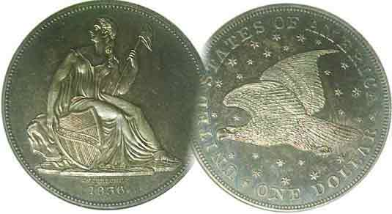
Pres. J.J. Engel
V .P. Pat James, diseased
Sec. Jim Mullaney
Treas. Chuck Goergen
Sgt. in Arms: Jim Sproull

Programs: Pat James
ANA Rep.: Glenn Sanders
Show Chair: Board members
Photos: Steve Kuhl
Publicity: Pat James
Newsletter: Arno Safran
E-Mail: arnosafran@comcast.net
Auctioneer: Jim Sproull
Web site: Susie Nulty (see above.)

Our next will be on Thursday, Oct. 6 at 6:45 PM in the South Aiken Presbyterian Church
Due to the latest Omicron variant of Covid-19, please wear a face mask inside the building

2022 Club Meeting Schedule
Volume 21, No. 10 the Stephen James CSRA Coin Club, Founded in 2001 Oct. 2022
Monthly Newsletter
Collecting early U.S. coppers are quite challenging
Jan. 6 Apr. 7 July 7 Oct. 6
Feb. 3 May 5 Aug. 4 Nov. 3
Mar. 3 June 2 Sept. 1 Dec. 1

A Club Member Never to be Forgotten



Pat James, Founder and Vice President of
The Stephen James CSRA Coin Club
at one of the club’s pre-Christmas annual holiday dinners

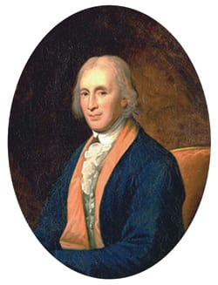
On August, 26 one of our most charming and energetic club members, Pat James passed away. Pat’s late husband, Stephen James operated a little coin shop on York Street in Aiken a number of years through 2000, the first year of 21st century before he died. Despite being an active attorney, Pat found a way to maintain her late husband’s coin shop and soon, a number of local customers who enjoyed collecting obsolete coins and paper money joined together to form a coin club which held its first official gathering in April, 2001 in a lovely anti-room at the Aiken Public Library. During this more than twenty year period, Pat served as Vice President and participated in various club activities such as arranging for club members and guests to display numismatic Show and Tells as well as presenting programs. She also assisted in the planning of annual club shows along with acquiring numismatic prizes for our pre Christmas parties. Pat had a charming personality and a wonderful spirit and will be sorely missed!
__________________________________________________________________________________________________________________________
Collecting large cents from the beginning
Part One By Arno Safran

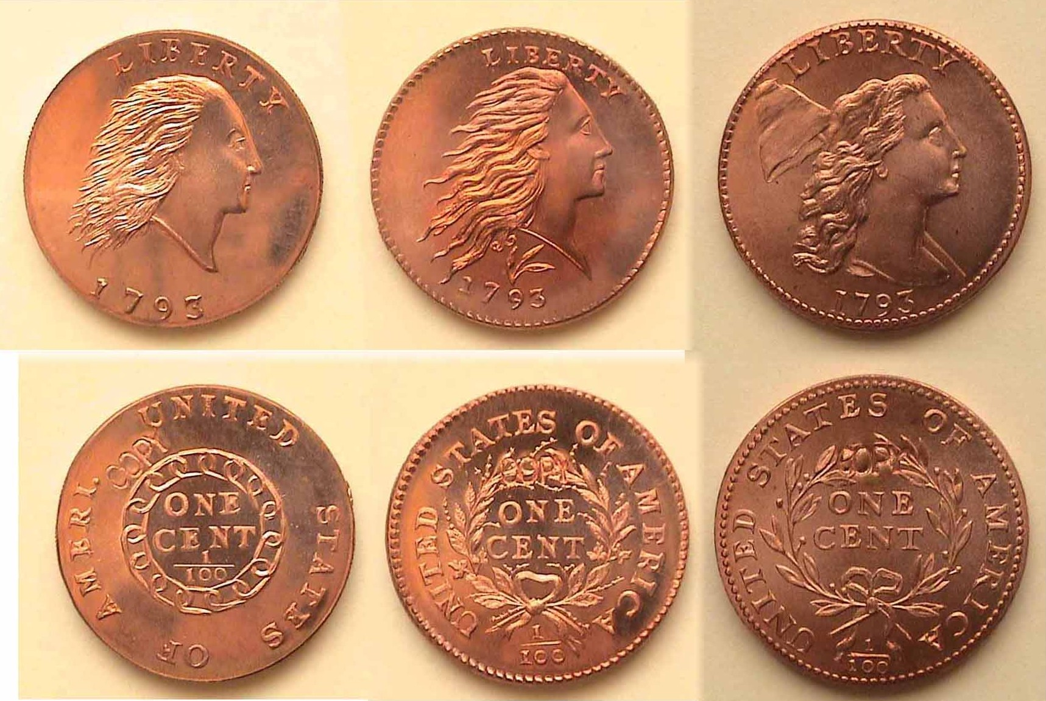

Gallery Mint replicas of the three sub-types of 1793 large cents
[Enlarge page to fit monitor screen or to 150% to view details.]

Shown above are magnificent replicas of our first three large cents; the crude Flowing Hair obverse and Chain Cent reverse at left, the modified Flowing Hair obverse with a wreath reverse with one cent in the center and the more sophisticated Liberty Cap obverse at the far right. The cent-types shown were all engraved by Ron Landis back in 1993 in honor of their 200th anniversary. Landis used the same alloys and screw press type of the originals at the Gallery Mint located in Eureka Springs, AK and are considered better than any examples previous engravers designed following the Hobby Protection Act of 1973 prohibiting the striking of obsolete US coinage without the word COPY on either the obverse or reverse of the coin. The word COPY appears on the reverse of each coin in a subtle manner.

As for the originals, in 1792, David Rittenhouse was appointed as our first Mint director. He was a brilliant scientist, astronomer and mathematician. He first, hired Henry Voigt, a clockmaker who had some engraving experience to create the Chain cent. A more talented Joseph Wright designed the wreath cent but Wright died prematurely due to the Yellow Fever epidemic in Philadelphia so Voight
David Rittenhouse supposedly engraved the wreath cent shone above.
_____________________________________________________________________________________________________________________________
(Continued on page 2, column 1)
Collecting large cents from the beginning
(Continued from page 1, column 2)

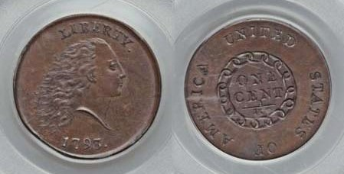

An Amazing 1793 Chain cent, S-4, R3+ graded MS-65 Bn. by PCGS
(Courtesy of Heritage Auction archives and PCGS COIN FACT)

Pictured directly above is an actual original 1793 Chain Cent that was at one time owned as part of the renowned Eliasberg collection. It is one of the highest grade examples for that type. It sold for $1.380.000 dollars at a Heritage auction held during the FUN Show held back in January, 2012. When the coin was first released for circulation in 1793, only 36,103 were minted. A vast majority of Americans were horrified by Miss Liberty’s hairdo and thought the chain symbol represented imprisonment when it was intended to embody strength, so Rittenhouse had Voigt make changes to Miss Liberty’s hairdo and replace the chain on the reverse with a wreath.
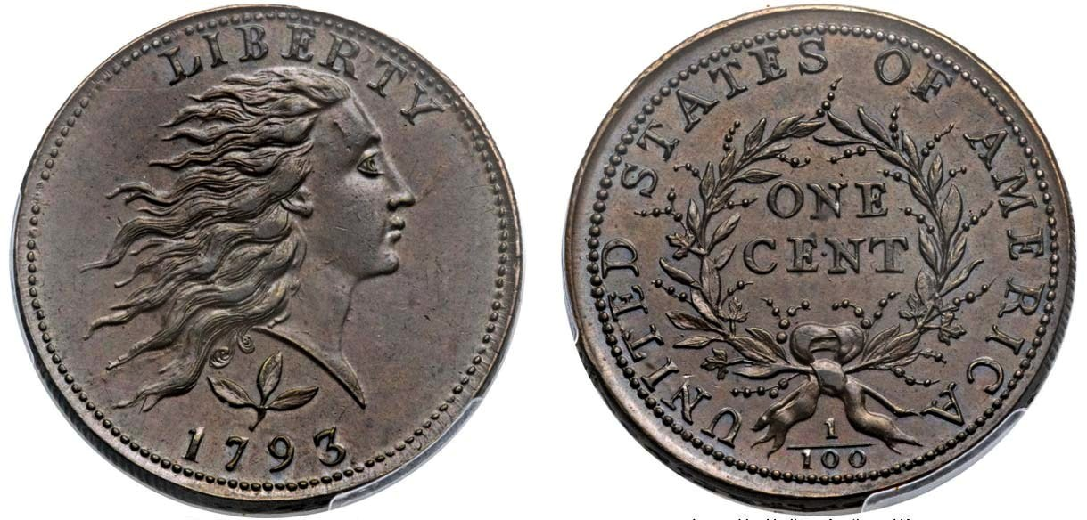

A 1793 wreath cent, S-5, R4 graded MS-65 Brown by PCGS
(Courtesy of Heritage Auction archives and PCGS COIN FACT)

This is a dazzling example of the second 1793 type, known as the Wreath cent type that replaced the unpopular Chain reverse. Miss Liberty’s hairdo on the obverse has been improved almost touching the letters in LIBERTY atop. Between the Bust of Liberty and the date at the bottom is a three leaf sprig which adds an attractive touch to the obverse as well. The reverse displays the full legend, UNITED STATE OF AMERICA with the wreath surrounding ONE CENT in the center and the fraction 1/100 at the bottom. The mintage for this sub-type was 63,353 yet is still considered extremely scarce especially in the ultra high grade shown. It sold for $258,500 at the Central States Numismatic Association convention in Chicago back in April 2014.

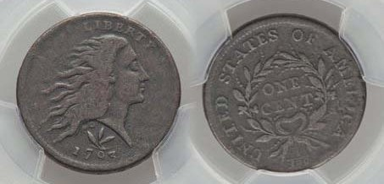

Another 1893 wreath cent but graded just VG-10 by PCGS
(Courtesy of Heritage Auction archives and PCGS COIN FACT)

Despite its low grade, this coin is rather attractive with evenly worn surfaces and perhaps a touch of porosity. Nevertheless, it still cost the winning bidder $4,440 at a Heritage auction held in Dallas, TX as recently as January, 2021. Currently, a VG-10 piece retails for $5,500, so one could say, the winning bidder did pretty well, but most collectors consider it beyond their means which is why the three Gallery Mint replicas atop page 1, column 2 struck in 1993, costing was a best-buy at just $8.00 a piece and have since increased in value.
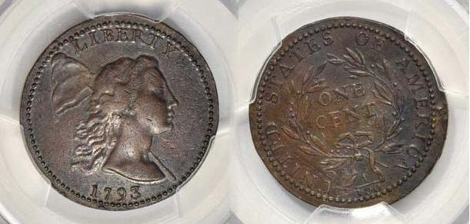

A 1793 Liberty Cap large cent, S-13, R4, graded AU-53 by PCGS
(Courtesy of Heritage Auction a chives and PCGS COIN FACT)

Lastly, shown atop is the third 1793 sub-type called the Liberty Cap large cent. The reported mintage was just 11,056, the rarest of the three and expensive in all grades. Fortunately, this third type was struck in 1794 thru 1796 with sufficiently larger mintages along with many die varieties and are more affordable, if only in the lower grades. While the 1793 Liberty Cap cent may have been originally designed by Joseph Wright it was later engraved by Robert Scot who was named our first Chief Engraver of the US Mint by David Rittenhouse. The coin’s diameter was slightly larger than the preceding two being increased from 27 mm to 29 mm. Wright may have been influenced by the French medalist, Augustin Dupree who created the famed LIBERTAS AMERICANA-medal July 4, 1776 in 1782. Benjamin Franklin is the one who apparently suggested the type of design to Dupree while he was living in France. While the figure of Liberty on the medal faces left, the actual coin above shows Liberty facing right.
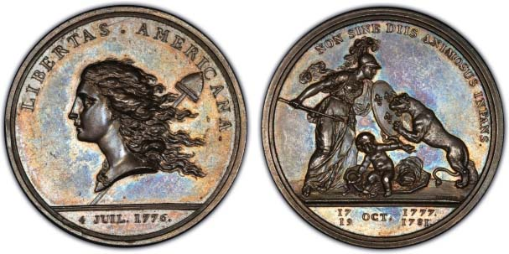
An example of Augustin Dupree’ s LIBERTUS AMERICANUS medal

Of the remaining three dates in the short-lived four year Liberty Cap large cent series, the best the author could afford was a VF-30 for the 1794, and only VG-10s for the 1795 and 1796.

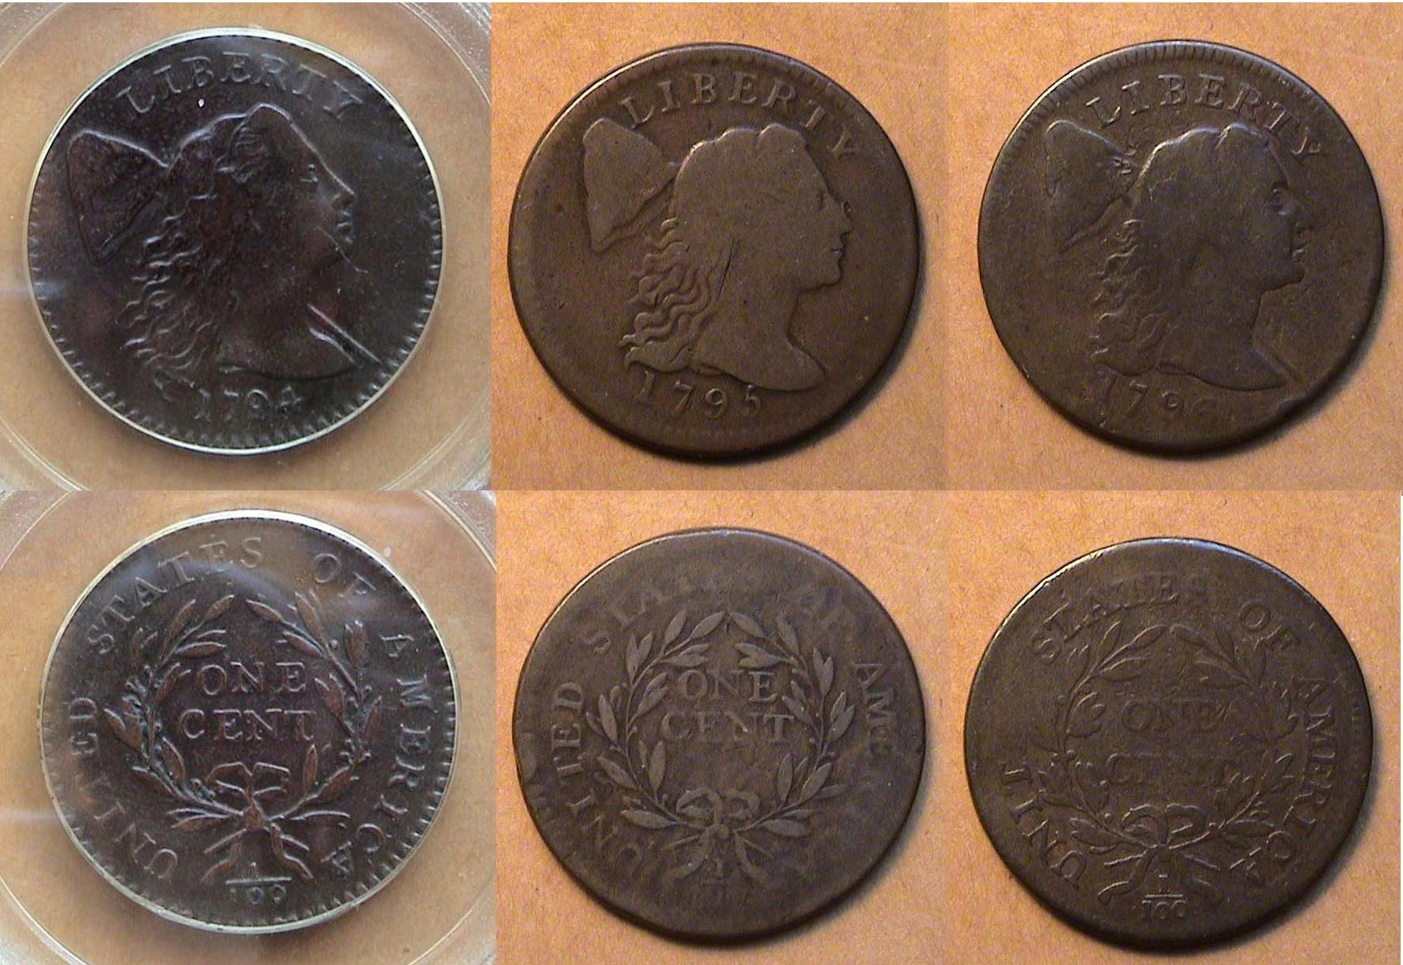

1794, VF-30, 1795 & 1796 , both VG-10s Liberty Cap large cents
The author acquired the 1794 in 2004, certified VF-30 by PCGS and it cost a pretty “penny”, but the 1795 and 1796 cents, both graded only VG-10, were purchased back in 1995 and cost only $200 each.
(Continued on page 3, column 1)
Collecting large cents from the beginning
(Continued from page 1, column 2)

The Drape Bust Type

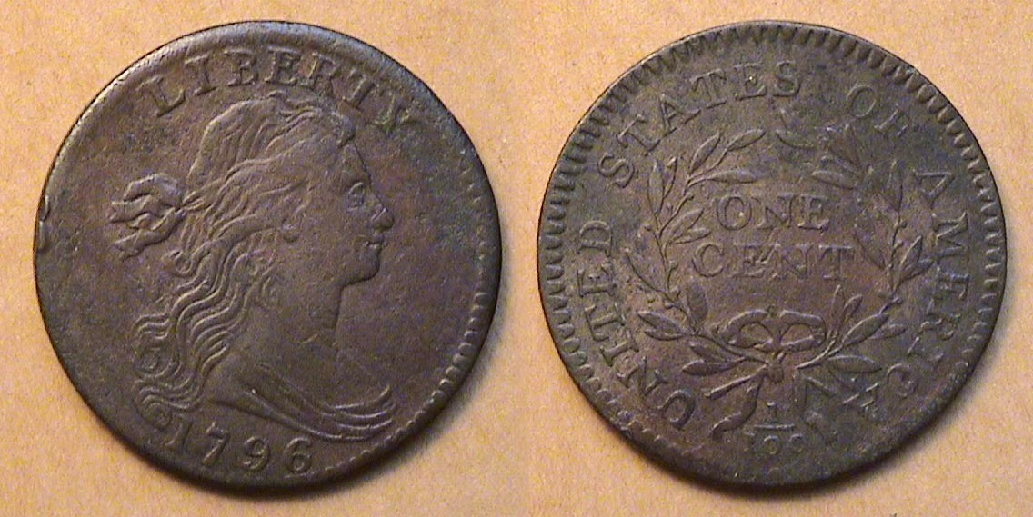

A 1796 Draped Bust large cent, S-108, R4, VF-20 details
[Enlarge page to fill the monitor screen or 150% to view details of all coins.]

Halfway through 1796, Scot replaced the Liberty Cap type with the Draped Bust design on the large cent. This type would be struck in every year thru 1807. Unfortunately both the 1799 with an unknown number of coins struck and the 1804 with a reported mintage of only 96,500 are virtual “stoppers” for most collectors of early US copper coin. With a reported mintage of 363,375, the 1796 Draped Bust cent shown above is also fairly scarce and the example displayed, alas, is somewhat porous; (i.e., a bit moldy) when magnified sufficiently.

One of the major researchers into the category of early American copper coinage was the late Dr. William Sheldon, a specialist in early large cents, who published a book back in 1958 called Penny Whimsy, revised in 1976, the very year the author entered the world of numismatics. The book covers all the then known die varieties of large cents struck from 1793 thru 1814. Since that time, other even larger tomes have appeared with clearer glossy pictures for each die variety.

Already in 1794, almost one million large cents were struck with over 75 die varieties. Back then, some varieties lasted a shorter time period than others. In the description spot located under each coin shown, appears the date and denomination followed by the type (in this case, Draped Bust) then the variety number preceded by the initial of the numismatist who originated the search; the S (for Dr. Sheldon); the number, (the particular die variety( and the R, (for Rarity factor), with a 1 to 3, being within the common spectrum, the R4 and 5, somewhat scarce to fairly scarce with the R6 to 8, rare to extremely rare with very few examples known to exist. The 1796 Draped Bust large cent shown above is designated as a Rarity-4, scarce whereas the S-167, R-1 coin directly below is considered a R1, very common.

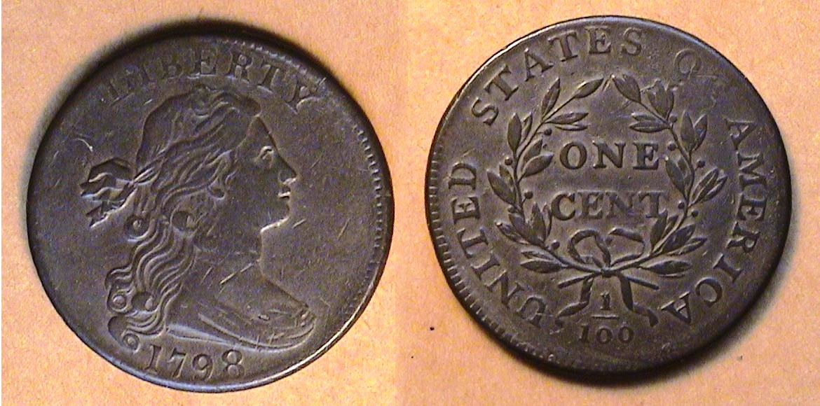

A 1798 Draped Bust large cent, S-167, R1 VF-35

While nowhere near as costly as some of the Liberty Cap issues, beginning in 1797, the number of available examples for each date increases with the 1798 among the most common and as a result, more affordable accounting for the author’s more attractive example than some of his earlier examples displayed. The coin shown directly above was nicknamed the whisker variety, supposedly due to a tiny dot under the Miss Liberty’s cheek when enlarged. The coin was acquired back in 1993 at a major show held at the Baltimore Convention Center where at the time, a VF-35 example cost just $325. Today it is listed at a retail figure of $1,400 according to PCGS’ COINFACT.
Collecting Interesting Varieties
The “Q” Variety

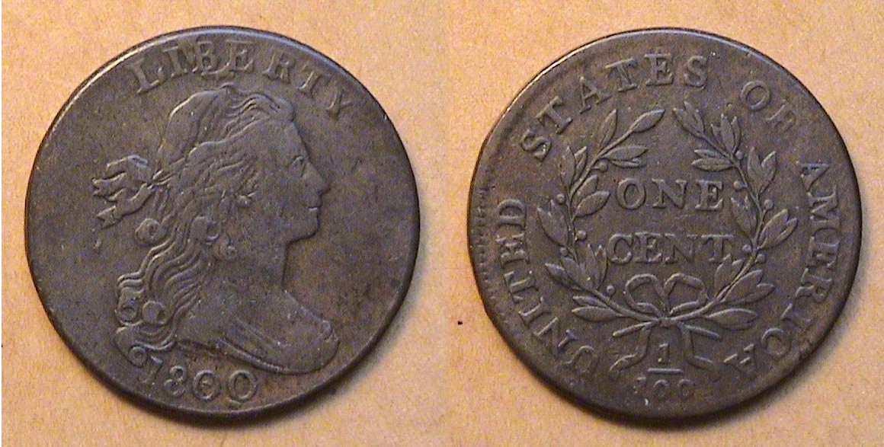

An 1800 Draped Bust Large S-197, R1 cent graded VF-20

In May of 1998, the author recalls attending the Atlantic Rarities Show in Baltimore and acquired the 1800 Draped But large cent from a renowned dealer who specialized in early American copper coins. Even in those days, high-end circulated large cents, let alone uncirculated ones were quite expensive and beyond the means of most collectors. What prompted the author to acquire this coin were three aspects; the fact that it represented a century date and it was an unusual example known as “the Q variety” since the first zero in the date had a break in the center followed by, another slightly to the left of the second zero appearing like the letter, Q and lastly, it was affordable. Today, the coin in the same grade would cost three times as much.

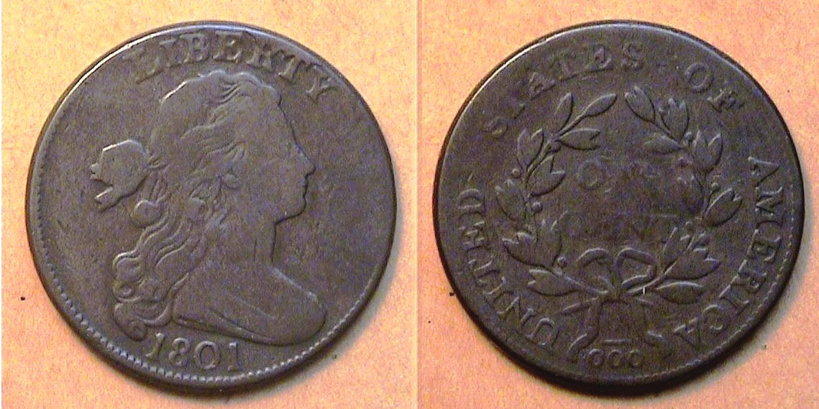

An 1801 Draped Bust large cent, S-223, R1 cent graded just Fine-12

This is yet another example of a Draped Bust large cent variety that was released into circulation with an error regarding the denomination. On the bottom of the reverse side of the coin where the 1 is usually placed over 100, it appears as 1/000 instead. Of the 18 die varieties for the 1801 cent; the 1/000 appears on four of them, Sheldon 218, 219, 220 and 223 with variety 222, not shown, displaying a 1 over the first of the three zeros. The S-223 variety is the most common of this group and was acquired it at a Garden State Numismatic Association show back in April 30, 1999 from the same dealer that sold him the 1800 piece shown atop the column; this one for only $160.

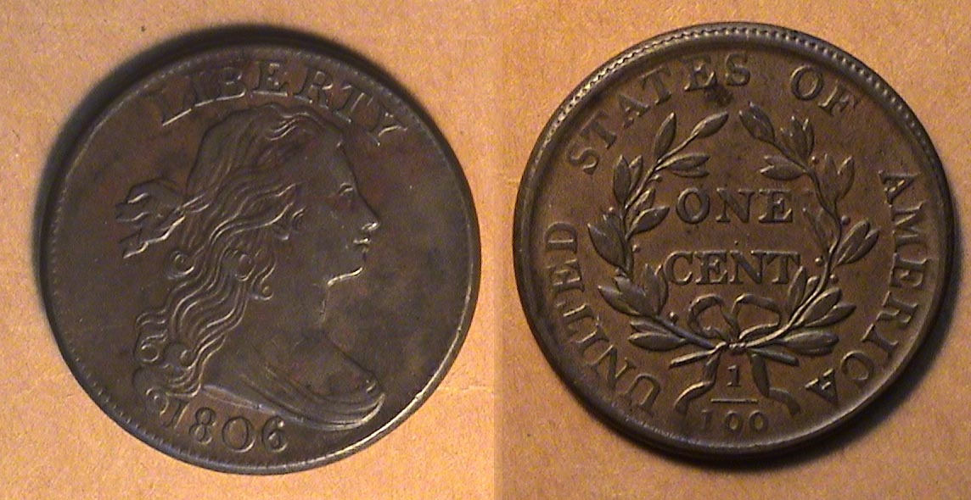

An 1806 Draped Bust large cent, S-270, R2 graded XF-40

Finally, the 1806 example shown directly above--with just one known variety--is perhaps the nicest piece in the author’s set. The coin displays only a slight a mount of wear while the surfaces are smooth and free of marks, scrapes or dings and the strike is beautifully balanced displaying the artistic qualities of the engraver Robert Scot’s talents as an engraver. The coin was acquired back in March, 2004 at the ANA Convention also held in Baltimore from another highly respected dealer who specializes in early American copper coins.
(to be continued!)
_____________________________________________________________________________________________________________________________
STEPHEN JAMES CSRA COIN CLUB
Regular Meeting Thursday, September 1, 2022

President J.J. Engel, called the regular meeting of the coin club to order at 6:50 p.m. in the Fellowship Hall of the South Aiken Presbyterian Church (SAPC). There were 17 members in attendance.

The meeting started with a moment of silence for our Vice President Pat James, who unexpected passed away last week.

Glenn Sanders won the member door prize drawing, a 2017 ¼ oz silver Mexican Libertad.

Jim Sproull reported there were many upcoming area coin shows in the summer months and the members could check in the SCanner publication of the SCNA for a complete list and the dates and places.

A motion was made by Chuck Goergen and seconded by Sharon Smoot to dispense with the reading of the Minutes of the August 2022 meeting. A copy of the August Meeting Minutes will be on file with the other club records and one appears in the Club newsletter.

Treasurer’s Report:
Chuck Goergen reported that the Club’s bank balance was $1,709, however $1005 is from coin show income that will be returned to dealers since this year’s show is cancelled.

Old Business:
This year’s September Coin Show for our club was cancelled last week. The gymnasium recently became unavailable as a Coin Show venue.
JJ Engel congratulated Steve Kuhl, editor of the SCanner (SCNA’s newsletter), for winning 2nd prize for electronic newsletters from the American Numismatic Association.

New Business:
President JJ Engel discussed some of the impact of Pat James’ passing on our Club. We will be looking for different individuals to fill the various roles Pat took care of so well for us.

Show and Tells (in lieu of a formal program we had a series of Show & Tell numismatic items displayed by various club members.):

Jim Sproull shared a 1970 silver coin from Finland he had purchased at the last Augusta Coin Club auction. Jim noted that he obtained the coin because he found it strikingly unattractive.

Jim Mullaney shared some silver bullion from several mints that were reported in last months program to have gone out of business, including Ohio Precious Metals and Elemetal. The Elemetal bullion was struck in ultra-high relief included examples from two different series Elemetal had made, Natural Wonders and
Pirate-themed.

Sonia Hillman brought in the remains of a gold nugget that had been transformed into
artwork by the same metallurgist from Kentucky that makes the Queens little horse trophies.

Chuck Goergen shared a 14 gram silver coin minted in Alexandria Egypt during the reign of Ptolemy the 12th.

Garry Naples shared two SC notes from the 1800’s. He’d obtained the first note and later learned that the SC note was printed on the back of half of a scarce Tallahassee State Stock Bank Note. He later decided to go to the SC state museum to look for similar Notes, and in searching through the 25-cent notes he found the backs were all blank – except for one that displayed the other half of a Tallahassee
State Stock Bank Note. Garry also shared a SC gamecock Note from July 1861 he’d cherry-picked from the state museum’s offerings.

Sgt at Arms Jim Sproull, assisted by Jim Mullaney, conducted the monthly club auction.
President Engel reminded the members that the next regular meeting would be at 6:45 p.m. on October 6th , 2022, in the Fellowship Hall at
South Aiken Presbyterian Church, and
then adjourned the meeting at 8:10 p.m.

Respectfully submitted,
Jim Mullaney, Secretary

Brown, Red-Brown & Red
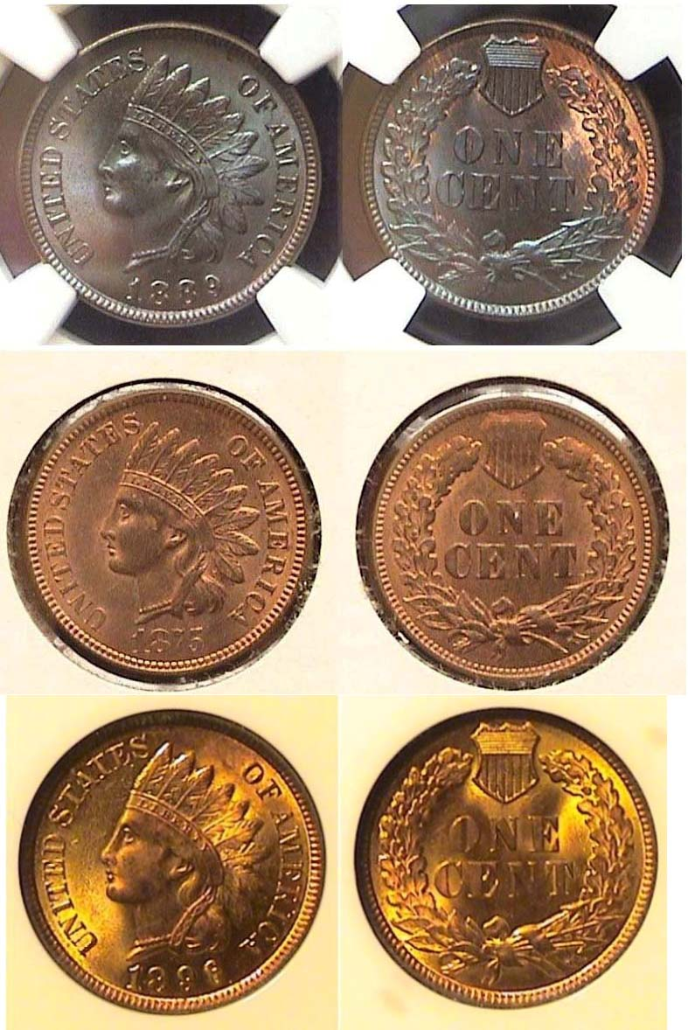

Brilliant Uncirculated 1889, 1875 and 1896 Indian Head cents
In Brown, Red-Brown and Red
[Enlarge page to fit monitor screen or to 150% to view details.]

The three attractive Indian Head cents shown directly above are considered fairly common dates and were all reasonably priced and affordable in the grades shown when the author obtained them at different coin shows. Despite their ease of attainment, acquiring them was still a challenge because the author was attempting to complete a mini set of copper cents which fell into each of the three BU grade categories; these being Brown, Red-brown and full Red.

Each year, many of us look forward to acquiring the new date out of circulation and usually the first denomination is the Lincoln/ Shield back cent which usually appears full red, but when collecting uncirculated copper coins struck decades earlier, a dazzling BU coin’s appearance at the time of its release may vary in color drastically because brilliant uncirculated copper coins are known to tone over time.

As a result, in recent years, the professional grading companies have adapted a system of grading uncirculated cents of earlier times into three value areas; brown, red-brown and full red with Brown being the least valuable, Red-brown more valuable and full Red , the most expensive.

If the reader enlarges the trio of Indian cents shown above sufficiently to view their details as separate entities, they will realize that all three coins are not just uncirculated and well struck, but differ in hues and radiance. The 1889 Indian head cent atop appears the sharpest of the three displaying the coin’s details with great clarity which was why it was certified MS-65 but the coin is heavily brownish as many 1889 cents are, so despite being the highest grade of the three, NS-65 BN, it was the least expensive, currently priced at $338 compared with $520 if it were graded Red-brown and a whopping $1,449 if it were graded full Red.
The second coin, the 1875 Indian Head cent, is attractive for its combination of Red and brown color but with a mintage of just 13,528,000 compared with considerably higher mintages for the 1889 and 1896, it was the most expensive of the three on that account alone. In MS-64 Brown, the 1875 is currently priced at $442 but in Red brown, $550, over a $100 more, while in full Red, $715.
Despite its dazzling appearance, the 1896 Indian Head cent was certified only MS-64 Red by NGC and in full red it is currently priced at $358 compared with $195 if it were Red- Brown or only $176 if it were just brown. Those are all current prices. So, when it comes to the pricing of Indian Head cents that are mint state specimens (i.e., MS -60 thru MS-70), these differences in color are important but only from a financial consideration, because after all that has been written, the author considers all three coins shown on the preceding column to be equal in appearance esthetically, if not financially, because each specimen displays a different type of artistic beauty aside from their historic importance as collectables.
___________________________________________________________________________________________________________________

Kindly patronize our Dealers
