Pres. Willie Simon
V .P. James Barry
Sec. Helen Barry
Treas. Pat James
Sgt. in Arms: J.J. Engel
Committees:
Auction: J.J. Engel
Programs: James Barry
Newsletter: Arno Safran
The Stephen James
CSRA Coin Club of Aiken
P.O. Box 1739
Aiken, SC 29802
Web site: www.sjcsracc.org
The SJ CSRA CC Now Meets on the 2nd Thursday of the Month at the Cedar Creek Community Center in Aiken, SC

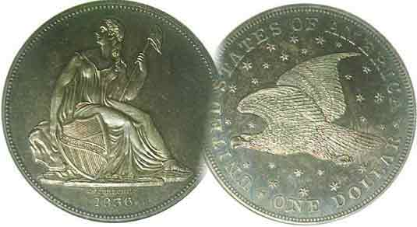

Volume 5, Number 11 the Stephen James CSRA Coin Club Monthly Newsletter November, 2006
SC Numismatic Assoc. Show One of the Best
Our Next Meeting is on the 2nd Thursday of the month, November 9, 2006 at 7:00 PM
2006 Club Meeting Schedule - 2nd Thursdays at 7 PM
June 8, July 13, Aug. 10, Sep 14,
Oct. 12 Nov. 9, Dinner Meeting, Dec 7

There’s Something about a Good State Coin Show

On Oct. 27, 28 and 29, the South Carolina Numismatic Association (SCNA) held their annual convention at the Embassy Suites in Greenville. This is the second year in a row that the event has been held at this site and hopefully SCNA will be able to hold many more for the location is beautiful and the hotel is one of the best values for those staying there.

There were around 50 different dealers set up around the 80 table bourse; most carrying a wide range of collector material from Mint state 20th Century US coinage to quality mid-grade earlier items such as large cents, Bust, Seated and Barber halves; also obsolete US, North American And Confederate currency notes. There were also dealers touting beautiful foreign and medalic art including fellow member Tony Chibbaro who is to be congratulated as General Show chairman for putting together another great numismatic event. This collector was able to add an 1807/6 Draped Bust large cent to his collection. At shows such as these there is usually something for virtually every collector starting with rolls of statehood quarters going back to the 1999 Delaware issue to the latest representing North Dakota. The South Dakota quarters should be out this month. Then there are the proof and mint set dealers who help collectors fill sets they may have missed.

One can learn a lot about coin rarity at shows such as these. For example, one dealer who had a neat display of certified mint state Buffalo nickels featured the commoner dates in mostly PCGS-65 holders but when it came to the tougher dates such as the 1918-P, it was housed in a PCGS-64 holder. The key branch Mint date such as the 1924-S was only in a VF holder. In addition to the coins for sale, there were several outstanding exhibits, mostly by young numismatists. There were a number of SJ CSRA CC members in attendance at the SCNA show. Helen Barry received an award for her service to SCNA as the editor of the journal as did Tony Chibbaro.
_________________________________________________________________________________________________________________________
(More Club news on page 4, column 1)
Early Latin American Republican Coinage,
Part I: Mexico by Arno Safran

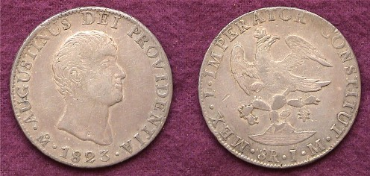.

An 1823 8 Reales of Augustin Iturbide, one of two major varieties struck during the self proclaimed Emperor’s short reign

After the Napoleonic wars, King Ferdinand VII returned to Spain and began purging the intellectuals whom he perceived had sided with the French despot. At the same time he ignored the pleas for greater autonomy from the Hispanic-American colonies across the Atlantic. From 1810 thru 1825 bitter battles raged all over the Spanish occupied lands in the New World. In Mexico, Augustin Iturbide, a military man--who first rejected the revolution only to side with the insurgency when it was evident that the Spanish were becoming war weary--managed to influence the landowners, clergy and military to put him in charge of the new Mexican government. Almost immediately he proclaimed himself Emperor Augustin I, sent an army to invade Central America and dissolved the legislature when they began questioning his decrees. Thus began his short if authoritarian rule which lasted less than a year. While in power, coins showing the Bust of Iturbide were struck. Two were coined in gold, the 4 and 8 escudos, both rare today; and four in silver; the 8, 2, 1 and ½ Reales. There were no 4 Reales coined with Iturbide’s portrait. After so many years of war, the replacing of the old tyrant by a new one was more than the Mexican Congress and Military could take. Iturbide was forced to abdicate in March 1823 and then was exiled to Europe. His craving for absolute power remained undiminished and he resolved to return, ignorant of a decree ordering his death if he should do so. Shortly after he landed back on Mexican shores in July of 1824 he was apprehended, tried, convicted and shot.
_______________________________________________________________________________________________________________
(Continued on page 2, column 1)
The Early Republican Coinage of Mexico
(Continued from page 1, column 2)

Due to the Iturbide’s short reign most of the coins bearing his portrait are scarce to rare except for the 8 Reales and ½ Real.
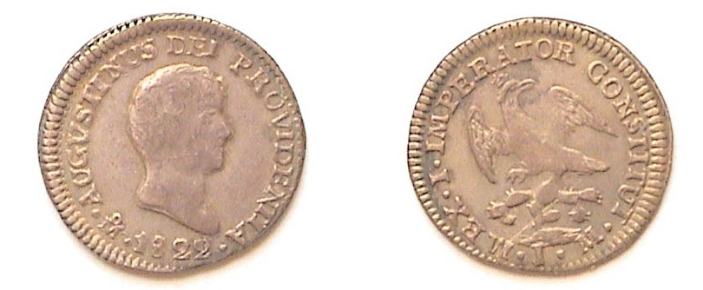

An 1822 ½ Real of self proclaimed emperor Augustin Iturbide I, the smallest of the four silver coins bearing Iturbide’s bust.
If you magnify to 500% one can observe the legend on the portrait side
which reads AUGUSTINUS DEI PROVENTIA. To the left of the date is the mintmark; Mo for Mexico City. The inscription on the reverse reads MEX. I. IMPERATOR CONSTITUT. followed by JM for the initials of the assayers.

During the War of Independence, four new mints were added to the Mexico City facility. These were Durango, Guadalajara, Guanajuato and Zacatecas. After Iturbide, the Mexican Congress produced a constitution and established a loosely confederated republic. Unfortunately, it lacked the checks and balances of our own constitution. From the start the idealists among the people and some of the clergy were at odds with the wealthy landowners--who more often than not--were backed by the military. Despite this instability the government did agree on a coinage that lasted well into the 19th and early 20th centuries. They incorporated the Aztec victory symbol, an eagle perched on a cactus holding a snake in its beak on one side and a Phrygian cap with rays emanating outward in all directions above the date on the other. All the legends were changed from Latin to Spanish.
The first versions of the new design featured a scripted LIBERTAD across the Phrygian cap while the eagle was shown with a hooked neck. The ½ Real, 1 Real and 2 Reales were struck in 1824 as a one year type at the Mexico City (Mo) and Durango (Do) Mints. The hooked neck eagle 8 Reales was struck in 1824 and 1825. No 4 Reales were issued with the hooked neck eagle design. High grade examples of all four denominations are scarce to rare. The author was able to find an 1824 ½ Real (Ch EF) and an about VF 2 Reales at the New York International Numismatic Convention back in 1997. Choice AU to UNC 8 Reales tends to be very pricey.

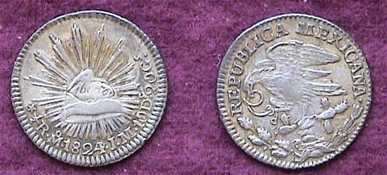

An 1824 Hooked Neck ½ Real grading CH XF from the author’s collection. [Magnify to 500% to see the details.]

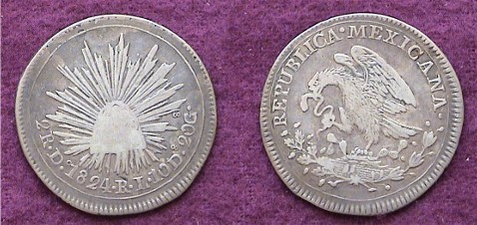

An 1824 Hooked neck 2 Reales grading A VF from the author’s collection. The lack of detail on the cap represents the usual weak strike that comes with this denomination and not just wear. [Magnify to 200%.]
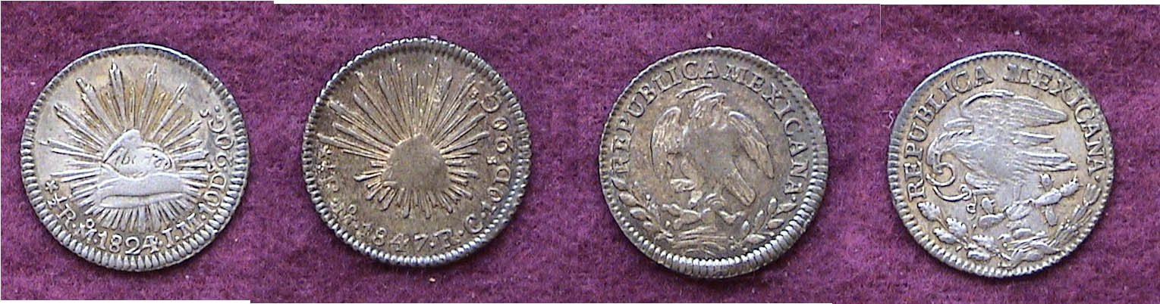

1824 & 1847 ½ Reales Hooked neck and standard eagle compared
The 1824 Hooked neck issue is at the extreme left and right.
Under 200% magnification observe the differences in the cap size and dimensionality; also the eagle which is erect on the standard issue (1825 on) and bent over to the left (1824) at extreme right.

During the 19th century the number of Mints increased to 14 and most Mints struck the Cap & Rays silver 8 Reales though not in the same numbers allowing for a number of rarities. On Republican Mexican coins the eagle is considered the obverse and the Cap and Rays the reverse.

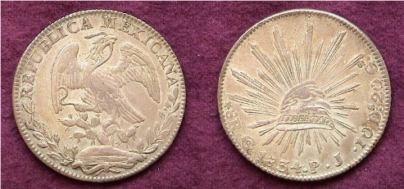

An 1834 Cap and Rays 8 Reales struck at the Guanajuato Mint
This coin was legal tender in the US for $1.00 until 1857.

The Cap and Rays design appeared on the lower denominations of the silver coinage as well. These included the 8 Reales, 4R, 2R, Real and ½ Real. The government even issued a tiny silver ¼ real (from 1842-63) featuring a Liberty-like figure of a Mayan chieftain with the denominator ¼ on the reverse.

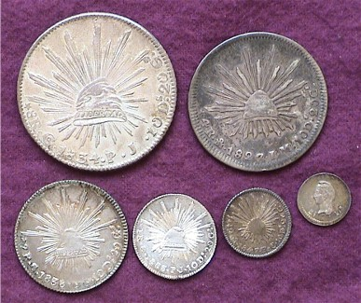

The date side of the Cap & Rays Silver set all struck before 1857
From left to right; atop, the 1834 8R Go (Guanajuato) and 1827/6 4R Mo (Mexico City); below, the 1838 2R Go, 1838/7 1R Go, 1847 ½R Mo and the 1842 ¼R Mo showing the Mayan chieftain. [Magnify!]

The Early Republican Cons of Mexico
(Continued from preceding page)

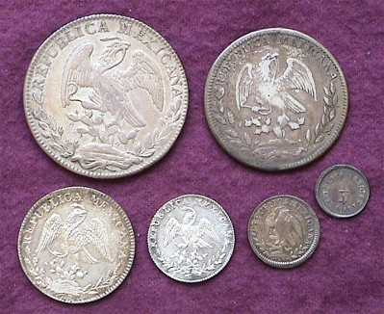

The rev. of the author’s six Republic of Mexico silver denominations
Top from left: 8 Reales and 4 Reales Bottom from left to right: The 2 Reales, 1 Real ½ Real and the tiny silver ¼ Real

All of the coins shown above were quite inexpensive relative to their contemporary US issues in the same grade. The 8 Reales ($1.00 value) boasted the largest mintages and were primarily struck for world trade or to be used as specie by banks in backing business transactions. In all likelihood the average Mexican citizen probably never used the big silver cartwheel. The 4 Reales were coined in small numbers and are scarce in mid grades, rare in AU to Uncirculated. While the mintages of the pre 1857 dates of the Cap & Rays silver series were fairly large--even for the minors--quality pieces; (e.g.., CH XF to Unc.) seldom surface today. The minor coins had tremendous buying power during this period--even more so in Mexico than the US--and in all probability most circulated until well worn.

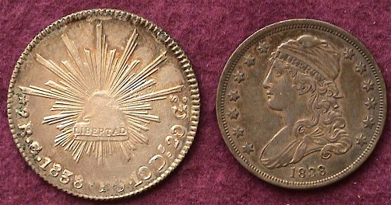

An 1838 Mexican Cap & Rays 2R in AU & 1838 US Bust 25¢ in XF-45
Today the Mexican coin is valued at $35.00; the US coin at $350.00.

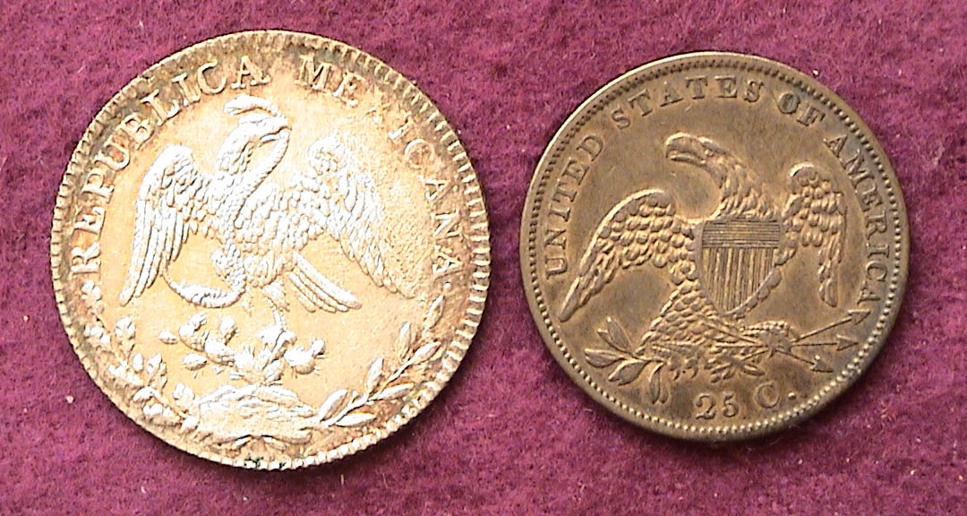

The Eagle sides of the 1838 Cap & Rays Mexican 2 Reales and Bust Quarter. In 1838 both coins were accepted for 25¢ value in the USA

Despite their paucity in the higher grades, the latest edition of the Standard Catalog of World Coins edited by Chester Krause, Clifford Mishler and Colin Bruce II lists moderate prices for all Cap & Rays denominations save the 4 Reales. The problem is, while dealers usually carry the dollar size 8 Reales in their inventories, they seldom bring the minors to shows because of their low catalog price listings. Still, when one compares the prices of these Mexican issues with their US counterparts in the same grade, the Mexican pieces are downright cheap.

Throughout history the Phrygian cap has been used as a symbol for freedom on coins and medals but nowhere is this design more prominent than on the silver coins of Mexico issued from 1824 through 1909. It is much more difficult to find a Gem BU example of the Cap & Rays 8 Reales struck before 1857 than after. The later dates--called Pesos after 1897--saw little circulation and like our Morgan dollar, Gem BU’s can be obtained for a very nominal price.
_______________________________________________________________________________________________________

Club News

At the October 12 meeting Treasurer, Pat James reported the club’s balance had reached $1,632.40; a record. Much of this increase came as a result of our successful coin show and member J. J. Engel received a warm round of applause for his efforts as Show Chairman. The winners of the three Show raffle prizes were announced and the grand prize was won by active member Merle Davis, Jr. who took home the 1988 Olympic Gold Commemorative set. Second prize was won by Pat Jacobson of Columbia who was the recipient of an uncirculated Morgan dollar. R.B. Gunter won the third prize in the Show raffle drawing. Speaking of prizes, Richard Smoot won the silver eagle drawing at the Oct. 12 meeting and Vilma Safran won the 50/50. Congratulations to winners, all.

December Dinner: VP Jim Barry announced confirmation of the club’s sixth annual pre holiday Christmas dinner party to take place at EE-Jay’s Restaurant (same site as last year) on the first Thursday, December 7 starting around 6:30 PM to 7:30 PM, Cash Bar with dinner to follow. [There will be no regular meeting on the second Thursday in December.] The cost to members is $10 each, non-members-$20; children-$5.00. The choice of entrée’s includes Prime Rib, Chicken Monterey and Fried or Broiled Shrimp. The deadline for remitting your order and payment is Thursday, Nov. 30. Please make checks payable to Pat James, P.O.Box 1739, Aiken, SC 29802. President Willie Simon expressed how much pleasure he and other members have derived from the past five pre-holiday dinners and reminded everybody that lots of prizes are given out at these affairs but you have to be there to receive one.

The Program: VP Jim Barry ran a video by David Lisot that explored some of the major collectible types of Large Paper Money and Fractional currency going back to 1776. The video offered the commentaries of leading paper money specialists and dealers--among them, our own Hugh Shull--who serves on the Board of the South Carolina Numismatic Association. Many of these notes are among the most beautiful in the history of bank notes; among these, the Series of 1896 silver certificates known as the Educational notes.
______________________________________________________________________________________________________________
(Club News continues on page 4, bottom of column 2)
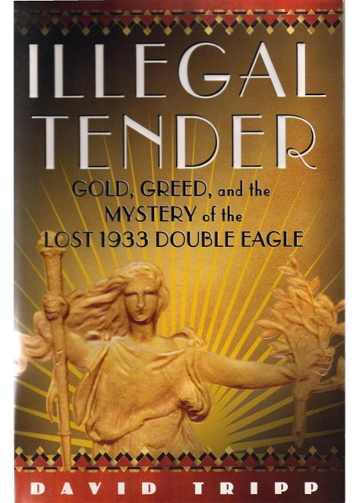

Illegal Tender: Gold, Greed and the Mystery of the Lost 1933 Double Eagle by David Tripp
Book Summary by Bill Myers

There has been a lot of publicity about the 1933 Double Eagle since the sale of the Farouk specimen. It is supposed to be the only legally owned specimen, but now 10 other 1933 Double Eagles have been turned in to the United States Mint and their destiny is still undetermined.

This book starts out with President Teddy Roosevelt trying to revamp the United States coins and convincing Augustus Saint-Gaudens, the greatest sculpture in the US at the time, to redesign the U.S. coinage. Saint-Gaudens considered this an honor and reduced his usual fee from $50,000 to $5,000. Unfortunately Saint-Gaudens was fighting cancer and struggled with pain to complete the project. He often had to direct some of his assistants to do the work. He died before ever seeing the circulating Eagle and Double Eagle released.

President Franklin Roosevelt put an end to Saint-Gaudens’ legacy by recalling gold in 1933, making it illegal to own most gold. Fortunately numismatic items were exempt so there are still some available for numismatists today. Trivia question: Did you know Alexander Hamilton named the $10 gold coin an Eagle because he could not think of anything else?

Even though the Treasury could not make payments in gold, the Mint continued to strike $10 & $20 gold coins. A hundred of the 1933 Eagles were made available to the public but the Double Eagles were never released.

In 1937 and 1938 a 1933 Double Eagle was shown at numismatic meetings and one was offered for sale in an ad by Smith & Son in 1941. The Mint and the Secret Service did not take notice until Stack’s included a 1933 Double Eagle in an auction and a reporter from the New York Herald Tribune sent an inquiry to the Mint. This started a Secret Service investigation and seizure of any 1933 Double Eagles in collectors’ hands. King Farouk of Egypt had just received his permit to export a 1933 Double Eagle a month earlier, and at the time of the Secret Service investigation the whereabouts of the coin was unknown.

Harry Strang and George Dreschler launched an investigation. They followed the trail of the 1933 Double Eagles which was a mixture of cooperation, lies, finger-pointing, memory losses and lack of responses. They investigated such numismatic luminaries as James Macallister, Abe Kosoff, Sol Kaplan and B. Max Mehl. The root of the investigation narrowed to mint cashier George McCann, dealers Israel Switt, Edward Silver and Ira Reed. Ten 1933 Double Eagles were finally recovered and melted but due to expiration of the statute of limitations no one was prosecuted.

The 1933 Double Eagle issue was buried but was reincarnated in 1993 when British dealers Andre de Clermont and Steven Fenton began to purchase coins from a Cairo jeweler who was selling them for a family of a deceased Colonel; a former member of the Egyptian Army. Some of the coins he was selling matched those in the Farouk sale but were unlisted as having buyers because they were withdrawn. One of the coins offered was a 1933 Double Eagle. Fenton bought it in 1995 for $220,000. He then contacted Jay Parrino in Kansas City about selling the coin with a price tag of $750,000. Parrino contacted Jack Moore, a small and relatively unsuccessful dealer, who had been buying Saint Gaudens Double Eagles for a wealthy client but instead of contacting his client, Moore contacted Special Agent R. David Freriks of the Secret Service instead. A sale of the coin for $1.65 million was arranged.

The sale became a sting operation with most of the participants being arrested except Moore who served as a confidential informant but the coin was confiscated. A long legal battle ensured resulting in a settlement rather then a trial. Fenton and the United States Mint would split the profits 50/50 from the sale of the coin. The coin was sold by Sotheby’s and Stack’s on July 30, 2002. Twelve approved bidders (the reserve was $2.5 million dollars) fought it out over 6 minutes and 21 seconds. An anonymous bidder won the coin when it hammered down at $6.6 million for a total of $7,590,020 with the 15% buyer’s premium. An additional fee of $20 was paid to monetize the coin, thus making it legal to own.
___________________________________________

More Club News
(Continued from page 3, column 2)

Augusta Club Show Coming Up: Glenn Sanders, Acting VP of the Augusta Coin Club announced that our sister club will be holding its Fall Show at the Belair Conference Center located just off I-20 at Exit 194 on Nov. 17 and 18. The dates fall on a Friday and Saturday. Around 35 dealers are expected to set up. The hours are 9:30 to 4:30 both days and the public is welcome at no charge. Glenn informed those present that this is a new location and can be seen behind the Hampton Inn and Waffle house on the right driving towards Fort Gordon before South Belair Road becomes Jimmy Dyess Parkway.

The next meeting of the SJ CSRA CC will be Thursday, Nov. 9 at the Cedar Creek Activity Center. Bring something in for Show & Tell. Hope to see you there.
_______________________________________________________________________________________________________________________________
Bill Myers’s publicizing of Iraq War Money (POGS)
To Be Included in New Paper Money Catalog
By Kathy Myers

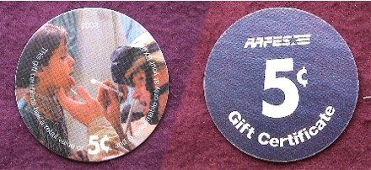

An AAFES 5¢ POG Gift Certificate

The newest edition of the Standard Catalog of World Paper Money from KP Books (F&W Publications) is now available. Club member Bill Myers was particularly eager to obtain his copy of the 12th edition.

When Bill returned from his first tour in Iraq, back in 2004, he spoke to the club about Military POGs, which he learned of and started collecting while in Iraq. Since that time, he has also put together an exhibit with the full collection of POGs, now in their 8th printing, which he has exhibited at the GNA, where it won First Runner-Up and at SCNA and FUN, both of which won Best of Show.

Now, for the first time, military POGs are included in the World Paper Money Catalog, and the editor called upon Bill for his assistance in preparing that section. You can find the POG listing under “United States” on pages 917-920. And Bill proudly tells us you can find his name on page VI, under the acknowledgments to contributors.

When Bill returns from Iraq after his current deployment, perhaps yet another printing will be out. If so, you can be sure Bill will have started his collection of those.
_________________________________________________________________________________________________________________

The Editor’s Coin of the Month

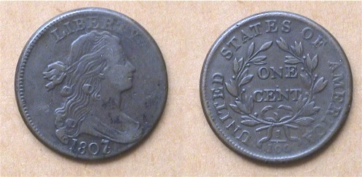

An 1807/6 Draped Bust Large Cent grading VF-30
829,221 minted, all kinds; the S-273 R1, Large 7 over 6 variety

When planning to attend a large regional show, one usually prepares a short want list. Having been fairly successful adding Bust half overdates or branch mint Barber Halves grading Fine to VF at past SCNA shows, I eagerly looked forward to the event. When I first attended the SCNA gathering back in 2002 I found mostly Morgan dollars and gold but did acquire a rare 1904-S Barber half dollar grading Fine. What I hadn’t expected to find were any large cents of quality but I was proved dead wrong. Midway through my trek along the 80 table bourse, I came across a very attractive grouping of 1798 large cents; all grading Choice VF or better; mostly scarcer varieties than my S-267, R1 which is classified as the most common. The initial S preceding the variety number stands for Dr. William Sheldon whose book, Penny Whimsy--published around the mid 20th Century--became the standard for attributing early large cents (1793-1814). Since I am a date collector first and a Red Book die variety collector second, I found myself more interested in a lovely 1807/6 specimen in the same dealer’s case because I didn’t have one and needed it to complete my overdate set of large cents. The coin, listed as an S-273 was only an R1, the most common of the five Red Book varieties for 1807 but it was also a very attractive specimen showing a pleasing chocolate color, even surfaces and plenty of detail.

