Pres. Willie Simon
V .P. James Barry
Sec. Helen Barry
Treas. Pat James
Sgt. in Arms: Glenn Sanders
Committees:
Programs: James Barry
Show Chairs: The Barry’s
Newsletter: Arno Safran
E-Mail: arnosafran@comcast.net
The Stephen James
CSRA Coin Club of Aiken
P.O. Box 1739
Aiken, SC 29802
Web site: www.sjcsracc.org
The SJ CSRA CC Now Meets on the 2nd Thursday of the Month at the Cedar Creek Community Center in Aiken, SC

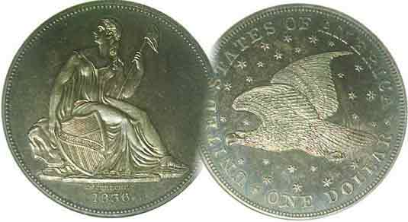

2008 Club Meeting Schedule
Volume 7, Numbers 11-12 the Stephen James CSRA Coin Club, Founded in 2001 Nov., Dec. 2008
Monthly Newsletter
Recovery of Lost Gold from SS Central America
Topic of DVD shown at October 9 Meeting
Our next meeting is Thursday, November 13, 2008 from 6:15 to 9:00 PM
Jan. 3 Apr. 10 July 10 Oct. 9
Feb. 14 May 8 Aug. 14 Nov. 13
Mar. 13 June 12 Sept. 11 Dec. 4 dinner
___________________________________________________________________________________________________________________________

Jim Barry shows History Channel Video
On the SS Central America which went down in the
Atlantic off the SC coast during the Hurricane of 1857

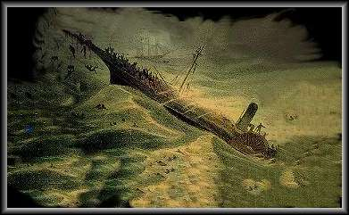

Sketch depicting the sinking of the SS Central America in 1857

Imagine taking a mid 19th century voyage from California down to Panama, then traveling across the isthmus to board another ship for passage northbound along the east coast. Envision yet a worst case scenario running into a hurricane on the final lap that lasts not just a few hours but several days. Such a horrendous event occurred in September of 1857 when the SS Central America bound from Panama to New York City, carrying 476 passengers and a crew of 102 was buffeted by 50 foot high waves finally breaking up and sinking off the Carolina coast with much loss of life and treasures that included massive amounts of gold bullion in coin and bars totaling more than three tons. This was the subject representing the first half of the History Channel video that VP and Programs Chairman Jim Barry showed to the club members at the October 9 meeting.
______________________________________________________________________________________________________________________
(Continued on page 4, column 1)

Collecting Short Sets by Type:
Barber Liberty Head Coinage by Arno Safran

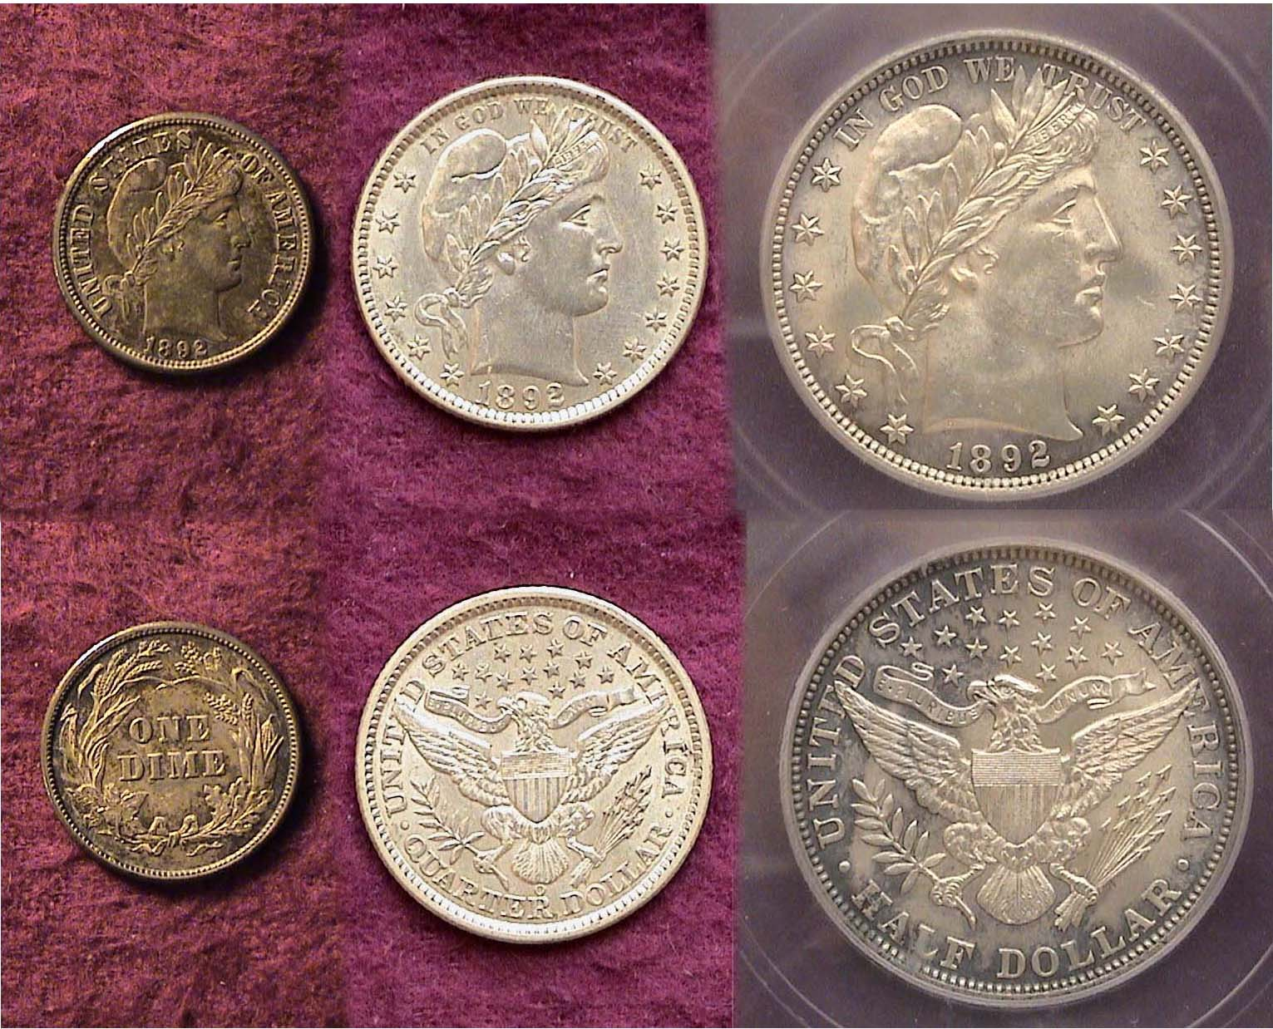

A set of 1892 Barber Liberty Head Silver Coins
The first year of issue for this type

After one of the longest tenures for a single type in US coinage history, the Liberty Seated coinage begun back in 1836 with the Gobrecht dollar was retired with the coinage of dimes, quarters and half dollars dated 1891. The reverse showing John Reich’s spread eagle design was first engraved on the Capped Bust half dollar in 1807 producing an even longer run of 85 years for a single reverse type. In 1890, Congress passed a law which stipulated that a coin type change could only occur after twenty-five years. Since the aforementioned Liberty Seated design had served for far more than a quarter of a century, such a change was valid. America’s leading sculptors were invited to participate in a design contest but due to too short a time frame with little reward, the sculptors refused. Charles Barber, the chief Mint engraver was eventually assigned the job of producing new designs for the dime, quarter and half dollar.
_________________________________________________________________________________________________________________________
(Continued on page 2, column 1)
A Short Set featuring Barber Liberty Coinage
(Continued from page 1, column 2)

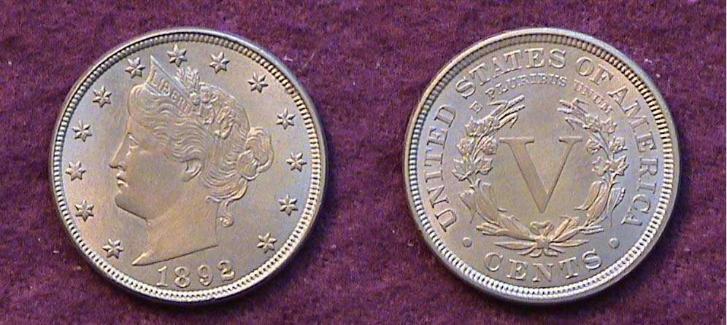

An 1892 Liberty “V” 5¢ nickel grading MS-63+
The coin was designed by Charles Barber and first released in 1883 without the word “CENTS”. The oversight was corrected later in the year.
[Magnify to 200% to see details more clearly.]

Charles Edward Barber (1840-1917) was the son of former Chief Mint Engraver William Barber (1807-1879) who is best known as the designer of the Trade dollar (1873-1885) and the ill fated 20¢ piece, (1875-1878). Like his father, the younger Barber studied to be an engraver and “inherited” the position of Chief engraver shortly after his father’s death in 1879. Both the younger Barber and George Morgan (1845-1925) engraver of the dollar coin that bears his name served as Assistant Engravers for a time but due to Charles Barber’s seniority at the Mint, he was given the premium post.

Barber designed four major circulating coin types; the Liberty nickel, (1883-1912), the Liberty Head dime and Quarter (1892-1916) and the Liberty Head Half dollar (1892-1915). He guarded his position at the Mint zealously often disparaging would be competitors sometimes to no avail as in the case of Augustus Saint-Gaudens in 1907. His coinage designs were not looked upon favorably by his contemporaries including the leading numismatists of his day. If he were alive during the past fifty years, he would claim to have had the last laugh as Barber coinage is among the most popular and sought after by modern day collectors going back to the 1960’s.

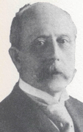

Charles E. Barber

The 1892 Liberty nickel shown above is a mint state example of the first circulating type Charles Barber created. As a date it is not scarce let alone rare such as the 1885 or 1886 issues but with a recorded mintage of 14,696, 897 the date falls roughly between the scarce and more common issues. Most scholarly numismatists believe Barber appropriated his colleague George Morgan’s dollar design reversing the portrait of Miss Anna Williams while adorning her with a tiara over a coiled hairdo. A comparison with Morgan’s 1879/80 $4.00 gold Stella pattern coin suggests possible similarities.

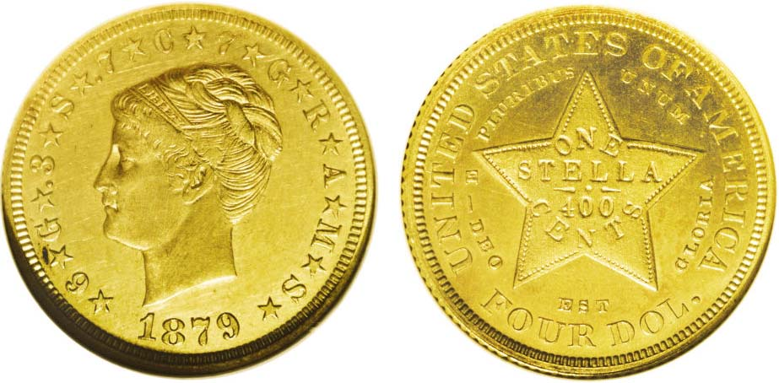

An 1879 Coiled Hair $4.00 Gold Stella graded Proof-63 by NGC.
(Courtesy of Heritage Auction Archives)
[Magnify to 200% to see details.]

Since most first year types are saved and therefore more readily available as well as less costly, I decided some years ago to assemble a Barber type Short set dated 1892, the year the new Liberty Head dime, quarter and half dollar were introduced to the public thus combining both the type and year set under the “short set” concept.

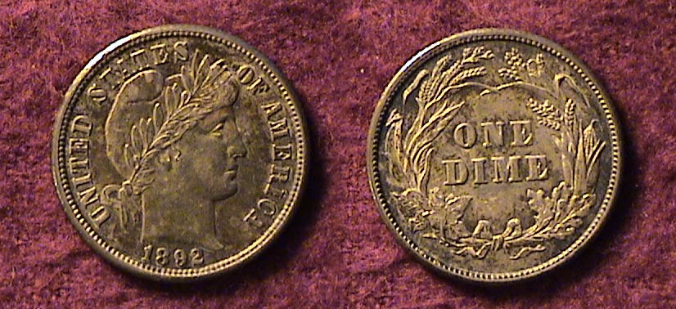

An 1892 Barber dime grading AU-58
[Magnify to 200% to see details more clearly.]

When contemplating Barber’s Liberty Head type for the dime, collectors may subconsciously muse about the reverse design as having seen it before and they would be right.

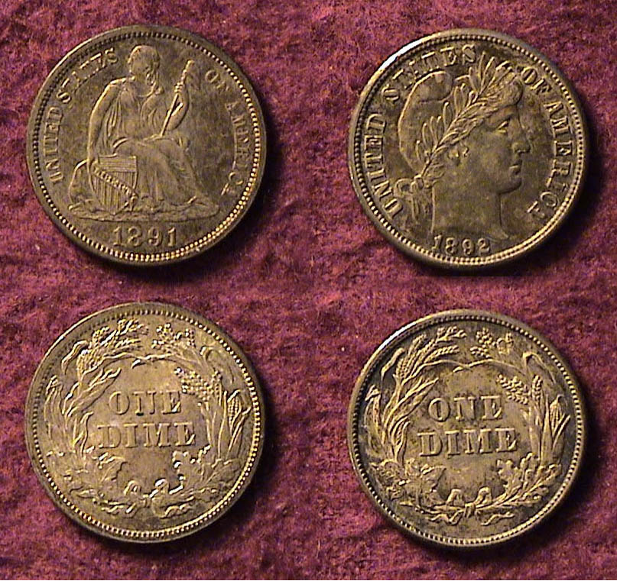

An 1891 Liberty Seated dime at left alongside
the new 1892 Barber Liberty Head dime at right,
both evenly matched in grade and toning.
Notice the identical reverses for both types.
[Magnify to 200% to see details more clearly.]

Whether it was due to the pressure of a deadline for preparing the new designs on all three silver coins, or as the late numismatic scholar Walter Breen opined in his Encyclopedia of US and Colonial Coins (1988), “Barber must have been feeling unusually lazy”, an observer can see that the wreath combining cotton, corn, tobacco and wheat surrounding ONE DIME is ostensibly identical to the reverse of the Liberty Seated with legend dime first coined in 1860. In any event, in its initial year some 12.1 million Barber dimes were struck in Philadelphia along with 3.8 million coined at New Orleans and 990,710 at the San Francisco facility. The 1892-P for date and type is easily the least expensive and in AU-55 to 58, a “Best buy” for moderate income collectors.

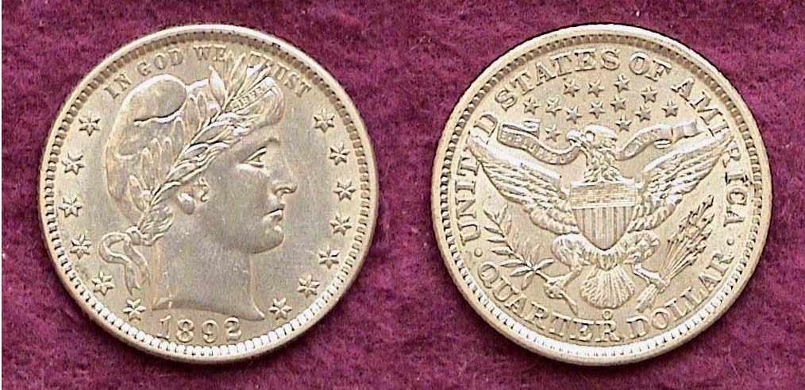

An 1892-O Barber Quarter in AU-55 showing the Type 2 reverse
The mint mark “o” appears just under the tail feathers
Once unpopular, now considered a pleasing functional design type
[Magnify to 200% to see details.]
___________________________________________________________________________________________________
(Continued on page 3, column 1)

Collecting “Short Sets”: The Barber Coinage of 1892
(Continued from the previous page)

The Barber Quarter as a series is a difficult one for the collector to complete because there are at least three “stoppers”, the 1896-S, 1901-S and 1913-S that are priced well beyond most collectors discretionary income. Fortunately there are a number of common dates from which a collector can select for type and the 1892-O shown on the previous page is one of them. According to one of the latest retail sources that provide price listings for both the AU-50 and AU-55 grades, an 1892-O Barber 25¢ grading AU-50 is listed at $160 and in AU-55, $225. Compare this with the key 1901-S 25¢ which is listed at $30,000 and $32,000 respectively in the same two grades. Even in Good-4, the lowest grade shown, the 1901-S is priced at $6,500. What most dealers won’t tell the average collector interested only in popular “key” date coins like the 1901-S quarter and 1916-D dime is how common they are in low grade.

Interestingly, the 1892-P, D & S Barber quarters provide two reverse die varieties. The enlargements shown below are accompanied by diagnostics.

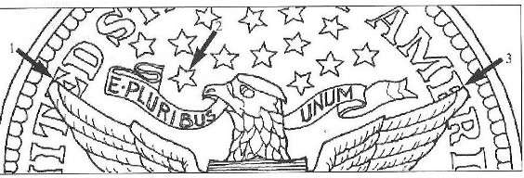

In the Type 1 reverse, the E in UNITED (1) is partially exposed as is the E in AMERICA (3). The star shown pointing directly above the R and I in "E PLURIBUS UNUM" has the open end atop and the pointed end down. (2).
This is the scarcer variety.

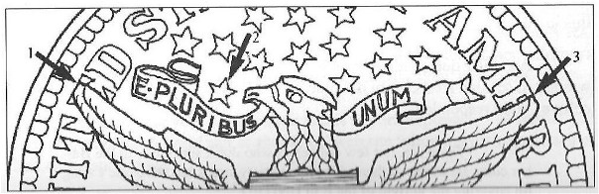

The Type 2 reverse shows the left wing almost completely covering the E in UNITED (1) while the right wing covers 2/3 of the E compared with 1/3 in the first type (3). The star facing PLURIBUS in the motto is in the reverse position with the pointed end facing upward and the open end facing downward (2).

[Courtesy of the Journal of the Barber Coin Collectors’ Society, Vol. 17, No. 4, 2006, based on the observations made by collector Steve Hastad.]

Of all the four Barber coinage denominations intended for general circulation the half dollar coin displays this type the best. Even in as low a grade as VG-8, the coin still has some modicum of eye appeal. Assembling a complete set of seventy-three Barber halves in Fine-12 through VF-30 is very tough but still within the realm of possibility and affordable over time since there are no “stoppers” despite a number of difficult dates. For many a collector on a middle class budget, obtaining just one mint state example with attractive surfaces and nice luster would be considerably rewarding.
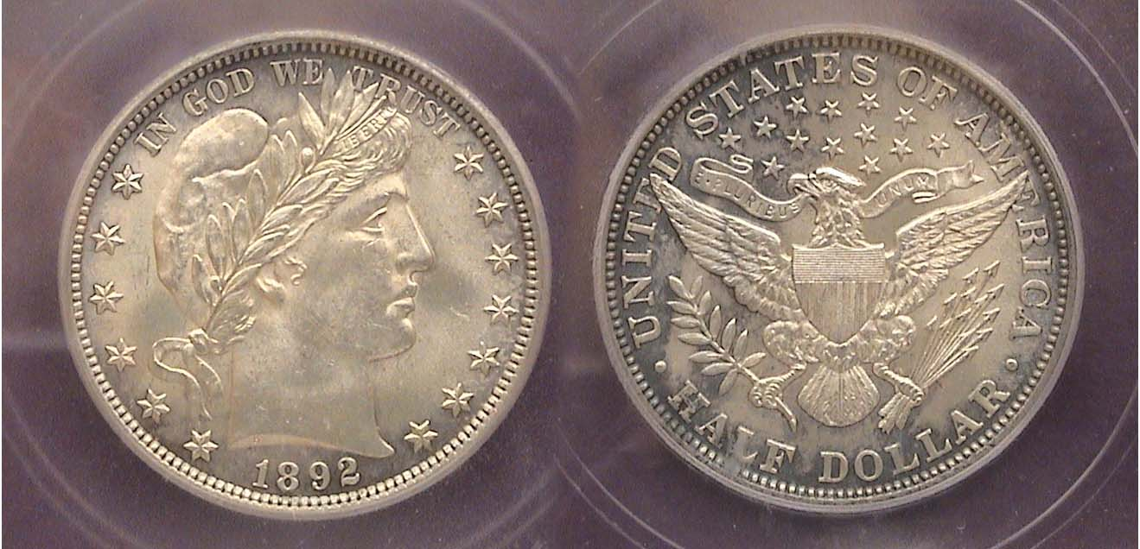

An 1892 Barber Half Dollar graded MS-62 by IGC
The mintage was only 934,000 but as a first year type, many were saved in mint state. [Magnify to 200% to see details]

As a youngster my cousin and I used to compare obsolete coin finds when we got together at grandma’s house. My biggest coup was showing him an 1899 Barber quarter in VF that I came across in change. Once in a while I would receive a well worn Barber half. To a twelve year old, all Barber coins didn’t just seem old. They were ancient. This was probably due to the austere look Miss Liberty received from Charles Barber’s aesthetic point of view; (i.e., classical Grecian elegance.) As a youth one didn’t see it that way. Today I regard the coin type as one of my personal favorites, and being able to acquire a mint state 1892 Barber half at the recently held Blue Ridge Numismatic Association show in Dalton, GA at the end of August represents the highlight of my coin collecting year.

One of the anomalies for this relatively common date is a triple die reverse that was discovered by Beistle in 1929. The Independent Grading Company (IGC) lists it as such on the holder but the photo of the actual coin fails to bring out the features supporting this attribution. Below is a Photostat taken from page 26 of “The Complete Guide To Barber Halves” by the late David Feigenbaum, a dealer who specialized in all four Barber coin type series under the pen name of David Lawrence.

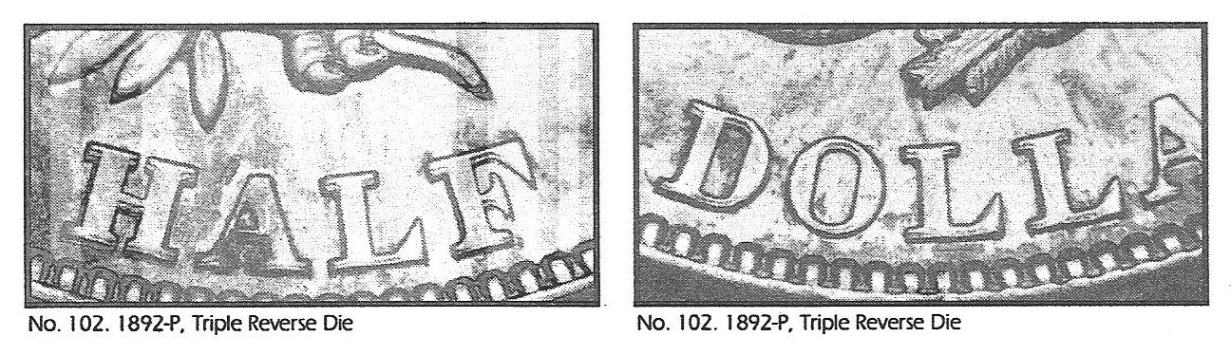
Observe the doubling and tripling of some of the letters,
not seen in the photo of the actual designated coin above.
The macro-photograph was taken by J.T. Stanton, co-author with Bill Fivaz of “The Cherry Pickers Guide to Rare Coin Varieties”
[Magnify detail to 200% to see doubling more clearly.]

Charles Barber was professionally active as Chief Mint Engraver during a time when the artistic styles were changing. Stylistically he was a traditionalist but in his chosen field, he was a master of his craft, second to none. The fact that the silver coinage that bears his name remained virtually unchanged during its quarter century run testifies to his abilities to combine art with functionality. Barber was also the designer of a number of our early commemorative coin types, most notably, the 1892-1893 Columbian half dollar, the 1893 Isabella Quarter, the 1900 Lafayette dollar and the 1904-1905 Louis & Clark Exposition gold dollar to name a few. Assembling a short sent of 1892 Barber coinage as displayed in this article represents an achievable goal honoring one of our outstanding engravers.
__________________________________________________________________________________________________________________
SS Central America Gold
(Continued from page 1, column 1)
The second half of the story detailed the discovery of the sunken steamer and the subsequent recovery of virtually all of the lost bullion by the Columbus-America Discovery Group founded by Thomas G. Thompson. It concluded with the successful litigation culminating in 1998 when coin dealer Dwight Manley acquired the vast hoard for over 100 million dollars.

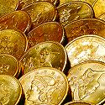

SS Columbia Gold Hoard

The club wishes to thank VP Jim Barry for sharing this video with the members.

In other club news our esteemed treasurer Miss Pat announced that due to the success for the club show our club’s coffers now hold a balance of $1,877.47. President Willie Simon praised all the members who helped to make our September show so successful, citing in particular our two co-show persons, Jim and Helen Barry for their efforts.
Under New Business, the club has reserved the Houndslake Country Club Restaurant for our pre Christmas holiday dinner. The new site is located at 901 Houndslake Drive off Hitchcock Road (Rte. 118) roughly 2/3 in from Rtes. 1-78 and 1/3 back of Pine Log Rd. The event is scheduled for Thursday, Dec. 4, Social Cash bar starting at 6:30 PM, with dinner at 7:00 PM. The cost to members will be $12.00 per and non members $25.00 each. The entrée choices are Chicken Picatta, Grilled Salmon and Rib eye Steak. The complete dinner includes a salad, assorted veggies, a nice sampling of desserts from which to choose, tea and coffee. Those interested in attending, please submit the completed attached reservation form and check payable to Pat James to Helen Barry, 81 Veranda Lane, Aiken, SC 29803 no later than Nov. 24 or at the meeting, Nov. 13. These dinners have always been the highlight of the club’s season with a number of drawings and prizes being awarded attendees. There will be no meeting held on the second Thursday at the Cedar Creek Activity Center in December.

The auction: In the absence of auctioneer Glenn Sanders who was attending his beloved USC Gamecocks defeat Kentucky up in KY, President Willie Simon ran the auction with help from members Jerry Axner and Helen Barry. The prize winners for the evening were Vilma Safran who received the door prize, a 2008 silver eagle and Jack Seech who won the 50/50 - $18.00. Congratulations to the winners. The Nov. 13 program will be a PowerPoint presentation by Arno Safran on US Coins during the Great Depression: the Early 1930’s.
___________________________________________________________________________________________________________________

SCNA Convention in Greenville Big Success

The three day South Carolina Numismatic Association convention took place in Greenville on October 24-26 at the Carolina First Center; a spacious well lit hall in a modern large building that can hold simultaneous conferences in different rooms. Our own James Barry is president of the state numismatic association. Over 1,000 patrons attended the three day show manned by some 80 dealers. Each arrival was presented with a free raffle ticket with numismatic prizes awarded on the hour during the show. There were exhibits along with two numismatic programs, one by Arno Safran on the “Political; Hard Times Tokens” presented to an audience of the Young Numismatists and their families. The other was given by Xavier Pique who repeated his wonderful presentation of “Heraldry: The History of Coats of Arms on Coinage”, seen earlier at our club. At the Sunday Awards Breakfast, Arno Safran received a plaque for “Most Outstanding Numismatist of the Year” for 2008, also awarded to fellow member Bill Myers in 2007.
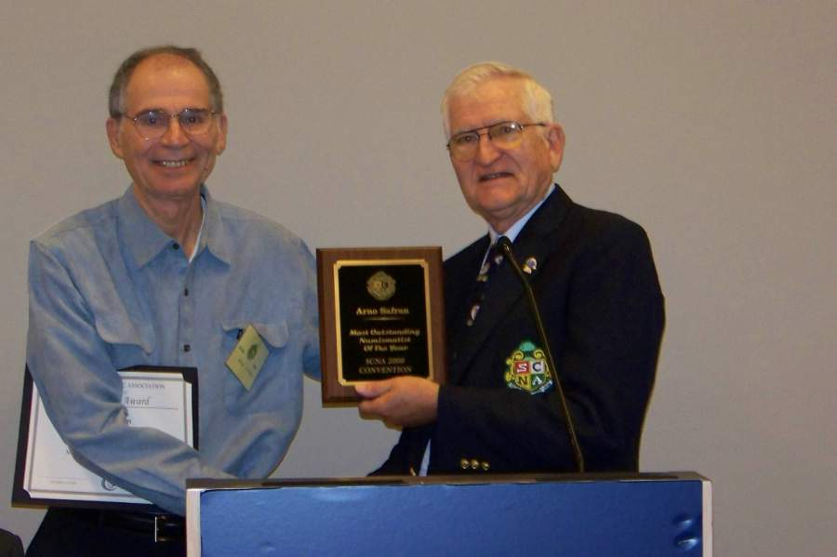

President Jim Barry of SCNA presenting SJ CSRA CC newsletter editor Arno Safran “Most Outstanding Numismatist of the Year” at the SCNA Convention Breakfast, October 26, 2008
________________________________________________________________________________________________________

THE WEST POINT MINT
By Elliot Huffman

West Point is a military academy established in 1778. It trains officers for combat who move up in rank faster and get paid more than most troops. West Point is located on a hill overlooking a turn on the Hudson River. It was established to sink the red coat ships sailing to split up the Continental Army and defeat the colonists. The army stretched a giant chain across the river to stop the red coats ships from sailing up the Hudson although there was no proof that it actually worked. George Washington himself described West Point as the key to the continent and sent one of his most trusted officers to safeguard the heights.
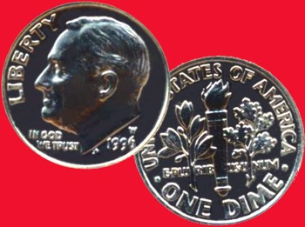

West Point also mints money. Starting in 1937, it served as a storage facility for silver bullion. Even without United States Mint status, it produced U.S. coinage. The West Point Mint mostly makes commemorative coins but they also made regular coins identical to the Philadelphia mint (the “P” mint). Some of the money included is the penny, quarter and the dime. On August 1st 1974 the mint began to make Lincoln cents identical to Philadelphia and Bicentennial quarters and regular Washington quarters were minted shortly after the Lincoln penny. September 1983 saw the first appearance of the "W" mint mark (still not an official U.S. Mint) on a $10 gold coin commemorating the 1984 Los Angeles Olympic Games. In 1988, the West Point Mint became an official US mint.

The West point mint is my favorite mint out of all the US mints. In 1996, a dime was minted to commemorate the 50th anniversary of the Roosevelt dime design. A Roosevelt dime with the “W” mint mark was placed inside the regular mint set that year. Over 1.457 million sets including the W dime were produced making it not particularly scarce. These were made only for collectors so don’t start looking in your change. This 1996-W dime is also special because it is on my birth year.
______________________________________________________________________________________________________________________________
This is one of the essays submitted for the YN Contest held by the Augusta Coin Club. The 12 year old author received first prize at the September, 2008 meeting of the ACC and it is reprinted here, Ed.
Coin of the Month
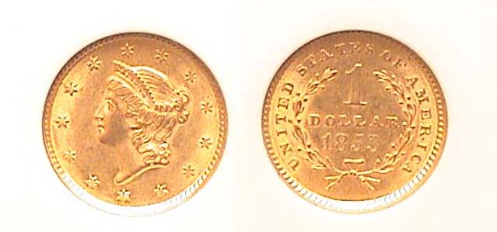
An 1853 $1.00 gold piece certified AU-58 by NGC
{Magnify to 200% to see details more clearly.]

In 1853 there were two dollar coins produced; the Liberty Seated silver dollar (originally designed by Christian Gobrecht and later modified by Charles Ball Hughes) and its little cousin shown above, the Coronet Type 1 gold dollar designed by James Barton Longacre first released in 1849. The large cartwheel-size silver dollar at 38.1mm hardly circulated even back then, so the Mint didn’t strike too many of them in a single year; only 46,100 in 1853 as compared with the record 4.3 million for the tiny 13mm gold dollar. Due to the smaller mintage, the Liberty Seated dollar certified AU-58 sells for around $2,000 today while the little gold bauble seen atop in the same grade is priced at only $275 as evidenced at the recently held SCNA convention held in Greenville last month. Another reason for the enormous price disparity is the unpopularity of the gold dollar coin. Like the slightly larger 3¢ silver trime at 14mm, collectors never took to the smaller denominations which may be why the $1.00 gold, 3¢ silver, 3¢ nickel and silver half dime denominations are relatively inexpensive in comparison with the others.
_______________________________________________________________________________________________________________

Augusta Club Show Coming Up Nov. 14 & 15

On Friday and Saturday, Nov. 14 & 15, The Augusta Coin Club will be holding its annual fall Coin and Paper Money show at the Belair Conference Center. The site is located just off Interchange 194 of I-20 on the Ford Gordon bound side of S. Belair Road. The Conference center itself is behind the Waffle House and Hampton Inn. The Augusta Club will post a sign visible to drivers on Belair Road. Hours both days are from 9 AM to 5 PM. The show is a virtual sellout with 47 tables sold and is free to the public. The maximum capacity of the well lit hall is 50 tables, so there may still be room for three more dealers who are interested in setting up at this show. The table rates are $120 which covers both days with each additional table, $95. Contact David Chism, the Show Chairman at dcchism@att.net or by phone at 706-541-4143 for further information. For CSRA collectors, this is a show that is accesable within 30 to 45 minutes drive and sure to please.

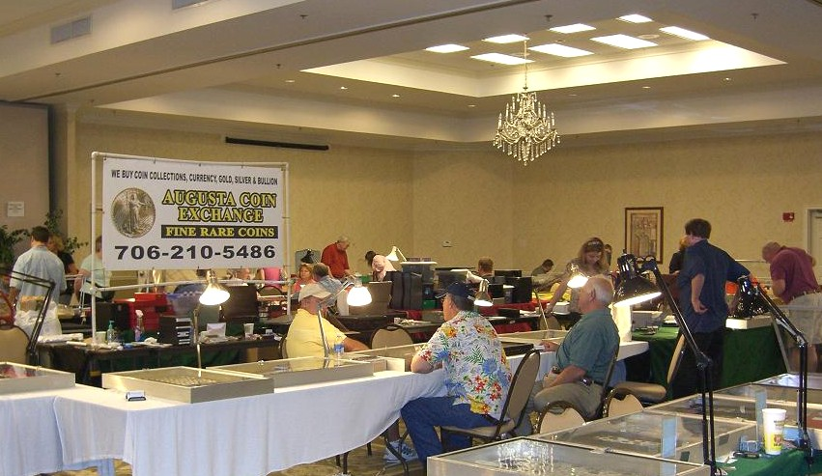

Scene at the Augusta Coin Club Show last May
_________________________________________________________________________________________________________

This will be the final newsletter of the year.

For those who are unable to make the November 13 meeting or December 4 dinner, the editor wishes all SJ CSRA CC members and their families Seasons Greetings for Thanksgiving, Christmas and the New Year.
__________________________________________________________________________________________

Display Ad Prices

For one month, $5.00, for one year, only $40.00.

If interested in taking a display ad for 2009, please contact Treasurer Pat James E-mail: palliejames@wmconnect.com.

Kindly Patronize Our Advertisers

