Pres. Steve Kuhl
V .P. Arno Safran
Sec. Jim Mullaney
Treas. Sharon Smoot
Sgt. in Arms: Glenn Sanders
The Stephen James
CSRA Coin Club of Aiken
P.O. Box 11
New Ellenton, SC 29809
Web site: www.sjcsracc.org
The SJ CSRA CC of Aiken, SC meets on the 1st Thursday of the month at the Aiken Public Library

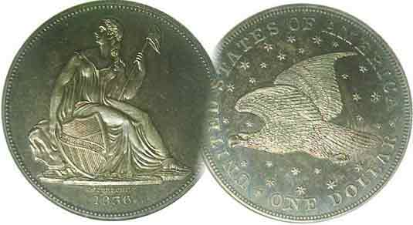
Committees:
Programs: Arno Safran
2010 Show: Jim & Helen Barry
Publicity: Jim Clapp
Newsletter: Arno Safran
E-Mail: arnosafran@comcast.net
Auctioneer: Glenn Sanders

2010 Club Meeting Schedule
Volume 9, Number 11 the Stephen James CSRA Coin Club, Founded in 2001 November, 2010
Monthly Newsletter
Postcard shows Stellar North Augusta Hotel in 1910
Our next meeting is on Thursday, Nov. 4, 2010 from 6:45 to 8:45 PM

Jan. 7 Apr. 1 July 1 Oct. 7
Feb. 4 May 6 Aug. 5 Nov. 4
Mar. 4 Jun. 3 Sep. 2 Dec. 2

____________________________________________________________________________________________________________

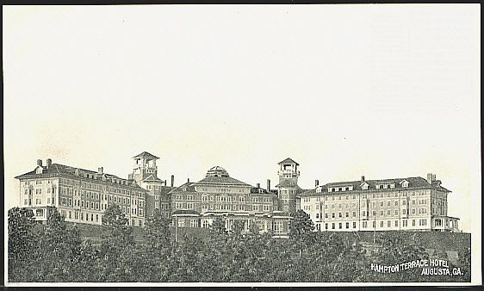

A classic postcard showing the Hampton Terrace Inn,
North Augusta’s opulent landmark hotel as seen in 1910
[To observe error use 3X glass or magnify to 200%.]

For Augusta born James Urquhart (pronounced Ir-qu-hart) Jackson (1856-1925) building a city across the Savannah River was a long time dream. A successful land and stockbroker by the age of 34, Jackson formed the North Augusta Land Co. in 1890 and purchased 5,600 acres of land from Mattie Butler Mealing who owned the land where Georgia Avenue and its surrounding streets now exist. The cost was $100,000, which would be equivalent to $2.4 million today. A year later, plans were approved to build the original North Augusta Bridge (designed by Charles Boeckh connecting 13th St. with Georgia Ave). This cost an additional $85,000. By 1897, the first trolley cars were in operation. In 1902, Jackson bought the Augusta Railway and Electric Company and built his new family home, Rosemary Hall at the northwest corner of Forest Avenue and Carolina Avenue. That same year he made plans to construct the massive Hampton Terrace Inn atop the hill below Martintown Road overlooking N. Augusta, the Savannah River and Augusta, GA. It opened its doors in 1903 and soon billed as one of the most sumptuous hotels in America.
________________________________________________________________________________________________________________________
(Continued on page 3, column 2)

Collecting the Coins of 1910 (exc. Gold): 100 years ago
By Arno Safran

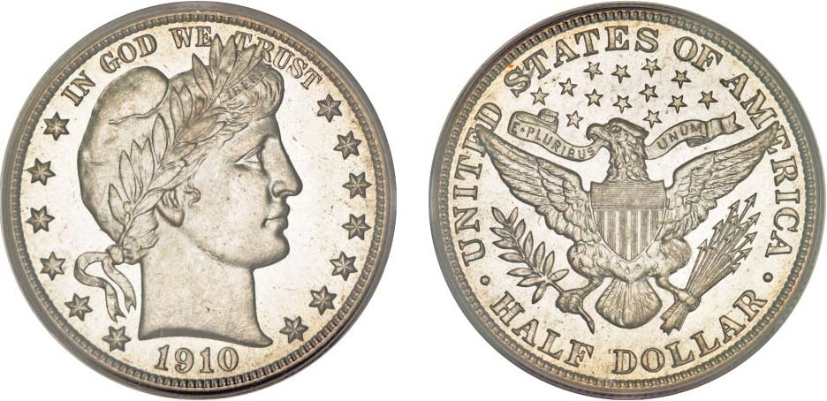

A 1910 Barber Liberty Head Half Dollar graded MS-65 by PCGS
It sold for $4,025 at the Heritage Long Beach, CA auction Sept. 17, 2008
[Courtesy of Heritage Auction Galleries] [Magnify up to 200% to see details.]

At our September 2 meeting member Rick Owen brought in a 1910 Proof Set that was housed in a certified NGC holder. The October 2010 issue of the Newsletter shows a picture of the set and an actual-size image of the 1910 Proof Barber half dollar. That Show & Tell presentation inspired me to do some research on the coins the US produced a century ago.

Nine denominations were struck for circulation in 1910; the Bronze Lincoln cent, Liberty five-cent nickel, Barber silver dime, quarter and half dollar along with the gold quarter eagle ($2.50), half eagle ($5.00), eagle (!0.00) and Double eagle (20.00). With gold currently trading over $1,300 an ounce as this is being written, most moderate income collectors are likely to forgo the yellow metal and concentrate on the minor coinage (1¢ thru 50¢). Depending on one’s discretionary income, the collector should be able to assemble a matched set of all five denominations from Fine-12 up through MS-63. Wonder coins such as the examples shown above and below are beyond the reach for most collectors but they are still worth viewing.
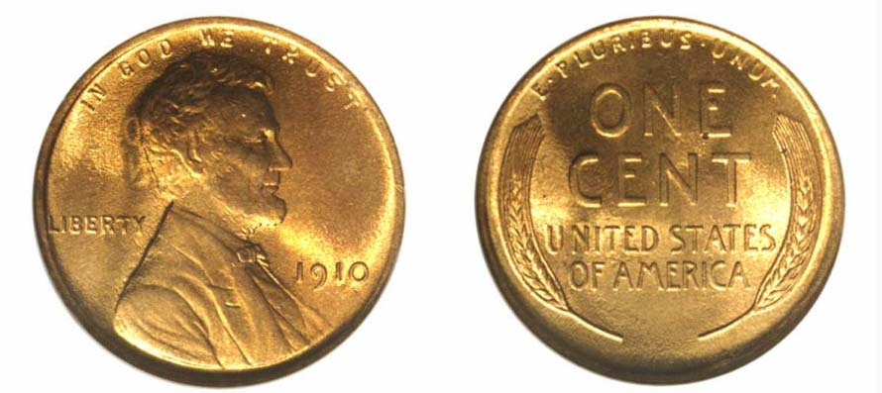

This 1910 Lincoln Cent grading MS-67 by NGC realized over $2,100
[Courtesy of Heritage Auction Archives]
[Use a threeX glass or magnify up to 200% to see details.]
___________________________________________________________________________________________________________
(Continued on page 2, column 1)

Collecting the Coins of 1910 (exc. Gold): 100 years ago
(Continued from page 1, column 2)

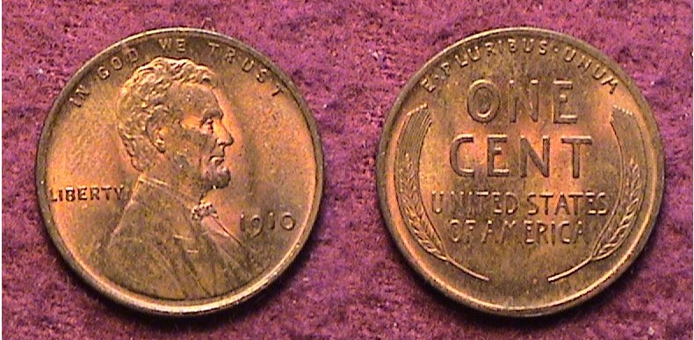

A 1910 Lincoln cent graded MS-62 Red/ Brown
[Use threeX glass or magnify to 200% to see details.]

In contrast with the lustrous gem Heritage auction specimen on the preceding page, the example of the 1910 Lincoln cent shown directly above pales in comparison. Upon magnification, one will observe the impression of a fingerprint to the left of Lincoln’s head but overall the details on the hair and on the wheat-sheaves are strong and there is still a lot of red in the coin. It cost the author $10.00 around twenty years ago. Today this specimen might sell for around $25.00. More than 146.8 million cents were struck at the Philadelphia Mint in 1910; and over 6 million were coined at the San Francisco facility but not nearly as many were saved or preserved in Gem BU condition as the first year 1909-P VDB issue.
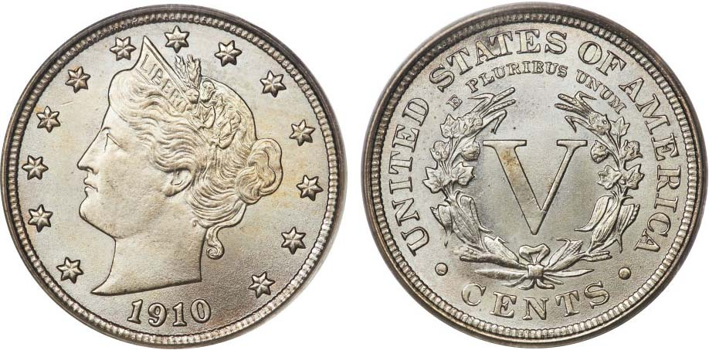

A 1910 Liberty nickel graded MS-66 by PCGS
It realized $2,990 at the F.U.N. Show in Orlando, FL on Jan. 5, 2010
Courtesy of Heritage Auctions Archives
[Use threeX glass or magnify to 200% to see details.]

The 1910 Liberty nickel shown above is a remarkable specimen but well beyond the means of most moderate-income collectors. It was graded MS-66 by NGC and realized almost $3,000 at the Heritage Signature auction held at the Florida United Numismatist’s (FUN) show back in early January, 2010.

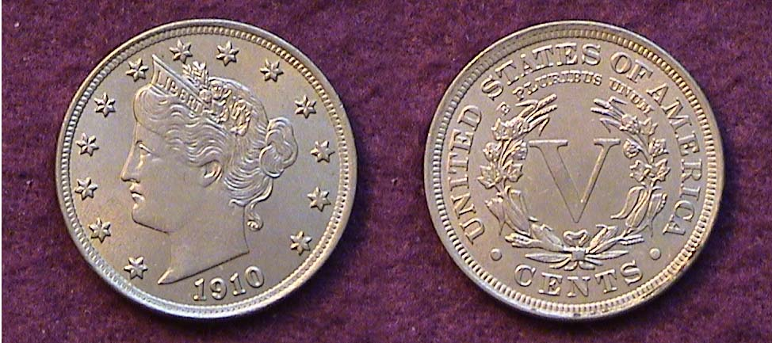

Another example of a 1910 Liberty nickel
[Use 3X glass or magnify to 200% to see details.]

The author’s “raw” example shown directly above may be no match for the Heritage MS-66 piece but whether one grades it MS-60 or AU-58 (due to the weak strike on the forehead) it is still attractive and at a far lower price; $60.00. Over 30 million Liberty “V” nickels were produced in 1910, all at the Philadelphia Mint. As a date, the 1910 nickel is common. Since five cents a century ago had the value of what $1.50 to $2.00 can purchase today, the vast majority of 1910 nickels went into circulation.

In 1910 the average wage was 22¢ an hour and $550 a year but a skilled person could earn anywhere from $1,500 to $5,000 per annum, (e.g. engineers, accountants and some members of the medical profession). A candy bar that costs 75¢ today was only 2¢ in 1910. Sugar cost 4¢ a pound. .A dozen eggs ranged from 14¢ to 23¢ and a pound of coffee was 15¢. (Today it is closer to $6.00 a pound, ground or whole bean.) In 1910, the five-cent nickel was the workhorse of the economy. In all probability less than 5% of the US population could afford the luxury of putting aside even one 1910 BU Liberty nickel for future appreciation.

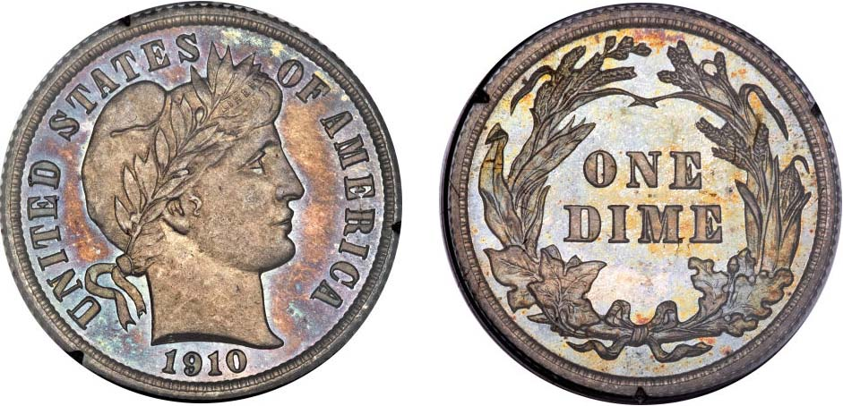

A 1910 Barber dime grading Proof-65 by PCGS
It realized $1,265.00 at the Central States Numismatic Assoc. Convention held in Milwaukee, WI on April 5, 2010 -Courtesy of Heritage Auctions- Archives
[Use 3X glass or magnify to 200% to see details.]

Charles Barber was the designer of the Liberty Head dime and quarter (1892-1916), also the half dollar (1892-1915) and while he may not have been the most imaginative Chief Mint engraver in our coinage history his coinage designs are among the most popular US numismatic collectibles today. Gem pieces bring fairly high prices. Proof specimens are also highly desirable yet are surprisingly reasonable considering their low mintages. Unlike business strike pieces that circulated heavily with most becoming warn, damaged or lost, proof coins were intended as souvenirs for collectors and most specimens were saved in mint state. Over the years, some toned beautifully as the 1910 Barber dime shown above demonstrates yet, when one contemplates its beauty, the $1,265 the coin realized at auction would seem a bargain considering only 551 were minted.

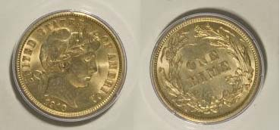

This attractive 1910 Barber dime graded MS-63 by PCGS
Realized only $161 at a Mail Bid auction held May, 9, 2009
Courtesy of Heritage Auctions Archives
[Use 3X glass or magnify to 200% to see details.]

In comparison with the number of proofs issued the recorded mintage fore the 1910-P Barber dime alone was a whopping 11,520,000. One need not have to pay much for a high end BU. The coin pictured directly above is a pleasing example of an affordable MS-63 specimen that would grace any moderate income collector’s year set.

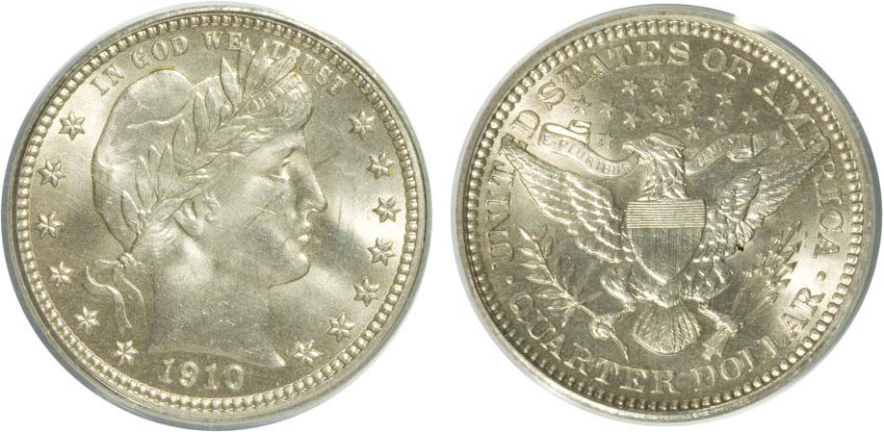

A 1910 Barber Quarter graded MS-64 by PCGS
The coin realized $431.25 at the Long beach auction held in May of 2009
-Courtesy of Heritage Auctions- [Magnify to 200% to see details.]

The light streak mark crossing Miss Liberty’s nose probably kept this 1910-P quarter from being graded MS-65.
_______________________________________________________________________________________________________________
(Continued on page 3, column 1)
Collecting the Coins of 1910 (exc. Gold), 100 years ago
(Continued from the preceding page)

Under greater magnification the coin is virtually spot free. In 1910, the Philadelphia Mint issued 2,244,000 Barber quarters while the Denver Mint struck 1.5 million. Compared with today’s output of clad quarters, these may not seem very much yet the date is considered common and priced moderately up through MS-64. By comparison, only 551 proofs were struck.

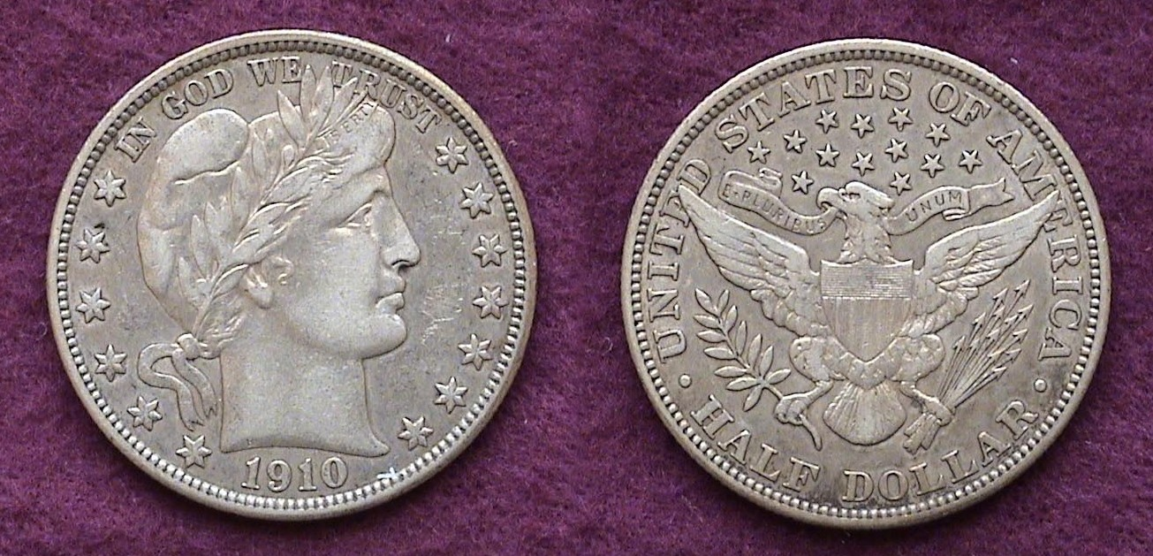

A 1910-P Barber Half dollar graded VF-35
The coin sold for $125.00
[Use 3X glass or magnify to 200% to see details.]

Just 418,000 Barber halves were struck at the Philadelphia Mint in 1910; the fifth lowest mintage of the 73 coin series. According to the late David Lawrence, author of The Complete Guide to Barber Halves (DLRC Press Virginia Beach 1991), this date is scarce when found in grades from Fine-12 up through XF-40. In those mid-range circulated grades it is regarded as an R-4, (i.e. quite scarce). From Good-4 to VG-10 it is considered common because of extensive hoarding by collectors and in Mint State, only an R-2, (i.e., fairly common) if somewhat pricey with MS-63 graded specimens costing around $800.00.

Of all the denominations struck in 1910, the Barber half-dollar appears the most resplendent in all grades from Fine-12 up. There is a large collector base for the series because there are no ”stoppers” such as with the Barber quarter set which has three prohibitively expensive keys highlighted by the 1901-S, a coin currently priced at over $12,000 grading only VG-8. One can assemble an entire 73-piece Barber half set in VG at a very modest price that will still appear attractive to the eye if “original”. The 1910-P Barber 50¢ specimen shown above is technically a VF-35 but many dealers would try to sell it as an XF-40 pricing it around $300 or higher according to the 2011 Red Book. In VF-20, the same source lists it at $160 today.

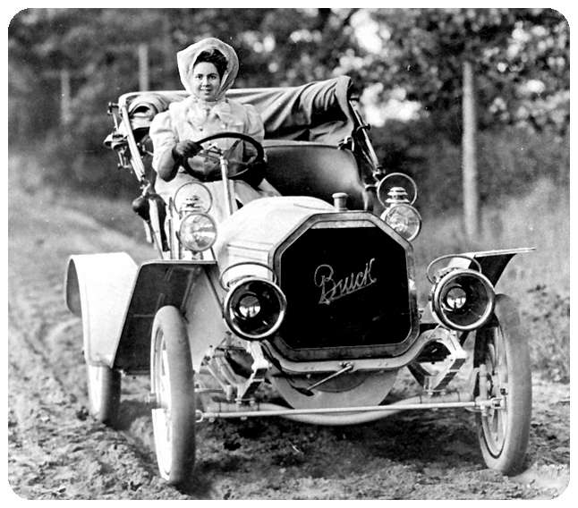
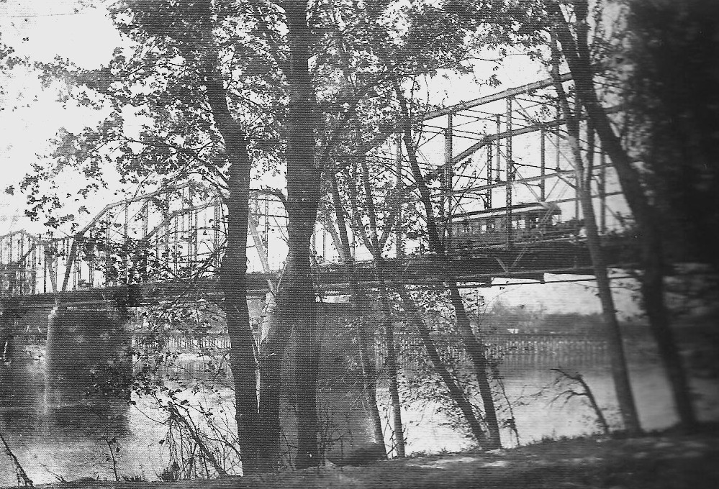
In 1910 the president was William Howard Taft. There were 46 states. The population of the US was 92.2 million. The average life expectancy for men was 47 years. 20% of the US population was illiterate and not more than 6% obtained a high school diploma. Gasoline for the estimated 8,000 cars on the 144 known paved roads had to be purchased at your local pharmacy. A Buick cost $750.

Behind the wheel of a 1910 Buick [Use 3X glass or magnify pic to 200%]

The coins of 1910 represent an interesting memento of the end of one era and the beginning of a new century.
__________________________________________________________________________________________________________________
North Augusta in 1910
(Continued from page 1, column 1)

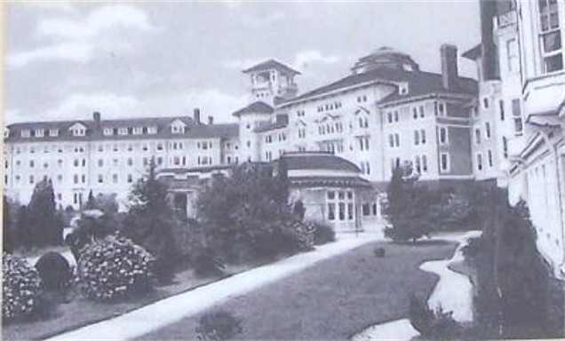

Another angle showing the Hampton Terrace Inn ca. 1910
[Use 3X glass or magnify to 200% to see details.]

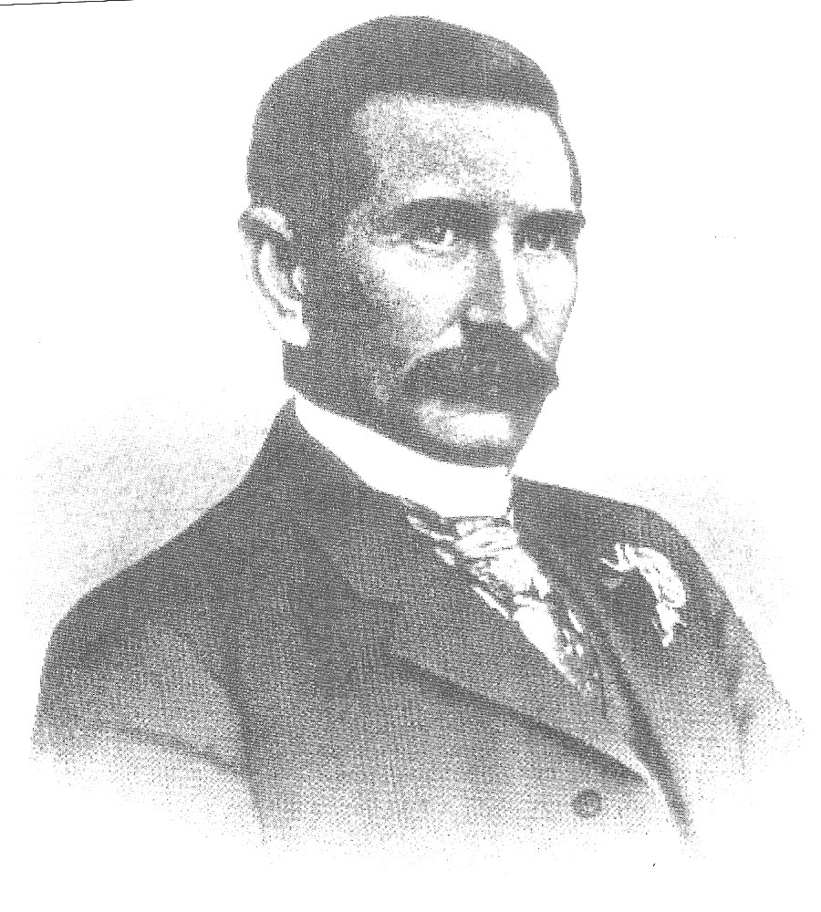
The Hampton Terrace was far from a rustic inn. In reality it was an exclusive hotel. It was five stories high, had over 300 guest rooms, a magnificent interior rotunda, a spacious ballroom and a special music room large enough to house and orchestra. The hotel even had its own private railway connecting to the main RR line from Charleston, SC to Augusta and beyond. The most famous of the famous were guests and President elect William Howard Taft was invited to speak there. At one point, it was rumored that the City of North Augusta was in the running to become the center of the growing motion picture industry. On New Year’s Eve in 1916, a devastating fire destroyed the entire edifice; the cause, faulty wiring during a massive renovation project being undertaken.

James Urquhart Jackson
Courtesy of Jeanne M. McDaniel, Author of “North Augusta: James u. Jackson’s Dream”

Despite efforts by Jackson to rebuild the hotel, other events were now in play beyond the control of this dynamic individual. In 1917, the United States would be embroiled in World War I. A boll weevil infestation would severely damage the cotton crop a few years later and by the time of Jackson’s death in 1925 at the age of 69, the rebuilding of the Hampton Terrace had virtually been abandoned.

At left is the horse-drawn trolley crossing the Savannah River over the first North Augusta Bridge.

[Magnify to 200%]
__________________________________________________________________________________________________________________
Club News

At the Oct. 7 meeting Treasurer Sharon Smoot announced a balance of almost $2,000, $1,993.42 to be precise. The record balance for the club was in part--no doubt--due to the income received from our recent coin show held in September. President Steve Kuhl thanked Jim and Helen Barry for the fine job they did as co-bourse chairpersons. He also praised all the other club members for helping out with the set up, serving at the Welcoming Desk during the show and with the breakdown at the end of the show. In making his final show report to the membership, Jim Barry reiterated that Helen and he were stepping down as bourse chairpersons and mentioned the importance of finding a replacement (or replacements) to coordinate plans for our annual show in September of 2011. The Barry’s have run the show six of the nine years that our club has been in existence.

Jim Barry announced the upcoming SCNA Convention to be held at the Carolina First Center in Greenville, Fri. thru Sun., Oct. 29 thru 31. There will be 94 tables with dealers carrying a wide variety of numismatic collectibles, coins, tokens, medals, paper money and scrip. Jim also mentioned that beginning on January 26, 2011 he will be presenting a course on the History of Coins as part of the Adult Education program held at the Aiken Community Center. The course will be held in four sessions on successive Wednesdays starting at 3:00 PM.

Our speaker for the evening was Tony Chibbaro who presented a PowerPoint program entitled, “Our first Coins”. Tony is regarded as an authority on medalic art with an accent on the tokens and medals of South Carolina. He has authored a published book on the subject, which is highly regarded. He has also written a marvelous compendium on South Carolina’s Low Country as part of the Images of America series. Therefore, it was no surprise that Tony delivered another outstanding program, this time on “Historic Gold Coins of the World: Part One.

The cover slide for Tony Chibbaro’s PP presentation

Tony explained that the birth of coinage began in ancient China and ancient Greece almost simultaneously in the late 7th century BC. He described the gradual metamorphosis of early coinage from the first prototype as a crude lump of electrum, weighing 2.63 grams, about 9 mm in diameter with no design moving to single punch, followed by double punch and later multi-punch pieces; all with no design. Finally, around 650 BC the first engraved crudely designed coin was fashioned with a virtually indiscernible object depicting God, monarch or beast. Gradual improvements in the art of engraving produced recognizable animals, monarchs, generals and Gods. The speaker’s presentation was well balanced with clear oral and written commentary supported by excellent photos of these early crude specimens. Most of the coins were tiny, the largest examples not bigger than our 3¢ silver trimes only much thicker. After his talk, Tony invited the members to view a sampling of some of the early coins from his collection. We now look forward to Part 2.

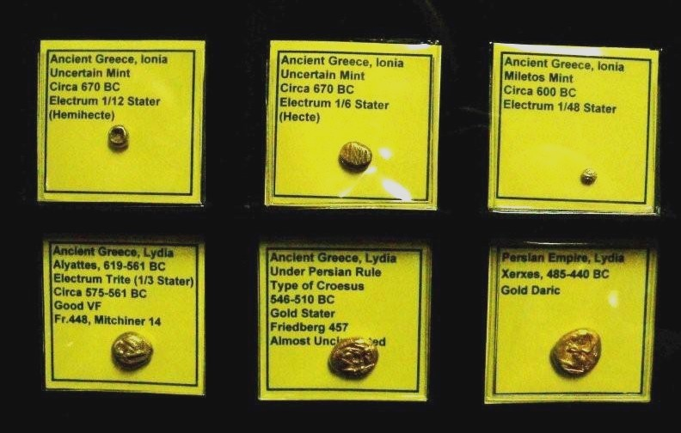

Six early gold coins from Tony Chibbaro’s collection
[Use 3X glass or magnify to 200%]
-Photo taken by Helen Barry-

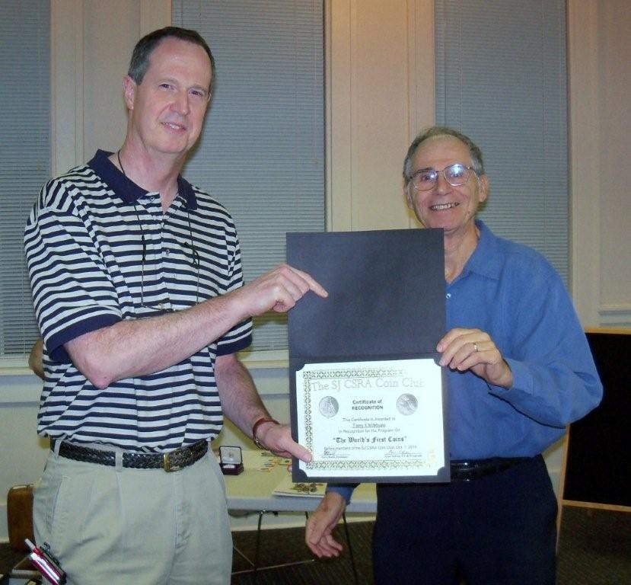

Tony receiving Certificate of appreciation from VP Arno Safran
-Photo taken by Helen Barry-

At our upcoming Nov. 4 meeting member Chuck Goergen will present a PowerPoint Program entitled Spanish Colonial Cobs and the Treasure from the Atocha.

The prizewinners at the Oct. 7 meeting were Dick Smoot who received a silver eagle and Roger Worpell who won the 50/50 $20.00. Congratulations gentlemen! Please bring in a 2-minute Show & Tell on Nov. 4. Do not forget that the deadline for the Dec. 2 dinner entrée choices and checks is November 23.
__________________________________________________________________________________________________________________________
Club Pre-Christmas Holiday Dinner Information

As reported earlier our pre Christmas holiday party is scheduled for Thursday, December 2 to be held at the Houndslake Country Club, 901 Houndslake Drive in Aiken. The time is 6:30 p.m. Social – Cash Bar, dinner starting at 7:00.
The menu options are 1. Beef tips with Gravy, 2. Chicken Picatta, 3. Grilled Salmon and 4. Rib eye steak. The complete dinner includes a house salad, standard veggies, a dessert buffet, coffee or tea. The entrée price for members is $16.00; $20 for the Rib eye steak. For non-members, the charge is $22.00, $26.00 for the steak. The deadline for respondents is Tuesday, Nov. 23. Checks should be made out the SJ CSRA CC. There will be no refunds after that. The attached reservation form with choices should be sent with remittance to Helen Barry, P.O. Box 11, New Ellenton, and SC 29809. One other important reminder: Although dinner jackets and ties are not required, no Jeans or denims are allowed in the clubhouse.
______________________________________________________________________________________________________________________________

The Copper Corner

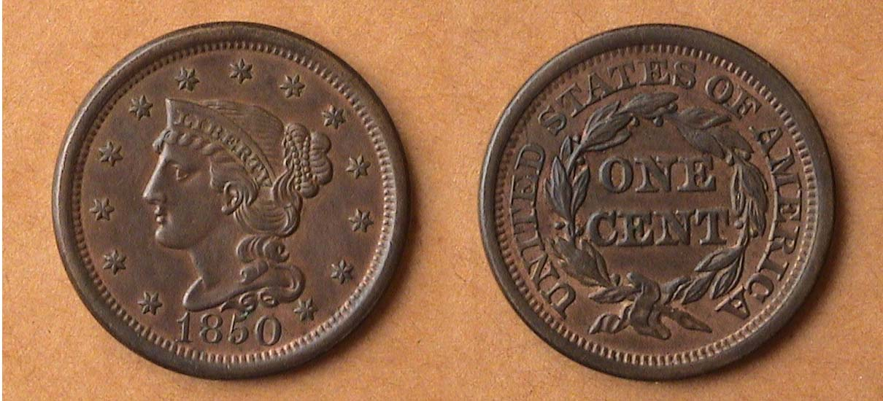

An 1850 Mature Head Braded Hair cent grading AU-50 RB, N-6 R2
[Use 3X glass or magnify to 200% to view details more clearly.]

Unlike the Classic Head cent shown in the previous issue, the 1850 Braided Hair cent seen directly above is an extremely common date with a reported mintage of over 4 million. The design is an offshoot of the original Coronet type (sometimes referred to unfavorably as Matron Head) struck between 1816 and 1839. It is now believed that Asst. Engraver John Reich and not Chief Engraver Robert Scot created the type that followed the short-lived Classic Head (1808-1814). Reich left the Mint in 1817 leaving Scot to continue preparing the dies. After Scot’s death in 1823, William Kneass was appointed Chief engraver and continued the design type through 1835 when he suffered a stroke. Christian Gobrecht was asked to replace him and almost immediately began tinkering with the design, which underwent subtle modifications in 1835, 1837 and finally 1839 when the Petite Head was introduced. In this version, the coin appeared slightly smaller in diameter with a closed collar around the rim but Miss Liberty’s head appeared to be tipped downward. From 1840 thru 1843, the Petite Head was the design of choice. Sometime in 1843, Gobrecht made one more modification. He raised the head to an upright position over the date. In this final version, the Braided Hair Coronet type came to be known as the Mature Head. It would remain intact through 1857, the last year of large cent production.

Most of the Mature head cent dates (1843-57) are inexpensive up through AU-50 and moderately priced. The cost soars for specimens graded MS-64 and MS-65 full Red.

________________________________________________________________________________________________________

Kindly Patronize our Advertisers

