Pres. Steve Kuhl
V .P. Pat James
Sec. Jim Mullaney
Treas. Sharon Smoot
Sgt. in Arms: Glenn Sanders
The Stephen James
CSRA Coin Club of Aiken
P.O. Box 11
New Ellenton, SC 29809
Web site: www.sjcsracc.org
The SJ CSRA CC of Aiken, SC meets on the 1st Thursday of the month at the Aiken Public Library

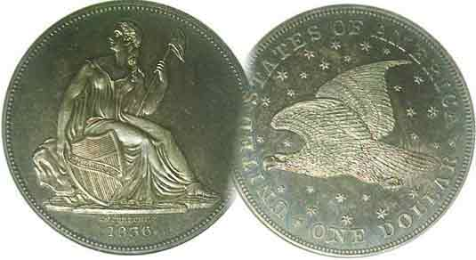
Programs: Pat James
Show: by Committee
ANA Representative: Jim Barry
Publicity: Jim Clapp
Newsletter: Arno Safran
E-Mail: arnosafran@comcast.net
Auctioneer: Glenn Sanders
Web site: Susie Nulty (see above.)

2011 Club Meeting Schedule
Volume 10, Number 11 the Stephen James CSRA Coin Club, Founded in 2001 November, 2011
Monthly Newsletter
When it comes to a coin’s value, Eye Appeal is Buy Appeal
Our next meeting is on Thursday, November 3, 2011 from 6:45 to 8:45 PM

Jan. 6 Apr. 7 July 7 Oct. 6
Feb. 3 May 5 Aug. 4 Nov. 3
Mar. 3 Jun. 2 Sep. 1 Dec. 1, (dinner)

______________________________________________________________________________________________________

Eye Appeal Is Buy Appeal

Many a would-be entrant to Numismatics becomes discouraged when they soon discover that many of the popular key date coins are beyond their financial means. For those who opt to acquire type coins, they soon come to realize that high end mint state examples range from pricey to extremely expensive, especially for the earlier US type as well as Foreign and Ancients. A hobby should provide one with both pleasure and enrichment and with pastimes that involve collecting, one’s discretionary income must always be taken into consideration.

Even with professional coin grading certification, many coin collectors consider grading to be the big bugaboo of numismatics. While third party certification has cut down on the marketing of over graded and doctoring of coins, it has not entirely eliminated the perception that over-grading practices may still be occurring. The writer has observed first hand that on some occasions dealers with large inventories tend to get the higher grades when submitting coins for certification than those who submit fewer coins.

The foregoing notwithstanding, grade is not the paramount issue when it comes to adding pieces to one’s collection. It is condition. For years the two were considered one and the same but they are not. The grade of a coin is based on whether it is uncirculated and if not, the varying degrees of wear the coin has undergone. The condition on the other hand of a coin describes its overall appearance regardless of the amount of wear based upon four distinct categories, its surfaces, (amount of blemishes) whether it appears “original” (its natural color for grade, not artificially toned or cleaned), the amount of luster and finally the strike; (its sharpness). A better-date warn 1811/10 Classic Head large cent graded VG-8 that is chocolate-brown with smooth surfaces has more eye appeal than one grading VF that is black, scratched, corroded or rim-nicked.
_____________________________________________________________________________________________________________________

(Continued on page 4, column 1)

Collecting the US Coins of 1811: 200 years ago
By Arno Safran

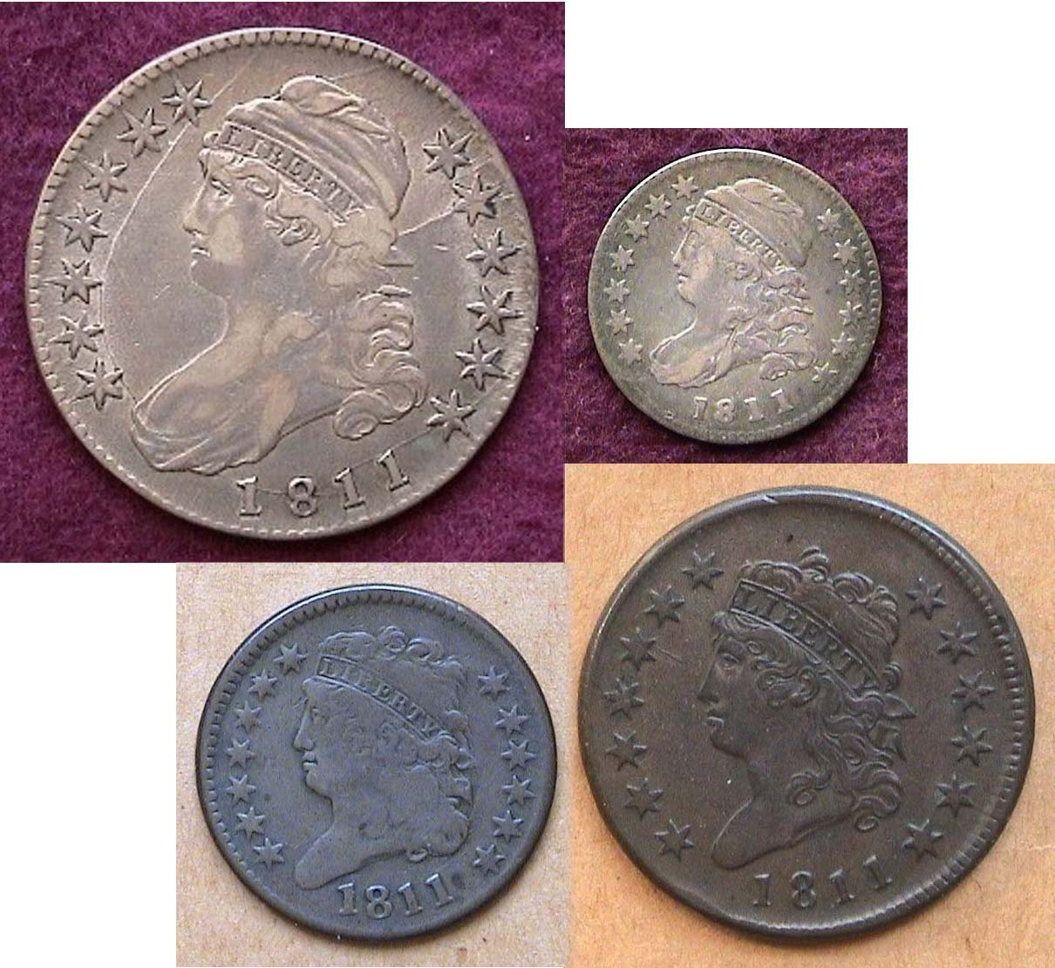

The obverses of the US Coins of 1811 (excluding gold)
Top row: Capped Bust 50¢ & 10¢
Bottom row: Classic Head ½¢ and large cent.
[Use 3X glass or magnify page to 200% to view details.]

In 1811 the United States Mint in Philadelphia issued just five coins, the ½¢, 1¢, 10¢, 50¢ and $5.00 denominations. With the exception of the Capped Bust half dollar which had a reported mintage of over 1.2 million all the others were issued in low numbers and are considered scarce, and in the case of the $5.00 half eagle, rare. The best a collector of moderate means can hope for is to assemble a four piece set in circulated grades. In those days, the US Mint acquired the copper planchets needed for coining half cents and large cents from the firm of Matthew Boulton whose manufacturary was located in Soho-Birmingham, England. The problem was that during the Napoleonic wars (since 1805) the British began to raid American vessels which they believed were harboring deserters. The commander of the British ships not only recaptured these men but imprisoned American sailors as well. As a result, conditions between the two countries began to deteriorate. President James Madison ordered a blockade against British trade which had little effect other than to limit our commercial needs including
___________________________________________________________________________________________________________________
(Continued on page 2, column 1)
Collecting the US Coins of 1811: 200 years ago
(Continued from page 1, column 2)

‘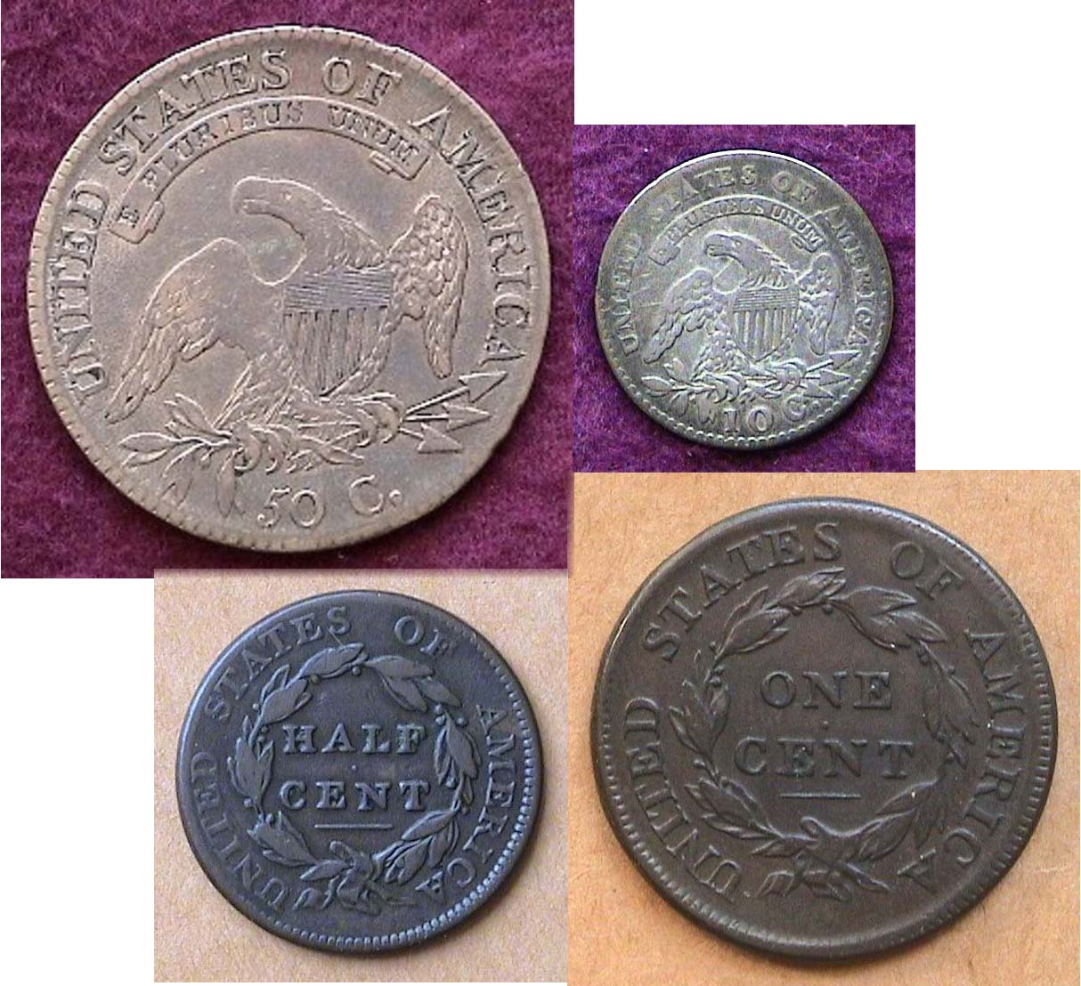

The reverses of the US Coins of 1811 (excluding gold)
Top row: Capped Bust 50¢ & 10¢
Bottom row: Classic Head ½¢ and large cent.
[Use 3X glass or magnify page to 200% to view details.]

the expediting of copper blanks for our cent and half cent. As it was, these planchets were in short supply, the cent denomination being the workhorse of our commerce back in the early 19th century. By 1811, the need for small denominations was becoming dire.

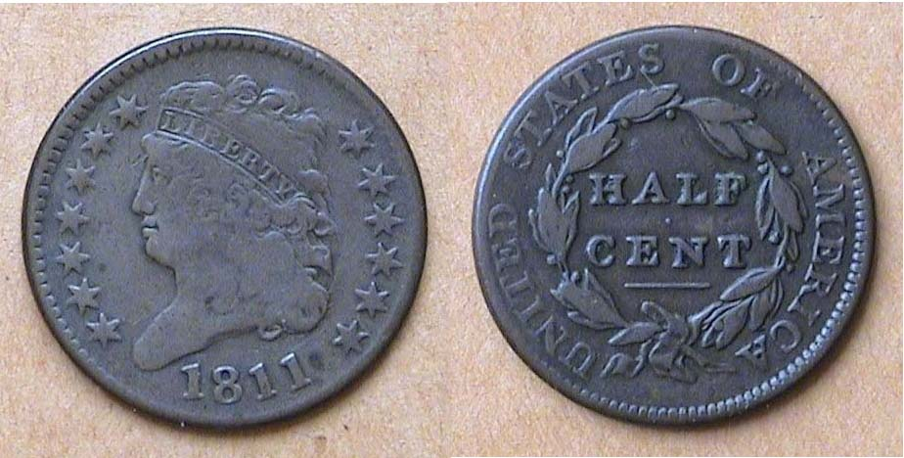

An 1811 Classic Head ½¢ C-2 grading VG-8
[Use 3X glass or magnify page to 200% to view details.]

The half cent had never been a popular denomination, being used more to make change for the Latin American Real (worth 12½¢) which was accepted for goods and circulated freely here. Due to its unpopularity along with the increasing shortage of copper for cent blanks, 1811 would be the final year for half cent coinage until 1825. The reported mintage for the 1811 ½¢ was a scant 63,140 issued. The date seldom surfaces above VG and when nice specimens appear in Fine-15 or better they can bring well over $1,000. The VG specimen shown was acquired years ago and still cost $250 back then.

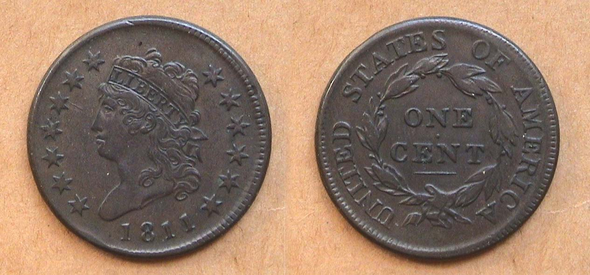

An 1811 Classic Head Large cent, S-287 graded VF-35
[Use 3X glass or magnify page to 200% to view details.]

The lovely Classic Head cent type was a short-lived series issued from 1808 through 1814 inclusive yet is arguably the most attractive design-type of the large cent series (1793-1857). Unfortunately, the conditions between the United States and England began deteriorating during the period when this type was struck. Whether this had anything to do with the poor care the copper blanks received on the long voyages across the Atlantic will never be known but many arrived damaged by corrosion displaying a dark charcoal color before they reached the Philadelphia Mint. As a result finding survivors appearing with a Chocolate coppery color free of porosity or corrosion has always been a challenge to the collector seeking a specimen with eye appeal. The 1811 issue was particularly vulnerable to the problems described, and to make matters worse, it had the lowest reported mintage of the series, just 218,025.

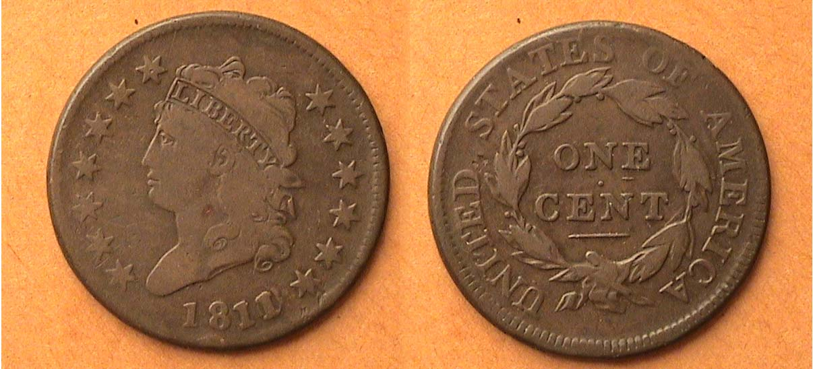

An 1811/10 Classic Head Large Cent, S-286 graded VG-8
[Use 3X glass or magnify page to 200% to view details.]

Avid collectors of large cents more often than not collect by die variety and there are many of them. Unlike the Liberty Cap (1793-96) and Draped Bust series (1796-1807) which boasts a large number of varieties for most dates, the Classic cent series has only 19 for its entire seven year run and three of them are easy to recognize. Two of the three are over-dates; the 1810/9, considered relatively common and the 1811/10, regarded as extremely rare in high grade and scarce in the lower grades as the one pictured above. The distinguishing diagnostic apart from the obvious 11/10 on the obverse is on the reverse where upon magnification one will observe a small horizontal dash under the E in ONE.

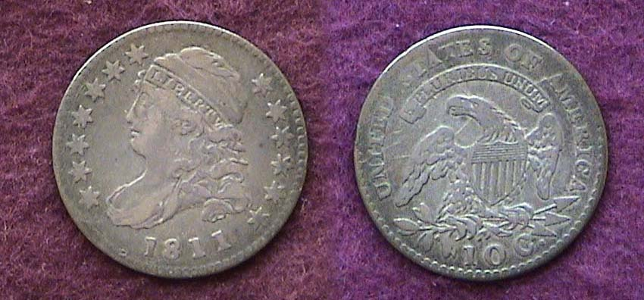

An 1811/9 Capped Bust dime grading VF-20
[Use 3X glass or magnify page to 200% to view details.]

Up until 1820, dimes were not struck on a yearly basis. During the teen decade of the 19th Century dimes were struck just twice, in 1811 and 1814. The reported mintage for the 1811 dated dime was just 65,180, a far cry from the mintages of the past 100 years. The 2012 Red Book lists the date at $275 in Fine-12 and $550 in VF-20, the coin shown above was acquired at a coin club meeting in the late 1980’s from a collector who was moving out of the area and decided to sell his collection peace-meal to fellow club members. This does not happen very often but it is one way to acquire better date coins at a reasonable price since a dealer’s profit is not involved.
______________________________________________________________________________________________________________
(Continued on page 3, column 1)

Collecting the US Coins of 1811: 200 years ago
(Continued from previous page)

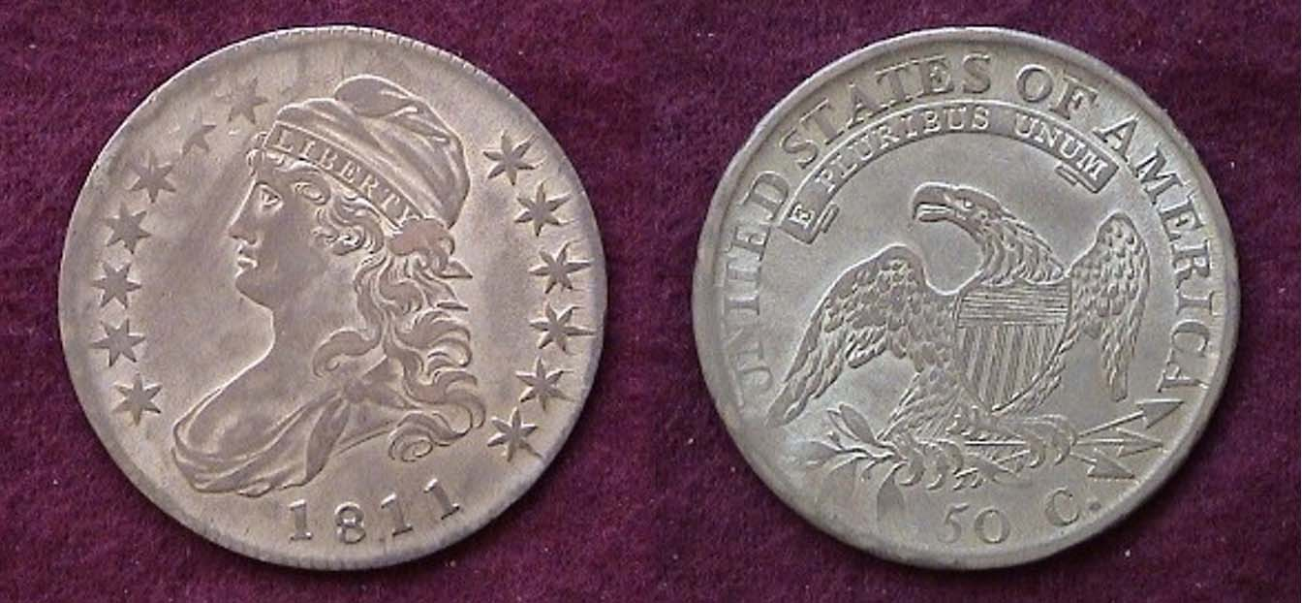

An 1811/10 Capped Bust half dollar O-101 R1 graded XF-45
(AKA 18.11 “punctured date” variety]
[Use 3X glass or magnify page to 200% to view details.]

In 1804, dollar coinage was suspended due to the shortage in silver and its high purchasing power, (the value of $17.00 today). As a result, the 50¢ coin became the largest circulating denomination. But even the half dollar had tremendous purchasing power back then, precisely $8.56, in 1811; so the coin was often stored by banks to be used more as specie to back larger business transactions and hardly circulated. This would account for so many high grade survivors in today’s numismatic marketplace.

The 18.11 coin shown above is one of the more popular varieties of the Capped Bust Lettered edge half dollar series (1807-1836). After Morgan dollars and large cents, the Bust half has probably the third largest collector base for US coins and like large cent collectors, many collect by die varieties. Overdates are the usually the easiest to spot and are probably the more popular. This 18.11 doesn’t appear as an overdate because it is a late die state but is distinguished by a visible dot between the two 1’s in the date caused by a die defect. This particular variety is also known as the “punctured date”.

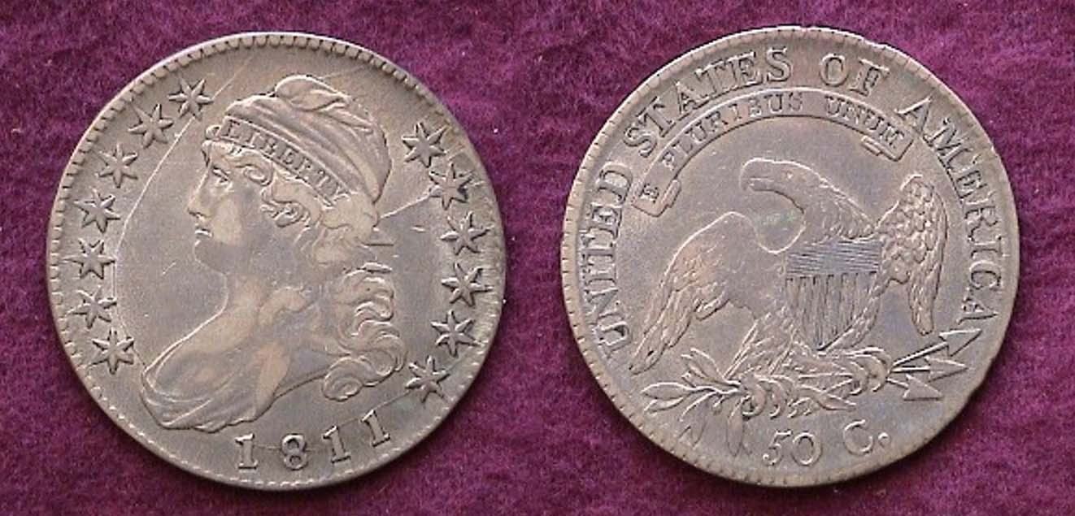

An 1811 Capped Bust half dollar O-112a, R5 graded VF-35
[Use 3X glass or magnify page to 200% to view details.]

Upon magnification (3X for printed copy) or 200% for digitized), the reader will observe two prominent die cracks; the larger of the two rising from Liberty’s Bust to the rim beyond the 7th star (top left) and the smaller at the right from just under the cap through the 9th star (2nd from upper right). These diagnostics only appear on the O-112a die variety which is considered one of the scarcer ones. The O stands for Harold Overton, the author of Early Half Dollar Die Varieties: 1794-1836 and the primary source for “Bust Nut” half dollar collectors. The number after the letter R regards “rarity”, “1” being the most common with “6” to “8” considered rare to extremely rare. R5 indicates “quite scarce”. Bust halves can appear attractive from F-12 up.

US Gold Coinage in 1811

The Coinage Act of 1792 authorized ten denominations, two in copper, five in silver and three in gold. The three gold coins were the quarter eagle ($2.50), the half-eagle ($5.00) and the Eagle ($10.00). The $10.00 coin was suspended from 1805 thru 1837 to be resumed in 1838. The $2.50 was suspended from 1809, not to be resumed until 1821 leaving just one gold coin, the $5.00 half eagle to be struck on a regular basis during the interim.

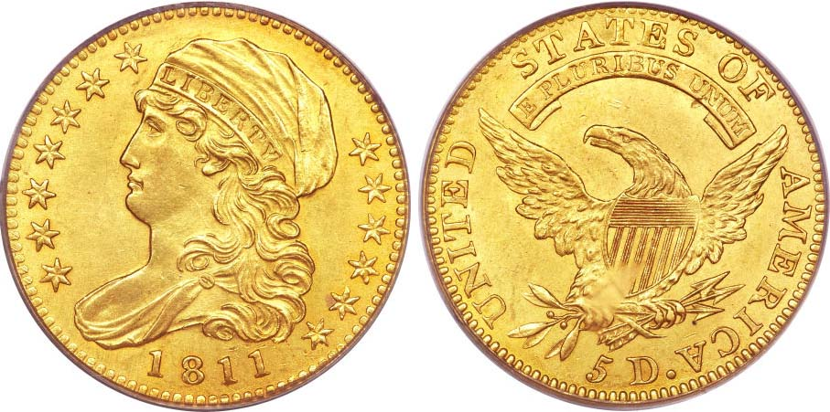

An 1811 $5.00 Half Eagle graded MS-63 by PCGS
(Courtesy of Heritage Auction Archives)
The coin realized $20,700 at the F.U.N. Show auction held in January, 2010
[Use 3X glass or magnify page to 200% to view details.]

Most of us can never hope to own an 1811 half eagle $5.00 gold piece. The 25 mm coin pictured above cost the winning bidder almost $21,000 but we have the pleasure of observing this gorgeous specimen at absolutely no charge via the internet, courtesy of Heritage Auction Archives. If we magnify the picture one will see the beautiful artwork of engraver John Reich. From 1807-1817 Reich was Asst. Engraver to Chief Engraver Robert Scot although he did virtually all the design work. He was hired at annual wage of $600 and received nary an increase ten years later when he submitted his resignation. The reported mintage for the 1811 $5.00 coin was 99,581. There are two varieties to this date; the large 5 and small 5 for $5.00 on the reverse. This is the small 5 variety. Neither is scarcer than the other and each is available for a price thanks to the larger than average mintage for this date. In 1811, a $5.00 gold piece had the purchasing power of $85.50.

The coins of 1811 (excluding gold) were a challenge but with the help of dealers and fellow collectors who specialized in early US coin types, the writer was able to complete the short set including the two interesting overdates at an affordable price.

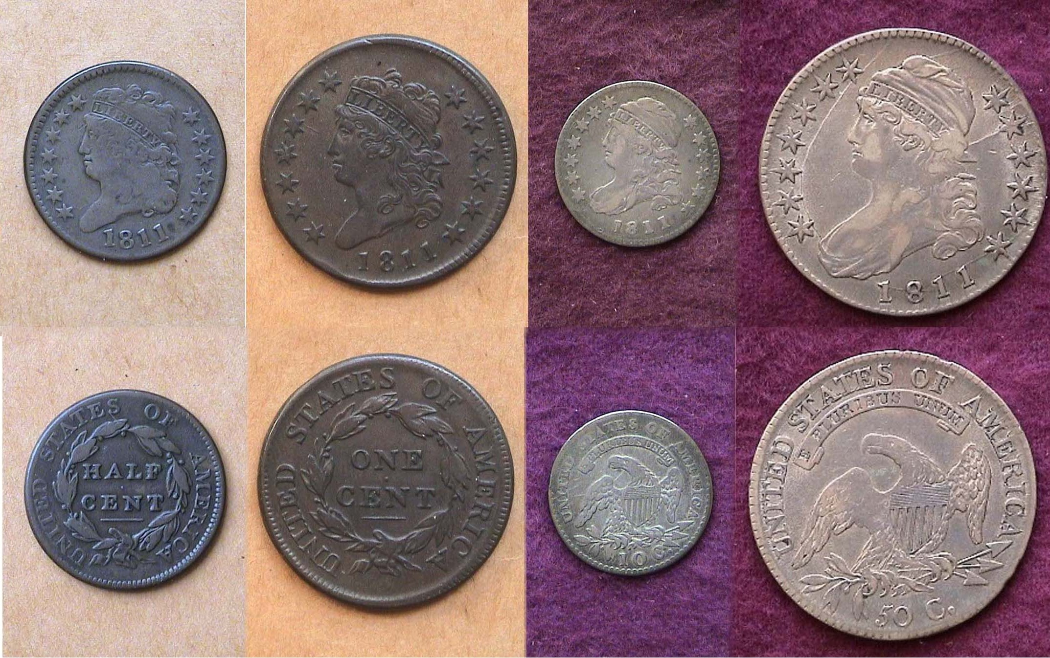

A basic 1811 Year set (excluding gold) shown reduced in size
[Use 3X glass or magnify page to 200% to view details.]
________________________________________________________________

Eye Appeal is Buy Appeal

(Continued from page 1, column 1)

With the exception of the one gold coin in the feature article on the Coins of 1811, all of the examples shown were well circulated specimens ranging in grade from VG-8 to XF-45 with most averaging VF-30. Acquiring any in mint state grades would be well beyond the discretionary income of the author. The important thing was to find the nicest specimens available at a reasonably affordable price. The collector considered the 1811 $5.00 Eagle unaffordable and therefore non-collectible but through the internet, one can at least display an example.

________________________________________________________________________________________________________________________

Club News

At our Nov. 3 meeting the Curator of the Aiken Museum, Elliot Levy will present a program on “The History of Money n Aiken County” At last month’s` meeting Secretary Jim Mullaney concluded his program on Coin Grading via PowerPoint displaying large pics of Barber halves and Morgan & Peace dollars on the big screen in the meeting room.

Following Jim’s program, the club held a more extensive Show & Tell session that included exhibits by Chuck Goergen, Rick Owen and Arno Safran. Chuck displayed three Hispanic-American colonial 8 Reales; two Pillars, including an attractive sea salvaged 1836 piece of eight from the reign of Philip V and a similar type 1755 from Ferdinand VI, also a portrait dollar dated 1783 of Charles III. Rick displayed a group of better date Morgan dollars all grading AU that he won at a recent auction, an 1889cc (NGC-53), 1893cc (NGC-55), 1893-O (NGC-55), 1894 (Anacs-50) [only 110,000 minted], and an 1895-S (NGC-55). These were followed by a blazing specimen Rick brought in of a 1917 Type I Standing Liberty quarter graded MS-66 by PCGS. (A finer one the editor has never seen!) Arno followed with three pieces he acquired at the Blue Ridge Numismatic Association Show held back in August, an 1883 Liberty no cents nickel housed in an NGC Proof 64 cameo holder, a russet toned 1917 Walking Liberty half graded MS-63 by PCGS and a 1926 Standing Liberty quarter graded MS-64 by ICG.

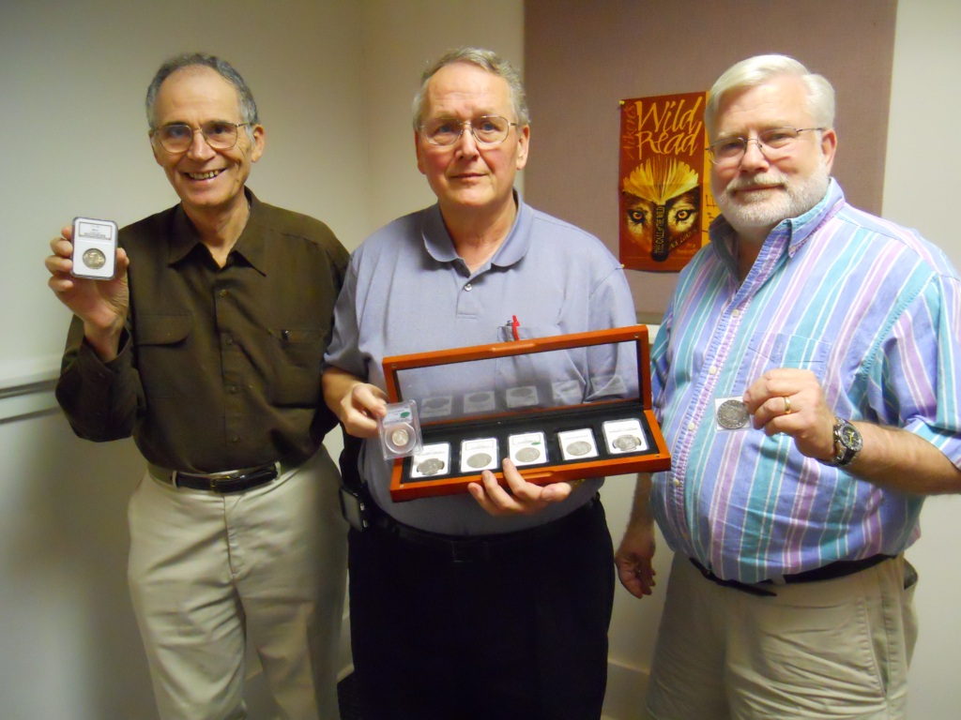

Arno Safran, Rick Owen and Chuck Goergen displaying their

Show & Tells at the SJ CSRA CC Meeting of October 6, 2011

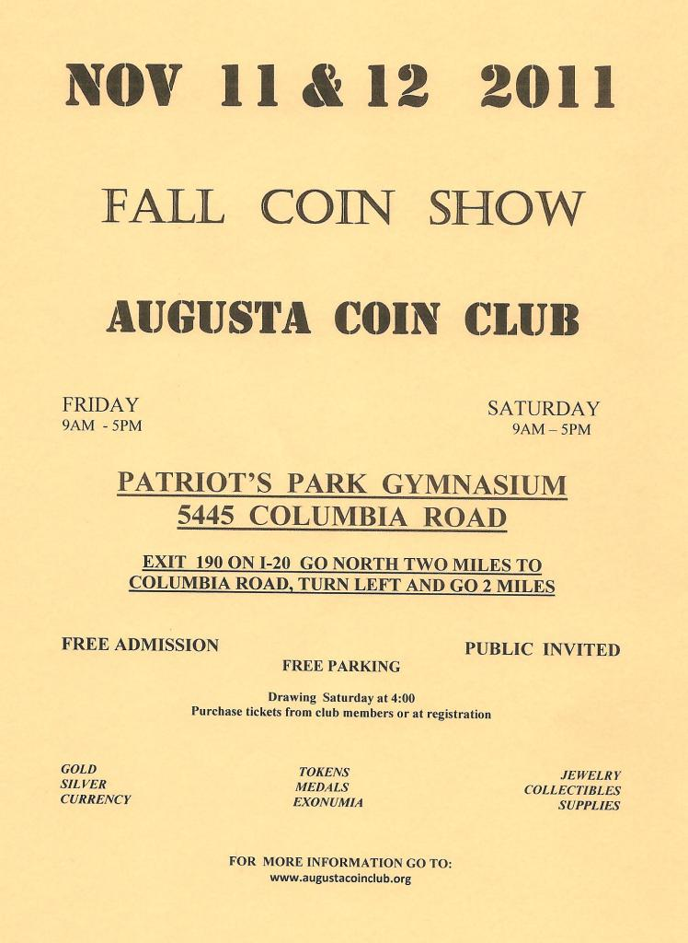
Glenn Sanders reported on the upcoming shows including the SCNA show scheduled in Grenville for Oct. 28-30 and the Augusta Club Show set for Nov. 11 & 12, at Patriot’s Park in Columbia County, GA.
President Steve Kuhl received a warm round of applause for his roll in running our successful Fall show. The door prize winner were Rick Owen and Jim Mullaney took the 50/50. Congratulations gentlemen. Our next meeting is Nov. 3; Christmas Party, Dec. 1 at the Hounds Lake Country Club. . To view details magnify to 200%

